# Using open SMR datasets E-SMR and LDR lite for research and training purposes

V. Tulkki

VTT Technical Research Centre of Finland ltd

Espoo, Finland

Email: ville.tulkki@vtt.fi

M. Szogradi, F. Alblouwy, R. Komu, R. Tuominen

VTT Technical Research Centre of Finland ltd

Espoo, Finland

Abstract

Many Small Modular Reactor (SMR) designs rely on innovative safety features, which may differ from those of currently operating in conventional nuclear power plants. Access to simulation models of such nuclear designs, allows interested parties to build expertise prior to licensing processes. Two SMR datasets, E-SMR and LDR lite, have been recently published, and this paper presents examples of design basis accident scenario simulations, performed by VTT, on models made with these datasets.

The E-SMR dataset was created in EURATOM-funded ELSMOR (towards European Licensing of Small Modular Reactors) project, to demonstrate a safety philosophy similar to other PWR-type SMRs. The dataset was published under the CC-BY-NC 4.0 license, and has been used to perform design basis accident scenario benchmarks.

The LDR lite dataset is a public version of the Low-temperature District heating Reactor (LDR-50), intended for academic research. Designed by VTT, LDR-50 is suitable for district heating and other low-temperature applications, which influenced the design of the reactor to include different innovative passive safety system designs and approaches.

## Introduction

As new small modular reactor designs are being introduced, there is a need to educate and train experts to analyze their safety features. However, as many of these safety functions rely on passive operation and natural circulation, it is important to understand the behaviour of the whole plant in order to assess these safety systems’ efficacy. The lack of available information and simulation models, creates a challenge in this activity. To alleviate this issue, two open datasets that describe simplified versions of SMR designs under development in Europe have been published: E-SMR and LDR lite. These datasets and accompanying published benchmark definitions can be used for education and training purposes by interested parties.

## E-SMR dataset

E-SMR is an integral PWR design developed within the EURATOM-funded ELSMOR (towards European Licensing of Small Modular Reactors) project [1]. The aim of the E-SMR was to act as a platform to test the developed simulation models and be used for a safety assessment “base case”. The design was inspired by the early publicly available French SMR design, with some parts integrating elements from several other SMR designs. As it is, the E-SMR shares its safety philosophy with the early French SMR design, but the technical design differs, as some of the non-published data was supplemented with data from similar SMR designs that are publicly available, supported by engineering judgment and sensitivity analysis. The initial design was iterated during the ELSMOR project to fulfill some chosen safety goals for design basis accidents. The dataset describing the E-SMR [2] is shared through FAIRDATA with CC-BY-NC 4.0 license. The complementary report [3] of the dataset provides an example calculation of Station Black-Out (SBO) case.

The E-SMR describes an integral PWR in a submerged containment inside a pool, as schematically described in Figure 1. The design utilizes six parallel identical Compact Steam Generators (CSG) for normal operation, producing heat to secondary circuit, while two Safety Compact Steam Generators (SCG) are used for decay heat removal to the water wall during transient conditions. Figure 1 also depicts the simulation scheme where 'CSG1’ and ‘CSG2’ represent the 3-3 CSGs while ‘SCSG’ denotes the two safety heat exchangers.

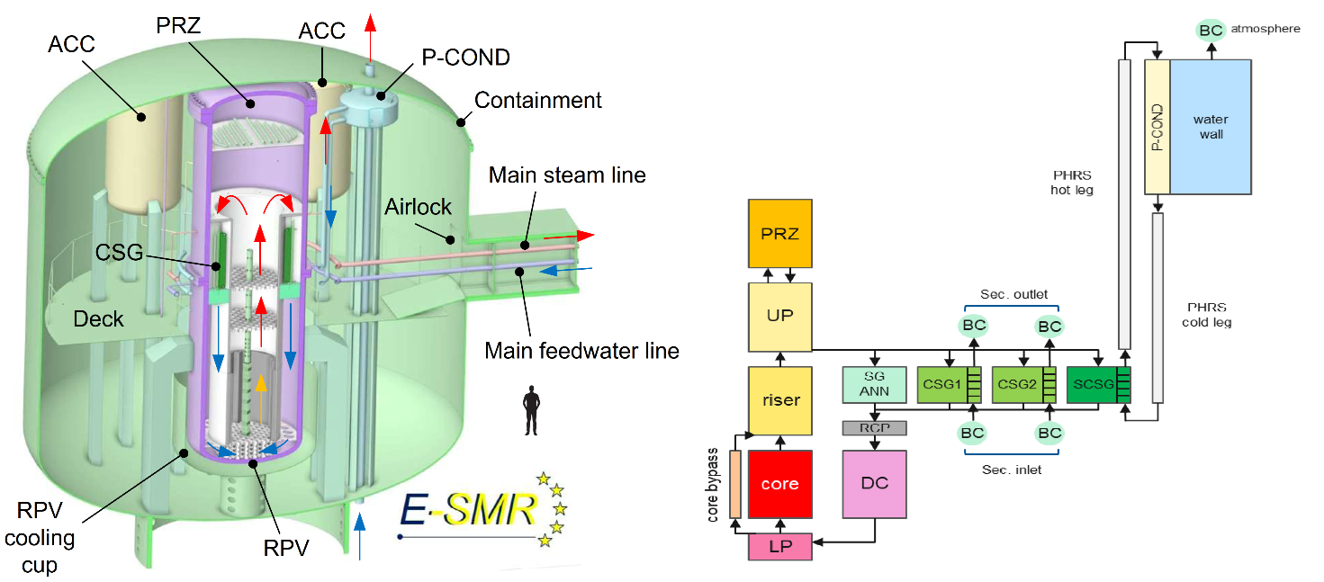

*Fig. 1: Image of E-SMR design and schematic description of the primary circuit with Lower and Upper plenum (LP, UP), Pressurizer (PRZ), CSGs (simulated with boundary conditions BC), and SCSGs.*

The SBO example case described in the model report [3] provides a set of initial boundary conditions as well as some reference results simulated with Apros code [4] by VTT. The temperatures and pressures decrease initially fast, but the negative pressure and temperature gradients decay after a few hours. Figure 2 describes the containment atmosphere (left) and water pool (right) temperature evolution during the 72 hours after the onset of the transient. Water pool features strong temperature stratification, and the top of the pool is near boiling-point at the end of the 72-hour period. However, the temperatures at the bottom of the pool and the inlet of the safety condenser (P-COND) have not varied much, ensuring the efficient removal of the decay heat. In case of the containment, the PHRS heating became quite notable in the late section of the simulation, despite the 50 mm insulation blanket enveloping the P-COND and its adjacent piping.

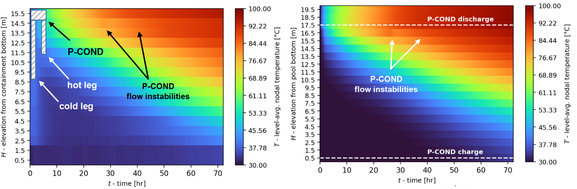

*Fig. 2: Containment atmosphere (left) and water pool (right) temperature evolution during the SBO scenario.*

## LDR lite

LDR lite is a public benchmark dataset of the LDR SMR design that is currently under development. LDR is a low-temperature low-pressure integral PWR designed to supply hot water (little over 100 °C) for low-temperature applications, e.g. district heating purposes. The nuclear facility would contain several 50 MWt modules depending on the end-user need. As the energy is supplied as low-temperature heat, the pressures and temperatures in the primary circuit can be kept well below 200 °C and 1 MPa. Each module has a dual pressure vessel submerged in a pool. The dual containment features a partially flooded annulus to allow for automatic emergency core cooling in case of power loss. The primary circuit works based on natural circulation, with forced circulation in the secondary side that also acts as a physical barrier for radionuclides protecting the district heating circuit (tertiary circuit). The low operating temperature allows for downcomer coolant temperatures low enough for allow the water in the annulus stay liquid. Should the usual heat removal through heat exchangers via the secondary circuit be lost, the temperature in the primary circuit rises, increasing also the water temperature in the annulus. When the annulus water begins to boil, the steam condenses to the outer wall that is cooled by the water pool, forming an efficient way to remove decay heat from the primary circuit. Schematic description as well as an example of the LDR lite Apros nodalization is shown in Figure 3. The database [5] describing the LDR lite along with description report [6] is publicly available.

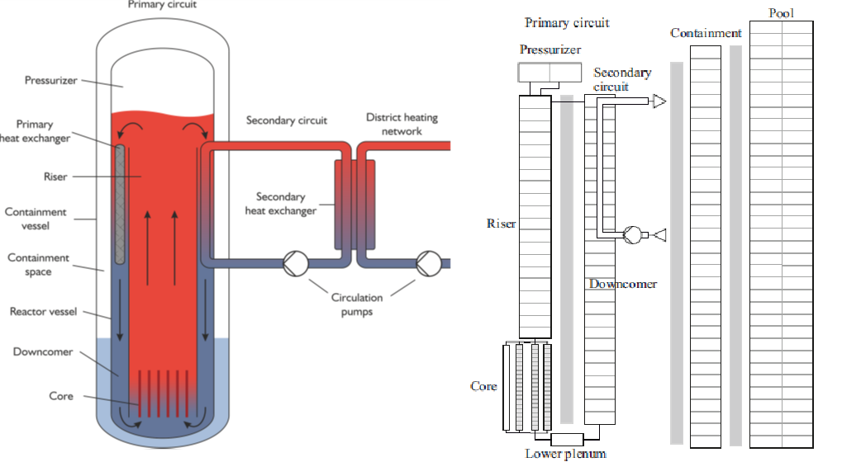

*Fig. 3: Schematic representation of the LDR lite with dual vessel configuration and partially flooded annulus, natural circulation in the primary circuit and forced circulation in the secondary circuit. On the right, Apros nodalization of the primary circuit, containment, and pool of the LDR lite design.*

A control rod drop transient benchmark was published recently [7] detailing also the LDR lite core as well as providing a benchmark exercise with reference results. The control rod transient allows for investigation of the 3D reactor dynamic behavior in the core with natural flow circulation. The core features low-enriched fuel and control rods in every bundle as described in Figure 4. The faulty control rod is in the safety group at the outer rim of the core, as shown in the same figure.

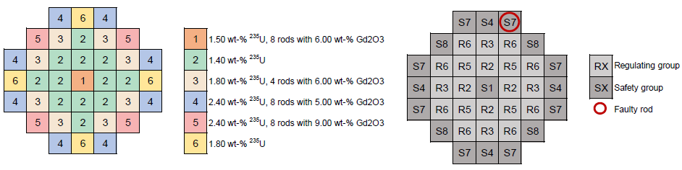

*Fig. 4: LDR lite core composition and the control rod configuration. Control Rod drop transient benchmark’s faulty rod is marked.*

Reference results for the control rod drop transient have been presented as part of the benchmark, and some example results gained using Apros for system and Ants [8] for core neutronics modelling are depicted in Figure 5. The reactor power decreases due to the rod drop, before it starts to increase due to temperature feedback.

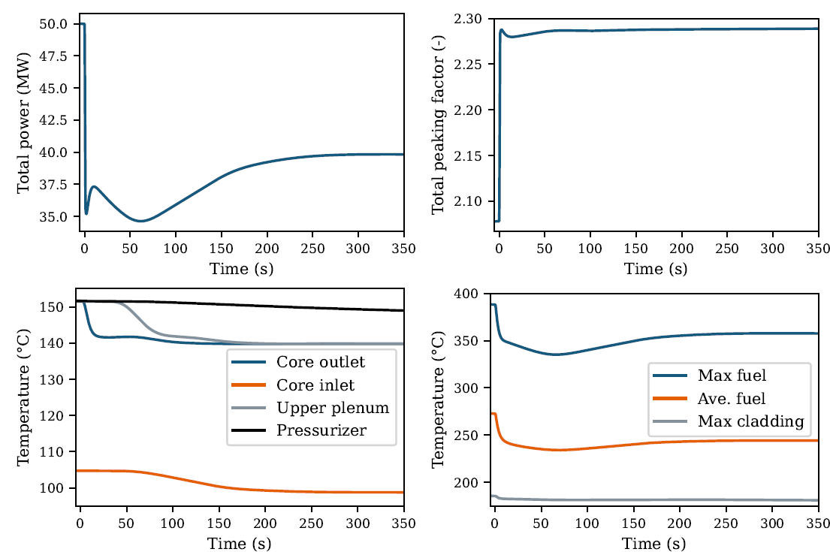

*Fig. 5: Core power, total power peaking factor, coolant temperature, and fuel temperature of the LDR lite during control rod drop transient.*

## Conclusions

The E-SMR and LDR lite datasets are recently published and are being used in ongoing and future joint research activities. Some of the details of both designs as well as example scenarios are provided here, but the full description is in the associated repositories and benchmark descriptions. These activities include EURATOM-funded projects TANDEM and EASI-SMR, where E-SMR is used as an example design in case studies, and SANE, where LDR lite serves as a case example for investigating safety issues for non-electric applications of nuclear energy.

References

1. <https://cordis.europa.eu/project/id/847553>
2. ELSMOR E-SMR dataset. Publisher: VTT Technical Research Centre of Finland Ltd. <https://doi.org/10.23729/474d23cf-60a7-4f78-9d6e-1e2d8633db4b>
3. F. Davelaar, N. Bakouta, A. Bersano, J. Bittan, S. Buchholz, C. Lombardo, A. Kaliatka, C. Liegeard, S. Lorenzi, K. Nikitin, M. Ricotti, M. Szogradi, M. Valinčius, E-SMR dataset description, ELSMOR Deliverable D5.2_public
4. M. Hänninen and J. Ylijoki. “The one-dimensional separate two-phase flow model of APROS.” VTT RESEARCH NOTES 2443, VTT Technical Research Centre of Finland, Espoo, Finland (2008). Available: https://publications.vtt.fi/pdf/tiedotteet/2008/T2443.pdf.
5. <https://www.ldr-reactor.fi/en/ldr-lite-benchmark/> as visited on 28.5.2024.
6. R. Komu. and R. Tuominen. "LDR lite benchmark specifications." LDR design document, LDR-PUB-VTT-10002-R2, VTT Technical Research Centre of Finland, 2023.
7. R. Komu, V. Valtavirta, R. Tuominen, S. Hillberg, “LDR Lite Benchmark: Coupled 3D Neutronics and Thermal-Hydraulics Analysis of a Control Rod Drop Transient”, PHYSOR2024.
8. V. Sahlberg and A. Rintala. “Development and first results of a new rectangular nodal diffusion solver of Ants.” In Proceedings of the PHYSOR 2018. Cancun, Mexico (2018).