Candu owners group: excellence through

collaboration for an evolving nuclear

landscape

S. IQBAL
CANDU Owners Group
Toronto, Canada
Email: Sonia.Iqbal@CANDU.ORG

Abstract

The CANDU Owners Group (COG) has been supporting its members over the last 40 years to achieve operational excellence and bring clean energy to the world. As the preeminent nuclear collaboration hub in Canada, COG is poised to support its members and the industry at large as the nuclear landscape evolves to meet national climate change goals and a shared vision of a sustainable and reliable power future. COG has established an SMR Program consisting of the Small and Medium Size Reactor Technology Forum (SMRTF) and the SMR Vendor Participant Program (SMR VPP). These groups drive a collaborative effort to accelerate the development and deployment of SMRs in Canada and worldwide, for both flexible on-grid and alternate applications. The integrated and collaborative approach of the COG SMR Program brings advantages by de-risking plans for all partners and providing support to new entrants to the nuclear industry. The paper will provide an overview of the COG SMR Program with a focus on collaborative efforts with respect to fuel supply and security, radioactive waste, security, nuclear liability, regulatory topics and the development of management systems.

INTRODUCTION
Canada has traditionally been a “CANDU-country”. However, with Canada’s ambitious decarbonization goals and the need for smaller, simpler and cost-effective sources of energy, there is a growing domestic and global market for small modular reactors (SMRs). As the preeminent nuclear collaboration hub in Canada, CANDU Owners Group (COG) is poised to support its members and the industry at large as the nuclear landscape evolves to meet national climate change goals and a shared vision of a sustainable and reliable power future.
COG has established an SMR Program consisting of the Small and Medium Size Reactor Technology Forum (SMRTF) and the SMR Vendor Participant Program (SMR VPP). These groups drive a collaborative effort to accelerate the development and deployment of SMRs in Canada and worldwide, for both flexible on-grid and alternate applications. The integrated and collaborative approach of the COG SMR Program brings advantages by de-risking plans for all partners and providing support to new entrants to the nuclear industry.
This paper will provide an overview of the COG SMR Program with a focus on collaborative efforts with respect to fuel supply and security, radioactive waste, security, nuclear liability, regulatory topics and the development of management systems.

CANDU Owners group
CANDU Owners Group (COG), is a private, non-profit corporation funded voluntarily by members and supplier and program participants in six countries worldwide to achieve excellence through collaboration in CANDU and advanced nuclear technologies to meet the world’s goals for clean, abundant energy.
Established in 1984, COG facilitates research, joint projects, information exchange, learning and development, and industry alignment on standards, regulations and the most recent trends and areas of interest of our members and participants.
Through its collaboration model, COG has been helping the industry succeed for the last 40 years through the creation, retention and transfer of knowledge to achieve continuous improvement and develop the nuclear innovations of tomorrow.

early industry collaboration to support smr development and deployment

SMR Roadmap
In 2017, the Government of Canada launched Generation Energy – an open and inclusive nationwide dialogue with stakeholders, experts and individual Canadians on Canada’s energy future. Through this dialogue, the Canadian government heard that a pan-Canadian approach to SMRs would reduce uncertainty and help guide decisions by investors and policymakers and inform decisions by regulators [1].
In response to the recommendations provided in the Generation Energy Council Report [1], the Canadian government led the development of the Canadian SMR Roadmap [2], a landmark, 10-month effort that was unlike any other initiative the sector has ever undertaken. Published in November 2018, the SMR Roadmap brought together the federal government, provinces, territories, utilities, Canada’s nuclear sector, and enabling partners to chart a vision for this emerging area of nuclear innovation. The vision was informed by expert analysis as well as dialogues across the country, including initial engagement with Northern and Indigenous communities and organizations.
The SMR Roadmap established a Team Canada approach for SMRs, involving actions from the essential enablers needed to realize the promise of SMRs in Canada, and is credited with initiating serious discussion about SMRs in Canada.
Throughout the development of the SMR Roadmap, it became clear that SMRs offer the next great opportunity and that Canada has what it needs to seize it, however strategic partnerships will be the key to success —across the sector and internationally [2].

SMR Action Plan
The SMR Action Plan [3] was published in December 2020. It responds to the recommendations in the Canadian SMR Roadmap [2] and includes additional voluntary actions. It outlines Canada's plan for the development, demonstration and deployment of SMRs for multiple applications at home and abroad.
Recognizing that strategic partnerships will be critical for the successful development and deployment of SMRs, the SMR Action Plan brought together over 100 key enablers from across the country, who have committed to more than 500 concrete actions to seize the SMR opportunity for Canada.

Canada’s Three Stream Strategy
As identified in the Canadian SMR Roadmap [2], SMRs cover a wide range of power levels, designs, technological readiness levels and end user-applications. In Canada, that can range from traditional on-grid generation to co-generation, heavy industry, mining, and remote community applications.
To meet this broad-based Canadian need, four Utilities (SaskPower, OPG, Bruce Power and NB Power) worked collaboratively to develop three streams of SMR projects which were outlined in the SMR Action Plan [3]. These three streams of projects will reduce carbon emissions and create growth opportunities for communities connected to the grid (Stream 1), will support advancement in nuclear technology and innovative methods to reduce nuclear by-products (Stream 2), and will bring affordable, clean energy to remote communities and mines (Stream 3). These three streams are being developed in parallel with equal priority.

Canadian nuclear landscape

The role of nuclear energy in meeting Canada’s decarbonization goals
Since the publication of the SMR Roadmap and SMR Action Plan, Canada has committed to achieving net-zero emissions by 2050, and by 2035 in the electricity sector. In order to achieve these ambitious goals, Canada will need to deploy various non- or low-emission technologies, including nuclear power.
More recently during COP28, Canada was one of the countries which endorsed the Declaration to Triple Nuclear Energy, in which all signatories committed to work together to advance a global aspirational goal of tripling nuclear energy capacity from 2020 by 2050 [4]. This pledge translates to an additional ~24GWe increase in capacity from 2020 [5].
It is expected that both large nuclear power plants and SMRs will need to be deployed to meet Canada’s decarbonization goals. SMRs are expected to play a critical role in the energy transition as they offer a diverse range of power levels, designs, and end-user applications.

Canada’s Three Stream Strategy: Vision to Reality
Since the Three Stream Strategy was established in 2020 (refer to Section 3.3), various technologies have been selected for deployment in Canada. Table 1 provides the status of the SMR projects that are currently underway.

TABLE 1. STATUS OF SMR PROJECTS IN CANADA
Licensee | Technology | Location | Status
Stream 1: On-grid SMR deployment
Ontario Power Generation | GE-Hitachi  BWRX-300 | Darlington, Ontario | October 2022: Application for Licence to Construct submitted to CNSC  Construction to be completed as early as end of 2028
SaskPower | GE-Hitachi  BWRX-300 | Two potential sites in Estevan, Saskatchewan | Final site selection in 2025  Decision on whether to build an SMR will be made in 2029  Potential deployment in mid-2030s
Stream 2: On-grid advanced reactor development
New Brunswick Power | ARC-100 | Point Lepreau, New Brunswick | June 2023: License to prepare site submitted  Targeted to be fully operational by early 2030’s
New Brunswick Power | Stable Salt Reactor -Wasteburner  (SSR-W) | Point Lepreau, New Brunswick | Expected to be in operation by early 2030s
Stream 3: Micro-SMR deployment to replace diesel use in remote communities and mines
Global First Power | USNC MMR | Chalk River, Ontario | Environmental and licensing assessments are ongoing
Saskatchewan Research Council (SRC) Nuclear | eVinci  micro-reactor | Saskatchewan | Expected to be operational by 2029 (subject to licensing and regulatory requirements)

cog smr program
In 2018, C​OG's mandate was expanded to include "advanced technologies”, demonstrating that the COG Collaboration Model is beneficial to non-CANDU technologies.
As COG members began to proceed with the development and deployment of advanced technologies, the COG SMR Program was established. The Program, as depicted in Fig. 1, consists of:
- The Small & Medium Size Reactor Technology Forum (SMRTF) and related Task Teams and Peer Group;
- The SMR Vendor Participant Program (SMR VPP).
Building upon the Team Canada approach that was used in the development of the SMR Roadmap [2], these groups were created to drive a pan-Canadian collaborative effort to accelerate the development and deployment of SMRs – for both flexible on-grid and alternate applications, including providing energy self-sufficiency in remote areas. An integrated and collaborative approach brings advantages by de-risking plans for all partners.
The COG SMR program allows members to share experiences and lessons they are learning during the early stages of regulatory and public engagement and with respect to “first-of-a-kind deployments” of novel technologies in Canada. Given the diversity of technologies and applications, and regions being considered for the deployment of SMRs, having members from various regions and organizations is beneficial to get diverse
perspectives, and also to allow for the sharing of experiences, particularly with those that are from regions that are new to nuclear.
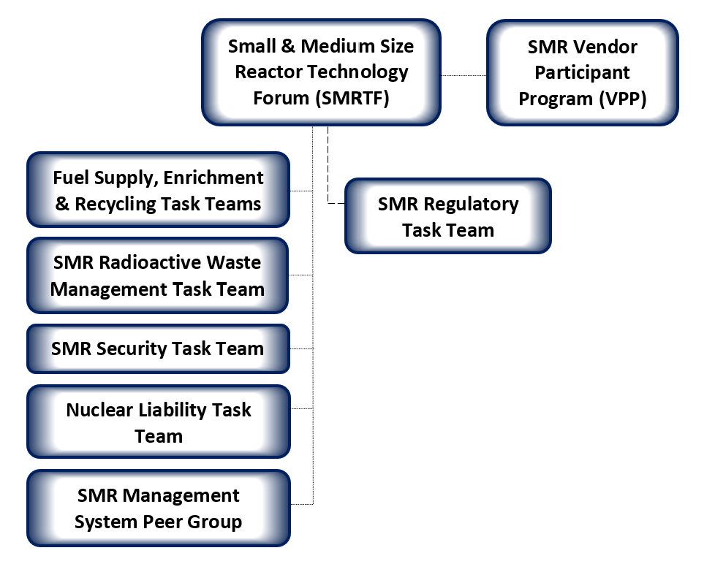
FIG. 1. COG SMR Program.
The members of the SMR Program are sharing information, pooling resources, and working together to develop and deploy SMRs in support of climate change goals. Working together, the members of the SMR Program are building a vibrant SMR industry based on the collaborative model that has been used to achieve CANDU excellence for four decades.

small & medium size reactor technology forum
Established in 2017, the Small & Medium Size Reactor Technology Forum (SMRTF) Members include Ontario Power Generation, Bruce Power, New Brunswick Power, SaskPower, Saskatchewan Research Council Nuclear, and Canadian Nuclear Laboratories, with several key stakeholder organizations participating as observer participants.
The primary objective of the SMRTF is to enable the successful deployment of SMRs in Canada, by supporting approaches to SMR regulation in Canada, providing trusted advice to decision-makers, supporting the development of industrial and human capacity, supporting international harmonization, and supporting the achievement of Canada’s net-zero goals.
The SMRTF plays a leading role in establishing technical positions and/or requirements supporting the development of a common policy and vision. To that end, the forum has established several task teams to develop technical positions on high-priority focus areas and a peer group to collaborate and share lessons learned from the development of SMR management systems (refer to Fig. 1 and the following subsections for further details).

Fuel Supply Task Team
The SMR designs being considered for deployment in Canada use fuels that are not currently manufactured or available in Canada, specifically fuels that use some form of enriched Uranium-235. Of the various types of enriched Uranium, High Assay Low Enriched Uranium (HALEU), with between 10-19.75 wt.% Uranium-235, is of greater scarcity. Therefore, fuel supply and security is a critical priority that needs to be addressed for initial and early SMR deployments.
The Fuel Supply Task Team (FSTT) was established to develop a policy needs paper for acquiring HALEU from outside Canada for the first SMR deployments. The FSTT published a position paper in 2021 which explores short-term acquisition of HALEU and its fuel forms for use in the initial deployments and early refuelling of SMRs. It also identifies a staged approach for increasing the security and diversity of supply and increasing the economic development potential for Canada.
The geopolitical landscape has changed significantly since this position paper was published. As such, the approach identified in the report, specifically the reliance on international supply in the early stages will need to be re-evaluated.
Although the FSTT has completed its mandate, the members continue to meet regularly to collaboratively support the overall fuel strategy for SMR fuel in Canada. This includes interfacing regularly with various government agencies to support their bi-lateral and multi-lateral discussions on fuel supply and security with their international counterparts.

Fuel Enrichment Task Team
In order to ensure long-term fuel security, consideration needs to be given to enriching uranium in Canada. Building on the work completed by the FSTT, the Fuel Enrichment Task Team (FETT) was established to perform a landscape analysis of the various benefits, challenges and issues related to introducing enrichment into Canada.
The FETT published a position paper in 2023 which presents several recommendations for securing a reliable source of enriched uranium for Canada. Given the changing geopolitical landscape, the report suggests that Canada should work with allies to diversify its supply and minimize reliance on a single source. To maximize benefits and minimize energy system risks in Canada, the paper also recommends exploring potential routes for securing fuel supply, including considering introducing uranium enrichment facilities in Canada along with broader national fuel cycle investments.
The landscape analysis is intended to be used to initiate dialogue and support national discussions regarding fuel supply and security in Canada.

Fuel Recycling Task Team
The CANDU reactors currently use a “once through fuel cycle” strategy. Some advanced reactor technologies being developed in Canada have the capability to recycle and reuse their spent fuel, and at least one technology is being designed to use recycled/reprocessed spent CANDU fuel. Since fuel reprocessing in Canada has thus far been limited to the reprocessing of spent fuel at the Canadian Nuclear Laboratories, it was deemed a priority to ensure that there are no regulatory or policy inhibitors to reprocessing.
The Fuel Recycling Task Team (FRTT) was established to produce a position paper that lays out the necessary background information, reviews the various potential benefits and concerns with recycling used fuel, and addresses these issues and concerns through either established processes or newly developed strategies. The FRTT was also tasked with determining if there are any regulatory or policy inhibitors and if any additional policies or regulatory amendments are necessary.
The work of the FRTT is currently on hold pending the results of a federal government review of reprocessing.

SMR Radioactive Waste Task Team
The SMR designs being considered for deployment in Canada will require a credible costed plan for the storage and long-term disposal of high, low and intermediate level radioactive waste. This plan will be required early in the reactor development phase to attract private investment for the detailed design and/or operation of the SMR and is required as part of the licensing and environmental assessment processes.
Since the SMR designs being considered for deployment in Canada use fuels that differ from CANDU fuel, there will be challenges regarding how the radioactive waste can be accommodated and in a cost-effective manner.
The SMR Radioactive Waste Task Team (RWTT) was established to facilitate the sharing of experience and information to coordinate discussions regarding the long-term disposal of all three levels of radioactive waste from SMRs. The SMR RWTT published a paper in 2023 which outlines the challenges and gaps regarding the disposal of SMR waste and presents various waste disposal strategies for SMRs.

SMR Security Task Team
The SMR Security Task Team (SSTT) was established as an outcome from a World Institute for Nuclear Security (WINS) for SMRs workshop held in Ottawa, Canada in November 2019, to explore options for introducing dose consequence considerations into the nuclear security regulations as potential performance objectives.
The SSTT published a report in 2020 which provides recommendations for revisions to the Canadian Nuclear Security Regulations using objective-based performance criteria. The report was submitted to the regulator for their consideration in the next revision of the Nuclear Security Regulations.

Nuclear Liability Task Team
The current Canadian nuclear liability limits for nuclear power plants are considered to be excessively high for SMRs and will significantly impact the economic viability of these reactors.
The Nuclear Liability Task Team (NLTT) was established to develop a graded approach to insurance limits, in proportion to the risks posed by the nuclear installations. The NLTT published a report in 2021 which proposes a methodology to establish liability limits for SMRs. This report was submitted to the government for their consideration and to support their review of liability limits.

SMR Regulatory Task Team
Recognizing that SMRs will not be successful if they are planned, licensed and operated in the same way as traditional plants, the SMR Regulatory Task Team was established to work collaboratively to drive innovation in interactions with the Canadian regulator, and work together to advocate for the regulatory changes necessary for successful fleets of SMRs.
The purpose of the SMR Regulatory Task Team is to develop strategies and plans for the timely resolution of common high-priority issues related to the various stages of the licensing process for nuclear facilities (i.e. site preparation, construction, operations, and decommissioning). This task team addresses common issues that affect more than one SMR design or licensee, or fleet deployment.
To date, the SMR Regulatory Task Team has established sub-teams to focus on the following topics: minimum shift complement, appropriately sized emergency planning zones, the SMR new applicant process, the SMR Regulatory framework and applicability to initial vs. subsequent deployments, and Indigenous engagement. The SMR Regulatory Task Team and the sub-teams meet regularly with the Regulator to discuss these focus topics. Position papers are being published to document the outcome of the discussion on these topics.

SMR Management System Peer Group
The development and deployment of new SMRs across Canada will require Management Systems to be effectively established and implemented in accordance with applicable regulatory requirements. The SMR Management System Peer Group (MSPG) was established earlier this year to collaborate and share lessons learned associated with the development and implementation of management systems to assist in the successful deployment of SMRs, and obtain alignment on understanding of regulatory requirements and industry best practices. The MSPG will develop position papers to document lessons learned and good practices as needed.

SMR VEndor participant program
The SMR Vendor Participant Program (SMR VPP) was established in 2018, recognizing that SMR technology developers are critical contributors to the dialogue to resolve challenges and maximize the SMR opportunity for Canada domestically, and abroad. The SMR VPP supports a pan-Canadian approach for deployment of SMRs, by providing the vendors with a forum for collaboration on common issues and access to operating experience and expertise from the COG members.
The members benefit from participating in a program where they can:
- Identify potential generic obstacles to deployment of SMR technology;
- discuss approaches to address such generic obstacles common to several participants within a community of practice that includes vendors, utilities, governments and regulators;
- share non‐commercially sensitive experiences and benefit from the experience of others (including COG groups such as the SMRTF);
- collectively leverage their experiences on generic issues to support SMR deployment.
The current members of the SMR VPP include ARC Clean Technology, GE-Hitachi, Terrestrial Energy, USNC, Westinghouse, and X-energy.

other smr initiatives
In addition to facilitating the SMRTF and SMR VPP, COG has been supporting the SMR industry through a number of other initiatives:
- COG members funded the development of a “Regulatory Priorities Briefing Book” which identifies priority activities to enhance the efficiency and effectiveness of the Canadian nuclear regulatory framework and process to support the modernization of the CANDU fleet and introduction of advanced reactor technologies;
- COG members are funding a joint project to provide recommendations for CSA Standards improvements to support the modernization of the CANDU fleet and introduction of advanced reactor technologies;
- COG members are funding an SMR Training & Certification Industry Group to coordinate the exchange of ideas between licensees in order to ensure alignment on requirements for SMR Training and Certification;
- COG is currently working with industry partners to establish a task team to support members with workforce and talent development;
- COG staff participate in a number of Canadian and international initiatives and working groups including: Canada/US Executive Task Force on SMR Regulation, Canadian Standards Association (CSA) Harmonization Task Force, CSA SMR Task Force, IAEA Technical Working Group on SMRs (TWG-SMRs), IAEA Nuclear Harmonization & Standardization Initiative (NHSI) Industry Track Working Groups, and NEI/EPRI Advanced Reactors Codes and Standards Collaborative (ARCSC).

looking ahead
As the Canadian nuclear landscape evolves to include SMRs, it is expected that the industry will continue to evolve with the projected widespread introduction of non-electric nuclear applications, new licensees and non-traditional operator/licensing models. COG will continue to support its members with their future aspirations and to accommodate broader industry collaboration.
Additionally, with the expected deployment of non-CANDU technologies in Canada, COG is poised to support its members with technology-specific research and development and joint projects to solve common challenges in compliance with the Canadian regulatory framework.

conclusion
Canada is on the path to becoming a world-leader with respect to SMR development and deployment. As they have been doing successfully for the last 40 years, COG will continue to support its members as they employ a pan-Canadian approach to advance new reactor technologies and to help Canada meet its decarbonization goals.
In order for Canada to meet its climate change goals it is projected that an additional ~24GWe of nuclear capacity will be needed by 2050 [5]. Between 1971 and 1992, there were 22 reactors deployed in Canada - leveraging the Team Canada approach that was established during the development of the SMR Roadmap [2] and the COG collaboration model, we can do this again, and we can do it better.
During the development of the SMR Roadmap it was recognized that the success of SMRs will rely on strategic partnerships across the sector and internationally, and that no single entity can do it alone [2]. The integrated and collaborative approach of the COG SMR Program ensures that no single entity needs to do it alone by de-risking plans for all partners and providing support to new entrants to the nuclear industry.
References
- Generation Energy Council, Generation Energy Council Report (2018), https://publications.gc.ca/collections/collection_2018/rncan-nrcan/M134-47-2018-eng.pdf.
- Canadian Small Modular Reactor Roadmap Steering Committee, A Call to Action: A Canadian Roadmap for Small Modular Reactors (2018), https://smrroadmap.ca/wp-content/uploads/2018/11/SMRroadmap_EN_nov6_Web-1.pdf?x93402.
- Government of Canada, Canada’s Small Modular Reactor Action Plan (2020), https://smractionplan.ca/.
- Natural Resources Canada, COP28: Declaration to Triple Nuclear Energy (2023), https://natural-resources.canada.ca/energy/resources/international-energy-cooperation/cop28-declaration-triple-nuclear-energy-2023/25591.
- Canada Energy Regulator, Canada’s Energy Future 2023 (2023), https://www.cer-rec.gc.ca/en/data-analysis/canada-energy-future/2023/canada-energy-futures-2023.pdf.

For the purposes of the paper, the term “small modular reactors” includes advanced reactors.
Canadian COG members: Bruce Power, Canadian Nuclear Laboratories (CNL), New Brunswick Power, Ontario Power Generation (OPG), Saskatchewan Research Council Nuclear (SRC-Nuclear) and SaskPower. International COG Members: China National Nuclear Operations Management (CNNO), Korea Hydro & Nuclear Power (KHNP), Nuclear Power Corporation of India (NPCIL), Nucleoeléctrica Argentina Sociedad Anónima​ ​(NA-SA), and Societatea Nationala Nuclearelectrica (SNN).

