# Heat Distribution Results from Experiments Using Array of Five Sodium Heat Pipes

P. Diaz Gomez Maqueo

Canadian Nuclear Laboratories

Chalk River, ON, Canada

Email: pablo.diazgomezmaqueo@cnl.ca

R. MacCoy

Canadian Nuclear Laboratories

Chalk River, ON, Canada

R. McGrath

Canadian Nuclear Laboratories

Chalk River, ON, Canada

C. Azih

Canadian Nuclear Laboratories

Chalk River, ON, Canada

**Abstract**

Heat pipes are self-contained two-phase passive cooling devices. Some microreactor concepts configure heat pipes in parallel banks (arrays) to transport heat away from the core and into an energy conversion system. The array heat pipe experiments performed at the High Temperature Fuel Channel Laboratory (HTFC) of the Canadian Nuclear Laboratories (CNL) simulate such configuration using 12 electrically heated channels to mimic the heat generated from the nuclear fuel and five cooling channels with heat pipes to remove the heat. The core is simulated as a stainless-steel block containing both heating and cooling channels. Power output is measured using a gas-cooled stainless-steel block at the opposite end of the heat pipe array. Of the five heat pipes, three can be turned off by injecting a non-condensable gas into them. An initial experiment was conducted and used as a baseline to compare with the subsequent cases that involved selectively turning off heat pipes in the array. The results of these tests show the heat distribution differences when compared with the baseline, and the effect of heat pipe failure when used in an array configuration.

## INTRODUCTION

As energy markets are progressing towards more de-centralized generation to accommodate energy generation from clean energy technologies, Small Modular Reactors (SMRs) are expected to play a significant role in the future of nuclear power generation. The advantages offered by SMRs in these markets, such as the portability, support its competitiveness in the energy market particularly to meet the energy demand for remote applications. New safety systems approaches are expected, commensurate to proposed remote and autonomous operation modes.

Currently, several SMR concepts incorporate passive cooling systems, which refer to systems with the ability to transfer heat during normal operation or accidents using no external source of energy or mechanical aid. In particular, some designs [1-5] utilize heat pipes as passive cooling devices. Heat pipes are highly conductive, self-contained two-phase natural circulation cooling devices first developed by Los Alamos National Laboratory [6]. Heat pipes were initially developed to provide passive cooling for space power applications [7], and now are utilized in many industries.

Heat pipes in microreactor concepts are arranged in parallel banks (arrays) to transport the heat away from the core and into power generating systems. The present array heat pipe experiment simulates such configuration. Three experiments were planned using the array heat pipe test setup. The objective of the first experiment was to operate the experimental rig at standard conditions to characterize its performance. For the second experiment, pulsed power was used to produce temperature fluctuations and test instabilities in the heat pipes observed previously in a single heat pipe experiment [8]. Two heat pipes were disabled to test their failure effect on the heating and cooling block temperature distributions. For the third experiment, heating oscillated in the heating block to characterize the temperature distribution on the heating and cooling blocks. Three heat pipes were disabled during this experiment to observe the effect on the remaining two.

## Experimental Methodology

The array heat pipe experimental rig was designed to be technologically and vendor agnostic and to still be able to produce data that is useful for benchmarking simulation codes. It is a rectangular lattice array comprising five 2.0 kW sodium heat pipes (each made of an Inconel‑600 tube) inserted into a 316L stainless‑steel heating block on one side and a 316L stainless‑steel cooling block on the other. The setup is fully insulated. Fig. 1 shows a photo of the array heat pipe experimental rig, and details of the instrumentation used. The full experimental rig measures 91.4 cm (36 in) long and is held vertically by an aluminium extrusion frame. The whole rig is insulated using mineral wool to reduce radial heat losses. A total of 28 thermocouples are used to monitor and measure the thermal performance of the test rig.

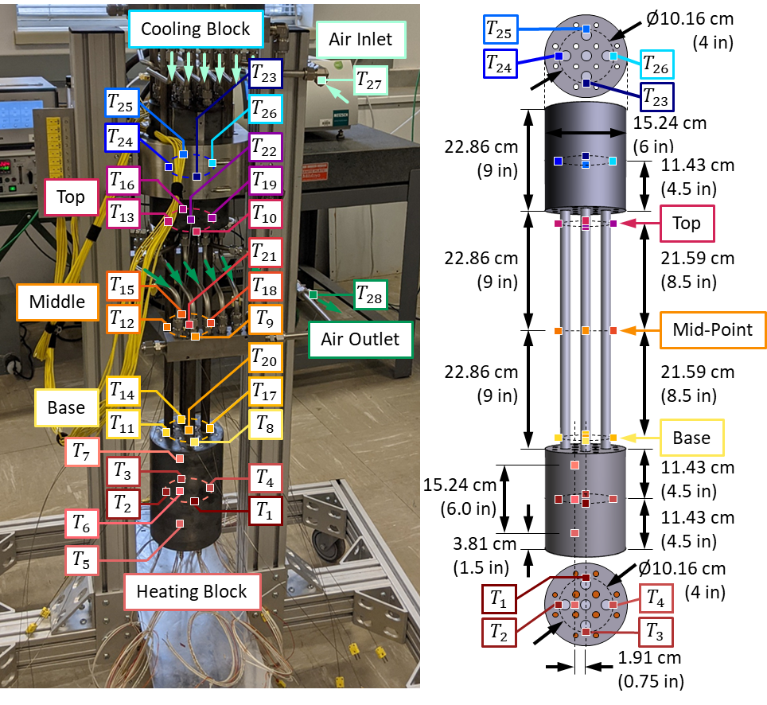

FIG. 1. Photo of test setup and instrumentation details.

The heating block is positioned at the bottom of the experimental rig, which has 12 cartridge heaters. The heaters simulate the heat generated from the fuel channels in a generic heat pipe reactor core. Fig. 2 shows details of the heating and cooling blocks. There are four 1.50 kW heaters near the centre and eight 0.50 kW heaters farther away from the centre. The power to each heater is controlled independently using relay switches. Power to each heater is set to a fraction of its total power (0 to 100 %). In the heating block, there are seven type‑k thermocouples labelled *T*1 to *T*7 (shown in Fig. 1).

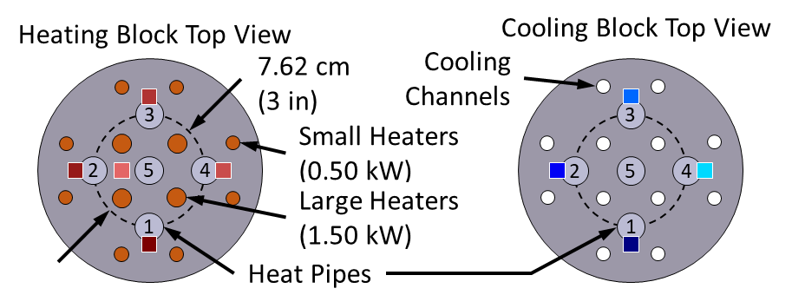

FIG. 2. Heating and cooling block details

The heat pipes are arranged in a cross shape with one heat pipe at the center (labelled heat pipe #5), and four exterior heat pipes (labelled heat pipe #1 to #4) located 3.81 cm (1.5 in) away from the center, as shown in Fig. 2. The part of the heat pipes encased in the heating block is the evaporator, the part encased in the cooling block is the condenser, and the rest is the adiabatic section. Of the five heat pipes, three (heat pipe #1, #4 and #5) have each a valve to control the injection of non-condensable gas (argon) into them. Each heat pipe has three thermocouples affixed to their exterior wall along the adiabatic section, for a total of 15 labelled *T*8 to *T*22. Of the three thermocouples, one is located 1.27 cm (0.5 in) away from the evaporator (labeled base), one at its mid‑point (labeled mid‑point) and one located 1.27 cm (0.5 in) away from the condenser (labeled top). These locations and labels are shown in Fig. 1.

The cooling block is located at the top of the experimental rig and has a matching heat pipe arrangement to the heating bock. The cooling block also has 12 interconnected equal-diameter cooling channels that use a single pass input line and single pass output line. Coolant working fluid was provided plant air connected to a rotameter with a metering valve set to a constant volumetric flow rate of 8 ft3/min at 20 °C and 1 atm for all experiments. The cooling block has six type‑k thermocouples labelled *T*23 to *T*28.

## BASELINE commissioning experiments

For the commissioning experiments, the heat pipe array was set to have all five heat pipes enabled and aimed to reach steady‑state. Heating power (${\dot{Q}}_{in}$) was applied to the heating block using the 12 joule‑type cartridge heaters. Since AC power was used, the root mean square (RMS) values were calculated for voltage and current and used to calculate the applied RMS power. Heat removed at the condenser by the air flow (${\dot{Q}}_{out}$) was calculated using the difference between the inlet and outlet temperatures, and the mass flow rate of air at steady state. Total heater power input and air-cooling details for the commissioning test are shown in Fig. 3.

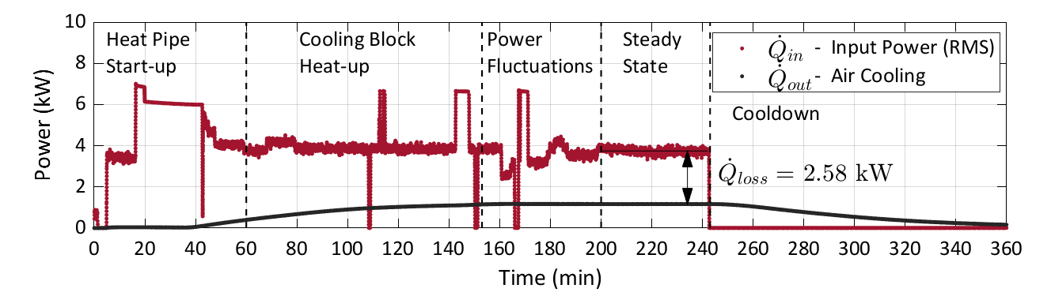

FIG. 3. Commissioning experiment power input and coolant output.

At steady state, air flow removed 1.17 kW from the 3.75 kW delivered by the heaters, and 2.58 kW were lost through other means. Using a thermal imager, a considerably high temperature hot spot at the bottom of the heating block was observed where the frame supports the testing rig. It is hypothesized most of the losses occurred through this. However, heat losses were not fully characterized for this experiment.

The commissioning experiment lasted ~240 min and can be divided into four parts: heat pipe start‑up, cooling block heat‑up, power fluctuations (adjustments to reach steady state) and steady state. The temperature profiles for this experiment are shown in Fig. 4. The thermocouple at the base of heat pipe #4 (*T*17) and the mid thermocouple of heat pipe #2 (*T*12) failed shortly after the experiment started and are not shown in Fig. 4.

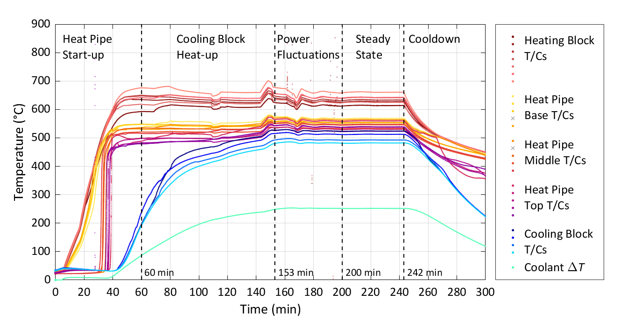

FIG. 4. Benchmark commissioning experiment temperature profiles.

At start-up, the heating block temperature steadily increased closely followed by an increase in the heat pipe base temperature, until the latter reached ~500 °C. At this point the heat pipe base temperature deviated from the trend of the heating block, which is also when the heat pipes turned on. After the start‑up phase, the heat pipes effectively transported heat from the heating block to the cooling block. Once the cooling block reached a similar temperature to the heat pipe top, the rate of change of the coolant outlet temperature started to diminish. Power was varied from nominal values to approach steady state, which was achieved ~200 min after the test started. Steady state operation was maintained for ~40 min, and then the test was ended by turning off power to the heating block.

Fig. 5 shows the temperature profiles of the five heat pipes, after start‑up, with heat pipe #1 at the top to heat pipe #5 at the bottom of the plot. The temperature difference between the base and the top of heat pipe #4 was not available due to failure of the base thermocouple of heat pipe #4. Starting at 90 min, the difference of temperature between the base of the heat pipes and the top ranged from 43.0 °C to 46.8 °C. The temperature difference remains nearly constant until the 150 min mark, which is when the cooling block reached a stable temperature. When the cooling block reaches ~500 °C, so does the condenser section of the heat pipe, ensuring all sodium has melted and a continuous sodium vapour flow is stablished along the full length of the heat pipe. From this point onward, the temperature difference along each heat pipe decreased considerably to a minimum difference in a range between 7.8 °C and 13.9 °C. After this point, the temperature difference along the heat pipe continued to remain small. At the end of the test, and at steady state, these temperature differences ranged between 8.9 °C and 17.0 °C.

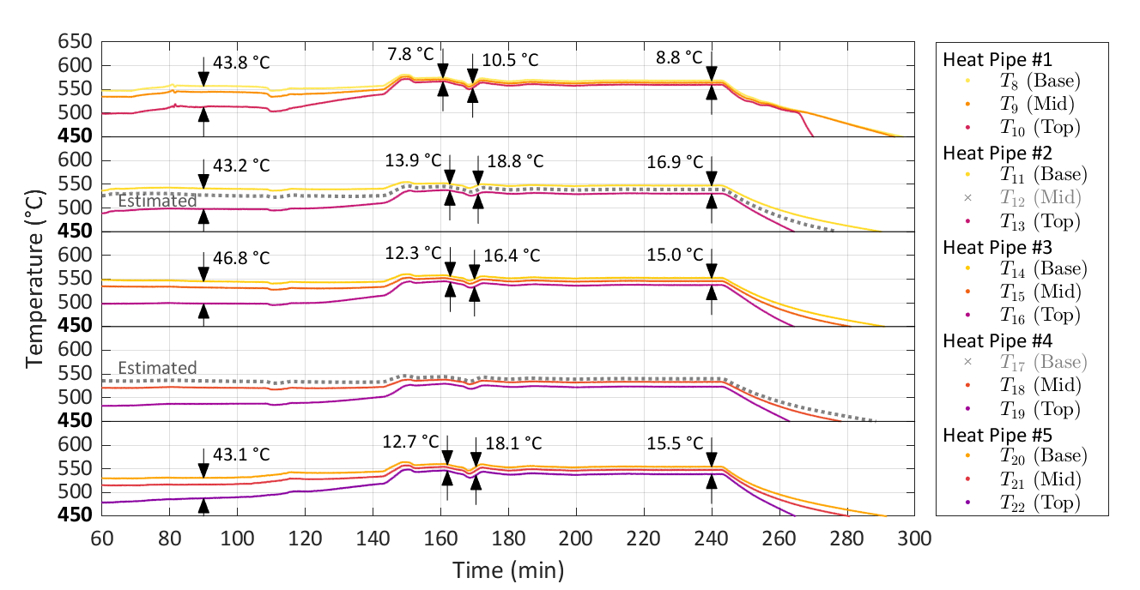

FIG. 5. Temperature profiles for the benchmark experiment after start-up. The plots from top to bottom correspond to heat pipe #1, heat pipe #2, heat pipe #3, heat pipe #4 and heat pipe #5, respectively.

## Pulsed Power and disabling of heat pipes

For this experiment power was initially applied in 5 min pulses, of which 2.5 min were 100 % power and the other 2.5 min were 0 % power. After 94.0 min, the power was switched to constant power, averaging 3.91 kW. Fig. 6 shows the characteristics of the input and output power. For this experiment, reaching steady state during the constant power phase was not an objective, and it was not reached before shutdown. At the end of the experiment, air removed 0.96 kW, a difference of 2.95 kW with the heat input, and similar to the values shown in Fig. 3.

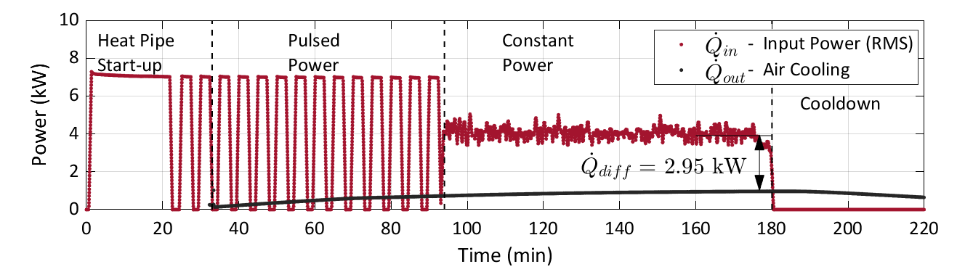

FIG. 6. Pulsed power characteristics and air power output.

The duration for this test was ~180 min. This experiment can be divided in three parts: heat pipe start‑up, pulsed power, and constant power. During the pulsed power stage and after 68 min, heat pipes #4 and #5 were disabled. The resulting temperature profiles for the heating block, base, mid‑section and top of the heat pipes, cooling block and coolant *ΔT* are shown in Fig. 7. The base thermocouple of heat pipe #4 (*T*17) failed shortly after the experiment started and is not shown in Fig. 7.

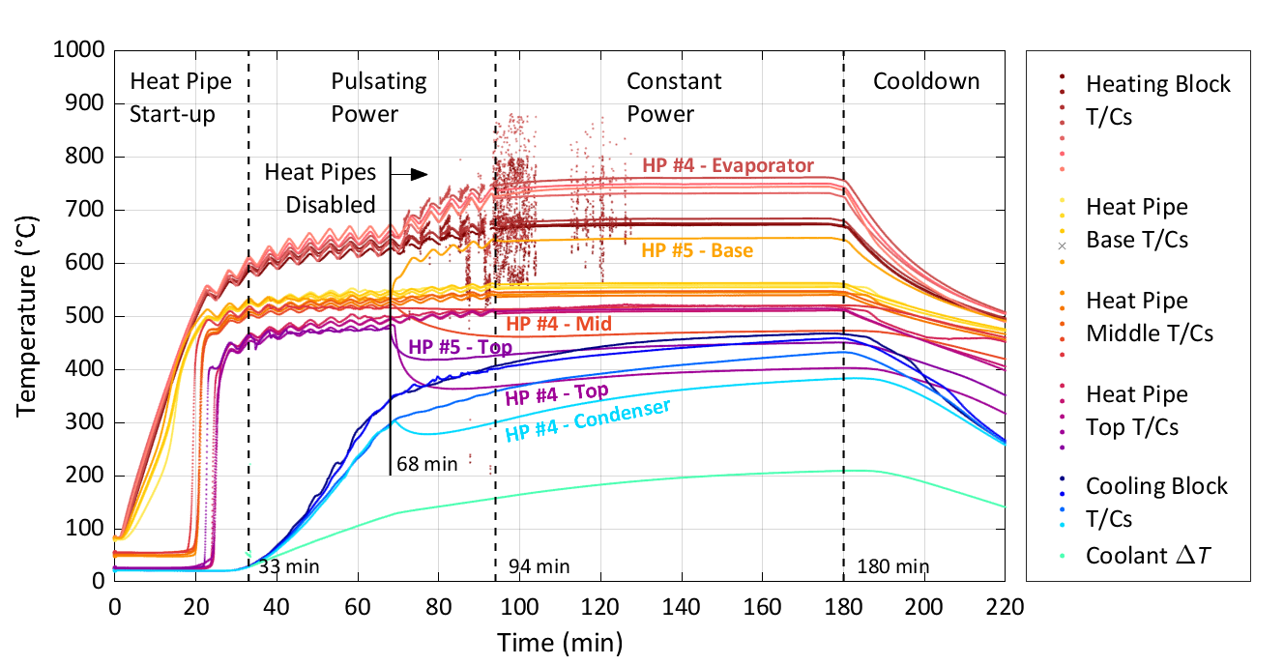

FIG. 7. Pulsed power experiment temperature profiles.

Start‑up was similar to that observed in the previous experiment, with the mid‑section and top increasing rapidly in temperature when the temperature of the base and mid‑section reached ~500 °C. The power pulses generated temperature fluctuations on the heating block and the heat pipe base, mid‑section and top. Some fluctuations are visible on the cooling block but of considerably lower amplitude, which is due to its large thermal inertia. The temperature fluctuations have the same period as the power pulses, a peak­‑to‑peak of ~20 °C on the heating block and ~10 °C on the heat pipes, and a delay between base and top of the heat pipe of ~6 seconds. After switching to constant power, the temperature fluctuations stopped. This differed from an instability observed in a previous experiment [8], where temperature fluctuations would continue after power was set back to constant.

Fig. 8 shows the temperature profiles of the heating block (evaporator), heat pipes #1, #4 and #5, and the cooling block (condenser) after start‑up. Before disabling the heat pipes, the temperature profiles look very similar to the benchmark experiment. However, the duration of this experiment was not sufficient for the heating block to reach 500 °C, preventing the heat pipes from reaching steady state, and resulting in a larger temperature difference between the base and top, ranging from 49.3 °C to 61.2 °C. Evaporator temperatures had a lower temperature difference ranging from 19.8 °C to 23.7 °C. Once heat pipes #4 and #5 were disabled, the evaporator in heat pipe #4 increased, reaching a difference with the other heat pipes between 88.6 °C and 88.8 °C. The mid‑section and top of heat pipe #4 had a drop in temperature of ~40 °C and ~120 °C respectively. Since *T*17 failed, an estimated base temperature is shown but no temperature difference was calculated. The base of heat pipe #5 had an increase in temperature of ~110 °C, while the top had a decrease of ~60 °C, resulting in a temperature difference between top and base ranging from 196.8 °C to 219.3 °C. The condenser temperature of heat pipe #4 dropped by ~50 °C, resulting in a temperature difference with the other heat pipes between 85.7 °C and 106 °C. These larger temperature difference along the heat pipe in addition to the increase in the evaporator and decrease in the condenser temperatures indicates heat transfer is primarily occurring through conduction in these heat pipe.

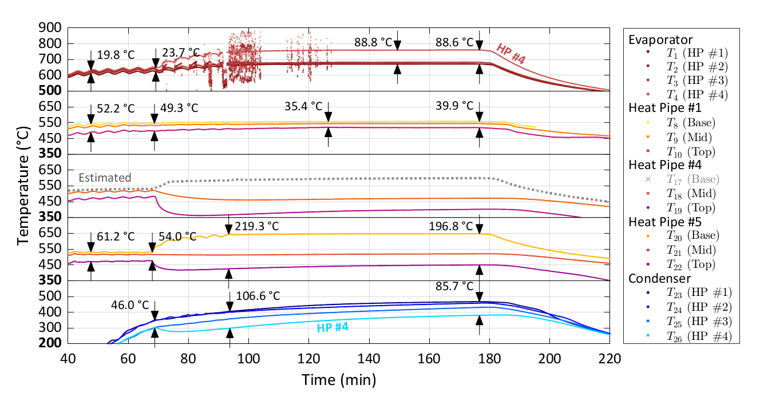

FIG. 8. Temperature profiles for the pulsed power experiment after start‑up. The plots from top to bottom correspond to the evaporator, heat pipe #1, heat pipe #4, heat pipe #5 and condenser, respectively.

## Transient non-uniform heating with disabled heat pipes

In this experiment, non‑uniform heating of the heating block was achieved by turning off a pair of exterior heaters while the rest remained at 100 %. Four pairs of exterior heaters were labelled as zone 1 to 4, with each zone corresponding to heat pipes #1 to 4, see Fig. 2 for details on heater location. A total of three oscillation cycles were completed; each cycle comprised turning off each zone once, in succession. Heating zones remained off 5 min during the first two cycles, and 10 min during the last cycle. After 122.0 min, the power was switched to constant power, averaging 3.90 kW. Fig. 9 shows the characteristics of the input and output power. At the end of the experiment air removed 0.96 kW, a difference of 2.94 kW with the heat input. These values are close to the previous experiment shown in Fig. 6, and similar to the values shown in Fig. 3.

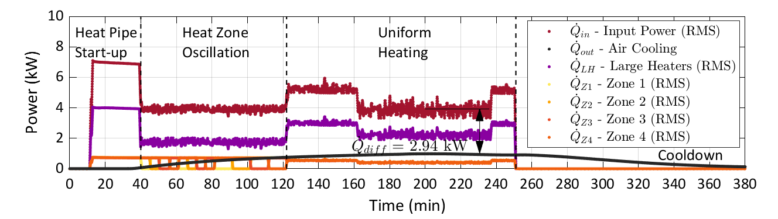

FIG. 9. Oscillating power characteristics and air-cooling output.

Before the start of this experiment, heat pipes #4 and #5 were reconditioned by drawing a vacuum into the heat pipes. However, this did not re-establish the heat pipes to their working condition. Fig. 10 shows the temperature profiles for the heat zone oscillation experiment. Heat pipe #4 and #5 had their base temperature following closely the heating block temperature, while the mid‑section and top slowly increased in temperature, following the cooling block temperature increase. These measurements show that both heat pipes are disabled, and heat transfer along these heat pipes occurs through conduction from the hotter cooling or heating blocks.

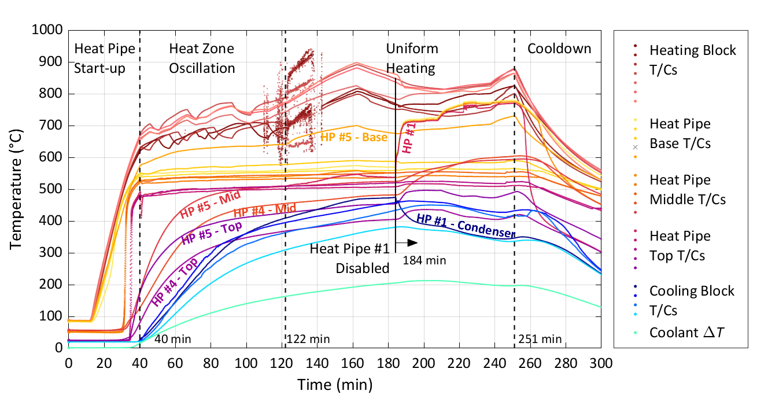

FIG. 10. Temperature profiles for the heat zone oscillation experiment

Heat zone oscillation is visible on the heating block temperatures. Hot spots were produced consecutively on each heat pipe and follow the same oscillation period as the input power parameters. The heating block temperature at heat pipe #4 starts at a higher temperature due to it’s being in an off state but follows the heating zone oscillation temperature changes. The oscillation does not seem to affect the heat pipe measurements, which do not show a corresponding temperature fluctuation as observed in the pulsed‑power experiment.

After 184 min, heat pipe 1 was disabled, and as expected, the condenser temperature dropped. However, the base, mid‑section and top temperatures remained close and increased, suggesting heat was still being transferred to the uppermost section of the heat pipe, but not into the cooling block. It is hypothesized that sodium, or a sodium compound (i.e. sodium carbonate) blocked the valve, and only allowed a small amount of argon into heat pipe #1. This amount of argon was not sufficient to disable the heat pipe but could be sufficient to have reduced the condenser length of the heat pipe via stratification of the non-condensable gas at the top of the heat pipe [9]. This process would effectively shorten the effective length of heat pipe’s condenser region and in this case the heat pipe condenser region may have been moved outside of the cooling block.

A detailed view of the heating block, the heat pipe base, mid‑section and top after start‑up are shown in Fig. 11. The heating block shows a temperature difference ranging from 76.8 °C to 109.9 °C caused by the disabled heat pipe #4. After disabling heat pipe #1, the evaporator temperature of heat pipe #1 increased and approached the evaporator temperature of heat pipe #4. At this point all sections of heat pipe #1 increased in temperature by ~230 °C and had a temperature difference that ranged from 3.0 °C to 9.2 °C. Heat pipe #4 and #5 remained in an off state throughout the experiment, and the temperature difference between the base and top of heat pipe #5 ranged from 189.3 °C to 250.7 °C. The cooling block temperatures followed a similar trend to the heating block, with a temperature difference ranging from 77.5 °C to 107.5 °C. When heat pipe #1 was disabled, its condenser (cooling block) temperature dropped by ~60 °C and followed heat pipe #4 until shut down.

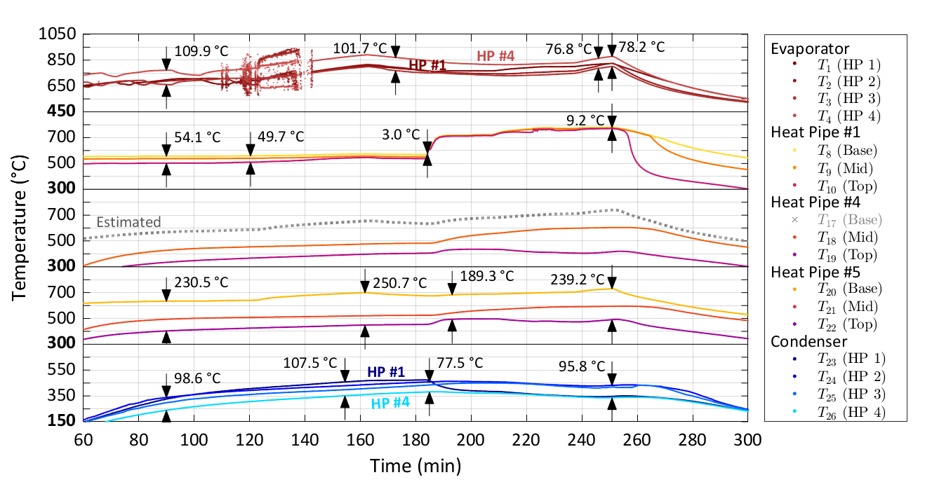

FIG. 11. Temperature profiles for the heat zone oscillation experiment after start‑up. The plots from top to bottom correspond to the evaporator, heat pipe #1, heat pipe #4, heat pipe #5 and condenser, respectively.

## Summary and conclusions

Three experiments were successfully conducted: the objective of the first was to characterize the performance of the test rig, the second was to test the effect of pulsed power and characterize heat distribution in the event of a heat pipe failure, and the third was to characterize the effect of transient non‑uniform heating.

For the first experiment, the measurements demonstrated the expected functionality of the sodium heat pipes: fast temperature increase at start-up and low-temperature differences along the heat pipe length. The “power fluctuations” stage of the test allowed for testing the response of the heat pipe array to power fluctuations. The measurements showed a temperature increase and a decrease following a change in the heater power input.

For the second experiment, power pulses produced associated heat pipe temperature fluctuations with the same period and a peak‑to‑peak value between ~10 °C and ~20 °C. Once back to constant power, the temperature fluctuations stopped, showing no pulsing instability for this experiment at the conditions tested. A key difference with a previous study where the pulsing instability was observed [8], was the size of the evaporator thermal mass.

After disabling two heat pipes, the temperature at the base increased and followed the heating block temperatures, while the temperature at the top decreased and followed the cooling block temperatures. The hot spot temperature produced on the heating block was ~100 °C higher next to the disabled heat pipes, while the cold spot temperature on the cooling block was ~50 °C lower next to the disabled heat pipes. However, the rest of the heat pipes continued to work as designed, transferring heat towards the cooling block.

For the third experiment, temperature on the heating block varied as power oscillated through the four zones. However, this oscillation was not seen on the adiabatic section (base, mid, and top), or the cooling block. The main difference with pulsed power (second experiment) is that in this one the total power remained constant. This suggests that temperature oscillations due to local changes in power (provided the total power remains the same) have no effect on the adiabatic section of the heat pipe and the cooling block temperature distribution.

During the third experiment heat pipe #1 was disabled while heat pipe #4 and #5 remained disabled and could not be recovered. Heat pipe #4 and #5 behaved as expected as disabled heat pipes. However, heat pipe #1 had its mid­‑section and top temperatures similar to its base temperature, as if the heat pipe remained enabled. It is hypothesized that this heat pipe was not fully disabled due to a valve blockage and operated with an effectively reduced condenser length.

ACKNOWLEDGEMENTS

This work was supported by Atomic Energy of Canada Limited’s Federal Nuclear Science & Technology Work Plan.

References

1. DICKINSON, T. J., Performance Analysis of a Liquid Metal Heat Pipe Space Shuttle Experiment, Thesis, Air Force Institute of Technology (1996).
2. WANG, C., LIU, L., LIU, M., ZHANG, D., TIAN, W, QIU, S., SU, G. H., Conceptual design and analysis of heat pipe cooled silo cooling system for the transportable fluoride-salt-cooled-high-temperature reactor, Annals of Nuclear Energy, **109** (2017) 458-468.
3. LEVINSKY, A., VAN WYK, J. J.M ARAFAT, Y., SMITH, M. C., Westinghouse eVinci reactor for off grid markets, Transaction of the American Nuclear Society, **119** (2018) 931-934.
4. EL-GENK, M. S., PALOMINO, L. M., SCHRIENER, T. M., Low-enrichment and long-life scalable liquid metal cooled small modular (SLIMM-1.2) reactor, Nuclear Engineering and Design, **316** (2017) 163-185.
5. DULERA, I. V., BASAK, A., KELKAR, P. P., SINHA, R. K., “Compact high temperature reactor (CHTR)”, 16th Annual Conference of Indian Nuclear Society (INSAC), (2005).
6. COTTER, T. P., Theory of Heat Pipes, No. L A-3246-MS, Los Alamos National Lab (1996).
7. REID, R. S., SENA, J. T., MERRIGAN, M. A., ELDER, M. G., MARTINEZ, A. L., Heat Pipe Development for Advanced Energy Transport Concepts, Report LA-13549-PR, Los Alamos National Lab (1999).
8. AZIH, C., “Development of experimental and modelling capabilities and tools at Canadian Nuclear Laboratories for investigations on inherent and passive safety designs of advanced reactor concepts”, International Conference on Topical Issues in Nuclear Installation Safety: Strengthening Safety of Evolutionary and Innovative Reactor Designs, No. IAEA-CN—308, Vienna Austria, (2022).
9. WANG, C., ZHANG, Z., ZHANG, M., LI, P., TIAN, Z., TIAN, W., QIU, S., SU, G. H., Numerical evaluation of non-condensable gas influence on the heat transfer characteristics of high-temperature lithium heat pipe during reactor operation, Annals of Nuclear Energy, **173** (2022) 109077.