# OVERVIEW OF modified Design features

# of smart-c

M. PARK

Korea Atomic Energy Research Institute

Daejeon, Republic of Korea

K. AHN

Korea Atomic Energy Research Institute

Daejeon, Republic of Korea

Y. BAE

Korea Atomic Energy Research Institute

Daejeon, Republic of Korea

S. LIM

Korea Atomic Energy Research Institute

Daejeon, Republic of Korea

Email: sw54176@kaeri.re.kr

**Abstract**

Small modular reactors (SMRs) has gained global attention owing to its numerous advantages. SMART (System-integrated Modular Advanced ReacTor) is one of the most verified SMR designs which has obtained standard design approval (SDA). Recently, a variation of SMART100 (System-integrated Modular Advanced ReacTor100), has been suggested. The newly proposed reactor, SMART-C is an advanced concept of the SMART100 in terms of portability and economic viability. The portability of the SMR is vital for the application of the SMR in rural areas and various industries including oil sand industries. In order to achieve these aspects, design modifications have been conducted on SMART100. The design modifications include; weight reduction of the reactor pressure vessel and simplification of the safety systems. In this paper, the modified design features of SMART-C are summarized and presented. Furthermore, the associated issues are addressed.

## INTRODUCTION

Global energy consumption has continuously increased for several decades. Moreover, this energy demand is posed to experience a significant leap due to industrial growth and technology development such as artificial intelligence (AI) advancement. Nuclear energy is the only practical and economical carbon-free energy source with the capacity to meet energy demands. Given that nuclear energy is being regarded as a viable solution to this matter, efforts have been made in nuclear field development. Particular focus has been placed on the SMRs due to their advantages over conventional nuclear power plants (NPPs). SMRs are considered relatively cost-efficient, flexible and safe compared to conventional NPPs.

SMART, the first integral reactor to have obtained licensing worldwide, also possesses these advantages. This SMR, developed in Korea, is one of the most verified and advanced SMR design suggested. The original SMART design has gained domestic standard design approval in 2012, and an advanced design of SMART, called SMART100 is currently under licensing process. And the most recently proposed design, modified version of SMART100 known as SMART-C is suggested with enhanced portability and economic efficiency. The portability has been improved through simplification of the reactor design. The design of SMART100 will be introduced together with the design modifications made for SMART-C. The achievements with the modified design and associated issues will be addressed.

## SMART100

### Background

Korea Atomic Energy Research Institute (KAERI) initiated the development of SMART in 1997. It was developed as an export-oriented reactor, particularly aiming for rural areas lacking power related infrastructures. Conceptual and basic design of SMART and the associated validations have been conducted for 10 years. Followed by the SMART technology validation and SDA project which has been carried out from 2009 to 2012. And finally, SMART obtained the standard design licensing in 2012. It was the first integral reactor to have obtained licensing. Furthermore, the necessity of passive safety systems has emerged post-Fukushima accident. Naturally, the adoption of passive safety systems in SMART have been studied. This was reflected in the future design of SMART.

As part of Korea-Saudi Arabia SMART partnership established through a memorandum of understanding (MOU) signed in 2015, the SMART pre-project engineering (PPE) project for the inaugural SMART construction in Saudi Arabia was conducted from 2015 to 2019. The reactor design developed during PPE project is called SMART100 and several modifications have been applied on the SMART design which gained licensing in 2012. For economic and safety enhancement, the thermal power was increased and the passive safety systems were implemented. The two reactor designs, SMART and SMART100 are compared in Table 1. As can be seen in the table, the major modifications are applied on power capacity and safety features. The safety of the reactor has been greatly improved by adopting fully passive safety systems.

TABLE 1. Comparison between SMART and SMART100

|  |  |  |
| --- | --- | --- |
|  | SMART | SMART100 |
| Power | 330 MWt | 365 MWt |
| Reactor type | PWR | PWR |
| Reactor configuration | Integral | Integral |
| Fuel and reactor core | 17×17 square UO2 | 17×17 square UO2 |
| Reactivity control | Control rod, burnable absorber rods, soluble boron | Control rod, burnable absorber rods, soluble boron |
| Refueling cycle, months | 36 | 30 |
| Steam generator (SG) | Helical once-through type | Helical once-through type |
| Pressurizer | Steam, heaters and spray | Steam, heaters and spray |
| Reactor coolant pump (RCP) | Canned motor pump | Canned motor pump |
| Design life time | 60 years | 60 years |
| Core damage frequency (CDF) | < 1.0×10-6 /RY | < 1.0×10-7 /RY |
| Grace time | 30 minutes | 72 hours |
| Safety injection | Active | Passive |
| Decay heat removal | Passive | Passive |
| Containment spray system | Active | Passive |
| Depressurization system | Active | Passive |

### Design Features of SMART100

In order to describe the design features of SMART-C, it is vital to layout the design of SMART100 as SMART-C is a variation of SMART100. SMART100 is a pressurized light water SMR with a thermal power of 365MWt. Its most distinctive design feature is that it is an integral-type reactor. Unlike conventional NPPs, major components such as pressurizer, steam generators and reactor coolant pumps are placed inside the reactor vessel as shown in Fig. 1. Due to the internal installation of the major components in the reactor vessel, no large connecting pipes are required between major components. This resulted in the elimination of the large connecting pipes and the associated large break loss of coolant accidents (LOCA) which is considered as the most severe design basis accident of NPPs.

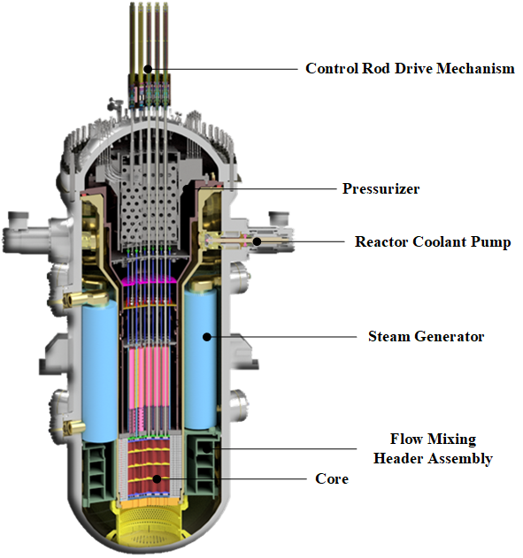

*FIG. 1 Schematic diagram of SMART100 reactor vessel [1]*

SMART100 consists of 4 canned motor RCPs without pump seals. This inherently eliminates small break LOCA associated with a loop seal failure [2]. The reactor consists of eight modular type once-through steam generators that contains helically coiled tubes. The in-vessel pressurizer is placed below the reactor vessel head and is designed to control the reactor coolant system pressure during normal operation. The flow mixing header assembly is implemented in order to mix the coolant in the case of an asymmetric cooling accident such as a steam line break (SLB). The core design of SMART100 is similar to that of SMART. The core is composed of 57 fuel assemblies and adopts 17 × 17 array with UO2 as in commercial PWRs. The enriched uranium oxide of less than 5.0 w/o is used. Each fuel assembly holds 264 fuel rods of 2.0 m in active height. The bottom end piece of the spacer grids is specifically designed to add resistance to the debris entrance into the core.

The safety of SMART100 has been enhanced by implementing passive safety systems. The safety systems are the passive residual heat removal system (PRHRS), the passive safety injection system (PSIS), the automatic depressurization system (ADS), and the containment pressure and radioactive suppression system (CPRSS). The passive safety systems allow the reactor to maintain safe shutdown condition for at least 72 hours without any operator action or AC power after post-DBAs. The PRHRS is designed to remove the post-accidents core heat by natural circulation when feedwater supply is unavailable. It is capable of cooling the RCS to safe shutdown condition in 36 hours and to maintain that condition for another 36 hours. The PSIS is designed to insert coolant in order to prevent core-uncovery during accidents such as small break loss of coolant (SBLOCA). There are 4 trains of PSIS and each train consists of core make up tank (CMT), and safety injection tank (SIT), safety injection line (SIL) and pressure balance line (PBL). The ADS functions to reduce RCS pressure during accident in order to facilitate safety injection of cooling water into the ADS. During total loss of secondary heat removal accident, ADS together with PSIS manages the core cooling and refilling of the RCS. The CPRSS suppresses the temperature and pressure of the containment when the high energy coolant is released into the containment. Furthermore, it removes the fission products from the containment area in the radioactive material removal tank (RRT).

## smart-c

### Modifications of SMART-C

The main concept of the newly proposed SMART-C design is to reduce the volume and weight of the reactor vessel and to simplify the safety systems in order to enhance portability and cost-effectiveness. Basically, the design of the reactor is similar to that of the SMART100 except for the modifications mentioned below. The diameter of the reactor vessel has decreased from 6.0 m to 4.55 m. This was mainly done by modifying the design of the SGs as shown in Fig. 2. As depicted in Fig. 1 and Fig.2, eight cassette type SGs were implemented in SMART100. This type of SGs are easy to install and dismantle, however it has drawbacks in terms of spatial efficiency. Thus, it is modified as a block type SG, where heat transfer tubes wrap around the entire core support barrel (CSB). As a single steam generator is used, the necessity of the flow mixing header assembly (FMHA) diminishes, thus, it is eliminated. These adjustments reduced the volume of the reactor vessel by 45%.

Due to the significant reduction in reactor vessel diameter and volume, associated modifications to the reactor internals ensued. As the diameter of the reactor vessel has decreased, the pressurizer volume had to be reduced in order to provide sufficient space for reactor coolant pump hydraulic section layout. In addition, structural modifications are conducted on other internal structures such as upper guide structure (UGS) upper support plate, UGS upper guide plate, UGS lower guide plate and UGS lower support plate, etc.

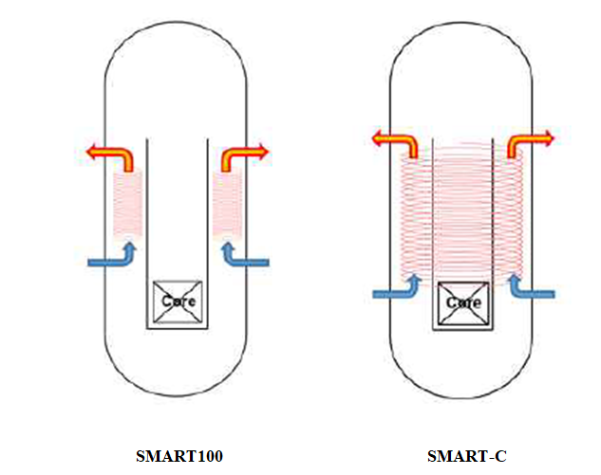

*FIG. 2 Steam generator design modification*

Furthermore, the passive safety injection system has been simplified. The number of trains have been reduced to two. And the two tanks, CMT and SIT are merged into a single two-stage SIT (TSIT) as shown in Fig. 3. The basic concept is to install two safety injection lines in a single integrated SIT [3]. Each safety injection tank is installed at a different height and resistance. Different resistance can be induced by implementing different orifices. By implementing two safety injection lines, two distinctive safety injection flowrates can be achieved. Additionally, the safety injection line nozzle size was reduced. 1 inch nozzle was proposed to mitigate the coolant loss during small break LOCA. Tank elevation and volume were optimized through performance analyses. By reducing the number of trains and tanks, the volume of the PSIS has been greatly reduced and simplified.

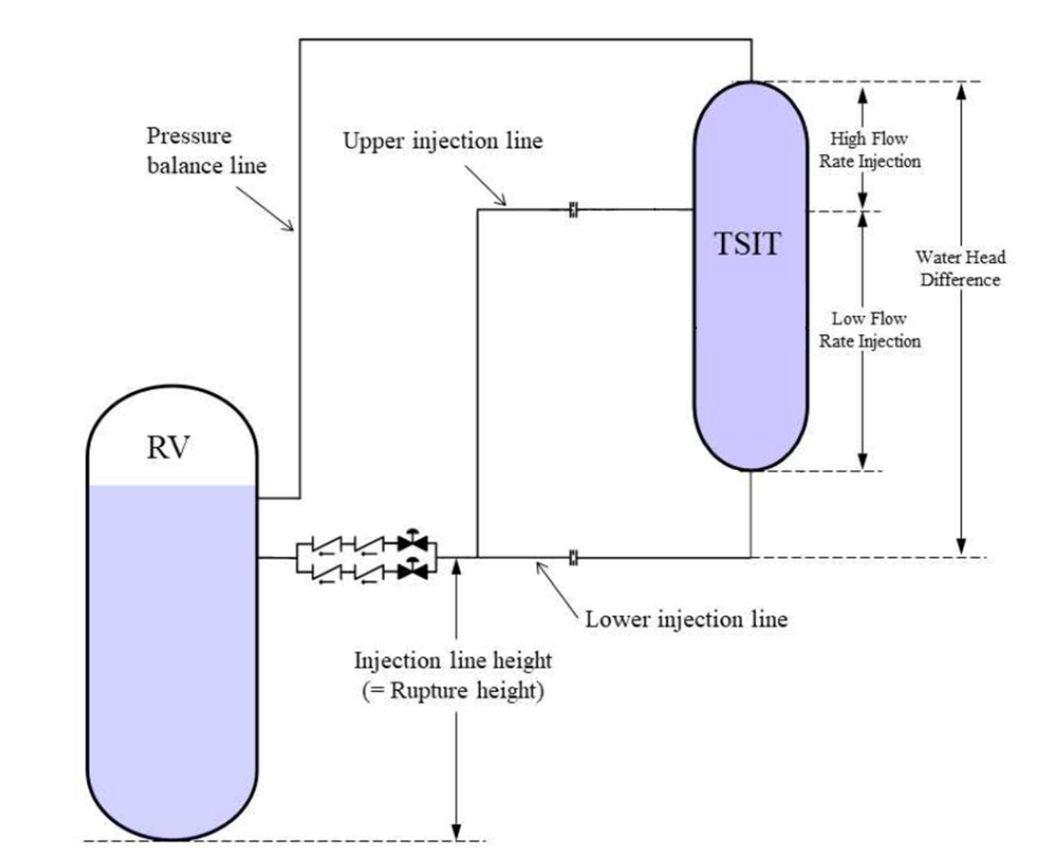

*FIG. 3 Modified configuration of PSIS [3]*

### Evaluation on the design modification

The major modification lies in the steam generator. Preliminary performance analysis has been conducted on the steam generator. As a result, the outlet steam pressure was calculated to be slightly lower than that of SMART100. Changes in the steam pressure requires modifications in the turbine component. This must be evaluated in the further phase. Furthermore, performance analysis on the volume reduced pressurizer has been carried out and it was evaluated to maintain the RCS pressure within the operating range during power ramp and step change operation.

The simplified PSIS was evaluated in terms of safety and performance. As a result, the target flowrate was well achieved. In terms of safety, the reduced nozzle size was expected to mitigate consequence of SBLOCA, however, due to the reduced nozzle size and number of trains, the water injection has reduced as well. Thus, further study is needed in terms of optimization of the modified PSIS to avoid core-uncovery. And the reduced nozzle size is predicted to affect the low temperature overpressure protection (LTOP) valve design as it branches from the safety injection line. This shall be evaluated in the further design phase.

## conclusion

SMART, developed in South Korea, is clearly one of the promising SMRs with a high degree of development completeness. SMART has gained the domestic standard design approval and SMART100, an advanced design of SMART, is currently successfully going through the last phase of licensing process. SMART-C, a variation of the SMART100, is improved in terms of portability and economically. Those aspects were achieved through design modifications such as simplification of the safety systems and reduction of the reactor vessel volume. These have been accomplished in order to deploy and employ SMART-C in various and practical industrial areas such as oil sands industry in Canada. Weight and volume reduced SMART-C is inland portable, thus, highly feasible. Further studies will be conducted on SMART-C and the feasibility of the modified design in various industrial fields shall also be evaluated.

References

1. Kang, H., Lee, B., Lim, S., Light water SMR development status in Korea, Nuclear Engineering and Design. 419 (2024) 112966
2. Chung, Y., Kim, S., Lim, S., Bae, K., TASS/SMR code improvement for small break LOCA applicability at an integral type reactor SMART, Nuclear Engineering and Design. 295 (2015) 221-227
3. Shin, S.J., Kim, Y.I., Ryu, S., Bae, Y., Cho, H., Peformance analysis of a multi-stage safety injection tank, Ann. Nuclear Energy 150 (2021) 107844