# HELICAL COIL STEAM GENERATOR THERMAL HYDRAULIC PERFORMANCE

J. B. Emanuel Giménez

National Commission of Atomic Energy, CAREM25, Thermal-Hydraulics Department

San Carlos de Bariloche, República Argentina

Email: egimenez@cab.cnea.gov.ar

D. Ramajo, D. Godino, S. Corzo

Research Center for Computational Methods CIMEC (CONICET-UNL)

Santa Fe, República Argentina

Email: dramajo@santafe-conicet.gov.ar

**Abstract**

CAREM25 operates with an innovative helical-coiled steam generator (SG) integrated within the reactor pressure vessel, envisioned to provide superheated steam while presenting a low hydraulic resistance that allows for the primary coolant's natural circulation. For this reason, the secondary coolant flows inside the SG’s pipes distributed across six annular arrangements named as “jackets”, and the primary coolant by the shell side. The one-dimensional lumped parameters formulation is suitable for a first order assessment of the SG’s heat transfer capacity and dynamic simulations; whilst it fails to provide intermediate fidelity information regarding temperature profiles across the axial axis for each jacket, secondary side quality distribution and other sensitivity analysis. On the other hand, a detailed CFD model, even when the primary side is modeled as porous media, requires extensive computational effort and several assumptions regarding the secondary side single- and two-phase flow. A steady state, 2D lumped parameter, MATLAB code named “MIGV” was developed to assess the thermal hydraulic performance of the CAREM25’s SG at different operational points. It is based on validated correlations for both the primary and secondary flows, particularly for the heat transfer calculation and the pressure loss coefficient of the secondary side. Thermal properties are evaluated at local conditions and the heat transfer area, flow passage sections and other relevant geometrical parameters are considered consistently with the actual manufactured SG. Results were compared against an OpenFOAM(R) CFD model, exhibiting consistent phenomenology. The code MIGV proved to be a versatile and agile tool for thermal-hydraulic assessment.

## INTRODUCTION

Helical Coil Steam Generators (HCSG) have proven to be efficient components due to their compact design and high heat transfer coefficients. In the nuclear industry, these exchangers play a vital role in improving reactor efficiency and safety. HCSGs are particularly valued for their ability to maximise heat transfer by reducing hydraulic resistance, thereby improving the natural circulation of coolant. Compared to straight tube heat exchangers, the heat transfer rate of HCSG is significantly higher due to the secondary flow pattern in planes perpendicular to the main flow [1]. The use of such units in nuclear reactors has increased due to their ability to withstand demanding operating conditions and their efficiency in producing superheated steam.

Much work has been carried out to investigate both heat transfer and pressure drop; based on experiments, Prasad et al. [2] concluded that the pressure drop and heat transfer values for the shell side followed the classical Blasius and Dittus-Boelter type relationships, while a strong dependence on the coil to tube diameter ratio was observed. Ghorbani et al. [3] also measured the heat transfer coefficient for various Reynolds and Reyleigh numbers, tube-to-coil diameter ratios and dimensionless coil pitches. Genić et al. [4] also performed experiments and proposed a specific correlation for HCSGs. Recently, numerical and experimental investigated the vortex structures in the tube bundle to obtain the shedding frequencies that cause tube vibrations [5,6,7] and to quantify the influence of the inhomogeneous flow distribution at the coil inlet on the local heat transfer and mechanical stresses [8].

The CAREM-25 reactor is an innovative Small Modular Reactor (SMR) developed in Argentina, using twelve HCSGs [9,10,11]. The reactor has no coolant pumps, so the coolant flows by natural circulation. Therefore, the hydraulic resistance must be kept as low as possible, while ensuring the required heat exchange. The present work reports the heat transfer coefficient and pressure drop obtained by a steady-state one/two-dimensional lumped parameter code called MIGV. The code is based on correlations for tube and shell side flows. The fluid properties are evaluated under local conditions and relevant geometric parameters of the real HCSG of CAREM-25 are considered. The results obtained with the MIGV code are compared with CFD models and show remarkable consistency, proving it to be a versatile and agile tool for the thermohydraulic evaluation of the CAREM-25 HCSGs under different operating conditions.

## CAREM25 Steam Generator Main Features

The CAREM25 SG consists of a single step, helical coil arrangement in which Inconel tubes are disposed as 6 (six) concentric jackets, providing a significantly higher heat transfer area per unit of axial length. Condensed water from BoP (Balance of Plant) enters through the liquid water plenum and then is distributed through the tubes, each of them with an average developed length of 30 m. The helical coiled section comprises the greatest tube portion and it develops through 3.5 m of height.

The secondary coolant flows down within an enclosure (internal casing) that prevents a primary coolant bypass from the helical coiled domain, afterwards each tube develops a 180° turn and then the helical coiled section begins. The secondary fluid enters the boiling regime after several coil rows (pre-heating) until fully developed boiling regime is achieved. Super-heated steam is produced nearly the end of the coiled zone and the delivered through the SG outlet plenum. The final steam temperature surpasses the 290 °C, and depending on the BoP mass flow rate, it can deliver up to 320 °C.

CAREM25 plant was designed to operate with 12 (twelve) SGs integrated into the reactor pressure vessel. The primary fluid enters through the top of each SG and passes through the concentric jackets created by the SG helically coiled tubes, to finally discharge to the downcomer. See Fig. 1.

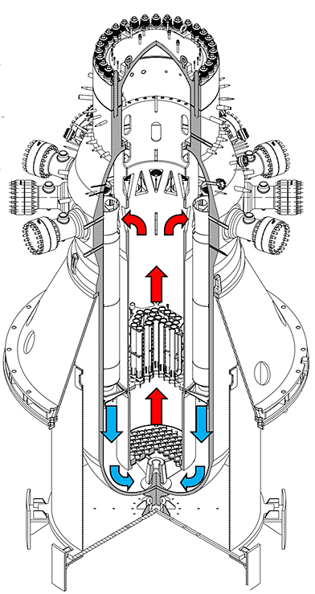

*FIG. 1. General view of the steam generator and its location within the RPV.*

## MIGV MODEL DESCRIPTION

MIGV discretization and modelling was developed based on the following assumptions:

1. Steady state, lumped parameters methodology. Mass, energy and momentum balance are solved for each node with the same axial discrimination for both primary and secondary. See Fig. 2.
2. The primary side is represented as seven parallel channels connected to each other by the lower and upper plenums respectively; cross flow is not allowed.
3. For the first iteration, a uniform mass flux in channels is used for each primary side channel. If a large pressure difference is found, mass flux is corrected.
4. The minimum passage area is used as a reference.
5. Special nodes are generated to treat the non-helical coiled regions: entrance, internal casing, lower region; all characterized by a single or several nodes.
6. The secondary flow is described for each jacket, considering an average tube for each one, axially discretized.
7. A homogeneous equilibrium model (HEM) is adopted; supported by heat transfer and pressure drop correlations developed ad-hoc for the HEM.

Fig. 3 shows the thermal coupling among the primary and secondary fluids, center in the secondary channel. The transferred thermal power is computed as DQ1 and DQ2 to note the left and right heat contribution from the primary side, for each axial node. Therefore, there is one extra primary channel compared to the secondary channel number.

*FIG.* *2. Global discretization scheme of the GV. Sections P1 to P7 and C1 to C6 correspond to the primary and secondary sides of the helical coiled region respectively. Some special nodes are used to describe entrance/outlet regions and the inner enclosure. SE and PE stand for the secondary and primary inlet volumes, the last is also connected to the SS (secondary exit). The SG lower region: SR is thermally connected to the primary node “PS”. The secondary tubes exchange heat with the semi-trapped fluid within the enclosure, these nodes are named as CAS and CAP respectively.*

*FIG. 3. SG discretization scheme, detail for secondary jacket C2 with clarification of the main variables. Index “i” applies to the secondary side, and “j” through the primary. Both indexes increase accordingly with the flow direction. MDOT_PR_J and MDOT_SE_I stand for the primary and secondary mass flow rate at the given channel/jacket.*

Regarding boundary conditions: the mass flow rate, pressure and inlet enthalpy are fixed for the primary side, while the pressure outlet and inlet enthalpy and inlet pressure are defined for the secondary fluid. Hence, the secondary mass flow rate and its outlet enthalpy are reported as MIGV main results, together with the enthalpy, temperature, title, mass flow rate and pressure for each secondary jacket, as a function of the axial variable. The primary side channels thermal-hydraulics parameters are also described at MIGV’s output.

Problem initialization: jackets C1 to C6 inlet nodes (when i=1) and primary channels P1 to P7 are fixed by the boundary conditions. A seed solution is generated for the primary side to start the iteration process. A constant pressure equal to the inlet pressure and a linear distribution is proposed for the enthalpy of the primary side, the same for all channels (P1 to P7). Given a reference thermal power for the overall SG, a seed mass flow rate is computed for the secondary side with a homogeneous mass flux distribution across the six jackets. Using the primary side seed data, the transferred thermal power DQ1 and DQ2 are calculated for each axial step. For the present work, 100 axial steps were implemented for each of the six jackets (C1 to C6), the seven primary channels (P1 to P7) and the special primary and secondary enclosure channels (CAP and CAS). Over 1500 nodes are used to represent each SG.

Heat transfer models are automatically selected for each node depending on the fluid side (primary or secondary) and weather there is a straight or helically coiled tube. The FAMA [13] correlation was specifically developed for the jackets bending ratio (tube inner diameter divided the jacket average diameter) and applies only to the single-phase flow (sub-cooled liquid or super-heated steam) internal flow, i.e., the secondary side. The boiling region at the secondary side is treated as sub-cooled boiling and saturated boiling, with the Bowring methodology and Chen correlation respectably. The effect of the tube curvature might influence the heat transfer coefficient, nevertheless, during the boiling sections this is the lowest thermal resistance when compared to the tube wall and primary side equivalent thermal resistance. The Zukauskas [14,15] correlation was implemented for the primary side.

Regarding pressure drop models and correlations, the primary side models are based on the well-kwon correlations for aligned tubes while the secondary side model for pressure drop was specially developed for coiled tubes. The FEMA [12] correlation was specifically developed for the CAREM operation range and is used both for single- and two-phase flow regimes. Every model and correlation are used at local conditions, i.e., using the node temperature, title and pressure to assess thermal properties [16]. The numerical implementation was accomplished in MATLAB [17].

## OpenFOAM(R) Model’s description

To reduce the computational time, the full geometry was reduced by solving only a fraction of the SG to improve the mesh quality around the inter-tube regions, see Fig. 4 as an example. This first CFD approach was carried out to capture the general flow pattern and the flow distribution in the upper part of the spiral coil. This model has two main geometric simplifications: first, the coil is not helical but a set of horizontal isolated rings without connection. This is not considered relevant as the helix angle is less than 5°. The second simplification relates to the full height, as only 0.6 m of the full 3.5 m has been solved. Nevertheless, the pressure drop is quickly established after a few rows of tubes and the actual model is sufficient to capture the flow characteristics. The CFD model was discretised using a hybrid mesh of 27,134,514 cells. The mesh quality was acceptable with a maximum and average non-orthogonality angle of 65° and 10.7° and a maximum skewness of 1.1. A mesh convergence study was not possible and will be performed at a later stage.

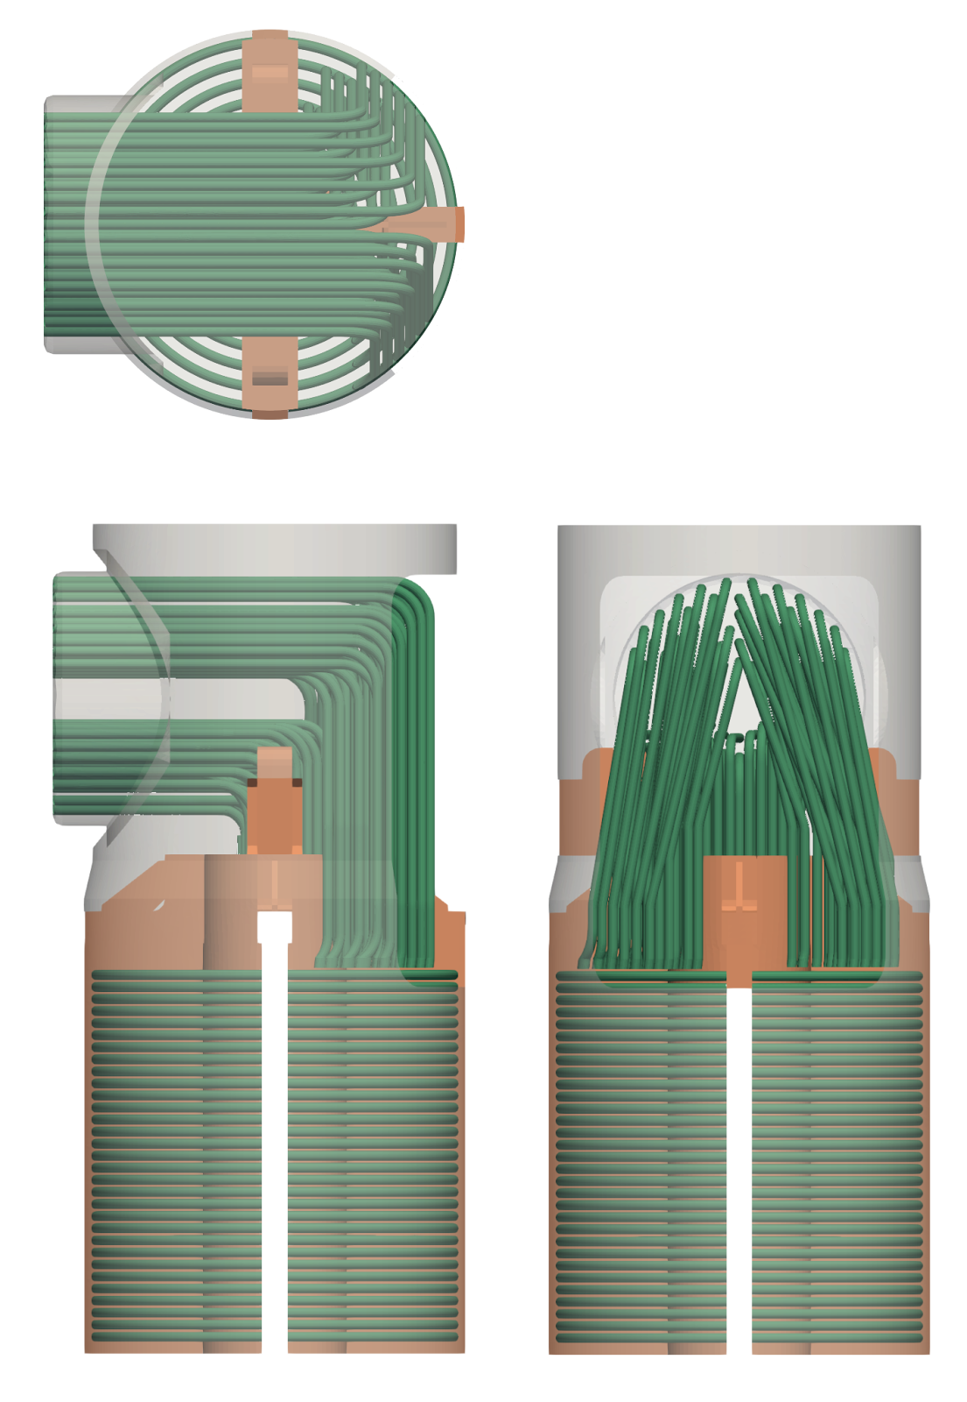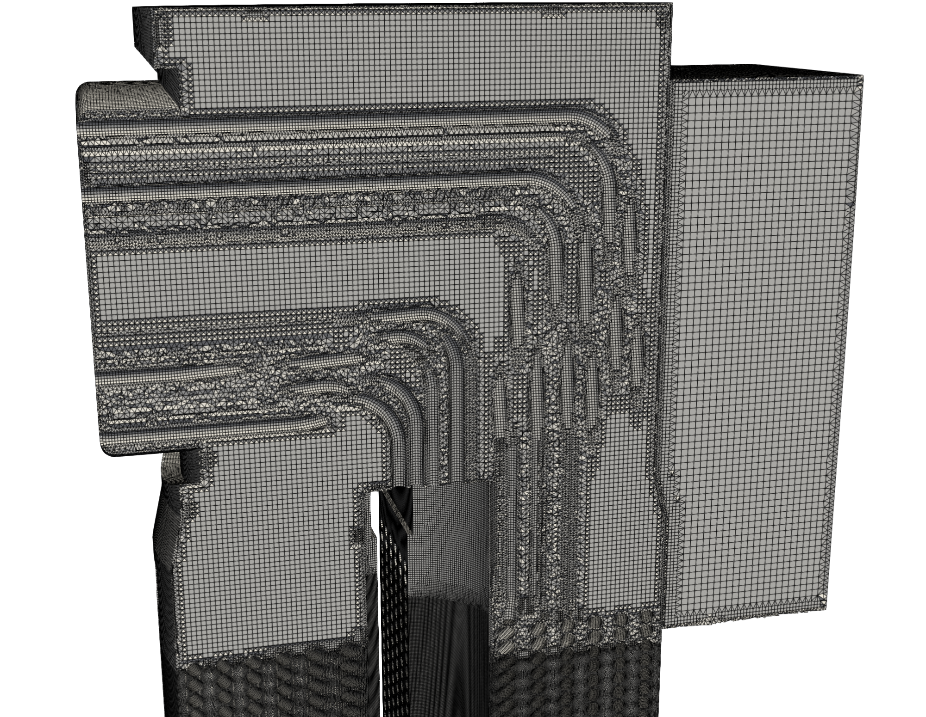

*FIG. 4. SG simplified geometry for the CFD model generation and a sample of the mesh.*

Simulations were performed using OpenFOAM 8 with the *buoyantPimpleFoam* solver, a transient turbulent single-phase solver for the Navier-Stokes transport equation coupled with an energy equation based on enthalpy balance. The fluid properties can be constant or follow a temperature variation based on constitutive laws, polynomial functions or data tables. In the present work constant fluid properties have been adopted, but polynomial functions will be implemented in future. To ensure convergence and stability, a first-order Euler scheme was used for the temporal discretisation and upwind schemes for the spatial discretisation of the divergence term, and Gaussian linear correction was used for the Laplacian terms. The tolerance criteria for each time step iteration of the pressure equation was an absolute residual less than 1x10-9 or a relative reduction of two orders.

## rESULTS AND VERFICATION

### 5.1 MIGV Results for full power operation

To test the MIGV functionality, a simulation for the CAREM25 full power case was performed. Secondary side title and velocity profiles and primary side temperature and velocity profiles were plotted against the axial axis at Fig. 5. Pressure gradient at the primary fluid is dominated by the gravitational term, which is expected because of the rather low mass flux and generous radial pitch among the secondary jackets. The secondary side transition from sub-cooled regime to boiling and then the production of super-heated steam is verified. Primary side velocities at the inlet zone are found around an average of 0.5 m/s.

*FIG. 5. MIGV results where primary and secondary temperature, velocity and thermos-dynamic title profile are plotted.*

### 5.2 CFD Results for full power operation

The CFD results focused on characterising the flow distribution in the inlet, which affects the homogeneity of the flow at the top of the coil and the pressure drop along it. FIG 6 on the left shows the pressure field over a vertical plane cutting the coil. The pressure is almost homogeneous at the inlet. This means that the pressure drop is almost negligible, even though the flow must pass through the tube bends and enter between the jackets. FIG 6 on the right shows the average vertical velocity over a horizontal plane cutting the first coil tube ring. As we have seen, the velocity varies between 0.05 and 0.7 m/s, but remains close to 0.5 m/s, except in the outermost channel (P7) where the minimum values are reached.

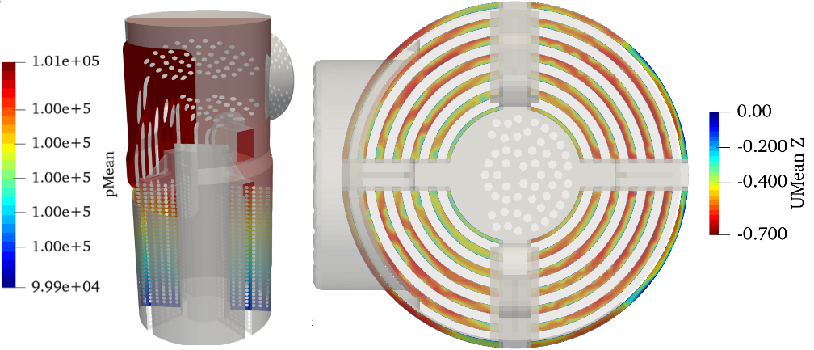

*FIG. 6. Left: pressure over a vertical plane. Right: Mean vertical velocity over a horizontal plane cutting the top side of the coil.*

FIG 7 on the left shows the average velocity across the channels. The cross-sectional area of the channels shows an average velocity between 0.42 and 0.57 m/s. The lower value corresponds to channel P1. The relationship between velocity and channel area is similar for channels P6, P3, P2 and P1, while in channels P5 and P4 the flow has a velocity higher than the average and in the peripheral channel the velocity is well below the average. The latter can be advantageous because the contact surface with the tubes is smaller, since this channel is not limited by two jackets, but by one jacket and the casing. Nevertheless, this homogeneous flow distribution justifies the use of a single inlet velocity for all ducts in the MIGV code. However, more realistic solutions will be obtained by incorporating the CFD results in future calculations. FIG 7 on the right shows the pressure drop along two vertical lines (line 1 in channel P3 and line 2 in channel P5). Despite the initial perturbation, the pressure drop is almost constant once the flow enters the channels. The broken lines are a consequence of the local acceleration/deceleration of the flow, which locally reduces and increases the static pressure, although a continuous pressure drop is observed.

*FIG. 7. Left: Mass flow rate and velocity across the channels. Right: mean pressure in two vertical lines.*

*FIG. 8. Time average velocity in a vertical plane.*

FIG. 8 shows a time averaged solution for velocity in a vertical section plane. The first row of tubes corresponds to the fourth row from the top of the coil. As noted, the flow is quite similar for all rows. The axial pitch is small and the flow between two adjacent rows remains quiescent. Therefore, the water only flows vertically and cross-flow is negligible. This confirms the MIGV assumptions, which neglect radial flow.

## CONCLUSIONS

The MIGV code methodology was presented together with an OpenFOAM model which verified the main assumptions. The CAREM25 helically coiled SG exhibits a one-dimensional flow once the primary side has entered the coiled region, which simplifies the pressure drop calculation together with the heat transfer assessment. Hence, the MIGV’s lumped parameters and validated correlations combined approach can be used to generate fast assessments regarding SG performance, mass flow rate and or enthalpy changes within the primary and secondary sides without running complex and time consuming CFD simulations.

References

1. Prabhanjan D, Raghavan G, Rennie T, Comparison of heat transfer rates between a straight tube heat exchanger and a helically coiled heat exchanger, Int. Com. Heat Mass Transfer, vol 29 (2002) 185-191.
2. Prasad B, Das D, Prabhakar A, Pressure drop, heat transfer and performance of a helically coiled tubular exchanger, Heat Recovery Systems and CHP, vol 9 (1989) 249-256.
3. Ghorbani N, Taherian H, Gorji M, Mirgolbabaei H, An experimental study of thermal performance of shell-and-coil heat exchangers, I J Heat & Mass Transfer, vol 37(2010) 775-781.
4. Genić S, Jaćimović B, Jarić M, Budimir N, Dobrnjac M, Research on the shell-side thermal performances of heat exchangers with helical tube coils, I J Heat & Mass Transfer, vol 55(2012) 4295-4300.
5. Mustafa Alper Yildiz, Haomin Yuan, et al.. Numerical Simulation of Isothermal Flow Across Slant Five-Tube Bundle with Spectral Element Method Code Nek5000. Nuclear Technology, vol 206 (2020) 296–306.
6. Mustafa Alper Yildiz, Elia Merzari, and Yassin Hassan (2019). “Spectral and Modal Analysis of the Flow in a Helical Coil Steam Generator Experiment with Large Eddy Simulation”. International Journal of Heat and Fluid Flow, vol 80 (2019) 108486.
7. Lee S, Hassan Y, Numerical investigation of helical coil tube bundle in turbulent cross flow using large eddy simulation, I J Heat and Fluid Flow, vol 82 (2020) 108529.
8. Liu K, Wang M, Zhang J, Guo K, Tian W, Qiu W, SU Q, Numerical investigation on the thermal load heterogeneity of multi-assembly helical coil steam generator in high temperature gas-cooled reactor, Energy, vol 281 (2023) 128355.
9. DELMASTRO, D.F., “Thermal-hydraulic Aspects of Self-Pressurized Natural Circulation Integral Reactors”, Proc. of Int. Workshop on Thermal-Hydraulics of Innovative Reactor and Transmutation Systems-THIRS, 2008, Eggenstein-Leopoldshafen, Germany, 2008.
10. MARCEL, C.P., FURCI, H.F., DELMASTRO, D.F., MASSON, V.P., Phenomenology involved in self-pressurized, natural circulation, low thermos-dynamic quality, nuclear reactors: The thermal-hydraulics of the CAREM-25 reactor, Nucl. Eng. Des. 254 (2013) 218-227.
11. MARCEL, C.P, Addressing the global energy problem: Perspectives, challenges, and potential solutions, Nucl. Eng. Des. 414 (2023) 112610.
12. FERRARIS, D.L., MARCEL, C.P., Two-phase flow frictional pressure drop prediction in helical coiled tubes, Int. J. Heat Mass Transfer 162 (2020) 120372.
13. FAZZARI, R.J., MARCEL, C., MASSON, V.P., Single-phase heat transfer prediction in helical coiled tubes in turbulent regime, Nucl. Eng. Des. 417 (2024) 112870.
14. SRBISLAB, B., Research of the shell-side thermal performances of heat exchangers with helical tube coils, Int. J. Heat Mass Transfer. 55 (2012) 4295-4300.
15. ZUKAUSKAS A., Heat Transfer from Tubes in Crossflow, Adv. H. transfer, 8 (1972) 93-160.
16. HOLMGREN, M., X Steam, Thermodynamic properties of water and steam (2022), [www.mathworks.com/matlabcentral/fileexchange/9817-x-steamthermodynamic-properties-of-water-and-steam](http://www.mathworks.com/matlabcentral/fileexchange/9817-x-steamthermodynamic-properties-of-water-and-steam)
17. The MathWorks Inc., MATLAB version: R2022a (2022), [www.mathworks.com](http://www.mathworks.com)

BIBLIOGRAPHY

Collier, J.G., Thome, J.R., Convective Boiling and Condensation, Clarendon Press, Oxford (1994).

Incropera, D., Bergman, L., Fundamentals of heat and mass transfer, Wiley, USA (2006).

Todreas, N.E, Kazimi, M.S., Nuclear Systems I Thermal Hydraulics fundamentals, MIT, USA (1990).

Todreas, N.E, Kazimi, M.S., Nuclear Systems II Thermal Hydraulics fundamentals, MIT, USA (1990).