Low Energy Linear Accelerator-Driven Subcritical Molten Salt Reactor to Produce Clean CO₂-Free Energy with Stirling Cycle

Eduardo D. Greaves^{1a}, Laszlo Sajo-Bohus^{2a} and Takashi Kamei^{3b}
ªUniversidad Simón Bolívar. Apartado 89000, Caracas 1080, Venezuela
^{b}International Thorium Molten Salt Forum, Japan
¹egreaves20002000@yahoo.com, ²sajobous@gmail.com, ³hae00675@nifty.com

Abstract

A radiotherapy electron accelerator LINAC operating on the usual bremsstrahlung producing energetic photons (5.5 – 25 MeV) provides demonstrated neutron production when operating in the Giant Dipole Resonance (GDR) region where most medical linacs are actively operated. It is employed with effectiveness to induce neutrons via the reactions (γ , n), (γ , fis) and (e , e’n) in the accelerator’s W-target and thereby controlling fission energy production in a subcritical Accelerator Driven Molten Salt Reactor operating in a thermal neutron regime. FLiBe molten salt with dissolved 0.25 mol% fissile ²³⁵U, ²³³U or ²³⁹Pu provides the reaction media with power totally controlled by the external electron accelerator X-Rays and neutron source. The thermal energy is used to drive a Stirling cycle engine to directly provide electric power production.

1. INTRODUCTION

Nuclear reactors driven by external devices have been in the literature for some time. The concept was proposed by W. B. Lewis in 1952, []. K. Furukawa et al. (1981) [] provided a numerical study and proposed this concept as accelerator molten salt breeder (AMSB). In 1997 Carlo Rubbia involved CRS4 in the Energy Amplifier Project (also called Rubbiatron): a subcritical fast nuclear reactor (Accelerator Driven System) coupled to a proton particle accelerator and cooled with liquid lead, able to use as fuel the radioactive waste produced by traditional nuclear reactors, together with thorium, a widely available element. The proposal by Carlo Rubbia, then at CERN, of using a proton accelerator to produce neutrons by spallation lead to a patent [].
Very extensive experience has been acquired in the operation of Accelerator Driven Systems (ADS) and critical assembly reactor [] studies of ADS since 2003 with the combined use of the Kyoto University Critical Assembly (KUCA) core and two accelerators: A pulsed-neutron generator of 14 MeV neutrons and a fixed-field alternating gradient accelerator of 100 MeV protons. Radiotherapy electron accelerators LINACs operating for the usual bremsstrahlung to produce energetic photons (5.5 – 25 MeV) provides demonstrated [,] neutron production when operating in the Giant Dipole Resonance (GDR) region where most medical linacs are actively operated. A subcritical molten salt reactor driven by a linear accelerator of up to 150 MeV electrons has been modeled by Lin Zuokang et al. (2013) [] estimating the fission power induced of about 280kW in the system, and a conversion ratio (CR) of 0.3836 for ²³²Th to ²³³U.
. More recently there are 314 pages of text in Chapter 15: Accelerator-driven systems in the Elsevier 2024 second edition of Molten Salt Reactors and Thorium Energy []
In most of these proposals a high energy proton accelerator beam of about 1 GeV produces abundant neutrons by directing it to a spallation target of heavy elements such as Pb, W, U, or Th. In the later Furukawa AMSB proposal [], the proton beam is made to strike directly the molten salt loaded with Th, U, or actinides and bringing the subcritical assembly to criticality thus producing fissile ²³³U while acting as a waste burner and energy source.
In this paper we propose an accelerator driven system that, instead of a large and extremely expensive high energy proton accelerator in the range of GeV, uses a relatively cheap high energy electron LINAC (4 – 20 MeV) that produces neutrons and a strong beam of X-Rays as currently used worldwide for radiotherapy in cancer treatment. In this case the X-Ray beam and neutrons directly strike the molten salt in a modified small subcritical UNOMI MSR []

2. THEORETICAL

The production of photoneutrons by the X-rays of a LINAC for radiotherapy is well established Tosi et al. (1991) [] derived the following expression:
(1)
Here, n(E) represents the amount of neutrons with energy between E and E + dE, α is the fraction of neutron evaporation, T is the target nuclear temperature, β is the fraction of knock-on neutrons, E_{max} is the maximum energy of accelerated electrons and S_{n} is the separation energy of neutrons in the target nucleus. Several reports of photonuclear detection in a LINACs have used Nuclear Track Detectors (NTD) to measure and quantify possible harm to patients undergoing treatment for cancer [,]. Modeling studies of photoneutrons impinging on molten salt assemblies [], have suggested the possibility of a LINAC-Molten Salt Reactor (MSR) scheme. Furthermore experimental studies [] have demonstrated photonuclear fission with an assembly including Nuclear Track detectors (NTD). More recently Adrian Sari (2023) [] in an extensive review has presented the state of the subject.
The model that describes nuclear reaction induced by photons is the so called "giant dipole resonance" (GDR) a phenomenon that occurs when the entire nucleus vibrates in a mode resembling the motion of a dipole, meaning the nucleus essentially deforms like a vibrating drop of fluid. The related dynamical process is that the atomic nuclei reach a higher energy state, causing it to vibrate in various modes, either via a pigmy dipole resonance (PDR) or a giant dipole resonance (GDR). The model is a theoretical framework used in nuclear physics to explain the collective motion of protons and neutrons within atomic nuclei. This model and a simple description of it were provided by M. Goldhaber and E. Teller in 1948 []. In the case of actinides, e.g. isotopes of thorium, uranium and plutonium, GDR may lead to photon-induced fission of the nuclei (photofission), a reaction which was already predicted by N. Bohr and J. A. Wheeler in 1939 []. An alternative view of the photofission process is that the nucleus vibrations and deformation from photons in the GDR region exceed W. E. Weber’s critical distance r < C_{d} below which like charged particles attract and above which r > C_{d} , like charges repel [, p. 57] leading to the nucleus breakdown and fission or photoneutron emission. Fig. 1 shows the cross section as a function of energy.
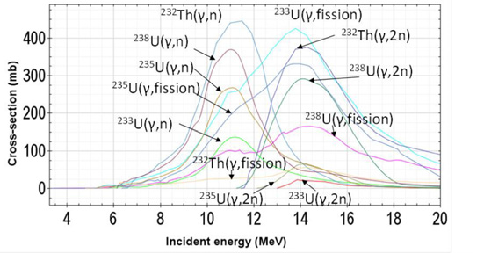
FIG. 1. Diagram of the total photonuclear cross-section per nucleon in mb as a function of the photon energy showing the giant dipole resonance. From [].

There are two processes considered in the photoneutron emission: 1.- Boiled off photoneutrons which are emitted by an evaporation process, they have lower energies and an isotropic emission. 2.- Knock-on photoneutrons which are produced by direct emission process, and are characterized by higher energies and an anisotropic emission, i.e. with a privileged emission angle around 90° from the incident photon.[Error: Reference source not found , p. 34]
Table 1 shows a sample of the wide number of reactions that may take place, if the molten salt of a subcritical reactor is directly irradiated with a beam of energetic X-rays in the (8 – 18 ) MeV range off the GDR.
Fig.2 shows the cross section for two heavy nuclei ²³⁸U and ²³²Th. The photonuclear reactions taking place in the molten salt directly supply a neutron flux to the reactor fuel. The maximum cross section is about 13 MeV, hence this value has been taken as the X-ray energy for transmission and attenuation calculations below.

TABLE 1. Relevant processes other than direct neutron induced fission with U_{nat} = 99.3% (²³⁸U) + 0.7% (²³⁵U); Th is assumed pure ²³²Th. Adapted from Sajo-Bohus et al.(2016)[]

Processes
²³⁸U + γ → ²³⁶U +2n + γ → ²³⁵U + n → fission fragments (A1, A2)
²³⁸U + γ → ²³⁷U +n + γ → ²³⁶U + n + γ → ²³⁵U + n → fission fragments (A1, A2)
²³⁸U + γ → ²³⁷U +n → ²³⁷Np +β- + γ → ²³⁵Np +2n + e → ²³⁵U + n → fission fragments (A1, A2)
²³²Th + γ →²³¹Th + n; ²³²Th + γ → fission fragments (A1, A2)

FIG. 2. Comparison between photofission cross section of two actinide isotopes to show similarities. Adapted from Caldwell et al. (1980) [].

The photoneutron emission process can be described as follows: [Error: Reference source not found] Due to collective oscillation in the heavy nuclei, neutrons break free during photonuclear (γ , n) and (γ , 2n), electronuclear (e , e’n) or (γ , p) reactions including (γ , fis). The total reaction cross-section may be expressed as the sum of cross sections for a set of possible reactions, in which and ν is the neutron multiplicity which for actinides fission is around 2.2.
The neutron yield per incident photon and energy group, for target elements assuming a parallel beam of photons, is given by where is the atomic density, is the cross-section for (γ , n) reaction of the j-th isotope and t is the target thickness. The factor takes into account photon attenuation when relatively thick target material is considered. This is the case with the LINAC radiation impinging directly on the reactor molten salt.
Desobry and Boyer (1991) [] compared, by two models, the Bremsstrahlung spectrum produced by LINAC electrons of 18.75 MeV. The result shows good agreement with a calculated spectrum. See Fig. 3. The spectrum shows that, in the region of interest between 10 and 16 MeV, the spectrum photon fluence distribution (Number of photons per unit area) where the GDR, shows a cross section peak (See Fig. 1) has a relative intensity about half of the maximum intensity. The calculations by Desobry and Boyer and elsewhere are done for the purpose of optimizing radiotherapy applications so that the target design incorporates filters, collimators and attenuators designed to modulate the X-ray beam and adequate it for cancer treatment. In the present case a naked beam is expected to exhibit a much higher overall fluence and the spectrum shows a convenient distribution for providing photoneutrons and photofissions to the reactor core.
The production of photoneutrons by various commercial radiotherapy LINACs (Varian, Elekta, Siemens, General Electric) has recently been reviewed by N. Banaee, et al. (2021) [ p. 948] from which we quote “The Q values range from 0.02 × 10¹² for a 10 MV beam to 1.44 ×10¹² neutrons per photon Gy (n /Gy) for a 25MV beam and different commercial LINACs such as Elekta SL (25MV) and GE Saturne 43 (18MV) have the highest Q values of 1.44×10¹² n /Gy and 1.32 × 10¹² n /Gy, respectively”
Photoneutron production which is an issue for radiotherapy treatment of cancer patients is a blessing for AD MSR as proposed here.
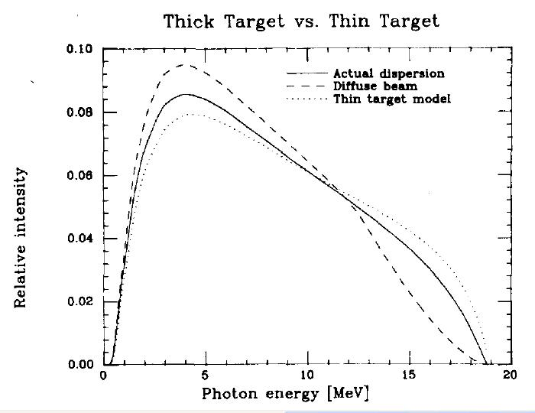
FIG. 3. Bremsstrahlung spectrum produced by LINAC electrons of 7.75 MeV X-rays filtered by 40 mm of iron and 7 mm of tungsten. From [Error: Reference source not found]
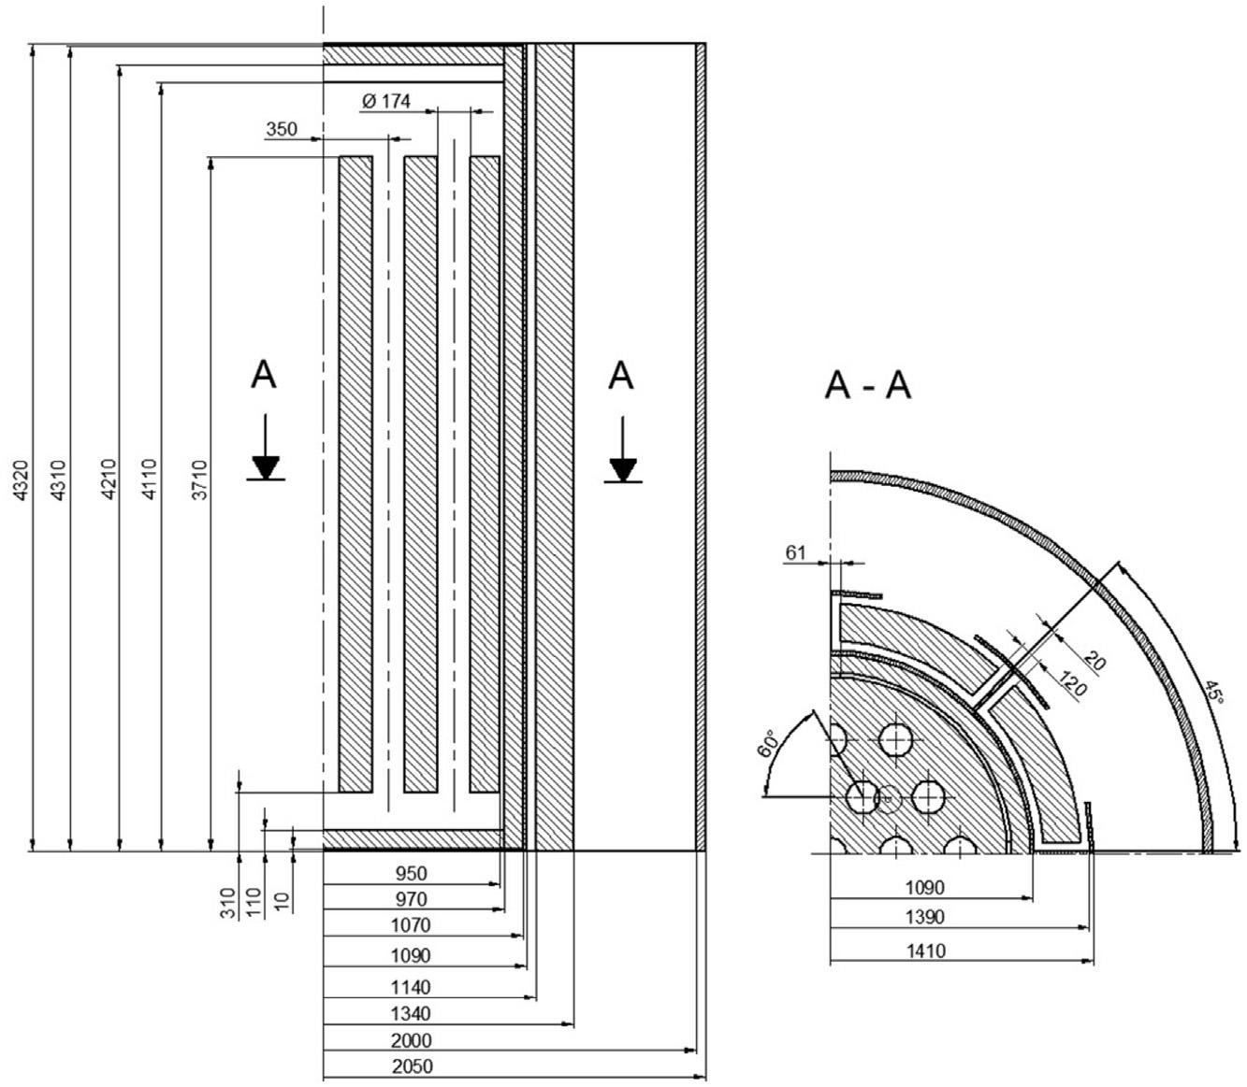

FIG. 4. Vertical and horizontal cross sections of the UNOMI reactor core with dimensions in mm [, ]

Fig. 4 shows the reactor core. If the X-Ray beam target is placed outside of the Hastelloy N containment vessel it is attenuated by the thick material (50 mm) of the vessel. The X-ray mass attenuation coefficient for Hastelloy components is shown in Table 2

TABLE 2. Values of the mass absorption coefficient for the main components of Hastelloy N

Element | Composition wt% | Fractional Composition | Element Mass absorption Coefficient at 10 MeV | Absorption coefficient in Hastelloy N
nickel: | 71 | 0.71 | 3.1850E-02 | 2.2614E-02
molybdenum | 16 | 0.16 | 3.6500E-02 | 5.8400E-03
chromium: | 7 | 0.07 | 2.8550E-02 | 1.9985E-03
iron: | 5 | 0.005 | 2.9940E-02 | 1.4970E-04
others: | 1

With the data in Table 2 the Hastelloy N total mass absorption coefficient for 13 MeV X-rays is calculated as 3.0602E-02 (cm/g) and the total linear absorption coefficient for 13 MeV X-rays 2.7113E-01 (cm⁻¹).
With these values the absorption of 13 MeV X-rays is shown in Fig 5.
FIG. 5. Transmission of a 13 MeV, X-ray beam of the LINAC in transversing the Hastelloy 5 cm thick containment vessel wall.

Fig. 5 shows the need of a “window” as the thick 5 cm containment vessel attenuates the X-ray beam to 0.258. The window has the purpose of allowing the radiation in while being a barrier for heat, neutrons, the escape of the heat transfer medium and the reactor molten salt. Fig. 6 below shows the reactor configuration with the LINAC tungsten target where the energetic electron beam strikes and produces an X-ray beam. Fig. 7 shows the LINAC target where the energetic electron beam strikes a tungsten slab reducing the electron beam to negligible electron leakage and producing a strong beam of X-rays
The window contains an external 8 cm thick Fiberfrax heat insulation. This is a ceramic insulator made from Al₂O₃ (43-47%), SiO₂ (53-57%) with high temperature resistance and very low heat conductivity < 0.15 W/(m K) at 600ºC. The heat insulation covers the whole of the containment vessel to reduce overall heat losses as shown below in Fig. 6.
The window contains a 1 cm thick Hastelloy plate. It is designed to allow ingress of X rays with transmission of 76.3 % and to withstand the internal pressure of the Helium coolant at ~ 4 MPa (40.8 kg/cm²).
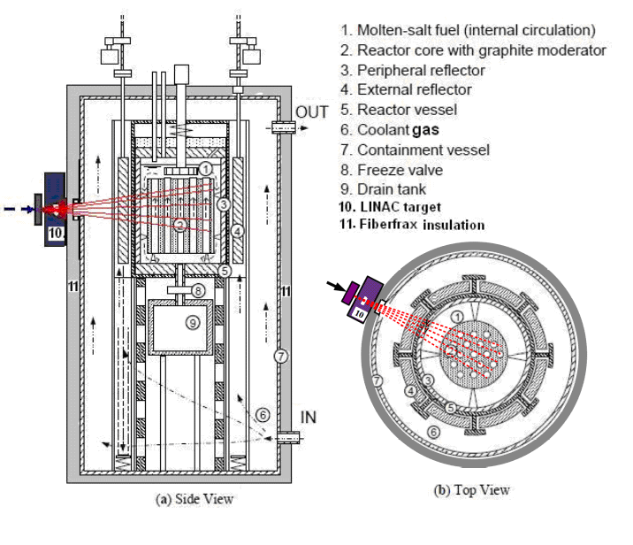
FIG. 6. UNOMI reactor showing the tungsten target of the LINAC and primary collimator attached to the window to allow the X-ray beam to enter and impinge on the reactor core. The IN and OUT port serve the supply of forced coolant helium gas to the output power Stirling engine.

To reach the reactor core the X-ray beam must cross the window, the coolant fluid, the external graphite reflector, the reactor vessel and the internal graphite reflector. The molten salt fuel flows within channels in the graphite reactor core. For an initial beam N_{o} produced at the target of the LINAC, the beam reaching the molten salt is attenuated by these materials, each given by , where is the incident beam on the i^{th} material, its linear absorption coefficient and is its thickness. We want to estimate the attenuation of these materials.

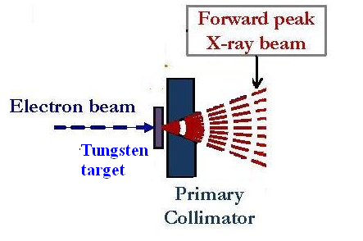
FIG. 7. Simplified LINAC target without the usual beam modification devices used to condition the X-ray beam for radiotherapy purposes as presented in []

The attenuated beam then enters the molten salt and again is attenuated by the elements contained in the salt, and by the photoneutron and photofission processes. In this study, FLiBe (LiF – BeF₂ – ThF4 – UF₄: 71.76, 16, 12, 0.24 mol%) is considered as fuel salt. [Error: Reference source not found]. The mass absorption coefficient is available for all elements from 1 keV to 20 MeV []. The mass attenuation coefficient for a mixture [, p. 840] is given by
(2)
where
(cm²/g) (3)
and is the fractional amount by weight of the i^{th} element in the mixture.

TABLE 3. Materials in the path of the X-ray beam from the LINAC target to the molten salt fuel, the attenuation and the % transmission of each.

Material | Thickness (mm) | linear attenuation coefficient (cm⁻¹) | Transmission  %
Window Hastelloy | 10 | 2.7113E-01 | 0.762
Coolant fluid is He | 660 |  | 0.981
External graphite reflector | 200 | 4.427E-2 | 0.412
The reactor vessel Hastelloy | 20 | 2.7113E-01 | 0.581
Internal graphite reflector | 100 | 4.427E-2 | 0.642

Table 4 shows the calculated attenuation results for FLiBe + U 0.25 Mol% + Th 12 Mol% obtained using Eq.(2) with data from NIST [Error: Reference source not found]

TABLE 4. Mass absorption coefficients calculated for the components in the pure molten salt, ignoring fission products and ignoring the attenuation contribution of the photoneutron and photofission processes at X-ray energy of 13 MeV
Compound | μ/ρ (cm²/g)
LiF | 2.67E-03
BeF2 | 4.58E-04
UF4 | 1.01E-04
ThF4 | 4.98E-03
FLiBe + 0.24 U +12 Th | 8.21E-03

The values μ/ρ (cm²/g) shown in Table 4 are values at room temperature for FLiBe with density which is quoted as 2.245(7). During operation the temperature of the molten salt increases and its density decreases, hence to obtain the linear absorption coefficient at the operational temperature of the fuel, the mass absorption coefficient has to be multiplied by the density which is a function of the salt temperature. The density of several molten salt fuels as a function of temperature was published by S. Cantor (1968) [].
The nearest composition in the Cantor report to the fuel considered here is the F3 fuel mixture (LiF – BeF₂ – ThF₄ – UF₄) with concentrations (68, 20, 11.7, 0.3). For this fuel the Density-Temperature equation for F3 fuel is: ρ = 3.687 – 6.3E-4 t, with t in ºC, ρ in g/cm³. At 600 ºC the calculated density is 3.309 g/cm³ and the Linear Absorption coefficient is then 0.0272 (cm⁻¹). The calculated variation of the beam of 13 MeV as it enters the molten salt is shown in Fig. 7.
FIG. 7. The calculated intensity of X-ray beam as it transverses the molten salt at 600 ºC. A characteristic distance of 36 cm is obtained for 13 MeV X-rays.

3. PROPOSAL

In this proposed AD-UNOMI, a LINAC produced X-Rays beam enters the reactor and increases the reactivity of the fuel through three mechanisms: 1.- The neutrons produced at the LINAC target entering the core, 2.- The photoneutrons produced by the LINAC X-Ray beam in the GDR energy region in the core, and 3.- The photofission produced by the LINAC beam in the GDR energy region.
It is proposed to operate the reactor closely near to criticality, k ~0.99, so that the operation of the LINAC and the effect of the three above mechanisms bring the reactor into critical conditions.

POWER CONSIDERATIONS.

The proposed system is the supply of the reactor generated heat to a Stirling engine to directly drive an electric generator as has been proposed [,]. Some advantages of Stirling engines are that the theoretical thermal efficiency equals that of the ideal Carnot cycle, i.e. the highest efficiency attainable by any heat engine. However, practical Stirling engines deviate substantially from the ideal cycle. Stirling engines can run directly on any available heat source and they use a single-phase working fluid that maintains an internal pressure close to the design pressure and thus, for a properly designed system, the risk of explosion is low. They can be built to run quietly and without an air supply, such as for air-independent propulsion use as in submarines or in space. Recently a Stirling engine use on China’s Tiangong space station has been reported [].
The heater is supplied by hot helium gas which is pumped and ingresses the reactor at the bottom IN port, ascends around the reactor vessel cooling the reactor, exits at the reactor OUT port and enters the Stirling engine HEATER thereby supplying heat energy. Pressure and temperature of the helium coolant are 4 MPa (40.8 kg/cm²) and 873 K, (600ºC) respectively. Then density of helium becomes 2.2 kg/m³, thermal conductivity becomes 0.33 W/m K, viscosity becomes 4.06 × 10⁻⁵ kg/ms and kinematic viscosity is 1.85 × 10⁻⁵ m²/s. [Error: Reference source not found]
The Stirling engine uses dry air as working medium. This is the recommended gas by the New Stirling Technology design [Error: Reference source not found]. The design allows a modification of the number of expansion and compression cylinders in order to handle the basic reactor output power. In principle load following could be accomplished by varying the LINAC produced irradiation of the molten salt fuel via variation of the electron beam striking the accelerator tungsten target.

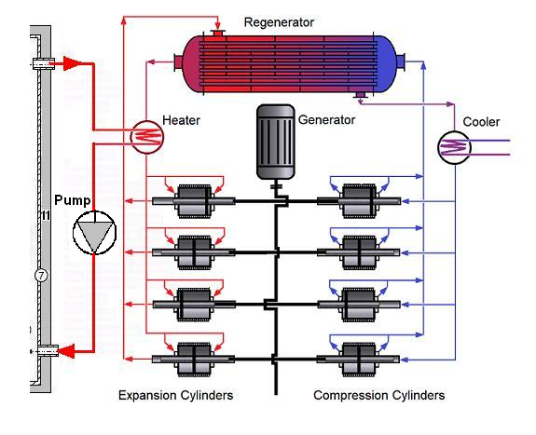
FIG. 8. Schematic multiple cylinder Stirling engine designed by New Stirling Technology [] connected to the AD UNOMI reactor (On the left) shown in figure 6.

4. CONCLUSION

The Accelerator Driven Molten Salt Reactor AD-UNOMI concept combines three distinct technologies: 1.- The molten salt reactor (MSR), 2.- An accelerator-driven system and 3.- A Stirling engine for electricity production
In the first place it combines the significant advantages of the thorium MSR concept: its inherent safety features; the liquid fuel in the form of molten salts with low viscosity, high specific heat and transport of the energy operating at relatively low pressure, i.e. no risk of catastrophic accidents like core meltdown or explosion. It addresses the nuclear waste problem by generating minute amounts of long lived actinides and the possibility of reprocessing of fuel in the same molten salt form for efficient removal of fission products and recycling of usable fuel. Thorium is cheaper and more abundant than uranium, does not require enrichment and produces less long-lived radioactive waste. It provides proliferation resistant characteristics compared to traditional nuclear fuel cycles due to the presences of highly radioactive ²³²U produced with the fissile ²³³U.
In the second case, a subcritical system with external neutron and energetic X-rays offers additional safety benefits as the reactor can be quickly shut down by turning off the accelerator avoiding runaway reactions. LINACS are mass produced for the radiotherapy market and hence have a relatively low cost. A subcritical facility as described could have several radial accelerators which could share power supply and other common requirements in order to supply sufficient external neutrons and X-ray beam to assure reactor control.
In the third case a Stirling heat engine provides a means to convert the reactor heat efficiently to electric power, it uses a single-phase working fluid and it runs quietly and without an air supply, such as for air-independent propulsion with possible space or submarine applications.
In conclusion, the AD-UNOMI concept as described holds promise for providing a safer, more sustainable form of nuclear energy with reduced waste production and enhanced proliferation resistance. However, further research, development, and experimentation are needed to overcome technical challenges and demonstrate the feasibility of this innovative nuclear reactor design.

ACKNOWLEDGMENTS

We want to acknowledge the help of the Sci/Hub web page to obtain literature without which this work would have not been completed, given the dismal budget for institutional libraries in third world countries, particularly in Venezuela where this manuscript was written.

REFERENCES

Lewis, W.B., (1952). The Significance of the yield of neutrons from heavy elements excited to high energies. AECL-968.
Furukawa, K., Tsukada, K., Nakahara, Y., (1981). Single-fluid-type accelerator molten-salt breeder concept. J. Nucl. Sci. Technol. 18 (1), 79 - 81.
Energy amplifier for nuclear energy production driven by a particle beam accelerator. Patent number: 5774514 Date of Patent: June 30, (1998), Inventor: Carlo Rubbia
Cheol Ho Pyeon Editor.(2021) Accelerator-Driven System at Kyoto University Critical Assembly ISBN 978-981-16-0344-0 (eBook) Open access. https://doi.org/10.1007/978-981-16-0344-0
R. R. Martín-Landrove, J. Dávila, H. R. Vega-Carrillo, M. T. Barrera, A.J. Kreiner, F. Pino, H. Barros, E. D. Greaves and L. Sajo-Bohus. (2015) GDR in Radiotherapy Treatment Fields with 18 MV Accelerators. pp 369-376 In PROCEEDINGS OF THE 14th INTERNATIONAL CONFERENCE ON NUCLEAR REACTION MECHANISMS Varenna (Italy), Villa Monastero, June 15 – 19, 2015, edited by F. Cerutti, M. Chadwick, A. Ferrari, T. Kawano and P. Schoofs
L. Sajo-Bohus and E. D. Greaves. (2016) Low energy linear accelerator-driven subcritical assembly. In Chap.15 of Molten Salt Reactors and Thorium Energy. Ed. Thomas Dolan, Pub. Elsevier.
Lin Zuokang, Chen Jingen, Guo Wei and Dai Zhimin. The conceptual design of electron-accelerator-driven subcritical thorium molten salt system. Energy Procedia 39 ( 2013 ) 267 – 274
Molten Salt Reactors and Thorium Energy, Second Edition. Edited by T. J. Dolan, I. Pázsit, A. Rykhlevskii, and R. Yoshioka. 2024. Woodhead Publishing Series in Energy Elsevier Ltd NY and London
K. Furukawa, E. D. Greaves, L. B. Erbay, M. Hron and Y. Kato. New Sustainable Secure Nuclear Industry based on Thorium Molten-Salt Nuclear Energy Synergetics(THORIMS-NES) in Nuclear Power, Book 1, INTECH Pubs. Pavel Tsvetkov Ed. Pp 407-444 (39 Pag) ISBN 978-953-307-185-5. (2011) http://j.mp/s4yNYh
Takashi Kamei. Recent Research of Thorium Molten-Salt Reactor from a Sustainability Viewpoint. Sustainability 2012, 4, 2399-2418; doi:10.3390/su4102399. www.mdpi.com/journal/sustainability
Tosi, G., Torresin, A., Agosteo, S., Flogio Para, A.F., Sangiust, V., Zeni, L., 1991.Neutron measurements around medical electron accelerators by active and passive détection techniques. Med. Phys. 18, 54–60.
H.R. Vega-Carrillo, S.A. Martınez-Ovalle, A.M. Lallena, G.A. Mercado, J.L. Benites-Rengifo. Neutron and photon spectra in LINACs. Applied Radiation and Isotopes. Vol. 71, Supp., Dec. 2012, pp 75-80
Vega-Carrillo, H.R., Baltazar-Raigosa, A., 2011. Photoneutron spectra around an 18 MV linac. J. Radioanal. Nucl. Chem. 287, 323–327.
Laszlo Sajo-Bohus, Eduardo D. Greaves, Jesus Davila, Haydn Barros, Felix Pino, Maria T. Barrera, and Fulvio Farina.Th and U fuel photofission study by NTD for AD-MSR subcritical assembly AIP Conference Proceedings 1671, 020009 (2015); doi: 10.1063/1.4927186
L. Sajo-Bohus and E. D. Greaves. (2016) Low energy linear accelerator-driven subcritical assembly. In Chap.15 of Molten Salt Reactors and Thorium Energy. Ed. Thomas Dolan, Pub. Elsevier.
Sari Adrian. Characterization of photoneutron fluxes emitted by electron accelerators in the 4-20 MeV range using Monte Carlo codes: A critical review. Appl Radiat Isot. 2023 Jan;191:110506. doi: 10.1016/j.apradiso.2022.110506. Epub 2022 Oct 5. PMID: 36370471.
M. Goldhaber, E. Teller, On Nuclear Dipole Vibrations, Phys Rev, 74 (1948) 1046-1049.
N. Bohr, J.A. Wheeler, The Mechanism of Nuclear Fission, Phys Rev, 56 (1939) 426-450.
A. K. T. Assis, K. H. Wiederkehr and G. Wolfschmidt, Weber´s Planetary Model if the Atom. Edited by G. Wolfschmidt (2011). ISBN 978-3-8424-0241-6
Rei Kimura, Hiroshi Sagara and Satoshi Chiba. (2017). Precision requirement of the photofission cross section for the nondestructive assay. EPJ Web of Conferences. 146. 09041. 10.1051/epjconf/201714609041
Laszlo Sajo-Bohus1 and Eduardo D. Greaves. Low energy linear accelerator-driven subcritical assembly. In Chap.15, Molten Salt Reactors (2016) Edt. Thomas Dolan, Pub. Elsevier
Caldwell J. T., Dowdy E. J., Berman B. L., Alvarez R. A. and Meyer P. (1980). Giant resonance for the actinide nuclei: Photoneutron and photofission cross sections for 235U, 236U, 238U and 232Th. Phys. Rev. C 21 (4) 1215-1231
G. E. Desobry and A. L. Boyer. Bremsstrahlung Review: An analysis of the Schiff spectrum Medical Physics 18, 497 (1991); doi: 10.1118/1.596653
Nooshin Banaee, Kiarash Goodarzi and Hassan Ali Nedaie. Neutron contamination in radiotherapy processes: a review study. Journal of Radiation Research, Vol. 62, No. 6, 2021, pp. 947–954 https://doi.org/10.1093/jrr/rrab076
Péter German, CFD simulation study of the molten salt reactor zone driven by natural circulation. Thesis, Department of Atomic Energy, Institute of Nuclear Technology. Budapest, 10/25/2013
Peter German, Sandor Feher, Szabolcs Czifrus, Bogdan Yamaji, Analysis of heat source distribution in internal circulating surface heat transfer molten salt reactor. Progress in Nuclear Energy 92 (2016) 155-163
Qiang Gao, Hao Zha, Huaibi Chen, Jiaru Shi. Design and Optimization of the Target in Electron Linear Accelerator, THPWA016, Proceedings of IPAC2013, Shanghai, China
J. H. Hubbell and S. M. Seltzer. Tables of X-Ray Mass Attenuation Coefficients and Mass Energy-Absorption Coefficients from 1 keV to 20 MeV for Elements Z = 1 to 92 and 48 Additional Substances of Dosimetric Interest. Radiation Physics Division, PML, NIST https://www.nist.gov/pml/x-ray-mass-attenuation-coefficients
C. M. Davisson Gamma ray attenuation coefficients. In Kai Siegbahn, editor, α β γ Ray Spectroscopy Vol. 1, North Holland Pub. Co. 1968, Amsterdam.
Cantor, S.; Cooke, W.; Dworkin, S.; Robbins, D.; Thoma, E.; Watson, M. Physical Properties of Molten-Salt Reactor Fuel, Coolant and Flush Salts; ORNL-TM-2316. Oak Ridge National Laboratory: Oak Ridge, TN. 1968
Lindsay Dempsey and Charles Forsberg. (2024) Electricity production. CHAPTER 2 in Molten Salt Reactors and Thorium Energy. Second Edition Edited by Thomas James Dolan, Imre Pázsit, Andrei Rykhlevskii and Ritsuo Yoshioka. 2024 Elsevier Ltd
L.B.Erbay, “A Discussion for the MSR-Stirling Power System”, Proceedings of IECEC’01, July 29-August 2, (2001), Savannah, Georgia, USA, P.423-427.
Darren Orf. For the First Time Ever, China Tested a Stirling Engine in Space. Popular Mechanics. May 01, 2023. https://www.popularmechanics.com/space/moon-mars/a43700416/stirling-power-converter-china/ Accessed April 2024.
Thomas Seidenschnur. New Stirling Technology.https://www.heat2power.com/NewStirling.html Accessed April, 2024

