# HEXANA: a sodium advanced modular reactor for

# sustainable industrial decarbonization

J.B Droin, P. Gauthé, H. Polge, P. Andreucci, S. Nizou,

HEXANA

Europarc de Pichaury 1330 Avenue Jean-René Guillibert Gautier de la Lauzière, Bat 5, 13290 Aix-en-Provence

Contact : [paul.gauthe@hexana.fr](mailto:paul.gauthe@hexana.fr)

**Abstract**

HEXANA is a French start-up committed to the design and development of an innovative small modular sodium fast reactor. Its objective is to deal with the key challenges of the energy transition that are still poorly addressed today, mainly through the decarbonization of the hard to abate energy intensive industries and the need for flexible power sources in addition to renewable energies. The Sodium Reactor technology has been chosen because of its favorable technical specifications for end-users (high temperature, good electrical efficiency⋯), but above all because of the high technological readiness level and the high level of credibility that it offers and which results in a quite short time-to-deployment compared to other systems. The proof of concept is already demonstrated at an industrial scale, but HEXANA brings several innovations in terms of architecture and of use of energy.

The power of this reactor is 400 MWth for each module, and HEXANA provides two twinned reactors associated with thermal storage (molten salt) offering flexible power delivery in response to the needs of its customers for industrial process needs. HEXANA integrates design options offering high guarantees from the point of view of safety, relying in particular on passive safety devices. The design of the nuclear island is made modular, so that factory-building and transport on-site by sea or by river is possible, which is a key driver for competitiveness. HEXANA is primarily targeting the combined production of heat and electricity, bases to produce hydrogen or synthetic fuels. The level of heat (up to 500℃) actually gives access to all the amenities needed to defossilize our economy: steam, hydrogen, CO2, synthetic fuels, green steel, chemical molecules, etc. All these features confirm that the solution proposed by HEXANA is relevant to decarbonize industrial hubs in a robust and credible way.

## INTRODUCTION

### The need for a clean industrial heat pathway

In order to fully decarbonize the economy by mid-century and potentially avert dangerous impacts from climate change, it is necessary to find as soon as today ways to reduce heating-related emissions from the industrial sector. This is a considerable challenge as most heat energy industry uses today comes from fossil fuel combustion (cf. Fig. 1: global industry energy consumption is 26 percent electricity and 74 percent heat, mostly from fossil fuel [1]). This fossil consumption accounts for about 10 percent of global carbon dioxide emissions, and many industrial processes require levels of heat that are physically and/or economically difficult to generate without burning fossil fuels. Thus, deploying clean heat solutions implies a paradigm shift in the way to produce our energy. Achieving net-zero emissions will require large scale change across all sectors of energy and economy. Efforts to drive this transition are intensifying, but with no significant results up to now in terms of substitution to fossils fuels, as illustrated in Fig. 2.

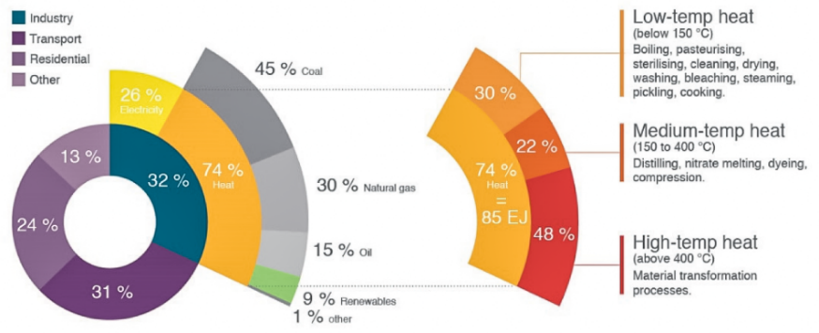

*FIG. 1. Total global energy consumption (all sectors, in relative) from [1]*

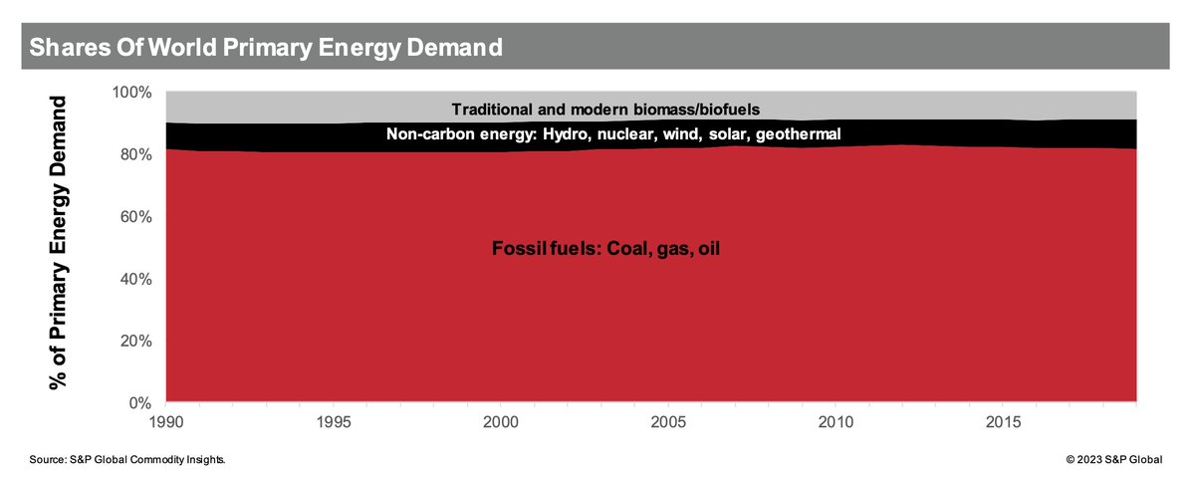

*FIG. 2. Evolution of the share of the world primary energy demand over the last decades [2]*

### Clean alternatives to natural gas

The paths for reducing heat-related emissions from industry involve either shifting to cleaner energy sources, capturing emissions, or minimizing the amount of energy needed. In all likelihood, all these solutions will be required in a complementary way. For what concerns the heat production sources, as illustrated in Fig. 3 from [1], a scalable decarbonized alternative to natural gas for industries might be found in: Biomass and biofuels, Electricity, Hydrogen, Nuclear heat.

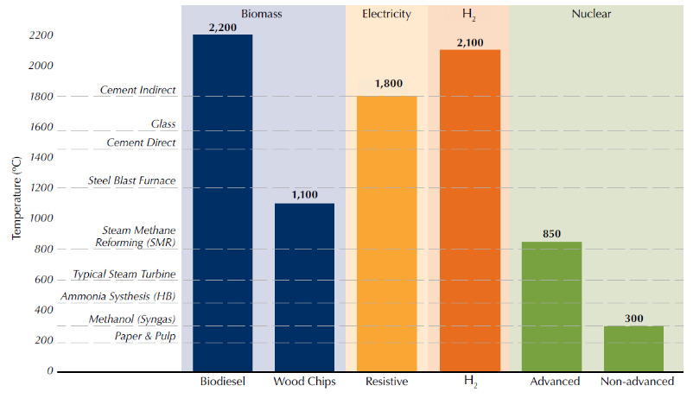

*FIG. 3. Temperature Requirements for some industry processes and capability of clean heat alternatives, from [1]*

Biomass and biofuels are no panacea to industrial issues due to their very large footprints relative to the heat output and to their potential use conflict between industry and agriculture or mobility sectors for instance. They cannot shoulder the whole heat paradigm shift by themselves. On the other hand, advanced nuclear sources, if adequately designed, might combine industrial heat delivery simultaneously through direct heat, H2 production and electricity, thus covering all other alternatives to fossil fuels for industries.

### The direct nuclear heat opportunity

If nuclear plants could be co-located with industrial facilities, they could provide enough heat for certain industrial processes, and some countries are even already utilizing nuclear energy for their industrial processes (Japan, Russia, China, etc.) [3]. Among the different nuclear technologies, the “non-advanced” nuclear in Fig. 3 refers to the current generation of light-water reactors, limited in their temperature level at 300°C (250°C regarding the heat delivery to the potential customer). They might be a good solution for low-grade heat services (paper mill, food industry, district heating…) if they are designed to provide a large amount of heat in addition to electricity production, which is rarely the case in practice. But heat generated by such reactors cannot achieve temperatures high enough for many industrial processes.

“Advanced” nuclear includes advanced technologies that will be able to generate heat at much higher temperatures, such as high temperature micro-reactors. The latter are nevertheless limited in terms of installed capacity, usually under 20 MW for each unit, which is not sufficient for heavy industries. Advanced nuclear also includes future technologies such as lead-cooled fast reactors or molten salt reactors. It is however commonly admitted that these plants have still feasibility issues and are largely in the early stages of development, years away from deployment. Hence, their commercialisation might be risky and incompatible with the industries net-zero roadmaps. In this clean energy ecosystem, the Sodium Fast Reactor technology appears as a good candidate as it benefits from a very high maturity (even at an industrial scale) compared to other advanced nuclear technology [4], and as it can be used for medium to high-temperature processes as described in the next section.

## Why a sodium fast reactor?

### A mature and credible technology

Sodium Fast Reactor technology is selected first of all because it is commonly admitted being the most mature advanced nuclear technology [4]. Indeed, it benefits from more than 400 cumulated years of operational feedback around the world. The French Phénix reactor demonstrated the qualification of MOX fuel and nuclear materials able to cope with the neutronic fast spectrum, but also the reliability of components during long-term operation with an high-temperature sodium environment. The French SuperPhénix reactor demonstrated the ability to build and operate SFR up to an industrial scale (1200 MWe), with an excellent availability (96% in 1996). More recently, the ASTRID project enabled to renew skills and expertise in the domains of design and safety as in the field of computational tools. This very valuable legacy makes the SFR the faster reactor that might be deployed industrially among the Generation IV technologies for several reasons: it is well known to safety authorities; fuel, clad and structures are already well qualified, etc. In addition, SFR creates far less waste than the current generation of nuclear plants, and need less cooling water (~-20% for electricity production) [5], which might be crucial in the next decades due to environmental issues. New designs are designed to be passive in incidental or accidental conditions, thanks to the good natural convection capabilities with liquid metals coolant, this is why future SFR designs might be qualified to be “walk-away safe”.

### Favorable technical specifications

Direct SFR heat can be delivered to an industrial customer up to 500°C. If supplemented by electric heating with self-produced electricity featured by an excellent efficiency (~42% of thermodynamic efficiency), SFR can address almost all industrial markets relying for now on natural gas for their heat supply. SFR is also featured by nice assets for H2 production thanks to its high primary temperature (cf. section 3.3).

### Optimized resources

Last but not least, SFR technology uses depleted uranium and PWR spent fuel as a fuel resource. Thus, the SFR choice avoids any dependency on the import or mining of uranium, and offers a strategic advantage in terms of sovereignty and sustainability, for countries as for industries. This enables the vendor to guarantee long term energy prices control for several decades. SFR also creates far less long-lived waste than the current generation of nuclear plants [5].

## HEXANA: an innovative SFR to decarbonize energy intensive industries

### A new French start-up

HEXANA is a new French start-up committed to the design and development of an innovative small modular sodium fast reactor. Its objective is to deal with the key challenges of the energy transition that are still poorly addressed today, mainly through the decarbonisation of the hard to abate energy intensive industries, as described in section 1.

As mentioned in section 2., the SFR technology has been chosen because of its favorable technical specifications for industrial end-user but above all because of the high technological readiness level and the high level of credibility that it offers for both industries and investors, and which results in a quite short time-to-deployment compared to other Gen-IV systems.

### General features and targets

The power of this Generation IV reactor is 400 MWth and the HEXANA system provides two twinned reactors associated with a thermal storage unit offering flexible power delivery in response to the needs of its customers (electricity and/or heat) for industrial process needs. It integrates design options offering high guarantees from the point of view of safety, relying in particular on passive safety devices. The design of the nuclear island is made modular, so that factory-building and transport on-site by sea or by river is possible, which is a key driver for competitiveness.

HEXANA is primarily targeting the energy-intensive and highly greenhouse gas-emitting industrial processes, with the combined production of heat and electricity, and of the bases for the production of hydrogen or synthetic fuels. The level of heat gives access to all the amenities needed to defossilize our economy: steam, hydrogen, CO2 capture, synthetic fuels, green steel, chemical molecules, fresh water by desalination, ammonia, fertilizers, etc.

### Breakthroughs and performances

If the main features of the SFR reactor are already proven technologies, HEXANA brings some major breakthroughs in the reactor design and in the use of nuclear energy in order to perfectly match with industrial needs (cf. Fig. 4).

1- The design is made modular thanks to, in particular, a compact vessel. This is crucial for competitive issues and this enables to twin two modules on site efficiently so that the energy delivery is continuous;

2- It includes heat storage tanks to ensure a high flexibility of the heat delivery, and a strong decoupling between the operation of the nuclear island and the power conversion system. The nuclear island is working on a base-load mode, increasing its plant capacity and reliability, its lifetime and, as a consequence, its revenue;

3- The whole concept is not built in a full electrical paradigm, neither in a small hybridisation prospect for which a small amount of heat is extracted from a Power Conversion System optimized for electricity production. Conversely, it is designed in an integrated way so that the industrial end-user is fed with the right balance of electricity and heat, and heat at the right temperature(s) level(s). In other words, HEXANA ambition is to become a taylor-made solution to guarantee an optimized energy delivery as an efficient substitute to fossil fuels.

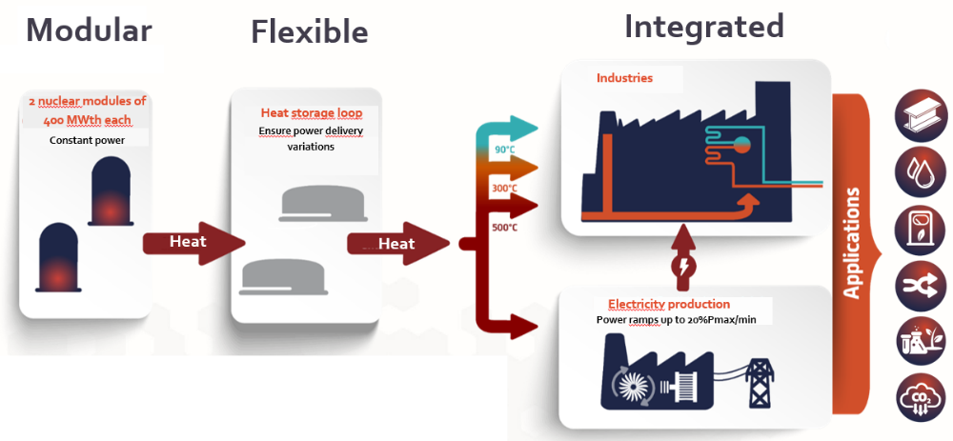

*FIG. 4. Schematic general principles of the HEXANA design*

If optimized for the hydrogen production, this approach results in the production of 200 tons of H2 per day for a twinned configuration. When compared to H2 production with a PWR featured by the same core power and the same thermal coupling possibilities between the reactor and the Solid Oxide Electrolyzer Cell (SOEC), HEXANA produces 25% more H2 than the PWR. This value reaches +50% if thermal coupling cannot be achieved with the PWR.

## Preliminary design of the conventional island (power conversion and heat storage)

The power conversion system for electricity generation is a superheated steam Rankine cycle for reasons of technological maturity and implementation, in relation to the molten salt/water steam generator already used in Concentrated Solar Power plants. As represented in figure 5, this energy conversion cycle uses a phase separator between the two high-pressure and low-pressure turbines to maintain turbine output steam quality above 0.85. Two feedwater heaters (regenerators) preheat the feedwater leaving the condenser using steam extracted from the turbine before entering the steam generator.

A steady-state model of the Balance of Plant (BOP) was developed in THERMOPTIM [6] together with a simplified model of the steam power conversion system. This model allowed us to perform parametric studies and sensitivity analysis for a nominal operation of the steam generator output at 800 MWth (two reactor modules being coupled). The optimization of the preheaters was carried out by determining the optimum parameters for the turbine bleed ratio and pressures to maximize the overall thermal efficiency of the cycle at nominal operation. The gross thermodynamic efficiency of this Rankine cycle reaches 43.9% if it is dedicated to electricity production.

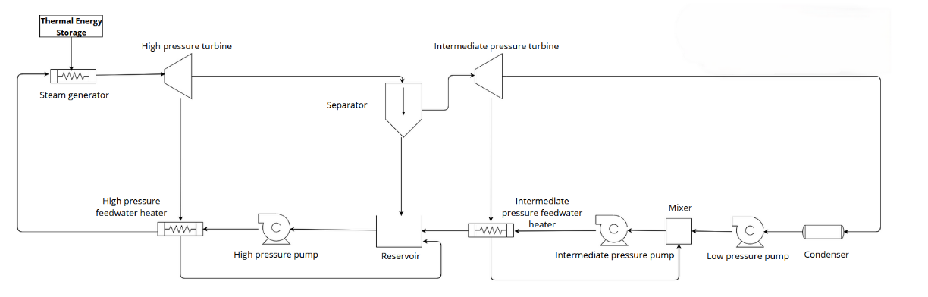

*FIG. 5. General architecture of the Power Conversion System of HEXANA*

### Cogenerating Power Conversion System design approach

The case study considers an industrial plant with heat requirement. For the postulated heat demand, two different temperatures are required for a total of 30 MWth. Various thermodynamic designs can meet the heat requirement. One approach is an energy-efficient design where a small amount of steam is extracted from the turbine at the necessary temperatures. In fact, these extraction temperatures are higher than those needed to maintain a realistic pinch point in the heat exchangers. Although this design offers the highest efficiency, the turbine casing design must be modified and the variation in heat supply will impact the turbo generator set. This approach results in a net electrical output that is 10 MWe lower than the cycle without the 30 MWth heat supply. An opposite design was also studied. The objective of this design is to minimize the impact of heat extraction on the turbo generator set. To achieve this, the heat is extracted before the high-pressure turbine, at the steam generator output, which results in reducing the cycle efficiency. Several intermediate alternative designs were also explored to balance efficiency and impact on turbine generator set. These results are detailed in figure 6. Therefore, the choice of architecture must strike a balance between cost and technological feasibility.

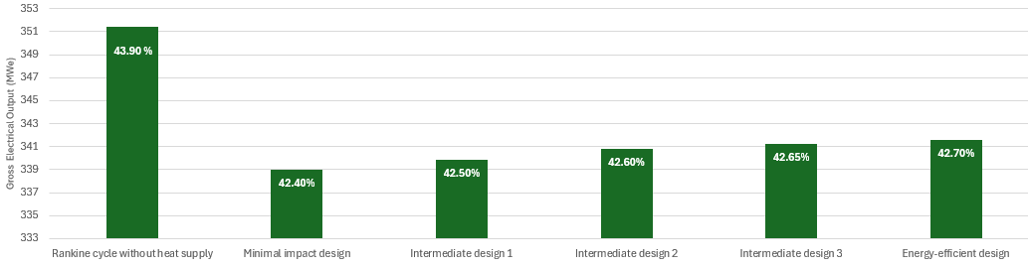

*FIG. 6. Gross electrical output for each thermodynamic cycle design*

### Heat storage design and strategy

The Thermal Energy Storage System (TES) is a two-tank molten salt design consisting of a hot tank at 500°C and a cold tank at 300°C, driven by two pumps. The primary function of the hot tank is to collect and store the thermal energy generated by the sodium fast reactor, which is then used to drive the steam cycle. After transferring its heat energy, the molten salt is returned to the cold tank. From there, the cooler salt is pumped back into the sodium/salt heat exchanger to be reheated and reused in the cycle.

A key feature of this system is the constant mass flow of molten salt from the cold tank to the hot tank through the sodium/salt heat exchanger. Conversely, the flow rate of molten salt from the hot tank to the cold tank through the steam generator is adjustable and varies according to energy demand. This variability allows the system to efficiently match energy output to current consumption needs, improving overall responsiveness.

In the following section we look at generic load data variations for industrial power and heat demand over the course of a year ($±$ 20% of nominal power). Two strategies are examined depending on the electrical demand and the load following capability of the TES with the lowest thermal efficiency corresponding to the minimal impact design define at the previous section. The methodology we use here is adaptable to different markets and allows for the sizing and tailoring of storage tanks for cogeneration applications.

**Buffer approach**

The TES can be used as a buffer to delay the import or the export of power to or from the grid. To delay the import or the export on the grid for one hour the TES must be dimensioned for the largest power difference in demand for one hour (60 MWe). In this case the required volume of molten salt in each tank are approximately 1000 m³, so with a 10% margin, the tanks have typically a diameter of 12.8m and a height of 8.5m. The following picture (Fig. 7) shows the typical thermal demand for electricity and heat supply and thermal power production over a 10-day period.

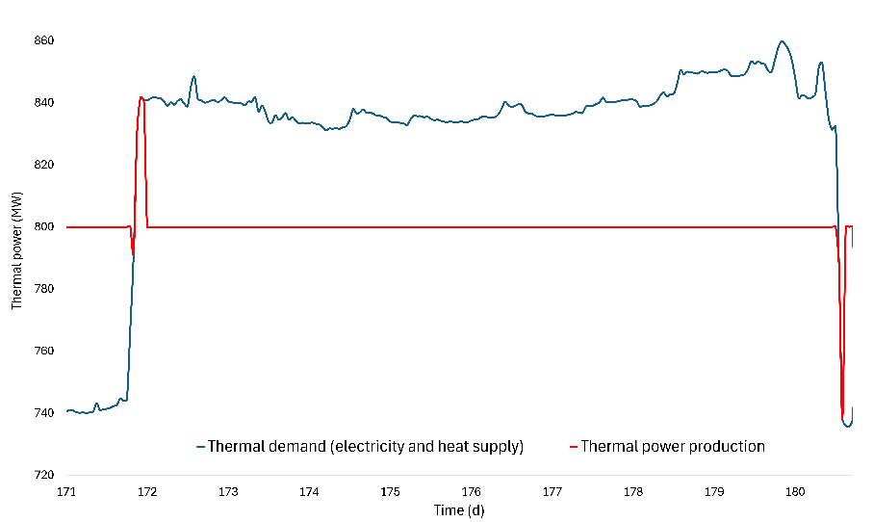

*FIG. 7. Power demand and production when considering a buffer approach for the heat storage design*

**Load following approach**

The TES can also be used to follow the demand in electricity of the industrial and minimize the import and export link to and from the grid. In this case, the tanks are dimensioned to allow some process stops (-45 MWe) during 30h without export to the grid. To increase the off-grid time, the number of tank pairs could be increased. With two tank pairs of 16000 m³ with 10% margin (typically 21m height and 31m diameter), the postulated industrial plant could be off grid for 22.5% of the year. The figure 8 illustrates the response of the power conversion system to demand over a 10-day period. While the system can generally follow the demand profile, it struggles to maintain boost for the entire peak (zone 1), resulting in some unmet demand and partial load following depending on the size of the storage. When demand falls below the rated capacity, the system enters a charging state (zone 3). Once the thermal energy storage is full, the system shifts to a steady state thermal output (zone 2), resulting in significant overproduction of power that cannot be used or stored. It is important to note that electricity production is tied to heat supply, which explains the slight fluctuations in electricity production despite the more stable electricity demand in zone 2. In fact, the thermal power exchange at the steam generator is at the 800 MWth nominal power along zone 2 as shown in figure 9.

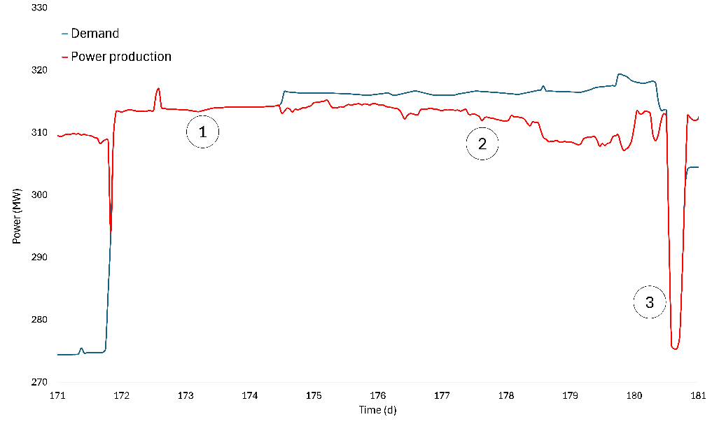

*FIG. 8. Power demand and production when considering a load following approach for the heat storage design*

*FIG. 9. Thermal power demand and production when considering a buffer approach for the heat storage design*

A balance must be found between the economic benefits of the purchase/resale of electricity on the grid and the investment in storage infrastructure, as well as the goal of operating independently from the grid. Each scenario requires careful analysis to determine the most suitable compromise for different industrial targets.

## Conclusions

HEXANA is a new French start-up committed to the design and development of an innovative small modular sodium fast reactor. The Sodium Fast Reactor technology has been chosen because of its favorable technical specifications for industrial end-user, but above all because of the high technological readiness level and credibility which results in a quite short time-to-deployment compared to other Gen-IV systems. A special effort is made in the design of HEXANA so that it matches very well the industrial needs for clean energy:

* The offer is compatible and optimized for industrial hubs demand (relevant size and power, limited footprint, continuous energy delivery thanks to twinning, tailor-made energy production…);
* It enables to effectively meet ambitious climate and environmental targets (high efficiency, less need for water, ultra-low carbon energy < 3gCO2/kWh [5], less waste than conventional nuclear…)
* It is reliable, predictable and price-guaranteed on several decades (independent from mining, imports or geopolitical instabilities, very flexible thanks to heat storage…);
* It eases the integration of renewables onsite (accommodation of intermittency thanks to storage, absorption of extra-energy…). In other words, in addition to its maturity and technical relevancy for industries, HEXANA can play the role of an industrial hub energy stabilizer without significant grid reinforcement measures.

Several design architecture are studied and optimized for what concerns the power conversion system and the heat storage facility, so that the power production perfectly matches with future industrial end-users needs. This taylor-made oriented design strategy is one of the keys for competitiveness for advanced reactors as proposed by HEXANA.

References

1. Doug Vine and Chris Henderson, *A clean heat pathways for industrial decarbonization*, Center for Climate and Energy Solutions, August 2021.
2. Source : S&P Global Commodity insights
3. *Opportunities for Cogeneration with Nuclear Energy*, IAEA Nuclear Energy Series No. NP-T-4.1, International Atomic Energy Agency, Vienna, 2017
4. AIEA Website: <https://www.iaea.org/topics/fast-reactors#:~:text=The%20most%20mature%20fast%20reactor,countries%2C%20including%20China%2C%20France%2C>
5. Serp, J.; Poinssot, C.; Bourg, S. *Assessment of the Anticipated Environmental Footprint of Future Nuclear Energy Systems. Evidence of the Beneficial Effect of Extensive Recycling*. Energies 2017, 10, 1445. <https://doi.org/10.3390/en10091445>
6. <https://direns.mines-paristech.fr/Sites/Thopt/en/co/_Arborescence_web.html>