# Experiment and Modelling Efforts to

# Support Development and Deployment

# of Advanced Energy Systems

PIYUSH SABHARWALL

Idaho National Laboratory

Idaho Falls, ID, USA

Email: Piyush.Sabharwall@inl.gov

MAURICIO TANO

Idaho National Laboratory

Idaho Falls, ID, USA

GEORGE MESINA

Idaho National Laboratory

Idaho Falls, ID, USA

YOUSSEF BALLOUT

Idaho National Laboratory

Idaho Falls, ID, USA

**Abstract**

Advanced energy systems are the next generation of energy systems with self-control and monitoring attributes along with passive safety measures that are being designed and developed across the globe. Self-control of primary processes refers to the inherent safety of the reactor, whereas passive safety features are vital for operations where a strong deviation of normal process behavior occurs. Currently, many modelling and experimental efforts are being developed and supported under various United States (U.S.) Department of Energy (DOE) programs to offer verification and validation assistance for these novel systems. However, both of these efforts need to be synergized to ensure a successful accelerated deployment. This article provides an overview on the test beds being designed and developed along with the Modelling efforts in the Multiphysics Object-Oriented Simulation Environment (MOOSE) that support the multiphysics Modelling and simulations (i.e., neutronics, thermal-hydraulics, thermomechanics, and thermochemistry) of advanced nuclear reactors for engineering design, safety studies, licensing, and operational support. The experiments being designed and carried out will support technology maturation, and reduce uncertainty and risk associated with the design, operation, and deployment of next generation energy systems, such as small modular reactors and microreactors.

*Keywords*: Thermal-Hydraulics, Experiments, Test Beds, MOOSE, Multiscale Modelling, and Validation

## INTRODUCTION

In early 2000, the United States (U.S.) Department of Energy (DOE) initiated the International Forum on Generation IV Reactors, which focused on six system designs using gas, water, molten salt, and liquid metal as respective coolants. The key attributes that Generation IV reactors were targeting was to provide more robust safety and reliability, higher proliferation resistance, and economic competitiveness, as well as establishing strong sustainable energy development. Today, these systems are being looked at further on a small modular reactor (300 MWe or less) and microreactor (50 MWe or less) scale with test bed development and enhancement in Modelling capabilities where verification and validation development needs can be ascertained all while reducing uncertainties.

This study provides a summary of selected experimental capabilities being developed to support the experimental testing and demonstration of technology in support of advanced energy systems. To ensure successful ongoing accelerated deployment efforts, DOE works closely with vendors and the U.S. Nuclear Regulatory Commission (NRC) to develop capabilities to demonstrate concept feasibility through experimental testing and is supporting programs for the development and validation of high-fidelity Modelling tools.

Major experimental capabilities include the Single Primary Heat Extraction and Removal Emulator (SPHERE) and the Microreactor Agile Non-nuclear Experimental Test Bed (MAGNET). The SPHERE facility allows for controlled testing of steady-state and transient heat-rejection capabilities for a single heat pipe using electrical heaters that simulate heating processes due to nuclear fission. The facility is capable of monitoring axial temperature profiles along the heat pipe and surrounding test articles during startup, steady-state operation, and transient conditions [1]. Instrumentation in the facility includes non-contact infrared thermal imaging, surface thermocouples, spatially distributed fiber-optic temperature and strain sensors, electrical power meters, and a water-cooled, gas-gap calorimeter for quantifying heat rejection from the heat pipe. The facility can be operated under both vacuum and inert-gas conditions. In addition, an in-operando heat pipe operation capability with x-ray imaging was recently added to further understand heat pipe dynamics. Fig. 1 shows a schematic of the SPHERE test facility, while Table 1 provides general information about the facility and operating conditions and constraints, respectively.

FIG. 1. SPHERE test bed schematic.

TABLE 1. SPHERE test bed design specification.

|  |  |
| --- | --- |
| Parameter | Value |
| Length | 10 ft |
| Diameter | 12 in |
| Tube Material | Stainless steel |
| Connections | Flanged for gas flow and instrumentation feedthrough |
| Maximum Power | 20 kW |
| Maximum Temperature | 900 C |
| Heat Removal | Passive radiation or water-cooled gas-gap calorimeter |

The MAGNET facility is a large-scale 250-kW electrically heated microreactor test bed that enables non-nuclear experimental evaluation for a variety of microreactor concepts. It can be supplied to electrically heat a scaled section of a microreactor and further test the capabilities of heat-rejection systems. The initial MAGNET experiments will support technology maturation, and reduce uncertainty and risk associated with the design, operation, and deployment of monolithic heat-pipe-based reactors. However, this test bed can be applied broadly to multiple microreactor concepts to evaluate a wide range of thermal-hydraulic and structural phenomena, such as interface-coupling with power-conversion units (PCUs) and other co-located systems. MAGNET is co-located with the Thermal Energy Distribution System (TEDS), which is a packed bed 200-kW energy storage system and 20-kW high-temperature steam electrolysis (HTSE) system that can be coupled to understand integrated system dynamics. Within MAGNET, systems and components can be safely tested, providing valuable information regarding failure modes, operating regimes, and thresholds [2]. The goal is to provide a test bed that is broadly applicable to multiple concepts. Various types of advanced energy systems are being proposed, and these can be classified according to their core-cooling method. Each reactor type poses a different set of design and operational challenges. The initial set of tests to be performed in MAGNET are targeted towards demonstrating the feasibility and performance of these reactors systems. Idaho National Laboratory (INL) is partnering with Los Alamos National Laboratory (LANL) and Oak Ridge National Laboratory (ORNL) to meet the required development of the testing and instrumentation needs. A graphic of the MAGNET environmental chamber is shown in Fig. 2. MAGNET design specifications are shown in Table 2.

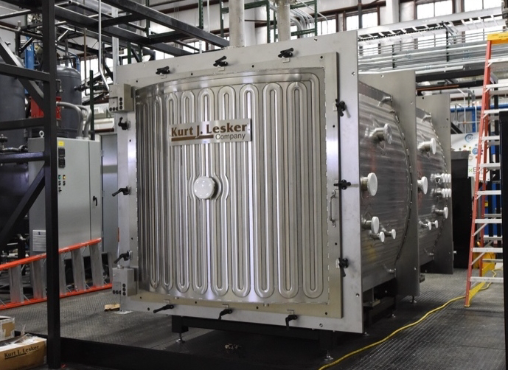

FIG. 2. MAGNET environmental enclosure.

TABLE 2. MAGNET test bed design specification.

|  |  |
| --- | --- |
| Parameter | Value |
| Chamber Size | 5 ft × 5 ft × 10 ft |
| Heat Removal | Liquid-cooled chamber walls, gas flow |
| Coolants | Air, inert gas (He, N2) |
| Gas Flow Rates | Up to 43.7 ACFM at 290 psig |
| Design Pressure | 22 barg |
| Maximum Power | 250 kW |
| Max Temperature | 750 C |
| Heat Removal | Passive radiation or water-cooled gas-gap calorimeter |

To provide capabilities for integrated PCU testing, a modified, commercially available Capstone C30 microturbine unit [3], as depicted in Fig. 3, has been acquired and will be integrated with MAGNET. Fig. 3 shows the key PCU components, including the compressor, turbine, alternator, internal recuperator, gas cooler, and power management and distribution (PMAD) subsystem [2]. Generated power can be fed to the electrical heaters in MAGNET to supplement externally supplied electricity or to a load bank as part of the co-located Microgrid Research Laboratory. The cycle is completely closed, and gas flows through the compressor and recuperator into the heat-source heat exchanger, into the turbine, back into the recuperator, and finally into the gas cooler for the rejection of waste heat.

FIG. 3. Layout of PCU loop connected to MAGNET.

Other test beds, as indicated in Fig. 4, at INL that are currently being designed and developed include:

* Demonstration of Operational Microreactor Experiments (DOME), which will support testing up to 20MWt
* Transient Reactor Test (TREAT) Microreactor Experiment Cell (T-REXC) test bed, which will support testing up to 100kWt
* Laboratory for Operation and Testing in the United States (LOTUS), which will support testing up to 500kWt.

FIG. 4. Advanced reactor demonstration test beds at the Materials and Fuels Complex (MFC) at INL.

## Modelling and Simulation Supporting Development and Deployment of Advanced Energy Systems

Modelling and simulation can serve to provide relevant insights from design to experimental data analysis throughout an entire experimental procedure. Most of the modelling and simulation efforts for advanced nuclear reactors at INL are associated with DOE’s Nuclear Energy Advanced Modelling and Simulation (NEAMS) program [4]. The mission of this program is to develop modelling and simulation tools for advanced nuclear reactors. The program encompasses five technical areas, namely fuel performance, reactor physics, structural materials and chemistry, thermal fluids, and materials and chemistry. Some of the tools developed under these technical areas and the scale to which they apply are shown in Fig. 5.

FIG. 5. Main NEAMS tools schematic chart for advanced nuclear reactor modelling and simulation support.

Griffin is the multi-fidelity reactor physics tool providing radiation transport solutions from lower fidelity diffusion methods to higher fidelity transport solutions. BISON is the fuel performance code that solves tightly coupled tensorial formulations of solid mechanics and heat transfer. Thermochimica is the thermochemistry application that solves for equilibrium thermodynamics to identify material property evolution under the fuel’s isotopic evolution and corrosion. Finally, due to the multiple scales involved in thermohydraulic phenomena in nuclear reactors, three applications support thermohydraulic Modelling: (1) Nek5000/nekRS, (2) Pronghorn, and (3) the Systems Analysis Module (SAM).

Nek5000 and nekRS—its new version supporting graphics processing units (GPUs)—are direct numerical simulation tools. They solve the Navier-Stokes and heat transfer equations up to the Kolmogorov scale without any approximations. In addition, large-eddy simulation capabilities have more recently been added to the Nek codes to support lower fidelity modelling.

Pronghorn is an engineering-scale thermal-hydraulics tool. Using a porous media formulation, Pronghorn allows multi-dimensional solving of thermal-hydraulic phenomena in nuclear reactor cores without the need to fully resolve the flow field down to the smallest scale. Pronghorn supports either Reynolds Average Navier-Stokes (RANS) formulations for modelling free flow to coarse-mesh porous media flow with dedicated friction and heat exchange coefficients for faster computations. A procedure called high-to-low has been developed to automatically tune closure models in Pronghorn from higher fidelity simulations.

SAM is the systems code for plant-scale simulation. Typically, in reactor analyses, the system model in SAM is coupled to a higher fidelity Pronghorn core model to capture the engineering-scale thermal-hydraulics at the core. For this purpose, a domain overlapping approach has been developed to seamlessly couple the system model in SAM to the higher fidelity model in Pronghorn. This coupling enables realistic studies of plant transients.

The NEAMS tools integrate two main components. The first is a method for solving the partial differential equations associated with the fluid phenomena (e.g., a finite volume solver for the Navier-Stokes equations). The second is a set of closure models adapted to a reactor configuration, such as the Kerntechnischer Ausschuss (KTA) correlations for modelling bulk friction in a pebble bed. While the latter models are proprietary and require access approval to the specific codes, the physics solvers are developed as open source, which allows the physics models to benefit from feedback from the larger user community, and thus, to be continuously improved. The open-source bases for the Pronghorn and SAM thermal-hydraulic codes are the models within the Multiphysics Object-Oriented Simulation Environment (MOOSE). In particular, the Navier-Stokes module, the subchannel module, and the thermal-hydraulics module form the physical basis for these NEAMS codes. Table 3 shows the scale, flow formulation, dimensions and typical number of elements, runtime, and simulation time of these modules [5].

TABLE 3. Open-source MOOSE modules that support the NEAMS thermal-hydraulics simulation tools.

|  |  |  |  |  |  |  |
| --- | --- | --- | --- | --- | --- | --- |
| Module | Scale | Flow Formulation | Dimension | Element Count | Typical Runtime | Typical Simulations |
| Navier-Stokes Module | Coarse-Mesh CFD  RANS-CFD Simulations | * Incompressible,   weakly compressible  or fully compressible   * 1- or multi-phase * 1- or multi-component flow | * Typically, 2D axisymmetricor 3D * Usable in 1D | 10,000 typically | 1 minute | * Flow through nuclear reactor core or plena * 3D multi-phase flow in pipes * Natural convection flow in open cavities |
| Subchannel Module | Subchannel Scale | * Incompressible or weakly compressible * Single-phase * Single- or multi-component flow | Typically, 3D  Can be used in 1D and 2D | 100,000 typically | 10 seconds | * Flow development, blockage, and natural convection cooling of nuclear reactor fuel assembly |
| Thermal-Hydraulics Module | Lumped-Parameters Simulations | * Compressible * Single-phase * Single-component flow | 1D, 0D | 100 typically | 10 seconds | * Heat extraction unit from reactor core; Thermal loops with compressibility effects |

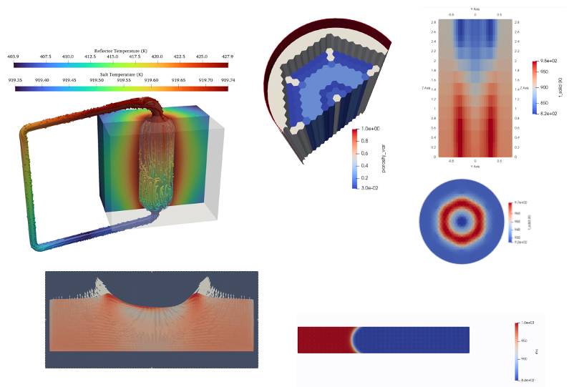

Flow with conjugated heat transfer in a pool-type molten salt reactor.

Porous media flow in high-temperature gas-cooled reactor core.

Lagrangian-Eulerian formulation model of melt pool during laser welding.

Two-phase model of permeation of molten salt flow into a graphite channel.

FIG. 6. Application examples of the Navier-Stokes Module.

Four characteristic application examples of the Navier-Stokes module are shown in Fig. 6. The Navier-Stokes module uses either a streamwise Pretrov-Galerkin-stabilized finite element discretization, which is mostly used for compressible flows, or a finite volume discretization, which is mostly used for incompressible and weakly compressible flows. For turbulence Modelling, the code supports standard RANS closures, such as the k-ϵ model. Software quality assurance of the code is based on hundreds of verification cases ensuring proper code convergence and non-regression, as well as a growing base of validation cases on canonical flow experiments from the European Research Community on Flow, Turbulence and Combustion (ERCOFTAC) database.

The subchannel module is applicable to water, liquid metal, or gas flows in reactor assemblies. This code solves the conservation equations for mass, momentum, and energy in a subchannel discretization. The code supports solutions for incompressible or weakly compressible flows with one or multiple components. The quality assurance of the code is based on hundreds of non-regression tests, while the validation of the code currently includes 41 validation cases involving six experimental facilities and the Experimental Breeder Reactor II (EBR‑II). An example of the code validation for the EBR-II shutdown and heat removal tests (SHRT) 17 and 45‑R is shown in Fig. 7.

|  |  |  |
| --- | --- | --- |
|  |  |  |

FIG. 7. Example of application and validation of the subchannel code for the SHRT in EBR-II. Left: Subchannel model of the XX09 assembly. Center: Validation of the outlet temperature profile for transient SHRT-17. Right: Validation of the outlet temperature profile for transient SHRT-45-R.

The thermal-hydraulics module solves for fully compressible, single-phase flow and uses the reconstructed discontinuous Galerkin method for discretization. The code integrates a modern component syntax that makes it easy to build system-level analyses. Closure correlations are available for laminar and turbulent flows. Quality assurance of the code is based on hundreds of regression tests, and the code has been validated against analytical solutions and experimental data.

Pronghorn is the primary reactor thermal-hydraulics engineering tool based on open-source modules. Pronghorn has been used to model the thermohydraulic phenomena in molten salt reactors, high-temperature reactors, both gas- and fluoride-cooled, and liquid-metal-cooled reactors. Many of the models developed are openly available on the National Reactor Innovation Center (NRIC)-NEAMS virtual test bed.

Current collaborative efforts either are planned or underway to increase the validation base of Pronghorn and other NEAMS thermal-hydraulics tools on DOE-funded experimental efforts. For example, the weakly compressible formulation for high-pressure, high-temperature helium flows over typical reactor components is a planned joint validation effort with the DOE Microreactor Program. In addition, validation of heat pipe Modelling tools is an ongoing joint effort between NEAMS and the DOE Microreactor Program.

A project is underway to couple MOOSE with the premier nuclear power plant safety code, the Reactor Excursion and Leak Analysis Program with 3D capabilities (RELAP5-3D) [6]. The combination will provide the nuclear industry with extraordinary new capabilities to analyse both existing and advanced reactors because INL has continuously adapted the code to support systems analysis of advanced nuclear reactors, while maintaining the ability to analyse the existing fleet on reactors. RELAP5-3D currently supports most of the proposed coolants for advanced nuclear reactors, including liquid metals, molten salts, and pressurized noble gases, among others. Because the code is verified, validated [7], and has a pedigree of billions of plant modelling runs by users all around the world, including fixes for over a thousand user trouble reports from four decades of use, the code is routinely used by utilities, training simulator companies, universities, national laboratories, and advanced reactor vendors for the calculation of reactor operating transients, safety cases, and aiding the design of new reactors.

Commercial Grade Dedications (CGD) of RELAP5-3D are used throughout the industry to create proprietary versions that are subsequently used for licensing submittals to the US Nuclear Regulatory Commission. Private companies have done for advanced reactor projects including mPower, NuScale, and CGD is underway for both the TerraPower Molten Chloride and Natrium reactors. It is also used in the design stage of new advanced reactors. For DOE, the code has been used for the integral design of the Microreactor Applications Research Validation and Evaluation (MARVEL) reactor potentially to be built at INL in the near future. Model validation is underway for the non-nuclear, electrically heated flow test mock-up of the MARVEL reactor, called the Primary Coolant Apparatus Test (PCAT). Currently HOLTEC and Pathfinder are using RELAP5-3D to develop their new advanced reactor designs under CRADA and GAIN vouchers.

And once these new reactors are built and deployed, there is need to train operators. RELAP5-3D has been adapted to serve as the thermal-hydraulic engine of many nuclear power plant training simulators and simulator companies are gearing up to do the same for emerging advanced reactors.

Recently, a consortium of INL, Naval Nuclear Laboratories (NNL), and Information Systems Laboratories (ISL) has formed to combine the advances made at the laboratories into a single code version with all the advantages of each separate version. This includes upgrades to the programming language, programming guidelines, version control method, manuals, expansion of the verification and validation for advanced reactors, and a vast expansion of dedicated analysts and developers. This version is being developed in conjunction with the effort to couple RELAP5 to MOOSE, when compiled together, through direct memory access for the fastest and most sure binding, while allowing both codes to continue to develop and run independently as well.

Once this new consortium code version is available and capable of being coupled with MOOSE, it will be capable of doing anything that RELAP-7 or RELAP5-3D can do, couple natively with MOOSE, and visualize its calculations in whole new and powerful ways.

## CONCLUSIONS

The current work provides a summary of selected experimental capabilities being developed to support advanced energy systems enabling the deployment of novel concepts. Additionally, a selection of Modelling approaches also was discussed that can support these experimental capabilities. The content represents ongoing efforts enabling accelerated development and demonstration of advanced energy systems.

## REFERENCES

1. SABHARWALL, P., et al., “SPHERE Assembly and Operation Demonstration,” INL/EXT-20-60782, Idaho National Laboratory, Idaho Falls, ID, USA (2020).
2. SABHARWALL, P., et al., “Nonnuclear experimental capabilities to support design, development and demonstration of microreactors,” *Nucl. Technol.* 209(1), special issue on the U.S. Department of Energy Microreactor Program (2023) S41–S59.
3. CAPSTONE GREEN ENERGY CORPORATION. “C30” website. Available at: <https://www.capstonegreenenergy.com/products/energy-conversion-products/capstonemicroturbines/c30> (last accessed June 28, 2021).
4. STANEK, C. R., “Overview of DOE-NE NEAMS Program,” LA-UR-19-22247, Los Alamos National Laboratory, Los Alamos, NM, USA (2019).
5. LINDSAY, A., et al., “MOOSE Navier–Stokes module,” *SoftwareX*, 23 (2023) 101503.
6. The RELAP5 Team Code Development Team, RELAP5-3D© Code Manual Vols. I and IV, Revision 4.5, INL/MIS-15-36723, Oct. 2023.
7. The RELAP5 Team Code Development Team, RELAP5-3D© Code Manual Vols. III, Revision 4.5, INL/MIS-15-36723, Oct. 2023.