# Italy’s Journey into Small Modular Reactors: Research, Safety Assessment, Testing, and Future Prospects

M. CARAMELLO, M. FRIGNANI

Ansaldo Nucleare SpA

Genova, Italy

Email: [marco.caramello@ann.ansaldoenergia.com](mailto:marco.caramello@ann.ansaldoenergia.com)

W. AMBROSINI

Pisa University

Pisa, Italy

G. CARUSO

Rome University

Roma, Italy

M. RICOTTI

Polytechnic of Milan

Milano, Italy

F. MASCARI, F. ROCCHI, C. LOMBARDO, M. POLIDORI, G. GRASSO, F. LODI, M. TARANTINO

ENEA

Bologna, Italy

A. PETRUZZI

NINE Engineering

Lucca, Italy

A. ACHILLI, R. FERRI, C. RANDACCIO, M.T. CAUZZI, A. BERSANO

SIET SpA

Piacenza, Italy

**Abstract**

Italy’s interest and involvement in Small Modular Reactors (SMR) and Advanced Modular Reactors (AMR) technologies dates back to almost two decades ago and had a notable surge in recent years. As a nation investigating the possibility of restarting a nuclear program, Italy has recognized the potential of innovative nuclear technologies to contribute to its energy security and sustainability goals, and to diversify its portfolio of low carbon resources. This article explores Italy’s engagement in SMRs and AMRs, spanning from design activities, numerical studies, safety assessment and testing endeavors. In particular, recent efforts within the context of design, thermal-hydraulics, safety and licensing are reported. Worth mentioning, the Italian nuclear sector leverages a collaborative effort between academic institutions, research organizations, and industry stakeholders. By providing a comprehensive overview of Italy’s involvement in forthcoming nuclear technologies, this article aims at contributing to the global discourse on nuclear energy innovation and its role in addressing contemporary energy challenges.

## INTRODUCTION

From the early use of nuclear power, Italy is one of those countries developing a domestic atomic market. The choice to build plants belonging to all the technologies available since the post-war period favored horizontal technical and scientific broadening, helping the formation of diversified skills along the entire value chain. The 1987 referendum forced Italian companies and research centers to enlarge towards international collaborations and activities, keeping some of the key skills of the industry active, supported by an academic panorama that continued to deliver courses of excellence on the subject. Over the past 20 years, the Italian system has continued to work at the forefront of nuclear technology, including research and development studies on SMR technologies. In this paper, we report some recent relevant experiences taken from the worlds of academia, research centers and industrial realities of the country.

## DESIGN AND MANUFACTURING

### Reactor Design

Italy is one of the first countries that has investigated the adoption of economically-sound small-sized reactors by exploiting plant simplifications, modularity and significant use of passive safety systems. One of the first studies was the ISIS project in the 1990s and involved an integrated reactor module of around 200 MWel with helical coil steam generators inside the main pressure vessel and external pressurizer [1]. Several reactor modules were then immersed in a pool of water. Initial plant conceptualization and studies were performed by Ansaldo Nucleare. In the same years, promoted by the University of Rome, the MARS concept was developed, which envisaged a single loop reactor equipped with plant simplifications including passive systems and reduced component size [2]. It was also one of the first plants focusing on decommissioning since early design. Several experimental plants aimed at testing systems and components were built and operated around MARS concept. More recently, the IRIS project was developed [3] which featured a 335 MWel fully integrated reactor with helical coil steam generators and optimized containment size. It has been a collaborative project in which the Italian research and industrial fabric operated together with Westinghouse Electric Company and other European research bodies. The plant was aimed also for process heat and desalination. From the point of view of water-cooled SMRs, these experiences allowed the Italian nuclear system to maintain the necessary know-how and know-why which has recently allowed the opening of international collaborations with various vendors who are now competing to develop the latest generation of SMRs.

|  |  |  |
| --- | --- | --- |
|  |  | Small Modular Reactors – Nuclear Reactors Group |
| Figure 1. ISIS Reactor | Figure 2. MARS Reactor | Figure 3. IRIS Reactor |

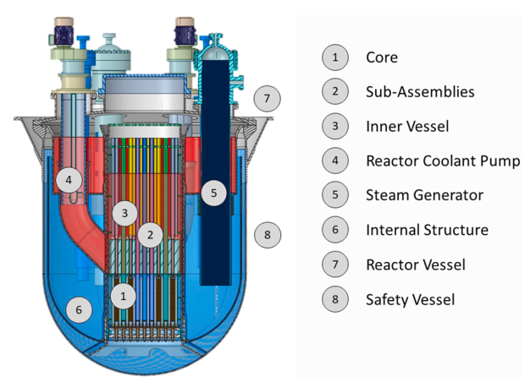

Figure 4. ALFRED Reactor

Developing compact plants with significant use of passive safety systems also covers fast reactor concepts, the most important example of which is ALFRED [4]. It is a 125 MWel lead-cooled fast spectrum reactor, distinctive for being the European technology demonstrator. It is designed by Ansaldo Nucleare in collaboration with ENEA and RATEN ICN within the FALCON consortium. The use of lead as a primary coolant promises to achieve safety levels equal to or higher than current technologies at competitive costs.

### Supply Chain

The Italian nuclear industry is born from several national programs which from the early 1960s to the first half of the 1980s favoured a context of growth covering of all key skills spanning between the fuel cycle, engineering and manufacturing of safety related components and erection of complex thermal process and electrical distribution systems. During the oil crisis in 1970s, the Italian national plan envisaged the construction of over 20 power reactors based on indigenous technology. Following the 1987 referendum, the national market suffered a contraction, where many companies in the sector needed to diversify or changed their operating sector. The industrial companies that continued their business within the nuclear sector have diversified their reference markets or focused on specific markets within which they could guarantee economic balance through the simultaneous presence on the national frame and the foreign one. It is not the purpose of this paper to detail the value chain of the Italian nuclear industry throughout history. However, by way of example, we reference the activities carried out on passive safety systems for the removal of decay heat, the studies on sodium and lead fast reactors with the contribution to the Superphoenix reactor construction in France [5] and the establishment of a national research infrastructure on lead fast reactors [6]. Still at national level, efforts are currently being made on the decommissioning of legacy nuclear sites including NPPs and design and future construction of DTT fusion research plant in [7].

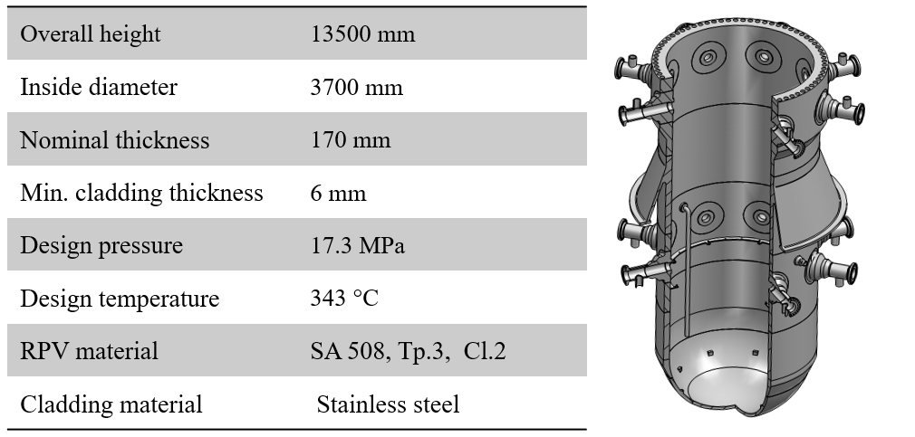

Figure 5. RPV Manufacturing case study main data

Several studies have been carried out over the last 20 years monitoring the Italian supply chain status both in conjunction with possible new national developments in atomic energy and in the context of fusion. In particular, the latter allowed new manufacturing companies within the national nuclear context, encouraging the growth of skills, innovation and the quality characteristics of Big Nuclear Science projects [8]. The resulting picture represents a country where key design skills and relevant manufacturing capability have been maintained over the years, with an actor pool of more than 50 private companies, research centers and universities. The advent of potential SMR development in the European field has recently been a case to test Italian manufacturing capacity with a study promoted by the Polytechnic of Milan and focused on the production capacity of a prototypical Reactor Pressure Vessel for SMRs (see Figure 5). Results suggest how the overall capacity of the Italian supply chain can support the annual production of approximately 8 RPVs per year [9].

## RESEARCH AND DEVELOPMENT

In support of the industrial initiatives, efforts are carried out by public and private research centres for the qualification and validation of systems, components and materials for direct application on SMR and AMR reactors. On water cooled reactor technology the main activities refer to the validation of passive safety features in transient operation, while material studies particularly concern the compatibility with liquid metals (notably lead) at high temperatures.

### Thermal-hydraulic testing and validation

One of the reference centres in Italy for testing innovative light water reactor systems and components is the SIET laboratory, where relevant experiences have been performed since the last two decades of the last century in the operation of large-scale thermo-hydraulic facilities for the qualification of components and systems for the safety of Nuclear Power Plants [10].

SIET involvement in SMR research and testing began in 2007 within the frame of a national programme, funded by the Ministry of Economic Development, to support the development of the IRIS (International Reactor Innovative and Secure) reactor with the design, construction and testing of an integral test facility for the simulation of accidental transients with the intervention of the safety systems typical of such a reactor [11]. All the tanks simulating the IRIS containment compartments were built and installed, but the programme was cancelled shortly after the Fukushima accident in Japan and the construction of the SPES3 facility was not completed (see Figure 6). Thanks to the renewed interest in nuclear energy in the recent years and the great interest in the development of SMRs, a feasibility study to upgrade the SPES3 facility to SPES4 is underway in the framework of the European EASI-SMR project, as an open-access facility for the simulation of the European reference SMR and the study of safety issues of common interest.

|  |  |
| --- | --- |
| RIGA3514 (Large) | DSC00169.JPG |

Figure 6 – SPES3 facility containment tanks

Between 2012 and 2024 SIET has built, installed and operated two mock-ups for the thermo-hydraulic and mechanical characterisation of the steam generator of the NuScale power SMR. In the first, prototypical helical coil steam generator has been installed on the SIET GEST facility and tested with fluid at nominal pressure, temperature and flow conditions for heat transfer characterisation and Density Wave Oscillation (DWO) investigation. A second test loop has been then installed and tested with cold water to characterise the vibration modes of the tubes and the safety margins against Vortex Shedding (VS) and Fluid Elasticity Instabilities (FEI) [7] (see Figure 7).

In the framework of the ELSMOR European Project (2019-2023), SIET, ENEA and CIRTEN contributed to the experimental verification of the performance of an innovative decay heat removal system with reduced height and natural circulation, based on a plate heat exchanger coupled to the primary system and a vertical tube heat exchanger immersed in a pool for final heat removal. The tests realized a range of operating conditions for the system and provided qualified data for post-test analyses and code validation [13] [14], Figure 8. New tests are foreseen in 2025 on an upgraded configuration of the ELSMOR facility in the framework of the European EASI-SMR project investigating the system behaviour under long-term conditions of a LOCA and a SBO with non-condensable gas in the primary system. SIET’s recent experimental activities also cover other fields of nuclear application, such as the thermo-hydraulic characterisation of bayonet tubes and passive safety systems for the development of the Generation IV lead-cooled reactors [15].

|  |  |
| --- | --- |
| V:\Archivio_Documenti\Articoli\Congressi riviste presentazioni\Presentazioni varie\2015-04-16 IAEA SMR Meeting\NP\IMG_3640.JPG |  |

Figure 7 – Mock ups of helical coil steam generators

|  |  |
| --- | --- |
|  |  |

Figure 8 – ELSMOR facility

Regarding code modelling, efforts have been made to benchmark state-of-the-art simulation codes for phenomena typical in SMRs, such as natural circulation and primary system to containment coupling. Notable examples include the analysis of the USNRC TRACE code within the CAMP framework, where the TRACE code has been validated to simulate natural circulation phenomena in integral configurations, primary-to-secondary heat transfer in helical coil steam generators, and primary containment coupling against the OSU-MASLWR facility; the scaling issue related to natural circulation is also under investigation [16], as shown in Figure 9. In relation to CATHARE and RELAP, it is worth mentioning the assessment of these codes against natural circulation phenomena in passive systems, tested against the HERO, PERSEO, and SACO facilities within the H2020 PASTELS project. It is also important to highlight the PERSEO benchmark coordinated by ENEA and developed within the OECD/NEA WGAMA framework and the IAEA International Collaborative Standard Problem (ICSP) on Integral PWR Design, Natural Circulation Flow Stability, and Thermohydraulic Coupling of Primary System and Containment during Accidents [17]. The PERSEO benchmark aimed to evaluate the current capabilities of several thermal-hydraulic system codes and severe accident codes in predicting phenomena occurring in passive safety systems. The benchmark also provides an overview of different modelling approaches, such as the simulation of large pools of liquid.

In relation to DBA and BDBA/SA modelling, the Horizon Euratom SASPAM-SA project, coordinated by ENEA has been developed, targeting the applicability and transfer of the operating large-LWR reactor knowledge and know-how to the near-term deployment of integral PWR (iPWR), in view of SA and Emergency Planning Zone (EPZ) European licensing analysis needs [18]. Within this regards it is worth mentioning the ASTEC and MELCOR analyses developed by ENEA and other Italian institution for generic light water SMR and the related uncertainty quantification [19][20]. Regarding the LFR modelling, ENEA, UNIROMA1 and UNIPI work together on the development of a system thermal-hydraulic modelling using mainly RELAP5 with a focus on validation using the experimental data from ENEA facilities as NACIE and CIRCE.

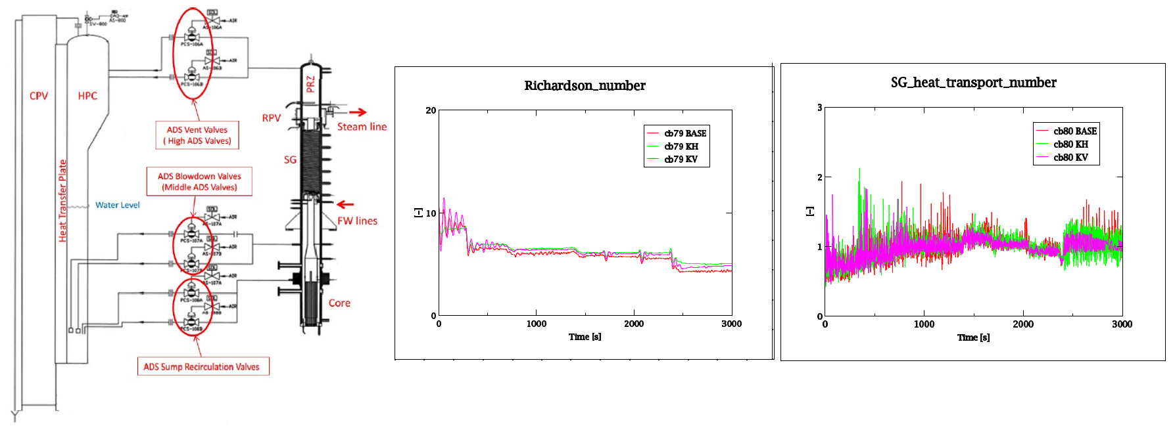

Figure 9: Numerical scaling and related Richardson number and SG heat transport number [16]*.*

### Safety and licensing

In recent years, licensing and safety activities have covered the approval of the operation or license application and/or renewal of various plants currently in operation both at a European level (ASCO NPP, Mohovche NPP, Hanhikivi NPP) and at an international level (Atucha I-II NPP, LABGENE NPP) [22][23]. These activities have been carried-out by NINE (and in respect to Atucha-II NPP also University of Pisa) adopting combined and BEPU safety approaches for licensing. It is worth to underline that important contributions have been made to the study of uncertainties through the Best Estimate Plus Uncertainty (BEPU) analysis which provides a more realistic approach to safety analysis [24]. These contributions have been used over the years for the drafting of plant safety dossiers, in particular for the preparation of chapter 15 (Transient and Accident Analyses), Chapter 4 (Reactor), Chapter 16 (Operational Limits and Conditions) and Chapter 19 - Probabilistic Risk Assessment - including Severe accidents). Another relevant aspect consists in the containment analysis through system codes (mainly GOTHIC) to support analyzes for severe accident conditions or calculation of hydrogen production and distribution [25]. The skills underlying these analyses and evaluations support the development of SMR technology starting from the early stages of design and experimental qualification of innovative solutions and accompany the project up to approval in the licensing process.

## CONCLUSIONS AND PERSPECTIVES

This paper highlights recent advancements in Italy's nuclear sector, particularly focusing on the emerging Small Modular Reactors (SMRs). Despite the contraction of Italy's nuclear industry following the cessation of domestic atomic energy use, essential skills and expertise have been maintained through active participation in the international market as well as research collaborations. These preserved industrial and research capabilities position Italy favourably to contribute to the potential deployment of SMRs across Europe.

References

1. CINOTTI, L., RIZZO, F.L., The Inherently Safe Immersed System (ISIS) reactor, Nucl. Eng. & Des. **143** 2-3 (1993) 295-300.
2. CAIRA, M., CUMO, M., NAVIGLIO, A., “The MARS nuclear reactor plant: A inherently safe, small/medium size multipurpose nuclear plant”, Nucl. Eng. & Des. **97** 2 (1986) 145-160.
3. CARELLI, M.D., CONWAY, L.E., ORIANI, L. et al., The Design and Safety Features of the IRIS Reactor, Nucl. Eng. & Des. **230** 1 (2004) 151-167.
4. ALEMBERTI, A., CARAMELLO, M., FRIGNANI, M., GRASSO, G., MERLI, F., MORRESI, G., TARANTINO, M., ALFRED Reactor Coolant System Design, Nucl. Eng. & Des. **370** (2020) 110884.
5. MARTH, W., The Story of the European Fast Reactor Cooperation, KfK 5255, Kernforschungszentrum Karlsruhe, Germany, 1993.
6. CARAMELLO, M., FRIGNANI, M., GRASSO, G., TARANTINO, M., MARTELLI, D., LORUSSO, P., DI PIAZZA, I., Improvement of ALFRED thermal hydraulics through experiments and numerical studies, Nucl. Eng. & Des. **409** 1 (2023) 112365.
7. MARTONE, R., ALBANESE, R., CRISANTI, F., MARTIN, P., PIZZUTO, A., Divertor Tokamak Test Facility – Interim Design Report, ENEA Frascati Research Center, Italy (2019).
8. BRUZZI, S., PECCHIONI, M., Investment in Science-based Sectors and European Competitiveness: the Role of the Italian Fusion Supply Chain, Eur. Uni. Rev. **27** 1(2022) 59-82.
9. RICOTTI, M., et al., Italian Nuclear Supply Chain For Small Modular Reactors, Dipartimento di Energia, Politecnico di Milano, 2024.
10. RIGAMONTI, M., SIVERII, R., “SIET experimental test facilities for the ALWR projects”. ENERGIA NUCLEARE (January-April 1996) 33–41.
11. FERRI, R., ACHILLI, A., CATTADORI, G., BIANCHI, F., LUCE, A., MONTI, S., MELONI, P., RICOTTI, M.E., “SPES3: the integral facility for safety experiments on small and medium sized reactors”. Proc. of the European Nuclear Conference (ENC 2012), Manchester, UK, December 9-12, 2012.
12. DANFORTH, R., HAND, O., FERRI, R., RANDACCIO, C., “Design of a test article and test facility to investigate flow-induced vibration of helical coil steam generator”. Proc. of the 19th International Topical Meeting on Nuclear Reactor Thermal Hydraulics (NURETH-19) Log nr.: 35099. Brussels, Belgium, March 6 - 11, 2022
13. FERRI, R., ACHILLI, A., CONGIU, C., MARCIANÒ, S., GANDOLFI, S., MARENGONI, M., BERSANI, A., PASSERIN D’ENTREVES, A., “ELSMOR European project: experimental results on an innovative decay heat removal system based on a plate-type heat exchanger”. Hindawi Science and technology of Nuclear Installations, Vol. 2023, Article ID 6672504.
14. BERSANO, A., LOMBARDO, C., ALBLOUWY, F., KARPPINEN, I., SLIDE, A., NIKITIN, K., GROSJEAN, B., MORIN, F., MARTIN, J., WEYERMANN, F., “Benchmark exercise on ELSMOR passive heat removal system”. Nuclear Engineering and Design, 419, 112961.
15. CARAMELLO, M., “Passive Decay Heat Removal (DHR) safety system for innovative nuclear energy systems”. Proc. of the Joint ICTP-IAEA Workshop on Nuclear Structure and Decay Data: Theory, Experiment and Evaluation. Trieste, Italy, October 15-26, 2018.
16. MASCARI, F., et al, (2024). Scaling-up assessment of natural circulation phenomena in integral Small Modular Reactor by TRACE code. *Nuclear Engineering and Design, 420*, 113018. <https://doi.org/10.1016/j.nucengdes.2024.113018>
17. INTERNATIONAL ATOMIC ENERGY AGENCY, Evaluation of Advanced Thermohydraulic System Codes for Design and Safety Analysis of Integral Type Reactors, IAEA-TECDOC-1733, IAEA, Vienna (2013)
18. SASPAM-SA Project, "SASPAM-SA: Severe Accident Simulation and Analysis for Small Modular Reactors," available online at [www.saspam-sa.eu](http://www.saspam-sa.eu)
19. MACCARI, P., et al., (2021). ASTEC code DBA analysis of a passive mitigation strategy on a generic IRIS SMR. *Annals of Nuclear Energy, 156*, 108194. <https://doi.org/10.1016/j.anucene.2021.108194>
20. Application of the probabilistic Method to Propagate Input Uncertainty on a DBA Sequence in a Generic iPWR, proceeding of ERMSAR-2024
21. CRP Benchmark of Transition from Forced to Natural Circulation Experiment with Heavy Liquid Metal Loop (2024), <https://www.iaea.org/projects/crp/i31038>
22. Petruzzi, A., Cherubini, M., Lanfredini, M., D’Auria, F., & Mazzantini, O. (2016). The BEPU Evaluation Model with RELAP5-3D for the Licensing of the Atucha-II NPP. Nuclear Technology, 193(1), 113–160. <https://doi.org/10.13182/NT14-145>
23. A. Petruzzi, W. Giannotti, Kv-scaling analysis to support the validation of Atucha-II Best Estimate Evaluation Model, Nuclear Engineering and Design, Volume 363, 2020, 110609, ISSN 0029-5493, <https://doi.org/10.1016/j.nucengdes.2020.110609>.
24. F. D'Auria, Best Estimate Plus Uncertainty (BEPU): Status and perspectives, Nuclear Engineering and Design, Volume 352, 2019, 110190, ISSN 0029-5493, <https://doi.org/10.1016/j.nucengdes.2019.110190>
25. A. Pop, A. Petruzzi, W. Giannotti, External function for GOTHIC code to estimate critical heat flux conditions for in-vessel retention assessment, Nuclear Engineering and Design, Volume 380, 2021, 111301, ISSN 0029-5493, <https://doi.org/10.1016/j.nucengdes.2021.111301>.