# **The Status of Supply Chain for Small Modular Reactors deployment in China**

ZHU Sheng

Nuclear Power Operations Research Institute

Shanghai, China

Email: [zhusheng@cnnp.com.cn](mailto:zhusheng@cnnp.com.cn)

**Abstract**

Small Modular Reactors (SMRs) have the characteristics of small size, light weight, strong application flexibility, and low initial investment. They can be widely used in various scenarios such as power generation, heating, and seawater desalination, and are one of the important choices for achieving zero carbon energy. China began the technological research and development of SMRs in the early 1980s, targeting the application needs of heating in cold regions, power supply in remote areas, and seawater desalination in coastal areas. Various types, power levels, and technical characteristics of SMRs were developed. Among them, the 200MWe high-temperature gas cooled SMR has been put into operation in 2023, and the 125MWe “Linglong one” integrated multi-purpose water cooled SMR is under construction，and is planned to be completed for power generation in 2026, and several SMRs are in different research and development stages currently. China has established a complete supply chain system through more than 30 years of research and development, construction, and application practice in the field of SMRs, which can provide strong support for the deployment of SMRs. This article will introduce the status of SMRs supply chains in China from various aspects such as materials and fuel, research and development, components manufacturing, construction, operation and maintenance, education and training. It will be helpful for the potential SMR users to understand China’s capabilities in SMR deployment, and promote the large-scale application of SMRs.

## INTRODUCTION

The application of nuclear energy is one of the greatest discoveries of the twentieth century. After more than half a century of development, nuclear energy has become an important part of the world's energy system. Large nuclear reactors, are capable of fulfilling much of the energy demand but face significant financing and infrastructure challenges. Small Modular Reactors (SMRs) are advanced nuclear reactors that have a power capacity of up to 300 MW(e) per unit[1]. SMRs have the characteristics of small size, light weight and strong application flexibility, and can be used in various scenarios such as power generation, heating and seawater desalination[2]. SMRs could provide a viable alternative, particularly in locations and countries that are not suitable for large reactors[3].

The IAEA's 2022 Annual Handbook of SMRs[4] counts 83 types of advanced small reactors, including: 33 light water reactors, 17 high-temperature gas-cooled reactors, 8 liquid metal fast reactors, 13 molten salt reactors, and 12 micro-reactors. Most of the SMRs adopt advanced safety features and are deploy-able either as a single or multi-module plant，Figure 1 shows some typical SMRs with different coolants and configurations.

Normally, the SMRs have 3 main advantages compared to the large nuclear power plants:

1. Up to one-third of the generating capacity of large nuclear power reactors with more flexibility and less financing requirement;
2. Components or systems can be factory fabricated and easily maintenance ;
3. Main equipment or systems can be transported as modules to the sites or installed.

There is increasing interest in SMRs and their applications. During the International Conference on Climate Change and the Role of Nuclear Power held in September 2019, SMRs were considered by many countries as a potential viable nuclear option to contribute in mitigating the climate change[4].

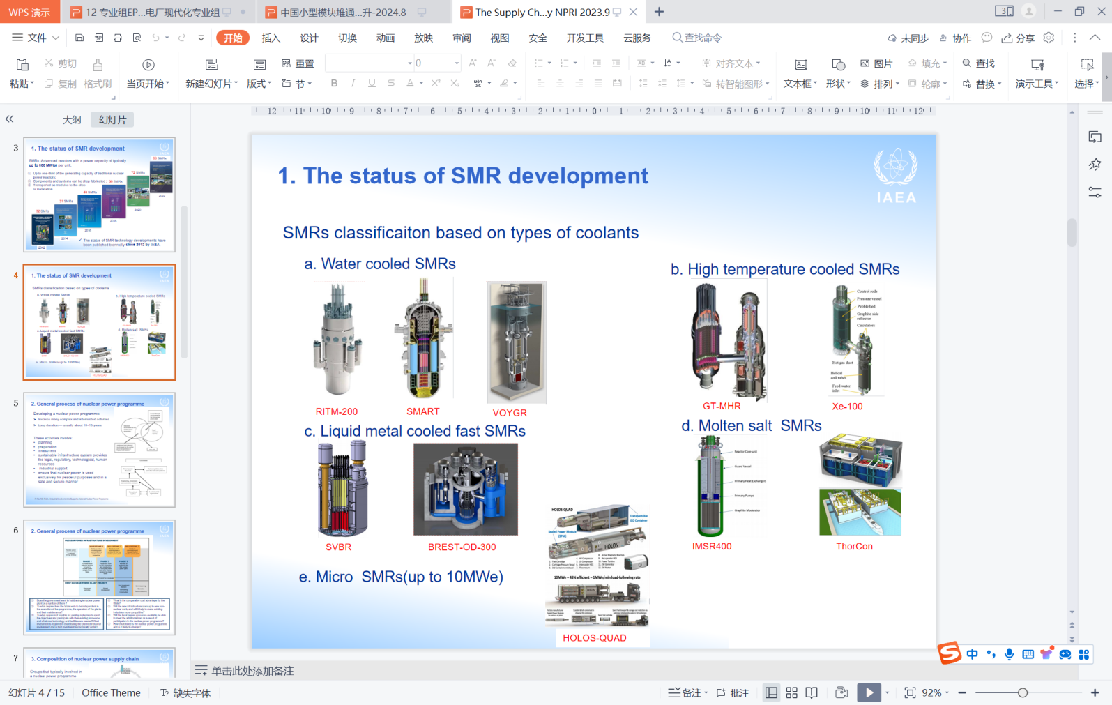

Fig 1 SMRs classificaiton and typical reactors

## General process of nuclear power programme

Developing a nuclear power programme is a major undertaking and involves many complex and interrelated activities of long duration (about 10~15 years). These activities involve, among others, planning, preparation and investment in a sustainable infrastructure that provides the legal, regulatory, technological, human resources and industrial support to ensure that nuclear power is used in a safe and secure manner[5].Fig 2 shows the Typical nuclear infrastructure development programme.

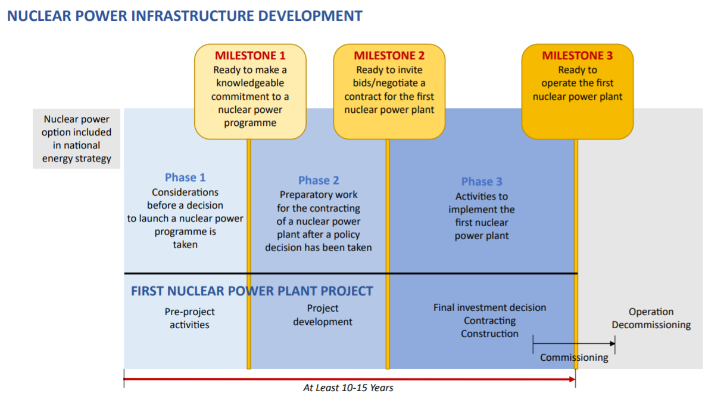

Fig 2 Typical nuclear infrastructure development programme[6]

Whether a nuclear energy project can be successfully completed requires not only a reasonable engineering management plan, but also the guarantee provided by a complete supply chain. Due to the high complexity and technical difficulty of nuclear energy projects, there are only a few countries worldwide that have a complete supply chain system for nuclear energy projects. Many countries' nuclear energy projects require support from the international community to be implemented.

In the applications of SMRs, an important application scenario is to provide energy for some small and medium-sized countries or emerging economies. These users do not have the circumstance to establish a complete supply chain system for SMRs by themselves and need to rely on the supply chain of SMR suppliers to provide guarantees for the smooth implementation of projects. The robustness of the supply chain will be one of the important factors affecting the application prospects of SMRs.

## Composition of nuclear power supply chain

Nuclear power supply chain encompasses all the members and activities involved in sourcing, designing, manufacturing, procurement, construction, operation and maintenance, conversion and logistics management. It also includes coordination and collaboration with suppliers, intermediaries, third party service providers or customers.

Typical nuclear supply chain including the nuclear materials&fuel, SMRs or large nuclear power reactors technology vendors,component manufacture,construction, operation&maintenance,and technique service. Typical nuclear supply chain are shown in Fig. 3. New build projects are typically concerned with how the SMR or large nuclear power plant technology vendors set up and manage their supply chains, while operating plants typically deal directly with equipment manufacturers and their sub-suppliers for spare parts associated with operation and maintenance activities[7]. All of the activities in the supply chain are invariably linked, and these activities will influence the performance of the SMR or large nuclear power plant .

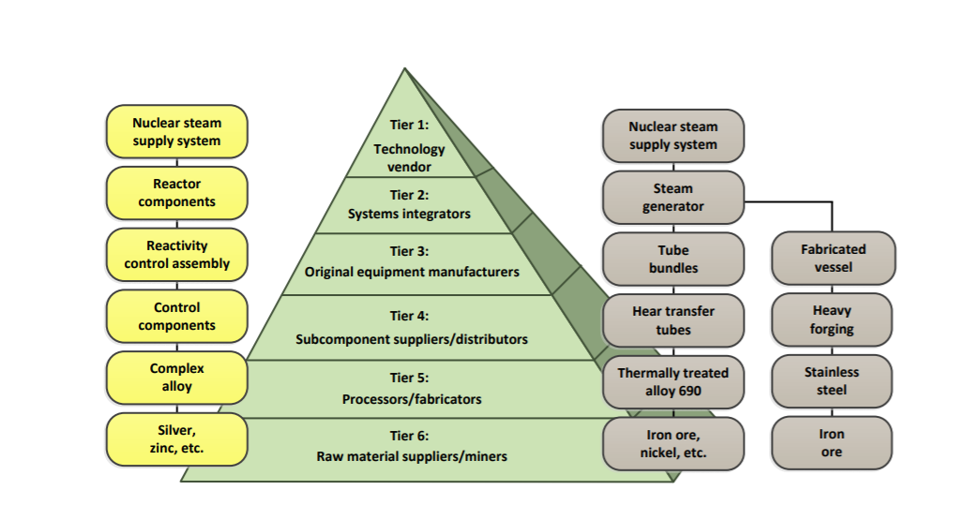

Fig 3 The main iteams of nuclear power supply chain[7]

Members that typically involved in a nuclear power programme supply chain include the Engineering companies, manufacturing companies, civil construction and system assembly companies, services companies, operation and maintenance companies, and technical support organizations.

Due to the particularity of nuclear energy, the implementation of nuclear energy requires special attention to the impact of nuclear safety on society and the environment, as well as nuclear safety issues at all stages of the nuclear energy supply chain.

## The SMRs supply chain in China

### The status of SMRs development and application in China

Since the beginning of the 21st century, China has developed a variety of types of small reactors with different power levels and technical characteristics for the needs of heating in cold areas, power supply in remote areas and seawater desalination in offshore areas(Table 1).

Among the SMRs in China, the ACP100“Linglong one” integrated small multi-purpose modular pressurized water reactor independently developed by China National Nuclear Corporation(CNNC) is under construction and is scheduled to be completed in 2026(Fig 4).The 210MWe HTR-PM (Fig 5)designed by the [Institute of Nuclear and New Energy Technology](https://www.inet.tsinghua.edu.cn/ineten/" \t "https://cn.bing.com/_blank)(INET) of Tsinghua University has connected to grid in December 2023[8]. The NHR200-II integrated low-temperature heating reactor designed by Tsinghua University and DHR-400 pool type heating reactor designed by CNNC have initially met the engineering application conditions. The State Power Investment Corporation(SPIC) has developed a 200MWe compact reactor and has completed the conceptual design , and China General Nuclear Power Corporation has developed an ACPR50S offshore floating reactor.

TBALE 1 The typical small reactor types in China[2]

| **No.** | **Design** | **Type** | **Output MWe** | **Designer** | **Status** |
| --- | --- | --- | --- | --- | --- |
| 1 | ACP100 | Integral PWR | 125 | CNNC/NPIC | Under Construction |
| 2 | ACP100S | Integral PWR | 125 | CNNC/NPIC | Basic Design |
| 3 | CAP200 | Compact PWR | ＞200 | SPIC/SNERDI | Basic Design |
| 4 | DHR 400 | Pool-type | 400 MWt | CNNC | Basic Design |
| 5 | HAPPY200 | PWR | 200MWt | SPIC | Detailed Design |
| 6 | NHR200-II | Integral PWR | 200MWt | Tsinghua University&CGN | Basic Design |
| 7 | ACPR50S | Compact PWR | 50 | CGNPC | Detailed Design |
| 8 | HTR-PM | HTGR | 210 | INET,Tsinghua University | In operation |
| 9 | HTR-10 | HTGR | 2.5 | INET,Tsinghua University | Operable |
| 10 | smTMSR | MSR | 168 | CAS/SINAP | conceptual Design |

|  |  |
| --- | --- |
| IMG_256 | IMG_256 |
| Fig 4 The reactor pressure vessel installed in place in Hainan province, China[9] | Fig 5 The 210MWe HTR-PM demonstration project in Shandong province，China |

### The status of SMRs supply chain in China

The nuclear power supply chain is a complex system that includes nuclear materials&fuel, research & development(R&D), equipment manufacturing, construction, operation and maintenance enterprises, as well as related universities, research institutes, training institutions and other companies. Due to the special characteristics of nuclear energy applications, it is particularly important to pay attention to the impact of nuclear safety on society and the environment. Therefore, strict requirements have been put forward for relevant enterprises, research institutions, universities, and training institutions in the nuclear power supply chain.

As one of the few countries in the world with an independent and complete nuclear industry systems, China has 55 operating nuclear power units by the end of 2023, ranking third in the world, and there are 26 nuclear power units are under construction, maintaining the world's leading position. In 2022 and 2023, 10 nuclear power units were applied to be built annually , and nuclear power construction entered a high-quality development period[10].

Among them, the first unite of China's independently developed “Hualong one”(Fig 6) advanced large pressurized water reactor nuclear power plant has been in operation since January 2021[11] and is currently undergoing mass construction; The development of the “Guohe one”(Fig 7) advanced passive pressurized water reactor nuclear power plant has also been completed in 2020[12]. China has established complete supply chain system during the research, development, construction, and operation of Hualong One and Guohe One.

|  |  |
| --- | --- |
| 华龙一号 |  |
| Fig 6 The Hualong One Nuclear power plant in Fujian province, China[13] | Fig 7 The Guohe One nuclear power plant under construction in Shandong province,China[12] |

The relevant members in the supply chains of “Hualong One” and “Guohe One” also have the ability to provide services for SMR projects, which can provide strong support for the development and application of SMRs in China.

Through a systematic analysis, the China's SMR supply chain has been sorted out from six aspects: nuclear material fuel, research and development, component manufacturing, engineering construction, operation and maintenance, and education and training(Fig 8).

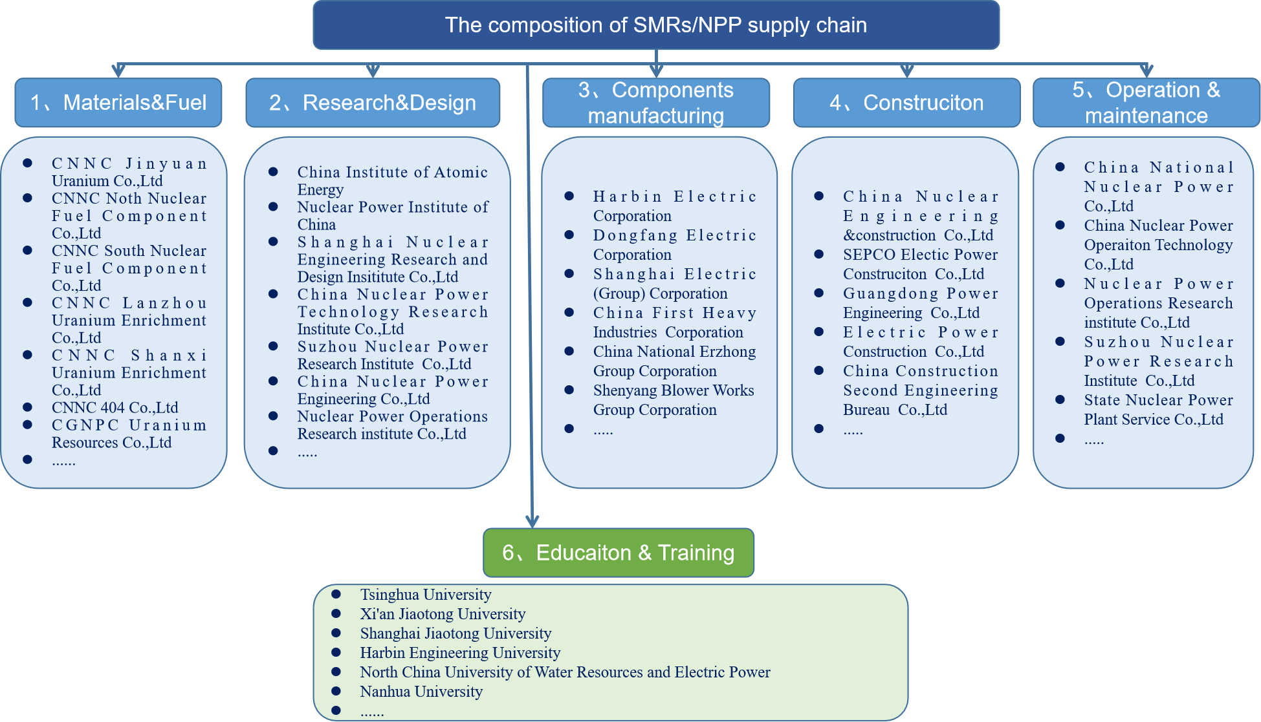

Fig 8 The composition of China SMRs/NPP supply chain

1. **Materials & Fuel:** The key items of nuclear fuel rods are fuel pellets and nuclear fuel rod cladding materials. Nuclear fuel pellets are the main contributor for generating heat in fission reactions, while the fuel cladding materials are the main factors affecting the performance of nuclear fuel rods. China's nuclear fuel manufacturing and supply are currently exclusively supplied by China National Nuclear Corporation (CNNC), which is the only enterprise in China with a complete nuclear fuel cycle industry. The China government authorizes CNNC to exercise exclusive control over the production, operation, import, and export of nuclear fuel and uranium products. CNNC Lanzhou Uranium Enrichment Co.,Ltd , CNNC North Nuclear Fuel Component Co.,Ltd,CNNC 404 Co., Ltd and China National Uranium Co., Ltd etc have complete qualifications and capabilities for manufacturing and processing nuclear fuel components, and can provide nuclear fuel for various SMRs and other nuclear facilities[14,15].
2. **Research & Development:** There are many companies and institutes in China have SMR research and development capabilities, which can engage in the research and development of various types of reactors including small pressurized water reactors, high-temperature gas cooled reactors, metal cooled reactors, etc. The main research and development groups include Nuclear Power Institute of China, China Nuclear Power Engineering Co.,Ltd, Nuclear China Institute of Atomic Energy, Shanghai Nuclear Engineering Research and Design Insititute Co.,Ltd, Tsinghua University, etc[14,15]. Among them, the HTR-PM high-temperature gas cooled reactor developed by Tsinghua University has been put into operation, and the ACP100 “Linglong one” mall pressurized water reactor developed by the Nuclear Power Institute is under construction as planned and is expected to be put into operation in 2026[16].
3. **Components manufacturing:** Nuclear power facilities can generally be divided into three parts: nuclear island equipment (NI), conventional island equipment (CI), and auxiliary systems (BOP). At present, China has established three major nuclear power equipment manufacturing bases in Northeast China, Shanghai, and Sichuan province, with more than 100 enterprises possessing the production capacity of nuclear power equipment. Generally, there are 3-4 individual equipment suppliers for one kind of equipment. At present, the supply status of nuclear island equipment is dominated by four enterprises: Shanghai Electric Corporation, Dongfang Electric Corporation, Harbin Electric Group, and China First Heavy Industries Corporation[14,15]. They undertake the manufacturing tasks of large pressurized water reactor nuclear power plants and various SMRs main equipment, including reactor pressure vessels, pressurizer, steam generators, turbine generators, main coolant pumps, and other core equipment.
4. **Construction:** Nuclear power facilities have a long construction period, large investment scale, and high quality requirements, requiring a sustainable team of technical workers and a large number of professional tools and equipment. In the past 20 years, China has been the most active region in the the field of nuclear power plants construction, with over 20 large nuclear power plants and 1 ACP100 “Linglong one”small modular reactor currently under construction. During this process, China has established a comprehensive capacity for nuclear power plant construction and formed a group of experienced nuclear power plant construction companies, such as China Nuclear Engineering &construction Co.,Ltd，SEPCO Electic Power Construciton Co.,Ltd, Guangdong Power Engineering Co.,Ltd, Electric Power Construction Co.,Ltd[14,15]. All of these construction companies have the capability of undertaking the construction work of large advanced pressurized water reactors and small modular reactors, including “Hualong One”, “Guohe One”, HTR-200, ACP100, etc.
5. **Operation & Maintenance:** By of the end of 2023, there are 55 nuclear power units in operation in China, and the operating indicators of each nuclear power plant are in a leading position globally, reflecting the excellent quality of Chinese nuclear power operation and maintenance enterprises. Relevant enterprises can also provide sufficient technical and manpower support for the operation and maintenance of SMRs. Companies that possess the technical capabilities for the operation and maintenance of nuclear power plants and SMRs include China National Nuclear Power Co.,Ltd、State Nuclear Power Plant Service Co.,Ltd，China Nuclear Power Operaiton Technology Co.,Ltd，Nuclear Power Operations Research institute Co.,Ltd[14].
6. **Education & Training:** With the rapid development of nuclear power in the past 20 years, China has also made significant progress in the education of nuclear energy professionals. More than 10 universities have established nuclear energy related majors, such as Tsinghua University, Shanghai Jiao Tong University, Xi'an Jiaotong University, Harbin Engineering University, etc[15]. Every year, they can provide hundreds of highly educated nuclear energy professionals for various areas in the nuclear energy supply chain. Many of them will enter SMRs research and development institute, operation companies and other enterprises, providing sufficient intellectual support for the development of SMRs in China.

From the above introduction, it can be seen that China has established a complete supply chain system in the field of SMRs, which can provide comprehensive support for different types of SMRs, application scenarios, and user needs.

## Conclusions

In the past 20 years, China has made great efforts in the field of SMRs research and application, and has developed various types of SMRs that can provide customized SMR products for different users. In terms of SMRs applications, China's 210MWt HTR-PM has been put into operation in 2023, and the small modular pressurized water reactor ACP100 “Linglong one” will also be completed in 2026, accumulating rich experience in SMR construction and operation.

During the development and application process of SMRs, China has established a complete supply chain system, which can provide full lifetime technical support and services for SMRs.

The SMRs and their supply chain system of China can not only provide support for domestic users, but also provide comprehensive services in advance for international users of China’s SMRs according to their needs. Meanwhile, based on China's existing experience in SMR construction and application, it can also provide technical and service support for other countries’ SMRs projects.

References

1. IAEA,What are Small Modular Reactors. https://www.iaea.org/newscenter/news/what-are-small-modular-reactors-smrs,2023.9.13
2. ZHU Sheng, YAN Zhen, The Prospects of Small Modular Reactor Development and Application in China Based on the User Requirements, ICONE 31, 2024.8
3. National Nuclear Laboratory, Small Modular Reactors (SMR) Feasibility Study, 2014.12
4. IAEA, ADVANCES IN SMALL MODULAR REACTOR TECHNOLOGY DEVELOPMENTS 2022 Edition ,A Supplement to: IAEA Advanced Reactors Information System (ARIS),2022.9
5. IAEA,No. NG-T-3.4,Industrial Involvement to Support a National Nuclear Power Programme,2016.12
6. IAEA, No. NG-G-3.1(rev.2), Milestones in the Development of a National Infrastructure for Nuclear Power,2024.6
7. IAEA, No. NP-T-3.21, Procurement Engineering and Supply Chain Guidelines in Support of Operation and Maintenance of Nuclear Facilities, 2016.9
8. National Energy Administration, The world's first commercial demonstration project of high-temperature gas-cooled reactor nuclear power plant was officially put into commercial operation in Rongcheng, Shandong, China. <https://www.nea.gov.cn/2023-12/06/c_1310753869.htm>
9. National Nuclear Safety Administration, The world's first core module of "Linglong one"is in place, <https://nnsa.mee.gov.cn/ywdt/hyzx/202308/t20230811_1038401.html>
10. China maintains the world's leading position in the number of 26 nuclear power units under construction, <https://www.gov.cn/yaowen/liebiao/202403/content_6940265.htm>
11. The Central People's Government of the People's Republic of China, A Creative Super Project - Perspective on the World's First Commercial Operation of "Hualong One", https://www.gov.cn/xinwen/2021-01/30/content\_5583826.htm
12. Nuclear Engineering International, China completes development of CAP1400, <https://www.neimagazine.com/news/china-completes-development-of-cap1400-8160701/>
13. The State Council of The People’s Republic of China, China's Hualong One reactor demonstration project fully operational, <https://english.www.gov.cn/news/topnews/202203/25/content_WS623dc5f1c6d02e53353284a1.html>
14. China National Nuclear Power Network, Panoramic analysis of the nuclear power industry chain, https://www.cnnpn.cn/article/25003.html
15. IAEA, Country Nuclear Power Profiles China (Updated 2022), https://www-pub.iaea.org/MTCD/Publications/PDF/cnpp2022/countryprofiles/China/China.htm
16. World Nuclear News, Linglong One reactor pit installed at Changjiang, <https://www.world-nuclear-news.org/Articles/Linglong-One-reactor-pit-installed-at-Changjiang>