# COMPUTATIONAL FLUID DYNAMICS APPROACH

# FOR OPTIMIZING TEMPERATURE AND FLOW

# PROFILE IN A NATURAL CIRCULATION BASED

# INTEGRATED SMR

A. SHAFIQUE

Pakistan Nuclear Regulatory Authority

Karachi, Pakistan

Email: [ammar.shafiq@pnra.org](mailto:ammar.shafiq@pnra.org)

N. SHAH

Pakistan Nuclear Regulatory Authority

Karachi, Pakistan

M. ISHTIAQ

Pakistan Nuclear Regulatory Authority

Karachi, Pakistan

M. KASHIF

Pakistan Nuclear Regulatory Authority

Karachi, Pakistan

**Abstract**

Objective of this work is to demonstrate applicability of computational fluid dynamics (CFD) techniques to perform design and safety assessment of passive primary coolant systems in integrated small modular reactors (SMRs). Passive primary coolant system, or natural circulation- based nuclear steam supply system (NSSS), is one of the most prominent features of SMR configurations where primary loop, steam generator and pressurizer are integrated into one single reactor pressure vessel (RPV). To simulate the primary coolant flow, iterative CFD analyses were performed where each analysis constitutes a certain combination of thermal gradient between the core and steam generator and their size and elevation. Given heat flux of the core, primary coolant temperature and velocity profile were computed along with heat transferred to the secondary side and corresponding temperature reduction on the primary side, in turn, improving the initially computed velocity profile for the primary coolant. The study concludes that CFD simulations offer viable solutions in terms of modeling flow and temperature distributions, thus contributing towards safe and efficient heat transport performance of primary systems in SMRs.

## INTRODUCTION

Primary coolant systems of SMR designs based on the PWR (pressurized light water reactor) technology, apart from diverse geometric and power configurations, can be broadly classified here into two types: forced circulation primary coolant systems and natural circulation (NC) primary coolant systems. Although there are several SMR designs that employ passive primary coolant systems [1], fact remains that achieving a stable NC flow is significantly more challenging than a forced circulation flow. Predicting flow behavior for NC flows is correspondingly more challenging as well ‎[2].

Moreover, weaker driving forces in NC based SMRs would result in low heat transfer from primary to secondary system. This necessitates employing a configuration that offers higher heat transfer area over shorter lengths. Helical coil steam generators (HCSG), owing to their compact geometry and higher heat transfer surface area, present an efficient solution for heat transfer for systems where high magnitudes of heat need to be transferred over small geometries.

Acknowledging novelty of practical application of NC systems to primary coolant systems in SMRs and observing the globally growing interest in the deployment of inherently safe reactor designs, CFD analysis was performed to investigate flow behaviour inside passive primary coolant loop of a generic design SMR using ANSYS Academic 2020 R1. Such analyses have been performed by Boyd (as elaborated in references ‎[3], ‎[4]and ‎[5]) for determining exact direction of flow of primary coolant naturally circulating between the RPV and steam generator (SG) inlet plenum during a postulated severe accident for a Westinghouse PWR. Similar methodology was adopted in the paper for a generic design SMR by analysing flow direction & velocity magnitudes of primary coolant naturally circulating inside the RPV between the core and HCSG. Boyd ‎[3] also explicitly mentioned that secondary side temperature conditions are the governing factor in determining primary coolant flow behaviour. This led to identifying the need to obtain secondary side temperatures for the HCSG tubes. Ilyas ‎[5] and Hoffer ‎[6] have performed thermal hydraulic analyses of HCSGs to calculate secondary side characteristics and the impact that they have on the primary side flow behaviour. However, considering the helical geometry of the secondary side at hand, applying thermal hydraulic results as boundary conditions to CFD analysis presented another challenge. Therefore, to obtain temperatures for the helical shaped secondary side (tubes), a separate CFD analysis was performed that calculated temperature profile at surface of the HCSG tubes while incorporating their helical geometry. This helically varying three-dimensional temperature profile – calculated through CFD analysis –was applied as boundary condition to CFD analysis of the NC primary system under consideration.

## Modeling Methodology

### Modeling the Naturally Circulating Primary Side

Multiple CFD analyses were performed to simulate natural circulation flow for a passive primary coolant system. The desired final outcome was an investigation of flow behavior inside the passive primary loop, vis a vis fluid temperature, velocity magnitudes and flow directions. The steady state NC flow can be mathematically represented by the following set of Navier-Stokes continuity, momentum and energy equations ‎[7]. For stress tensor terms in the momentum and energy equations, the k-ω SST (shear stress transport) turbulence model was used for its superior capabilities in handling near-wall computations:

$$\frac{∂ṁ}{∂s}=0 Eq. 1$$

$$\frac{∂(ρu^{2})}{∂s}+ \frac{∂P}{∂s}= \frac{1}{Re}\frac{∂τ_{ss}}{∂s} Eq. 2$$

$$\frac{∂(uE_{T})}{∂s}+ \frac{∂(uP)}{∂s}+ \frac{1}{RePr}\frac{∂q_{s}}{∂s}=\frac{1}{Re}\frac{∂τ_{ss}}{∂s} Eq. 3$$

Where ‘s’ represents all three spatial dimensions, ṁ is the mass flow rate, ρ is average density, P is static pressure, τ is the stress tensor, *u* represents velocity magnitudes in all three dimensions, ET is the total energy, q is heat flux and Re & Pr are Reynolds and Prandtl numbers, respectively. In this case, however, since the density would be changing with temperature as well which would, in turn, affect the mass flow rate inside the loop, following equation ‎[8] will also come into play as pictorially presented in FIG.1.

$$ṁ= {\left[\frac{2ρA^{2}\left(ρ_{c}- ρ_{h}\right)H}{R}\right]}^{\frac{1}{2}} Eq. 4$$

Where, ρc and ρh are densities at the sink and source, respectively, A is flow area, H is elevation difference between source and sink (loop height) and R is the hydraulic resistance.

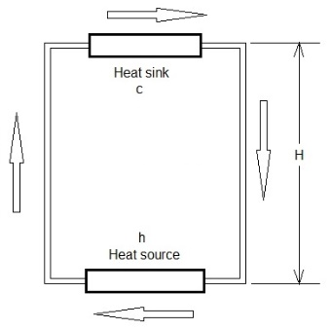

*FIG. 1. A typical natural circulation loop*

### Overview of Modeling Approach for the Primary Loop

Similar to the arrangement shown in FIG. 1, passive primary loop was modeled for a generic integrated SMR, as shown in FIG. 2, in order to analyze flow behavior of primary coolant under the influence of thermal and gravitational forces. Three-dimensional model of the primary system was deemed necessary because of the asymmetric temperature loads introduced by the HCSG tubes into the primary loop.

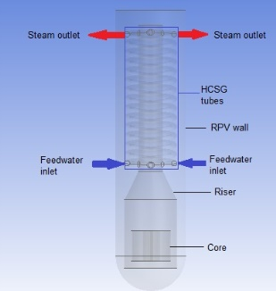 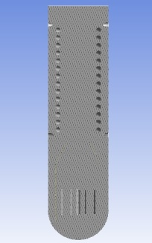

*FIG. 2. Complete and sliced CFD model of an integrated primary loop*

### Modeling the Secondary Side – Helical Coil Steam Generator

As mentioned earlier, separate CFD analysis was performed to calculate primary to secondary heat transfer. Recognizing asymmetry of thermal loads on the secondary side, three-dimensional modeling approach was adopted. Two different HCSG configurations were modeled: consisting of one (01) HCSG and two (02) interwoven HCSGs. Through this CFD analysis, temperature profile for the HCSG tube was calculated while incorporating primary and secondary flow conditions. Model for calculating primary to secondary heat transfer is shown in *FIG. 3*:

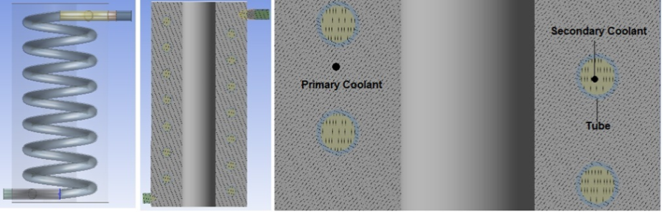

*FIG. 3. One-tube HCSG complete and sliced configuration*

Owing to the complexity of the model shown above, free meshing was used for all the three zones, that is, secondary coolant, HCSG tubes and the primary coolant. Boundary layer was created on the inner and outer surfaces of the tubes to more accurately capture temperature results. A variety of node numbers were tested for the analysis – 220000, 230000 and 240000. After checking sensitivity of results against the number of elements, ~230000 nodes were used.

## ASSUMPTIONS

Only steady state analysis was performed while acknowledging the widely understood fact that behaviour of NC flows cannot be completely captured without performing a thorough transient analysis. Moreover, since only temperatures was required on the outer surface of the HCSG tube, the secondary coolant was modelled as single-phase fluid, assuming that it would contribute same heat content, as steam would, to the tube material. However, while treating the secondary coolant as single-phase fluid, temperature-dependent density has been incorporated in order to model a relatively realistic fluid flow as mentioned in TABLE 1.

## Properties and Boundary Conditions

Based on the information available in the IAEA Advanced Reactors Information System (ARIS) ‎[1] and most commonly used materials, some generic material properties and parameter values were selected to perform the analysis. These properties and boundary conditions are presented in TABLE 1:

TABLE 1. DIMENSIONS, MATERIAL PROPERTIES AND BOUNDARY CONDITIONS USED IN THE ANALYSIS

|  |  |
| --- | --- |
| Parameter | Value |
| RPV height/diameter ‘m’ | 18.3/5.6 |
| HCSG diameter ‘m’ | 1.55 |
| HCSG tube material, number of tubes (dia/thickness) ‘mm’ | Inconel 718, 1 (512/50)  2 (362/35) |
| Tubes thermal conductivity ‘W/m.K’ | 10.7 |
| Tubes specific heat capacity ‘J/kg.K’ | 435 |
| Tubes density ‘kg/m3’ | 8190 |
| Core heat flux ‘W/m2’ | 600000 |
| Secondary coolant inlet velocity ‘m/s’ | 0.7 |
| Primary coolant inlet velocity ‘m/s’ | 0.45 |
| Secondary coolant inlet temperature ‘oC’ | 224 |
| Primary coolant inlet temperature ‘oC’  (where it starts its contact with the HCSG tubes) | 323 |
| Coolant density – primary and secondary ‘kg/m3’  (water-liquid) | Piece-wise linear |

## CFD Analysis Methodology

* + 1. Analysis Approach for the HCSG Tube

3D helical tube geometry was modelled to calculate primary-to-secondary heat transfer. Fluid-structure-interaction (FSI) analysis of HCSG was performed employing conjugate heat transfer in which all the three zones – primary coolant, HCSG tubes and secondary coolant – are simultaneously analysed. Flow and thermal boundary conditions were defined separately for the primary and secondary coolant as shown in *FIG. 4*.

Boundary conditions were applied to the secondary side as shown below:

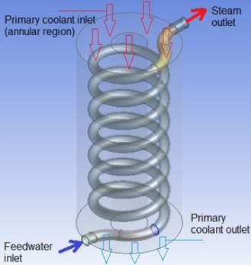

*FIG. 4. Assigning boundaries to the secondary side model*

### Primary-to-Secondary Heat Transfer – FSI Analysis Results

Outer surface temperatures were obtained for the helical tube as shown in *FIG. 5*.

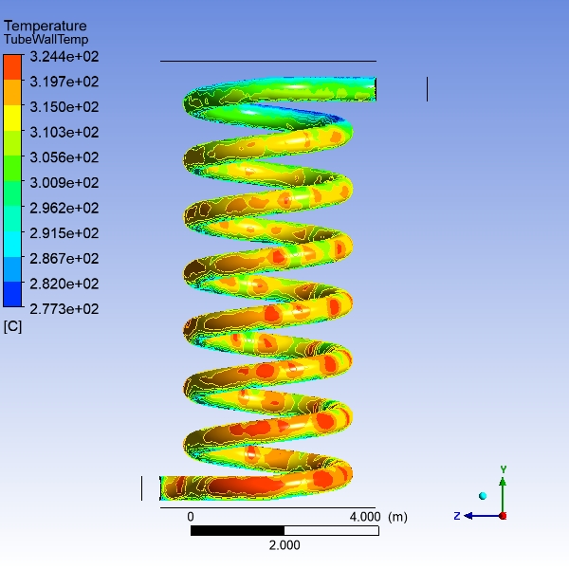 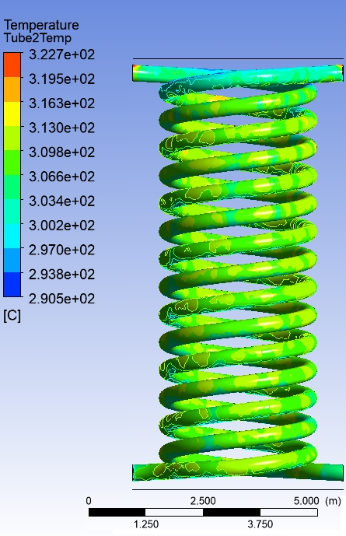

*FIG. 5. Helical tube mesh and temperature profile – FSI results – for both HCSGs*

TABLE 2. RESULTS FOR THE HCSG FSI ANALYSIS

|  |  |  |  |  |
| --- | --- | --- | --- | --- |
| Parameter | One-tube HCSG | | Two-tube HCSG | |
| Heat transfer area on primary side ‘m2’ | 2.15 | | 3.05 | |
| Secondary coolant temperature ‘oC' | Inlet | Outlet | Inlet | Outlet |
| 224 | 323 | 224 | 323 |
| HCSG Tube temperature ‘oC' | Min | Max | Min | Max |
| 293.8 | 324.4 | 290.5 | 322.7 |
| Primary coolant temperature ‘oC' | Inlet | Outlet | Inlet | Outlet |
| 323 | 288.6 | 323 | 288.7 |

### Analysis Approach for the Naturally Circulating Primary Coolant

#### Incorporating Source (Core) and Sink (HCSG Tubes) Thermal Loads

Asymmetric thermal loads – calculated from FSI analysis of the HCSG tubes – were imported into the primary coolant CFD analysis environment and applied on the helical surfaces so indicated in *FIG. 2*. Core was modeled as three concentric cylindrical solids with parameters as presented in TABLE 3. The concentric cylinders model was chosen to apply symmetric thermal source conditions to the primary coolant region between core and secondary coolant inlet nozzle.

TABLE 3. CORE PARAMETERS

|  |  |
| --- | --- |
| Parameter | Value |
| Core height ‘m’ | 2 |
| No. of concentric cylinders | 3 |
| Radius of inner-most, middle and outer-most cylinder, ‘mm’ | 50, 500, 1200 |
| Thickness of each cylinder ‘mm’ | 100 |
| Flow area through the core for heat transfer ‘m2’ | 4.3 |
| Core surface area ‘m2’ | 50.2 |

For the primary loop as well, free meshing was used for the primary coolant body. After performing sensitivity analysis for a variety of number of nodes – ~33500, ~38000 and ~41000 – the 38000 nodes configuration was used as the optimum configuration.

As anticipated, naturally circulating flow was obtained, driven by the density and elevation difference, as quantified in Eq. 4.

#### Analyzing the Effect of Elevation (Loop Height)

In order to study the effect of loop height ‘H’, which irrevocably affects hydraulic resistance ‘R’, the primary coolant CFD analysis was performed for two elevations (H) – 4 m and 3.5 m. Noticeable difference in flow behavior was observed in results against different core locations as presented in TABLE 4. The primary coolant exits from the top of the core due to its lighter density caused by its higher temperature. The upward flow then accelerates as it travels through the transitionally reducing cross sectional area of the riser. After exiting the riser, the coolant circumferentially expands and begins to travel downward while exchanging heat with the tubes of the HCSGs, getting colder and heavier in the process, till it reaches the bottom of the core (see *FIG. 2* for geometrical orientation) where it starts getting heated again and restarts its upward journey.

For both elevations, combined with the effect of secondary side thermal boundary conditions, no flow instabilities were observed inside the primary loop.

* + 1. Natural Circulation Flow Results

Overall results are summarized in TABLE 4:

TABLE 4. RESULTS OF CFD ANALYSIS OF PRIMARY SYSTEM

|  |  |  |  |  |
| --- | --- | --- | --- | --- |
| Parameter | One-tube HCSG | | Two-tube HCSG | |
| Loop height ‘H’ | 4 m | 3.5 m | 4 m | 3.5 m |
| Maximum primary coolant velocity achieved ‘m/s’ | 1.429 | 1.285 | 2.070 | 2.023 |
| Core inlet / outlet temperatures ‘oC’ | 372.2 / 395.2 | 372.6 / 387.1 | 346.9 / 361.8 | 346.4 / 366.4 |

## Conclusion

Detailed CFD analyses were performed to simulate natural circulation flow for a passive primary coolant system based integrated SMR design against two different HCSG configurations and core elevations. The secondary coolant temperature rise was found to be 99 oC for both one-tube and two-tube HCSG configurations, respectively, as compared to ~95 oC for HCSGs in SMR design ‎[5]. Also, it was found that the primary coolant temperature reduces by ~25 oC lower when the 2-tube HCSG configuration is used as compared to 1-tube arrangement. That is, heat transferred to the secondary side increases with increasing number of HCSG tubes. Maximum flow velocities have been calculated to be 1.429 m/s and 2.07 m/s for 1-tube and 2-tubes HCSGs, respectively. Since primary coolant velocities for NC based SMR available designs were not available, no comparison with actual values can be made right now.

Furthermore, analyses were performed for core-HCSG elevation differences of 3.5 m and 4 m. It was observed that increasing elevation difference from 3.5 m to 4 m, for both HCSG configurations, increases the velocity by ~0.2 m/s. Since these outcomes support established mathematical understanding of the phenomenon, the calculated results give certain level of confidence in the current CFD methodology. The higher velocities, however, would create a more challenging environment for the reactor internals which might require corresponding configurational modifications for several other internal mechanical components.

No flow reversal was observed for any of the configurations. While maintaining desired flow *direction* in the primary loop, velocity *magnitudes* were found to show fluctuation. Ultimate aim of any natural circulation loop design is to achieve a ‘stable’ flow that maintains constant magnitude while circulating in the desired flow direction. The obtained natural circulation flow – fluctuating in magnitude but maintaining the desired flow direction – has been classified as ‘neutral’ ‎[9]. However, no particular configuration was conclusively identified as more ‘suitable’ than others. The anticipated, yet inconclusive, outcome highlights, both, the need for improvement in current modeling methodology and augmenting the current methodology with other investigative techniques, such as, experiments.

## References

1. International Atomic Energy Agency (IAEA), “Advances in Small Modular Reactor Technology Developments, A Supplement to IAEA Advanced Reactors Information System (ARIS)”, 2020.
2. BOYD C.F, HARDESTY, K., “CFD Analysis of 1/7th Scale Steam Generator Inlet Plenum Mixing During a PWR Severe Accident”, U.S. Nuclear Regulatory Commission, Washington, DC, October 2003.
3. BOYD, C.F and ARMSTRONG, K., “Computational Fluid Dynamics Analysis of Natural Circulation Flows in a Pressurized-Water Reactor Loop under Severe Accident Conditions”, Nuclear Regulatory Commission, Washington, DC,
4. BOYD, C.F., HELTON, D.M., HARDESTY, K., “CFD Analysis of Full-Scale Steam Generator Inlet Plenum Mixing During a PWR Severe Accident”, U.S. Nuclear Regulatory Commission, Washington, DC, May, 2004.
5. ILYAS, M., AYDOGAN, F., “Steam generator performance improvements for integral small modular reactors”, Nuclear Engineering and Technology 49 (2017) 1669-1679, 2017.
6. HOFFER, N. V., SABHARWALL, P., ANDERSON, N. A., “Modeling a Helical-coil Steam Generator in RELAP5-3D for the Next Generation Nuclear Plant”, Idaho National Laboratory, January, 2011.
7. OLIVEIRA, R. D., ARAUJO, P. D., MOREIRA, M. D. L., “Methodology for Studies of Natural Circulation in Closed Circuits”, International Nuclear Atlantic Conference, 2009.
8. VIJAYAN, P.K., NAYAK, A.K., “Natural Circulation Systems: Advantages and Challenges”, Natural Circulation in Water Cooled Nuclear Power Plants, IAEA-TECDOC-1474, November 2005.
9. D’AURIA, F. D., NEVO, D. A., MUELLNER, N., “Insights into Natural Circulation Stability - Updated”, IAEA Course on Natural Circulation, ICTP, Trieste, Italy, May 17 – 21, 2010, Paper ID T-7.