OPPORTUNITIES IN DEVELOPMENT BANKS’ FINANCING FRAMEWORK IN THE ACCEPTABILITY OF ADVANCED NUCLEAR REACTORS IN KENYA

Musyoka D.

Nuclear Power and Energy Agency

Nairobi, Kenya

Email: [dmusyoka@nuclear.co.ke](mailto:dmusyoka@nuclear.co.ke)

Nyawinda B.

Nuclear Power and Energy Agency

Nairobi, Kenya

**Abstract**

In Kenya, nuclear energy is poised to complement renewable sources, particularly by adopting small modular reactors. Long-term national energy plans outline the incorporation of three units of nuclear power plants, each generating 291 megawatts, into the grid by 2038. Preliminary assessments for Kenya's inaugural nuclear power plant reveal a capital cost of approximately 500 billion Kenya shillings for a 300-megawatt plant. Financing hurdles such as high initial investment and public opposition, driven by concerns over safety and waste management are key among the challenges for Kenya’s first nuclear power plant. Following COP28, calls were made for development institutions like the World Bank to finance new nuclear energy projects. International Finance Institutions, including the World Bank, have a successful track record in financing capital-intensive energy projects like geothermal power generation in Kenya; this can be attributed to robust environmental and social safeguards. Kenya's strategic environmental assessment for its nuclear program recommends the adoption of international finance institutions' guidelines for environmental due diligence to complement the national environmental laws and regulations. Acquisition of financing from international finance institutions presents multiple opportunities for Kenya's nuclear power project: The financing challenge for the project will be met; leveraging international finance institutions such as the World Bank's environmental and social standards also presents an opportunity to garner local community and stakeholder acceptance of the nuclear project; and the national environmental and social framework will be enhanced. These opportunities will expedite the deployment of advanced nuclear power technology in Kenya.

## INTRODUCTION

Emerging nations are paving their way to capitalise on the advantages of nuclear power. Sixteen (16) of the approximately sixty (60) reactors now under construction worldwide are located in emerging countries like Bangladesh, India, and Pakistan, which are still striving to provide universal access to power for their expanding populations. Since nuclear energy is expected to be a key component of the global energy transition towards emissions-free energy and universal access to electricity, many developing nations are eager to advance nuclear technology (The Breakthrough Institute, 2024).

Nuclear energy has the potential to supplement renewable energy sources in Kenya. According to long-term national energy plans, it is projected three nuclear power plant units, each producing 291 megawatts going into the grid, will be added to the system by 2038 (Government of Kenya, 2023a). Preliminary assessments for Kenya's inaugural nuclear power plant reveal a capital cost of approximately 500 billion Kenya shillings for a 300-megawatt plant. This projection points to the choice of reactor technology for Kenya as being the small modular reactor (SMR). High-level national policy documents on climate change mitigation recognise nuclear power as a key player in greenhouse gas emission reduction in Kenya. The National Climate Change Action Plan 2023-2027 recommends research on new and emerging energy technologies that would reduce GHG emissions in the energy sector, referencing SMRs (Government of Kenya, 2023b).

Kenya has collaborated with international institutions under the Nuclear Innovation: Clean Energy Future (NICE Future) initiative in a study to evaluate the economic and job impacts of adopting nuclear energy. Preliminary results indicate the following: Adding nuclear energy into the energy mix reduces system-wide energy costs; Adding nuclear energy into the energy mix increases renewables, especially wind, deployments due to smaller, more flexible reactors that can respond to changes in wind output; Nuclear energy increases local jobs and positively affects the local economy it is built in; Nuclear energy decreases dependence of Kenya on foreign fuels and reduces fuel imports and emissions; Nuclear energy enables local industry when it is coupled to thermally driven processes; and Nuclear energy could also serve non-grid applications by providing heat for industrial applications, desalination, and energy for micro grids (NICE Future Initiative, 2024). Similar to large infrastructure projects, nuclear power plant projects are prone to challenges resulting from concerns about their impacts on people and the environment. These concerns are addressed initially through the process of environmental impact assessment. If addressed effectively this will ensure there is timely project implementation which prevents cost overruns. The environmental assessment structure for NPPs should therefore help minimize controversies and enhance timeliness in project authorization (Musyoka & Field, 2018).

1. Problem Statement

Kenya has conducted a strategic environmental assessment (SEA) for its nuclear power programme. This assessment evaluates the high-level policy implications of establishing a nuclear power programme with the ultimate goal of construction and operation of a nuclear power plant. Key to its recommendations is to develop national guidelines for environmental and social impact assessment for nuclear power and radioactive facilities. The assessment acknowledges that negative socio-economic outcomes of resource extraction are inevitable in the nuclear power sector. However, they can be tackled and mitigated through effective strategies and, adoption of international social performance standards and best practices. The SEA report further recommends development of public consultation and information disclosure guidelines adopted from equator principles aligned to International Finance Institutions (IFIs) such as the World Bank, in areas of land acquisition, resettlement, and compensation (Nuclear Power and Energy Agency, 2024).

As Kenya is enhancing the nuclear infrastructure towards the construction and operation of its first nuclear power plant, it is also conducting activities towards achieving public support for nuclear power. The key public concerns on nuclear energy prospects in Kenya include nuclear accidents leading to exposure to radiation and radioactive waste generation. These in addition to the impacts on ecosystems, land and water use, remain a key challenge for nuclear energy requiring careful assessment of the environmental stresses associated with proposed projects (Musyoka & Field, 2018). The IAEA recommends that involving stakeholders in decision making can enhance the confidence of the public in the application of nuclear science and technology (International Atomic Energy Agency, 2011). Increased public participation in decisions can help develop appreciation of the actual risks and benefits of nuclear technologies (International Atomic Energy Agency, 2021).

Multilateral banks, such as the World Bank and regional development banks like the African Development Bank, typically avoid funding nuclear activities due to a blend of economic, environmental, social, and political factors as illustrated in Fig. 1. (The Center for Strategic and International Studies , 2024).

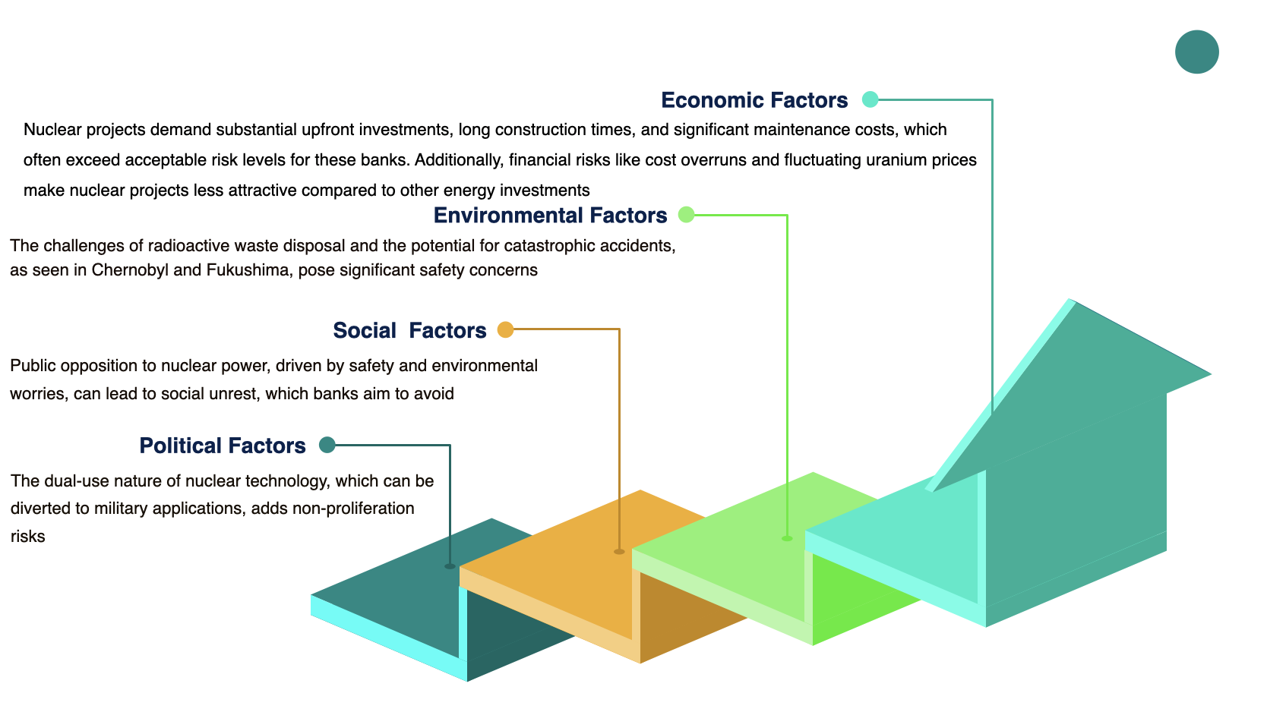

FIG. 1 Summary of Factors Hindering Financing of Nuclear Power Plants by DFIs

1. THE CASE FOR FINANCING KENYA’S NUCLEAR POWER PLANT THROUGH INTERNATIONAL FINANCE INSTITUTIONS

Kenya's infrastructure landscape illustrates a dynamic blend of achievements and challenges in financing large-scale projects. The Standard Gauge Railway (SGR) and the Lamu Port-South Sudan-Ethiopia Transport (LAPSSET) Corridor are prime examples of Kenya's success in attracting substantial investments through government funding, concessional loans, and Public-Private Partnerships (PPPs). However, these projects have also faced issues related to debt sustainability and execution. The Nairobi Expressway, a 27-kilometer road funded through a $600 million PPP with the China Road and Bridge Corporation, is a notable success story, highlighting effective private sector engagement in infrastructure development.

Nuclear power has proven to be competitive in attracting funding from multilateral banks, bolstered by several key factors. With a high capacity factor, nuclear plants can operate near maximum capacity for extended periods, increasing total electricity output and driving down the Levelized Cost of Electricity (LCOE). Additionally, nuclear power benefits from low fuel costs and stable, predictable operating expenses, making it less susceptible to fuel price fluctuations. Its emission-free nature adds significant value, particularly in regions with carbon pricing or emissions reduction targets. Cost efficiencies are further achieved through economies of scale, standardized reactor designs, and streamlined construction practices. Government support, including loan guarantees, tax incentives, and long-term power purchase agreements, along with clear regulatory frameworks, significantly enhances the financial attractiveness of nuclear projects. Moreover, innovative financing models, such as PPPs, can help distribute risks and attract private investment, making nuclear power a compelling option for multilateral bank funding.

Kenya has conducted numerous technical reviews on various financing models for nuclear power plants, identifying Vendor Equity and PPPs as the most feasible options. Vendor equity arrangements offer advantages such as access to capital, risk-sharing, and enhanced collaboration. However, potential drawbacks include dilution of ownership, valuation challenges, and conflicts of interest. The PPP model offers the potential for more efficient and innovative delivery of public services and infrastructure. Nevertheless, it also comes with risks and challenges that require a robust mitigation management plan to ensure success (NuPEA, 2023).

1. IMPACT OF FINANCING OF POWER PLANTS IN KENYA BY DEVELOPMENT FINANCE INSTITUTIONS AND APPLICATION OF ENVIRONMENTAL SAFEGUARDS FRAMEWORK

Development finance institutions (DFIs) in Kenya have a critical role to play in financing power plant projects in the country. These institutions have a track record of providing long-term financing to various sectors as part of the industrialization strategy, and the energy sector is a key area for investment to support economic growth. By leveraging their expertise in financial assistance and investment, DFIs have always bridged the financing gap for power plant projects in Kenya, especially in Geothermal and transmission projects, which often require significant capital investment. Additionally, DFIs have also collaborated with other financial institutions and stakeholders to mobilize resources and provide tailored financial solutions to support the development of power plants in Kenya.

In 2010, the European Investment Bank, the World Bank, the French Development Agency (AFD), the German development bank Kreditanstalt für Wiederaufbau (KfW), and the Japanese development financiers (JICA) invested in the expansion of the Olkaria I and IV geothermal power plants in Kenya. The share of financial investment by organizations including the Kenya government is illustrated in Fig. 2.

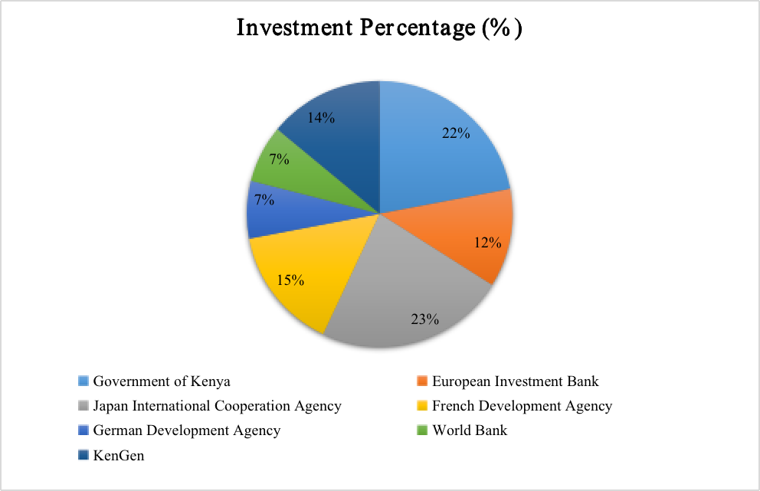

FIG. 2. Share of Investment for Olkaria IV

The implementation of the project led to the relocation of four native Maasai villages. Mediation was therefore necessary due to the need to resolve conflicts with the local host community over their relocation and compensation concerns. Olkaria IV project conflict was manifested through socio-economic (51%), environmental (21%), cultural (14%) and political (14%) dimensions. Inadequate information and participation in the decision-making process on project design, relocation and compensation can be attributed to the discontentment. The project was implemented as guided by the financiers’ environmental and social safeguards. KenGen was able to mediate the conflicts through procedural application of the recommendations for resolving such conflicts and all complaints were resolved without going to court. This facilitated project implementation including successful relocation of project affected people in 2014 paving way for development of the 280 megawatt power project. In Africa, mediation is often donor-driven including the Olkaria IV mediation which was implemented as per the recommendations of the European Investment Bank and World Bank (Kong’ani, 2022).

## CONCLUSION

Energy mix projections in Kenya support the inclusion of nuclear power generation. Preliminary reactor technology studies indicate small modular reactors are more favorable per the country's current needs and conditions. The reactor technology is therefore likely to be one of the advanced nuclear reactors under development with enhanced safety features. The safety of people and the environment is therefore guaranteed from these advanced nuclear reactor technologies, leaving the only challenge to deployment being financing and public acceptance. Concerted international efforts to enhance the availability of finance for accelerating the deployment of nuclear and other clean energy sources have been recognised as one of the immediate needs toward net zero. This creates an opportunity for development finance institutions to contribute to advancing their climate change mitigation goals as evidenced by the significant investment in renewable energy sources.

Kenya seeks to mobilize the necessary resources and expertise to advance its nuclear power program sustainably. Additionally, Kenya will engage stakeholders, conduct thorough feasibility studies, and adhere to stringent safety and regulatory standards throughout the project. Given the significant capital investment required for NPP projects, DFIs could potentially play a crucial role in financing such projects by leveraging their expertise in financial assistance and investment. DFIs need to align their policies and strategies to support the development of NPPs in Kenya, considering the long-term nature of these investments and the potential impact on the energy sector and overall economic growth (Njenga, Ngugi, & Mwaura, 2006). To enhance their effectiveness in financing power plants, DFIs in Kenya may need to address challenges such as bureaucratic processes, political interference, and non-performing loans. Policy options to improve the operations of DFIs could include streamlining decision-making processes, reducing government ownership to minimize political influence, and diversifying funding sources to ensure sustainability. By strengthening their institutional structures, enhancing efficiency, and adopting appropriate investment strategies, DFIs can play a crucial role in financing nuclear power projects and supporting the growth of the energy sector in Kenya (Njenga, Ngugi, & Mwaura, 2006).

The World Bank has set out an environmental and social framework for sustainability in the projects it funds. Key to this framework is the Environmental and Social Standards (ESS). The ESS are the set of requirements for borrowers to subscribe to in the identification and assessment of environmental and social impacts of projects financed by the Bank. One of the goals of the ESS is the enhancement of sustainable development outcomes through stakeholder engagement (World Bank, 2017). Stakeholder engagement is key in nuclear power plants. The World Bank states that it can use a country’s environmental safeguard framework in environmental impact assessment, provided it will address all project risks to the environment. If the framework is not sufficient, the WB has a provision for enhancing it through measures and actions to address gaps in order to ensure the framework meets the requirements of the ESS (World Bank, 2017).

Indirect benefits for embarking countries in nuclear power project financing through development finance institutions would be through application of these development financial institutions’ environmental and social safeguards. These environmental safeguards have a reputation for ensuring due diligence in protection of people and the environment. This ultimately leads to conflict elimination and facilitates project implementation reducing project delays which could result in cost overruns. The application of such state of the art standards would go a long way in enhancing stakeholder confidence in Kenya’s nuclear power project by the host community and general public.

The IAEA has issued Safety Standards for use by Member States. These are a global reference for protecting people and the environment from harmful effects of ionizing radiation. Since the inception of the nuclear power programme in Kenya, IAEA Safety Standards have been used in developing the necessary infrastructure as they offer recommendations and best practices. A combination of these with international requirements goes further to enhance nuclear power programmes. In the area of environmental sustainability, environmental safeguards will play a key role in addressing the numerous socio-economic issues and concerns of nuclear power programmes and complement IAEA Safety Standards and the framework set out in Member States.

## REFERENCES

[1] Government of Kenya. (2023a). *Least Cost Power Development Plan, 2023-2042.* Nairobi: Government of Kenya.

[2] Government of Kenya. (2023b). *National Climate Change Action Plan 2023-2027.* Nairobi.

[3] Humphrey, C., & Prizzon , A. (2024, May 30). *Why and how multilateral development banks should operate in middle-income countries.* Retrieved from ODI: https://odi.org/en/insights/why-and-how-multilateral-development-banks-should-operate-in-middle-income-countries/#:~:text=MDBs%20have%20a%20critical%20role,returns%20for%20the%20entire%20planet.

[4] The Breakthrough Institute, (2024, May 30). *How Multilateral Banks Are Holding Back the Developing World*. Retrieved from The Breakthough Institute: https://thebreakthrough.org/blog/how-multilateral-banks-are-holding-back-the-developing-world

[5] International Atomic Energy Agency. (2011). *Stakeholder Involvement Throughout the Life Cycle of Nuclear Facilities. .* Vienna: IAEA.

[6] International Atomic Energy Agency. (2021). *Stakeholder Engagement in Nuclear Programmes.* Vienna: IAEA.

[7] Kong’ani, L. N. (2022). *Using Mediation to Resolve Development Project Conflicts: a Case of Olkaria Iv Geothermal Project, Kenya (Doctoral dissertation, University of Nairobi).* Nairobi: University of Nairobi.

[8] Musyoka, D., & Field, R. M. (2018). Review of the environmental oversight framework in Kenya, in light of a nuclear power programme. *Progress in Nuclear Energy*, 108, 89-98.

[9] NICE Future Initiative. (2024, May 20). *Evaluating Nuclear Energy as Part of Kenya's Clean, Reliable Energy Future*. Retrieved from https://www.nice-future.org/kenya-nuclear-energy-future#

[10] Njenga, G., Ngugi, R., & Mwaura, M. (2006). *Development Finance Institutions in Kenya: Issues and Policy Options (No. 14).* Nairobi: Kenya Institute for Public Policy Research and Analysis.

[11] Nuclear Power and Energy Agency. (2024, May 28). *Nuclear Power and Energy Agency. Strategic Environmental Assessment Report for Kenya’s Nuclear Power Programme.* Retrieved from https://www.nema.go.ke/images/Docs/SEA%20Reports/Final%20NuPEA%20SEA%20REPORT%2014.07.2023-min.pdf

[12] Nuclear Power and Energy Agency. (2023). *Funding Plan for the Kenya Nuclear Power Programme - Final draft.* Nairobi: Nuclear Power and Energy Agency.

[13] The Center for Strategic and International Studies . (2024). *The World Bank and the International Monetary Fund Should Do Less to Achieve More.*

[14] World Bank. (2017). *The World Bank environmental and social framework.* Washington DC: World Bank Group.