MAKING THE COMPLEx simple
The application of parametric design tools
in the realisation of Rolls-Royce SMR.

A. CRABB
Rolls-Royce SMR / AtkinsRéalis
Bristol, United Kingdom
andy.crabb@atkinsrealis.com

S. GALVIN
Rolls-Royce SMR/ AtkinsRéalis
London, United Kingdom
sean.galvin@atkinsrealis.com

Abstract

The application of parametric thinking has enabled Rolls-Royce SMR to design its Small Modular Reactor (SMR) to encompass modularity throughout its evolution from the first principles of its bold architectural vision through to the detail of how the smallest elements are put together. Parametric modelling has given the power of great design thinking back to the designers to be able to deal with immense complexity in a coherent and coordinated way. This innovative toolset enables true three-dimensional design modelling to happen in real time, while taking onboard an unintelligible number of variables. This innovative way of thinking has opened fresh new areas of computational design that can adapt to many environments ranging from shell roof structures, earthworks, functional optimisation, modular construction to cost and schedule control. All fundamental in a production line of multiple SMR units that will benefit from design optimisation. Parametric thinking has been fundamental to the production of an efficient new design for energy production for our future energy security in the form of Rolls-Royce SMR.
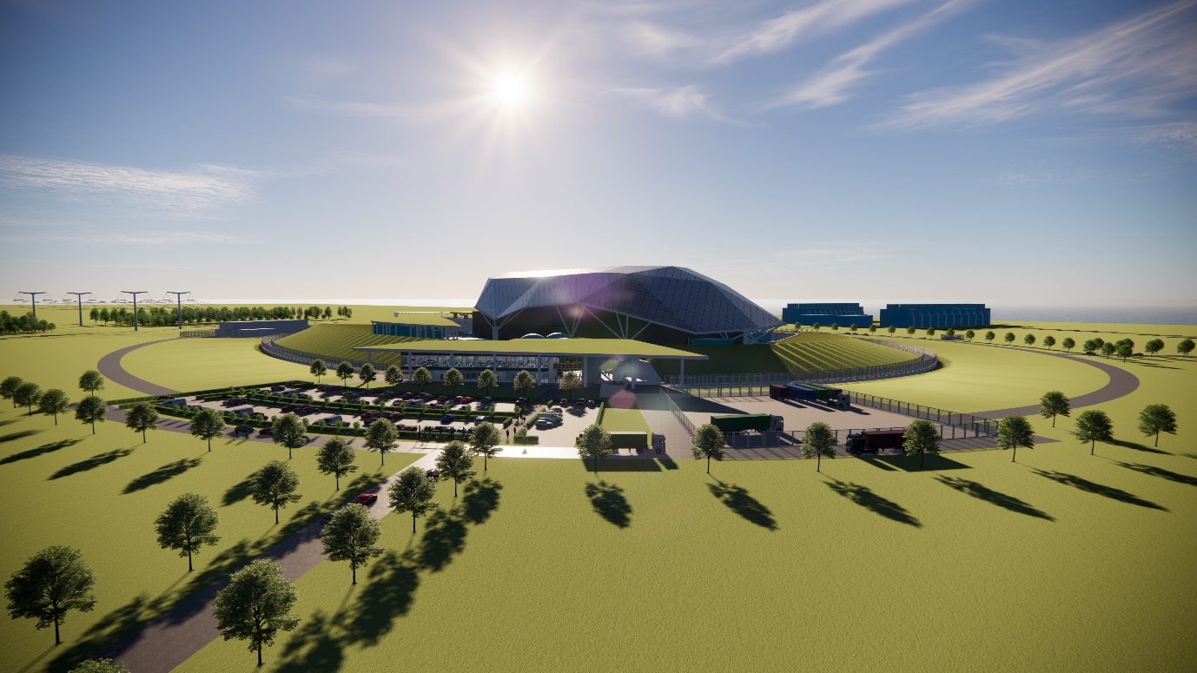
FIG. 1. Rolls-Royce SMR vision.

INTRODUCTION

Background
Rolls-Royce SMR (RR SMR) is a radically different approach to delivering new nuclear power. This approach takes advantage of factory-built modularisation processes, reducing the amount of on-site construction required. This means it is possible to deliver a low-cost solution that is competitive with renewable alternatives. Modularisation of reliable and proven technology lies at the heart of the concept behind RR SMR which maximises the effective use of a factory environment combining standard components with advanced manufacturing techniques. In the realisation of RR SMR we have established the largest national engineering collaboration the UK has ever seen, uniting some of the most respected and innovative engineering organisations on the planet such as AtkinsRéalis, Assystem, Jacobs, Laing O’Rourke and BAM who now act as supply chain partners, able to contribute their design and industry experience to the delivery of the project.
The SMR will operate at very high levels of availability (>92%) for 60 years, providing long term stable clean energy, to support both on-grid electricity as well as a range of off-grid clean energy solutions. It will support the decarbonisation of industry and the production of clean fuels to enable the energy transition in the wider heat and transportation sectors. For nuclear power to be widely adopted and meaningfully contribute to the global effort to decarbonise, it needs to be commercially investable and reliably delivered. The current model of nuclear new build as a major, one-off infrastructure project is not appropriate in a world that needs new nuclear power stations delivered quickly and affordably to a wide variety of global locations.
The RR SMR approach means that approximately 90% of the plant will be factory fabricated and designed to be road transportable in sealed modules, then prepared on site where the plant is assembled and commissioned by the team under a turnkey Engineering, Manufacture, Assembly (EMA) contract. Offering a complete nuclear power station as a manufactured product delivers the cost and risk reductions and quality improvements associated with factory fabrication, while simultaneously removing the expense, lead-time and risk associated with developing a new, inexperienced supply chain and EPC contractor team for each new plant constructed.
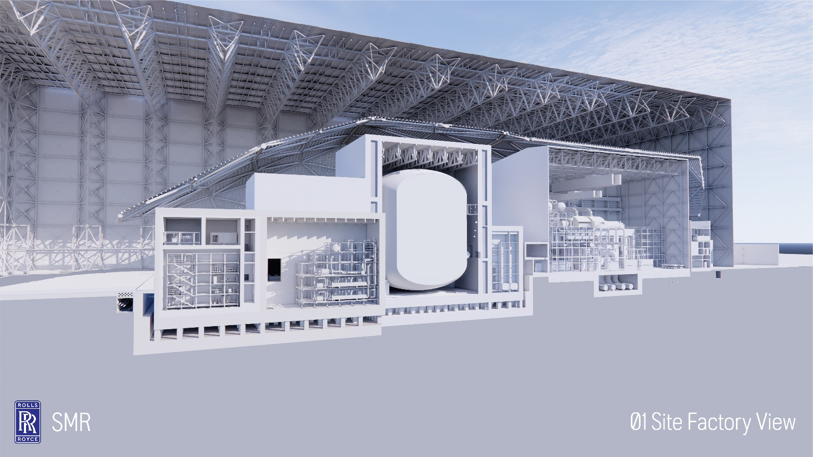
FIG. 2. Rolls-Royce SMR site factory long section.

The application of parametric design tools
This paper highlights examples where parametric modelling has enabled the swift coordinated design of complex structures through a user friendly and interactive human-centric approach. Parametric thinking embodies a new method of applying a vast set of variables in a way that can be simply manipulated by the human mind. A subject is explored to isolate the key design aspirations to allow a computer storyboard to be developed to encompass the various design attributes tied to a computer logic that can visually manipulate the variables in real time. This paper exhibits the application of parametric thinking in the RR SMR design in three specific areas: A. Module design, distribution and interconnectivity; B. Shell roof design; C. Berm design.
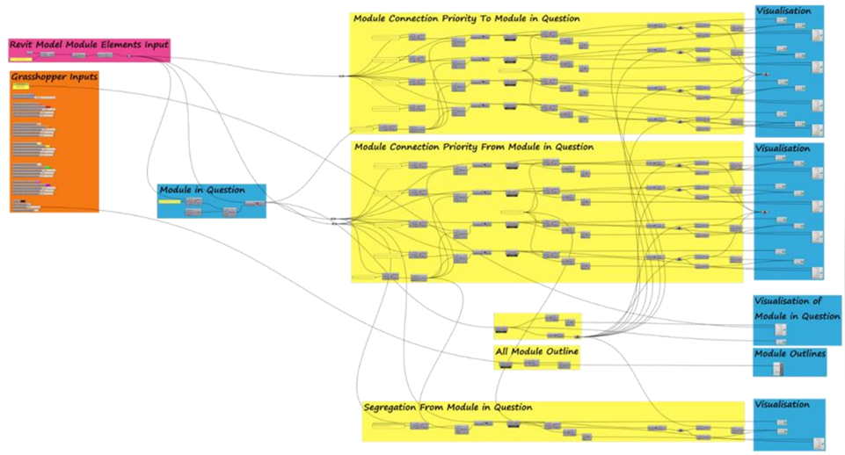
FIG. 3. Example of the algorithm.

CASE STUDY A: mODULAR DISPOSITION

Background
It is intended that RR SMR represents an optimised solution to the production of energy. Optimisation of design is key to an optimised layout to enable an optimised solution. Modularisation of a nuclear power station represents an immensely complex challenge that needs to understand the design from micro detail to macro masterplanning and understand the interplay between innumerable functional systems, personnel and built forms. RR SMR utilises a factory-built modular concept where each module holds a specific function or part function within a vast three-dimensional array of modules. The optimisation of the matrix of connectivity between the modules, the built form, the reactor containment core area and the wider site represented an immensely challenging brief with a design team working from many perspectives. To enable coordinated thinking across many teams a methodology was required to somehow pull together the thousands of threads to optimise the three-dimensional realisation of the main system’s disposition. Parametric thinking was applied to this complex challenge as a tool which enabled a highly optimised solution to be found.
A module is a detachable self-contained unit that usually forms part of a set of standardised parts that ultimately can come together to construct a more complex structure. Modular design in essence is a design approach that subdivides a system into smaller parts to create things with standard interfaces. A module in RR SMR is a volumetric space that can be delivered on the back of a lorry and craned into place on site, speeding up the construction process while providing assurance on cost and programme delivery.

  - Objectives

The objective, in this specific case, was to understand, govern, manipulate, optimise and eventually set out the volumetric design and connectivity for the modularisation of the main functional systems to support RR SMR within the reactor building around the central core area.
As time progresses in a project’s design evolution the number of variables frequently increase as the knowledge base increases. This frequently results in design creep, increases in layout areas, increases in program, increases in costs and a design that can stray from its original defining criteria. When designing a Small Modular Reactor this challenge is very relevant with many teams of specialised designers concentrating on specific areas.
The objective within the modularisation process was to keep the evolution of the design tangible, concise and realisable in order to keep control of design evolution. As the title of this document states, ‘Making the complex simple’ was the objective in the design evolution for RR SMR through the use of modelling techniques that would bring together a wide-ranging set of teams and facilitate a holistic common understanding.
Parametric modelling is well understood and widely utilised in the architectural profession. The objective with RR SMR has been to take best practice thinking from other sectors to overlay and inform thinking in the nuclear sector in order to manipulate complex structures and volumetric forms in a more efficient, more simplified way. Parametric modelling is a methodology to bring together many criteria in a way that the human brain can cope with. It involves setting out what the objective of the design exercise is, identifying and extracting the design drivers, setting the drivers into an algorithm then utilising a series of dedicated software to manipulate the drivers.
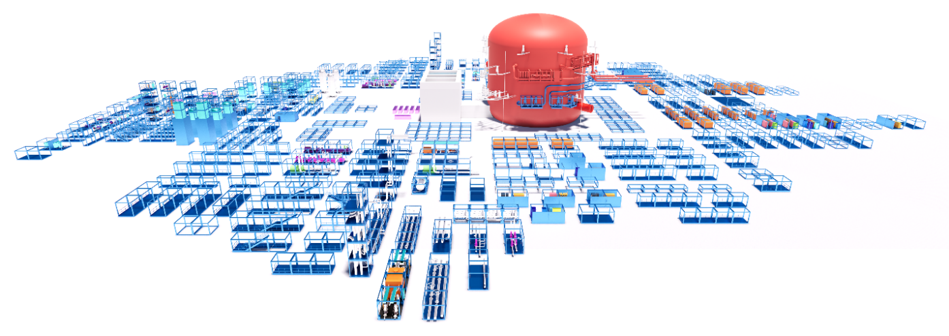
FIG. 4. Modular kit of parts.

  - The application of parametric design

To successfully apply parametric thinking to any design clear definition of what is trying to be achieved is fundamental. In principle parametric modelling mimics many of the working processes of the human brain. To resolve designs in your head requires clarity of thinking and clear identification of what the design aspirations and challenges are, understanding how the design can be separated into its constituent parts, understanding how these parts overlap and the interplay between them, and how to integrate these dense layers of information. Our brains do this naturally and we do not notice the processes involved in our computational thinking. Within parametric modelling these processes need to be clearly extracted and identified.
To enable optimisation for the disposition of the modularisation of RR SMR a series of metadata criteria were identified that governed the setting out of the functional systems. These were identified within each module and fed into from the various teams that were formulating the evolving designs. A series of metadata was embodied into each system and module to identify significant linkages, significant separations, placement criteria, symbiotic relationships, proximities, heights above other elements, access criteria, seismology and radiological criteria. The metadata list was agreed in advance to give a full breakdown of what needed to be understood in a fully considered design. The metadata was outlined for all modules including outline modules still in evolution.
A sliding scale of criteria was identified that set a variability into the computational analysis utilising several visualisation techniques to best exhibit the area in question. For example, a colour-coded traffic light type visualisation system where red represented poor conformity, amber reasonable conformity and green good compatibility to the specific criteria under investigation was used in certain cases. Occasionally a simple line represented connection distance, occasionally the thickness of a line indicated importance. Fig. 6 shows a modular element under consideration, in this case the focus module is highlighted in blue with purple indicating a direct adjacency, yellow an important adjacency and green a preferred adjacency. The onscreen (or in headset) model enabled real time manipulation of these many sets of interacting metadata to inform volumetric layout optimisation and balance from the required perspectives. It also aided design and linkages interrogation at both the micro and macro scale, allowing the architects to seamlessly flip from one to the other.
The volumetric disposition of the systems via the module layout was studied from many perspectives to conclude the most optimised layout from the various, and frequently opposing, systems and requirements. The major advantage with the adoption of parametric modelling was that these complex adjacencies and studies of best solutions were all considered in the same format in a visually simple and engaging way. Changes to the layout and implications on linkages were instantly updated and could be easily disseminated, understood, discussed and agreed across the various teams. The tangibility afforded by the parametric modelling to all parties helped accelerate conjoined design consideration across many teams and across many challenges to evolve a design that truly balances the raft of inputs involved.
The following illustrations indicate some working screen extracts of metadata manipulation via parametric modelling in real time. Each design team was able to see how their requirements were being accommodated, or challenged, in the context of other systems. The metadata enabled a wider interrogation of the challenges involved in the disposition of systems to compose a nuclear power plant in a quicker, more efficient and more tangible way that would not have been possible without the power of parametric modelling.
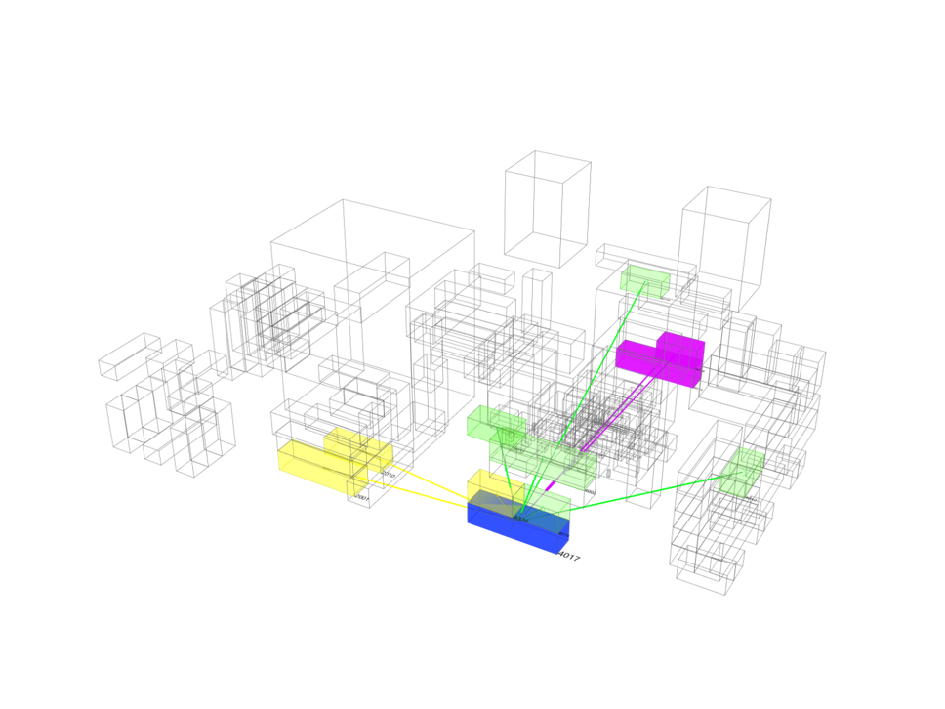
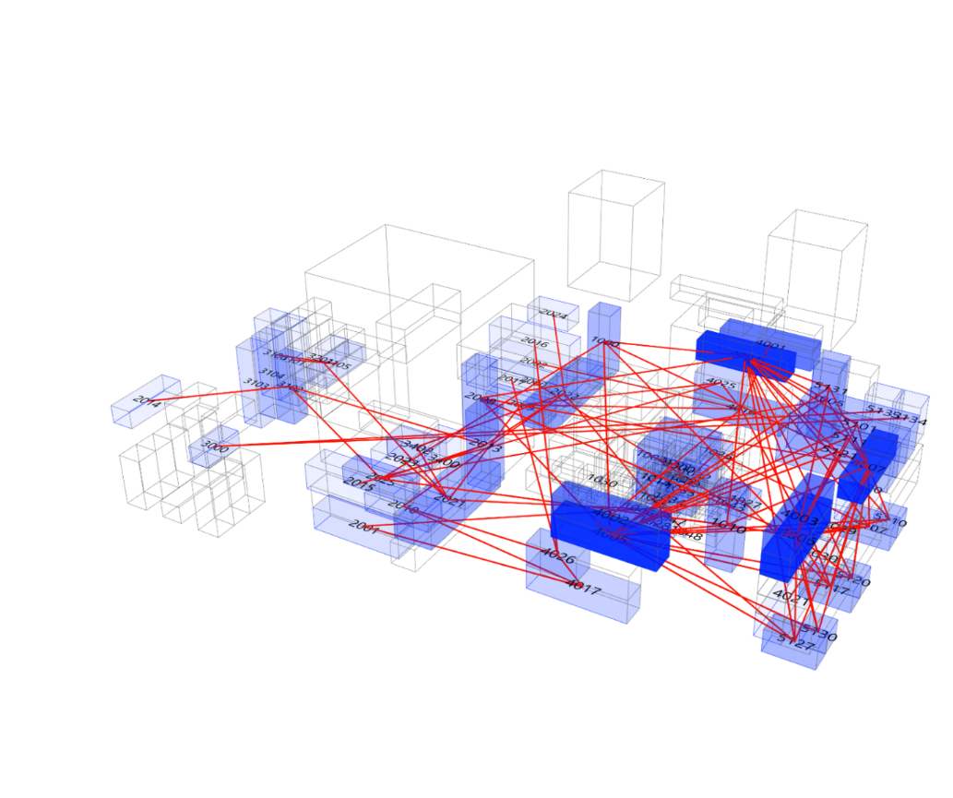
FIG. 5. Dynamic nodal diagram.
FIG. 6. Segregation diagram.

CASE STUDY B: SHELL ROOF

3.1. Background
FIG. 7. Elevational view showing the shell roof.
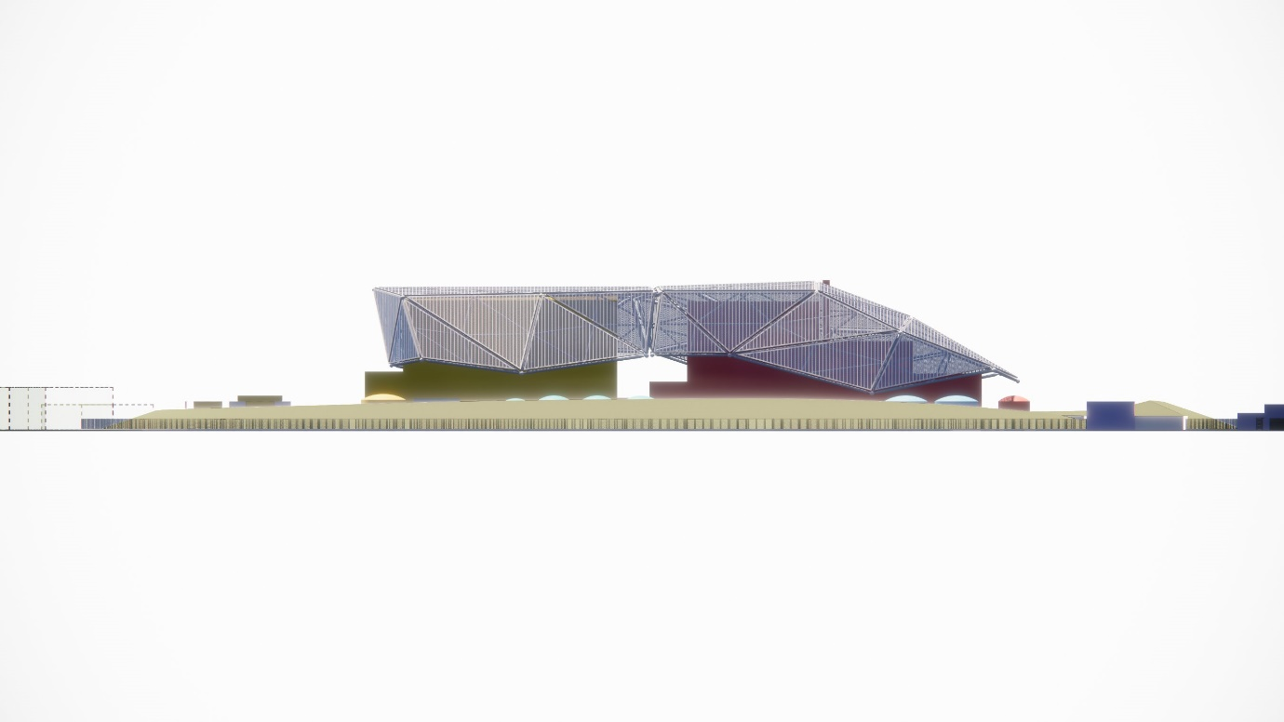
Base – Berm
Middle – Functional Building
Top – Shell Roof
The shell roof responds to the functional technical forms that sit below it (Reactor and Turbine Building) acting as a unifying element, merging two vital and typically distinct elements into one visually dynamic form shown in Fig 7. To minimise the visual ‘weight’ and solidity of the roof and to create a lightness the form was conceived as an elevated floating surface allowing views of the façade and buildings below through the semi-transparent skin, while expressing the structure below and how it was assembled. The elevations have been set out with a clearly articulated base (berm), middle (functional buildings below shell roof) and top (shell roof) shown in Fig 7.
The architectural vision for the shell roof was conceptualised as an angular form to facilitate with a dynamic stance. The angle of how the building ends is also fundamentally important to maintain this dynamism, visually guiding the eye along the elevation. The shell is not symmetrical generating a directional form with a ‘head’ towards the site approach and ‘tail’ away from the site approach. The profile along the bottom of the roof is also fundamental to the facilitation of movement and dynamism in the form seen in Fig 7.
The shell has been specifically designed to give an identifiable skyline image to RR SMR. It makes for simple recognition and branding logic. The shell gives a considered singular visual profile rather than a series of many parts and buildings to be negotiated under the Development Consent Order (DCO) process, specific to the UK planning context. This in turn aids to shorten the DCO consideration period. By concentrating the aesthetic element of the design into a single shell it frees much of the built form from the complexities of visual consideration. This allows for a much more robust, functional, simple, and commercially aware design for many of the built elements of RR SMR.
The speed of design development means that the form, size, volume, and location of many elements of RR SMR are not fixed and need to be frequently reconsidered. The image set by the shell form establishes a clear architectural vision to provide funding and tangibility in advance of a fixed design for the various complex elements of a new form of nuclear power station. The adaptability of the shell roof allows for a simply amended ‘skin’ that could adapt to the environment within which it is set, rather than adapting the base buildings design.

3.2. Objectives

When developing the design for the shell roof there were several design and functional objectives, all of which were used as direct and indirect parameters that were built into the algorithm used to develop the shell roof design proposition. The design objectives include:

- The shell roof is intended to give RR SMR identity: establishing an iconic profile, to aid commercial realisation in consort with a high quality design.
- The shell roof needs to be adaptable: to respond to program requirements it needs to have a level of flexibility and adjustability in its overall design to be able to dynamically respond to various siting requirements.
- The shell roof needs to be cost effective: design optimisation of the roof will generate the optimal form for increased cost saving while providing a robust set of detailing.
- The shell roof is to be designed with modularity at its core: delivered through unifying modular elements speeding up the process of construction.
- Planning/DCO process: The shell roof is part of the generic design meaning that it will provide clarity of design to the planning process.

The performance objectives include:

- Lightweight in construction.
- Modular in assembly.
- Air, light and rain permeability.
- Screens and unifies without hiding or blocking.

3.3. The application of parametric design

When developing the algorithm, the architectural team used the design and performance objectives set out in Section 3.2 as key parameters to drive the design output of the shell roof. One of the first design iterations was to optimise the number of panels or facets required to panellise the shell roof. Using parameters such as the longest length of steel that can be achieved to cover such distances, the required number of panels was reduced from 46 to 45.
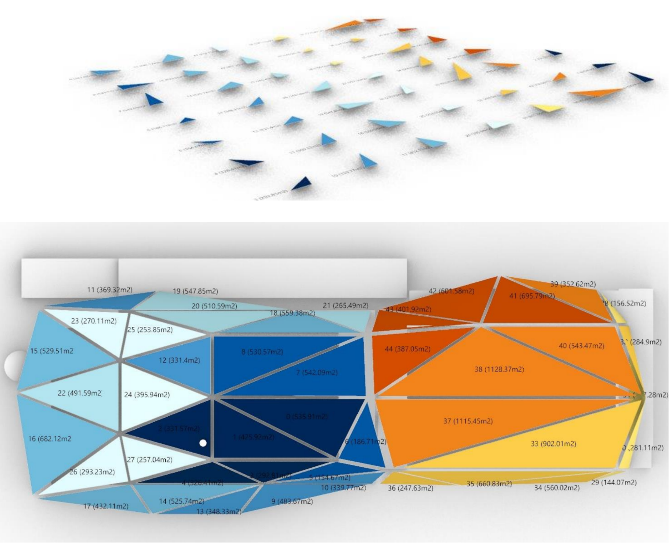
FIG. 8. Shell roof kit of parts.

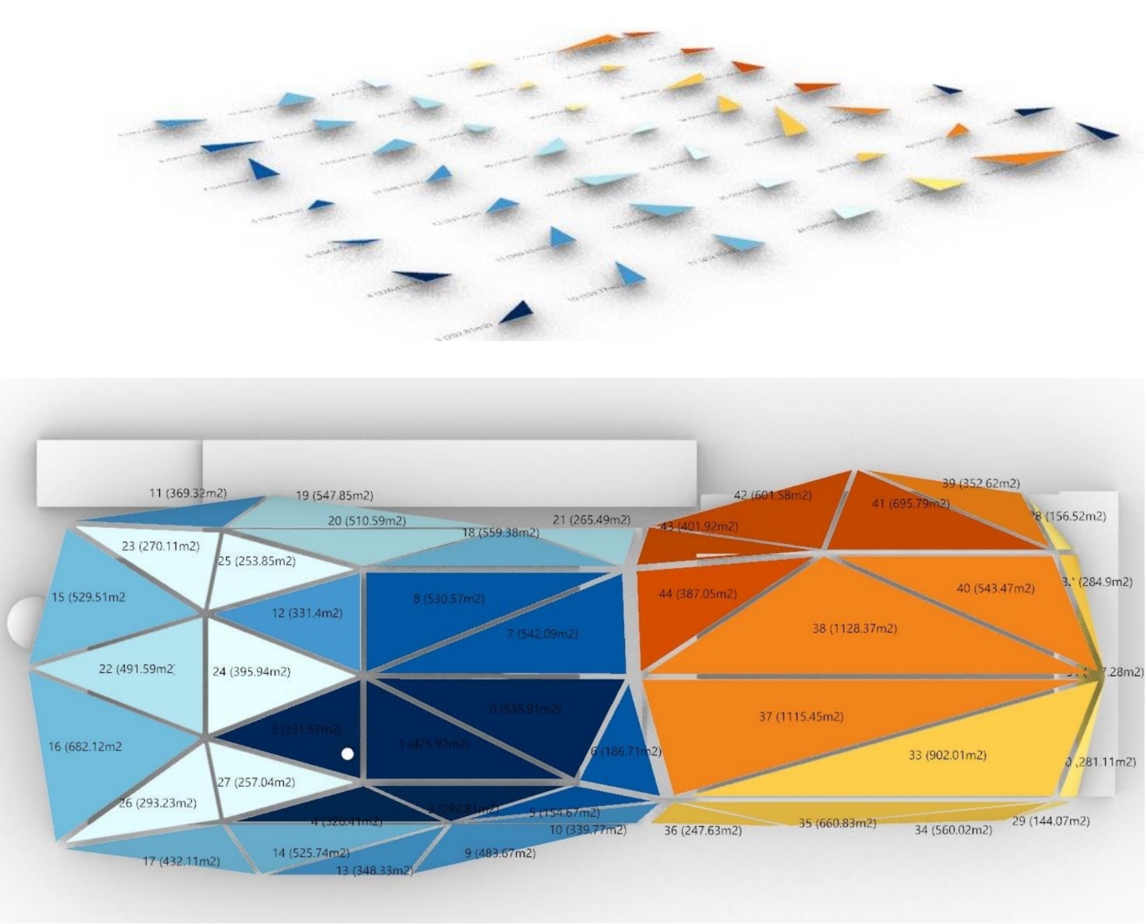
FIG. 9. Panel optimisation.

Optimising the number of panels also enabled optimisation of the size of the panels. This process achieved a significantly narrower form, which can be seen in Fig. 10. The grey line highlights the form and panel separation of the previous shell roof, where the green region emphasises the optimised shell roof. As a result of this algorithmic process, the overall surface area of the shell roof was reduced by 14.6% as shown in Table 1.
An additional realised benefit of the application of an algorithmic process has meant that the shell roof fits more comfortably within the site factory, which will aid the construction process. This process has also reduced oversailing elements by bringing the shell tighter to the building beneath. This can be seen in Fig. 10, which highlights the white massing of the building beneath and the reduced sailing elements highlighted in red.
By utilising such tools, the design team has been able to realise the reduction in number of facets, as well as overall surface area which will help reduce the overall cost to RR SMR. A full analysis of cost implications and reductions is presently ongoing as a product of the parametric design for the shell roof.

​ TABLE 1. OPTIMISATION OF SURFACE AREA

Optimisation | Before | After | Percentage change
Roof Surface Area | 23,755m2 | 20,295m2 | 14.6%
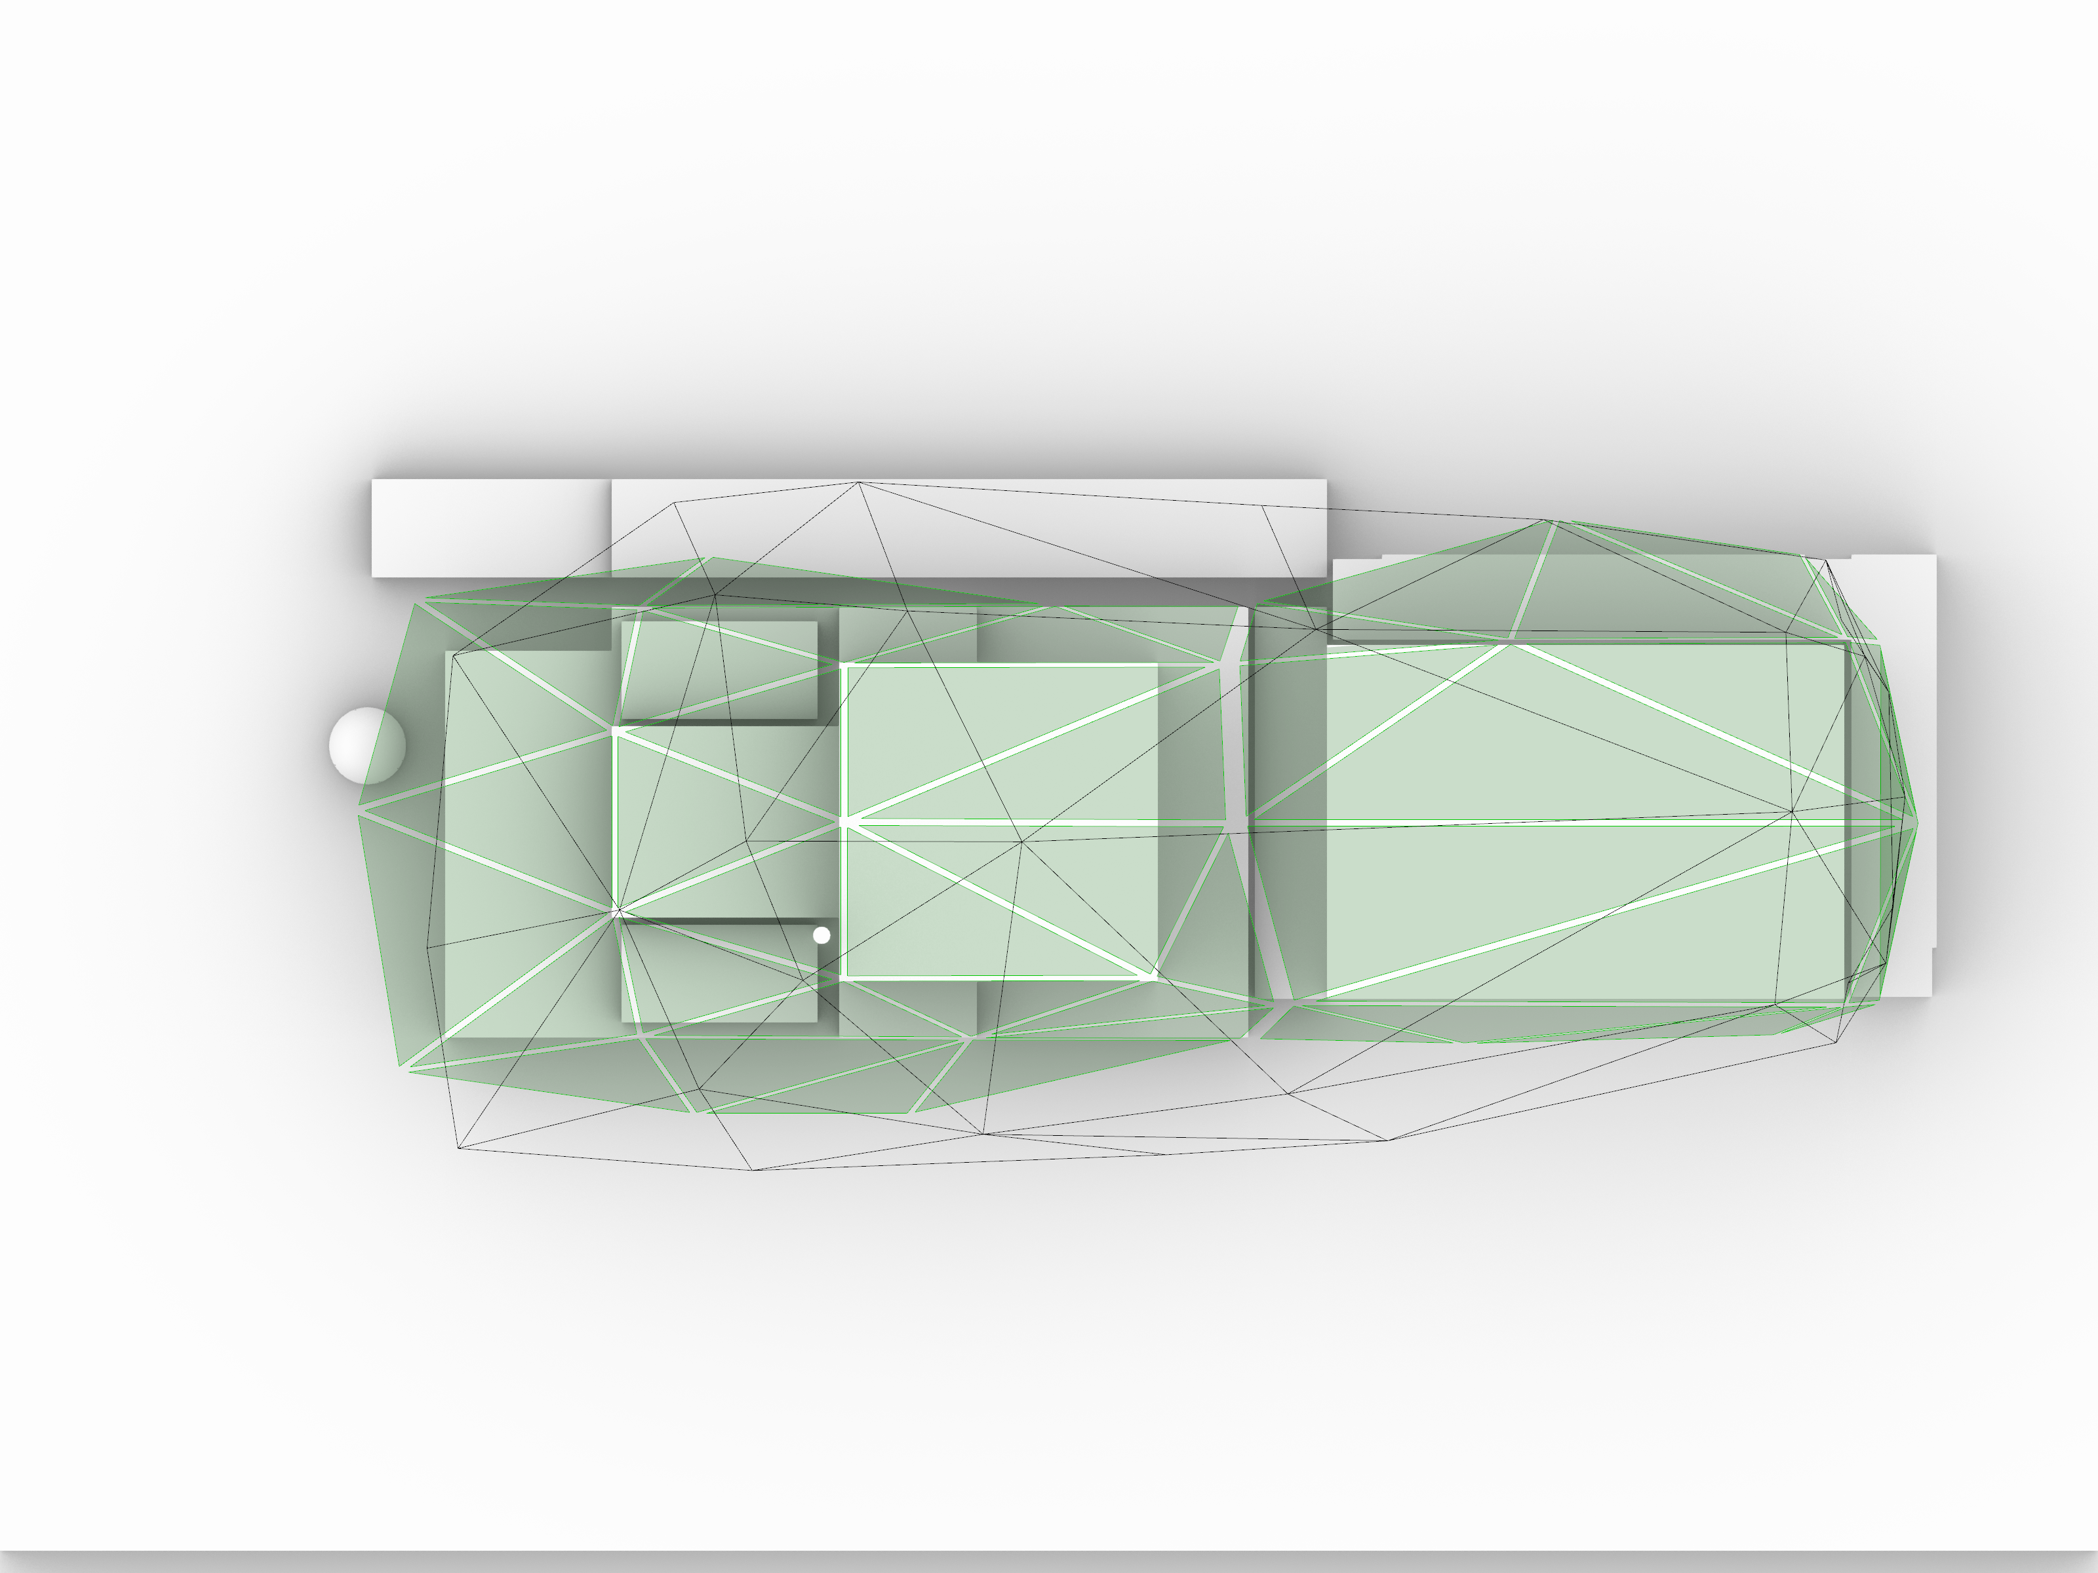
FIG. 10. Reduced shell roof footprint.

CASE STUDY C: BERM

4.1. Background
The RR SMR design is surrounded by a berm that wraps around the site. A berm is a level space, shelf, or raised barrier, often made of compacted soil. The berm in RR SMR has been conceived as a response to sustainably reuse the soil that is excavated during the construction of the reactor and turbine building which also contributes to the overall sustainability strategy of the entire site.

4.2. Objectives

In addition to the sustainability aspects of the berm, the design also serves the following purposes:

- The organic form of the berm acts as a visual barrier to obscure the plethora of Balance of Plant facilities from view and acts as an anchor point to the land, as the shell acts as a touch point to the sky.
- Situated on the periphery of the site, the berm helps envelop the majority of SMR facilities from the harsh attributes of a marine environment.
- Conceptually the berm forms a methodology to adapt to differing site conditions and constraints. It is intended that the earthwork berm highlights the sustainable credentials of RR SMR within a high quality, iconic and organic environment.

The berm has several dynamic and static functional requirements which impact its form, these include:

- Dynamic gradient that changes around the outside perimeter of the berm.
- Static maximum gradient around the inside perimeter of the berm.
- Dynamic high and low point of the berm that directly responds to the internal context.

The application of parametric design
The architectural team used the design aspects and functional requirements set out above to develop the algorithm to produce the form of the berm. Figures 11 and 12 illustrate the improved control and accuracy associated with parametric design, with a smoother perimeter edge shown in Fig. 12 compared to Fig. 11.
Parametric modelling enabled the architectural team to reduce the length of retailing walls required. This was done through dynamically increasing the gradient in various areas around the site to be able to bring the internal face of the berm directly to the ground, eliminating the need for a retailing wall in. A realised benefit from this optimisation process was a reduction of 45% in retaining wall length highlighted in Table 3 below.

​ TABLE 2. OPTIMISATION IN REQUIRED LENGTH OF RETAINING WALL

Optimisation | Before | After | Percentage change
Length of retaining wall | 1,056m | 570m | 45%

The reduction in retaining wall highlighted in red can be seen across the site when comparing Fig. 11 and Fig. 12. It is also evident in these figures how we were able to achieve an even gradient with the outside and inside perimeter of the berm having a more balanced distance from the highpoint of the berm (Fig. 13). Gradients can be calculated by dividing the vertical height by the horizontal distance. Fig. 12 shows how the horizontal distance from the vertical height of the highpoint is more even across the whole 360 degrees, this indicates a consistent gradient around the site. Compared to Fig. 11, the horizontal distance (run) of the perimeter from the vertical height (rise) of the highpoint changes across the site. This difference is illustrated in Fig. 13 below.

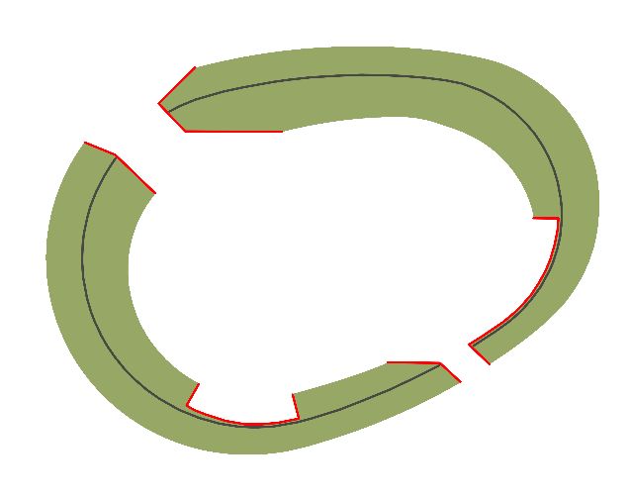
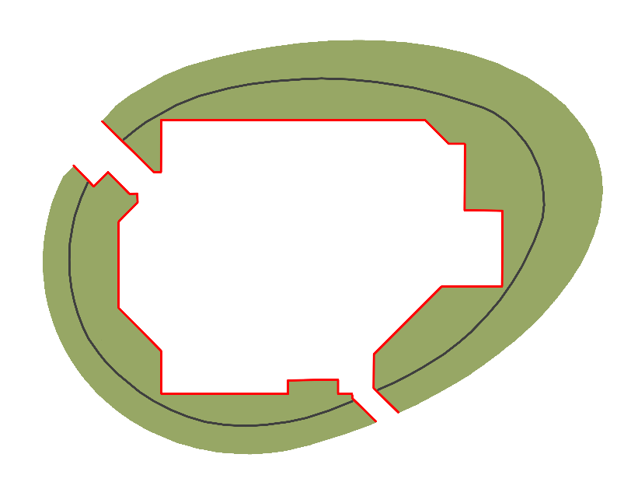
Highpoint
Highpoint
Outside of Berm
Inside of Berm
Outside of Berm
Retaining Wall
Retaining Wall
Inside of Berm

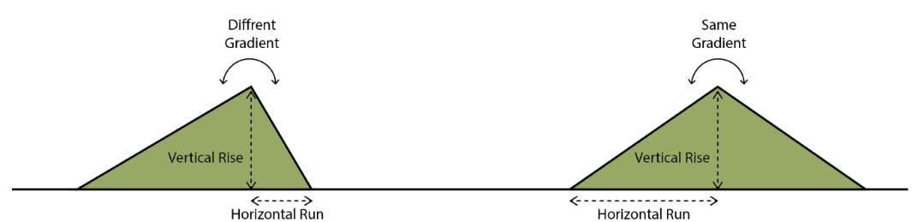
FIG. 11. Berm iteration 1.
FIG. 12. Berm parametrically modelled.
FIG. 13. Section through berm.

CONCLUSION
These three case studies, each addressing a separate aspect of the design for RR SMR, illustrate the advantages of early adoption and integration of parametric thinking into the design process, be it for a corporate headquarters building or the design for a new vision of nuclear power for the future in the form of RR SMR. The architecture team have been able develop the design with greater levels of accuracy and control, enabling effective optimisation and a generic design that is more responsive and adaptive to the ever-evolving requirements and constraints of the site. These optimisations, offering cost and time savings to the construction of the RR SMR design, are summarised in Table 4.

TABLE 3. SUMMARY OF OPTIMISATION BENEFITS

Optimisation | Before | After | Percentage change
Case Study A:  Modular connectivity | undefined | optimised | N/A
Case Study B:  Roof Surface Area | 23,755m2 | 20,295m2 | 15%
Case Study C:  Length of retaining wall | 1,056m | 570m | 45%

Through the use of parametric thinking, the complex has been simplified to enable the evolution of an efficient and innovative new vision of energy production in the form of RR SMR.

FIGURES
Figure 1 – Rolls-Royce SMR vision.
Figure 2 – Rolls-Royce SMR long section.
Figure 3 – Example of the algorithm.
Figure 4 – Modular kit of parts.
Figure 5 – Dynamic nodal diagram.
Figure 6 – Segregation diagram.
Figure 7 – Elevational view showing the shell roof.
Figure 8 – Shell roof kit of parts.
Figure 9 – Panel optimisation.
Figure 10 – Reduced shell roof footprint.
Figure 11 – Berm iteration 1.
Figure 12 – Berm parametrically modelled.
Figure 13 – Section through berm.

ACKNOWLEDGEMENTS
The authors would like to acknowledge Rolls-Royce SMR for the support and the wider RR SMR team for the continued efforts towards this incredible project. The views expressed in this paper are those of the authors and do not necessarily represent those of Rolls-Royce SMR. This paper is published with the permission of Rolls-Royce SMR.

