Parametric survey on critical core of RFBB-SS

S. ODMAA

School of Engineering and Technology, Nuclear Research Center, National University of Mongolia

Ulaanbaatar, Mongolia

Email: sodmaa1@num.edu.mn, sodmaa1@gmail.com

A.TSENDSUREN

Nuclear Research Center, National University of Mongolia

Ulaanbaatar, Mongolia

V.KH.HOANG

Faculty of Fundamental Sciences, Phenikaa University

Hanoi, Vietnam

T.OBARA

Laboratory for Zero-Carbon Energy, Institute of Innovative Research, Tokyo Institute of Technology

Tokyo, Japan

**Abstract**

Breed-and-burn (B&B) reactors maximize uranium utilization by using depleted or natural uranium and breeding fissile fuels while burning them. For this design, the neutron economy must be high during core operation to achieve critical core. This can be accomplished by locating fuels with large neutron multiplication factors in the high-neutron flux region via appropriate shuffling schemes.

Our previous analysis showed that a small power (750 MWe) rotational fuel-shuffling B&B reactor with silicide fuel and sodium coolant (RFBB-SS) core could maintain critical condition and sustain the B&B operating mode; however, we did not consider the fuel assembly (FA) duct and control rod assemblies (CRAs).

The objective of the present study is to clarify the impact of several parameters on burnup performance in a practical RFBB-SS core, including FA duct and CRAs, by conducting burnup analysis using the Monte Carlo SERPENT code. This analysis thus clarifies the impact of the parameters on core criticality in the equilibrium state. We found that a small practical RFBB-SS core loaded with 85 TD fuel, 180-cm high, with 55 FAs per one-sixth core, and a shuffling interval of 700 days could operate in critical condition.

## INTRODUCTION

Nuclear energy is one reliable, sustainable, and clean way to satisfy the increasing global energy demand due to population growth. Most current nuclear reactors are LWRs that cannot utilize uranium resources effectively. However, fast reactors such as breed-and burn (B&B) reactors maximize uranium utilization by using depleted or natural uranium and breeding fissile fuels while burning them [1]. Other advantages of B&B fast reactors include the reduction of spent nuclear fuel, and elimination of the need for fuel reprocessing plants.

To achieve critical core without enriched fuel, high-reactivity fuel must always be located in the high-neutron flux region by operating using an appropriate shuffling scheme. In pursuit of this goal, the concept of the rotational fuel-shuffling B&B fast reactor (RFBB) concept was developed [2]. Several RFBBs have been studied [2,3]. Our previous work focused on the feasibility of an RFBB with nitride fueled LFR to sustain the B&B operating condition [3]. In a subsequent study, a triuranium disilicide (U3Si2)-fuel was utilized for a B&B SFR core, and its feasibility was demonstrated [4]. U3Si2 fuel is usually used as a fuel for research and test reactors due to its high uranium density. It has a lower melting temperature than uranium carbide or uranium dioxide fuel. There is no need for enrichment of N-15 compared to uranium nitride fuel. Therefore, it is currently under development as an accident tolerance fuel and has the expected feature of proliferation resistance. It is therefore possible to achieve high burnup without using nitride fuel in an RFBB.

Our previous design study for an RFBB-SS did not consider fuel assembly (FA) duct or control rod assemblies (CRAs) [4]. The objective of the current study is to clarify the impact of several parameters on burnup performance in a practical RFBB-SS core, including FA duct and CRAs, by conducting burnup analysis. First, we carried out a core analysis using 96.7% of theoretical density (TD) fuel and considering FA duct and CRAs. Then, the core was redesigned by adding more fuel assemblies in the radial direction, and the shuffling interval was changed to achieve critical condition. Due to high fuel swelling in fast reactors, the fuel smear density had to be reduced to 85%TD for example in the present study. The practical core analysis using this smear density was performed by adding more fuel assemblies in the radial direction, changing the shuffling interval, and increasing the core height to achieve critical core.

## Reference core analysis with high density fuel

In our previous study, we investigated the feasibility of a small RFBB reactor using U3Si2 fuel of natural uranium and sodium coolant (RFBB-SS). The core achieved the B&B condition, but FA duct and CRAs were not considered. Core specifications were 140-cm height, 133 cm in equivalent radius, and 750 MW of power. There was a total of 168 FAs in a core (e.g., 28 FAs per one-sixth core). To sustain B&B operating mode, a 540-day shuffling interval was considered optimal for this design [4].

For a more realistic reactor, both FA duct and CRAs must be considered in the core design. When only the FA duct is considered in the core design, obviously the core becomes subcritical due to the inclusion of a metallic duct. To achieve critical core, FAs in the radial direction were increased to 45, making the core equivalent radius 200 cm. Then, CRA was considered; one location in the 45 FAs per one-sixth core was intended for one CRA. Fuel burnup analyses were then performed for cores with 45 FAs without CRA, and 44 FAs with one CRA per one-sixth core. The main specifications of the core are listed in Table 1. Fig. 1 shows the FA locations and shuffling scheme of both one-sixth core designs. The CRA location would be utilized as a coolant channel when CRAs are withdrawn from the core in Fig. 1b.

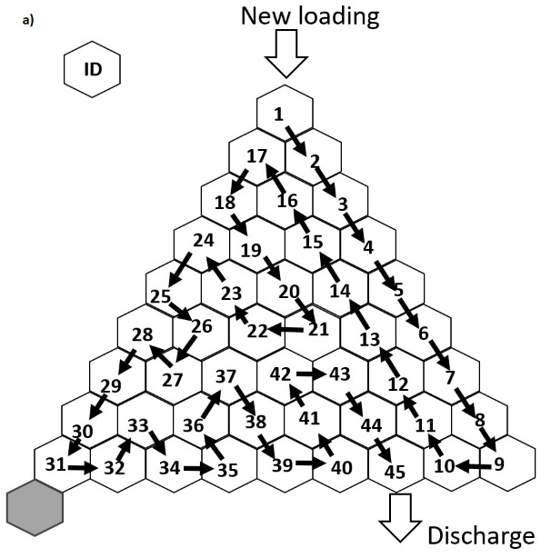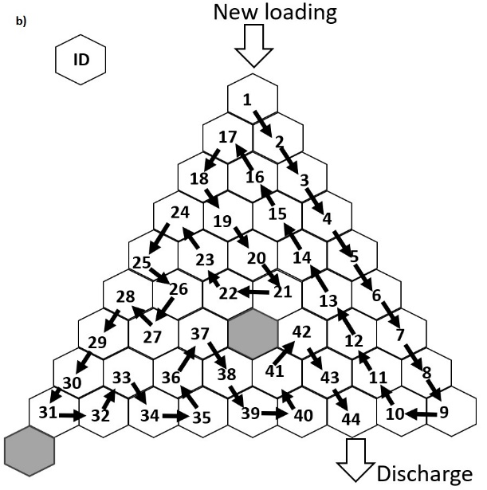

*FIG. 1. FA position ID and shuffling scheme of one-sixth of the core:*   
*(a) without CRA; (b) with CRA, which is withdrawn from the core.*

TABLE 1. Main core characteristics

|  |  |  |  |  |
| --- | --- | --- | --- | --- |
| Parameter | Value |  | Parameter | Value |
| Thermal power (MW) | 750 |  | Cladding outer radius (cm) | 0.51 |
| Active core height (cm) | 140 |  | Fuel pin pitch (cm) | 1.034 |
| Equivalent radius of core (cm) | 133 |  | Duct thickness (cm) | 0.2 |
| Total number of fuel assemblies | 270/264 |  | Distance between fuel assemblies (cm) | 0.2 |
| Number of coolant channel assemblies | 1/7 |  | Duct material | HT9 steel |
| Number of fuel pins in an assembly | 331 |  | Smear density of fuel | 97.6%TD |
| Fuel assembly pitch (cm) | 20.09 |  | Average fuel temperature (K) | 800 |
| Fuel material | U3Si2 |  | Average cladding temperature (K) | 700 |
| Fuel enrichment | Natural uranium |  | Average coolant temperature (K) | 700 |
| Coolant material | Sodium |  | Top and bottom reflector thickness (m) | 1 |
| Cladding material | HT9 steel |  | Radial reflector thickness (m) | 1.5 |
| Fuel rod radius (cm) | 0.45 |  | Reflector material | Sodium |

For neutron transport and burnup analyses of the proposed core, the continuous-energy Monte Carlo code SERPENT 2.1 [5] was used with the ENDF-B/VII.0 nuclear data library [6]. Each FA was equally divided into 7 burnup axial regions, each 20-cm high. As for the neutronic calculation conditions, the number of neutron histories per batch and total active batches were set at 50000 and 200, respectively. The first 50 active batches were kept as inactive batches for statistical treatment. These conditions were maintained for all burnup analyses calculations.

The lateral shuffling pattern was called a lateral big omega ($Ω$) scheme in our previous paper [4]. In the present work, there were 9 radial zones, 2 more than previously. Since the number of radial zones was increased, we renamed this similar shuffling pattern the lateral Christmas-tree shuffling scheme. A detailed explanation of the shuffling scheme is available in our previous work. Briefly, at the 1st shuffling step, all FAs were fresh; from the next step on, fresh fuel was loaded in position ID-1 with every shuffle, as shown in Fig. 1. The FA in the ID-1 location in the 1st shuffling step shifted to the ID-2 location in the 2nd step, while FA 2 transferred to 3 and so forth. After 9 shuffling steps, the initial fresh FA was transferred from the 9th radial zone to the 8th, and after another 8 steps, it moved to the ID-18 location. Moving along the lateral Christmas-tree path, after the 44th or 45th shuffling step, the first freshly loaded FA was discharged from ID-44 or ID-45.

The burnup analysis of the proposed core for two cycles of the RF scheme was carried out with a shuffling interval of 800 days. The objective was for the core to reach a critical state and sustain the B&B operating mode. Fig. 2 shows the changes in the effective multiplication factor (keff) of the core during the shuffling step. The core was able to operate at critical condition.

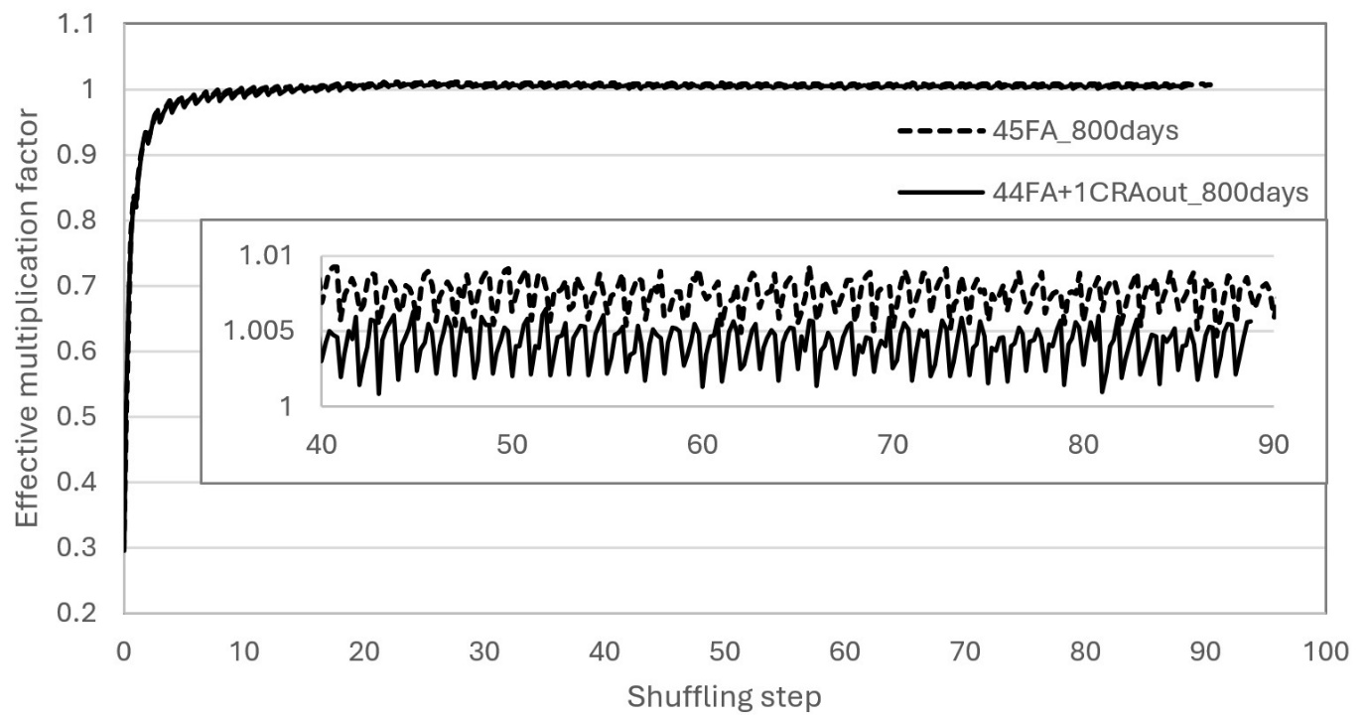

*FIG. 2. Changes in k-eff in a core with 45 and 44 FAs in one-sixth core.*

## Practical core analysis using reduced fuel smear density

The neutron flux is high in fast reactors, so that fuel swelling might be larger than in an LWR. To avoid fuel-cladding mechanical interaction, fuel smear density was reduced to 85%TD. We performed several burnup calculations, changing design parameters to achieve critical core; the fuel smear density was 85%TD in all cases. Details of cases are listed in Table 2. Case-1 in Table 2 differed from that in Section II in that both fuel smear density and shuffling interval were reduced. Since fuel density was reduced, it was necessary to redesign the core by increasing the fuel assemblies in the radial direction to 55 FAs per one-sixth core and increasing the shuffling interval as in Case-2 in Table 2. However, it was difficult to achieve critical core by changing the shuffling interval for the first two cores. Thus, the core height was increased from 140 to 180 cm by adding one more block to the top and bottom of the reference core, as Case-3 in Table 2. Finally, CRA was included in larger core, leaving a configuration of 54 FAs and 1 CRA block as in Case-4 in Table-2. For the last two cases, the shuffling interval was changed to achieve critical core. Fig. 3 represents the horizontal cross section of the larger core with and without CRA. Fig. 4 shows the change in the effective multiplication factor of various cores with the parameters listed in Table 2 during a shuffling step. As may be seen in the Fig. 4, the 180-cm high core with 85%TD of smear fuel density and a 700-day shuffling interval could achieve critical condition.

*FIG. 3. (a) All 55-FA position IDs and rotational shuffling scheme of one-sixth of the core without CRA;*

*(b) 54-FA position IDs and shuffling scheme with the same one-sixth core*

Table 2. Parameters for burnup analyses to achieve critical core

|  |  |  |  |  |
| --- | --- | --- | --- | --- |
| Case | Fuel smear density, %TD | The number of FA in 1/6 core | Core height, cm | Shuffling interval, days |
| Case-1 | 85 | 45 | 140 | 600 |
| Case-2 | 85 | 55 | 140 | 1000 |
| Case-3 | 85 | 55 | 180 | 700 |
| Case-4 | 85 | 54+1CRAout | 180 | 700 |

*FIG. 4. Change in effective multiplication factor of various cores listed in Table 2*

*during a) all shuffling steps, b) last several shuffling steps.*

## CONCLUSIONS

In this paper, we studied the feasibility of a small RFBB-SS by carrying out neutronic analyses. Our analysis clarified the impact of the parameters on the criticality of the core in the equilibrium state. We found that a small practical RFBB-SS core loaded with fuel of 85 TD, 180 cm in height, with 55 FAs (or 54 FAs and one CRA) per one-sixth core, and a shuffling interval of 700 days could operate in critical condition The sustainability of a high-neutron-economy B&B mode using a lateral Christmas-tree‒RF scheme was thus confirmed.

ACKNOWLEDGEMENTS

This work was supported by the National University of Mongolia under grant number P2023- 4611.

References

1. ROBERTO L.S, LUIS F.J., The breed and burn nuclear reactor: A chronological, conceptual, and technological review, Int. J. Energy Res., (2017) 1-13.
2. OBARA T, KUWAGAKI K, NISHIYAMA J., “Feasibility of burning wave fast reactor concept with rotational fuel shuffling”, International Conference of Fast Reactors and Related Fuel Cycles: Next Generation Nuclear Systems for Sustainable Development (FR17). IAEA-CN245-051, Yekaterinburg, Russia (2017).
3. SAMBUU O, et al., Feasibility of breed-and-burn reactor core design with nitride fuel and lead coolant, Ann. Nucl. Energy., 182 (2023) 109583; <https://doi.org/10.1016/j.anucene.2022.109583>.
4. SAMBUU O, et al., Feasibility of RFBBs with Silicide Fuel and Sodium Coolant, Transactions of the American Nuclear Society., Washington. D.C., November 12-15, (2023) 896-899. doi.org/10.13182/T129-42602
5. Leppänen J. Serpent—a Continuous-energy Monte Carlo Reactor Physics Burnup Calculation Code, VTT Technical Research Centre of Finland (2015).
6. Chadwick MB, et al. ENDF/B-VII.0: Next Generation Evaluated Nuclear Data Library for Nuclear Science and Technology, Nuclear data sheets, 107, 12, 2931 (2006).