NUCLEAR-RENEWABLE HYBRID ENERGY SYSTEMS: CONSIDERATIONS FOR FUTURE DEPLOYMENT IN GHANA

EMMANUEL K. BOAFO

National Nuclear Research Institute

Ghana Atomic Energy Commission

Kwabenya/Accra, Ghana

Email: Emmanuel.Boafo@gaec.gov.gh

EDWARD SHITSI

National Nuclear Research Institute

Ghana Atomic Energy Commission

Kwabenya/Accra, Ghana

HOSSAM A. GABBAR

Faculty of Engineering and Applied Science

Ontario Tech University

Oshawa, ON L1G 0C5, Canada

**Abstract**

Nuclear and renewable energy offer the potential for significant long-term supply of heat and power at relatively stable prices, and for producing lower GHG emissions than alternative fossil-fuel sources. Owing to their large capital and low fuel costs, nuclear power plants require a high load or capacity factor to be economically viable. Renewable energy sources on the other hand have the benefits of strong societal acceptance and the potential for smaller-scale, distributed installations. The integration of nuclear energy and renewable energy into a single nuclear-renewable hybrid energy system (NHES), using various coupling schemes, would enable a nuclear power plant to run at high capacity while also addressing the need for flexibility of generation rates and producing energy services, ancillary services, and low-carbon co-products. Small Modular Reactors (SMRs) are designed with safety as a top priority, incorporating advanced features and inherent safety mechanisms. These characteristics, coupled with their modular nature, make SMRs an attractive choice for newcomer countries such as Ghana. The opportunities in harnessing the benefits of both nuclear energy and renewable energy systems through the deployment of an integrated hybrid energy system are enormous. Despite the several benefits, however, several factors need to be considered before making an informed decision for the deployment of NHES. Some of these considerations include techno-economic analysis, regulatory aspects, stakeholder engagement, as well as policy and governmental considerations. In this paper, these considerations will be discussed in detail and the current needs analyzed in the Ghanaian context. Suggestions and recommendations that are expected to facilitate the deployment of NHES are also discussed.

## INTRODUCTION

The impact of climate change on the infrastructure and economy of Ghana has been experienced including impacts from rising sea levels, increased storm surges, extreme rainfall, flooding, and increased frequency and severity of drought [1]. The National Climate Change Adaptation Strategy has thus called for diversifying the power supply mix and avoiding heavily relying on hydropower. These developments are expected to result in the significant capacity additions of variable renewable energy systems such as wind and photovoltaic power in the electric power sector. These changes, although beneficial in terms of greenhouse gas (GHG) emission reductions and improved fuel diversity in some cases would lead to a need for additional operating reserves and other ancillary services [2].

Globally, the energy landscape is transitioning toward grid decarbonization. Significant efforts are being made to meet clean energy targets, including deploying nuclear energy to provide clean and reliable baseload power generation. Nuclear Power Plants (NPPs) provide carbon-free and reliable baseload generation 24 hours a day, seven days a week, and accounting for 1/5th of the total electricity generation. Nevertheless, power generation mixes are rapidly changing due to technological advancements, emissions targets, and market factors [3].

The inclusion of increasing fractions of variable renewable energy resources in the energy mix of countries globally is motivated by economic and social development concerns. While introducing new challenges, this transition also presents potential synergies and opportunities for sustainable development. In particular, the proposed coupling or tighter integration of nuclear and renewable resources appears mutually beneficial. For example, NPPs coupled with energy storage could supply power to the grid during times of scarcity and store energy during periods of excess supply. The stored energy is later converted to electricity to supply the grid in a power-storage-power scenario. Integrating energy storage with existing NPPs would allow plants to maintain high-capacity factors [4].

Nuclear–renewable Hybrid Energy Systems (NHESs) are integrated facilities consisting of nuclear reactors, renewable energy generation, and industrial processes capable of simultaneously addressing the need for grid flexibility, GHG emission reductions, and the optimal use of investments. These systems are commonly known as Integrated Energy Systems (IESs) that incorporate multiple generators and produce multiple energy products in either coordinated systems (i.e. a loosely coupled network of generators in a grid balancing area) or tightly coupled energy systems (i.e. an energy park scenario in which subsystems are codesigned and co-controlled) [4]. Integrating nuclear energy and renewable energy into a single NHES, using various coupling schemes, would enable a nuclear power plant to run at high capacity while also addressing the need for flexibility of generation rates and producing energy services, ancillary services, and low-carbon co-products. Although there are several opportunities to harness the benefits of nuclear and renewable energy systems through deploying NHESs, several factors must be considered to make informed choices.

This study discusses considerations such as techno-economic analysis, regulatory aspects, stakeholder engagement, and policy and governmental considerations. A significant effort was devoted to the techno-economic analysis, which has been undertaken using the Holistic Energy Resource Optimization Network (HERON) software for capacity and dispatch optimization. The objective is to investigate the economic viability and optimal portfolios of NHES that could be deployed in Ghana. Some suggestions and recommendations that could facilitate the deployment process are also discussed in the paper.

## TECHNO-ECONOMIC ANALYSIS

For 2024, hydropower and thermal plants are projected to generate 8,734 GWh (34.9%) and 16,091 GWh (64.4%) of the total electricity supply in Ghana. The remaining supply of 172 GWh, representing 0.7%, is expected to be met by other renewables, including solar PV and biogas operating at the sub-transmission level [8].

As of November 2023, hydro plants contributed 28.9% of the total installed capacity, with conventional thermal plants and renewable sources contributing 69.1% and 2.0% respectively. Thermal plants contributed about 71.2% of the dependable capacity used to meet the peak demand of the country in 2023 [1].

### Renewable Energy Sources in Ghana

The total renewable capacity in 2024 is expected to be 117 MW. The Volta River Authority (VRA) contributes 18.8 % of the total utility-scale and grid-connected solar plants in Ghana. These are made up of a 2.5 MW plant in Navrongo, a 6.5 MW facility in Lawra, and a 13 MW installation in Kaleo. The Bui Power Authority (BPA) contributes a 50 MW Bui solar PV farm and a 5 MW floating solar facility to the renewable capacity in Ghana [8].

#### Wind Resource Potential

The Ghana Integrated Power System Masterplan for 2023 (GH-IPM) captures only onshore wind generation as a potential source of energy, which is limited to only the South-East zone of Ghana because of the relatively better and more economical wind regime as well as the availability of ground-measured data. The maximum wind capacity stated in the 2023 IPSMP is 700 MW. Historical hourly wind resource data from the Energy Commission of Ghana for the generation pattern of a typical day in a month for the South-West zone is shown in Figure 1. Wind is expected to contribute approximately 20% of its installed capacity to the reserve margin [1].

#### Solar Resource Potential

Similar to the wind resource, the maximum possible solar PV capacity is limited in the various zones in Ghana due to operational and interconnection constraints. The limits as adapted from the IPSMP 2023 report are summarized in Table 1.

TABLE 1. Reference Solar Photovoltaic Capacity Limit in Ghana [1]

|  |  |  |
| --- | --- | --- |
|  | IPM Model Zone | Maximum Capacity (MW) |
| Solar PV | AshantiGH  NorthGH  SouthEastGH  SouthWestGH | 217.5  1440  960  845 |
| Solar PV with Storage | AshantiGH  NorthGH  SouthEastGH  SouthWestGH | 117.5  585  640  375 |

Solar and wind plants have negligible operational costs, and they would be dispatched whenever they are available. A typical hourly solar generation profile obtained from existing solar generation units is presented in Fig. 1 for both solar PV and solar PV with storage.

#### Overview of Hydro Resources in Ghana

#### Ghana’s total hydropower potential is estimated to be ~ 2,420 MW, of which 65.3% (1,580 MW) has been exploited [9]. This includes the Akosombo Hydropower Plant with an installed capacity of 1,020 MW and a dependable capacity of 900 MW, the Kpong Hydropower Plant with an installed capacity of 160 MW and a dependable capacity of 140 MW, and the Bui Hydropower Plant with an installed capacity of 404 MW and a dependable capacity of 333.5 MW. The remaining 840 MW is yet to be exploited and is estimated to yield a dependable capacity of ~500 MW [9]. Factors such as increasing electricity demand, pollution, and climate change are expected to result in a decrease of the untapped hydro resource below the 840 MW estimate.

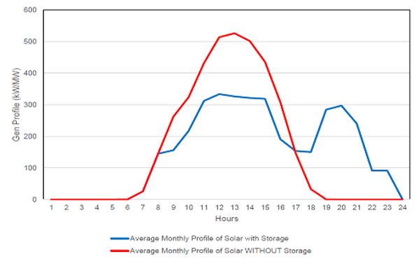

*FIG. 1. Typical hourly solar generation profile by the Energy Commission [1].*

Solar PV with storage contributes to the reserve margin because the solar PV power output does not coincide with the peak demand. The solar with storage option contributes about 30% to the reserve margin because of its availability during the peak demand period.

## **2.2. Energy and Electricity Demand in Ghana**

The peak load for 2024 is estimated at 3,788 MW, representing a 4.7% increase from the December 2023 peak demand [8]. The factors influencing the peak demand include population growth, expansion of the Electricity Company of Ghana (ECG) and the Northern Electricity Distribution Company (NEDCo) networks that are expected to result in increased loads, and the commissioning of ongoing rural electrification within ECG and NEDCo distribution zones. The demand for electricity in Ghana is expected to increase annually at an average rate of 5 % until 2040. Various organizations have projected Ghana’s electricity demand to increase in the short, and medium-to-long term [10, 11]. Although the rate of energy demand projected varies, it is obvious that the increase is imminent and Ghana needs to adopt appropriate measures to meet the increasing demand. An example of total energy demand projections by the Energy Commission for two different demand cases —a high and a low demand case—relative to the reference case is shown in Fig. 2.

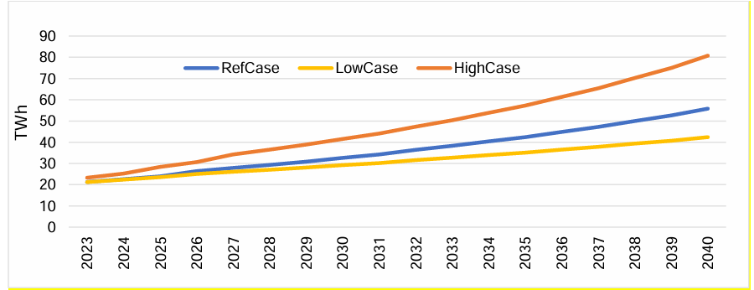

*FIG. 2. Energy demand forecast for Ghana by the Energy Commission [1]*

**2.3. A suite of Technologies to be considered for deployment as NHES in Ghana**

The selection of a nuclear energy technology considers the power level/range needed to support the intended purpose. Several designs for small (10-300 MWe) and medium (<700 MWe) nuclear reactors are in development around the world. These reactors are more versatile than the traditional large ones of 1000 – 1700 MWe, designed to capture economies of scale operating as baseload plants [12].

A possible application of NHES in Ghana would be to provide energy to meet the demand of large industrial plants. Since the thermal demand of a large chemical plant for instance is in the range of a few hundred megawatts, one or a few small or medium-size reactors could be matched to industrial-scale process plants to obtain a single operating complex. Further research and development are required to support the choice of an appropriate reactor technology to be utilized in the NHES specifically with thermal interconnections for industrial applications. Both static process models and dynamic system predictive models could be used to understand system response to variable and uncertain grid demand and on-site variable energy production. Technical and economic evaluations should consider the costs and benefits of design alternatives for the nuclear reactor, external thermal heat transfer loops, the power block, and the energy storage buffer [12].

* 1. **Use of HERON for Techno-economic Analysis**

In this study, HERON was utilized for a stochastic techno-economic analysis set to investigate the economic viability and optimal portfolios of selected configurations of NHES that could be deployed in Ghana. The study is a preliminary effort aimed at highlighting the potential economic and environmental benefits to be derived from the deployment of NHES as the simulated model relies on synthetic Auto Regressions Moving Average (ARMA) generated wind and load demand profiles available in the Risk Analysis Virtual Environment (RAVEN) framework, which did not originate from Ghana. The optimal sizing of the various components was explored based on the uncertainties in the load demand and the weather data. The use of HERON makes it possible for training models that produce unique synthetic scenarios. These scenarios allow for the introduction of uncertainty in the economic metrics for any energy mix and are propagated through the optimization of the NHES capacities. The workflow of HERON involves a two-layer optimization approach as shown in Fig. 3. The analysis of macro variables such as component capacity, market sizes, and tuning variables constitute the outer layer, while the inner layer involves taking macro variables as constants, and generations of synthetic multi-year scenarios are produced to assess the economic viability of the selected component mix of NHES. The two-layer optimization implemented in HERON is further elaborated in Fig. 4, where each inner-layer analysis yields a statistical representation of economic metrics such as the Net Present Value (NPV, the value of an investment throughout its lifetime, discounted to today’s value), given optimized component dispatch for the generated scenarios.

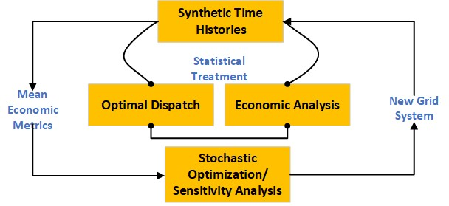

*FIG. 3. HERON workflow overview*

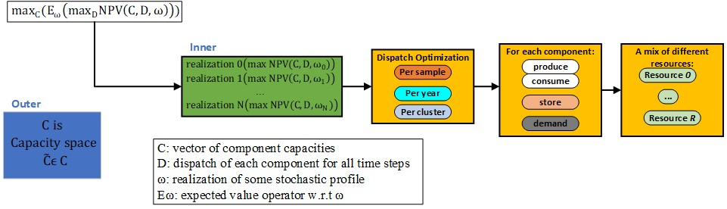

*FIG. 4. Detailed HERON workflow*

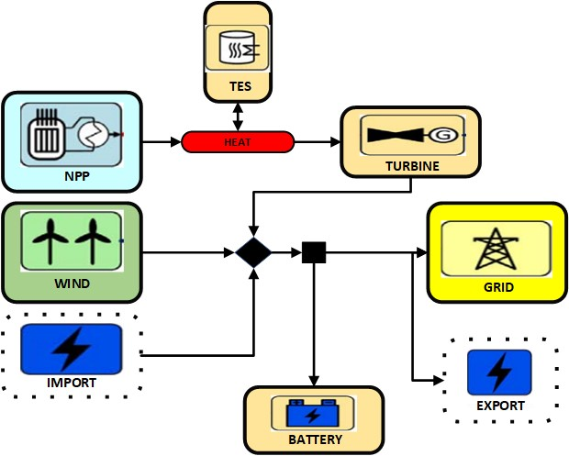

*FIG. 5. NHES configuration with thermal energy storage*

* + 1. *NHES Scenario Simulation in HERON*

For the demonstration of the capabilities in HERON to be used for the techno-economic analysis of various NHES configurations, the scenario as depicted in Fig. 5 was modeled and simulated. The model consists of an NPP, a wind farm, a turbine generator, and a thermal energy storage unit. The objective of the simulation was to find the capacities and dispatch strategies that satisfy the load demand and minimize costs or maximize profits using the NPV as the economic metric. The model utilizes load demand profiles and wind utilization capacities throughout the year that were obtained using synthetic time histories based on the ARMA algorithm in RAVEN. The ARMA model had been trained and the synthetic histories were generated using data from the New York ISO [5]. This data is plotted in Fig. 6 and is available in HERON and was utilized in this study. Furthermore, it is assumed in the model that the NPP is decoupled from electricity generation but instead produces heat that can be converted to electricity by a turbine generator. A thermal energy storage (TES) unit is also included in the NHES model, which charges with heat and discharges through some dispatch strategy. The wind farm has a rated capacity that varies based on wind speeds and the capacity factor simulated was obtained from synthetic time histories. A battery storage was also included in the model for storing electricity. Finally, a grid that consists of import and export was included in the model. The import of electricity is supposed to help meet demand when there is a shortfall, while the export sends electricity to other countries when generation exceeds demand.

In Table 2, a summary of the economic data for each component is presented. The data is based on prevailing rates in Ghana for 2024 and the information obtained from the literature for the components not currently in use in Ghana. For this study, only capital expenditure costs were simulated, and operation and maintenance costs were not considered.

TABLE 2. NHES Configuration and Scenario Data

|  |  |
| --- | --- |
| **Component** | **Capital Expenditure** |
| NPP  Wind  Thermal Energy Storage (TES)  Turbine  Battery | $8.4 M/MW  $1.5 M/MW  $30.0 /MWt  -  $151 /MWe |
| **Electricity Grid Demand** | |
| Grid  Import  Export | 24000 GWh   1. GWh   400 GWh |
| **Economics Data** | |
| Project Lifetime  Discount Rate  Tax Rate  Inflation Rate  ARMA Samples | 20 years  12%  25%  25%  50 |

|  |  |
| --- | --- |
| C:\Users\LENOVO\AppData\Local\Packages\Microsoft.Windows.Photos_8wekyb3d8bbwe\TempState\ShareServiceTempFolder\Load Demand.jpeg | C:\Users\LENOVO\AppData\Local\Packages\Microsoft.Windows.Photos_8wekyb3d8bbwe\TempState\ShareServiceTempFolder\WIND Capacity.jpeg |
| Time (Hours) | |

*FIG. 6. Synthetic History of Load Demand and Wind Utilization adapted from [5]*

* + 1. *Dispatching Results*

Fig. 7 shows the dispatch optimization mechanics during HERON runs. The Figure shows how the model handles energy demand during specific hours of the day. It can be observed from the dispatch optimization figures that when the electricity demand is high, the electricity absorbed by the grid is a large negative value, while the electricity absorbed by the grid is a small negative value when the electricity demand is low. Figure 9 shows the wind availability as a percentage of installed capacity and the total load demand obtained from each stochastic history. A relationship can be observed between Figs. 7 and 8 in that when the variable renewable energy peaks, the amount of energy demanded by the grid reduces. The TES and battery build-up storage as the electricity clearing price is low. The dispatch optimization reveals how the NHES can meet the load demand by varying the capacities of generators.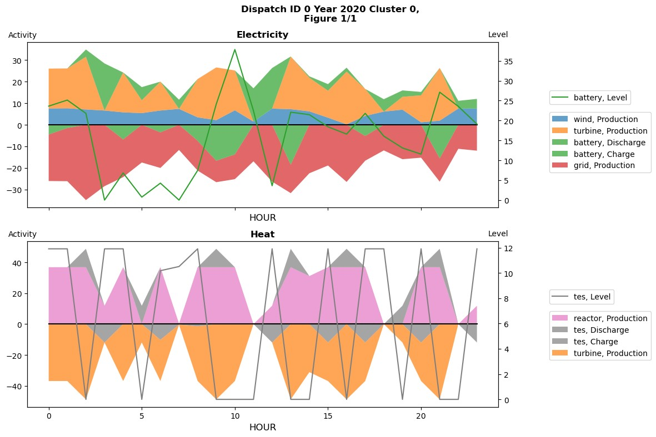

*FIG 7. Example Dispatch Strategy*

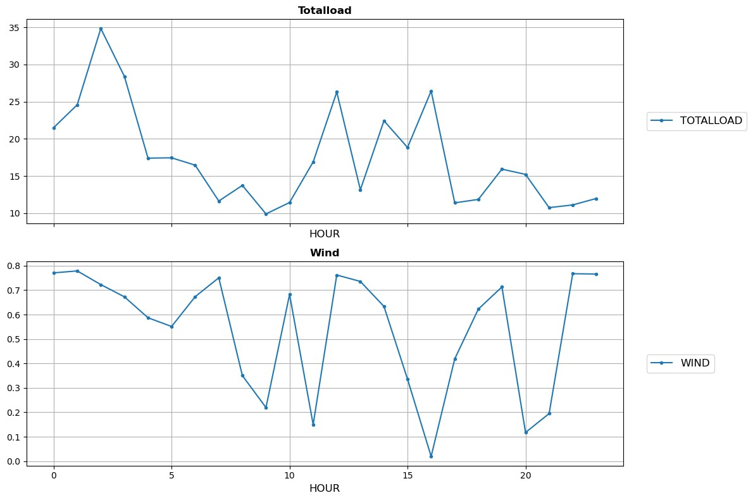

*FIG 8. Example Synthetic History in Dispatch Window*

* + 1. *Optimization Results*

Table 3 summarizes the optimization results achieved after simulating the model in HERON. The mean NPV for the optimal solution is $3.19 Billion for a project lifetime of 20 years. Fig. 9 shows the evolution of the optimization decisions made by HERON as a function of the number of iterations. At each iteration, HERON evaluates the NPV of a configuration by sampling several synthetic histories and optimizing dispatch to each. The Bayesian Optimizer (BO) option in HERON was selected for the analysis. Within the BO, the Expected Improvement (EI) option, which estimates the degree to which the best solution will be improved by sampling the given point was selected. The BO is known to yield improved evaluation efficiency, and it is considered a more efficient global optimizer compared to the Gradient Descent (GD) optimizer [6].

It can be seen from Fig. 9 that the optimizer ran 50 initial samples and found an acceptable solution in that initial exploration phase at the 40th iteration. The BO sampled an additional 33 points but none improved the acquisition function more than the answer found in the initial exploration phase. So, the first accepted solution was recorded as the final. Although a sampler limit of 300 was selected to run in the outer loop, the optimization terminated earlier as it found an acceptable solution. In this application case, each iteration had simulated 50 inner samples where each inner sample runs dispatch optimization over the requested project lifetime of 20 years.

TABLE 3. Optimization Results

|  |  |
| --- | --- |
| Parameter | Value |
| Mean NPV ($)  Wind (GW)  NPP (GW)  TES (GW)  Battery (GW) | 3.19×109  9.82  36.90  11.91  37.84 |

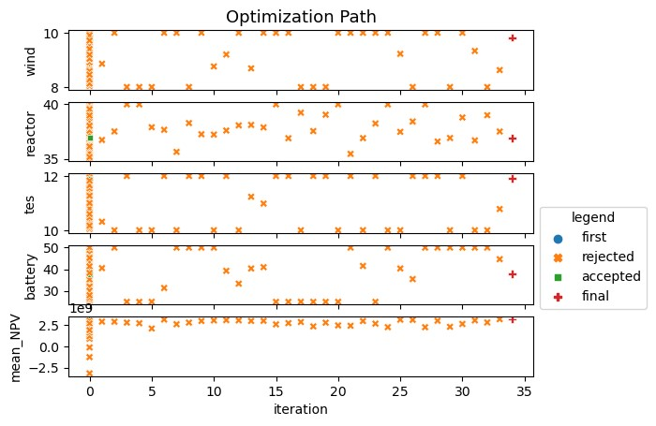

*FIG. 9. Optimization results of scenario simulated in HERON*

1. REGULATORY ASPECTS

Implementing any new energy project such as deploying NHES requires engagement with multiple regulators. Regulation engagement should begin early in project development so that awareness can be created for pending requests for review and to be abreast with the required processes for licensing. For the deployment of an NHES in Ghana, the Nuclear Regulatory Authority (NRA), the Environmental Protection Agency (EPA), and the Public Utilities Regulatory Commission (PURC) are the relevant regulatory bodies that could be engaged. Since the generation of electricity using hydro, gas, and thermal already exists in Ghana, the emphasis in this paper will be on the NRA.

The NRA was established by an act of parliament (Act 895) in 2015 to provide for the regulation and management of activities related to the peaceful use of nuclear material, energy or radioactive material in order to protect people and the environment against the harmful effects of radiation hazards in Ghana. In line with its mandate, the NRA is currently drafting regulations to govern activities including siting, design, construction, commissioning, operation of nuclear installations, revalidation of the operating license, modification, and decommissioning. The draft licensing regulation for nuclear installations in Ghana for instance, specifies the processes and procedures that potential licensees need to follow regarding their license applications.

The Ghana Nuclear Power Program Organization (GNPPO), consisting of governmental agencies, private companies, and academia was established to drive activities that will result in the addition of nuclear power to the energy generation mix. The NRA plays a key role within the GNPPO in assuring the public that it is competent in ensuring that all activities related to nuclear and radioactive materials are undertaken safely and securely. In preparation to effectively play this role, the NRA is setting up the regulatory infrastructure, drafting relevant regulations, guides, and documents, and actively participating in the activities of the GNPPO. Given the NRA’s high level of involvement in Ghana’s nuclear program, it is expected that the regulatory infrastructure and processes would be capable of supporting the deployment of NHES in the future.

1. STAKEHOLDER ENGAGEMENT

Engaging relevant stakeholders is important for successfully siting, constructing, and operating a major facility such as an NHES [4]. These stakeholders include key organizations (government, operator, private, or regulator), and individuals or groups who may have an interest or feel the project may affect them. Technically, engaging the following group of stakeholders may be beneficial in deploying NHES in Ghana: designers, owners, and operators of the types of subsystems in the intended NHES to ensure that systems are technically compatible and that the stakeholders for each subsystem are comfortable with the proposed integration.

Ghana is currently in Phase 2 of the IAEA’s milestones approach in implementing its nuclear power program. Under Phase 1, studies were undertaken to identify candidates and preferred sites for constructing its first NPP. The Nuclear Power Ghana (NPG), which is the owner/operator organization, and the Nuclear Power Institute (NPI) of the Ghana Atomic Energy Commission (GAEC) together with other governmental agencies such as the Geological Survey Authority (GSA) led the siting activities. Apart from engaging relevant agencies within the GNPPO, the media, and communities where these candidate sites were discovered have been engaged adequately. Additionally, Ghana has operated a research reactor for over 2 decades that has been utilized for conducting research and for educating scientists and engineers. Through the operation of the research reactor, there is a level of public awareness and acceptance regarding the peaceful uses of nuclear science. It is worth noting that further stakeholder engagement activities need to be carried out across the country through public outreach and information campaigns to enhance the level of understanding of stakeholders on the potential benefits such as employment and energy sufficiency before deploying an NHES.

1. POLICY AND GOVERNMENTAL CONSIDERATIONS

The policies established by a government have the potential to significantly impact the selection and deployment of energy systems such as NHES. Several goals and standards have been established by countries to deploy clean energy technologies in line with the goal of the Intergovernmental Panel on Climate Change’s projection of a 2.7°C increase in global temperatures by 2040 if global GHG emissions continue at the 2017 rate [4].

As part of Ghana’s Energy Transition Framework to decarbonize the energy sector, nuclear energy for power generation is expected to account for approximately 50% of the generation mix in the 2060s. The Government of Ghana in 2022, approved the acquisition of the preferred site to host Ghana’s first nuclear power plant, which is expected to either be a large nuclear power technology or SMRs [1].

The Renewable Energy Masterplan (REMP) set out the following targets to be achieved by 2030: increase the proportion of renewable energy in the national energy generation mix from 42.5 MW in 2015 to 1363.63 MW (with grid-connected systems totaling 1094.63 MW), reduce the dependence on biomass as the main fuel for thermal energy applications, provide renewable energy-based decentralized electrification options in 1,000 off-grid communities, and promote local content and local participation in the renewable energy industry [7]. In line with the Renewable Energy Act, 2011 (Act 832), the Ministry of Energy was tasked to implement the plan by establishing the REMP Coordinating Unit. Furthermore, the Ministry of Energy was also tasked to designate relevant entities to implement key aspects of the REMP.

Given the policies and commitment by the Government of Ghana to include both nuclear and renewable energy in the national energy generation mix as highlighted above, it is obvious that these policies would facilitate the deployment of NHES in the future. In addition to the favorable governmental policies, macroeconomic factors such as economic output, unemployment, inflation, and poverty levels would be considered by the government as justification for facilitating the deployment of NHES, which has the potential to contribute to boosting economic growth and the enhancement of the quality of life of Ghanaian citizens.

1. CONCLUSION AND RECOMMENDATIONS

The deployment of NHES in Ghana has the potential to yield significant economic and environmental benefits. Several considerations need to be thoroughly evaluated before this deployment. This study discussed techno-economic analysis, regulatory aspects, stakeholder engagement, and policy and governmental considerations. A major effort was dedicated to the techno-economic analysis using the HERON software for capacity and dispatch optimization. The study explored the economic viability and optimal portfolios of NHES that could be deployed in Ghana.

The techno-economic analysis was successfully performed with HERON to estimate the economic viability of an NHES through minimizing costs and maximizing profits. Based on the assumptions and models simulated, the estimated NPV required to meet the objective function was approximately $ 3.19 billion for a project lifetime of 20 years. Although this estimate cannot be relied upon for decision-making, this preliminary study can serve as the basis for further detailed analysis. The capabilities of HERON have been highlighted and demonstrated in the study as a tool that can be used to perform a full-scale techno-economic analysis for deploying NHES in Ghana. Furthermore, the analysis revealed the importance of integrating various components including storage systems to effectively handle variations in electricity demand and use generation units optimally. The study also highlighted the importance of high-fidelity data to be used as inputs to the computational models.

The nuclear regulatory infrastructure has been established, and it is expected to mature for effectively regulating activities related to the peaceful application of nuclear science and energy in Ghana. Apart from the regulatory structures, relevant stakeholders have also been engaged to help them appreciate the importance of implementing a nuclear power program in Ghana. Finally, favorable governmental policies concerning nuclear and renewable energy were also identified and are expected to facilitate the deployment of NHES in Ghana.

Based on the findings from this study, it is recommended that the relevant agencies take steps to implement data collection strategies because the use of high-fidelity data on electricity demand, consumption, and available capacities of renewable energy sources is essential for effectively modeling, simulating, and planning for the deployment of energy systems in the future. It is also suggested that the scenarios modeled and simulated in this study be expanded to represent other NHES configurations. The engagement of the NRA in key activities of the GNPPO is commendable, and this collaboration should be encouraged and enhanced going forward. On stakeholder engagement, it is recommended that more effort be invested in educating the general public on the potential benefits of nuclear energy and the high safety standards maintained in the industry. Finally, the commitment by the government to promoting nuclear and renewable energy through policy formulation and support needs to be sustained as this can play a crucial role in the successful deployment of NHES in Ghana.

**ACKNOWLEDGMENTS**

The authors acknowledge the immense technical support from Paul Talbot and Gabriel J. Gonzalez of the Idaho National Laboratory on using HERON.

**REFERENCES**

[1] Ghana Integrated Power Sector Master Plan – 2023. Energy Commission of Ghana. Available: <https://www.energycom.gov.gh/newsite/index.php/planning/ipsmp-data>.

[2] Ela E, Milligan M, Kirby B. Operating reserves and variable generation, 2011. NREL/ TP-5500-51978, National Renewable Energy Laboratory, Golden, CO. [accessed 28.08.12]

[3] D. J. McDowell, P. W. Talbot, A. M. Wrobel, K. L. Frick, H. C. Bryan, C. Boyer, R. D. Boardman, J. Taber, J. K. Hansen, 2021. A Technical and Economic Assessment of LWR Flexible Operation for Generation and Demand Balancing to Optimize Plant Revenue, Idaho National Laboratory, Report INL/EXT-21-65443-Revision-1.

[4] International Atomic Energy Agency, 2022. Nuclear–renewable Hybrid Energy Systems, Nuclear Energy Series NR-T-1.24, ISSN 1995–7807.

[5] The New York ISO Annual Grid & Markets Report- Power Trends 2021,” New York ISO, 2020. [Online]. Available: https://www.nyiso.com/documents/20142/2223020/2021-Power-Trends Report.pdf/471a65f8-4f3a-59f9-4f8c-3d9f2754d7de.

[6] P.W. Talbot , G.J.S. Gonzalez, P. Bikash, P.T. Bennett, G. Anthoney, A.S. Epiney. 2023. 2023 Force Development Status Update, , Idaho National Laboratory, Report INL/RPT-23-74915-Rev000.

[7] Energy Commission Ghana, 2019. Ghana Renewable Energy Masterplan. Available: <https://www.energycom.gov.gh/newsite/index.php/reports>.

[8] Energy Commission Ghana, 2024. Energy Outlook for Ghana – Demand and Supply Outlook. Available: <https://www.energycom.gov.gh/newsite/index.php/reports>.

[9] W. Ahiataku-Togobo, Renewable energy resources and potentials in Ghana, Ministry of Power- RAED, 2016.

[10] Energy Commission Ghana, Strategic National Energy Plan (SNEP 2030) energy demand projections for the economy of Ghana. VOLUME ONE Energy, 2019, July 2020, http://www .energycom.gov.gh/files/SNEP.

[11] USAID, IRRP modeling inputs and assumptions demand forecast summary of key assumptions, pp. 1–7, 2018.

[12] M. F. Rutha, O. R. Zinamana, M. Antkowiaka, R. D. Boardmanb, R. S. Cherryb, M. D. Bazilian, 2014. Nuclear-renewable hybrid energy systems: Opportunities, interconnections, and needs. Energy Conversion and Management 78 (2014) 684–694.