# ANALYSIS SUPPORT FOR ENHANCED NUCLEAR

# ENERGY SUSTAINABILITY: AN INPRO SERVICE

# TO MEMBER STATES

J.M.C. JOHARI

International Atomic Energy Agency

Vienna, Austria

Email: J.M.C.Johari@iaea.org

V. KUZNETSOV, G. FESENKO, A. BYCHKOV

Vienna, Austria

S. JEON

International Atomic Energy Agency

Vienna, Austria

**Abstract**

The IAEA’s International Project on Innovative Nuclear Reactors and Fuel Cycles (INPRO) supports Member States in their long-term strategic planning for deploying sustainable nuclear energy. Over the past decade, INPRO developed methods and scientific-technical analysis tools to support modelling and analysis of nuclear energy systems, including global and regional scenarios. These analysis tools are available to Member States and come in a service package called the “Analysis Support for Enhanced Nuclear Energy Sustainability” (ASENES). INPRO uses ASENES analyses to develop a global vision of sustainable nuclear energy in the current century and beyond. An ongoing collaborative project called ASENES-SMR, addresses sustainable deployment scenarios for small modular reactors (SMRs). This project has 14 national and regional case studies, and the support of twelve Member States. The project identified some preliminary factors for successful deployment of SMRs: improving cost competitiveness and attractiveness for investment; introducing innovations in technology; and implementing institutional arrangements. For favourable economics, there needs to be a transition from economy of scale to the economy of mass production of reactors modules. The studies may assist Member States in the future planning and deployment of SMRs in strategically sustainable nuclear energy systems.

## INTRODUCTION

The International Atomic Energy Agency’s (IAEA’s) International Project on Innovative Nuclear Reactors and Fuel Cycles (INPRO) supports Member States in their long-term strategic planning for deploying sustainable nuclear energy. The INPRO definition of sustainable nuclear energy system builds upon the definition of sustainable development from the Brundtland Commission Report “Our Common Future” [1]: "Sustainable development is the capacity to meet the needs of the present without compromising the ability of future generations to meet their own needs". INPRO developed a methodology for performing a sustainability assessment of a nuclear energy system (NES) based on a comprehensive set of internationally agreed upon basic principles, requirements and criteria in subject areas important for nuclear energy [2].

In the framework of INPRO activities, global and regional nuclear energy evolution scenarios are being developed and analysed, using developed scientific-technical analysis tools. The efforts altogether are envisaged to lead to a global vision of sustainable nuclear energy development in the current century and beyond. Over the past decade INPRO successfully implemented a number of collaborative studies with broad participation of INPRO Member States [3-7]. Some important outputs of the projects are the development of methods and software tools to achieve the project goals, including recommendations on their use and examples of their application in case studies. These analysis methods and tools are available to Member States and come in a service package called the “Analysis Support for Enhanced Nuclear Energy Sustainability” (ASENES) [8]; when new tools become available, they are added to the ASENES service package [9].

In 2021 INPRO launched the ASENES pilot study on sustainable deployment scenarios for small modular reactors (ASENES SMR) as a collaborative project. The project currently has 12 Member States performing 14 national and regional case studies. In 2024 work is on drafting the final report.

## Elements of ASENES Service Package

The ASENES service package [8] facilitates capacity building in Member States. The package supports strengthening the competence and skills of national experts to analyse alternative nuclear energy evolution scenarios and collaborative arrangements, and to develop strategic plans for deployment of sustainable nuclear energy. The ASENES package is a vehicle for implementation of INPRO collaborative studies, such as those related to deployment scenarios and analysis for sustainability, and comparison of different energy systems. ASENES could effectively complement or be complemented by other methods and tools. There are several elements in the ASENES service package highlighted below.

### Modelling Nuclear Energy System (NES) with Model of Energy Supply Strategy Alternatives and their General Environmental Impacts (MESSAGE) (MESSAGE-NES)

The IAEA Nuclear Energy (NE) Department adapted the MESSAGE model and software tool [10] for modelling material flows in the evolution scenarios of complex NESs considering their specific technical features [11]. The MESSAGE tool is a system engineering optimization model for medium- and long-term energy system planning, energy policy and scenario development. It can act as a convenient platform for modelling material flows in complex systems involving multiple NESs of countries with different nuclear fuel cycle policies and can account for collaboration (nuclear trade) among countries in any fuel cycle stage or stages. Extension of the MESSAGE capabilities for such modelling was documented in the publication Modelling Nuclear Energy Systems with MESSAGE: A Users’ Guide [11]; with the corresponding model name MESSAGE-NES. The MESSAGE-NES capability appears unique as most of the material flow analysis codes available worldwide can model only a single NES, be it national, regional, or global.

The MESSAGE-NES user’s guide [11] includes guidance on building mathematical models for dynamic mass flow calculations, preparing input data for a variety of facilities, and addressing the specifics of NES modelling with MESSAGE as well as an explanation of outputs. Users can modify the NES models described in the guide [11] by adopting a different nuclear fuel cycle modelling approach. Users can create a heterogeneous world model with several country groups pursuing different policies in fuel cycle back-end [3]. There are many examples of the application of MESSAGE-NES [12] and results of cross-verification with several material flow analysis codes available worldwide [3].

### Key Indicators for Innovative Nuclear Energy Systems (KIND-ET)

INPRO adapted and elaborated the multi criteria decision analysis (MCDA) methods of judgment aggregation and uncertainty analysis to enable effective comparative evaluation of NES or nuclear energy evolution scenario options. The efforts took into account best practices in multi criteria decision making application and the most significant recent findings in decision support making.

The theoretical basis and mathematical foundation for comparative evaluation of NES evolution scenarios was developed within the INPRO activity KIND [5, 6]. The state of art methods of expert judgement aggregation and uncertainty analysis were carefully analysed, cross-verified and adapted to enable effective comparative evaluation of options or scenarios. Amongst MCDA methods, INPRO selected the multi-attribute value theory (MAVT) for its application to a wide range of decision-making problems in the area of multi-criteria comparative evaluation of nuclear reactors, related fuel cycles and NESs.

The approach developed by INPRO (hereafter, the KIND approach) provides a means of analysis for the hierarchy objective tree with a defined set of alternatives [5] (Fig. 2). The objective tree structure facilitates aggregation in multi-level modelling of the evaluation process; the structure is elaborated before doing the multi-criteria comparative evaluation. Experts perform the aggregation of tree components (from right to left in Fig. 2) and define weights at the key indicator level. While decision makers are involved at the higher levels, i.e., ‘Evaluation areas’ and ‘High-level objectives. Thus, the KIND approach serves the objective of establishing a productive dialogue between energy-option proponents and decision makers regarding preferences for sustainable energy options.

INPRO published a generic guidance on a problem-tailored set of key and secondary indicators to make best possible use of the MCDA theory potential for comparative evaluation of NES/scenario options [5]. Further developments led to a decision support software tool named KIND-Evaluation Tool (KIND-ET) that supports applications of KIND in comparative evaluation problems [5,6,8]. KIND-ET architecture and functional capabilities, based as an Excel template, may be easily modified by users. The KIND-ET was verified with numerical examples by means of comparison with the calculations based on commercial decision-making software [5]. Reports [5,6] contain multiple examples of KIND-ET application to comparative evaluation problems for NESs and scenarios. Figure 3 shows the output for 5 hypothetical NESs from KIND-ET.

|  |  |
| --- | --- |
|  |  |
| *FIG. 2. Possible schematics of the objective tree [5].* | *FIG. 3. Presentation of outputs in KIND-ET (example) [5].* |

### NESA economics support tool (NEST)

INPRO originally developed the Nuclear Energy System Assessment (NESA) Economics Support Tool (NEST) to support the economics sustainability assessment [2,13]. Based on a set of economic and technical inputs for a reactor and the associated fuel cycle, NEST calculates the economic functionals [13] including LUEC (levelized unit energy cost), IRR (internal rate of return), ROI (return on investment), NPV (net present value) and total investment. At the time of NEST development there were collaborations between IAEA INPRO and the Generation IV International Forum (GIF) Economic Methodology Working Group (EMWG), which included the benchmarking between the G4-ECONS (the GIF economics model) and NEST. There was excellent agreement between the codes when performing the same types of calculations [14]. Later, expanded NEST capabilities made it possible to compare economic functionals and their components for different nuclear technologies and NESs (Fig. 4).

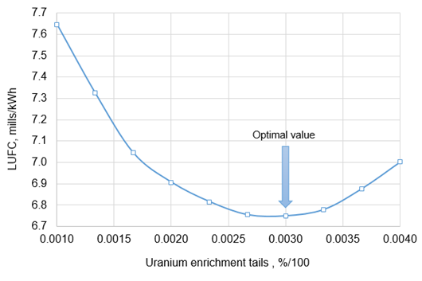

*FIG. 4. Economic optimization of uranium enrichment tails assay for a PWR (example of NEST application for analysis) [15]*.

A later IAEA publication highlights essential aspects of conducting economic analysis in alternative NES, such as system effects, environmental and external costs, and macroeconomic impacts. The publication also explains the limits in applying economic evaluation approaches: “The projects implemented at different timesteps and aimed to serve the specific needs of a NES (for example, fast breeder reactors) are not to be directly compared with other projects within the same NES based on just economic indicators and criteria. However, an economic evaluation of the complete proposed NES can be performed” [15]; meaning all economic aspects should be include when comparing NES and potential alternatives.

### Roadmaps for a Transition to Globally Sustainable Nuclear Energy Systems (ROADMAPS)

INPRO integrated the findings of the INPRO methodology for NES sustainability assessment [2] and in the INPRO activities [3-6] to develop the ROADMAPS tool. The ROADMAP template represents a structured approach for achieving globally sustainable nuclear energy, providing models for international cooperation and frameworks for documenting actions, scope of work, and timeframes for specific collaborative efforts by stakeholders [7]. The template is intended for country-level roadmaps, which one could later combine. The tool allows consideration of all factors important to enhancing nuclear energy sustainability related to both, innovations in technology with changes in policy, and increased collaboration (nuclear trade) among countries. In other words, the design of the template supports long term sustainable nuclear energy planning.

The ROADMAP template includes several structural elements, interrelated by a common logic, and allows characterizing of the current situation in the nuclear energy sector, as well as plans and projections for nuclear energy development in the time perspective under consideration. These structural elements include:

* General country information;
* National plans and projections on nuclear energy development;
* Metrics on nuclear energy status and prospects;
* Key tasks and developments;
* Evolution of reactor fleet and nuclear fuel cycles;
* Integration and cross cutting analysis (when two or more countries perform road mapping together);
* Progress monitoring;
* Database and informational sources;
* Nuclear energy planning and scenario analysis tools [7].

The ROADMAPS Excel-based Tool (ROADMAPS-ET) is a spreadsheet realization of the ROADMAP template [7]. It is not a computational code but an analytical decision support tool for structuring and unifying data on issues related to making a transition to sustainable NESs. The tool makes use of Gantt charts, which are very popular in project management applications to illustrate project schedules and can also support planning, (Fig. 5). The inclusion of nuclear fuel cycle material flow information for existing and future reactors makes it possible to employ material flow analysis models (e.g., MESSAGE-NES) to derive the evolution of fuel cycle requirements over time for a considered strategy of evolutionary and innovative NPP deployment [7].

ROADMAPS-ET could be used to develop very detailed complex roadmaps, including a progress monitoring element. ROADMAPS-ET can also produce condensed single-page roadmaps with better appeal to decision makers and the general public [7].

### NES Simulators

NES simulators, initially developed for training purposes, provides simplified estimates for mass flows and economic indicators of various options for nuclear energy development [9]. Benchmarking with NEST, MESSAGE and NFCCS (Nuclear Fuel Cycle Simulation System) tools under similar assumptions confirmed the applicability of these simulators for simplified NES scenario analysis and modelling [9]. A total of six NES simulators are now available, covering once-through and closed (partially or completely) nuclear fuel cycles with reactors of different types (LWR, heavy water reactors and fast reactors), which also addresses material flow analysis (including fuel depletion) and economics.

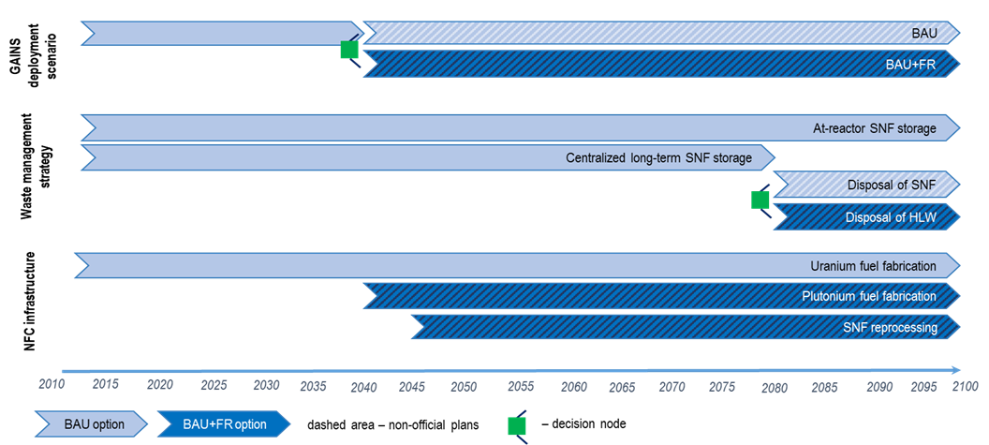

*FIG 5. Example of a condensed roadmap developed with the use of ROADMAPS-ET [7]. Legend: GAINS – INPRO collaborative project “Global Architectures of Innovative NESs with Thermal and Fast Reactors and a Closed Nuclear Fuel Cycle” [6]; BAU – business as usual (once-through fuel cycle with thermal neutron spectrum reactors); FR – fast reactors; SNF – spent nuclear fuel; HLW – high level waste, NFC – nuclear fuel cycle; decision node marker green means a national decision not conditioned by decisions of other countries.*

## DELIVERY AND APPLICATION OF ASENES Service

The ASENES service brings together five primary INPRO tools (MESSAGE-NES, KIND-ET, NEST, ROADMAPS-ET and NES Simulators) for use by interested IAEA Member States. The following are some uses:

* Self-education using the ASENES e-learning course (available in English, Russian and Spanish) and INPRO methods and tools (available in English) in the IAEA Learning Management System (LMS)[1];
* Instructor assisted distant training; and
* Face-to-face user training, including at INPRO schools.

Supplementary materials for the ASENES service are demo cases, thematic collection of external reports and publications, including ASENES related papers, and glossary, which are available in the IAEA LMS.

Anticipated users of the ASENES service are national technical experts working in planning of a national nuclear power programme, innovative technology development for nuclear power, NES analysis and assessment, and officers of ministries responsible for nuclear energy development programmes and international cooperation. The ASENES service supports dialogue between nuclear energy option proponents and decision makers regarding preferences for sustainable energy options. To obtain meaningful results, a user needs to possess:

* Access to information and data on the status, plans and prospects of nuclear energy in her (his) country including that on the status, plans and prospects of cooperation (nuclear trade) with other countries;
* In-depth knowledge of the discussion points regarding NES development in her (his) country.

## APPLICATION OF ASENES SERVICE FOR SMR

The current objective of the collaborative study, ASENES SMR, is the formulation and evaluation of promising scenarios and success factors for the deployment of sustainable NESs with SMRs, including the prospective models of cooperation. The achievement of the objective is through a series of national or joint case studies building upon the vision and experience of project participants. The studies use the ASENES service package but also involve the application of relevant national approaches and tools.

To overcome negative economic impacts of from SMRs, it is important to transition from the economy of scale to the economy of mass production of standard reactor modules. Such a transition requires keeping a balance of offer and demand over time.

The ASENES SMR project has 14 national and regional case studies with experts from Armenia, Bangladesh, Belarus, China, Indonesia, Jordan, Mexico, Pakistan, Romania, Russian Federation, Thailand, and Ukraine performing case studies. Also, there are project observers from Bulgaria, Chile, Ghana, Malaysia, Morocco, USA, and Viet Nam

Case study topics are shown in Fig. 6 with several SMR deployment scenarios in Fig. 7. The project identified some preliminary factors for successful deployment of SMRs: improving cost competitiveness and attractiveness for investment; introducing innovations in technology; and implementing institutional arrangements. For favourable economics, there needs to be a transition from economy of scale (large NPPs) to the economy of mass production of many reactors modules.

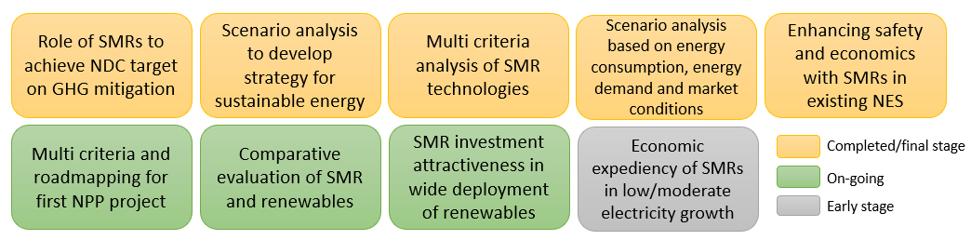*FIG. 6. Topics of case studies as performed by Member States.*

|  |  |
| --- | --- |
|  |  |
| (a) Multi criteria analysis of SMR technologies using KIND-ET | (b) Multi criteria analysis of SMR and coal technologies, evaluated using KIND-ET and NEST |

*FIG. 7. Example of scenarios for SMR deployment developed by Member States using ASENES service package and other relevant tools.*

## Conclusion

The IAEA INPRO developed a service for Member States, “Analysis Support for Enhanced Nuclear Energy Sustainability” (ASENES). This service assists Member States in formulating national strategies for enhancing nuclear energy sustainability. The service contains 5 INPRO methods and tools: MESSAGE-NES, KIND-ET, NEST (block “Analysis”), ROADMAPS-ET, and NES Simulators. The ASENES service is part of INPRO’s advisory service, and available upon request by Member States. The ASENES service is also a driver for new INPRO activities related to analysis of NES and evolution scenario options.

The ASENES service is overall configured to support establishing a productive dialogue between nuclear energy option proponents and decision makers regarding preferences for sustainable energy options. Developing ASENES is an open-ended activity. INPRO addresses new analysis related topics, and develops new methods and software tools, which supports finding solutions of relevance to sustainable nuclear energy; these activities will expand the scope and content of ASENES.

ACKNOWLEDGEMENTS

The authors would like to express sincere gratitude to V. Sargsyan (Armenia), P. Grudev (Bulgaria), A. Schwenk-Ferrero (Germany), A.I. Jalal (Pakistan), C.A. Margeanu (Romania), A. Andrianov (Russian Federation), A. Korinny and O. Godun (Ukraine), and B. Dixon (USA) for their invaluable contributions to the development of ASENES service. The development of ASENES was by experts from Argentina, Bangladesh, Belarus, Brazil, Bulgaria, Canada, China, Croatia, Egypt, France, Germany, Indonesia, Kenya, Malaysia, Mexico, Morocco, Mongolia, Pakistan, Romania, Russian Federation, Thailand, Tunisia, USA, Ukraine and Viet Nam who participated in technical meetings, performed verification and validation of tools and took part in pilot trainings. The authors would also like to thank Carolynn Scherer from INPRO for reviewing the paper.

References

1. BRUNDTLAND COMMISSION, World Commission on Environment and Development, “Our Common Future”, Oxford University Press, Oxford (1987).
2. INTERNATIONAL ATOMIC ENERGY AGENCY, Guidance for the Application of an Assessment Methodology for Innovative Nuclear Energy Systems: INPRO Manual – Overview of the Methodology, IAEA-TECDOC-1575, IAEA, Vienna (2008).
3. INTERNATIONAL ATOMIC ENERGY AGENCY, Framework for Assessing Dynamic Nuclear Energy Systems for Sustainability, Final Report of the INPRO Collaborative Project on Global Architectures of Innovative Nuclear Energy Systems with Thermal and Fast Reactors and a Closed Nuclear Fuel Cycle (GAINS), IAEA Nuclear Energy Series NP-T-1.14, IAEA, Vienna (2013).
4. INTERNATIONAL ATOMIC ENERGY AGENCY, Enhancing Benefits of Nuclear Energy Technology Innovation through Cooperation among Countries, Final Report of the INPRO Collaborative Project on Synergistic nuclear energy regional group interactions evaluated for sustainability (SYNERGIES), IAEA Nuclear Energy Series NP-T-4, IAEA, Vienna (2018).
5. INTERNATIONAL ATOMIC ENERGY AGENCY, Application of Multi-criteria Decision Analysis Methods to Comparative Evaluation of Nuclear Energy System Options: Final Report of the INPRO Collaborative Project KIND, IAEA Nuclear Energy Series No. NG-T-3.20, IAEA, Vienna (2019).
6. INTERNATIONAL ATOMIC ENERGY AGENCY, Comparative Evaluation of Nuclear Energy System Options; Country case studies, Final Report of the INPRO Collaborative Project CENESO, IAEA-TECDOC-2027, IAEA, Vienna (2023).
7. INTERNATIONAL ATOMIC ENERGY AGENCY, Developing Roadmaps to Enhance Nuclear Energy Sustainability: Final Report of the INPRO Collaborative Project ROADMAPS, IAEA Nuclear Energy Series No. NG-T-3.22, IAEA, Vienna (2021).
8. INTERNATIONAL ATOMIC ENERGY AGENCY, Planning Enhanced Nuclear Energy Sustainability: An INPRO Service to Member States, Analysis Support for Enhanced Nuclear Energy Sustainability (ASENES), IAEA Nuclear Energy Series No. NG-T-3.19, IAEA, Vienna (2021).
9. INTERNATIONAL ATOMIC ENERGY AGENCY, Simulators for Scenario Analysis of Nuclear Energy Systems, Training Course Series, IAEA, Vienna (in preparation).
10. INTERNATIONAL INSTITUTE FOR APPLIED SYSTEMS ANALYSIS, Energy Modeling Framework: Model for Energy Supply Strategy Alternatives and their General Environmental Impact (MESSAGE), IIASA, Laxenburg (2009).
11. INTERNATIONAL ATOMIC ENERGY AGENCY, Modelling Nuclear Energy Systems with MESSAGE: A Users’ Guide, IAEA Nuclear Energy Series No. NG - T - 5.2, IAEA, Vienna (2016).
12. INTERNATIONAL ATOMIC ENERGY AGENCY, Experience in Modelling Nuclear Energy Systems with MESSAGE: Country Case Studies, IAEA-TECDOC-1837, IAEA, Vienna (2018).
13. INTERNATIONAL ATOMIC ENERGY AGENCY, INPRO Methodology for Sustainability Assessment of Nuclear Energy Systems: Economics, IAEA Nuclear Energy Series No., NG-T-4.4, IAEA, Vienna (2014).
14. MOORE, M., KORINNY, A., SHROPSHIRE, D., SADHANKAR, R., Benchmarking of Nuclear Economics Tools, Annals of Nuclear Energy, 103, Elsevier (2017).
15. INTERNATIONAL ATOMIC ENERGY AGENCY, Economic Evaluation of Alternative Nuclear Energy Systems: A Supplement for the INPRO ASENES Service, IAEA-TECDOC-2014, IAEA, Vienna (2022).

1. The IAEA Learning Management System provides learning materials as a part of the Cyber Learning Platform for Network (CLP4NET): <https://elearning.iaea.org/m2/>.