# carem project – the argentinean smr

Author: Ignacio de Arenaza

National Atomic Energy Commission of Argentina (CNEA)

Buenos Aires, Argentina

Email: ignaciodearenaza@cnea.gob.ar

Co-author: Francisco Etchegaray Centeno

National Atomic Energy Commission of Argentina (CNEA)

Buenos Aires, Argentina

Email: franciscoetchegaray@cnea.gob.ar

**Abstract**

CAREM is a national SMR development project, based on LWR technology, coordinated by National Atomic Energy Commission of Argentina (CNEA) in collaboration with leading nuclear companies in Argentina with the purpose to develop, design and construct innovative small nuclear power plants with high level of safety and economic competitiveness. CAREM is an integral PWR type NPP, based on indirect steam cycle with features that simplify the design and support the objective of achieving a higher level of safety. Regarding CAREM25, it is the demonstration plant of CAREM SMR, developed using domestic technology. The construction of CAREM25 has commenced, and the civil work on the reactor building is currently 86% complete.

## INTRODUCTION

CAREM is a natural circulation based indirect-cycle reactor with features that simplify the design and improve safety performance. Its primary circuit is fully contained in the reactor vessel and it does not need any primary recirculation pumps. The self-pressurization is achieved by balancing steam production and condensation in the vessel, without a separate pressurizer vessel. CAREM design reduces the number of sensitive components and potentially risky interactions with the environment. Some of the significant design characteristics are: integrated primary cooling system; self-pressurized; core cooling by natural circulation; in-vessel control rod drive mechanisms; and passive safety systems.

## CAREM PROJECT INNOVATION

CAREM is an indirect cycle reactor with some distinctive and characteristic features that greatly simplify the reactor and also contribute to a higher level of safety:

* Integrated primary cooling system;
* Primary cooling by natural circulation;
* Self-pressurised;
* Passive Safety systems.

### Primary System

The CAREM25 reactor pressure vessel (RPV) contains the core, steam generators (SG), the whole primary coolant and the absorber rods drive mechanisms (FIG. 1). The RPV diameter is about 3.2 m and the overall length is about 11 m.

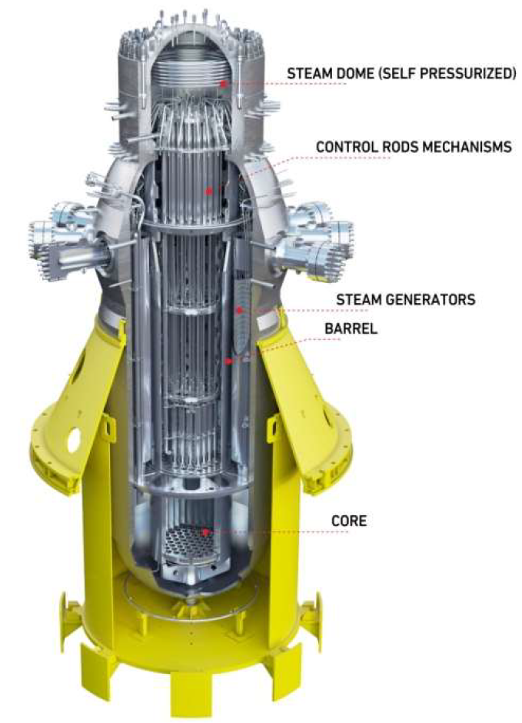

FIG. 1. Reactor Pressure Vessel

The CAREM25 core has 61 hexagonal cross section fuel assemblies (FA) having about 1.4 m active length. Each fuel assembly contains 108 fuel rods, 18 guide thimbles and 1 instrumentation thimble (FIG. 2). Its components are typical of the PWR fuel assemblies. The fuel is enriched UO2. Core reactivity is controlled by the use of Gd2O3 as burnable poison in specific fuel rods and movable absorbing elements belonging to the Adjust and Control System. Chemical compounds are not used in the water for reactivity control during normal operation. Fuel cycle can be tailored to customer requirements, with a reference design of 390 full-power days and 50% of core replacement. The total core power is 100 MW thermal.

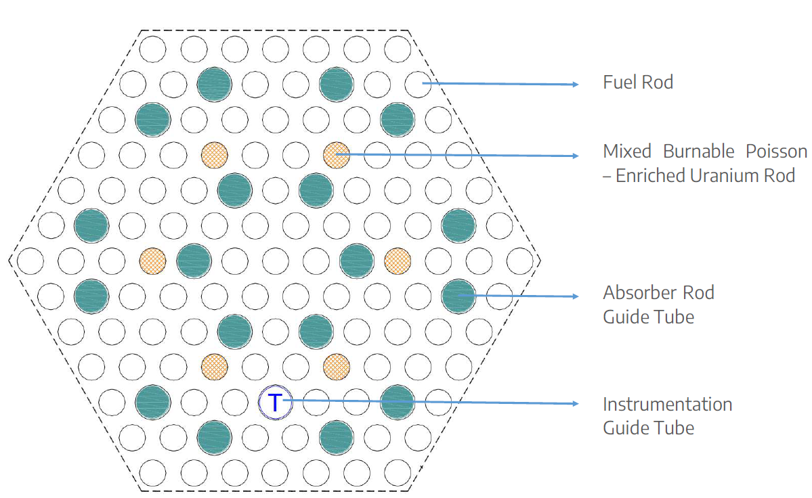

FIG. 2. Fuel Assembly Diagram

Each Absorbing Element (AE) consists of a cluster of rods linked by a structural element (namely “spider”), so the whole cluster moves as a single unit. Absorber rods fit into the guide thimbles (FIG. 3). The absorbent material is the commonly used Ag-In-Cd alloy. The AE are used for reactivity control during normal operation (Adjust and Control System), and to produce a sudden interruption of the nuclear chain reaction when required (Fast Shutdown System).

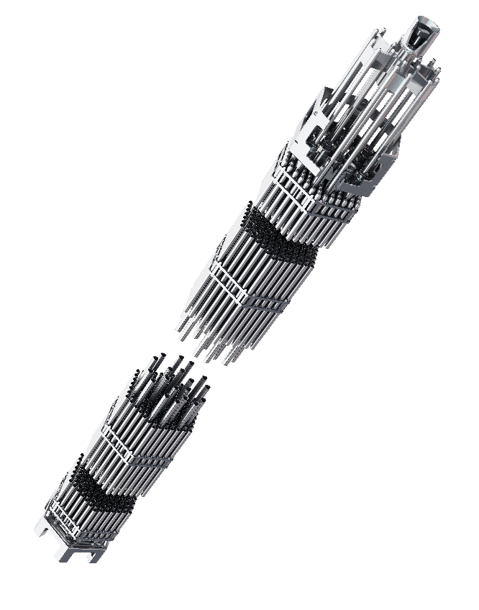

FIG. 3. Fuel Assembly and Absorbing Element

Twelve identical ‘Mini-helical’ vertical SG, of the “once-through” type are placed equally distant from each other along the inner surface of the RPV (FIG. 4). They are used to transfer heat from the primary to the secondary circuit, producing dry steam at 47 bar, with 30°C of superheating.

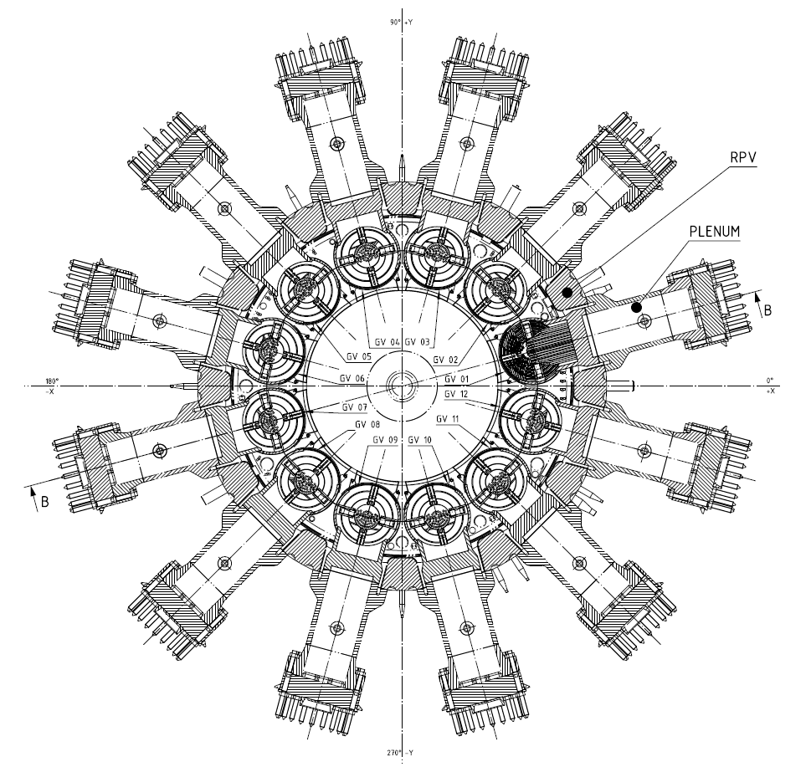

FIG. 4. Steam Generation Layout

The location of the SG above the core produces natural circulation in the primary circuit. The secondary system circulates upwards within the tubes, while the primary goes in counter-current flow. An external shell surrounding the outer coil layer and adequate seal form the flow separation system. It guarantees that the entire stream of the primary system flows through the SG.

In order to achieve a rather uniform pressure-loss and superheating on the secondary side, the length of all tubes is equalized by changing the number of tubes per coil layer. Thus, the outer coil layers will hold a larger number of tubes than the inner ones. Due to safety reasons, SG are designed to withstand the primary pressure without pressure in the secondary side and the whole live steam system is designed to withstand primary pressure up to isolation valves (including the steam outlet / water inlet headers) for the case of SG tube brake. The natural circulation of de coolant produces different flow rates in the primary system according to the power generated (and removed). Under different power transients a self-correcting response in the flow rate is obtained.

Due to the self-pressurization of the RPV (steam dome), the system maintains pressure very close to the saturation pressure. Under all operating conditions, this has proven to be sufficient to ensure remarkable stability in the RPV pressure response. The control system is capable of keeping the reactor pressure practically at the operating set point through various transients, even during power ramps. The combination of negative reactivity feedback coefficients, the large water inventory of the primary circuit, and the self-pressurization features allows this behaviour with minimal control rod movement. In conclusion, the reactor exhibits excellent performance under operational transients.

### Nuclear Safety

Nuclear safety has been incorporated in CAREM 25 since the beginning of the design. The defence-in-depth concept has specially been considered. Many intrinsic characteristics contribute to the avoidance or mitigation of eventual accidents.

CAREM 25 safety systems are based on passive features and must guarantee no need of active actions to mitigate the accidents during a long period. They are duplicated to full fill the redundancy criteria. The shutdown system should be diversified to full fill regulatory requirements.

The First Shutdown System (FSS) is designed to shut down the core when an abnormality or a deviation from normal situations occurs, and to maintain the core sub-critical during all shutdown states. This function is achieved by dropping a total of 25 neutron-absorbing elements into the core by the action of gravity. Each neutron absorbing element is a cluster composed of a maximum of 18 individual rods which are together in a single unit. Each unit fits well into guide thimbles of each FA.

Hydraulic Control Rods Drives (CRD) avoid the use of mechanical shafts passing through RPV, or the extension of the primary pressure boundary, and thus eliminates any possibilities of big Loss of Coolant Accidents (LOCA) since the whole device is located inside the RPV. Their design is an important development in the CAREM concept. Six out of twenty-five CRD (simplified operating diagrams are shown in FIG. 5) are the Fast Shutdown System. During normal operation they are kept in the upper position, where the piston partially closes the outlet orifice and reduces the water flow to a leakage. The CRD of the Adjust and Control System is a hinged device, controlled in steps fixed in position by pulses over a base flow, designed to guarantee that each pulse will produce only one step.

Both types of device perform the SCRAM function by the same principle: “rod drops by gravity when flow is interrupted”, so malfunction of any powered part of the hydraulic circuit (i.e. valve or pump failures) will cause the immediate shutdown of the reactor. CRD of the Fast Shutdown System is designed using a large gap between piston and cylinder in order to obtain a minimum dropping time thus taking few seconds to insert absorbing rods completely inside the core. For the Adjust and Control System CRD manufacturing and assembling allowances are stricter and clearances are narrower, but there is no stringent requirement on dropping time.

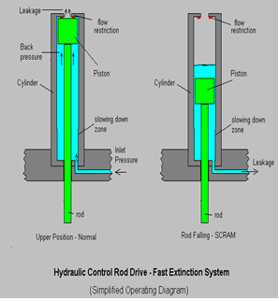

FIG. 5. Simplified operating diagram of a Hydraulic Control Rod Drive (Fast Shutdown System)

The second shutdown system is a gravity-driven injection device of borated water at high pressure. It actuates automatically when the Reactor Protection System detects the failure of the First Shutdown System or in case of LOCA. The system consists of two tanks located in the upper part of the containment. Each of them is connected to the reactor vessel by two piping lines: one from the steam dome to the upper part of the tank, and the other from a position below the reactor water level to the lower part of the tank. When the system is triggered, the valves open automatically and the borated water drains into the primary system by gravity. The discharge of a single tank produces the complete shutdown of the reactor.

The residual heat removal system has been designed to reduce the pressure on the primary system and to remove the decay heat in case of loss of heat sink. It is a simple and reliable system that operates condensing steam from the primary system in emergency condensers. The emergency condensers are heat exchangers consisting of an arrangement of parallel horizontal U tubes between two common headers. The top header is connected to the reactor vessel steam dome, while the lower header is connected to the reactor vessel at a position below the reactor water level. The condensers are located in a pool filled with cold water inside the containment building. The inlet valves in the steam line are always open, while the outlet valves are normally closed, therefore the tube bundles are filled with condensate. When the system is triggered, the outlet valves open automatically. The water drains from the tubes and steam from the primary system enters the tube bundles and is condensed on the cold surface of the tubes. The condensate is returned to the reactor vessel forming a natural circulation circuit. In this way, heat is removed from the reactor coolant. During the condensation process the heat is transferred to the water of the pool by a boiling process. This evaporated water is then condensed in the suppression pool of the containment.

The Emergency Injection System prevents core exposure in case of LOCA. In the event of such accident, the primary system is depressurised with the help of the emergency condensers to less than 15 bar, with the water level over the top of the core. At 15 bar a low pressure water injection system comes into operation. The system consists of two tanks with borated water connected to the RPV. The tanks are pressurized, thus when during a LOCA the pressure in the reactor vessel reaches 15 bar, the rupture disks break and the flooding of the RPV starts.

Three safety relief valves protect the integrity of the reactor pressure vessel against overpressure, in case of strong unbalances between the core power and the power removed from the RPV. Each valve is capable of producing 100% of the necessary relief. The blow-down pipes from the safety valves are routed to the suppression pool.

The primary system, the reactor coolant pressure boundary, safety systems and high-pressure components of the reactor auxiliary systems are enclosed in the primary containment - a cylindrical concrete structure with an embedded steel liner. The primary containment is of pressure-suppression type with two major compartments: a drywell and wetwell. The lower part of wetwell volume is filled with water that works as the condensation pool, and the upper part is a gas compression chamber.

A simplified diagram of the containment and safety systems is presented below (FIG. 6):

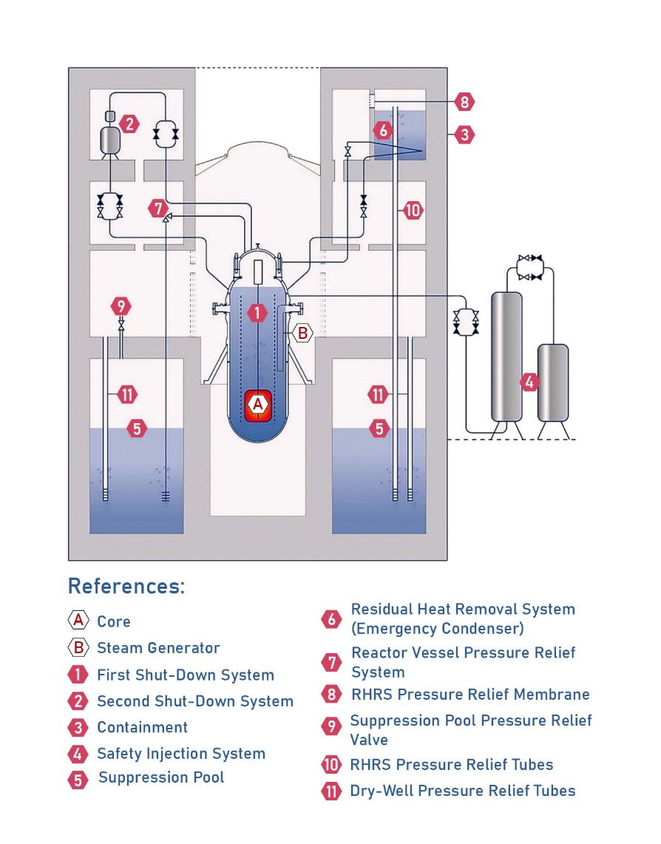

FIG. 6. Containment and Safety Systems Diagram

### Advantages of CAREM design

Technical and economic advantages are achieved with the CAREM design compared to traditional designs:

* No Loss of Flow Accident (LOCA) as the core is cooled by natural circulation;
* No large LOCA has to be handled by the safety systems due to the absence of large diameter piping associated to the primary system. The size of maximum possible break in the primary is 38 mm;
* Innovative Hydraulic Drive Control Rods avoid Rod Ejection Accident;
* Large coolant inventory in the primary results in large thermal inertia and long response time in case of transients or accidents;
* Shielding requirements are reduced by the elimination of gamma sources of dispersed primary piping and parts;
* The large water volume between the core and the wall leads to a very low fast neutron dose over the RPV wall;
* Passive Safety Systems with a grace period of 36 hours;
* The ergonomic design and layout make maintenance easier. Maintenance activities, such as the inspection of steam generator tubes, do not compete with refueling activities because they are carried out from outside the vessel;
* The use of less active components increases plant availability and load factor, reducing the frequency and kind of initiating events.

## CAREM25 PLANT DESIGN

The CAREM25 plant is comprised of three principal buildings: the Reactor Building, Service Building, and Turbine Building (FIG. 7). The Reactor Building specifically contains the Containment structure, the Spent Fuel Pool, and the structures and components housing the Safety and Process Systems. Additionally, the Main Control Room and the Emergency Control Room are situated within the Reactor Building.

CAREM25 Containment is of the pressure-suppressing type. It is a cylindrical structure measuring 27 meters in height, 19.5 meters in diameter, and 1.2 meters in exterior wall thickness, constructed of reinforced concrete and designed to withstand both the pressure and temperature conditions generated by postulated events and seismic actions. Additionally, it has an interior lining of carbon steel aimed at ensuring the tightness and confinement of radioactive material.

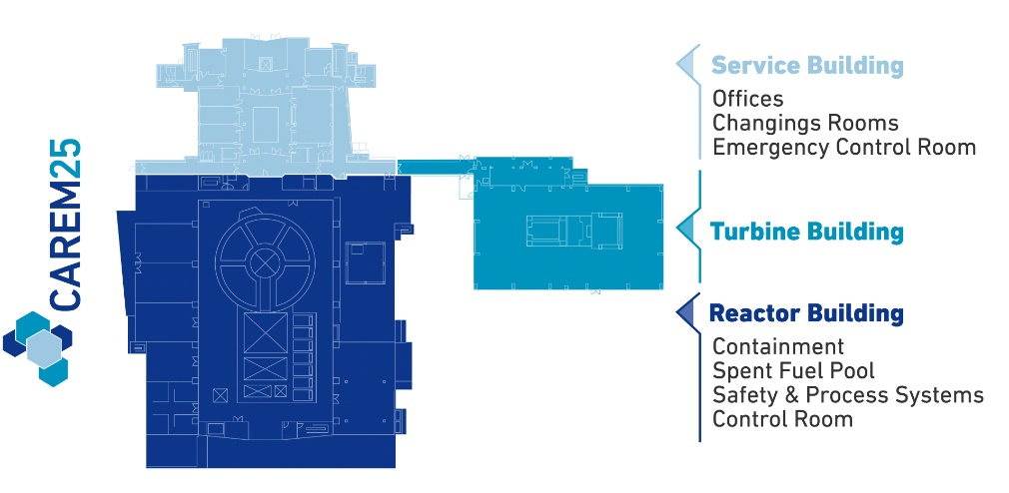

FIG. 7. CAREM25 layout

## CAREM25 STATUS

The basic design of the project has been completed. Through the signing of contracts with specialists and Argentinean stake-holders, detailed engineering of the process systems has advanced, achieving a progress of 60%.

The fuel design is complete, including transportation, hydraulic, hydrodynamic, and seismic tests. Additionally, the endurance test has been defined and is scheduled to be conducted in the near term at the CNEA facilities. The manufacturing process has commenced and is currently 65% complete (FIG. 8).

Regarding supplies, the manufacturing of the main components of the Plant has commenced, with the following notable advancements:

* RPV: 73% progress (FIG. 9);
* SG: Pre-series is completed (FIG. 10). Manufacturing planned to commence in the near term.

Regarding the construction of the CAREM25 Plant, it has successfully commenced through agreements and contracts with prominent Argentine companies, achieving a progress rate of 86%.

Finally, considering the international context, the CAREM Project is in a privileged position in the following areas: Licensing, Siting, Financing, Supply Chain, Engagement and Fuel. This positions it as one of the foremost SMR projects under development worldwide ([4]).

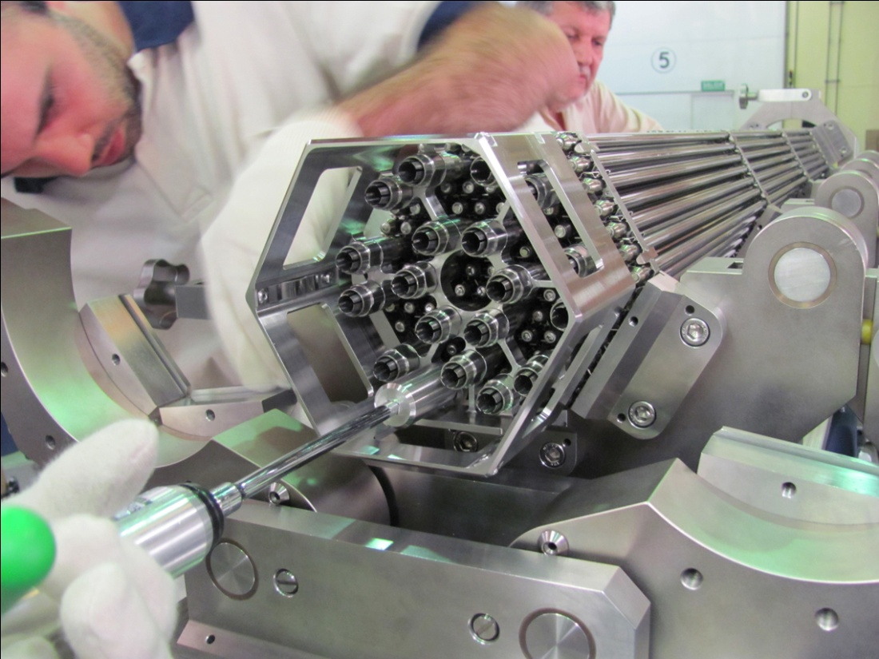

FIG. 8. CAREM25 Fuel Fabrication

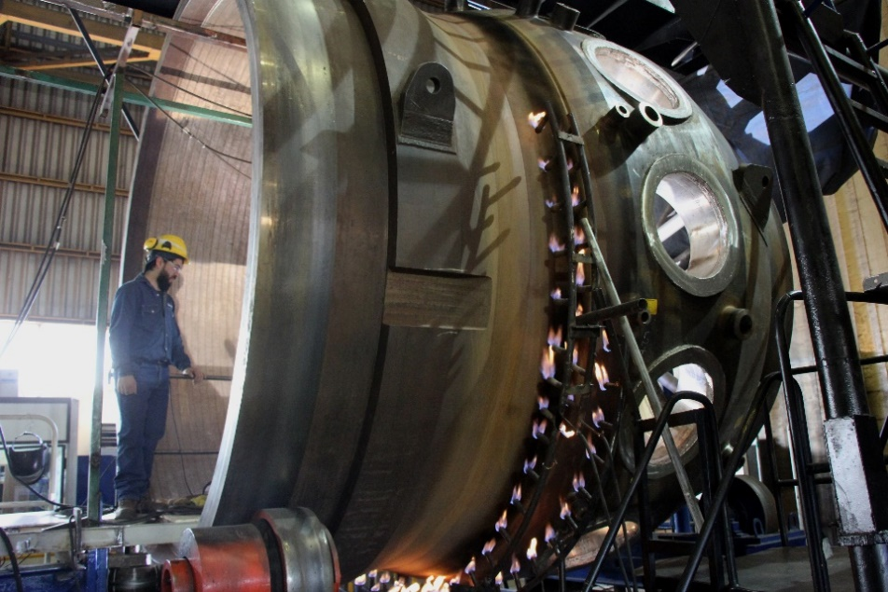

FIG. 9. CAREM25 RPV Fabrication

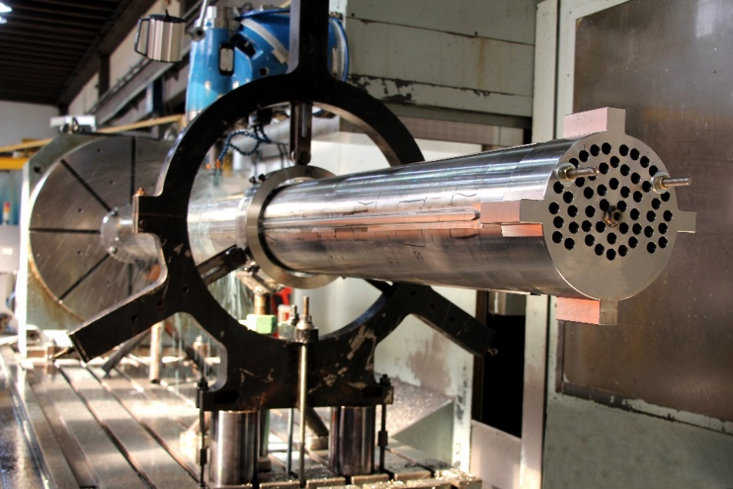

FIG. 10. CAREM25 Steam Generator Fabrication

References

1. H. BOADO MAGAN, D. F. DELMASTRO, M. MARKIEWICZ, E. LOPASSO, F. DIEZ, M. GIMENEZ, A. RAUSCHERT, S. HALPERT, M. CHOCRON, J.C. DEZZUTTI, H. PIRANI, C. BALBI “CAREM Prototype Construction and Licensing Status” IAEA-CN-164-5S01.
2. H. BOADO MAGAN, D. F. DELMASTRO, M. MARKIEWICZ, E. LOPASSO, F. DIEZ, M. GIMENEZ, A. RAUSCHERT, S. HALPERT, M. CHOCRON, J.C. DEZZUTTI, H. PIRANI, C. BALBI, A. FITTIPALDI, M. SCHLAMP, G.M. MURMIS, H. LIS “CAREM Project Status”.

BIBLIOGRAPHY

1. INTERNATIONAL ATOMIC ENERGY AGENCY, Advances in Small Modular Reactor Technology Developments, 2022 Edition.
2. NUCLEAR ENERGY AGENCY, The NEA Small Modular Reactor Dashboard, Second Edition (2024).