**ANALYSIS OF NEUTRONIC PERFORMANE FOR**

**SMART REACTOR WITH URANIUM NITRIDE AND**

**THORIUM FUEL**

MOUSTAFA AZIZ

Egyptian Atomic Energy Authority

3 Ahmed Alzomr Str. , 11762

Nasr City , Cairo , Egypt

[moustafaaai@yahoo.com](mailto:moustafaaai@yahoo.com)

**Abstract**

Maximizing the life cycle of fuel inside the reactor core has an important economic factor. It reduces the volume of spent fuel and spent fuel storage pools inside the reactor. In this paper, Uranium nitride and Thorium fuels in addition to traditional UO2 fuel were used to increase the fuel cycle residence time inside the SMART reactor. A model of the reactor core has been designed by using MCNPX Computer code package. The multiplication factor was calculated over the fuel cycle residence period. The results showed that uranium nitride and thorium mixed with 233U of the same fuel enrichment gives a higher fuel cycle length than uranium oxide. The breeding capabilities were compared between different types of fuel that have been used. The isotopes produced as a result of burning and irradiating the fuel inside the reactor core are calculated.

**1** INTRODUCTION

SMART reactor is a typical small modular reactor , which is developed by Korea Atomic Energy Research Institute. The reactors produces 330 MW thermal energy in a dual purpose conditions which can be used for Electricity generation and water desalination. The modular design of the reactor enable the primary circuit ( Steam generators , pumps , self pressurizer ) to be integrated within a single pressure vessel. This design reduces or minimizes the occurrences of small or Large loss of coolant accident.

SMART (System-integrated Modular Advanced ReacTor), which is conceptually developed by KAERI (Korea Atomic Energy Research Institute), is a small-sized advanced integral PWR that produces 330 MW of thermal energy under full power operating conditions. Major components including reactor coolant pumps, steam generators and a self-pressurizer are integrated within a single pressure vessel, in which the arrangement of components differs from the conventional loop-type reactors [1,2].

Nuclear power reactors produce approximately 13 % of the worldwide electricity needs and is CO2 free. Generation IV nuclear reactors have supported other fuel options to improve efficiency of nuclear reactors and strengthen safety and security, Nuclear fuel such as nitrides, carbides, silicides and Thorium. Among them, Nitrides Uranium has shown many superior qualities over the standard oxide fuel such as: higher uranium density leading to higher fuel residence time in the core, and potentially fuel higher burnup. Uranium nitride also have higher thermal conductivity and heat capacitythan uranium oxide at operating conditions which leads to higher safety margin and accident resistance at higher temperature and pressure. Optimizing and increasing the life time and burnup of fuel in the nuclear reactor have several advantages such as enhancing fuel utilization, increasing energy production per cycle as well as reducing the volume of spent fuel over the entire life of the core [3,4,5,6,7,8 ].

Thorium is three times more abundant in nature compared to uranium ore. Thorium absorbs neutrons and converts to the fissile isotope 233U which fissions by neutron producing energy. Thorium oxide has also better mechanical and thermal characteristics at the operating temperature of nuclear reactors. Thorium is usually mixed with fissile materials such as Plutonium isotopes or 233U [9,10,11].

In the present paper MCNPX code is used to model SMART reactor core and four types of fuel are assumed for the reactor core UN (Uranium Nitride ) , Uranium Nitride mixed with Zirconium oxide ( ZrO2 ) , and Thorium mixed with 233U , as well as its traditional fuel UO2. Reactor parameters are calculated and compared between all four fuel types, such as reactor multiplication factor ( Keff ) , cycle length , discharge burn up , 235U burn up ( or 233U for thorium case ) and Pu isotopes build up. In the following , Section II Reactor data and analysis , Section III contains Computational Model , Section VI Results and discussions. Conclusion and Reference are given at the end of the paper.

2 CORE DATA AND ANALYSIS

The SMART core is composed of 57 fuel assemblies, of which design and performance are based on the 17x17 fuel rods per assembly. Each fuel assembly holds 264 fuel rods of 8.05 mm in diameter and 2.0 m in active height, 21 guide tubes for control rods and 4 instrumentation thimbles,all fuel assemblies contain burnable absorbers to control the power distribution and the excess reactivity. The cycle length of SMART amounts to 990 EFPD corresponding to a cycle burnup of 26,250 MWD/MTU. SMART has compact and simplified design by designing the pressure vessel which contains 4 pumps and 12 steam generator as well as , its pressurizer. This design enhance the safety and eliminate the large break LOCA. The core is free from soluble boron , and this simplifies the volume and chemical control system. 4.95 w/o enriched uranium dioxide is used as a fuel to provide enough reactivity required for a three-year operation. Due to the use of various burnable absorbers, the fuel assemblies are classified into 3 different sub-batches A, B ,and C according to the type and number of burnable poisons in each assembly. Table 1 contains the number of assembly for each batch A, B, C and number of fuel and burnable poison rod per assembly Fig. 1 illustrates reactor core and distribution of each assembly type in the core. Table 2 contains reactor data and parameters. more details can be found at reference [ 12,13,14].

Table 1 Fuel assembly distributions in the core [14 ]

|  |  |  |  |  |
| --- | --- | --- | --- | --- |
| Assembly Type | Number of assembly | No. of fuel rod | No. of Al2O3- B4C | No. of Gd2O3-UO2 |
| A | 8 | 224 | 28 | 12 |
| B | 28 | 240 | 20 | 4 |
| C | 21 | 236 | 24 | 4 |

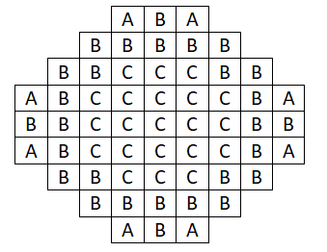

FIG. 1 SMART core loading pattern

Table 2 Core and Fuel data

|  |  |
| --- | --- |
| Parameter | value |
| Thermal power Mwth | 330 |
| Inlet/outlet coolant temperature | 270/310 oC |
| Primary circuit pressure | 15 Mpa |
| Peaking factor | 3.6 |
| No. of fuel assemblies | 57 |
| No. of Control assemblies | 41 |
| Fuel rod arrays | 17 x17 |
| Fuel rod pitch | 1.26 cm |
| Pellet diameter | 0.802 cm |
| Pellet density | 10.4 g/cm3 |
| Clad materials | Zircaloy -4 |
| Clad inner diameter | 0.822 |
| Clad outer diameter | 0.95 cm |
| Gap thickness | 0.0085 cm |
| Active core height | 200 cm |
| Assembly dimensions | 21.4x21.4 cm |
| Fuel materials | UO2 |

3 COMPUTER MODEL

MCNPX Computer code [15] is used to model whole SMART core with all details of fuel , control rods and burnable poisons are incorporated in the model. Burnup cards are activated in the model to analyse the time dependent fuel burnup and reactor operation. Fig. 3 (a,b,c) represents code model to type A,B,C, fuel assembly Batches. Fig (4.d) represents MCNPX code model for SMART reactor core.

Four fuel types are considered and accordingly 4 code inputs are prepared separately :-

Case 1. UO2 typical fuel case with enrichment 4.95 % and cladding Zircaloy-4

Case 2 Uranium nitride ( UN ) with the same Uranium enrichment 4.95 %.

Case 3 Uranium Nitride mixed with ZrO2 with weight ratio 90 % and 10 % respectively and enrichments 4.95 %.

Case 4 Thorium mixed with 233U ( Th+233U ) , 233U enrichments is 4.95 % similar to case 1.

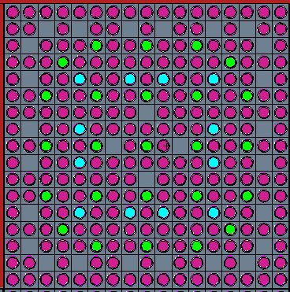

FIG (3.a )Type A MCNPX Model

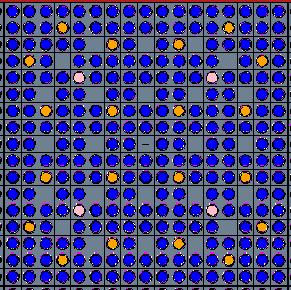

FIG (3.b) Type B MCNPX Model

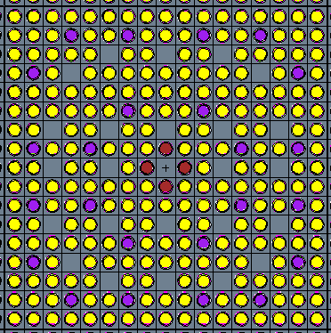

FIG (3.c ) Type C MCNPX Model

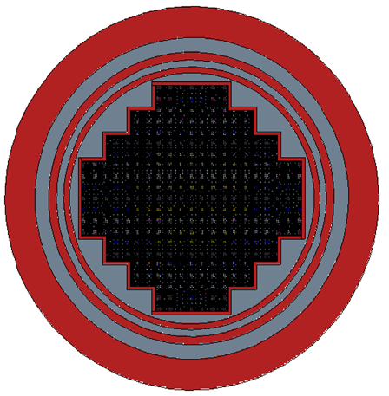

FIG (4.d ) Code Model for the reactor core

4 RESULTS AND DISCUSSIONS

Fig. 4 illustrates core multiplication factor Keff versus operation time (day ) for different types of fuel UO2 , UN , UN+ZrO2 , and Th+ 233U . The initial multiplication factor is 1.2444, 1.25090 , 1.24655 , and 1.39485 respectively. Keff decreases rapidly at the beginning of reactor operation due to xenon build up and then (Keff ) smoothly due to fuel burn up. The cycle length is the operation times (days ) for which Keff > 1. Accordingly the cycle length for the different types of fuel is 1080 , 1540 , 1450 , and 1540 days respectively. Typical fuel UO2 has cycle length of 1080 days which corresponds to 3 years. UN has the higher cycle length because it has higher fissile isotopes mass. Thorium and U-233 fuel e has similar cycle length to UN fuel. Table 3 Compare between Keff at startup and cycle length for different fuel types.

Table 3 Keff and Cycle length

|  |  |  |  |  |
| --- | --- | --- | --- | --- |
| Fuel type | UO2 Fuel  Case 1 | UN Fuel  Case 2 | UN+ZrO2  Case 3 | Th+233U  Case 4 |
| Keff initial | 1.2444 | 1.2509 | 1.24655 | 1.39485 |
| Cycle length , days | 1080 | 1540 | 1450 | 1540 |
| Discharge burnup (GWd/T) | 28.6 | 26.8 | 27.9 | 39.1 |

Fig. 5 illustrates the average fuel burnup (GWd/T) versus operation time (days ) for different cores UO2 , UN , ( UN+ZrO2 ) and Thorium case. The fuel burnup increases linearly with time in all cases. The results indicate that average discharge fuel burn up are 28.6 , 26.8 , 27.9 and 39.1 ( GWd/T ) respectively. Table 3 shows the average discharge burnup for each fuel type.

Fig. 6 illustrates 235U (gm ) for UO2 , UN and UN+ZrO2  versus operation time (days ) in the reactor core. 235U initial concentrations are 6.09x105 , 8.695x105 and 7.83x105 (gm ) respectively which reduces to 2.834x105 ,4.21 x105 and 3.817 x105 (gm ) respectively at the end of their respective cycles. The consumption ratio which is the ( $1-\frac{discharge mass}{initial mass}$) for the 3 types of fuel are 0.535 , 0.515 and 0.508 respectively.

Fig. 7 illustrates Fissile isotopes 233U and 235U (gm) versus operation time (days ) for Thorium Fuel. 233U concentration (gm ) reduces from 6.04x105 to 2.94x105 at the end of cycle. The burnup ratio is 0.51 while 235U increases from zero at beginning of cycle to 1.1 x104 gm at end of cycle. The results also indicate that for the case of thorium fuel the amount of Plutonium isotopes are negligible ( very small ). Thorium interact with neutrons to produce Thorium-233, which decay by beta to protactinium-233 , which also β-decay to 233U. 233U interact with neutrons to form 234U, which capture neutrons to form 235U. So The output of Thorium-232 is 233U and with lesser amount of 235U.

Figure 8 illustrates Plutonium fissile isotopes (Kg ) versus operation time (day ) forUO2 , UN and UN+ZrO2. Fissile Pu isotopes are the summation of 239Pu and 241Pu. The results indicate that the amount of fissile isotopes are 78 (Kg ) , 129.6 Kg , and 110.6 Kg respectively , which indicates that UN fuel producing more fissile isotopes than UO2.

Figure 9illustrates total fissile isotopes (Kg ) versus operation time (day ) forUO2 , UN and UN+ZrO2. Total fissile is the summation of 235U , 239Pu and 241Pu. The results illustrate that at beginning of Cycle (BOC ). Total fissile isotopes are 609 , 869 and 783 (Kg) respectively while at End of cycle 322 , 544 , 469 Kg respectively.

Figure 10 Total fissile isotopes (Kg ) for Thorium fuel versus operation time (day ). Total fissile is the summation of 233U and 235U. The total mass at BOC is 604 Kg and at EOC 305 Kg.

Figure 11 illustrates Xe-135 concentration (atom/barn.cm ) versus operation time (day ) for various fuel types. Xe-135 concentration which start from zero at initial condition reach equilibrium after 1 operation day and proportional to the concentration of fissile isotopes , so it reduces with time due to burnup of fissile isotopes.

5 CONCLUSION

* MCNPX computer Code is used to model SMART Reactor core , four types of fuel are tested in the reactor , namely UO2 , UN , UN+ZrO2 and Thorium fuel.

The results indicate that Thorium mixed with 233U and UN achieve the highest fuel cycle (1540 days ) in comparison to the typical UO2 fuel (1080 days ).

* Thorium mixed with 233U achieves the highest fuel burn up 39.1 MWd/T.
* UN has higher conversion ratio to 239Pu , while Thorium fuel has negligible Plutonium isotopes which complies with safeguard regulations.

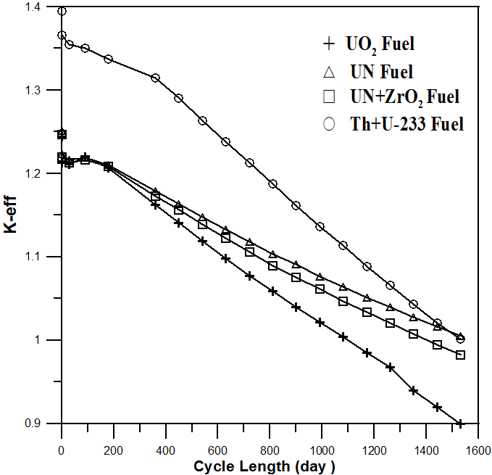

FIG 4 Keff versus operation time (day ) for different fuel types in the reactor core

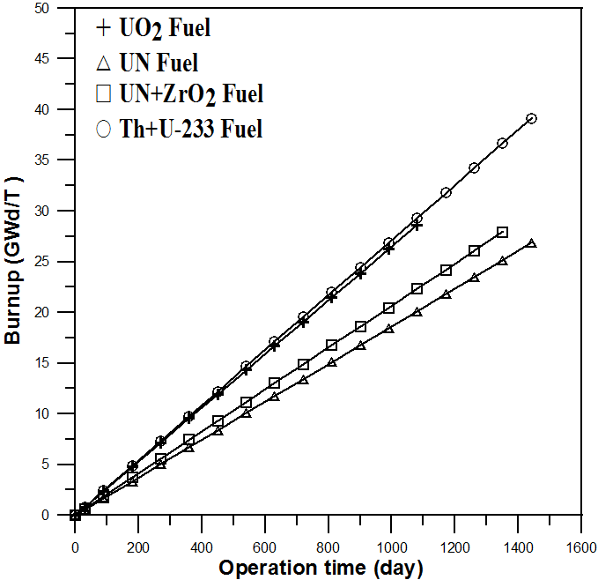

FIG. 5 Average fuel burnup (GWd/T) versus operation time (days )

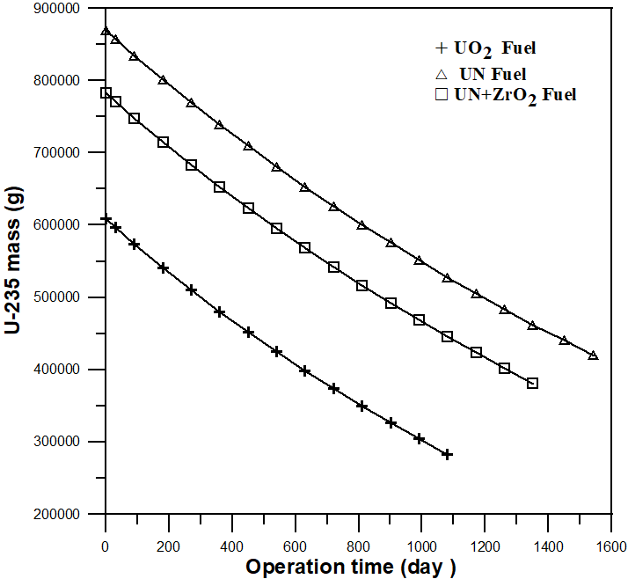

FIG. 6 235U (atom/barn. cm ) versus operation time (days ) for the reactor core

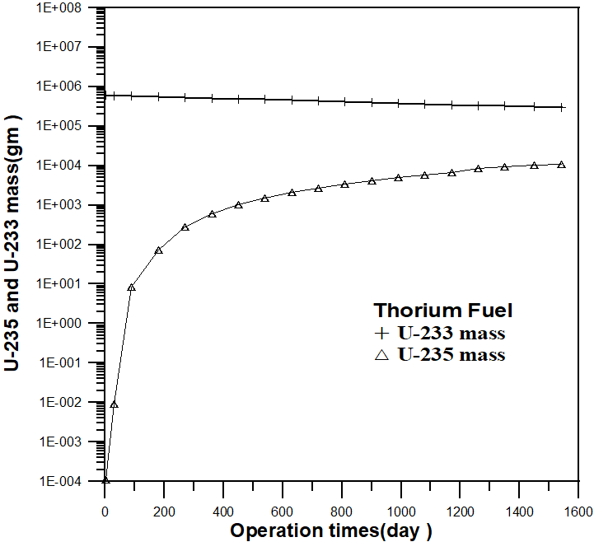

FIG. 7 Fissile isotopes (gm) versus operation time (days ) for Thorium Fuel

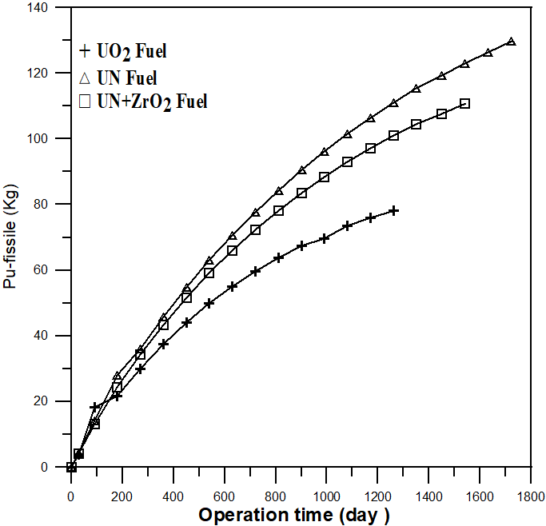

FIG. 8 Plutonium fissile isotopes (Kg ) versus operation time (day )

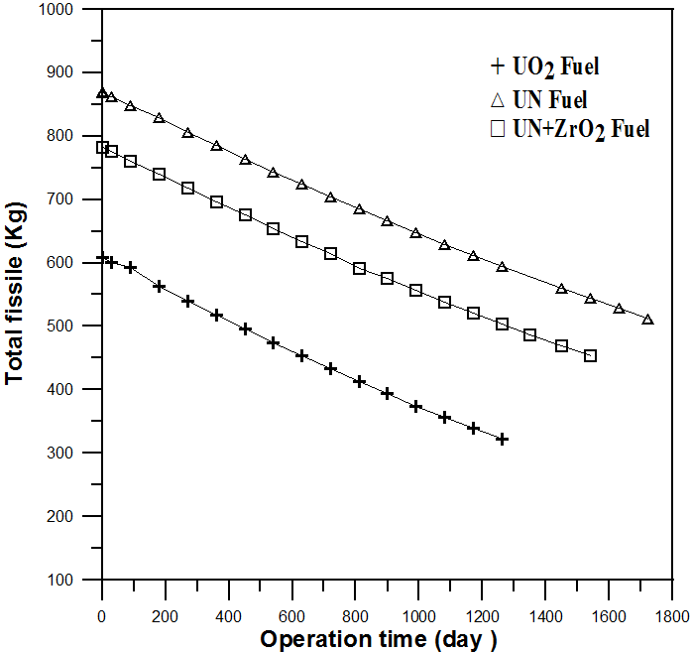

FIG. 9 total fissile isotopes (Kg ) versus operation time (day )

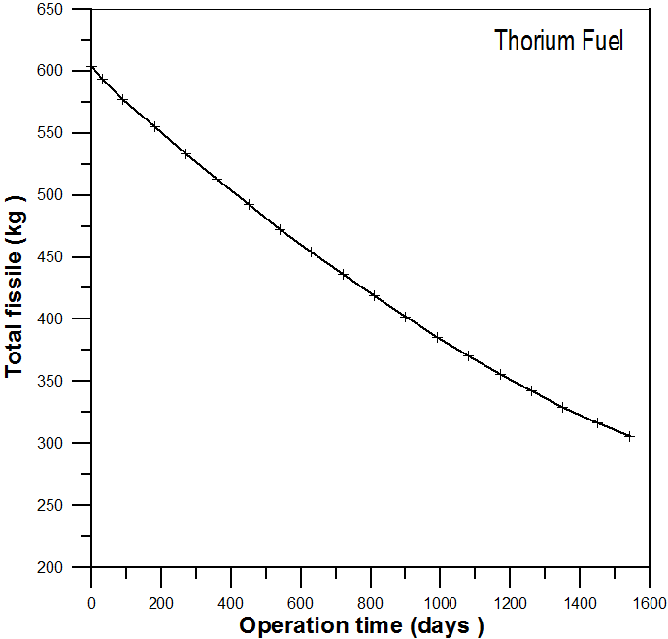

FIG.10 Total fissile isotopes (Kg ) for Thorium fuel versus operation time (day )

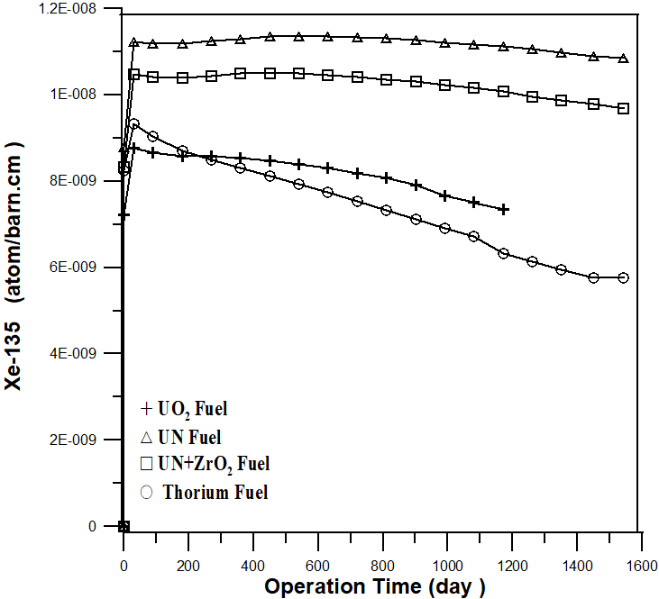

FIG. 11 Xe-135 concentration (atom/barn.cm ) versus operation time (day ) for

various fuel types

6 REFERENCES

[1] Status report 77 - System-Integrated Modular Advanced Reactor (SMART), International Atomic

Energy Authority. Vienna ( 2011)

[2] Jaejun Lee , Jong Hyuck Won , Nam Zin Cho , Yong Ho Ryu , and Ju Yeop Park

A Preliminary Analysis of SMART Reactor Core Using the COREDAX Code.

Transactions of the Korean Nuclear Society, Autumn Meeting Jeju, Korea, October 21-22,(2010)

**[ 3]** B. Feng, E. Shwageraus, B. Forget, M. S. Kazimi

Light Water Breeding with Nitride Fuel. Progress in Nuclear Energy, 53, 862-866 (2011)

[4] L. Juárez, and J. François

Study of the homogeneous and heterogeneous Am transmutation in an

ELFR-like reactor loaded with nitride fuel. Annals of Nuclear Energy

127,19-29(2019)

[5 ] J. Zakova , J. Wallenius

Fuel residence time in BWRs with nitride fuels. Annals of Nuclear Energy 47,182–191(2012)

[6] G. Giudicelli

Achievable Power Uprates in Pressurized Water Reactors Using Uranium Nitride

Fuel. M.Sc Thesis , Mssachusetts Institute of Technology , February 2017

[7 ] C. Ekberg , D. R. Costa , M. Hedberg, and M. Jolkkonen

Nitride fuel for Gen IV nuclear power systems. Journal of Radioanalytical and

Nuclear Chemistry. November 2018. https://doi.org/10.1007/s10967-018-6316-0

[ 8] I. A. Hassan, A. A. Badawi , A. El Saghir , M. K. Shaat

Viability of uranium nitride (UN) as annular fuel for AP-1000, Progress in Nuclear

Energy. 110 , 170-177(2019)

[9] Maiorino, J.R., Moreira, J.M.L., Stefani, L.G., Busse, A., Santos, T., “Thorium as a New

Primary Source of Nuclear Energy”, in. IX Congresso Brasileiro de anejamento Energético,

Florianópolis, Brasil, August 25-27, Sociedade Brasileira de Planejamento Energético, 2014,

pp 1-11.

[10] IAEA Tecdoc 1450 , Thorium fuel cycle potential benefits and challenges , International

atomic energy authority , Vienna , (2005)

[11] IAEA Tecdoc 1349. Potential of Thorium based fuel cycles to constrain plutonium and

reduce long lived Waste Toxicity, International atomic energy authority , Vienna (2003)

[12 ] Khurram Mehboob, · Yahya A. Al-Zahrani· Abdulsalam Alhusawai1,· Majid Ali (2023 )

Neutronic Analysis of SMART Reactor Core for (U-Th)O2 and MOX Fuel Hybrid Configurations. Arabian

Journal for Science and Engineering, January, https://doi.org/10.1007/s13369-022-07541-7

[13] Yiming Zhong , Paul Norman and Wenbin Wu (2022 )

A Feasibility Study of SMART Reactors Power performance optimizations-Part 1: Steady

State and Burnup Ansalysis. Fronters in Energy Research . 1-12, 30 Augest, Doi

10.3389 , fenrg 2022,976602

[14] Rahmi N. Ramdhani1 , Puguh A. Prastyo1 , Abdul Waris,, Widayani and Rizal Kurniadi (2017)

Neutronics Analysis of SMART Small Modular Reactor using SRAC 2006 Code. IOP Conf.

Series: Journal of Physics: Conf. Series 877 (2017) 012067 doi :10.1088/1742-

6596/877/1/012067

[15] Hendricks J. S. et.,al. MCNPX2.6D Computer Code package. Los Alamos National Lab. (2007) LA-UR

074137.