# The Development status of i-SMR and Future Plan

S. Heo, S. G. Lim, and H. G. Kim

Innovative SMR Development Agency

Science Center / Taejeon, Republic of Korea

Email: sunny@ismr.or.kr

**Abstract**

This paper discusses Korea's advancements in Small Modular Reactor (SMR) and explains current development status and the design characteristics of i-SMR, particularly focusing on innovative design features and passive engineered safety features. It emphasizes the importance of SMR in achieving zero carbon emissions and addresses the need for alternative energy sources to complement renewables. The i-SMR development program showcases efforts to create a safer, more economical, and more flexible energy source. Design philosophy, characteristics, and safety features of the i-SMR are detailed, including its integral primary coolant system, fuel and reactor core design, reactivity control manners, containment vessel, and building designs. The document also outlines the engineered safety features such as the Passive Emergency Core Cooling System (PECCS), Passive Auxiliary Feedwater System (PAFS), and Passive Containment Cooling System (PCCS), as well as the integrated main control room and the human factor engineering. The current status and future plans for the i-SMR development, including regulatory approvals schedule and construction plan, are also discussed.

## INTRODUCTION

South Korea has continued to build nuclear power plant for more than forty and to develops advanced designs. Korea Electric Power Corporation (KEPCO) and Korea Hydro & Nuclear Power (KHNP, Subsidiary company of KEPCO) developed Advanced Power Reactor 1400 (APR1400) which is PWR of 1,400 MWe-class. The standard design of APR1400 was approved by Korean regulatory in 2002 and certified by US NRC in 2019. Twelve plants of APR1400 are being operated or under construction in South Korean and United Arab Emirates KAERI (Korea Atomic Energy Research Institute) had developed System-integrated Modular Advanced ReacTor (SMART) which is PWR-type Small Modular Reactor (SMR) of 100 MWe-class. SMART obtained standard design approval in 2012 and Advanced design of SMART is now in license process [1].

In order to achieve zero carbon, it is essential to not only expand renewable energy but also secure alternative energy sources that can compensate for the intermittency of renewable energy. International Energy Agency (IEA) predicted that the electricity generation by nuclear will gradually increases and be 3,777 TWh in 2030 and 5,497 TWh in 2050. These values are 40% and 104 % higher than that of 2020 [2]. OECD NEA predicted that the share of SMRs increases if larger shares of variable renewables are introduced into the system and the share of SMRs in the total installed nuclear capacity also increases [3].

Since the early 2020, KHNP, KAERI and many organizations are cooperating to develop a more safe and more innovative SMR than former SMRs. Top-tier requirement and design concept are decided in 2020 and basic design began in early 2021. The i-SMR development program which is supported by government was approved for the first half of 2022 and government decide to support 217 million US$ for six years. At early 2023, i-SMR development agency was established and has managed the entire progresses of technology developments, design and licensing. In April 2023, Nuclear Safety and Security Commission (NSSC) announced its Policy Statement on the Regulation of SMRs to ensure the highest level of safety and implement a reasonable safety regulation backed by scientific technology and expertise with innovative technology. Now Korea Institute of Nuclear Safety (KINS) and Korea Institute of Nuclear Non-proliferation and Control (KINAC) are conducting the preliminary design review of i-SMR under the support of NSSC to pro-actively establish regulatory base.

## Design Philosophy and Characteristics

### Design Philosophy

The i-SMR is basically based on a proven technology used for many decades in dozens PWR plant. The experiences of KHNP are also applied to the i-SMR design. KHNP has constructed and is operating more than twenty plants for more than forty years. To achieve the highest level of safety, i-SMR adapted an integrated primary coolant loop, passive-operating and simplified safety system and boron-free operation. The key design objectives of i-SMR are safety, economics and flexibility, as following;

1. Safety: The probability of accident accommodating a severe core damage is negligible and the consequence of the accident is very small so that the evacuation of people near plant is not required.
2. Economic: To be competitive with other electricity power sources in market of large grid, the cost of electricity generation is lower than those of coal-/oil-powered plant and old nuclear power plants in most countries and areas.
3. Flexibility: It adopts the capability of flexible operation to compensate the intermittency of renewable energy and maintain the integrity of electricity transmission grid.

### Design Characteristics

The i-SMR adopts an integral primary system. All components, such as reactor core, reactor coolant pump, steam generator, pressurizer, etc, forming primary coolant system are integrated in a steal reactor pressure vessel. Since there are no large pipe which penetrate the reactor pressure vessel, the possibility of a Large Break Loss of Coolant Accident (LBLOCA) is eliminated. The overall design characteristics of the i-SMR are summarized in Table 1.

TABLE 1. Design Characteristics of i-SMR

|  |  |
| --- | --- |
| Parameter | Value |
| Reactor Type | Integrated PWR |
| Power Capacity for 4 modules, MWe | 680 |
| NSSS Output per Module, MWth | 520 |
| RCP Type/Quantity | Vertical, Canned Motor / 4 |
| NSSS Operating Pressure, MPa | 15 |
| Core Coolant Temperature (Inlet/Outlet), ℃ | 295.5 / 320.0 |
| Fuel / Enrichment, w/o | UO2 / < 5 |
| Fuel Assembly Type | 17×17 Square Lattice |
| Fuel Assembly Effective Length, m | 2.4 |
| Fuel Assembly Quantity, EA | 69 |
| Fuel Burnup, MWD/MTU | < 62 |
| Refuelling Cycle, month | 24 |
| Reactivity Control | Control Rods, Burnable Poison Rods, Moderator Temperature Coeff. (Boron-free) |
| Steam Generator | Spiral, Helical-coil Heat Exchanger |
| Safety Systems | Passive and simplified |
| Design Lifetime, year | 80 |
| Seismic Design, g | 0.5 |

## REactor and Reactivity CONTROL

### Fuel and reactor core

The fuel is low enriched uranium dioxide (UO2) and enrichment is lower than 5 weight-percentage. The fuel shape is cylindrical pallet and fuel cladding is zirconium alloy, which is a proven fuel in commercial Pressurized Water Reactors. The Fuel Assembly (FA) is designed with a 17 × 17 array of fuel rods and the effective height of fuel rod is 2.4 meters. Each FA consists of 260 fuel rods, 28 guide tubes, and 1 instrumentation tube arranged in a square array. The fuel assembly is designed to accommodate power maneuvering operations within the range of 20-100% power. The i-SMR core design is comprised of 69 FAs. The reactor core is designed to achieve more than 693 Effective Full Power Days (EFPD) during a 24-month operation period.

### Reactivity Control

The reactivity is controlled by means of control rods, moderator feedback and solid burnable poison. Reactivity control during normal operation including daily load-following operation is achieved by control rods and large negative moderator temperature coefficient. A chemical shim, such as boron, in coolant is not used in the i-SMR. The boron-free core has large negative feedback effect and it serves inherent safety. There are 49 Control Rod Assemblies (CRAs) and the CRAs are classified into 5 shutdown groups and 4 regulating groups. The i-SMR adopts an internal Control Rod Drive Mechanism (CRDM) which is located in reactor vessel and excludes the rod ejection accident. Those control rods assure a relatively high control rod worth enough to maintain sub-critical under conservative condition with single failure.

By control the pressure of secondary side, the i-SMR can control the coolant temperature of core inlet and suppress the reactor power without changing the position of control rods nor adding neutron absorbing material into core.

To compensate a reactivity defect due to fuel burnup, burnable poison, consisting of a neutron absorbing material, Gd2O3, are introduced in fuel rod. The burnable poison decreases the burden of control rods. The boron-free core is designed to consistently have a negative moderator temperature coefficient throughout the entire operation period, ensuring an unfavorable exposure time of ‘ZERO’ during Anticipated Transient Without Scram (ATWS) conditions.

## Nulear SteaM Supply System

### Reactor Coolant System and Reactor Pressure Vessel

The Reactor Coolant System (RCS) transfers heat generated from the core to the secondary system through the SG and Reactor Coolant Pressure Boundary (RCPB) plays a role of a barrier that prevents the release of radioactive materials to the out-side of RCS and to public. Most component consisting of the RCS is enclosed in steel pressure vessel, which is named the Integral Reactor Vessel (IRV). IRV contains reactor core, CRDM, pressurizer, reactor coolant pump, steam generator and reactor internal. The RCS and its supporting systems are designed with sufficient core cooling margin for protecting the reactor core from damage during all normal operation and Anticipated Operational Occurrences (AOO).

### Steam Generator

The steam generator is a set of helical once-through tubes and is installed on upper part of annular space between reactor core and reactor vessel wall, is a set of helical once-through tubes. The tubes are divided into 8 groups and tubes of each group are connected to feedwater and steam plenums of each group. The coolant of secondary side - Feedwater - flow upward through the inside of the steam generator tube. The primary coolant flow downward crossing the outside of the tubes.

### Pressurizer

The pressurizer is located at top-side of the reactor vessel. It is the steam pressurizer in which saturated steam and water are co-existed. The steam pressurizer has an advantage that the simple control schemes are provided by two-phase phenomena during the transients. By installing the pressurizer on top of the reactor vessel, heat transfer between the high water inside the pressurizer and the subcooled water outside the pressurizer can be minimized. Such configuration has advantages for pressurizing the reactor coolant in a subcooled state. The steam pressurizer can minimize pressure fluctuations during abnormal conditions and allow pressure control through phase change using a spray and a heater.

The pressurizer functions to stabilize RCS pressure during high pressure conditions so that the reactor coolant is sustained at the subcooled conditions even in the high temperature conditions. The pressurizer is designed to have sufficient volume to accommodate reactor coolant volume changes to operate the RCS within operational limits. During the low-pressure transients, the pressurizer water level is maintained above the top of the heaters, and during overpressure transients, the pressurizer water level is prevented from reaching the depressurization valve nozzles on the top of pressurizer.

### Canned-Motor Reactor Coolant Pump

The i-SMR has eight reactor coolant pumps vertically installed at upper part of the closure header of integral reactor vessel. Each pump is an integral unit consisting of a canned asynchronous three phase motor. Since a canned motor pump does not require pump seals and sealing fluid, this design eliminates the possibility of the Small Break Loss of Coolant Accident (SBLOCA) associated with a pump seal failure.

## Containment and Building Designs

### Steel Containment Vessel

The containment vessel (CV) is composed of stainless steel, and divided to upper and lower regions of distinct diameters. The CV is supported by support lugs located beneath the CV. Outer surface of the CV is exposed to inner atmosphere of the Reactor Protection Building (RPB). The CV provides penetration of PCCS piping connected between the PCCS Heat exchangers (HX) and the ECT, and main steam and feedwater piping, etc. Double isolation valves mounted on the CV are installed to prevent LOCA outside containment events for the RCPB lines penetrating the CV.

### Reactor Protection Building

The power block of the i-SMR consists of the reactor protection building, the control building, the turbine generator building and the compound building. The reactor protection building is composed of the buildings that house the reactor pressure vessels, containment vessels, engineered safety features, some auxiliary systems and their related systems required for operation.

The reactor protection building is classified as a Seismic Category I reinforced concrete structure with rectangular walls, floor slabs, and a single basemat foundation. The reactor protection building is designed to provide protection against the external hazard, which includes flooding, typhoon, tornado, aircraft crash, etc. For enhanced construction schedule and structural efficiency, a Steel-plate Concrete (SC) structure is being considered and might be used as an alternative to the conventional reinforced concrete structures in the major buildings.

The number of reactors in a building can vary according to the demand of power or the size of a site while the standard layout of i-SMR is designed to accommodate four integrated reactors. It means that the reactor protection building houses four (4) Integrated Nuclear Steam Supply Module (INSSM) with each reactor, containment vessel, safety related systems including Passive Auxiliary Feedwater System (PAFS), Passive Containment Cooling System (PCCS) and Emergency Coolant Tank (ECT). The building also houses a fresh fuel storage pool and a spent fuel storage pool with a 20-year capacity.

## Integrated MAIN CONTROL Room

The Human Factor Engineering (HFE) and Instrumentation and Control (I&C) are designed such that the plant can be operated from the Integrated Main Control Room (IMCR) under all operating conditions including accidents. This advanced Human-Machine Interface System (HMIS) is designed to meet all regulatory requirements including independence, redundancy, defense-in-depth and diversification requirements and to increase the likelihood of operators being able to correct errors.

The HMIS is designed with data communication, network-based distributed digital control system, and compact workstation-based Human-Machine Interface (HMI) in the control room. The digitalized common control system platform based on Semiconductor-based Controller (SBC) is used for protection system. The diverse SBC platforms are used to address the concern about the Common Cause Failure (CCF) of digital HMIS. The common control system platform based on the Distributed Control System (DCS) is used for non-safety control system. This design approach improves functionality, operability and safety of control and HMI system.

The compact workstation-type operator consoles, that can provide convenient working environment to the control room operators, facilitate display of plant operating status information for the operators such that the operability and reliability can be enhanced and the human error can be minimized to a great extent.

## Engineered Safety Features

### Engineered Safety System Approach and Configuration

Safety approach for design and operation of the i-SMR is based on the defence-in-depth philosophy. Multiple physical barriers such as fuel pellet, cladding, reactor vessel, and containment prevent radioactive release to the environment and those barriers are protected by fully passive safety systems. The safety systems of i-SMR, a sensible mixture of proven technologies and advanced features, are designed to function passively or automatically on demand without critical operator action. Under a postulated design basis accident, the safety systems cool the reactor coolant system, lead to the safe shutdown condition within 36 hours and keep the core undamaged for 72 hours without any corrective actions by operators nor AC/DC power. Heat from the reactor coolant system can be dissipated to the ultimate heat sinks, such as the emergency cooling tank and the reactor protection building atmosphere. The safety systems of i-SMR include passive emergency core cooling system, passive auxiliary feedwater system, passive containment cooling system and main control room heating, ventilation and air conditioning systems, spent fuel storage tank and emergency cooling tank.

### Emergency Core Cooling System

The Passive Emergency Core Cooling System (PECCS) is composed of Emergency Depressurization Valves (EDVs) and Emergency Recirculation Valves (ERVs) without pumps nor tanks for coolant makeup. Figure 1 shows the schematic diagram of the PECCS. EDVs and ERVs open by ECCS actuation signal When an accident - for example, over-pressurization or loss of cooling - occurs, the primary coolant of reactor vessel releases to the containment annulus between the reactor vessel and the containment through EDVs. When ERVs open, water flows into the reactor through ERVs due to the hydrostatic head difference and it forms natural recirculation. Since EDVs and ERVs remains closed by the hydrostatic pressure for each value and the electric power for maintaining the hydrostatic pressure, EDVs or ERVs open without ECCS actuation signal after the loss of DC power to the supporting system. EDVs and ERVs can maintain the safety position using passive manner even if a station black-out occurs.

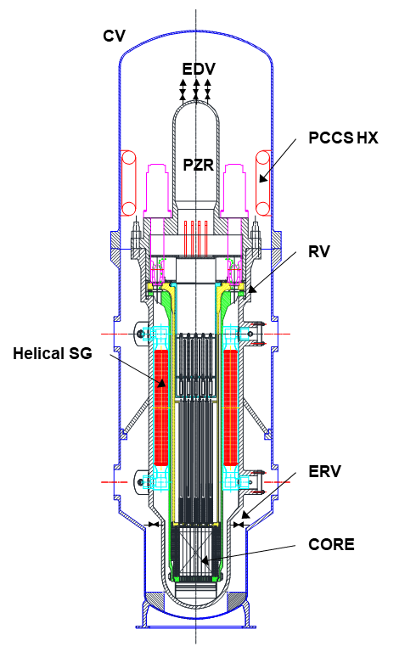

*FIG. 1. Schematic Diagram of the PECCS.*

### Passive Auxiliary Feedwater System

Decay heat is removed by a Passive Auxiliary Feedwater System (PAFS) and Passive Containment Cooling System (PCCS) in non-LOCA and LOCA scenarios, respectively. After reactor trip, when normal decay heat removal mechanism utilizing the secondary system is not working properly, the PAFS transfer heat from steam generator tube to heat exchanger located in Emergency Cooling Tank (ECT) which is the safety-grade ultimate heat sink for accident condition. The PAFS can brings the RCS to safe shutdown condition within 36 hours after accident initiation and maintains the safe shutdown condition for at least another 36 hours. The PAFS is physically separated into has two trains and each train has inlet pipes, heat exchangers, outlet pipes, and actuation valves. The inlet pipe connects a main steam line of secondary coolant circuit and the heat exchanger while the outlet pipe connects the heat exchanger and a feedwater line. Figure 2 shows the schematic diagram of the PAFS.

In normal operation, actuation valves are closed and main steam flows from steam generator to the turbine. When the PAFS signal occurs or the electric power for PAFS valves losses, the PAFS actuation valve and main steam isolation valves are closed. Hence, the steam generated in the SG flows from the main steam line to the PAFS heat exchangers and condensed by the cold water in ECT. The condensed water returns to steam generator, which make a natural circulation and cooling circuit. PAFS can maintains the safety function for at least 72 hours without any corrective action by operator or the aid of AC/DC power while there is a sufficient amount of water in ECT.

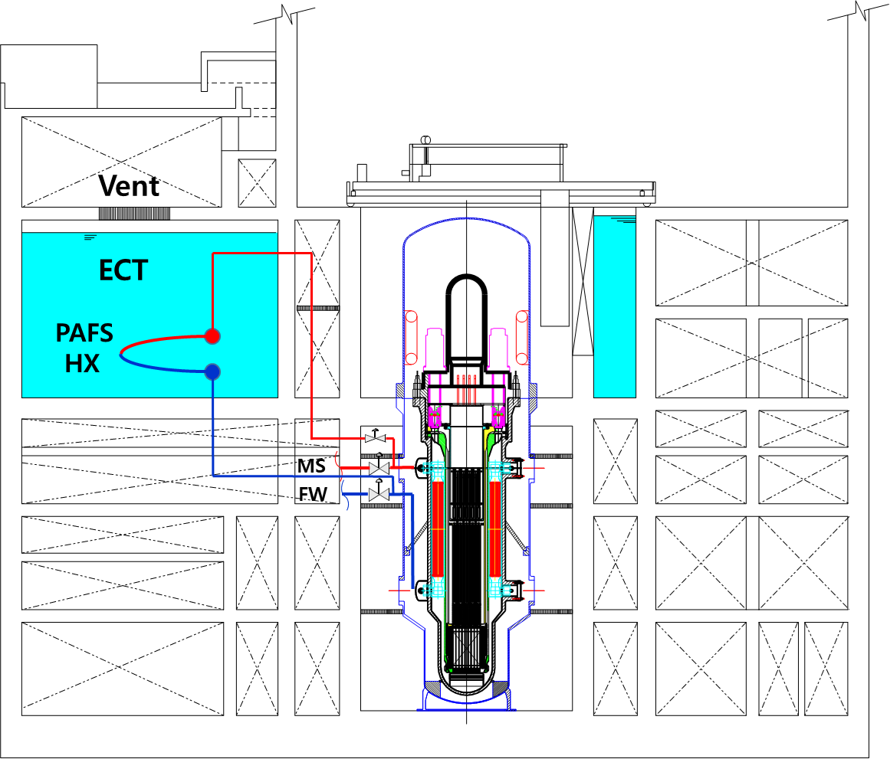

*FIG. 2. Schematic Diagram of the PAFS.*

### Passive Containment Cooling System

While the PAFS transfers the decay heat to the ECT through the steam generator and PAFS heat exchanger, Passive Containment Cooling System (PCCS) transfers the heat to the ECT through the PCCS heat exchanger.

The PCCS is physically separated into has four trains and each train consists of inlet pipe, heat exchangers and return pipes. The PCCS heat exchangers are located inside the upper header of the containment and the inlet pipe or the outlet pipe directly connects the heat exchangers to ECT. When a hot coolant comes from reactor vessel to containment vessel following a break of reactor pressure boundary or the opening of EDVs and/or ERVs, the hot steam contacts the outer surface of PCCS heat exchanger and condenses on the surface.

The water in the PCCS heat exchanger is heated by the heat transfer from primary coolant and the water flows upward to the ECT. Cold water from ECT is replenished to the lower header of PCCS heat exchanger and natural circulation flow path is formed between the PCCS heat exchanger and the ECT. In the system, there are no actuation signal, no electric power nor operator action required to perform its safety function. Figure 3 shows the schematic diagram of the PCCS.

### Emergency Cooling Tank

The Emergency Cooling Tank (ECT) serves as an ultimate heat sink for the i-SMR in the event of an accident. The PAFS heat exchangers are submerged in the water pool of ECT. Also, piping connected to the PCCS heat exchangers are installed on the ECT walls to provide cooling of the PCCS heat exchangers. Boiled steam from the ECT during the cooling of decay heat is discharged to the outer atmosphere via vents on the reactor protection building.

The ECT has sufficient capacity to supply coolant to cool down the core and maintain a safe shutdown condition for more than 72 hours using PECCS, PAFS, and PCCS. The ECT is designed to be located below ground level to minimize the impact of aircraft crash.

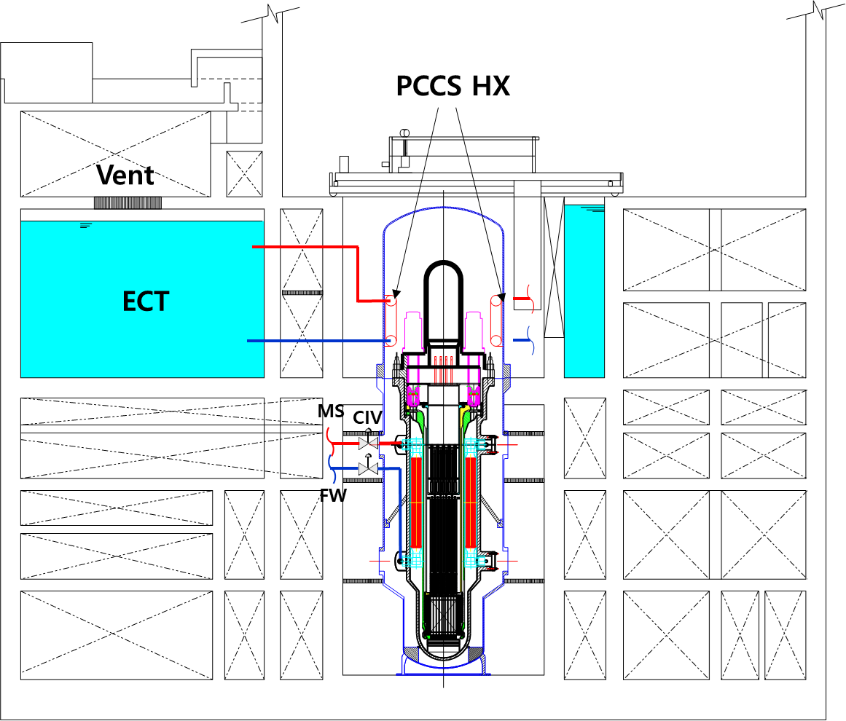

*FIG. 3. Schematic Diagram of the PCCS.*

## Current Status and Future Plan

Figure 4 shows the brief schedule for the i-SMR development. Now Standard Design which is the second stage of basic design is in progress, in which the basic design has being more optimized and licensing document for standard design approval will be prepared.

The preliminary design review of i-SMR is conducted in parallel with the standard design. Nuclear Safety and Security Commission and related institutes are reviewing the design and plan to establish regulatory requirements and standards for a small modular reactor with innovative design features before the Application Summit, which is scheduled for early 2026 in the i-SMR development plan. It is expected that the preliminary design review will increases the efficiency of the main review, shorten the period, and ultimately helps complete the standard design approval by 2028.

In May 2024, Korea government announce a draft working plan of “The 11th Basic Plan on Electricity Demand and Supply”, in which it is planned to build and operate one SMR plant with a power generation capacity of 700 MWe by 2035. To achieve the plan, a construction site will be decided in a few years and a construction permit will be applied immediately after obtaining standard design approval.

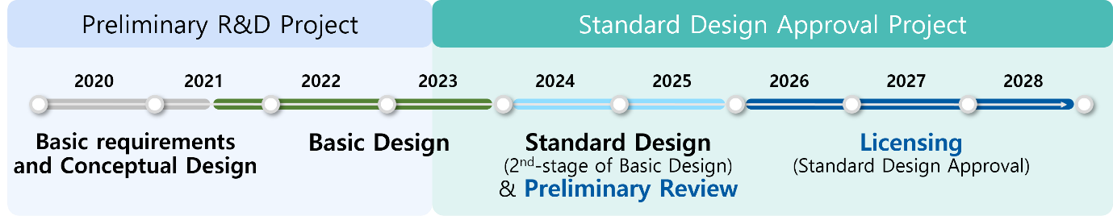

*FIG. 4. Development Schedule.*

ACKNOWLEDGEMENTS

This work was supported by the Innovative Small Modular Reactor Development Agency grant funded by the Korea Government (MOTIE). (No. RS-2024- 00404240)

References

1. Han Ok Kang *et al.*, Light water SMR development status in Korea, Nuclear Engineering and Design, v.419 (2024).
2. Net Zero by 2050 : A Roadmap for the Global Energy Sector, IEA, 2021.
3. Small Modular Reactors: Nuclear Energy Market Potential for Near-term Deployment, OECD NEA, 2016.