# dynamic analysis of steam DUMP SYSTEM OF SMR

YE ZHU

Science and Technology on Reactor System Design Technology Laboratory

Chengdu, China

Email: 353010307@qq.com

SONG DANRONG, ZENG CHANG, LIU MINGHAO, CAI ZHIYUN, REN YUN

Science and Technology on Reactor System Design Technology Laboratory

Chengdu, China

**Abstract**

The steam dump system of nuclear power plant is designed to provide an artificial secondary side load that balances the power difference between the reactor and the turbine. The steam dump system, including both process and control elements, is one of the most complicate systems in nuclear power plant, which is closely related to reactor power control, feedwater control and other process. Especially for some small modular reactors which apply casing steam generators, the characteristic is much different from the traditional NPP. In this paper, a full scope APROS model including reactor core, primary/secondary circuit and I&C system for Hainan Changjiang SMR (ACP100) is built.

## INTRODUCTION

The function of steam dump system is to provide a artificial load for the reactor during steam turbine load rapidly decreasing condition while the reactor power can't follow at the same pace, to ensure the safety of the reactor. The surplus steam bypasses the turbine and directly enters the condenser. Thus the temperature and pressure of primary side reactor coolant are maintain at a reasonable range.

The steam dump system is considered to be the most important system in nuclear power plant as it is closely related to reactor safety. Various studies have been conducted about the design, operation and simulation of the steam dump system. Hainan Changjiang small module reactors (SMR) applied casing steam generator and integrated reactor vessel. The casing steam generator secondary side water inventory is relatively limited and steam pressure is directly affected by the feedwater pressure. Thus the design and characteristic of the SMR steam dump steam differ notably from the tradition nuclear power plant.

Recently many studies has been conducted on steam dump system and its operation. Kong et al. (2013) established a two-phase flow simulation model to analyse the dynamic parameters of condenser during steam dump process [1]. Wang et al. (2011) compiled a visual dynamic real-time simulation program for the steam dump control system with VC++.net software [2]. He (2017) conducted the steady-state thermal calculation to verify the main engine group’s 100% steam dump capacity and the maximum steam dump capacity of the condenser for the nuclear powered ship [3]. Lin et al. (2011) established TRACE model for Maanshan power plant which includes steam dump control system. The feedwater control system and steam dump control system responses during large-load reduction transient is studied [4]. Wang et al. (2015) studied on two load rejection transient for AP1000 reactor. Vaidyanathan (2011) studied the response of the steam dump system in the event of turbine generator trip [5]. Lu et al. study the dynamics process of steam dump system in scram condition of nuclear power plant [6]. Zhang et al. (2015) analysed the dynamic characteristic of turbine steam bypass system [7].

The above papers are mainly focus on steam dump process of nuclear power plant & ship with nature cycle U-tube steam generators. Relatively few research has been conducted on the steam dump system of SMR which applied casing steam generator. In this paper, simulation is conducted using APROS Nuclear simulation and analysis software. As the steam dump process is closely coupled with reactor power, primary side coolant temperature, feedwater pressure, a complete model including the process and control elements of primary/secondary side is built. The steam dump process under different condition is simulated and analysed.

## SMR Steam dump SYSTEM DESCRIPTION

Base on Hainan Changjiang SMR (ACP100) which is currently under construction, the composition, design parameters and control logic of the steam dump system are described in this chapter.

### Process system

The steam dump system is connected to main steam pipe and condenser. The steam dump system has a total of 4 sets of steam dump pipelines. Each group consists of one steam bypass valve with a capacity of 21.25% of rated steam flow. The steam dump system draws from two main steam pipes on each side of the turbine. Each main steam pipe connects to 2 sets of steam dump pipelines. The outlet steam from the four sets of bypass valves is discharged to the condenser. The sketch of steam dump system is shown in Figure 1. The main design parameters of SMR is shown in Table 1 [8].

TABLE 1. SMR TECHNICAL PARAMETER

|  |  |  |
| --- | --- | --- |
| Parameter | Unit | Data |
| Rated reactor power | MW | 385 |
| Rated electrical power | MWe | 127 |
| Number of fuel assembly | / | 57 |
| Number of CSG | / | 16 |
| Number of RCP | / | 4 |
| Design life | year | 60 |
| Feedwater/Steam flowrate | t/h | 596.8 |
| Steam pressure | MPa | 4.5 |
| Steam dump capacity | % | 85 |



*FIG. 1. Sketch of steam dump system*

### Instrument and control system

There are two modes of steam bypass control logics, one is load-difference and the other is pressure-difference mode.

The steam dump control logic is divided into two channels with different control variables: one is power difference control channel and the other is steam pressure control channel. The pressure control channel (pressure regulated mode) is used for automatic control of steam dump from turbine runup during normal reactor startup. After the turbine runup is complete, it should be switched to the power difference control channel, which is used for automatic control of steam dump under reactor power operation.

#### Load difference control channel

After the turbine completes the runup, the power difference control channel implements the steam dump process according to the power difference between the reactor and turbine. When the unit has a turbine trip or disconnected from the external electric grid breaker, the turbine load suddenly drops to less than 40% rated power. The load difference control channel is further divided to 2 modes based on the difference between the nuclear power signal and the turbine load signal:

1. Power difference regulation mode

When the difference between the turbine load and the reactor is less than 40%. The difference is processed by a function generator to produce a steam dump flow demand signal. The function generator has a dead zone, and the steam dump flow demand output signal is linear related to the power difference to maintain the load balance of the primary and secondary cycle.

1. Power difference quick-open mode

When the difference between the turbine load and the reactor is greater than 40%, the power differential quick-open dump process is triggered. The 4 groups of bypass valves open according to the low to high quick-open dump set point. When the quick-open signal disappears, each discharge valve returns to the power difference regulation mode. This mode is effective under any operating condition.

#### Pressure control mode

The steam pressure control channel implements the following dump controls based on the deviation between the steam measurement pressure and the pressure set point:

1. Steam pressure regulation mode

The steam dump system is put into steam pressure regulation mode when the unit normal start-up and turbine is runup. When the steam pressure is higher than the set value, the steam pressure measurement signal is compared with the steam pressure set point, and the resulting deviation signal is sent to the proportional-integral controller to generate a steam dump flow demand signal to prevent the steam pressure from being too high.

1. Steam pressure high quick-opening mode

In this mode, a rapid increase in steam pressure above the bypass valve quick-open setpoint triggers quick-opening signal. The four sets of bypass valves open in sequence according to the low to high quick-open set point. When the quick-open signal disappears, the bypass valves switch back to regulation mode.

The dump demand signal calculated by the control channels lets each bypass valve to open according to different working conditions, so that each emission valve opens in sequence, i.e., each emission valve adopts the sequence of opening in which the first valve opens fully before the second valve opens, and the closing sequence is the other way round. This mode is effective under any operating condition, along with power difference quick-open mode.



*FIG. 2. Control logic of steam dump system*

## Related SYSTEM and coMponents DESCRIPTION

The steam dump process is a joint operation and the steam dump system is closely coupled with other primary and secondary side systems. So the related systems are also described in this chatper.

### Feedwater system

The feedwater system mainly consists of 3 feedwater pumps and a feedwater control valve set. The control logic of feedwater system is to maintain a fixed steam pressure. The steam pressure is controlled by regulating feedwater pump rotation speed. The position of feedwater control valve is adjusted by the turbine load [9].

### Reactor coolant system

The reactor coolant system (RCS) mainly consists of 4 reactor coolant pumps (RCP), 16 casing steam generators which located inside the reactor pressure vessel (RPV), a pressurizer and related instrument devices. The reactor coolant of primary side flows into 16 casing through steam generators, transfers heat to the secondary side feedwater.

### Reactor and power control system

There are 4 "R" control rods to regulate the reactor core power. The position of control rods is affected by two sets of control logic: the reactor coolant average temperature channel and reactor power-turbine load difference channel. The purpose is to maintain the balance of reactor power and-turbine load, and keep the average temperature of reactor coolant is at the set point.

### Main steam safety valves

4 main steam safety valves are installed at the main steam line. The opening set point is 5.7MPa for the 1st group and 6.1MPa for the 2nd group of two main steam safety valves.

## moDELING OF APROS SIMULATION MODEL

APROS, developed by the Research Centre VTT and Fortum Engineering in Finland, is a program package that enables development of dynamical simulations for engineering purposes [10]. The tool is suitable for modelling and simulation of the dynamics of a process plant during all phases of its life span from pre-design to training and model supported operation and control, for small simple models and full scope simulators.

### Steam dump system modelling

#### Process component

The 4 steam bypass valves are built by CONTROL_VALVE component; the connecting pipes are built by PIPE component; the steam main pipe is built by TANK_HORI component. All equipment parameters, pipe length and elevation are according to realistic design. The steam dump system nodalization schemes can be seen in Figure 3.

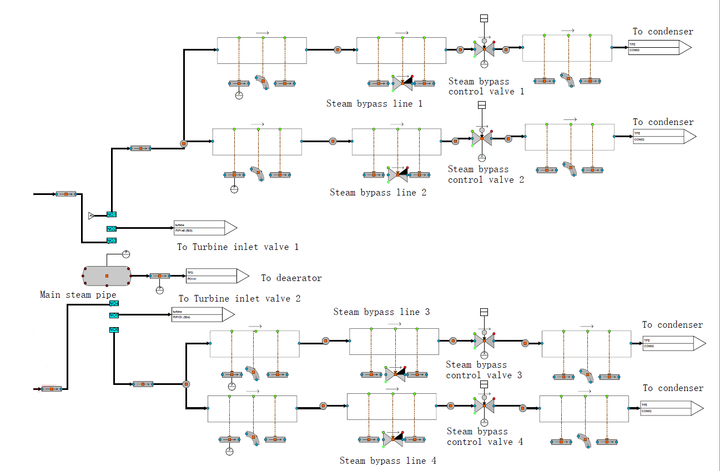

*FIG. 3. Steam dump system process model*

#### Control Logic

The control logic is built according to chapter 2.2. APROS automation components such as FILTER, ANALOG_SWITCH, ANALOG_MEMORY, LV_CHECKER, FUNCTION, and PID_CONTROLLER etc. are used. The automation diagram is shown below.

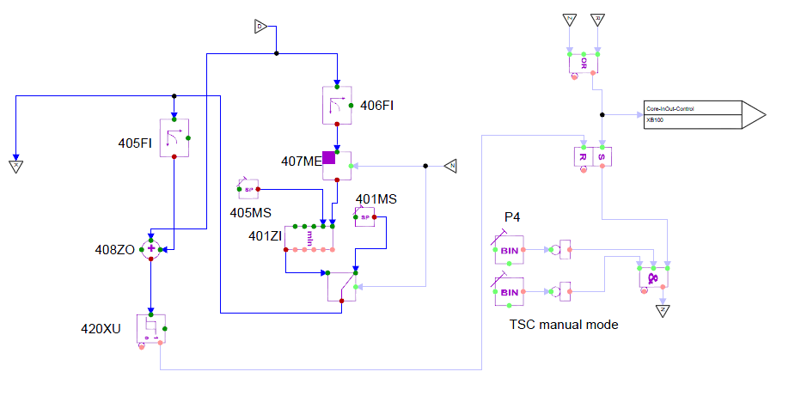

*FIG. 4. Steam dump system control logic model(1)*

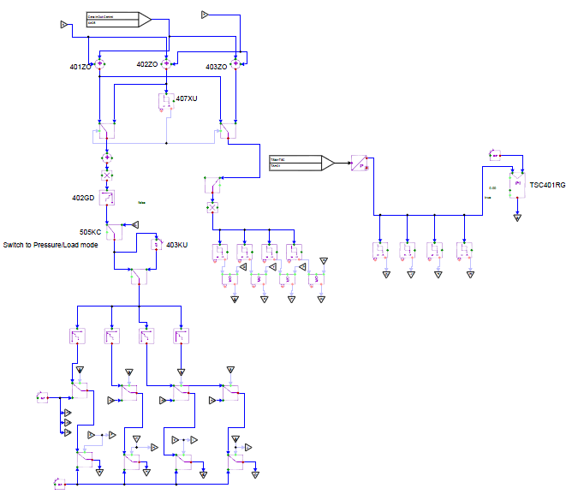

*FIG. 5. Steam dump system control logic model(2)*

### Steady state simulation

The operating parameters of main process systems under 100% loading condition has been calculated by APROS. They are then compared to their design values and have been listed in Table 2.

TABLE 2. Steady state parameter before and after turbine trip

|  |  |  |  |  |
| --- | --- | --- | --- | --- |
| Parameters | Units | Design | Simulation | Error(%) |
| Reactor power | MW | 385.0 | 385.8 | -0.21 |
| RCS hot side temperature | ℃ | 319.5 | 318.8 | 0.22 |
| RCS cold side temperature | ℃ | 286.5 | 286.2 | 0.10 |
| Pressurizer pressure | MPa | 15.0 | 15.0 | 0.00 |
| Steam flowrate | t/h | 596.8 | 593.9 | 0.49 |
| Feedwater flowrate | t/h | 596.8 | 593.0 | 0.64 |
| Steam pressure | MPa | 4.5 | 4.49 | 0.22 |
| Steam temperature | ℃ | 293.8 | 292.2 | 0.54 |
| Turbine power | MW | 125 | 122.28 | 2.18 |

## Steam dump process simulation and analysis

The harshest and worst condition is turbine load rejection condition at full power. The turbine load rejection condition can be further divided into two cases.

* Turbine reject to plant power load: In this case, the turbine load reduces to ~8%, resulting turbine shaft speed remarkably increased. Thus the turbine inlet valves close in 0.3s due to the turbine over-speed protection signal. The 4 steam bypass valves open in sequence according to reactor power-turbine load difference. After the turbine shaft speed reduced to normal range, the turbine inlet valves adjust to a small opening position to provide plant electric power. In this mode, the final reactor power is set to 40%.
* Turbine trip: In this case, the turbine inlet valves close at ~0.2s. The 4 steam bypass valves open in sequence according to reactor power-turbine load difference. The final reactor power is set to 40%.

### Turbine reject to plant power load simulation

The transient begins with the manually triggered turbine reject to plant power load signal. The transient process is shown below.



*FIG. 6. Variation of parameters during turbine reject to plant power load transit (1).*



*FIG. 7. Variation of parameters during turbine reject to plant power load transit (2).*



*FIG. 8. Variation of parameters during turbine reject to plant power load transit (3).*



*FIG. 9. Variation of parameters during turbine reject to plant power load transit (4).*



*FIG. 10. Variation of parameters during turbine reject to plant power load transit (5).*

The sudden closure of turbine inlet valves resulted dramatically decreasing of steam/feedwater flowrate as well as dramatically increasing of steam pressure. All 4 steam bypass valves opened on in sequence to provide an artificial load. Because of increasing coolant temperature and decreasing secondary side load, the reactor control rods inserted to reduce the reactor power. At 144s, the turbine inlet valve reopened to a small opening to provide plant electric load. So the steam dump flowrate is lower than Steam and Feedwater flowrate as some steam enters the turbine. The peak value of steam pressure reaches ~5.5MPa but it is still lower than main steam safety valves opening set point (5.7 and 6.1MPa). Finally after about 150s, the whole system reached a new steady state. The steady state parameters before and after dump process are shown in Table 3.

TABLE 3. Steady state parameter before and after turbine reject to plant power load

|  |  |  |  |
| --- | --- | --- | --- |
| Parameters | Units | Before | After |
| Reactor power | % | 100.1 | 43.1 |
| RCS hot side temperature | ℃ | 318.8 | 310.3 |
| RCS cold side temperature | ℃ | 286.2 | 295.9 |
| Pressurizer pressure | MPa | 15.0 | 14.9 |
| Steam flowrate | t/h | 593.9 | 246.8 |
| Feedwater flowrate | t/h | 593.0 | 246.6 |
| Steam pressure | MPa | 4.49 | 4.47 |
| Steam temperature | ℃ | 292.0 | 309.1 |
| Steam bypass valve 1 postion | % | 0 | 100.0 |
| Steam bypass valve 2 postion | % | 0 | 45.9 |
| Steam bypass valve 3 postion | % | 0 | 0 |
| Steam bypass valve 4 postion | % | 0 | 0 |

### Turbine trip simulation

The transient begins with the manually triggered turbine trip signal. The transient process is shown below.



*FIG. 11. Variation of parameters during turbine trip transit (1).*



*FIG. 12. Variation of parameters during turbine trip transit (2).*



*FIG. 13. Variation of parameters during turbine trip transit (3).*



*FIG. 14. Variation of parameters during turbine trip transit (4).*



*FIG. 15. Variation of parameters during turbine trip transit (5).*

The process is similar to turbine reject to plant power load condition. The difference is the turbine load is set to 0 once the turbine trip signal is detected resulting almost simultaneously opening of all 4 steam bypass valves. Besides, the turbine inlet valve do not reopened. Finally after about 150s, the whole system reached a new steady state. The steady state parameters before and after dump process are shown in Table 4.

TABLE 4. Steady state parameter before and after turbine trip

|  |  |  |  |
| --- | --- | --- | --- |
| Parameters | Units | Before | After |
| Reactor power | % | 100.1 | 43.4 |
| RCS hot side temperature | ℃ | 318.8 | 310.52 |
| RCS cold side temperature | ℃ | 286.2 | 296.0 |
| Pressurizer pressure | MPa | 15.0 | 14.9 |
| Steam flowrate | t/h | 593.9 | 248.4 |
| Feedwater flowrate | t/h | 593.0 | 248.2 |
| Steam pressure | MPa | 4.49 | 4.48 |
| Steam temperature | ℃ | 292.0 | 309.3 |
| Steam bypass valve 1 postion | % | 0 | 100.0 |
| Steam bypass valve 2 postion | % | 0 | 69.2 |
| Steam bypass valve 3 postion | % | 0 | 0 |
| Steam bypass valve 4 postion | % | 0 | 0 |

### Result analysis

Basically the steam and feedwater flowrate should be the same at totally steady state according to mass balance. But at the “steady state” before and after steam dump, a small difference between steam and feedwater flowrate is observed. The reason is that APROS is a simulator, where the basic assumption is that only dynamic calculation is used. So there is no real steady state in APROS and some small difference between steam and feedwater flowrate does exist.

During these 2 above transit, the steam dump system generally performed its function, that is, provide an artificial load on the secondary side to avoid primary side overheat/overpressure, reactor trip or main steam safety valve open. During the steam dump process, oscillation can be observed on the 3rd steam bypass valve position.

## conclusion

Based on the APROS simulation software, a dynamic simulation model of SMR steam dump and other related system is presented including the steam generator and reactor core.

Then this paper studied the dynamic changes of nuclear power plant parameters during scram. The simulation results showed that the established process and control model can simulate the dynamic steam dump process. And the jointly operation of the steam dump system, reactor power control system and feedwater system can enable the plant to implement turbine load rejection and turbine trip operations successfully and safely without initiating the reactor trip or steam safety valves open. According to the simulation results, the steam dump system responds quicker in turbine trip mode. Further analysis and optimization can be done in the future to reduce or avoid frequently open/close of valve.

References

1. Kong, X. M., Wang, W., Meng, H. B., Liu, X. X., Chen B. T. Simulation study on dynamic characteristic of steam condenser for steam discharge system. *Atomic Energy Science and Technology*. **47** 12 (2013) 2272-2276.
2. Wang, B. S., Wang, D. Q., Zhang, J. M., Qiu, J. W., and Wang, J. Real-time simulation study on steam-dump control system of pressurized water reactor nuclear power plant. *Nuclear Power Engineering*. **32** 5 (2011) 38-44.
3. He, J. Design of steam discharge system on nuclear-powered ship. *Ship power plant*. **28** 3 (2017) 48-53.
4. Lin, H. T., Wang, J. R., Shin, C., The feedwater control system and steam dump control system responses during large-load reduction transient for Maanshan PWR Plant. *Procedia Engineering*. **15** (2011) 3668-3672.
5. Wang, P. F., Chen, Z., Zhang, Z., Sun, J., He, Z. X., Zhao, F. Y., and Wei, X. Y. Control simulation and study of load rejection transient for AP1000. *Progress in Nuclear Energy*. **85** (2015) 28-43.
6. Lu N., Li Y., Pan L., Wu X., Shen J., Liu Z., and Kwang K. Study on Dynamics of Steam Dump System in Scram Condition of Nuclear Power Plant. *IFAC Papers OnLine*. **52-4** (2019) 360-365.
7. Zhang, X. S., Sun P. W., Wei, X. Y. Dynamic Characteristic Analysis of Steam Bypass Exhaust System of Steam Turbine. *Nuclear Power Engineering.* **42-2** (2021) 25-28.
8. Song, D. R., Qin, Z. Progress of LING LONG SMR Technology and Demonstration Project, *China Nuclear Power*,(2018) 21-23.
9. Ye, Z., Qiao, L., Liao, X. W., Cai, Z. Y., Liu, .M. H. SMR Feedwater System Analysis, Proceedings of the 30nd International Conference on Nuclear Engineering (Kyoto, 20-26 May 2023), ICONE30, Kyoto (2023).
10. APROS Nuclear documentation, VTT and Fortum, 2012.