Education through science.
NNSTU master’s program
«Nuclear power plants with SMR»

A.A. DOBROV
Nizhny Novgorod State Technical University n.a. R.E. Alekseev
Nizhny Novgorod, Russian Federation
Email: dobrov@nntu.ru

M.A. LEGCHANOV
Nizhny Novgorod State Technical University n.a. R.E. Alekseev
Nizhny Novgorod, Russian Federation
Email: legchanov@nntu.ru

A.E. KHROBOSTOV
Nizhny Novgorod State Technical University n.a. R.E. Alekseev
Nizhny Novgorod, Russian Federation
Email: khrobostov@nntu.ru

Abstract

Since 2020, in cooperation with the Technical Academy of Rosatom, NNSTU (Nizhny Novgorod State Technical University, Russian Federation) implemented a project to prepare the short-term courses and a full-fledged master's program «NPP with SMR» in English. The project consists of two parts. The first one - a program of train-the-trainer’s courses "NPPs with SMR: Main Aspects and Life-cycle" - a new educational product aimed at improving the qualifications of specialists from foreign partner countries in this field of engineering. The second - two-year master's program, whose graduates are preparing for research, design and development activities in the field of nuclear engineering of NPPs with SMR.

INTRODUCTION
The future development of nuclear energy is closely related to low power projects and small modular reactors. The Russian Federation's experience in the development and safe operation of low-power reactors goes back several decades. The world's first nuclear power plant, a nuclear icebreaker fleet, the world's only floating nuclear thermal power plant "Akademik Lomonosov" - each of these projects is based on Russian small reactor technologies.
In May 2024, Rosatom entered into a cooperation agreement on the construction of a low-power nuclear power plant in the Republic of Uzbekistan. The NPP is based on six RITM-200N reactor units with an electrical power of 55 MW each. Rosatom is currently building a nuclear power plant in Yakutia (Russia), where RITM-200N reactors will also be installed. The launch of the first unit is expected in 2027. The Russian State Atomic Energy Corporation is actively promoting its small nuclear power plant projects abroad. Potential partners include countries in Africa, Latin America and Southeast Asia.
In this regard, the issue of training engineering personnel for such facilities becomes very important. This requires new educational programs at universities that take into account the specifics of the design and operation of equipment for low-power nuclear power plants.

MASTER’S PROGRAM «NUCLEAR POWER PLANTS WITH SMR»
Since 2020, in cooperation with the Technical Academy of Rosatom, NNSTU (Nizny Novgorod, Russia) implemented a project to prepare the short-term courses and a full-fledged master's program «NPP with SMR» in English. This is a two-year master program, a graduate of which is ready to do research, design and engineering work in the field of nuclear energy, including the subject of NPP with SMR, has the necessary skills to analyze design and engineering documentation.
- Innovative approaches in the design and construction of nuclear power plants
- NPP Safety Assurance
- Hydrodynamics and heat transfer in equipment of nuclear power plants
- Methods for solving engineering problems in R&D of NPPs
- Organization and conduct of scientific researches
- Tribological aspects of power plant design and construction
- Modelling of heat and mass transfer processes in R&D for the creation of NPPs
- Rosatom production system in the design and construction of power plants
- Economic assessment of decision-making efficiency in the energy sector
And, of course, a lot of practice in NNSTU scientific labs, which takes up more than half student’s time. In laboratories students make their own scientific research.
Many companies of the State Atomic Energy Corporation Rosatom are located near our university, so NNSTU and science have always been closely connected. Actual needs of the Rosatom top companies allow to improve the educational process.

EXPERIMENTAL BASIS FOR STUDENTS PRACTICE
It should be noted that for many years NNSTU has been implementing the "Education through Science" program. Thanks to this program, all bachelors and master’s students have the opportunity to gain experience in operation in unique research facilities.

Aerodynamic facility FT-50
To study the characteristics of the coolant flow in the models of fuel assemblies RITM-200, KLT-40S, PWR and WWER, there is an aerodynamic experimental facility FT-50, which is an open circuit through which air is pumped. The organization of the coolant flow is as follows: air is pumped into the receiver tank by means of a high-pressure radial fan and then, after passing through the flow meter manifold and the experimental model, it flows into the atmosphere. General view of this facility is shown on Fig. 1. The QR-code on the figure allows to see one of the dynamic photos of this laboratory using smartphone.
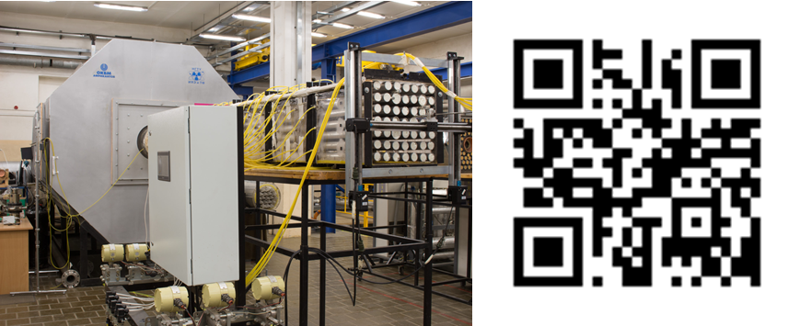
FIG. 1. Aerodynamic facility FT-50

Students of the master's program conduct laboratory works on this facility, and can also work on their master's thesis, the topic of which is related to the study of the coolant local hydrodynamics in the elements of reactor cores.

Experimental complex FT-40 with a capacity of 1.5 MWe
FT-40 (Fig. 2) is a large-scale test facility for research of the hydrodynamics of the coolant flow in the main equipment of nuclear power plants with an electric power up to 1 MW.
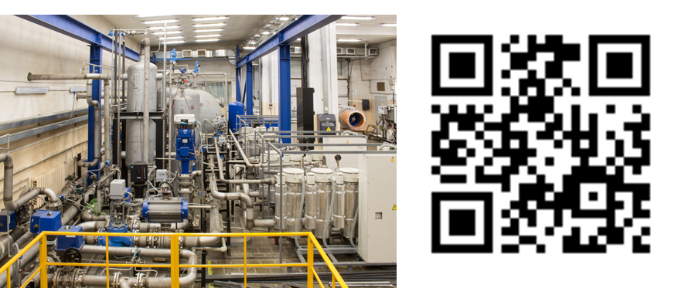
FIG. 2. Experimental complex FT-40

This facility allows to carry out the following types of research:
- investigation of mixing processes of isothermal and non-isothermal coolant flows in reactor vessel in steady state and transient conditions;
- study of the thermal hydraulics of the coolant flow in the main equipment of the nuclear power plant, such as pumps, valves, filters, pressurizers;
- research of thermal-hydraulic and resource characteristics of high-stress heat-exchange elements.
Nowadays, NNSTU scientists and students are investigating the features of the coolant flow in a SMR (Fig. 3) for NPP.

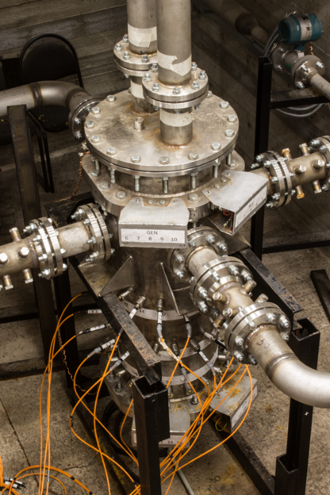
FIG. 3. Experimental model of SMR part of FT-40 facility

Research laboratory «Technology and thermophysics of heavy liquid metal coolants»
Research laboratory "Technology and thermal physics of liquid metal coolants" for research of heat transfer in the heavy liquid metal coolant. Large multipurpose circulation test facility (Fig. 4) with a lead coolant consumption of ~ 2000 t/h allows to carry out the following types of research:
- study of the thermophysical characteristics of the lead coolant with the operational parameters of the nuclear power plant;
- study of the features of the interaction of lead coolant with various construction materials;
- study of the features of the flow of liquid metal coolants in a magnetic field.
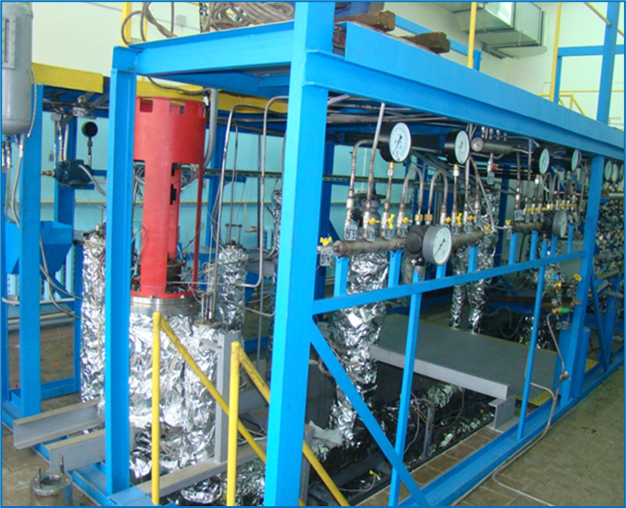
FIG. 4. Experimental complex FT-4 with liquid lead as coolant

To date, laboratory staff and students of NNSTU have designed and manufactured an original axial pump for liquid lead (Fig. 5). The pump was included in the experimental test loop and underwent life tests, during which its hydraulic characteristics and reliability were confirmed.

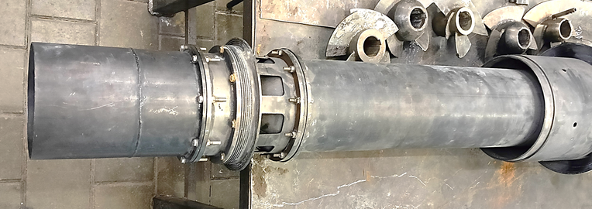
FIG. 5. Pump for liquid lead designed in NNSTU

Facilities FT-A1 and FT-A2 for modelling HTGR coolant hydrodynamics
NNSTU is a member of the state program Schools of Advanced Engineering Studies. NNSTU dedicated this project to research in the field of High-Temperature Gas-Cooled Reactors for hydrogen producing. As part of this program, there was created a new laboratory for Simulation of Gas Dynamics in HTGR. There are two new test facilities FT-A1 and FT-A2. The first one (Fig. 6) is devoted to the study of the processes of mixing helium flows from different temperatures in the bottom collecting vessel of the HTGR. Students of the master’s program «NPP with SMR» are also involved in the design and assembly of research facilities, that’s why students gain unique experience and practical skills.
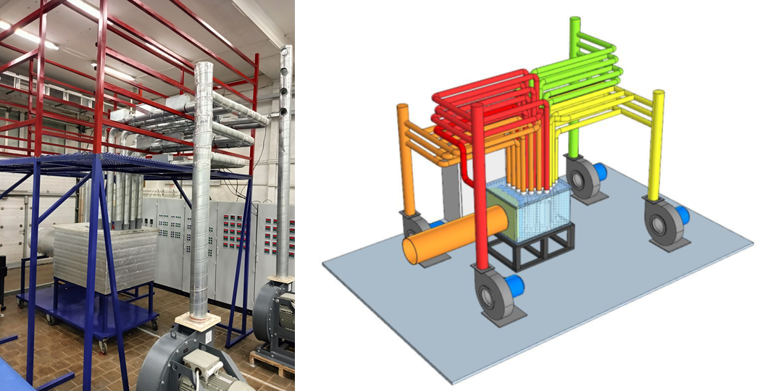
FIG. 6. General view (left) and scheme (right) of the FT-A1 test facility for HTGR researches

Another facility FT-A2 (Fig. 7) is related to the study of hydrodynamic processes in the prismatic core of the nuclear reactor and is made in the real scale, including three models of fuels assemblies.
At each of these facilities, in addition to scientific research, a series of laboratory work is planned, devoted to studying the characteristics of the equipment, its design, and methods for processing experimental data.
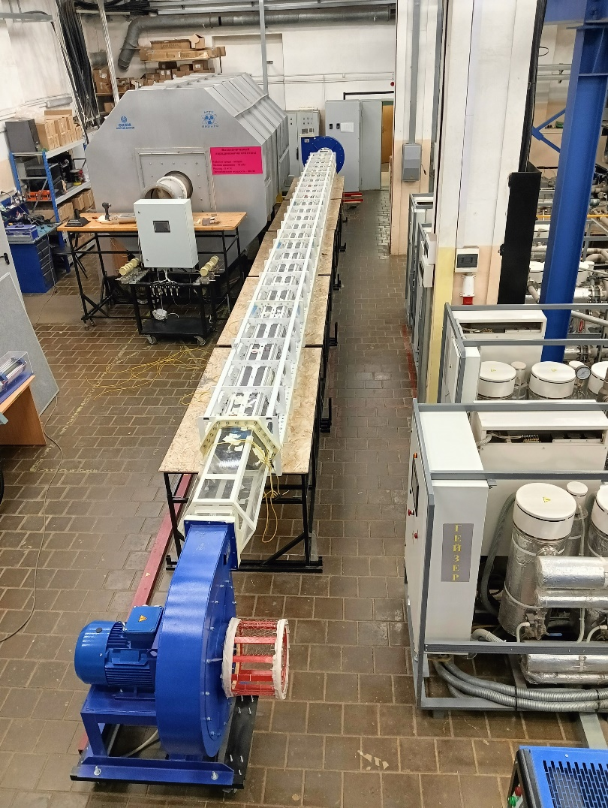
FIG. 7. General view of the FT-A1 test facility for HTGR core researches

Basic laboratory works
In addition to scientific research facilities for students, there are laboratory facilities that are involved in the educational process. This is a study of the process of natural circulation of fluid in channels, which is important to understanding the principles of operation op passive safety systems. There are facilities with various measurement devices, that are used at NPP. There are also an electrical heated model of a three-loop NPP, which make it possible to study dynamic operation modes which are so important for SMR.
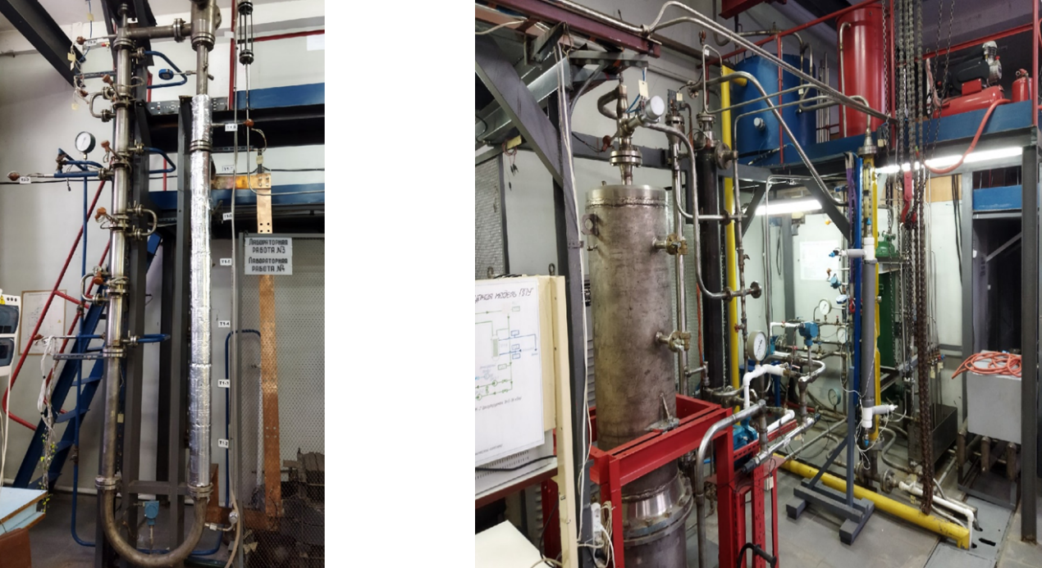
FIG. 8. Facility for investigation of multiphase natural circulation processes (left) and facility for study of transient dynamic characteristics in a three-circuit NPP (right)

Additional Virtual Laboratory Works (VLW) based on real experimental data
Unfortunately, not all students have opportunity to study face-to-face. That’s why NNSTU specialists decided to create digital analogues of test facilities in the form of computer applications. This technology is based on the real experimental data. All parameters and variables are recorded in steady state and transient modes of operation. This is not a simulation, but a real recording of a huge number of experimental data. Each VLW is accompanied by video material, which presents the facilities, as well as the methodology of obtaining and processing the results. This technology during the Covid-19 pandemic allowed not to stop practical training and not to still student’s time to gain practical skills in working with real equipment. Several examples of such VLW are shown oh Fig. 9-11.
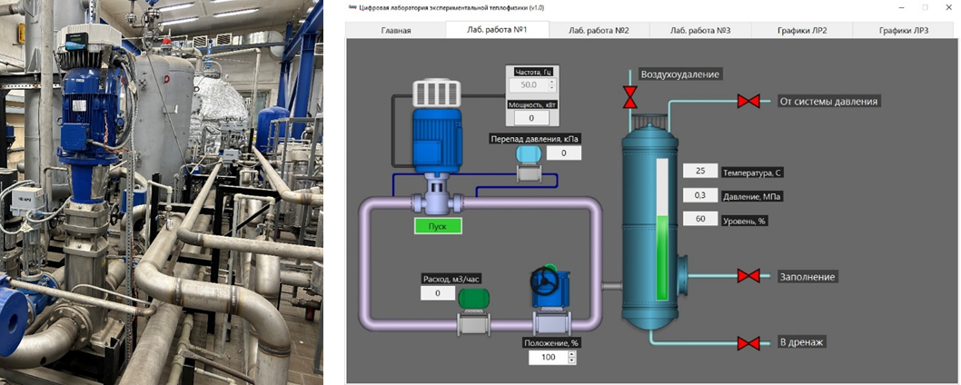
FIG. 9. Main coolant pump of FT-40 facility (left) and VLW «Studying of the pump characteristics» (right)

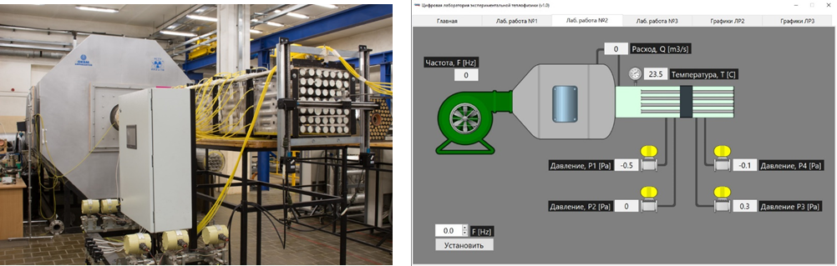
FIG. 10. FT-50 facility (left) and VLW « Studying of the pump characteristics» (right)

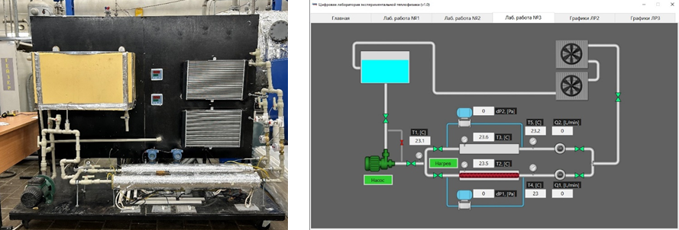
FIG. 11. Students’ laboratory test loop (left) and VLW «Investigation of heat exchanger effectiveness with intensifiers» (right)

CONCLUSION
Close cooperation of NNSTU with nuclear industry enterprises, mechanical engineering and design enterprises, as well as the experience and knowledge of employees involved in training specialists for the design and operation of naval nuclear propulsions, made it possible to create a new educational program for masters «NPP with SMR».
However, an engineer cannot be trained at his desk. Skills in practical work with nuclear power plant equipment are required, as well as experience in conducting scientific research and working with experimental data. NNSTU has a unique experimental base on which advanced current research is carried out in many areas of development of SMR. Therefore, in addition to studying, students are involved in the scientific activities of the university. This approach to training, called «Education through science» makes it possible to prepare a highly qualified specialists who is ready to solve real problems of enterprises immediately after they studies at the NNSTU.

