# Initiatives in INPRO for SMRs

INPRO is the International Project on   
Innovative Nuclear Reactors and   
Fuel Cycles

N. DAS

International Atomic Energy Agency

Vienna, Austria

[ni.das@iaea.org](mailto:ni.das@iaea.org)

S. JEON, G. SAYIN, C. SCHERER

International Atomic Energy Agency

Vienna, Austria

**Abstract**

The concept of sustainable nuclear energy development through strategic energy planning is facilitated by the International Project on Innovative Nuclear Reactors and Fuel Cycles (INPRO), a key programme of the International Atomic Energy Agency (IAEA). The INPRO programme has various activities supporting Member States (MSs) in strategic planning for sustainable nuclear energy incorporating small modular reactors (SMRs). INPRO brings together technology developers and users to explore joint actions that support the development and deployment of sustainable nuclear energy. INPRO’s collaborative SMR projects, aim to formulate prospective scenarios and success factors for sustainable nuclear energy systems deployment with SMRs, including potential cooperation models. Additionally, INPRO supports MSs through its nuclear energy system assessment (NESA) utilizing the holistic INPRO methodology, which encompasses six key areas for sustainability: economics, safety, infrastructure, environmental impacts, proliferation resistance, and waste management. The INPRO methodology helps identify gaps in sustainability including during design phases of a nuclear energy system (NES) and promotes advancing sustainable NES deployment. INPRO is working with several MSs including technology holders in performing NESAs for SMRs. Another project is the INPRO Dialogue Forums (DF), which provides a platform for technology holders and users to exchange knowledge on sustainable nuclear energy development and deployment; specifically, the 21st and 22nd DFs addressed SMRs.

## INTRODUCTION

INPRO is an agency wide programme of the International Atomic Energy Agency (IAEA) dealing with strategic planning for sustainable nuclear energy systems (NESs). INPRO developed a methodology for assessing the sustainability of NESs in six key areas that align with the United Nations (UN) concept of sustainable development. These aeras are economics, infrastructure, environmental impacts, safety, waste management and proliferation resistance. The methodology is therefore a holistic approach for assessing sustainability of advanced and innovative systems including SMRs.

There are four task areas in INPRO: 1) Global Scenarios, 2) Innovations, 3) Sustainability Assessments and Strategies, and 4) Dialogue and Outreach. Each of these tasks contributes to the successful and sustainable deployment of SMRs, such as in scenario assessments, economic assessments, studies on innovative SMRs, and creating a global platform for stakeholders to discuss challenges related to sustainable deployment of SMRs.

## INPRO TASK areas

The activities under INPRO support development of globally sustainable NES based on the INPRO methodology, and the holistic approaches to analysis and sustainability assessments. These analyses also include identification of enhancements for NES in technology and institutional arrangements [1].

The INPRO Task 1: Global Scenarios has the objective to support MSs in developing national, regional, and global sustainable nuclear energy scenarios through studies that use INPRO analysis tools and other modelling tools [2]. These analyses support developing sustainable nuclear scenarios through a century. This task has the collaborative project, Sustainable Deployment Scenarios for Small Modular Reactors: A Study Supported by the INPRO Service “Analysis Support for Enhanced Nuclear Energy Sustainability” (ASENES), referred to as ASENES-SMR.

Task 2: Innovations’ main objective is to investigate innovative nuclear energy technologies and institutional arrangements to support sustainable nuclear energy development [2]. One of the key projects under this task area is the study on deployment of factory fuelled SMRs, which focuses on transportable nuclear power plants (TNPPs). There was a preliminary TNPP study published in 2013 [3] and a follow-study titled “Case Study for Deployment of Factory Fuelled SMR” (TNNP-2) is nearing completion.

Task 3: Sustainability Assessments and Strategies’ purpose is to assists MSs in performing NES assessments (NESAs) in sustainability [2]. This task has two projects related to SMRs, the first is applying the INPRO methodology in sustainability assessments to SMRs. The second collaborative project is the Framework for Modelling Energy Systems (FRAMES), a modelling framework and tool to perform assessing and analysing NES for grid integration with renewables and advanced nuclear technologies, especially SMRs.

Task 4: Dialogue and Outreach provides an international venue for MSs to exchange information and ideas on NES strategies and deployment, and on long-range NES strategies, including outreach, training, and capacity building activities. One method to accomplish this purpose is through INPRO Dialogue Forums. Additionally, all training activities and workshops have an SMR component [2].

## smr projects IN INPRO Task areas

INPRO has many tasks that have SMR components [4]. The following describes some of the projects according to INPRO task area.

### 3.1. Task 1: ASENES SMR Collaborative Project

The ASENES SMR pilot study, launched in September 2020, responded to the strong interest of MSs expressed during the 28th Steering Committee Meeting in 2019. This project involves formulating and evaluating promising scenarios and success factors for the deployment of sustainable NES with SMRs, including prospective models of cooperation. The project’s MSs are performing several case studies by applying different INPRO methods and tools to support the sustainability assessment. The key objectives of the case studies are analysing scenarios, considering nationally determined contribution targets, future energy demand, market conditions, strategic planning, and investment attractiveness for SMRs. This collaborative project will result in an IAEA TECDOC publication. Below are some of the key ideas and themes of the case studies[2]:

1. Role of SMRs in mitigating greenhouse gases and achieving nationally determined targets while ensuring the least-cost solution for energy system development over the entire planning horizon.
2. Economic aspects of SMR deployment in countries with financial limitation to support nuclear energy projects.
3. Prospects of adopting sustainable SMR deployment in NES configurations with existing with large reactors.
4. Analysis of nuclear energy deployment scenarios and possible SMR roles based on trend analysis of energy consumption and the latest national plans.
5. Scenario analysis on SMR deployment in the context of future energy demand and market conditions, including with conventional and alternative energy sources and current renewable energy resources.
6. Verification of previous SMR studies and development of multi-aspect comparison of SMR projects [5].

### 3.2 Task 2: Transportable Nuclear Power Plants

The first study, initiated in 2008, resulted in a 2013 publication, *Legal and Institutional Issues of Transportable Nuclear Power Plants: A Preliminary Study* [3]*,* (see FIG. 1). One of the key findings of the preliminary study were the identification of gaps in existing international legal instruments related to nuclear law and in the non-binding international norms for TNPPs.

In 2015, INPRO launched a second collaborative project, TNPP-2, to explore legal and institutional aspects related to exporting a factory-fuelled, tested, and sealed modular reactor, see FIG. 1. The study is investigating the broader aspects of deploying transportable and modular reactor facilities, covering cross-cutting aspects such as infrastructure, civil liability, licensing, nuclear security (physical protection), non-proliferation, safeguards, safety, and personnel management. The study has a comprehensive approach and covers the lifecycle of a deployed factory fuelled SMR and is currently being prepared for publication as an IAEA TECDOC.

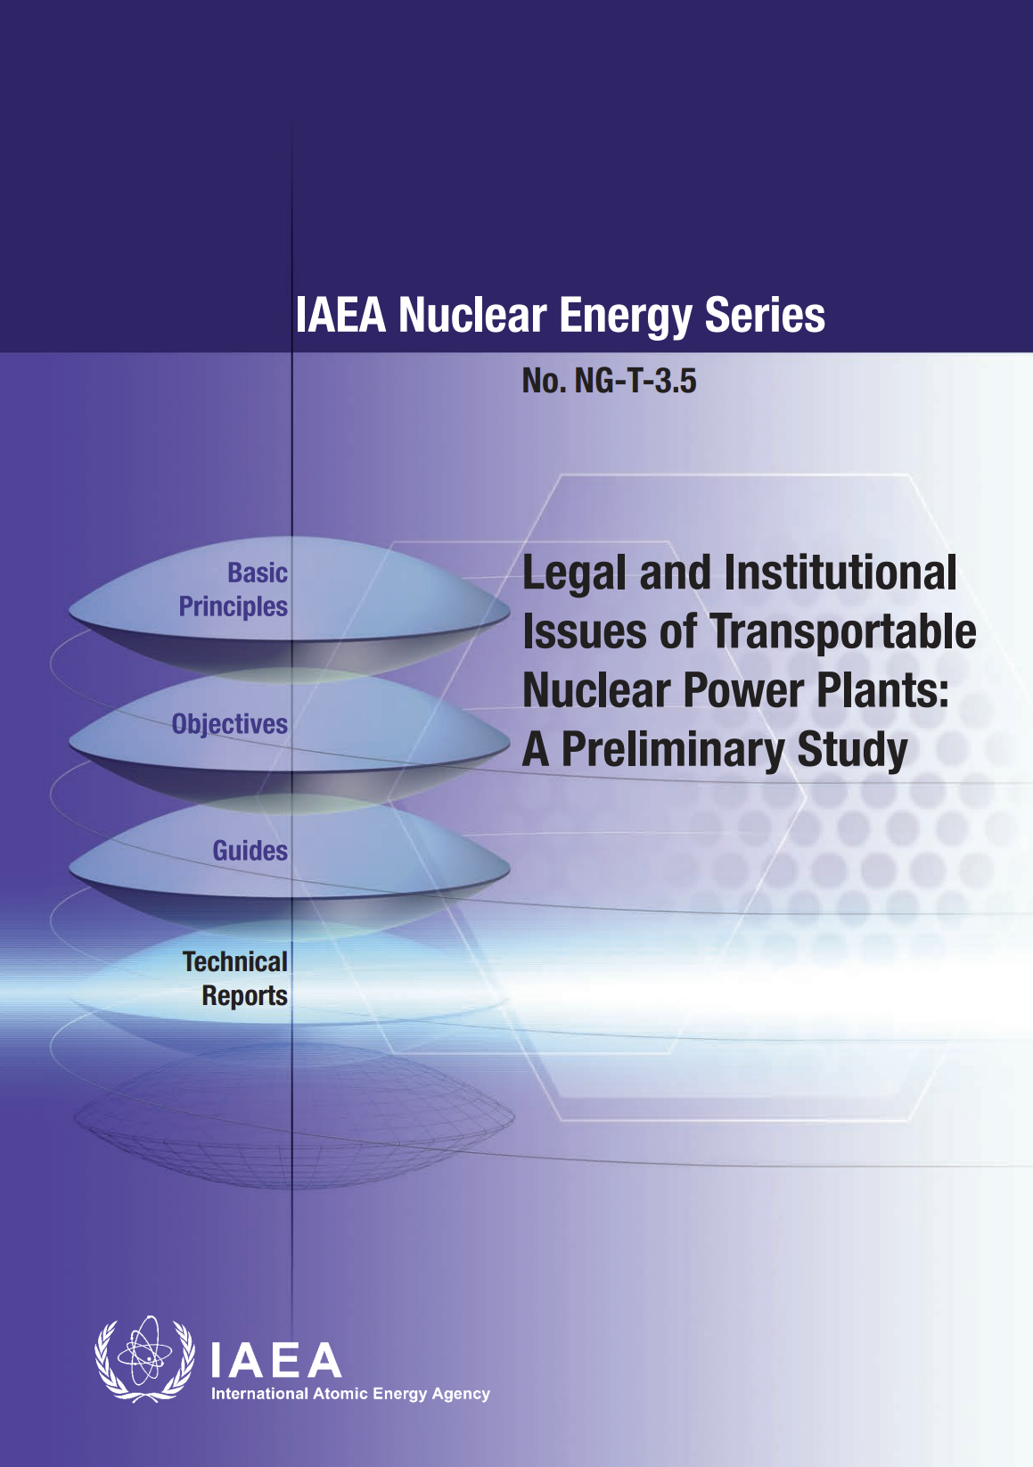 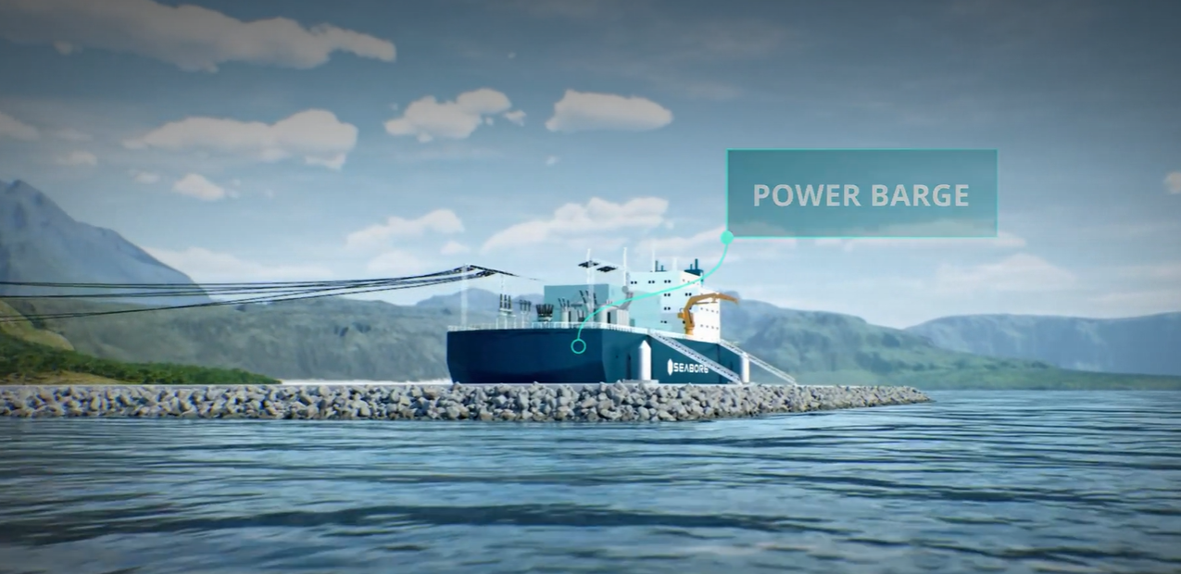

FIG. 1. First TNPP published in Nuclear Energy Series (left) and FNPP prototype model by Seaborg [6] (right).

In 2023, INPRO took the lead in organising the first IAEA International Symposium on Floating Nuclear Power Plants (FNPPs). There were 168 participants from 44 MSs and four International Organizations. This event brought together a wide range of stakeholders essential to the development and deployment of FNPPs, including representatives from the nuclear and maritime industries, regulatory bodies, maritime classification societies, and legal experts. INPRO along with Nuclear Safety and other departments in IAEA played a key role in organizing the symposium. A key outcome was the need for the IAEA to work closely with the International Maritime Organization (IMO) to ensure that available international instruments are updated for application to FNPPs.

### 3.3 Task 3: Sustainability Assessments and Strategies

The development of the original INPRO methodology was mainly for NES containing large nuclear power plants (NPPs). The methodology has six key areas shown in FIG. 2.

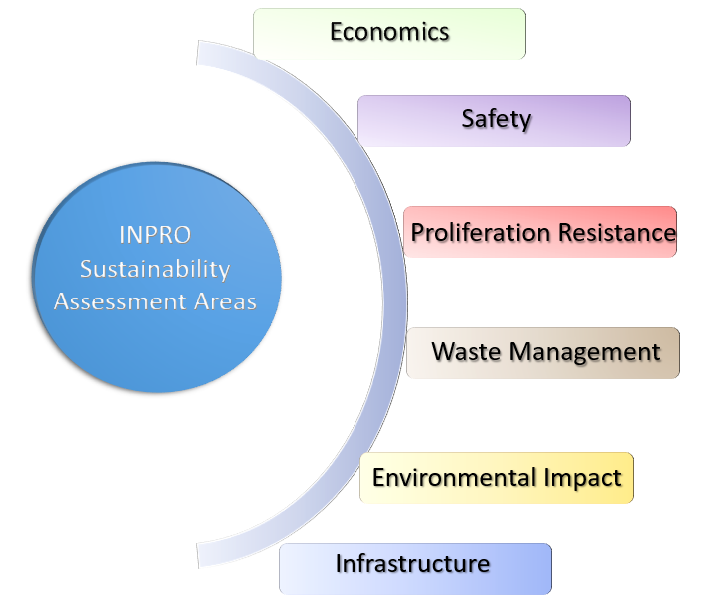

FIG. 2. Diagrammatic representation of INPRO sustainability assessment areas.

The first project is working withs MS in applying NESA to SMRs and evaluating if there are any updates needed to the INPRO methodology to better address SMRs. NESA helps MSs evaluate the sustainability of NES to assess the long-term sustainability. This assessment aids decision-makers in effectively planning, maintaining, or expanding nuclear energy programs with sustainability in mind. Performing a NESA helps MSs in identifying gaps and drawbacks in sustainability, which designers and other stakeholders can be address prior deployment of NES. There are two NESA SMR projects in all six areas; one with Viet Nam and Seaborg Technologies CMSR (compact molten salt reactor), and the other with Indonesia and SMART (a Korean design). Other NESA SMR projects are of limited scope, one with Russia on their RITM-200M reactor in the areas of economics and safety.

The second activity under Task 3 is the FRAMES project, which held the kick-off meeting for the collaborative project in March 2024. The overall goal of the project is to support MSs by further developing the FRAMES model and tool for eventual use in assessing and analysing NES. The resultant tool will be user friendly and support MSs in strategies and policies for grid integration of intermittent renewables and advanced nuclear technologies, including SMRs.

### 3.4 Task 4: Dialogue and Outreach

The INPRO DF is a platform where technology holders, technology users, and other stakeholders come together to discuss and share perspectives and challenges related to the deployment of sustainable nuclear energy systems. The DFs focus not only on technology, but also on institutional aspects, such as market resources, effects of regulations, public acceptance, and contribute to sustainable nuclear energy deployment. The main focus of the two recent DFs was SMRs.

#### 3.4.1 21st INPRO Dialogue Forum on Deployment of SMR Projects and Technologies to support (UN) Sustainable Development Goals (SDGs)

The INPRO Section, along with the IAEA Nuclear Power Technology Development Section (NPTDS) and the Russian Federation via Rosatom Technical Academy, organized the 21st DF, held in St. Petersburg, Russia, 28 August - 1 September 2023. The DF attracted 78 participants from 31 MSs and an international organization (STAR-NET). See FIG. 3. The key objective of the DF was the role of SMRs in achieving SDGs, which brought a broad set of perspectives from technology developers, potential suppliers, and users. Participants identified functions and features of SMRs that contribute to MSs achieving SDGs and the role various SMR- industries and institutions play in contributing to SDGs [7]. The following are the key outcomes from this DF.

* Deployment and fuel cycle preparations are accelerating with various SMRs in demonstration and near deployment phases.
* SMRs will contribute to achieving over 9 UN SDGs.
* SMRs will create new opportunities but also have challenges.
* Information sharing and capacity building through the IAEA are crucial for newcomer countries.
* The IAEA should provide resources to SMR activities, and with MSs and international organizations seek to strengthen international collaboration and knowledge sharing at global and regional levels.
* The IAEA should organize dedicated events and develop specific standards and guidance for SMRs to support SMR integration into energy strategies aligned with SDGs.
* The 21st Dialogue Forum was found to be informative, inspiring, interactive, and diverse. [7].

#### 3.4.2 22nd INPRO Dialogue Forum on Successful Development and Sustainable Deployment of SMRs

The 22nd DF, held in the Republic of Korea, 6-10 May 2024, brought together 174 experts from government, industry, academia, and research from 31 member states and 1 international organization. See FIG. 5. The hosts of this DF were the Korea Nuclear International Cooperation Foundation (KONICOF) and Korea Nuclear Society. The dialogue forum had five plenary sessions, with the following key objectives: the exchange of knowledge, experiences, and best practices to accelerate SMR development and deployment; the fostering of collaboration in research and development efforts to enhance SMR safety, efficiency, and cost-effectiveness; discussions on common safety standards, licensing procedures, and guidelines [8]. Below are highlights of some key outcomes of INPRO’s 22nd DF.

* SMRs boost grid stability, cut emissions, and improve energy security. Adopting nations gain reliable, low-carbon energy and economic growth. Success needs global cooperation, IAEA support, industry-government collaboration, and R&D.
* Early SMR deployment can be facilitated by ensuring regulatory predictability, adapting regulations for innovation, supporting newcomer countries, and providing data-driven safety evaluations through the IAEA and established nations.
* Ensuring SMR economic competitiveness and supply chain sustainability requires early design and R&D consideration, manufacturability collaboration, international cooperation, new entrant engagement, government support, and transparent regulation.
* To overcome FNPP deployment challenges, collaborate across industries and regulators, innovate for safety and cost-effectiveness, accelerate deployment through international cooperation and shared lessons, and integrate efficiently with existing shipyard infrastructure and workforce.
* Key challenges in SMR infrastructure development: skilled human resources, nuclear industry infrastructure, economic viability, and international collaboration with the IAEA [8].

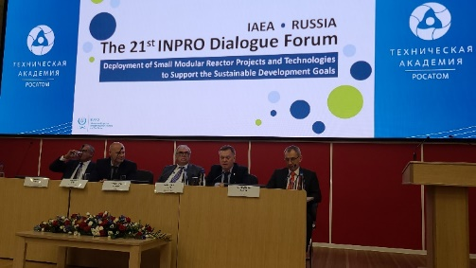 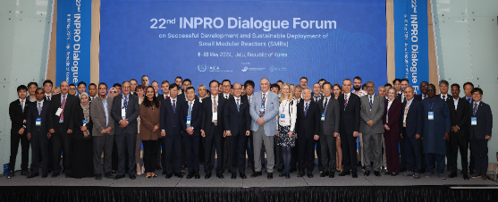

FIG. 3. Photographs from the 21st DF, Saint Petersburg, Russia (left), and the 22nd DF, Jeju Island, Republic of Korea (courtesy of KONICOF).

The DF concluded with participants completing two surveys. The results from the first survey revealed that the key challenges for deploying SMRs are economics, harmonized licensing regimes, public acceptance, supply chain, and the need for standardized designs. See FIG. 4.

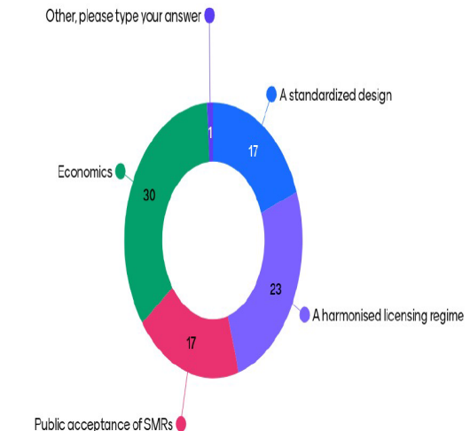 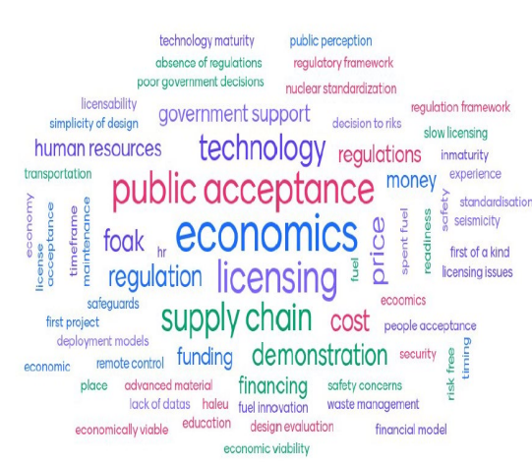

*FIG. 4. Survey results from participants at DF 22 [8].*

The second survey identified affordability, small grid-fit size, and flexible operation as crucial features for deploying SMRs in embarking countries. Additionally, human resource development and collaboration can actively involve the nations interested in adopting SMRs. See FIG. 7. These survey results show that this DF was informative, insightful, and engaging for the participants.

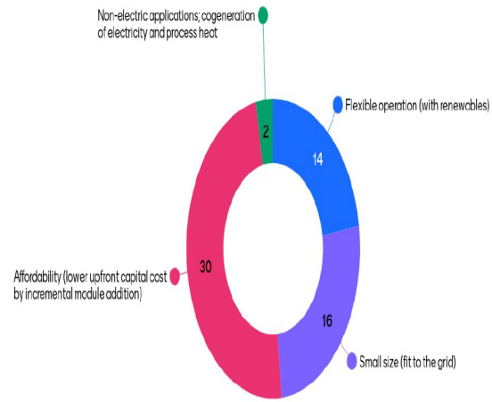 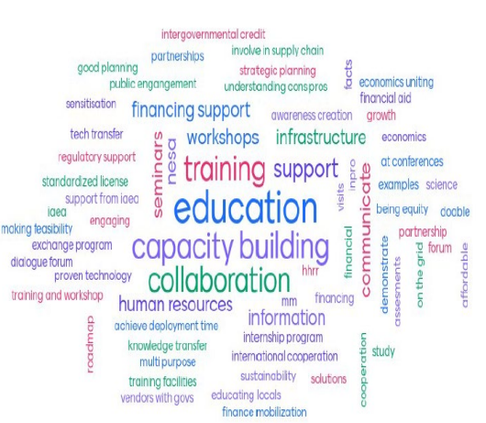

*FIG. 5. Second survey results from participants at DF 22 [8].*

#### 3.4.3 INPRO Workshops and Schools

The INPRO Section organises training schools on Strategic Planning for Sustainable Nuclear Energy (the INPRO School), to help MSs build local expertise and for capacity building. The first joint course with Abdus Salam International Centre for Theoretical Physics (ICTP) was organised in 2022. Besides educating with INPRO methods and tools, one of the key topics of the lectures includes various aspects related to planning and deployment of SMRs sustainably. The course enlightens participants on various SMR designs around the globe, challenges involved for MS, technical aspects, sustainable deployment challenges, advantages, issues, and actions to be implemented. Recently, INPRO initiated regional schools upon request from MSs and SMR is a popular topic of discussion. The school also holds lectures and discussions on microreactors (a type of SMR) besides teaching INPRO Methodology topics. INPRO has held joint schools yearly at ICTP. See FIG. 6 for a photograph of the 2023 IAEA-ICTP INPRO school [9].

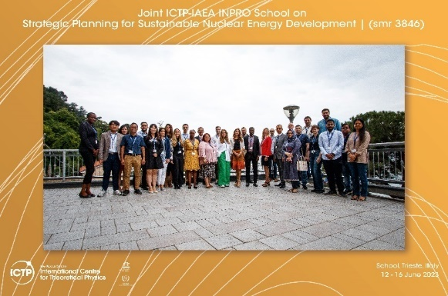

*FIG. 6. Photograph of participants of joint IAEA-ICTP INPRO School 2023, Trieste, Italy.*

## Summary

INPRO has several key projects addressing the sustainable deployment of SMRs in NES. Through NESA using INPRO methodology, INPRO helps MSs identify gaps in sustainability, which can be addressed in design phases of SMRs prior to deployment. Scenarios for deployment of SMRs are analysed to identify success factors and potential cooperation models. Institutional and legal impediments of transportable and modular reactor facilities continue to be investigated to ensure alignment with, among other, maritime practices. Overall, INPRO actively supports MSs for sustainable NES development, including NES with SMRs, through assessment methodology, modelling and analysis, dialogue and capacity building.

ACKNOWLEDGEMENTS

This work’s funding was through INPRO MSs extrabudgetary contributions to the INPRO Section. These contributions support INPRO activities and are implemented by INPRO Members together with and assisted by the INPRO Section staff and are subject to availability of staff and budgetary resources.

References

1. INTERNATIONAL ATOMIC ENERGY AGENCY, International Project on Innovative Nuclear Reactors and Fuel Cycles (INPRO), (accessed: 15 July 2024), https://www.iaea.org/services/key-programmes/international-project-on-innovative-nuclear-reactors-and-fuel-cycles-inpro.
2. INTERNATIONAL ATOMIC ENERGY AGENCY, International Project on Innovative Nuclear Reactors and Fuel Cycles (INPRO) Subprogramme Plan 2024-2025, Subprogramme 1.1.4 INPRO, Rev. 0 (2023).
3. INTERNATIONAL ATOMIC ENERGY AGENCY, Legal and Institutional Issues of Transportable Nuclear Power Plants: A Preliminary Study, IAEA Nuclear Energy Series No. NG-T-3.5, IAEA, Vienna (2013).
4. BYCHKOV, A., SCHERER, C., “INPRO Work in SMR”, presented at the 4th International Atomic Energy Agency, Technical Working Group Meeting on SMR (2022).
5. TOR ASENES-SMR
6. SEABORG, Rethinking Nuclear, accessed 15 July 2024, https://www.seaborg.com/
7. MRABIT, K., “Chairperson’s Summary”, presented at The 21st INPRO Dialogue Forum on the Deployment of Small Modular Reactor projects and Technologies to support the sustainable development goals, Saint Petersburg, Russia.
8. SEO, J.T., “Chairperson’s Summary”, presented at The 22nd INPRO Dialogue Forum on Successful Development and Sustainable Deployment of SMRs, Jeju Island, South Korea, Jeju Island, South Korea, 2024
9. INTERNATIONAL ATOMIC ENERGY AGENCY, IAEA and ICTP Run First School on Nuclear Energy Strategic Planning, https://www.iaea.org/newscenter/news/iaea-and-ictp-run-first-school-on-nuclear-energy-strategic-planning, (2022).