Collaboration – the key to standardized SMR deployment

R.. TANGUY
World Nuclear Association
London, United Kingdom
Email: ronan.tanguy@world-nuclear.org

A.CARSON
World Nuclear Association
London, United Kingdom

Abstract

The successful worldwide deployment of small modular reactors (SMR) is fundamentally dependent on developers’ ability to construct plants with factory produced modules that are as identical as possible. Differences in approaches to national nuclear regulation however currently demand significant changes to nuclear power plant (NPP) designs when a reactor is exported. These national approaches to regulation effectively reset projects outside the reactors’ country of origin to first of a kind (FOAK) deployments. This is not only a regulatory challenge and the presentation will also explore the role of industry in developing and utilizing relevant good practice to support deployment of standardized designs To learn the lessons from previous licensing, construction, and operation experience and support N^{th} of a kind (NOAK) deployment of SMRs it is critical that greater collaboration between stakeholders is facilitated as soon as possible.

INTRODUCTION
The nuclear industry and governments came together during COP28 to sign pledges in support of tripling nuclear capacity by 2050. This will require the deployment of 40GWe nuclear capacity every year for the next 25 years, equivalent to a yearly addition of 70 SMRs and 20 GW NPPs. This is a four-fold increase on the current build rate which will require both a multiplication of projects and a reduction in build times.

The recently released joint industry association framework report [1] outlines a 3-phase approach moving towards greater efficiency and collaboration in regulatory reviews, which is a critical component to support the scale of deployment necessary. Such a framework requires a shift in mindset and approaches but there are many steps along this journey and changes will not be overnight. The initial proposal would be to start small and develop the process and bounding criteria for a small number of diverse regulators on specific designs.

UNLOCKING SMR POTENTIAL
SMRs aim to bring scaling to the nuclear industry through the use of production line manufacturing and modular construction techniques. The use of production line manufacturing means that components for multiple plants can be built and tested off-site before being transported to sit for construction where they will plug into their neighbouring modules. This is in contrast to traditional gigawatt scale NPP for which components are typically manufactured as one-offs and installed on site using conventional building techniques. Assuming a sufficient number of plant orders, the initial capital costs for establishing factory production lines can be outweighed by its ability to rapidly produce modules at a lower cost than bespoke one-off components.

This production line approach and scaling assumes that identical (or near-identical) modules are able to be used for construction across all projects, i.e. there is a standardised plant design. In practice however, this is only currently viable when the target market is large enough to justify the initial capital outlay for the factory as differences in regulatory requirements [2] impose design changes between countries. In order to unlock the potential of the SMR approach, is it therefore necessary for national nuclear regulators and industries to work together to find a common path and minimise, if not eliminate, currently required design changes between their respective markets.

CURRENT STATUS
The past two years have seen the launch of international regulatory initiatives on the joint evaluation of SMR designs. In North America, the United States Nuclear Regulatory Commission (US NRC) and the Canadian Nuclear Safety Commission (CNSC) signed a charter on a collaborative review of the GE-Hitachi BWRX-300 design. In Europe, meanwhile, the French Nuclear Safety Authority (ASN) is leading a Joint Early Review (JER) of the EDF Nuward design alongside the Czech (SUJB) and Finnish (STUK) safety authorities, a further three European nuclear regulators from Poland (PAA), the Netherlands (ANVS) and Sweden (SSM).

These initiatives seek to grow respective knowledge and understanding of the regulators’ respective practices and inform the reactor vendors’ abilities to anticipate the challenges of international licensing, enabling them to minimise design changes between markets. Regulators are currently ahead of other parts of the nuclear sector with regards to international cooperation. Their proactive approaches reflect their understanding of their key role in enabling the growth of nuclear energy and subsequent reduction in greenhouse gas emissions. Their initial activities show great promise and must be supported by governments to allow them to continue, expand and bear fruitful results for the sector.

The nuclear industry needs to follow the regulators’ lead and intensity its efforts, engaging in similar collaborative activities, both internally and alongside regulators. The International Atomic Energy Agency’s (IAEA) Nuclear Harmonization and Standardization Initiative (NHSI) has been active on these fronts.

INDUSTRY STANDARDIZATION INITIATIVES
The nuclear industry is a global one, yet it is smaller in terms of workforce than many other global industrial sectors. The proposed tripling of nuclear power will require the whole sector to collaborate to find ways to accelerate deployment and find mutually beneficial approaches as not only will all reactor vendors be needed to meet this challenge but there will be enough room in the market for all of them. The nuclear industry must therefore look to collaborative work that it can undertake without the need for regulatory or governmental participation.

Industrial codes and standards

Engineering codes and standards for the design and construction of nuclear power plants are a principal technical requirement for the safety of nuclear power plants. Listed in the IAEA standards for the safety of nuclear power plants, SSR2/1 [3], under Requirement 18, their applications have significant impact on the design of structures, systems, and components (SSC) across all engineering disciplines. Reactor developers typically work with their national codes and standards as they are most familiar but international and regional ones do exist. Differences between codes and standards can therefore lead to differences in plant design, for the same reactor deployed in two different countries, but not necessarily to differences in plant safety and performance.
A significant amount of work has been undertaken to identify differences and similarities across nuclear design codes and standards for both mechanical [4] [5] [6] and electrical/instrumentation and controls [7] disciplines. Groups such as the Standard Developing Organisations Convergence Board (SDO CB) work to limit divergence of nuclear mechanical code development work and to harmonize codes where possible. On the instrumentation and controls side, the IEC and IEEE have developed a dual-logo approach which allows IEC to adopt existing IEEE standards intact and provides possibilities for future joint code revision and development. This is a lengthy process however and the industry must find a way of accelerating.

Standardising the selection of codes and standards chosen by reactor developers across a target market region and focusing code development work on common gaps across reactor development projects with the support of regulators could well prove to be a fruitful approach.

Common procurement and industrialization
Similarly to gigawatt scale reactors, SMRs use large heavy components with long lead times and safety-related components with strict requirements which could result in supply chain bottlenecks. SMR designs do have an advantage however as their smaller scale opens up a wider range of forges and manufacturing facilities that are able to satisfy their requirements. It is still foreseeable however that the current manufacturing capacity would be overwhelmed by the increased anticipated demand. SMR vendors should collaborate on mutually beneficial projects with key supply chain partners to unlock common technology neutral opportunities within the supply chain for such large items.

The use of commercial or industrial-grade components that are not based on nuclear quality assurance codes is slowly being introduced into the nuclear industry. Procedures for post-procurement quality checks of commercial-grade products have also been developed for items important for nuclear safety. These approaches have the advantage of opening up the global supplier base to SMR projects. Collaborative approaches to procurement and qualification practices have already proven beneficial in Nordic countries through the KELPO project.

REgulatory streamlining initiatives
As previously mentioned, there are currently a number of ongoing international regulatory cooperation efforts, both multinational and bi-lateral which aim at advancing towards a level of harmonization through increased cooperation. All of these efforts add significant value and are essential steps towards a future in which reactors can be deployed more quickly without compromising on safety. Most of these activities are taking place in silos however, and greater benefits could be drawn from a more coordinated approach. Such an approach should include:

- A means to develop and provide input to a lessons learnt or best practice repository;
- Identifying gaps in existing activities and developing a plan to fill them;
- Join industry and regulatory activities to identify subsequent steps such as:
      - Identifying design and safety topics for specific focus, and driving a plan to foster greater harmonization across these topics
      - Building upon previously completed equivalency assessments for codes and standards and determining how increased multi-national use of codes and standards can be reached
- Identifying which organizations are best placed to undertake certain tasks.

A phased approach to increasing regulatory efficiency is proposed [1], starting with small groups of regulators with compatible levels of experience and approaches, with a common interest in reviewing the same reactor design. The current multi-national European and North American initiatives, as well as the bi-lateral work that has been undertaken by Korea and the UAE, Russian and Bangladesh, and Chine and Pakistan provide ideal opportunities to learn lessons and best practice to benefit future activities.

The second phase will aim to develop collaborative regulatory activities in such a way that the regulators understand what they can use from the outcomes of another regulatory process (and vice versa) to support their own review activities. It is envisaged that this would lead towards a pathway that could be used by regulators to translate outputs from one regulatory review process into their own review process (like a “Rosetta stone”). The technical cooperation and collaborative efforts of small groups of regulators developed in Phase 1 would be the starting point for Phase 2 and would enable the increased collaboration required and the expansion of the group to other regulators interested in the review of a specific design.

The third phase will build upon the lessons, best practices, and approaches developed during the second phase, with the aim of developing greater alignment between national regulators on safety objectives, requirements, and expectations and which would allow one regulator to validate the outcomes of another regulator’s design reviews. These three phases are illustrated in the diagram below:

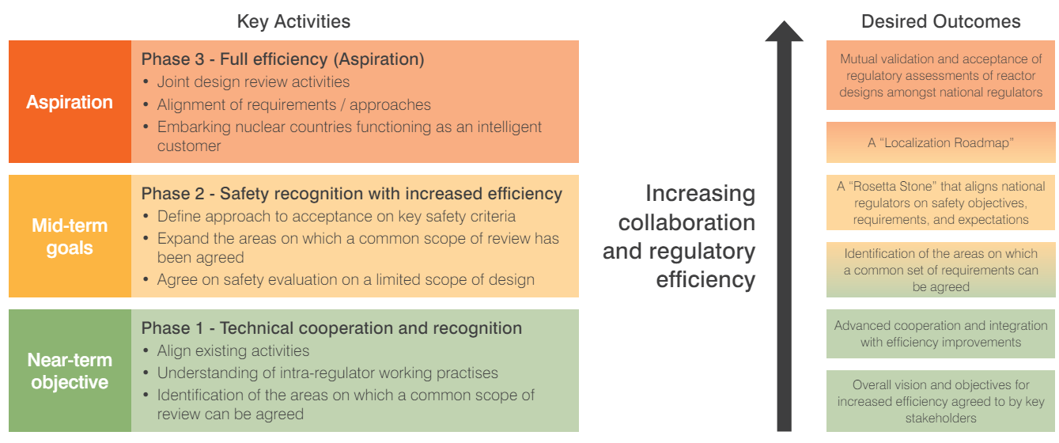
FIG. 1. Three-phase approach to increasing collaboration and regulatory efficiency

CONCLUSION
To achieve the ambitious tripling of nuclear energy between now and 2050, as pledged by governments and industry significant challenges must be overcome. These challenges include policy enablers, harmonized and efficient approaches from and between regulators, particularly safety assessment and reviews of reactor design, standardization of designs, development of a highly integrated supply chain, and human resource availability. The scale of this challenge demands a new approach.

Collaboration is key to this new approach, both amongst similar stakeholder organisations within the nuclear sector and cross-sector. While competition is both desired and inevitable, a growing nuclear sector provides greater opportunities for all parties and this can only be achieved through cooperation. Initial stages are expected to be slow and resource demanding, which is why suitable governmental and policy support are put in place to enable these agreements to develop. International organisations must act as the glue between initiatives, playing to their strengths, whether that be aggregating industry views and intervening on industry’s behalf, providing regulatory forums or convening government representatives to unlock the necessary policy support.

The imperatives of greenhouse gas emission reductions and energy security mean that unlocking the promise of fast, scaling, world-wide SMR deployment is more urgent than ever and collaboration is the only way in which the nuclear sector can succeed, working united toward this common goal.

References
- WORLD NUCLEAR ASSOCIATION, A Framework for International Regulatory Efficiency to Accelerate Nuclear Deployment, London (2023).
- WORLD NUCLEAR ASSOCIATION, Different Interpretations of Regulatory Requirements, London (2021).
- INTERNATIONAL ATOMIC ENERGY AGENCY, Safety of Nuclear Power Plants: Design SSR-2/1, IAEA, Vienna (2016)
- AMERICAN SOCIETY OF MECHANICAL ENGINEERS, Code Comparison Report for Class 1 Nuclear Power Plant Components (2012)
- WORLD NUCLEAR ASSOCIATION, Comparison of Pressure Vessel Fatigue Codified Design Rules Based on S-N Approach, London (2020).
- WORLD NUCLEAR ASSOCIATION, Non-Linear Analysis Design Rules; Part 1: Code Comparison, London (2017).
- WORLD NUCLEAR ASSOCIATION, International Nuclear I&C and Electrical System Standards Tables with URLs, London (2023).

