Systematic Review on Public Perception and Acceptance of Small Modular Reactors: Challenges and Strategies

B.R. CARVALHO
University of Brasilia
Brasilia, Brazil
Email: beatrizrodriguescarvalho@gmail.com

E.A. RODRIGUES
Nuclear and Energy Research Institute IPEN - CNEN
São Paulo, Brazil

D.A. ANDRADE
Nuclear and Energy Research Institute IPEN - CNEN
São Paulo, Brazil

Abstract

Small Modular Reactors (SMRs) have emerged as a promising alternative for decarbonization, with significant advantages in terms of flexibility, safety and cost. Their success depends on technical feasibility, an adequate regulatory framework and public acceptance. Based on a comprehensive systematic literature review, the aim of this study is to analyze public perception and acceptance of Small Modular Reactors. The systematic literature review was done using the scientific databases Scopus and Web of Science, with descriptors related to the subject. The results were synthesized systematically, identifying patterns, trends and gaps in the literature related to public perception and acceptance of SMRs. The main concerns raised by the studies were highlighted, as were the factors that positively or negatively influence the acceptance of these technologies, as well as the implications of the evidence for public policy, regulation and the practice of the nuclear industry.

INTRODUCTION
The impacts of climate change can be perceived on several places of the world. Gobal warming already surpassed 1ºC, leading to a wide range of impacts on human societies and the environment, highlighting the urgency of implementing mitigation and adaptation measures [1].
The production and use of energy are the biggest sources of greenhouse gas emissions and the cause of global warming [2-3]. As nuclear energy is a low-carbon energy, it contributes on a large scale to a green energy, with 11% of total global electricity generation - equivalent to a third of the low-carbon electricity produced in the world [2,4].
The level to which nuclear power can respond to long-term energy needs will be defined by the pace and adequacy of technological and political solutions to issues such as waste, safety, security and non-proliferation [3]. Small modular reactors (SMRs) could respond adequately to these issues, with a simpler, standardized and safer modular design, built in a factory, easily transportable and autonomous, they could be installed in isolated locations without advanced infrastructure and without a power grid, or they could be grouped together on the same site to provide a multi-module power plant contributing to overcoming energy poverty problems in growing economies, without increasing carbon emissions [2-4,6]. However, achieving climate mitigation objectives with the support of SMRs requires rapid deployment, which may be limited by institutional, social and behavioral issues [5]. In this context, the aim of this study is to analyze public perception and acceptance of SMRs.

METHODOLOGY
This study was developed through a broad and systematic review of the literature. The search for publications was conducted through the scientific database Web of Science (WoS) and Scopus, on April 26, 2024, with the aim of identifying articles that contribute to the analysis of public perception and acceptance of small modular reactors. The search string defined in TABLE 1 was used.

TABLE 1. SEARCH STRING USED IN THE SCIENTIFIC DATABASE WEB OF SCIENCE AND SCOPUS, ON APRIL 26, 2024.

WoS | ("micro nuclear reactor*" OR "micronuclear reactor*") OR ("small modular reactor*") or ("SMR*" AND "nuclear energy") (Topic) and ("socio-political" or "social" or "political" or culture) (Topic) and Article OR Review OR Early Access (Document Type) and Review Article or Article (Document Types)
Scoupus | TITLE-ABS-KEY ( "micro nuclear reactor*" OR "micronuclear reactor*" OR "small modular reactor*" OR ( "SMR*" AND "nuclear energy" ) ) AND TITLE-ABS-KEY ( "socio-political" OR "social" OR "political" OR "culture" ) AND DOCTYPE ( re ) OR DOCTYPE ( ar )

The search identified 34 records in the WoS database, and 44 records in the Scopus database, published between 2002 and 2024, which covered document types; “Article”; “Review article” and “Early access” (for the WoS database). The choice of the scientific databases WoS and Scopus was based on their credibility, interdisciplinary coverage, access to updated and reliable information, and advanced search resources, which provide quality and relevance to the information collected (Figure 1).

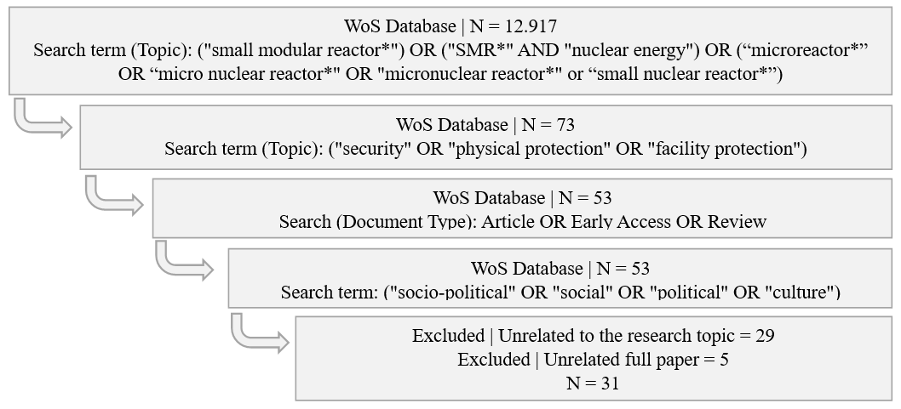

FIG 1.

The search results were systematized in an Excel spreadsheet, which contains the title and authorship of the study, year of publication, scientific base of indexing, DOI, and three variables to validate each record <abstract evaluation> with the values <included/excluded/insufficient>; <complete evaluation> with the values <included/excludec> and < reason for exclusion>, with the values <does not answer the research question/full paper unavailable>. In this systematization, duplicate records were excluded, leaving a total of 51 studies for analysis of their convergence with the research subject.
After identifying the studies, they were analyzed in terms of their title, abstract and keywords, considering as criteria the availability of the complete article for consultation and its suitability for the research subject. This analysis was carried out by a member of the research team. If the information available at this stage did not allow the study to be included or excluded from the review, it was recorded as <insufficient> in the <abstract evaluation> variable.
After the full evaluation, five studies of the 51 articles found were excluded due to the unavailability of the full paper and 29 because they were unrelated to the research subject. The 17 resulting articles were subjected to a new complete reading, and were kept for technical analysis within the scope of this review.
To create the co-authorship chart by country, the seventeen publications were reviewed to extract the list of authors and their respective affiliations, which were standardized to ensure consistency in identifying the countries. The authors were then grouped by country to identify the collaboration between them in each article. The number of collaborations between countries was recorded and the countries were classified into two regions - Global North, for developed countries with advanced economies; and Global South, representing developing countries. Generative artificial intelligence was used to structure and automate the graphic visualization, using a network of nodes and edges, where each node represents a country and its size is proportional to the number of authors and the edges represent the collaborations between countries, with classification of the regions based on the authors' affiliations.
To create the word cloud, the titles, abstracts and keywords of the seventeen articles were first selected. Generative AI algorithms were used to compile the extracted texts into a single document, excluding words with only one occurrence and “stop-words” (words that don't need to be indexed because they have little meaning, such as prepositions, articles and conjunctions) and classifying the words by their level of frequency (Low = 2 occurrences; Moderate = 3 to 9 occurrences; High = 10 or more occurrences). This file was analysed by the research team to normalize the indexed terms (standardizing synonyms and different forms of the same word). Generative AI algorithms were again used for tokenization (separating the text into individual units - the tokens), counting their frequency and identifying the most recurrent terms in the dataset. Once the research team had validated the results of this process, algorithms were used to select an appropriate tool for creating the word cloud, such as Python's WordCloud library; this tool was fed with the data prepared for generating the graphic visualization, highlighting the words according to their frequency and importance. The results were reviewed by a specialist in nuclear science to ensure their accuracy and the relevance of the word cloud generated, and adjusted and refined.

RESULTS AND DISCUSSION
The bibliometric analysis identified a small number of publications and highlighted research gaps that directly involve the human, social and behavioral aspects related to the development of nuclear technology in general and specifically in relation to SMRs.
The studies selected for this review were published between 2012 and 2023. Of the seventeen studies, nine were common to both scientific databases, while six were indexed only in Scopus and two only in WoS, which suggests that, for the topic researched, the Scopus scientific database offered a better return on the literature, with a total of 15 studies. An analysis of the co-authorship network of these publications identified 47 authors from 11 countries, the majority from the USA (40%) and Canada (32%). This high number of authors suggests a strong research base in these countries, which have invested significantly in developing SMRs as part of their strategies for decarbonization and energy security.
The co-authorship graph suggests important aspects about the dynamics of research in relation to public perception and acceptance of SRMs. Firstly, the few international collaborations identified between Canada and the United Kingdom [17]; the United States, Austria and Kuwait [15]; and the Philippines and Taiwan [22] may suggest that most studies were conducted independently by each country or national collaboration, a pattern that may be influenced by barriers such as infrastructure and funding policies that favor national collaborations. Still from a geopolitical perspective, the vast majority of publications and collaborations identified involve countries from the global north, with only two studies involving researchers from the global south [15,22]. This can be attributed to greater investment in research and development on SMRs, more advanced scientific infrastructure and policies that encourage research (Figure 2).

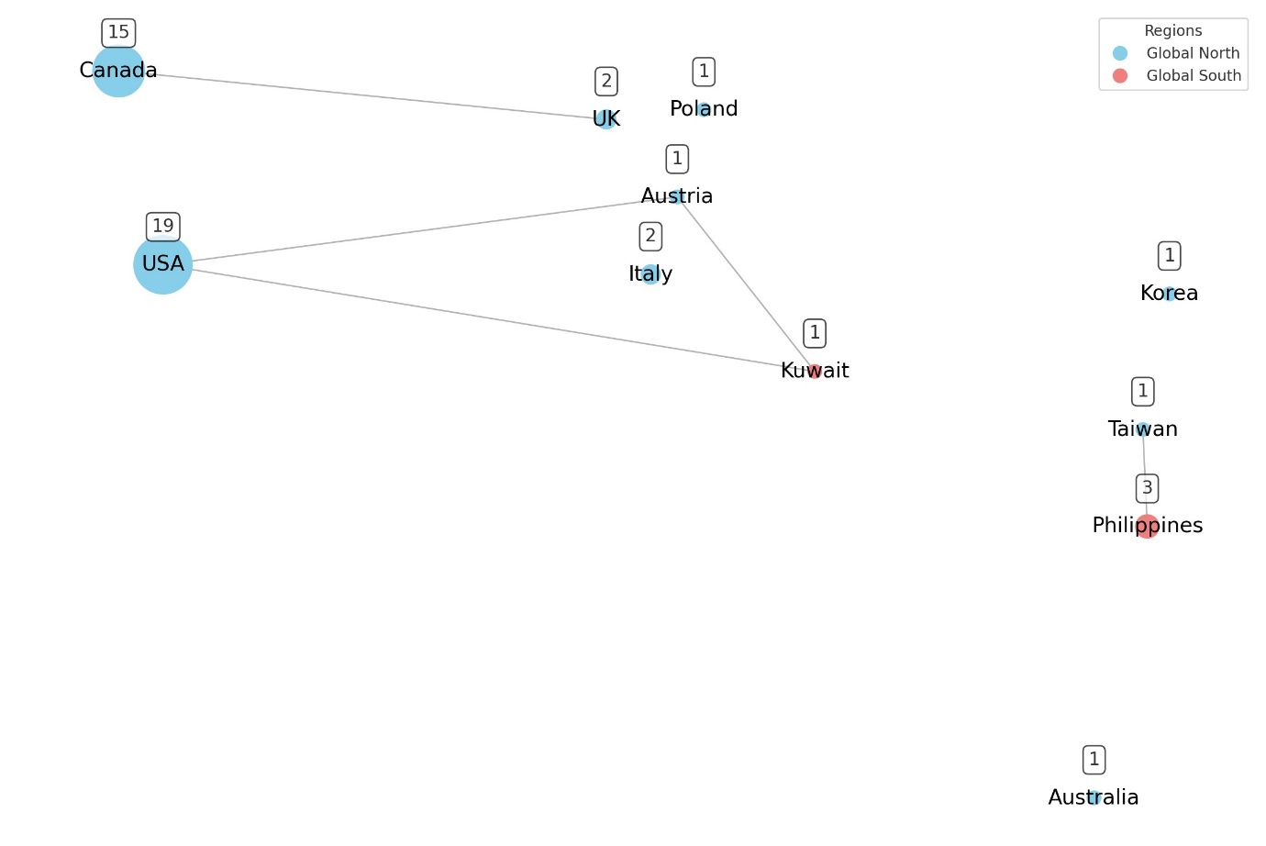

FIG 2. Co-authorship network by country, indicating the number of authors and the regional distribution of countries in the global north and south.

One of the most important elements in electricity production is the choice of the most suitable plant, which must be made on the basis of economic and non-economic aspects. As the nuclear industry is very sensitive to public opinion [10, 12-13, 18, 23], these considerations must be taken into account for the production of energy through new nuclear power plants (NPP), with the structuring of well-designed and continuous marketing strategies for the presentation and development of SRM projects and with new approaches for the involvement of scientists, companies, regulators and decision makers [7, 12, 15].
To better understand the context in which SRM technologies are embedded, concepts used by technicians associated with the nuclear industry to create political and financial support for these reactors were analyzed and grouped into five theoretical future scenarios imbued with fantasy: in the “risk-free energy” scenario, the use of SMRs would eliminate catastrophic accidents and collapses; in “self-energization”, SMRs would allow access to energy for remote indigenous communities and developing economies; in the “water security” scenario SMRs would satisfy the world's water needs from desalination plants; while in “environmental nirvana” they would provide zero-waste, zero-carbon energy to preserve the Earth's biosphere; and in the “space exploration” scenario SMRs would assist in the colonization of the Moon, Mars and possibly other planets [8].
These scenarios are used to erase previous nuclear failures from the collective memory [8] related to the controversial history of nuclear energy, the legacy of high-profile accidents, fear of radiation exposure and security threats [10, 15, 18, 23]. Previous research has shown that negative events have a greater influence on public opinion than positive events and have led to a general loss of confidence in nuclear power [9-10] and concerns about the safe long-term storage of nuclear waste [10-11, 15].
From another perspective, in order to familiarize the public with nuclear energy and generate social approval in Poland, SMRs have been portrayed as “small”, “ultramodern”, “ecological” and “originating in the United States”, which guarantees their reliability [21]. This narrative combines ecology, modernity and climate protection to create an atmosphere towards SMRs similar to that of the United States, in which the nuclear industry, institutions and academics have constructed a series of theoretical scenarios that have fostered a technological utopianism among leaders and financial investors [21]. On the other hand, in the province of Saskatchewan, Canada, institutional actions to support SMR action plans have encountered both opposition to nuclear power and insecurity about the use of SMRs on the part of some indigenous peoples who are skeptical about its necessity, and support for the technology shown by other indigenous peoples close to uranium mining [19]. The full list of studies included in this review is shown in Table 2.

TABLE 2. STUDIES ON PUBLIC PERCEPTION AND ACCEPTANCE OF SMR SELECTED FOR SYSTEMATIC REVIEW AND BIBLIOMETRIC ANALYSIS
Author / Year | Ref. | Title
Locatelli & Mancini (2012) | [7] | A framework for the selection of the right nuclear power plant
Sovacool & Ramana (2014) | [8] | Back to the Future: Small Modular Reactors, Nuclear Fantasies, and Symbolic Convergence
Iyer et al. (2014) | [9] | Implications of small modular reactors for climate change mitigation
Ramana & Mian (2014) | [10] | One size doesn’t fit all: Social priorities and technical conflicts for small modular reactors
Boldon et al. (2015) | [11] | Sustainability Development Platform for Nuclear-Renewable Energy Integration: Environmental Impacts, Economics, and Socio-Political Implications
Woo (2016) | [12] | Assessment of the small modular reactor (SMR) marketing using modified network dynamics-based system dynamics (SD) method
Hanna et al. (2019) | [13] | An analysis of the state of impact assessment research for low carbon power production: Building a better understanding of information and knowledge gaps
Yang et al. (2019) | [14] | How stable are preferences among emerging electricity generation technologies
Iakovleva et al. (2020) | [15] | Breaking Out of a Niche: Lessons for SMRs from Sustainability Transitions Studies
Zhang et al. (2021) | [16] | A multicriteria small modular reactor site selection model under long-term variations of climatic conditions -- A case study for the province of Saskatchewan, Canada
Maletesta (2021) | [17] | The Environmental, Economic, and Social Performance of Nuclear Technology in Australia
Budnitz et al. (2018) | [18] | Expansion of nuclear power technology to new countries – SMRs, safety culture issues, and the need for an improved international safety regime
Hurlbert & Akpan (2022) | [19] | Dialectic narratives, hostile actors, and Earth’s resources in Saskatchewan, Canada
Kiser & Otero (2023) | [20] | Multi-criteria decision model for selection of nuclear power plant type
Zuk (2023) | [21] | Soft power and the media management of energy transition: Analysis of the media narrative about the construction of nuclear power plants in Poland
Vinoya et al. (2023) | [22] | State-of-the-Art Review of Small Modular Reactors
Hurlbert et al. (2023) | [23] | Transformative power production futures: citizen jury deliberations in Saskatchewan, Canada.
Preconceived ideas held by the general public that do not necessarily represent knowledge and facts also contribute to nuclear energy being a controversial subject that is difficult to discuss [17]. Although SMRs are an innovative nuclear technology, on a smaller scale and with different costs, location and management requirements, they probably have the same public perception of safety associated with larger nuclear facilities [13]. Proponents of SMRs highlight their safety advantages over other nuclear plants, with the elimination of most accident initiators and the inclusion of passive heat removal, better transportability and flexibility in site selection, a smaller plant footprint and the use of seismic isolators to increase safety [10]. And even with the potentially better opportunities and risk profile of SMRs, the nuclear industry faces the challenge of regaining favorable public opinion [9].
Although the amount of waste generated by SMRs is less than that produced by NPPs with large power reactors, the level of public resistance and opposition does not seem to be particularly sensitive to the amount of waste destined for the repositories, but rather to their existence itself; thus, even if the repository is designed for a significantly smaller volume of nuclear waste, there may be no corresponding decrease in opposition to the location of its installation, with evidence of the need for greater public involvement to increase society's acceptance of SMRs [10; 11].
In contrast, case studies of sustainable energy innovations have shown that many, if not most, innovations go through the same situation. Technologies that are currently well accepted are seen in this way due to the continuous and planned work of their proponents, presenting narratives that expose them as a solution to certain problems in order to gain the trust of those initially skeptical about the balance between their risks and benefits [15], since the public perception of the risk associated with a new technology will have a major impact on its support [17].
In the case of SMRs, the growing and more intense impacts of climate change are also contributing to a shift in public opinion towards energy sources [17] that is driving the resurgence of the nuclear power industry, with greater public support being seen in the United States [14] and in European Union countries following publicity for nuclear power as a low-carbon technology [17, 21].
In-depth analysis of the need for and feasibility of deploying SRMs should include the selection of suitable sites [7, 16] in a multi-faceted and multi-consideration process; however, studies on the selection of such sites are still limited and most are carried out from a single aspect [16]. The development and maintenance of a highly competent and independent national regulatory system, complemented and supported by a strengthened international nuclear safety regime, are also important aspects in determining whether nuclear power can be successfully and safely deployed [18]. However, the literature on SMRs is largely strategic, with important knowledge gaps in relation to social, political and cultural aspects [7, 13].
These external factors linked to the acceptance of the local community, impacts on the well-being of the population and historical and political aspects of the project's life cycle are less controllable by investors due to their qualitative and subjective nature, but they strongly influence operations and are capable of strongly affecting the attractiveness of the investment [7].
Studies on SMRs impose the need to build political arguments for the development of a technology that is expensive and has potentially significant public concerns. As building trust and awareness of SMR technology among regulators and the public is an immediate need, studies on its impact should have a stronger operational and tactical representation [13]. In this scenario, the analysis of soft power seems appropriate in the context of disputes over the desired model of energy policy and the formation of public opinion on the subject, since it makes it possible to expose the agents and the type of arguments used, to examine in what sense energy policy is developed, in what social environment it is constructed in relation to the energy models promoted by the state and what social attitudes are shaped under the influence of soft power mechanisms for acceptance of the development of nuclear energy [21].
While the contribution of SMRs to employability is pointed out as a positive point for their acceptance, the population's desire not to have a nuclear installation near where they live is a potential obstacle to their widespread deployment. Even considering that these simpler and safer reactors, which can be transported, installed and expanded as the environment allows, would result in an improvement in the population's perception of safety, these safety characteristics of SMRs are pointed out as not sufficient to influence countries to invest in the technology [22]. Public opposition and anti-nuclear politics [18], terrorism, radioactive waste disposal and misuse of nuclear material can impact public support for nuclear power and delay or prevent its deployment in certain regions [9].
While countries that have installed nuclear energy capacities may have easier public support, countries that do not have nuclear facilities on their territory tend to have greater difficulties in implementing SRMs due to the lack of a safety culture and the role that the public plays in defining and developing a country's policies [17, 22]. On the other hand, OECD countries have actively debated the use of nuclear energy due to increased safety concerns following the Fukushima accident in 2011, and prospects for the use of this energy remain positive in non-OECD countries, mainly in Asia - these expectations of expansion occur both in countries that already operate nuclear power plants and in more than twenty countries that do not have operational nuclear facilities [18].
Although public acceptance is one of the most important social issues in relation to the installation of SMRs [22], public and stakeholder opinion is not explored in depth, being discussed only subtly as part of the social issues affecting project development, with evidence of the need to respond to public concerns and perceptions about energy security and cost before political and social acceptance is possible [13].
Public acceptance is associated with mental health problems, trust in the civil service and attitudes towards nuclear power generation [22]. As SMRs evoke more complex, less clear and less stable concerns linked to discomfort with nuclear power [14], proper education, broad communication and involvement of people in decision-making are important to ensure that the public understands the real risks and values of the technology, with the possibility of a shift in favorable public opinion towards SMRs as a potential energy source [17; 23]. Although support from the social sciences can benefit the development and advancement of SMRs as an alternative energy source [13], research teams often carry out science-intensive work with little involvement from social scientists and policy experts. Scientists and business leaders must engage with the general public and especially with the communities that will be directly related to SMRs [15].
Proponents of SMR technologies should recognize that, in the contemporary environment, community consultation, public education and policy co-production are central elements in both technology production and sustainable transitions [15] and that more work is needed that addresses socio-political, environmental and energy transition issues for this type of energy. The resurgence of the nuclear energy industry, especially with SMRs, has promoted changes in regulatory requirements that open up new opportunities while requiring a holistic understanding of plant technology, operations, construction, licensing, public opinion and the political atmosphere [23].
Public and stakeholder opinion on the impacts of energy generation projects appears as an important topic in the literature, especially wind, solar and hydroelectric, but is absent in the literature on SMRs, with evidence of a significant knowledge gap regarding the social, political and cultural impacts of this technology [16]. As innovations face difficulties in bringing together financial sustainability, technological capacity, public acceptance and a suitable regulatory environment - without social acceptance, SMR technologies will have great difficulties in becoming widely applied [15]. Thus, successful implementation of SRMs requires policy development and dissemination and new approaches based on a strong understanding of the social aspects of technological innovation that can potentially accelerate the movement of technologies from the laboratory to the field [15]. Figure 3 shows the word cloud related to public perception and acceptance of SRMs.

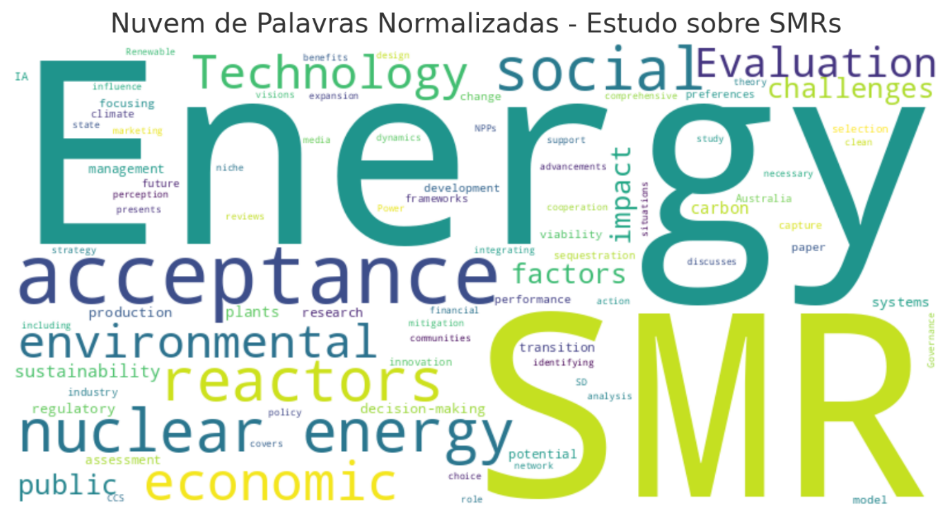

FIG. 3 Main themes related to public perception and acceptance of SMRs.

Analysis of the word cloud generated from the study on public perception and acceptance of SMRs makes it possible to visually identify the areas of greatest focus in the literature reviewed. The prominence of terms such as “acceptance”, “modular”, “energy”, “reactors” and “nuclear” indicates that these studies focus significantly on public acceptance and the technical characteristics of SMRs. The association of the terms “power”, “evaluation”, “environmental”, “technology”, “nuclear energy” and “social” as high frequency suggests that the literature analyzed focuses on several key interrelated areas, such as the power generation capacity of SMRs and their potential contribution as a low-carbon energy matrix; the importance of technical, economic and environmental evaluations of these technologies; the focus on technological advances and innovations associated with SMRs; and the relevance of public acceptance and social issues related to the implementation of these technologies. Analysis based on semantic groupings of moderately frequent terms indicates that research on SMRs is multifaceted and ranges from technical and development issues to environmental, political and management considerations. This diversity of topics suggests a comprehensive and interdisciplinary approach to the literature consulted and reflects the complexity and multiple challenges associated with the implementation and acceptance of SRMs.
By adopting an interdisciplinary approach and mapping the existing literature, this study provides a solid basis for future research and policy development, with practical implications for policymakers, technology developers and academics, with a view to more informed and accepted implementation of SMRs. Nevertheless, the research presents a significant bias due to the limited choice of databases and descriptors. By restricting the systematic review to the Scopus and Web of Science databases, the research may not capture the totality of the available literature, especially regional studies or studies published in other languages that could offer complementary perspectives. The selection of descriptors used may also have excluded relevant studies that address cultural, psychological or behavioral aspects important to a full understanding of public acceptance of new nuclear technologies. This bias may result in an incomplete view of public perceptions and concerns regarding SMRs.
As the review had a predominance of studies carried out in countries of the Global North, such as the United States and Canada, with little representation of the Global South, this may introduce a geopolitical bias, where the concerns and perceptions of developing nations would be under-represented, despite the fact that these regions may have different challenges and perspectives on SMRs. In addition, periods of significant change related to nuclear events, such as the Fukushima accident or the military occupation of nuclear power plants in the Russia-Ukraine conflict, may not have been sufficiently analyzed in relation to their influence on public perception. To improve the breadth and depth of research into public perceptions and acceptance of SMRs, future investigations should consider complementing with other scientific databases and reviewing the descriptors used in the search strings to capture additional and diverse studies that may include weakly identified regional aspects.

CONCLUSIONS
The analysis of the current literature on SMRs, with a focus on public perception and acceptance of SMRs, provides a solid basis for future research and public policy development. Its findings highlight that references on the subject are multidisciplinary in nature but still incipient and range from technical and development issues to environmental, political and management considerations. The evidence shows a significant gap in research that directly investigates socio-cultural and political aspects of SMR acceptance. To overcome the challenges of public acceptance, it is essential to promote greater engagement with the public and develop effective communication strategies that highlight the benefits and mitigate the concerns associated with SMRs and nuclear technology, in a holistic approach to technical and social aspects. In addition, international collaboration and continued investment in research are key to the advancement and successful implementation of this promising technology.
For SMRs to become a viable solution for decarbonization and energy security, a coordinated effort is needed to engage the public, educate about the benefits of the technology and develop regulatory policies that support its implementation. New and innovative research also needs to be developed beyond the technical issues of SMRs, addressing socio-political and cultural issues to contribute to the development of more balanced and informed approaches to the acceptance of this emerging technology.
ACKNOWLEDGEMENTS
The authors thank CAPES and the support of Postgraduate Program in Nuclear Technology (IPEN-CNEN).
References
- IPCC. “Climate Change 2023: Synthesis Report”, Contribution of Working Groups I, II and III to the Sixth Assessment Report of the Intergovernmental Panel on Climate Change, Geneva (2023).
- Mathew, M. D. (2022). Nuclear energy: A pathway towards mitigation of global warming. Progress in Nuclear Energy, 143, 104080. https://doi.org/10.1016/j.pnucene.2021.104080
- Vujić, J., Bergmann, R. M., Škoda, R., & Miletić, M. (2012). Small modular reactors: Simpler, safer, cheaper?. Energy, 45(1), 288-295. https://doi.org/10.1016/j.energy.2012.01.078
- Black, G., Black, M. A. T., Solan, D., & Shropshire, D. (2015). Carbon free energy development and the role of small modular reactors: A review and decision framework for deployment in developing countries. Renewable and Sustainable Energy Reviews, 43, 83-94. https://doi.org/10.1016/j.rser.2014.11.011
- Iyer, G., Hultman, N., Fetter, S., & Kim, S. H. (2014). Implications of small modular reactors for climate change mitigation. Energy Economics, 45, 144-154. https://doi.org/10.1016/j.eneco.2014.06.023
- Di Maio, F., Bani, L., & Zio, E. (2022). The Contribution of Small Modular Reactors to the Resilience of Power Supply. Journal of Nuclear Engineering, 3(2), 152-162. https://doi.org/10.3390/jne3020009
- Locatelli, G., & Mancini, M. (2012). A framework for the selection of the right nuclear power plant. International Journal of Production Research, 50(17), 4753-4766. https://doi.org/10.1080/00207543.2012.657965
- Sovacool, B. K., & Ramana, M. V. (2015). Back to the future: Small modular reactors, nuclear fantasies, and symbolic convergence. Science, Technology, & Human Values, 40(1), 96-125. https://doi.org/10.1177/0162243914542350
- Iyer, G., Hultman, N., Fetter, S., & Kim, S. H. (2014). Implications of small modular reactors for climate change mitigation. Energy Economics, 45, 144-154. https://doi.org/10.1016/j.eneco.2014.06.023
- Ramana, M. V., & Mian, Z. (2014). One size doesn’t fit all: Social priorities and technical conflicts for small modular reactors. Energy Research & Social Science, 2, 115-124. https://doi.org/10.1016/j.erss.2014.04.015
- Boldon, L., Sabharwall, P., Bragg-Sitton, S., Abreu, N., & Liu, L. (2015). Sustainability development platform for nuclear-renewable energy integration: Environmental impacts, economics, and socio-political implications. International Journal of Energy, Environment, Economics, 23(INL/JOU-15-34963).
- Woo, T. H. (2016). Assessment of the small modular reactor (SMR) marketing using modified network dynamics-based system dynamics (SD) method. International journal of green energy, 13(15), 1626-1633. https://doi.org/10.1080/15435075.2016.1188103
- Hanna, K., McGuigan, E., Noble, B., & Parkins, J. (2019). An analysis of the state of impact assessment research for low carbon power production: Building a better understanding of information and knowledge gaps. Energy Research & Social Science, 50, 116-128. https://doi.org/10.1016/j.erss.2018.10.017
- Yang, Y., Wong-Parodi, G., & Fischhoff, B. (2019). How stable are preferences among emerging electricity generation technologies. Environmental Research Communications, 1(7), 071002. https://doi.org/10.1088/2515-7620/ab2ec0
- Budnitz, R. J., Rogner, H. H., & Shihab-Eldin, A. (2018). Expansion of nuclear power technology to new countries–SMRs, safety culture issues, and the need for an improved international safety regime. Energy policy, 119, 535-544. https://doi.org/10.1016/j.enpol.2018.04.051
- Iakovleva, M., Rayner, J., & Coates, K. (2021). Breaking Out of a Niche: Lessons for SMRs from Sustainability Transitions Studies. Nuclear Technology, 207(9), 1351-1365. https://doi.org/10.1080/00295450.2020.1855947
- Zhang, X., Huang, G., Zhou, X., Liu, L., & Fan, Y. (2021). A multicriteria small modular reactor site selection model under long-term variations of climatic conditions--A case study for the province of Saskatchewan, Canada. Journal of cleaner production, 290, 125651. https://doi.org/10.1016/j.jclepro.2020.125651
- Malatesta, T. (2021). The Environmental, Economic, and Social Performance of Nuclear Technology in Australia. Journal of Nuclear Engineering and Radiation Science, 7(4), 041202. https://doi.org/10.1115/1.4049758
- Hurlbert, M. A., & Akpan, J. (2023). Dialectic narratives, hostile actors, and Earth’s resources in Saskatchewan, Canada. Sustainability Science, 18(1), 285-301. https://doi.org/10.1007/s11625-022-01214-y
- Kiser, L., & Otero, L. D. (2023). Multi-criteria decision model for selection of nuclear power plant type. Progress in Nuclear Energy, 159, 104647. https://doi.org/10.1016/j.pnucene.2023.104647
- Żuk, P. (2023). Soft power and the media management of energy transition: Analysis of the media narrative about the construction of nuclear power plants in Poland. Energy Reports, 9, 568-583. https://doi.org/10.1016/j.egyr.2022.11.192
- Vinoya, C. L., Ubando, A. T., Culaba, A. B., & Chen, W. H. (2023). State-of-the-Art Review of Small Modular Reactors. Energies, 16(7), 3224. https://doi.org/10.3390/en16073224
- Hurlbert, M., Das, T., & Vitto, C. (2023). Transformative power production futures: citizen jury deliberations in Saskatchewan, Canada. Energy, Sustainability and Society, 13(1), 44.

