# Systematic Literature Review about risks of Small Modular Reactors (SMR)

B. KOCSIS

MVM Paks NPP Ltd

Paks, Hungary

Email: kocsisb@npp.hu

**Abstract**

This study investigates the trends in SMR research from 2014 to 2024 by analyzing publications indexed in Scopus and Web of Science. Using predefined search criteria, 26 relevant articles were identified and analyzed. The research highlights the temporal distribution of publications, the interdisciplinary nature of the studies, and the leading countries in SMR research. The findings emphasize the need for further technological, regulatory, and business innovations to address the challenges and enhance the adoption of SMRs. Despite advancements, the complexity of passive safety systems and their operational interactions pose significant challenges. The ongoing development of SMRs aims to improve safety, reduce environmental impact, and provide sustainable energy solutions.

## INTRODUCTION

The use of renewable energy sources is expanding worldwide because they are environmentally friendly and abundantly present in nature, which has come to the fore especially due to the decreasing availability of fossil fuels. Nuclear power generation is currently one of the most reliable source of electricity, and its operation does not emit carbon dioxide. Their reliability has been proven in 50 countries, with 411 nuclear reactors in operation worldwide, together producing more than 10% of the world's electricity [1].

For the nuclear industry, one of the lessons of the Chernobyl disaster in 1986 and the Fukushima disaster in 2011 was that the trend towards building larger, more robust and longer-lived nuclear power plants since the 1960s should be reconsidered. It is essential to rethink the mainstream of power and heat generation unit design, development and construction, which since the early 2020s has increasingly brought with it the promise of the possible commissioning of small modular reactors (SMRs). According to the International Atomic Energy Agency (IAEA), global interest is focused on power plants with a capacity of at least 10 MW and up to 300 MW, due to their lower cost and smaller environmental footprint compared to conventional technologies (1000, 1200 or 1600 MW) [2].

## Methodology

### Systematic Literature Review (SLR) has several advantages over traditional methods through its unique process. SLR encourages the inclusion of studies that are outside the narrow field of study but relevant through links [3]. It is transparent, due to the use of comprehensive, pre-defined search terms and standard inclusion and exclusion criteria. [4] Without this method, the completeness of the literature review and its transparency would be very difficult to demonstrate [5]

## the subject of research

The study focuses on the risks associated with small modular nuclear power plants. They have advantages in that they have a high energy potential and do not directly emit carbon dioxide, but in the event of an accident they have a significant impact on the environment. In addition to the obvious advantages, there is a social issue of the economic viability of these plants, the potential for nuclear accidents and the management of the waste generated by their operation.

## Research Questions

* How many Scopus and Web of Science (WoS) indexed articles are there in this topic between 2014 and 2024?
* What is the trend in the number of articles on SMR research over this period?
* How many citations come from articles on SMR research during this period?
* In which countries were the studies produced?
* What are the main research topics?

## Research method

I used the Scopus and Web Of Science databases. The search phrase used in Scopus: "nuclear AND smr AND risk" and the time period is limited to 2013 to 2024. This resulted: "TITLE-ABS-KEY ( nuclear AND smr AND risk ) AND PUBYEAR > 2013 AND PUBYEAR < 2025". It is crucial to decide whether or not the search result can be used as a data source. Only studies were allowed in the search filter and the categories Conference Paper, Letter, Book, and Review were excluded. For this reason, the search term was expanded to produce "TITLE-ABS-KEY ( nuclear AND smr AND risk ) AND PUBYEAR > 2013 AND PUBYEAR < 2025 AND ( LIMIT-TO ( DOCTYPE, "ar" ) )" After the inclusion and exclusion criteria were defined, the list was narrowed down to 48 articles. The results then had to be hand-selected, yielding 31 articles.

The search query used in the Web Of Science database is available at the link below: [*https://www.webofscience.com/wos/alldb/summary/c45592cd-ded2-4c10-8833-5609aceb2458-c6a0a6d7/relevance/1*](https://www.webofscience.com/wos/alldb/summary/c45592cd-ded2-4c10-8833-5609aceb2458-c6a0a6d7/relevance/1)The query returned 70 results, with many of the topics related to medical science. After filtering out irrelevant topics, 45 remained. I summarized the results from the two databases using the Mendeley Reference Manager program, and after filtering out duplicates, I obtained 50 publications on the same topic, which I analysed in detail.

The temporal distribution follows the relevance of the topic, from 2020 onwards there was a jump in the number of publications compared to previous years, so I excluded studies with a low number of references (5 or less) from the analysis to increase the relevance of the topics. This allowed me to focus on those papers that are more widely accepted and recognised, thus increasing the quality of the scientific work and the reliability of the results obtained. The selecting process is shown on Fig. 1.

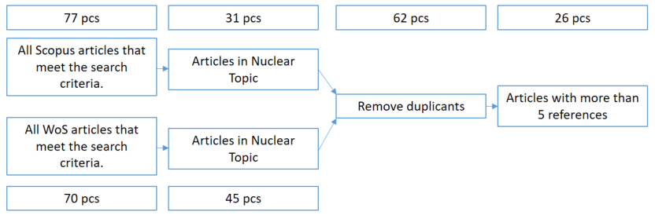

*FIG. 1. Process of articles selection included into research.*

No studies from 2016, 2017 or 2023 were included in the shortlist because they did not meet the 5 citation criteria. I do not consider this to be an error, as they do not have a sufficiently high ranking either because of their novelty or due to their over-specificity or quality. Changes in research topics, the growth of information, the speed of electronic publication and the changing interest in current research topics are all factors that influence the dynamics of citations and explain the changing patterns over time, as shown on Fig. 2.

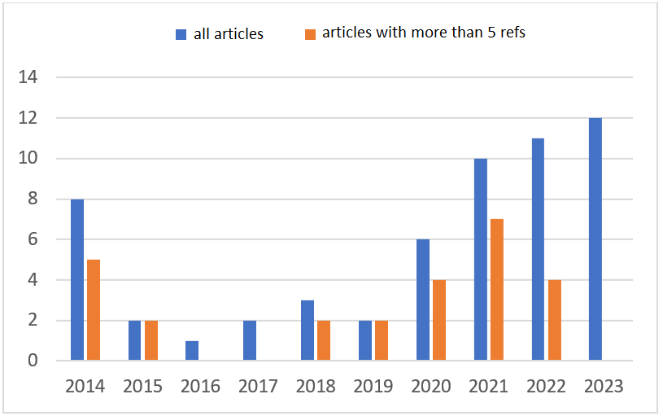

*FIG. 2. Yearly distribution of articles meet research criteria*

Over time, cumulative knowledge is built up, with newer findings and research referring back to previous ones. The citations to highly reputed studies are prominent due to their classical status, which is clearly observed in the 2014 works. A normal course of scientific processes and research trends can be observed for the period 2017-2022, as shown in Fig. 3.

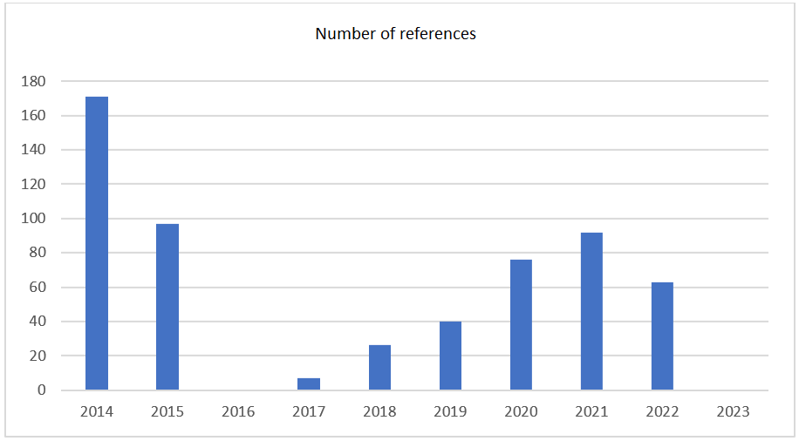

*FIG. 3. References to studies by year*

As I mentioned before, scientific research is usually based on facts that are already known and accepted. Authors tend to refer to previous work when describing new findings, which contributes to the increase in citations. Electronic publications and online databases allow researchers to easily access these works, thus increasing the potential for citations. Both the dissemination of information and the increase in its accessibility play a role in the correlation between the number of citations in a study and the number of publications per year (Fig. 4).

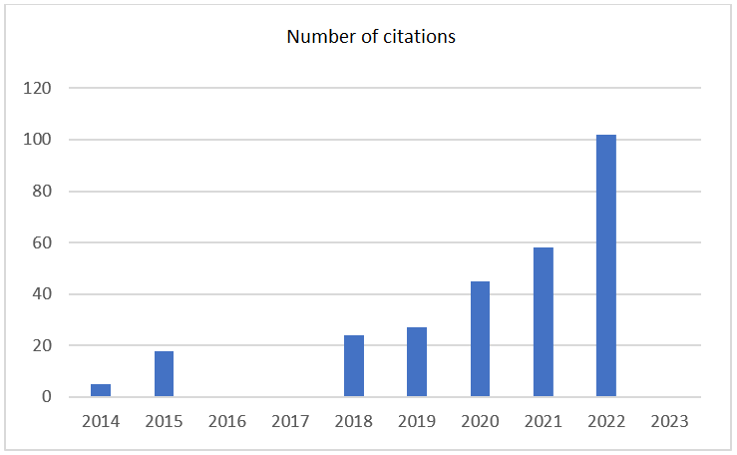

*FIG. 4. Citations in studies by year*

The overall data show that the number of publications and the distribution of journals has varied over the years. Publications are not limited to a single discipline, their interdisciplinary nature is clearly visible in Table 1. It is worth highlighting Nuclear Engineering And Design for having published an article meeting the research criteria for two years in succession.

TABLE 1. Most relevant Journals

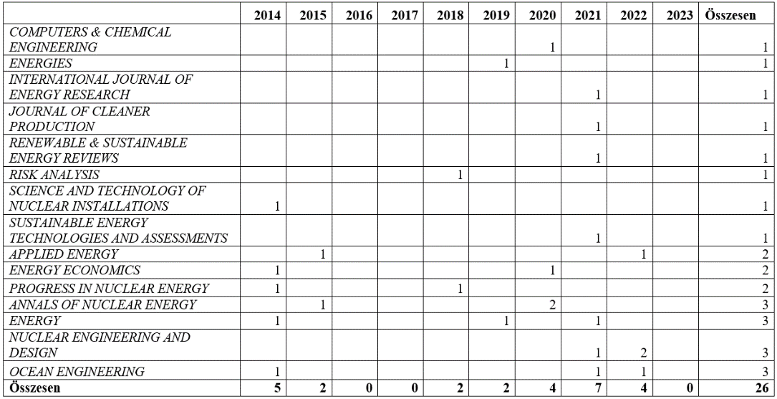

The potential for accidents, the management of radioactive waste and social issues are important considerations when setting up a power plant. The US, China and the UK are leading the way in research into the potential of SMR technology and the associated risks, as in Fig. 5.

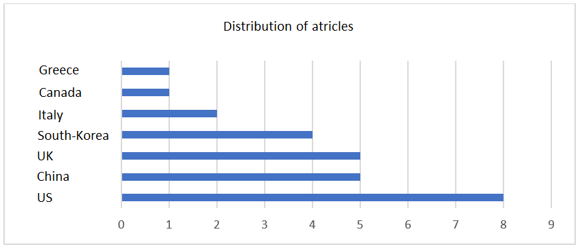

*FIG. 5. Citations in studies by year*

The most common themes and their distribution over time are visually illustrated in Figure 6, in a network generated using the VOSViewer program. Several nodes display the theme of potential accidents and their impacts, reinforcing the key issue raised by the technology.

Through the graphical representation, it is notable that the keywords "case, unit, concept" are relatively common in the studies. Through "case" studies, researchers investigate real or theoretical situations. "Unit" is essential to analyse the technical characteristics of reactors, modules or other important components, while "concept" is relevant to the general design and operating principles of SMR technology, comparing different concepts and exploring innovation opportunities that are key to effectively support development.

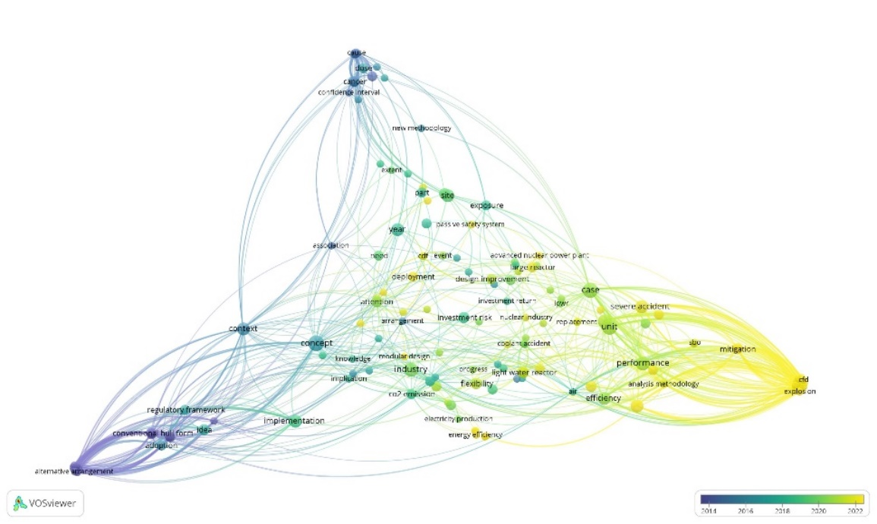

*FIG. 6. Citations in studies by year*

## Conclusion

Over the past decade, there have been significant developments and advances in the development of small modular reactors (SMRs). Various countries and companies are actively involved in this process, as the demand for clean and sustainable energy sources is constant. For SMRs, it is important to consider the advantages and opportunities that conventional, larger reactors do not offer. Their smaller size, modularity and flexibility of installation location can be advantageous, reducing accident risks and environmental impacts. They operate with smaller quantities of fuel, reducing potential radiation hazards and the risk of misuse of nuclear materials, are based on newer technology, use more efficient, possibly closed-loop cooling systems and have more advanced safety solutions.

It is important to emphasise that the development of SMR is a process and that technological, business and regulatory challenges need to be addressed for widespread adoption and deployment. New generation nuclear technologies, such as fourth generation reactors and small modular reactors (SMRs), have addressed many of the technical challenges and represent a major technological advance in recent years. They bring with them the benefits of a high level of automation and advanced passive safety systems that can significantly reduce the risk of human error and accidents. Despite technological progress, one of the major challenges is the complexity of passive safety systems and their interaction with other reactor systems. The effectiveness of complex technical solutions can be strongly influenced by operating conditions, such as the continuous operating time of the reactor or the frequency of maintenance. Further innovation is expected to facilitate their uptake in the coming years.

ACKNOWLEDGEMENTS

Project no. 2023-2.1.2-KDP-2023-00010 has been implemented with the support provided by the Ministry of Culture and Innovation of Hungary from the National Research, Development and Innovation Fund, financed under the KDP-2023 funding scheme.

References

[1] IAEA, Nuclear Power reactors in the world 2023 edition, IAEA, Vienna (2023)

[2] IAEA, Benefits and Challenges of Small Modular Fast Reactors, IAEA, Vienna (2021)

[3] Robinson, P., Lowe, J., Literature reviews vs systematic reviews. Aust. N. Z. J. Public Health 39(2), 103(2015)

[4] Greyson, D., Rafferty, E., Slater, L., MacDonald, N., Bettinger, J.A., Dubé, È., MacDonald, S.E., Systematic review searches must be systematic, comprehensive, and transparent: a critique of Perman et al. BMC Public Health 19(1), 1–6 (2019)

[5] Dixon-Woods, M., Agarwal, S., Jones, D., Young, B., Sutton, A., Synthesising qualitative and quantitative evidence: a review of possible methods. J. Health Serv. Res. Policy 10(1), 45–53 (2005)