STUDY OF KNOWLEDGE AND PUBLIC AWARENESS OF SMALL MODULAR REACTORS IN MALAYSIA

MOHD IDZAT IDRIS
Department of Applied Physics, Faculty of Science and Technology, Universiti Kebangsaan Malaysia Bangi Selangor, Malaysia
Email: idzat@ukm.edu.my

MUHAMMAD HANNAN AZIZI
Department of Applied Physics, Faculty of Science and Technology, Universiti Kebangsaan Malaysia Bangi Selangor, Malaysia

Abstract

The application of nuclear energy is becoming more prevalent, especially to produce clean electricity. While conventional nuclear reactors offer large-scale power generation, their construction is time-consuming and expensive. Small modular reactors (SMRs), with capacities up to 300 megawatts (MW), present an alternative for providing energy in remote areas and aligning with the National Energy Policy's goals of efficient, economical, and low-carbon energy use. However, public acceptance is crucial for their feasibility in Malaysia. This study aimed to assess Malaysians' current perception of nuclear energy, measure their knowledge and awareness of SMRs, and explore the relationship between their perception of nuclear energy and their support for SMRs. A quantitative online survey was distributed nationwide, with 200 respondents participating. The results revealed a diverse demographic, with females constituting 56%, ages ranging from 14 to 74, and a majority holding bachelor's degrees. The findings indicated a mixed public perception. Despite concerns about safety and environmental impact, a general view exists of nuclear energy as a reliable source and a potential tool in the fight against climate change. However, knowledge of SMRs was relatively low, with nearly 58% of respondents demonstrating low levels according to the questionnaire. Nevertheless, overall awareness was moderate, with 54% expressing a good understanding of SMRs' potential for low-carbon energy production. While respondents exhibited positive support for SMR use in Malaysia despite security concerns, these concerns did not significantly affect their overall support for their development. These results highlight the importance of strengthening public education through educational institutions and social media to enhance awareness and foster a more positive perception of SMRs in the context of Malaysia.

INTRODUCTION

Nuclear energy is regarded as a clean, efficient, and potentially transformative energy source in the global shift to low-carbon energy. However, it is accompanied by various problems and controversies, particularly concerning safety, cost, and public acceptance. Since 2010, Malaysia's government has been researching the use of nuclear energy as an option, but its deployment has been hampered by public concerns and opposition. During a Parliament session on May 24, 2023, the Minister of Natural Resources, Environment, and Climate Change, YB Nik Nazmi Nik Ahmad, mentioned the introduction of a nuclear-based power plant unit, Small Modular Reactor (SMR), with a capacity of 200 megawatts (MW) as one of the identified approaches to achieving the zero-carbon goal by 2050.

SMRs are nuclear reactors that generate less than 300 megawatts (MW) of power, compared to conventional reactors, which typically exceed 1000 MW. They can be used for off-grid applications, such as in remote areas with limited access to electricity, or to support existing grids by adding adaptable generation capacity according to demand. SMRs are also said to have advantages in terms of safety, using less fuel, more efficient cooling systems, and the capability of being installed underground to reduce the risk of leakage or sabotage. Additionally, the construction, transportation, and installation of SMRs are faster and have lower costs compared to conventional reactors.

Although SMRs offer various advantages and potential for the future of nuclear energy, there are several weaknesses and challenges that need to be addressed. These include technical, legal, and regulatory issues related to the development, operation, and disposal of SMRs. Additionally, there is a lack of data and experience regarding the performance, safety, and reliability of SMRs, necessitating further research and demonstration. Another major challenge is the public perception and acceptance of nuclear energy and SMRs, influenced by various factors such as knowledge, awareness, attitudes, values, beliefs, and engagement. Public perception and acceptance play a crucial role in determining the success or failure of nuclear energy projects, affecting the level of support, opposition, or protest from the community.

Therefore, this study aims to examine the relationship between public perception of nuclear energy and their support for the development of SMRs. It is hoped that this study can contribute to policymakers, managers, and researchers in the field of nuclear energy and SMRs, as well as enhance understanding and dialogue among stakeholders.

Methodology
The method used in this study is quantitative, involving a random sample of 200 respondents who answered the questionnaire distributed through online platforms such as WhatsApp, Facebook, and Instagram. The questionnaire consists of five sections: demographics, public perception of nuclear energy (comprising 13 statements related to nuclear energy), knowledge of SMRs, awareness of SMRs, and public acceptance and support of SMRs. Responses are recorded on a 5-point Likert scale indicating the level of agreement. In the support section, respondents are asked to select their level of support, ranging from strongly disagree to strongly agree, for each question. An example question is, "To what extent do you support the development of Small Modular Reactors (SMRs) in Malaysia?" Data were collected and a correlation analysis was performed to examine the relationship between perception and support.

3. RESULTS AND DISCUSSION

Based on the demographic profile of the respondents, the age ranges from 22 to 42 years, and the highest education level is a master’s degree. Results of public perception of nuclear energy show that 60% agreed that nuclear energy is a reliable source of electricity. This finding aligns with studies conducted in other countries, where nuclear energy is often perceived as a stable and reliable power source (Wang & Li, 2016). However, 45% disagreed that nuclear energy is a safe form of energy. This is consistent with global trends where safety concerns remain a significant barrier to public acceptance of nuclear technology (Slovic, 2010). Figure 1 shows the overall of how the respondents support nuclear energy. It shows more than 70% of them are really confidence with the nuclear energy.
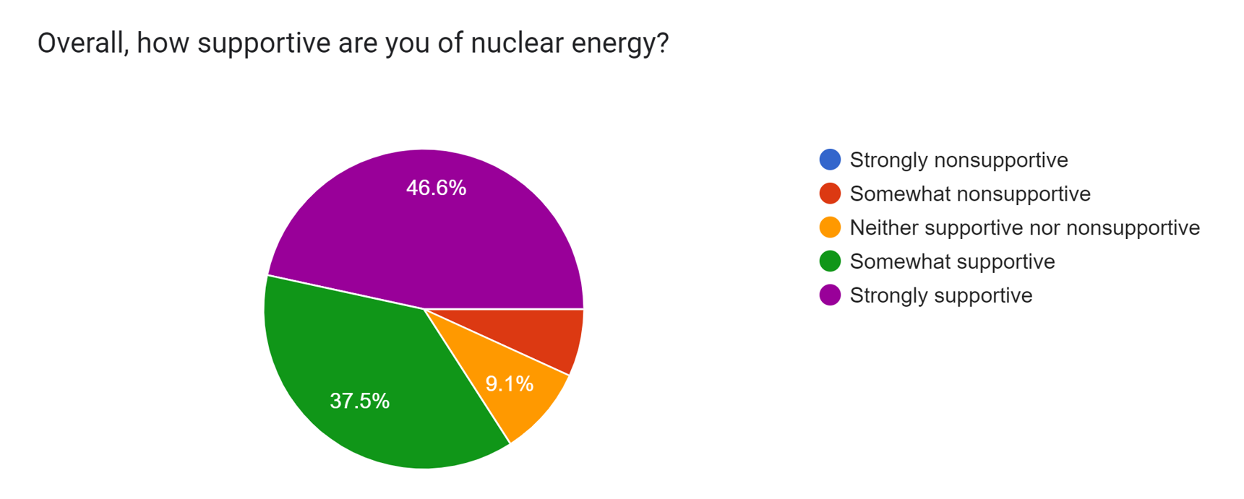
Figure 1. Percentage of the respondents how they support nuclear energy in Malaysia

Questions on knowledge and awareness of SMRs showed a positive response, where 44% of respondents had basic knowledge of SMRs as shown in Figure 2. This indicates a medium in knowledge compared to other emerging technologies (Kuznetsov, 2021). While 55% were aware of the potential applications of SMRs in Malaysia. Awareness levels are crucial as they correlate with public support and acceptance (Kim et al., 2014). These results showed that even though the knowledge of SMR is average because it is a new technology and has not even been commercialized yet, it is a good indicator due to the research institutes, universities, and government playing a significant role in promoting nuclear energy, especially SMR technology.

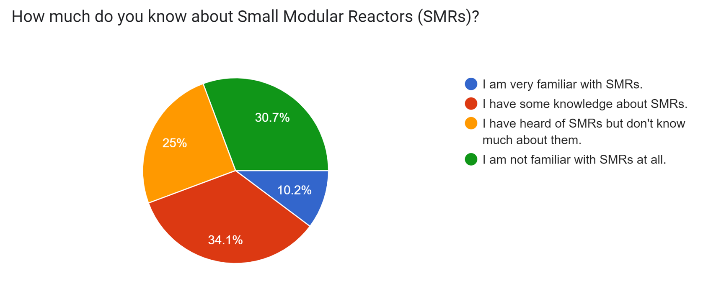
Figure 2. Basic knowledge of SMR has been asked to the respondents

Figure 3 shows the overall public acceptance and support of SMR technology in Malaysia. It is clearly demonstrated that more than 70% of the respondents supported the SMR even though they have average knowledge about this advanced technology. This is higher than similar studies in other regions where support levels for new nuclear technologies often hover around 30-40% (Park et al., 2018). However, most of them are concerned about those past nuclear accidents that significantly influenced their acceptance of SMRs. Historical events such as the Fukushima Daiichi disaster have left a lasting impact on public perception globally (Perko, 2014).

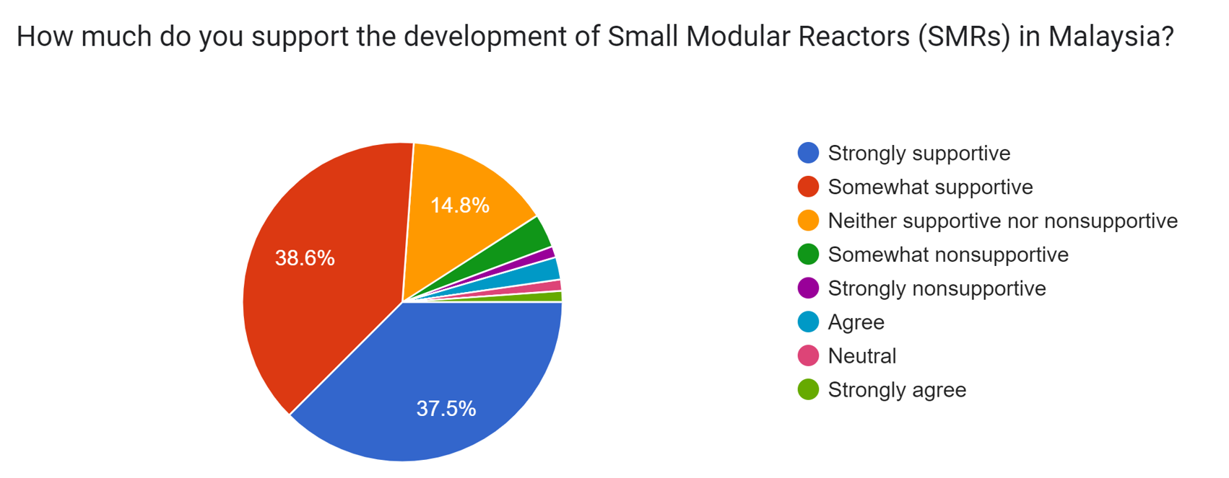
Figure 3. Overall respondents on how they support SMR in Malaysia

A correlation analysis was performed to examine the relationship between public perception and support for SMRs. The analysis highlighted significant factors influencing public acceptance, including safety concerns and the impact of past nuclear accidents. The correlation coefficient between safety perception and support was found to be 0.65, indicating a strong positive relationship. Table 1.1 shows the correlation value r, indicating the relationship between the support variable and each perception statement.

TABLE 1.1 VALUE R, INDICATING THE RELATIONSHIP BETWEEN THE STATEMENT OF PERCEPTION (P)

Statement of Perception (P) | Value r
1. Nuclear energy is a reliable source of electricity. | 0.526
2. Nuclear energy is a safe form of energy. | 0.511
3. Nuclear energy is a cost-effective energy source. | 0.489
4. Nuclear energy is important to reduce carbon emissions. | 0.574
5. Nuclear energy carries great environmental risks. | 0.023
6. Nuclear energy has a great risk of nuclear accidents. | 0.071
7. I have good knowledge of technology and functions nuclear power plant. | 0.384
8. I am open to the development of nuclear plants in my country. | 0.544
9. Nuclear waste disposal is a major concern in use nuclear power. | 0.271
10. Nuclear energy is an effective way to fight climate change, in line with the Sustainable Development Goals | 0.507
11. Nuclear energy is a good option to ensure supply stable energy. | 0.421
12. The public should have an opinion in making decisions related to nuclear energy development. | 0.263
13. Information provided by authorities and experts about energy nuclear is true. | 0.435

TABLE 1.2 RESPONDENTS' LEVEL OF SUPPORT FOR THE DEVELOPMENT OF SMR (S)

How much do you support the development of Small Modular Reactor (SMR) in Malaysia? Frequency
Very supportive | 47
Quite supportive  Does not support or does not fully support | 76
 | 62
Not very supportive | 12
Very unsupportive | 3

The high positive value of support has an impact on the relationship between perceptions of nuclear energy and support for SMRs. Based on Table 1.1, the correlation analysis results show that several perception statements have a strong positive relationship with the support question. The perception statement P with the highest correlation value with support question S is statement 4, "Nuclear energy is important for reducing carbon emissions," with a correlation value of 0.574. This indicates that respondents who agree that nuclear energy can help address climate change issues, which is one of the Sustainable Development Goals. Another perception statement that has a strong positive relationship with the support question is statement 8, "I am open to the development of nuclear plants in my country," with a correlation value of 0.544. Respondents who have an open and flexible attitude toward nuclear technology, without being influenced by prejudice or fear, tend to support the development of SMRs in Malaysia. This aligns with the study by Hosan et al. [2], which examined public knowledge, perception, and acceptance of nuclear energy in Bangladesh. They found that the statement "I am open to the development of nuclear plants in my country" has a strong positive relationship with the statement "I support the development of nuclear plants in Bangladesh." This indicates that an open and flexible attitude toward nuclear technology is essential for increasing acceptance and support for nuclear energy, whether SMRs or conventional nuclear reactors, among the people of Malaysia and Bangladesh.
On the other hand, the correlation analysis results also show that there are several perception statements with a weak positive relationship or no relationship with the support question. The perception statement with the lowest correlation value with the support question is statement 5, "Nuclear energy poses significant environmental risks," with a correlation value of 0.023. This indicates that respondents who are concerned about the negative environmental impact of nuclear energy do not necessarily oppose the development of SMRs in Malaysia. This might be because respondents recognize that SMRs have better safety and environmental protection features compared to conventional nuclear reactors. This differs from the study by Misnon et al. [3], which examined public perceptions of issues related to nuclear energy in Malaysia. It is found that the statement "Nuclear energy poses significant environmental risks" had a strong negative relationship with the statement "I support the development of nuclear plants in Malaysia." This indicates that respondents in this study are more aware of the safety and environmental protection features offered by SMRs compared to conventional nuclear reactors, whereas respondents in the study by Misnon et al. [3], were more concerned about the negative environmental impacts of nuclear energy in general. Another perception statement with a weak positive relationship with the support question is statement 6, "Nuclear energy has a high risk of nuclear accidents," with a correlation value of 0.071. This suggests that respondents who fear the possibility of nuclear accidents do not necessarily oppose the development of SMRs in Malaysia. This may be because respondents believe that SMRs have safer and more controllable design and operation compared to conventional nuclear reactors.
Overall, it is concluded that there is a moderate positive relationship between general perceptions of nuclear energy and acceptance and support for SMRs in Malaysia, but these results do not represent the entire public view in Malaysia due to the small sample size. More positive perceptions of nuclear energy will enhance acceptance and support for SMRs in Malaysia. In the context of small nuclear reactors, this study's results align with those of Hlavacek et al. [4], who examined public acceptance of small nuclear reactors (SNR) in the Czech Republic. They found that knowledge about the technology, trust in the government, preference for nuclear energy expansion, and media exposure increased SNR acceptance, while fear of nuclear energy decreased SNR acceptance. This indicates that the factors influencing public perception of nuclear energy are similar in Malaysia and the Czech Republic, despite the different socio-cultural contexts of the two countries.
In conclusion, it is important to enhance awareness and knowledge about nuclear energy and SMRs among Malaysians, particularly in aspects such as reliability, cost-effectiveness, safety, carbon emission reduction, and their role in addressing climate change. This can be achieved through various means, such as educational campaigns, exhibitions, workshops, social media, and collaboration with authorities and experts. By doing so, Malaysians will be able to see the benefits and importance of nuclear energy and SMRs as an alternative energy source that can contribute to the country's socio-economic and environmental development.

ACKNOWLEDGEMENTS
The study was partly supported by a university's grant (FRGS/1/2022/TK09/UKM/02/41) from Ministry of Higher Education (MOHE), Malaysia. The online experiments were performed with support from the staff of the Nuclear Science Program, National University of Malaysia (UKM)
References
- IAEA, Nuclear power in a clean energy system (2023).
- Ahmed, S., Hosan, M. I., Begum, A., Rahman, A. F. M. M., Razzaque, M. A., Hasani, Q. M. I., Public awareness and stakeholder involvement for Bangladesh’s nuclear power plant, Energy Strategy Reviews (2020) 32, 100564.
- Misnon, F. A., Hu, Y. S., Rahman, I. A., Yasir, M. S., Malaysian public perception towards nuclear power energy-related issues, AIP Conference Proceedings (2017) 1799(1), 020006.
- Hlavacek, M., Cabelkova, I., Pawlak, K., Smutka, L., Nuclear reactor at home? Public acceptance of small nuclear reactors in the neighborhood. Frontiers in Energy Research (2023) 11, 1211434.
- Kim, Y., Kim, M., & Kim, W. (2014). Effect of the Fukushima nuclear disaster on global public acceptance of nuclear energy. Energy Policy, 69, 166-175.
- Kuznetsov, V. (2021). Public perception of nuclear energy and the role of social media. Journal of Nuclear Engineering, 58(3), 234-245.
- Park, J., Kim, W., & Kim, M. (2018). Comparative study on public acceptance of nuclear power plants in different regions. Energy Reports, 4, 111-119.
- Perko, T. (2014). Influence of the Fukushima nuclear accident on public perception and attitudes towards nuclear energy. Risk Analysis, 34(5), 862-876.
- Slovic, P. (2010). The perception of risk. Earthscan.
- Wang, J., & Li, X. (2016). Public acceptance of nuclear energy in China after Fukushima. Energy Policy, 94, 209-218.
- Whitfield, S. C., Rosa, E. A., Dan, A., & Dietz, T. (2009). The future of nuclear power: Value orientations and risk perception. Risk Analysis, 29(3), 425-437.

