MAPPING DISCOURSE COALITIONS IN TWITTER

DEBATES ON NUCLEAR POLICY: A STUDY OF

ARGENTINA'S CAREM-25

RUBENS YANES
Johnson‑Shoyama Graduate School of Public Policy, University of Saskatchewan
Saskatoon, Canada
Email: ruy111@mail.usask.ca

JEREMY RAYNER
Johnson‑Shoyama Graduate School of Public Policy, University of Saskatchewan
Saskatoon, Canada

JUSTIN LONGO
Johnson‑Shoyama Graduate School of Public Policy, University of Regina
Regina, Canada

PETER W. B. PHILIPS
Johnson‑Shoyama Graduate School of Public Policy, University of Saskatchewan
Saskatoon, Canada

SCOTT BELL
University of Saskatchewan
Saskatoon, Canada

Abstract
The paper explores the dynamics of Argentina's nuclear policy discourse on Twitter, focusing on the development and construction of CAREM-25, the nation's first small modular reactor (SMR). Covering the period from 2010 to 2022, the study uses Discourse Network Analysis to dissect stakeholder involvement, coalition formations, and evolving narratives. The research confirms the existence of coalitions both advocating for and opposing CAREM-25, offering insights into the diverse composition and dynamics of these groups. It underscores the fluid nature of political discourse and challenges assumptions about a direct correlation between support for nuclear power generation and the ideological positions of actors.

INTRODUCTION
CAREM-25 is the first small modular reactor (SMR) completely designed and constructed in Argentina for commercial purposes. Patented in 1985, construction of the prototype began in 2014 and, after several delays, the project is expected to be completed in 2028. This paper seeks to offer a descriptive view of the coalitions formed in Argentina to support the development and construction of CAREM-25 and to discuss how they interacted with opposing groups and citizens through public discourses.
Encouraged by both international and national organizations and by scientists, the CAREM-25 project represents efforts to develop a new generation of nuclear reactors, which have accelerated worldwide since the Fukushima accident in 2011. Several other countries are pursuing the development of commercially viable SMRs, including the US, China, Russia, and Canada (Ingersoll, 2016), representing a trend identified by some scholars as part of a nuclear renaissance (Bratt, 2012a; Jewell, 2011). SMRs are proposed as an alternative for power generation, with purported safety enhancements, cost competitiveness, low CO2 emissions, and easy deployment in isolated locations. Their promoters claim that they are useful for powering processes such as water desalination, heating, and hydrogen production (Marcel et al., 2017; Sovacool & Ramana, 2015; World Nuclear Association, 2021). Argentine technicians and officials foresaw some of these qualities as early as the 1980s when they initiated the development of the CAREM project (Castro Madero & Takacs, 1991).
CAREM (the acronym is derived from the phrase Central Argentina de Elementos Modulares) is a smaller pressurized water reactor (PWR) with the capacity to produce 32Mw. Its design includes innovative features that enhance safety and cost efficiency, such as:
- an integrated and self-pressurized primary system, which contains “the core, the steam generators, the whole primary coolant, and the absorber rod drive mechanisms” (Delmastro et al. 2011, 2);
- a cooling system supported by natural circulation; and
- passive safety systems that require no action to mitigate accidents (Marcel et al. 2017).
The development of SMRs has involved the joint work of private firms and public agencies worldwide, reviving nuclear power generation after decades of stagnation following the Fukushima accident (Dunn & Wunnava, 2019). In Argentina, for example, the development of CAREM-25 has become a key piece of the 2006 reactivation of the Argentine nuclear program and has infused investments into a state-owned ecosystem since 2009 (De Dicco et al., 2015; IAEA, 2022). Nevertheless, little is known about the political dynamics that explain the revival of nuclear power in Argentina. What actors are involved in the policy debate? How do they organize to influence policymakers? And what arguments help them to gain support? These are questions that remain unanswered about nuclear energy in many countries but are pivotal to understanding how innovations have progressed and how nuclear advocates and stakeholders have gained the required approvals, resources, regulatory accommodations, and public support (or managed public opposition) to jump-start the development and construction of a new generation of SMRs.
In the present study, we aim to understand the involvement and interaction amongst stakeholders in the public debate about the CAREM-25 project as it played out on the Twitter social media platform between 2010 and 2022. Before Elon Musk acquired Twitter (since renamed X) in 2023, researchers had identified it as a rich source of data and a political arena in its own right (Barberá et al., 2015; Conover et al., 2011). From its founding until today, political actors have followed and engaged in public debates on the platform and built discourse coalitions (Bossner & Nagel, 2020). Following the research stream that has developed from the large volume of data generated on the platform, we apply Discourse Network Analysis (DNA) to Twitter data—a methodology that allows researchers to link actors to the political narratives used in the public policy debate— to address these research questions: (1) Who are the stakeholders involved in the public debate and to what extent are they aligned in a coalition? (2) What narratives bind the coalitions, and how did they evolve? (3) To what extent is polarization between advocacy coalitions increasing over time? And (4) to what extent does political ideology influence the narratives of the actors involved in the debate?

A BRIEF HISTORY OF CAREM-25
The Argentine nuclear subsystem comprises a set of agencies, companies, and educational organizations under state control. Since 1979, when the military dictatorship (1976-1983) decreed the Nuclear Plan, parts of the subsystem have been aligned to oversee the construction of four large nuclear power plants (NPPs) to generate electricity and to complete the work to master the entire uranium cycle (Barceló, 2007; Hurtado, 2014). During the military dictatorship, INVAP—a state-owned company—worked on the development of a small reactor for submarine propulsion, which eventually became the CAREM project (Gil Gerbino, 2022; Greenpeace, 2002).
The arrival of democracy, and the ensuing economic turbulence, hindered the project from accessing the resources it needed (De Dicco, Deluchi, and Ferrer 2015), and the Nuclear Plan languished. As Table I shows, in 2003, when left-wing Peronist leader Nestor Kirchner came to power, he instructed his minister Julio de Vido to reactivate the plan. Under the presidency of his wife Cristina Kirchner, the construction of a 100Mw CAREM reactor was first announced in the province of Formosa, igniting a public debate about the project. Environmental organizations, local leaders, and officials of the Paraguayan government opposed the deployment of a nuclear reactor in the province (A. G. Piaz 2020). After several months of public debate, the project was put on hold. Finally, the government decided to build a smaller prototype (32 MW) in the province of Buenos Aires where NPPs Atucha I and II were located. The construction started in 2014 under the leadership of the National Atomic Energy Commission (CNEA), which signed contracts with public and private companies to carry out various aspects of the project.
TABLE 1. TIMELINE OF CAREM-25
National Context | Project´s Events
1983–2003: Arrival of democracy  - Hyperinflation (1989–1990)  - Neoliberal governments (1989–2001)  - Financial crisis (2001) | - CAREM is patented and presented at an IAEA event about small reactors in Peru  - Development starts
2003–2015: Kirchner’s era (left wing)  Nestor Kirchner (2003–2007)  - Reactivation of the Nuclear Plan (2006) | - Inclusion in Nuclear Plan (2006)
Cristina Fernandez (2007–2015)  - Debt restructuration (2010–2010)  - Debt default (2014) | - Announcement of construction in the province of Formosa (2012)  - Start of construction in the province of Buenos Aires (2014)
2015–2019 Macri administration (right wing)  - Debt restructuring (2015–2017)  - Financial crisis (2017–2019) | - Changes in project´s contractors  - Layoffs of workers, renegotiation of contracts, and stoppage of works
2019–2022 Fernandez administration (left wing)  - Covid pandemic (2020)  - Debt default (2020) | - Work stoppages  - Nationalization of contractors
Sources: CNEA Annual Reports 1983–2020 and press articles published in Clarin, La Nación, and Infobae

In the following years, during the Macri and Fernandez administrations, some of the suppliers had to be replaced or assisted by the government to complete their tasks. For example, the civil works were awarded to the state-owned electricity company Nucleoeléctrica by the government of Cristina Kirchner, but when Mauricio Macri came to power, they were reassigned to Techint, which would later relinquish the contract during the government of Alberto Fernández. Today, Nucleoélectrica is again in charge of the civil works. Something similar happened with TECNA, which was awarded the contract to build the Balance of Plant (BOP) by the Macri administration but resigned during the Fernandez administration, which reassigned the contract to Siemens. Finally, the privately owned firm IMPSA, chosen to build the reactor´s main container, faced financial problems and required aid from the government in 2021. All these changes generated tensions among the stakeholders that were reflected in different spheres: traditional media, social media, and in the streets in the form of protests.
Since the early days, the new reactor has been highly promoted nationally and internationally, attracting the interest of foreign governments and officials. The most recent official update shows that it is 62% complete and could be completed by 2028 (Bellato, 2023).
Based on Twitter data, this study seeks to identify active local and international actors and coalitions formed in the public debate about the project, their evolution over time, and the issues that have arisen during the debate. This information will be useful in identifying dynamics that could affect other projects in Argentina and for governments and other actors contemplating similar projects in other countries’ nuclear sectors.

LITERATURE REVIEW

Policy and Discourse Coalitions
Political coalitions are key elements in explaining change (or continuity) in public policies and the learning of policy actors. This is the view of the Advocacy Coalitions Framework (ACF), which suggests focusing on the interactions of coalitions built around different sets of shared values in a multilevel political arena to understand the formulation of public policies (Jenkins-Smith & Sabatier, 1994; Sabatier, 1988). Comprising diverse actors, the ACF includes legislators, bureaucrats, interest group members, academics, journalists, local authorities, and the media. Coalitions are formed within a single policy domain around common values categorized by the framework’s authors as deep core values, policy core values, and beliefs. These values and beliefs range from those that are the most unbending and central to the coalition to those that are the most malleable and secondary. Although deep core values tend to be immutable, actors can adapt policy core values and beliefs based on their learning, bargaining processes, and interaction with policy brokers. ACF recognizes that the power of learning is limited in explaining abrupt change in public policy, which happens when sudden transformations outside the policy domain occur. However, the framework is good for understanding stability and gradual policy changes, as well as how coalitions evolve, altering the distribution of power over time.
Despite ACF’s utility, values and beliefs are abstract and difficult to capture. Discourses seem an alternative way to catch them in a political debate. Political coalitions share discourses that reflect but also shape their vision of policies (Fischer, 2005; Hajer, 1993; Schmidt, 2010). By developing a narrative, political actors frame problems and possible solutions in a way that allows them to gain support (Baumgartner & Jones, 1991; Kingdon, 2003). According to Hajer (1993), these actors sharing the same discourse in a debate can be thought of as members of a political coalition. They manage to integrate these narratives on a political issue. By doing so, they consolidate themselves as a group, although they could develop different arguments and stories. Coalitions try to impose their discourses on others and infuse them into institutions in the form of rules, practices, or forms of organizations. That is why they frame and reframe their ideas in a dynamic process of interaction with others, and also why they make a formidable attempt to disseminate these ideas through different means: debates, media, and, recently, social media.

Discourse Network Analysis
Discourse network analysis (DNA) measures actors’ policy beliefs and discourses systematically and molds them into a data format that is compatible with policy network analysis (Leifeld, 2020). DNA aims to describe the construction of political discourses based on written documents, such as speeches, legislative records, press articles, and, in fewer cases, messages spread through social platforms. Its foundations can be traced to the work of Hajer (1993), Sabatier (1998), and Sabatier and Jenkins (1994), mentioned earlier, and to the concept of frames—sets of ideas, political preferences, beliefs, or justifications— introduced by Goffman, Rein, and Schön (Leifeld 2016).
Combining content analysis and social network analysis, DNA methodology traces concepts and policy alternatives in public discourses and links actors across them during a particular period or throughout the evolution of a public debate. It allows the construction of networks that reflect the level of congruence or conflict among actors about the ideas under discussion. This approach has been used in nearly 200 published investigations on dozens of policy issues, including pension system reform (Leifeld 2016), climate politics (Fisher, Waggle, and Leifeld 2013; Fisher, Leifeld, and Iwaki 2013; Ghinoi and Steiner 2020; Kukkonen and Ylä-Anttila 2020), energy policy (Černý & Ocelík, 2020; Rinscheid, 2020), water policy (Schaub & Metz, 2020), software patents and property rights (Leifeld and Haunss 2012), health policy (Hilton et al., 2020), nuclear energy (Gupta et al., 2021; Haunss et al., 2022; Minin, 2020; Nam et al., 2022; Rinscheid, 2015), among others.
DNA studies based on social media are scarcer than those based on traditional media, interviews, official reports, or congressional records. They depict debates or discussions in a broader sense, potentially including users from different jurisdictions within transnational conversations, and reflecting the impact of external events on the debates (Vaughan, 2020; Wallaschek et al., 2022). As others conduct research based on social media, they face some common challenges: how to filter the messages to obtain an unbiased and representative dataset, how to deal with bots and fake users, and how to code a huge amount of data. To deal with these issues, scholars have tried different strategies such as carefully analyzing in advance what terms better reflect the issue under study in the selected social platform (Bossner & Nagel, 2020; Wallaschek et al., 2022); identifying users offline using information from sources such as congressional hearings or newspapers articles and then looking for them on the social platform (Gupta et al., 2021; Steinfeld, 2016; Vaughan, 2020); carefully classifying users into categories that could facilitate the analysis (Gupta et al., 2018; Jin et al., 2022); and trying automatic ways of coding based on techniques such as Natural Processing Language (Haunss et al., 2020; Vaughan, 2020).

METHODOLOGY

Working hypotheses
In Germany, South Korea, Japan, Canada, and Switzerland, DNA has been used to research changes in nuclear policy in the aftermath of the Fukushima disaster (Haunss et al., 2022; Nam et al., 2022; Rinscheid, 2015, 2020; Schmid et al., 2020). In most works, scholars have identified two coalitions based on their attitude toward nuclear power: supporters and opponents. Nuclear vendors, utilities, government officials, and unions tend to be part of pro-nuclear coalitions, whereas environmentalist NGOs, members of left and green parties, and businesses linked to renewables join anti-nuclear coalitions.
Interestingly, authors writing about the response to the Fukushima accident in a variety of countries have noted differences. Germany, for example, decreed a nuclear phase-out (IEAE, 2023; Rinscheid, 2015), while in Canada and Japan, incremental changes slowed down the development of nuclear energy (Bratt, 2012b; Rinscheid, 2015). These different outcomes can be explained by examining the structure of the subsystem in each country and the dynamics among actors, including how they framed the issue. If high polarization and fragmentation existed before the event, major change was more feasible. In these scenarios, policy brokers usually redoubled their efforts to frame policy alternatives in a noticeable way (Nam et al., 2022). When enough powerful actors changed their views about nuclear power and spread the message, change became more feasible. When change was only incremental, a strong hegemonic coalition had existed (Rinscheid, 2015; Rinscheid et al., 2020), and either too few actors changed their minds or the ruling coalition influenced voters to avoid change (Rinscheid, 2020). Interestingly, none of the works studied the issue during a boom, when investments in nuclear power were increasing and new projects were under development.
Previous works have explored coalitions in the Argentinian nuclear subsystem to explain the evolution of Argentinian nuclear exports and the development of CAREM (Malacalza, 2017; Patterson, 2018) . Based on interviews with relevant actors, Malacalza identified four competing coalitions made up mostly of officials from different agencies: i) supporters of protectionism and import substitution policies, most of whom belong to the federal agency Comisión Nacional de Energía Atómica CNEA; ii) proponents of technological development and South-South integration concentrated in state–owned company INVAP; iii) free market advocates, who also support major integration with western developed countries, represented by the Foreign Minister and INVAP technicians; and iv) opponents of nuclear power represented by NGOs and environmentalists. The changes in the balance of power among these four coalitions explain how Argentina went from developing nuclear energy for its own use to exporting atomic technology to countries with a higher level of economic development (Malacalza, 2017). Similarly, Patterson (2018) investigated how CAREM managed to survive as a project from the period of the dictatorship to the end of the Kirchner government, based on interviews and official documents from CNEA.
The research of both Malacalza (2017) and Patterson (2018) shared commonalities: First, they showed that changes in policies correspond to alterations in the arrangement of coalitions in the subsystem, even though they did not explain how changes in the coalition structures and beliefs occurred. Second, they demonstrated that government agencies may have conflicting criteria for policymaking, even when they are part of the same administration. Third, they highlighted the importance of events outside the subsystem that alter its equilibrium (mainly elections). Notably, however, both scholars focused only on the subsystem’s dominant coalition, consisting of officials of CNEA, INVAP, and the Ministry of Foreign Affairs. This approach excluded other relevant stakeholders such as politicians, academics, legislators, and journalists. Moreover, the authors barely addressed the coalition of opponents, dismissing their influence on the development of the subsystem in recent years.
Since the current study focuses on Twitter data, we expect to have a more comprehensive picture of the subsystem, as stated in the first hypothesis:
H1) Most stakeholders are aligned in coalitions in favor of or against the construction of CAREM-25. The composition of the coalitions will be like those observed in other countries, with actors from different sectors blended according to common narratives and their attitude toward nuclear power.

Another aspect of our study is the evolution of the ideas under discussion, whether these are policy alternatives or narratives about the project. Previous studies about the Argentinian nuclear subsystem have identified some central ideas used by the dominant coalition: a nationalistic sense that ignites the search for technological autonomy, international prestige, and greater independence, through the development of a nuclear sector under the oversight of the State (Hurtado, 2014; Hymans, 2014; Patterson, 2018). Other studies have found that pro-nuclear actors argued that nuclear technology can be exported and that its development can be opened to private investment (Malacalza, 2017). Finally, the literature pointed out that new ideas were also added to the supporters’ narratives: Nuclear energy could be beneficial in fighting climate change, and it has a potential military use beyond the development of explosives (Patterson, 2018; Stirling & Johnstone, 2018). Similarly, opponents of nuclear energy also embraced notions debated worldwide, pointing out its risky nature and the harm it can inflict on the environment because of its hazardous waste. They supported renewable energy sources instead. (A. Piaz 2015; A. G. Piaz 2020; Malacalza 2017).

DNA and agenda-setting theories offers reasons to think that actors organize these ideas differently in their discourses over time. First, we can expect that after external events, issues can evolve. As the literature has suggested (Baumgartner & Jones, 1991; Kingdon, 2003), policy brokers may frame the subject in different ways, and some beliefs may be more binding than others in obtaining support. In continuously reframing the subject, these actors discard or refresh old arguments that no longer apply and introduce new ones. This process is important in our case, especially when changes in the distribution of political power occur. If a government loses an election and becomes the opposition, it may change its view on certain issues or adjust its beliefs by taking over pre-existing policies. Changes in the context determine changes in the strategy and therefore changes in the narratives. Similarly, decisions generate policy feedback, which can lead to learning. ACF recognizes that coalitions can adjust their beliefs based on policy outcomes or new information from the policy subsystem (Jenkins-Smith & Sabatier, 1994; Sabatier, 1988).

Although it is difficult to discern whether certain responses represent learning or mere strategic accommodation, the theory recognizes that adjustments in narratives can occur for both reasons. A good example is contested choices on nuclear energy. Suppose a decision is made to build a new nuclear plant in a place with no prior nuclear facilities. Usually, these types of decisions trigger protests. People may oppose the construction of the plant for ‘not in my backyard’ reasons, which are well-documented in the literature (Guo & Ren, 2017). The conflict would likely ignite the need for new and more convincing arguments on each side. To gain attention from other actors, the coalitions opposed to the plant would create striking narratives to expand the conflict (Baumgartner & Jones, 1991), while supporters wishing to increase support would aim both to increase science literacy and share the benefits of the project (Gupta et al., 2018; Ho et al., 2019).

We expect to find this kind of situation in our case, along with adjustments to narratives on the project's risks and costs from its opponents and on its benefits in economic or environmental terms from its supporters (Ho et al., 2019).

H2) Actor’s narratives and strategies might change throughout the debate, based on their policy belief and their position in the policy subsystem.

External shocks can produce sudden and rapid policy change (Baumgartner & Jones, 1991; Kingdon, 2003; Sabatier, 1988) . To explain the magnitude and pace of change following a shock, DNA scholars have concentrated on gauging social network polarization and clustering. If high polarization existed before the event, major change is more likely, because policy brokers usually increase their efforts in framing policy alternatives and powerful actors change their views. (Nam et al., 2022). If a strong hegemonic coalition existed, change is only incremental because not enough political actors have changed their minds about the issue, or the ruling coalition influenced voters avoiding radical change of the policy (Rinscheid, 2015; Rinscheid et al., 2020). Although most of the literature on nuclear focuses on the Fukushima disaster, we note that other types of political events are also important to trigger changes, such as elections or economic shocks (Kingdon, 2003). However, none of the cited studies have focused on a booming context, where investments in nuclear energy are increasing and new projects are under development.

Post-dictatorship Argentina offers an interesting environment because CAREM-25, as a specific policy oriented toward the development of nuclear power reactors, has been backed by administrations of different ideological signs that have alternated in power, amid several economic shocks and high economic volatility before and after the Covid pandemic. This scenario suggests two alternative explanations: Either the coalition’s polarization has remained stable while supporters of the project have been able to keep the policy running despite the obstacles, or Argentina’s subsystem has been evolving toward consensus that the project should proceed. The policy has not changed since the decision to build CAREM-25, but the coalitions could have. In either case, stability would be the outcome.

H3) The subsystem will show either a tendency to support the installation of a consensus, or a static equilibrium to maintain the policy’s stability, despite external events such as elections, natural disasters, or economic shocks.

The aforementioned DNA studies on nuclear power did not consider the actor’s political ideology. This feature could be relevant in the case of Argentina, a country described as highly polarized ideologically by scholars and local media (Moltó, 2021; Obradovich et al., 2021; Schuliaquer & Vommaro, 2020). Previous studies have identified differences both in actors´ ideologies in issues related to income distribution (Kessler & Vommaro, 2021) and in those related to the administration of justice used strategically by political parties (Cecchini Murúa, 2022). Scholars focusing on the nuclear subsystem make a key distinction between the approaches of governments of different ideological signatures. They argue that right-wing governments have opposed maintaining the sector under state control since the neoliberal government of Carlos Menem, who attempted to privatize the nuclear power plants and reform the entire subsystem. Interestingly, authors who have reviewed the history of the sector emphasize its historical links with Peron and, more recently, with the Kirchners, leaders of the democratic left. The support brought by these leaders contrasts with the weakening suffered during the neoliberal administrations of the 80s and 90s (De Dicco et al., 2015; Gaggioli, 2003; Hurtado, 2014). This feature makes the Argentinian case atypical since studies on the acceptance of nuclear power in other countries have established that conservatives are more likely than those on the left tend to support nuclear power (Slovic, 1999; Truelove & Greenberg, 2013; Xia et al., 2019).

However, none of the cited works include the post-Kirchner governments or digital platforms. Therefore, it is unclear if ideological polarization can explain the adoption of ideas about nuclear power, or if the so-called ideological "rift " can be perceived in the discussions on the subject on Twitter. Interestingly, Kessler and Vommaro (2021) described Argentine Twitter users as mostly left-wing citizens and the platform as an ideal place to witness ideological polarization. Therefore, we hope to find that most left-wing users support nuclear energy, thus verifying the relationship between political ideology and support for the project.

H4) Support or opposition to the project will be highly correlated to the ideological position of the actors.

Our four hypotheses help validate several theories about the coalitions that may have formed around CAREM-25. The first hypothesis verifies the presence of coalitions formed around common beliefs and the participation of political actors in them. The second focuses on the coalitions' strategies in discursive terms, while the third looks at the evolution of the subsystem structure in Argentina and seeks to explain the stability of the policy over time. The fourth explores the relationship between political ideology and attitude toward the project.

Data collection, coding, and analysis
We collected Tweets from 2010 to 2022 through the Twitter API for Academic Research, which gave us access to the entire Twitter archive before its acquisition by Elon Musk. To access Twitter API, we used two channels: the R package academictwitteR (Barrie & Ho, 2021), and the automatic Twitter developer downloader. For both, we created a query with the following search terms: “proyecto Carem,” "reactor Carem," "CAREM-25," "Carem25," "nuclear carem," "Proyecto Carem25," "reactor Carem25," and "nuclear carem25." We made successive connections to the API to download as many tweets as possible since the results obtained in terms of tweets counted and tweets downloaded differed between the two channels. Attempts were made until we did not obtain new tweets. The total number of tweets downloaded was 28,635 in different languages. Before 2009, we obtained no tweets. Retrieved tweets were filtered manually using DiscoverText (Shulman, 2011). All unrelated messages were removed, and the final sample contained 18,705 tweets.
As a second step, we validated users manually, tracking them on other social platforms such as LinkedIn, Instagram, Facebook, or in the press. We differentiated from the organization’s official accounts and those from individuals. Then we segregated users into the following categories: 1) political parties, 2) government agencies; 3) NGOs, 4) business or business associations, 5) unions, 6) international organizations, 7) academics or scientists, and 8) the public (Neil et al., 2018). We split government agencies into federal and provincial because the latter were relevant in the Argentinian context. Individuals were assigned to a specific category if the user belonged to an organization and had some level of responsibility in it (Leifeld 2013). Otherwise, the individual was assigned to the public category and was excluded from this analysis since our focus is formal stakeholders. The ideological preference was further discerned by examining the user's biography and the tweets from the last month in their timeline. They were classified as Left, Center, or Right users. Two coders did the job, following a customized codebook. Based on O’Connor and Joffe 2020, a primary coder cataloged most of the users, and a second coder independently worked on a random sample of 12% of the entire dataset. Both coders’ observations were used to adjust the codebook and the process. The inter-coder reliability index was above 91%. At the end of the process, we excluded tweets produced by unverified accounts and users categorized as public. Therefore, the sample was reduced to 3,993 tweets produced by 1,537 users.
Based on the sample of verified users, we coded the tweets containing statements in any of the two forms identified by DNA (Leifeld 2016): policy alternatives or narratives. Using rDNA, we imported the data into the Discourse Network Analyzer program and coded them using a mixed method. Some categories of statements had been previously identified after reviewing the extant literature, official documents, and press articles. However, other actors emerged from the tweets during the coding process. New stakeholders also appeared during the content analysis of tweets since they referred to statements or actions of third actors. Two coders completed this process, having regular meetings to assess differences. Intercoder reliability reached 96%. At the end of this stage, 4,849 statements were identified with 43 concepts issued by 1,284 individual stakeholders representing 808 organizations.
Finally, we obtained the affiliation and congruence networks from DNA and drew them in Visone (Brandes & Wagner, 2004). Affiliation networks are two-mode networks linking concepts and actors. They clarify how certain actors engage with certain ideas. Congruence networks are one-mode networks built from affiliation networks, which show how actors are linked based on the concepts they support or reject. We excluded the most accepted concepts when needed, calculated the betweenness centrality of nodes, set a threshold value to the normalized link’s weight, and applied the Girvan Newman algorithm to identify the coalitions (Leifeld 2016; Girvan and Newman 2003). We built these networks for each year and then grouped them into three phases according to the issues under debate about the project. Results are shown in the next section.

RESULTS

Coalitions
The public debate about the CAREM project from 2010 to 2022 can be grouped into three periods based on the topics under discussion and the events surrounding the debate (see Figure1):
- Period 1: 2010 to 2016: initial controversy
- Period 2: 2017 to 2019: building consensus
- Period 3: 2019 to 2022: consensus consolidation
The first period covered the government of Cristina Fernandez, a period characterized by tensions between two main conflicting groups advocating in favor and against the construction of a CAREM reactor (Figure 1a). Supporters comprised mainly federal agencies, (i.e., CNEA, MinPLan), the ruling party (PJ), the Formosa provincial administration, and several media that echoed the announcements made by officials. Opponents were identified as environmental organizations, the Catholic Church, the government of Paraguay, and political parties linked to broader opposition to the government (PRO, UCR, and Los Verdes). From 2011 to 2014, opponents gained support from different actors and were able to force the provincial government of Formosa to abandon the plan to host a CAREM reactor. The strength of the opposing coalition can explain the decision to build only the current prototype in Buenos Aires province, where two nuclear plants were already in place. However, the initial success in Formosa of the anti-nuclear coalition, made up of local actors, could also explain its subsequent weakening, as most of the actors abandoned the debate when the project moved to the province of Buenos Aires. These events seem to confirm the power of the ‘not in my backyard’ syndrome in mobilizing actors.
The first year of Macri's government also belongs to this period of analysis, basically because neither the correlation of forces nor the narratives were altered during this time, despite the change of government. The opposition coalition continued to push for the project to be scrapped, while federal agencies (now under the control of the former opposition) remained largely silent, but active, in bringing the project to fruition.
During the first period CNEA, the Minister of Planification and PJ were the most influential actors in both the network and the pro-project coalition, while the UCR was the most prominent actor among opponents. These actors acted as bridges between the two opposing coalitions.

The second period (2017-2019) includes the last years of Macri’s administration when a crisis erupted due to the temporary stoppage of the project and the dismissal of numerous workers. The situation was first denounced on Twitter, strengthening the pro-project coalition. The conflict received wide media coverage and triggered protests. The coalition brought together unions, PJ and other left-wing parties, academics, and several industrial organizations.
On the other hand, the conflict fragmented the anti-nuclear coalition. Federal agencies (controlled by a government sympathetic to anti-nuclear groups) were forced to ratify their support to avoid the administration being held responsible for the shutdown. Likewise, some political parties were forced to change their positions to mitigate the high political cost of the labor disputes. Figure 1b shows a diminished antinuclear coalition because actors no longer interested in the debate abandoned it and some of the remaining stakeholders changed their minds. For its part, the coalition in favor of the project appears fragmented into two blocks since they were focusing on different aspects of the conflict: the labor dispute and the shutdown of the project. PJ was among the most influential actors in the network due to the high involvement of its leaders in the conflict and its ability to attract the attention of a broader audience of other unions, media, businesses, and academics.
The third period (2019-2022) comprises PJ’s return to power and the year of the pandemic lockdown. New supporters emerged as relevant actors, especially from academia, media, and international organizations (IAEA), who became regular participants in the discussion. The antinuclear coalition remained small, but its actors gained influence since their ideas were echoed by some supporters of the project, as we explore below.

Figure 1a. 2010-2016  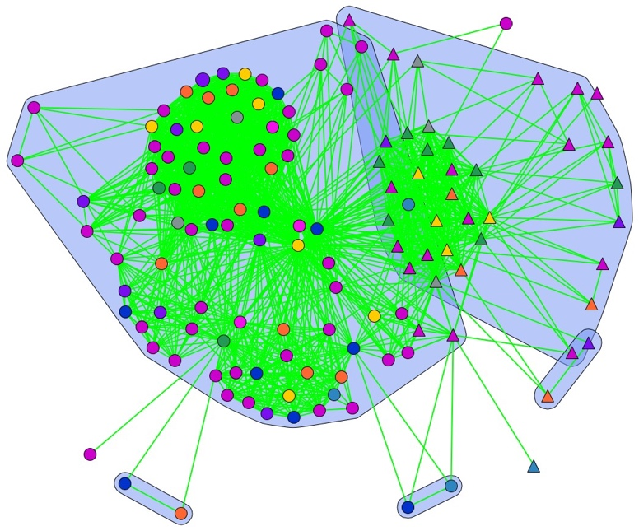 | Figure 1b. 2017-2019.  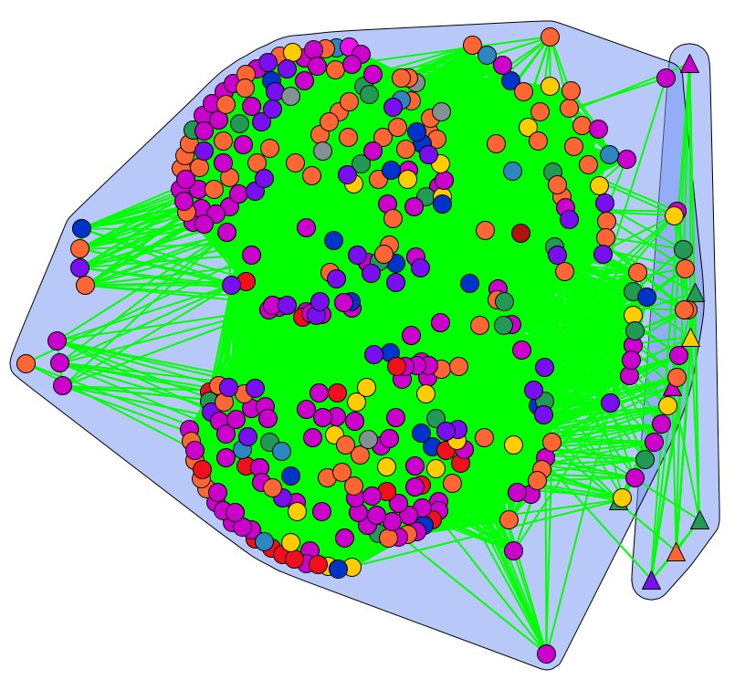
Figure 1c. 2019-2022  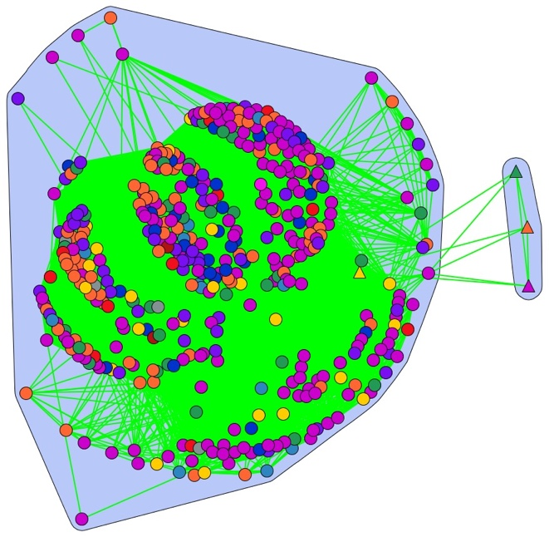 | FIGURE 2. DISCOURSE NETWORKS FOR CAREM-25, 2010-2022. One-mode networks constructed with DNA show the relationship between actors during the three periods of analysis. The nodes represent organizations and agglutinate different representatives of these organizations, as well as the official accounts of each of them. The actors are connected by sharing their appreciation of a particular concept. The shape of the nodes represents whether they are for or against nuclear energy, represented by the project in question. The circular nodes are supporters of the project. The triangular nodes are opponents. The color of the nodes represents the sector to which they belong: yellow—political organizations; blue—federal agencies; pink—media and influencers; purple—academics; light blue—provincial and local authorities; green—non-governmental organizations and think tanks; grey—international or foreign organizations; orange—businesses and business associations; and red—unions. The blue slices represent discursive coalitions generated after applying the Newman Girvan algorithm to networks with different threshold values to the weight of the links: period 1: weight >= 0.091; period 2: weight >=0.2; period 3 >= 0.286. Network density per period: 1) 0.342; 2) 0.409; 3) 0.509.

These results expand the view of the Argentine nuclear subsystem captured in previous works. First, they demonstrate that most actors involved in the debate aligned themselves in coalitions, either in favor or against the policy, confirming our first hypothesis (H1). Second, they offer a detailed portrait of these coalitions over time. We found that the advocacy coalition in favor of the project was much wider than expressed by the extant literature on the subdomain. Certainly, CNEA was among the most influential actors because of its role in the subdomain. But CNEA, INVAP, and the Minister of Foreign Affairs were connected to numerous actors from different sectors, such as political parties, other agencies at the federal and regional level, labor unions, academics, businesses, and think tanks focused on energy and science development. On the other hand, opponents of nuclear energy were limited to a few academics, environmental NGOs, and activists with weak ties to political groups, none of which hold a strong position on nuclear energy.
In terms of influence, our results are revealing. Table 2 shows the most influential actors according to betweenness centrality. Political parties played a key role alongside a broader spectrum of federal agencies, CNEA being confirmed as pivotal. In the first period, the PJ was highly influential, along with CNEA and the Minister of Planning. These pro-nuclear actors were followed by opponents of the project: Los Verdes, Greenpeace, and the UCR. These results confirm the leadership of these actors in the early debate about the construction of the reactor. During the second phase, PJ maintained its dominant position in terms of influence, followed by CNEA. But other organizations gained influence, including academic institutions; specialized media, and science think tanks. Although many unions joined the debate during this period, only academics and think tanks gained influence. In the third period, the top influential stakeholders included officials from CNEA and other federal agencies, academics, think tanks and businesses.
TABLE 3. TOP INFLUENTIAL NODES
Period 1 |  | Period 2 |  | Period 3
PJ | 11.20 | PJ | 5.83 | CNEA | 2.43
CNEA | 10.79 | CNEA | 3.93 | Def La Ciencia | 2.38
MinPlan | 7.94 | UNAHUR | 3.65 | MinCiencia | 1.91
Los Verdes | 7.85 | Econojournal | 3.53 | MinDesarrollo | 1.78
Greenpeace | 6.41 | Def La Ciencia | 2.79 | Secretaria Energia | 1.66
UCR | 5.38 | Nucleoelectrica | 2.41 | Livent | 1.59
Most influential stakeholders according to the measurement of the betweenness centrality of the network during the three periods under study.

These results show that CNEA was a key stakeholder in the development of the sector subsystem, while the importance of INVAP and the Ministry of Foreign Affairs was questionable. They also reveal that the roles of several other actors have not been noted in the existing literature, CNEA’s influence seemed to be decline, while the density of the network increased (see the density reported in Figure 1). It seems that the actors established a greater number of direct connections between them as time passed, so the importance of CNEA and other bridges decreased. These trends could be interpreted as evidence of a growing consensus and fluid conversations among more balanced actors.
Interestingly, influence is not related to rates of participation. The media has the largest presence in the sample, disseminating almost half of the concepts in each period. As a group, they show high fragmentation by including many diverse actors ranging from major newspapers to individual influencers. The general media visited the issue sporadically at times of high conflict or special relevance, while the coverage of specialized media in energy, economics, or science was more continuous and influential. The evidence shows that over the years most media aligned themselves with the pro-nuclear coalition by giving more coverage to its narrative. This trend started during the coverage of labor disputes in the second period of the project, while in the last phase, it became evident that the supporters undertook a more active promotion of the project, shaping the media narrative. Similarly, the role of unions was important in consolidating support for the project. Their participation increased in the second period both because of labor conflicts and the practice of inter-union solidarity. Although the layoffs affected members of one specific union, many others spoke out in support of their colleagues. Notably, however, this linkage was made possible by the action of the PJ leaders, who accompanied the workers in their protests and were successful in expanding the conflict.
In summary, our findings confirmed H1: most actors engaged in coalitions in favor or against the project. However, coalitions are malleable and change over time, according to certain events and the outcomes of the policy process. Actors enter and leave the debate according to their agendas, or they can change their positions in the debate according to the costs they face. Overall, Figure 1 shows that the coalition of supporters was much broader in composition than previous studies have indicated, and included influential political parties, academics and think tanks, as well as federal agencies dedicated to the nuclear issue.

Evolution of narratives
Our second hypothesis was that the debate would evolve, depending on the actors' positions. Given the assumptions of DNA, actors might incorporate new narratives or policy alternatives into the debate. Accordingly, we calculated the frequencies with which each coalition agreed or disagreed with each concept during a given period, noting which concepts were included or excluded. Net statements were calculated by subtracting the expressions of rejection from the expressions of support for a given concept. Figure 2 shows net statements of support or rejection of each concept by both coalitions.
In the first period (Figure 2a), the distribution of statements denotes a conflict at the start of the project. Supporters of nuclear energy backed a set of concepts that confirm some of Hurtado (2014), Hymans (2014), and Patterson's (2018) notions about the Argentine nuclear subsystem: its high nationalistic sense, its search for prestige, and its desire for technological development to achieve other benefits to society. Thus, assessed positively, a nuclear power reactor in Argentina would not only place the country at the technological forefront and provide continuity for the nuclear but would also benefit the environment and the economy, and would be a source of pride. Yet our observations also reveal two interesting and little-noticed issues. First, at the heart of the discourse of the pro-nuclear coalition is the successful development of the project (“CAREM progresses”). This makes sense because the continuous reaffirmation of its successful development provides credibility, guarantees the necessary resources, increases cohesion, and makes any attempt to stop the project more costly. Second, the military use of the project is not as important as some authors have suggested (Patterson, 2018; Stirling & Johnstone, 2018). Certainly, when support is sought, the possible military use of nuclear technology is mentioned, but it does not seem to be a compelling argument and carries a great cost as it is highly contested by opponents of nuclear energy. On the other hand, opponents raise arguments about nuclear energy’s risk for people and the environment, question the alleged benefits asserted by their opponents, and propose alternatives such as the development of renewables and greater inclusion in decision-making. In addition, they link the project to a set of fears rooted in the Argentine reality: of dictatorship, of terrorism (due to the historical links between Argentina and Iran), and of corruption.
For the second period (Figure 2b), the positions of actors switched. The coalition led by PJ was now in the opposition and the former opposition (linked to anti-nuclear groups) had come to power. Agencies were now ruled by officials of the new administration, and the project suffered interruptions in its development. In these circumstances, we found that a few former opponents switched their positions and adopted the supporters’ statements. Accordingly, we altered the notation of their attitude, and the results reflect these changes. Therefore, we found a greater disbalance between supporters' and opponents’ participation in this period.
Despite this situation, we identified several disagreements. Concepts related to the progress of the project and its employment generation capabilities were highly contested by traditional supporters, who also sewed doubts about the continuity of the project. In addition, a controversy started about who had supported the project: the current (Macri´s) or past administration (Kirchner’s). The few remaining openly anti-nuclear actors continued to doubt the benefits of the project. They introduced a new frame that characterized the project as ‘only propaganda,’ since several years after its inception, it had yet to bear any results. All these changes transformed the debate: It was no longer about whether to build the project, its benefits, and its risks but about its continuity and who can claim its authorship.

Figure 2a. 2010-2016 | Figure 2b. 2017-2019. | Figure 2c. 2020-2022.
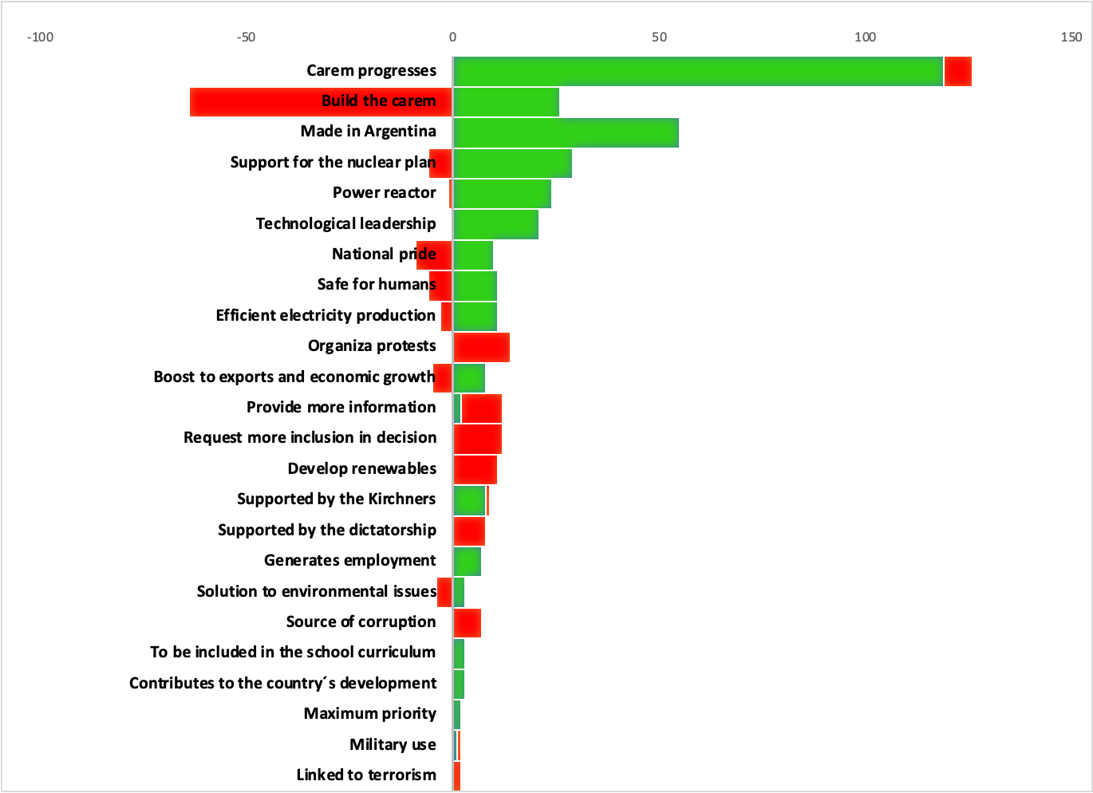 | 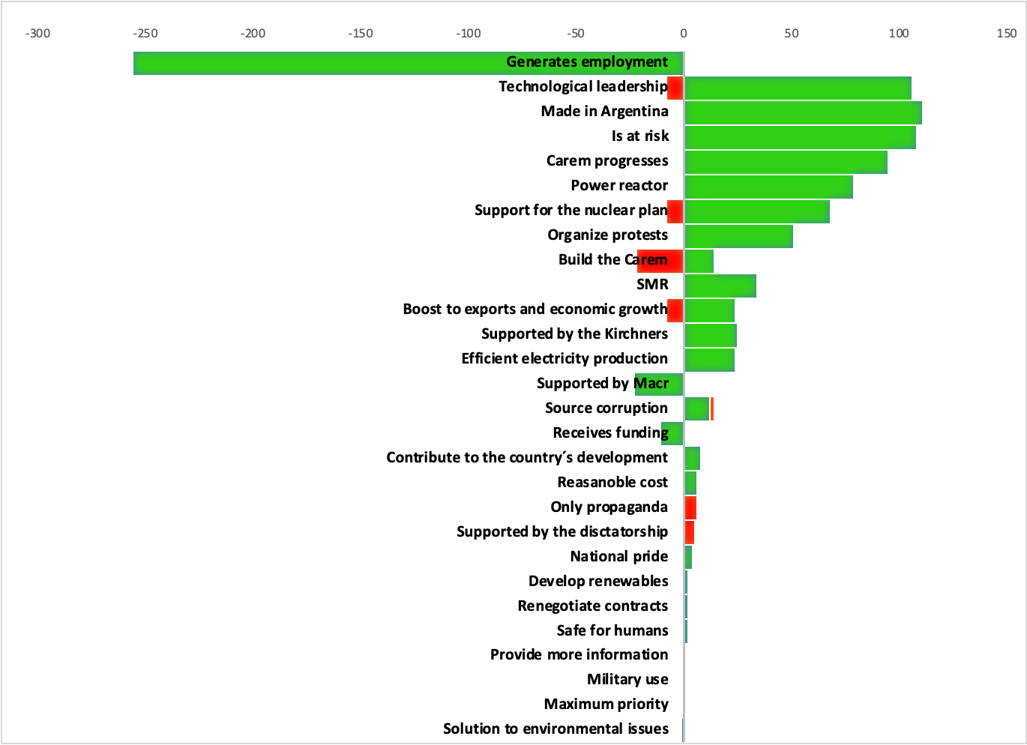 | 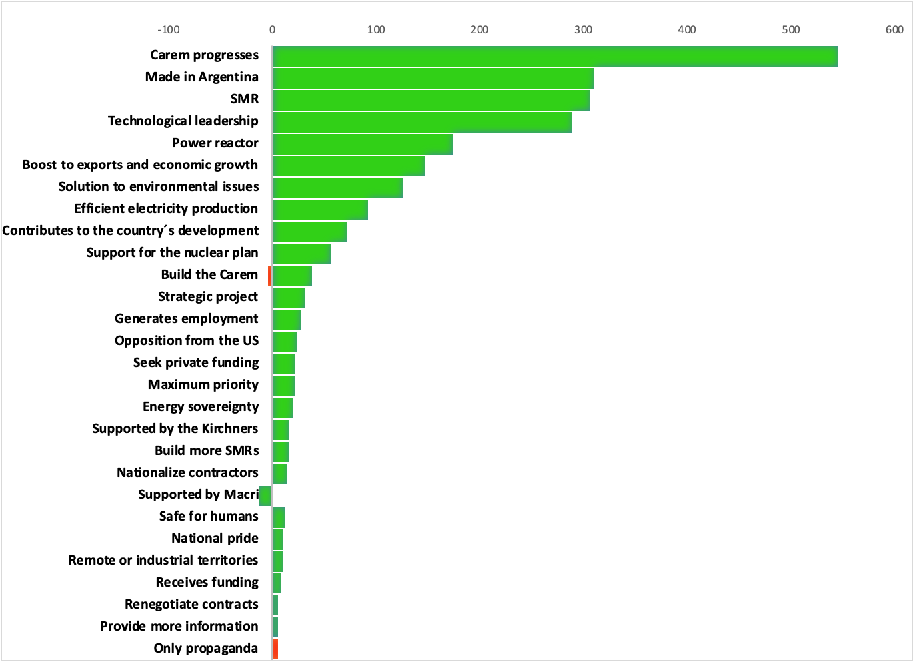
FIGURE 2. FRAMES USED BY ADVOCACY COALITIONS, 2010-2022. The bar shows the net assessment of the 29 most mentioned concepts of each period by each coalition. Positive figures mean support, while negative numbers mean rejection. Colors identify each coalition: red for anti-nuclear actors and green to identify pro-nuclear.

The last period of the debate is the richest in terms of new concepts (Figure 2c). It focused on the potential of the project. The context included some facts such as the return of traditional supporters to power, announcements made by competing vendors in other countries about their progress in developing SMRs, and the temporary suspension of the project for the pandemic. However, these situations were handled very differently than in the previous period, and the emphasis shifted to bringing sustainability to the project. New frames were popularized such as the need for funding alternatives; the contribution of the project to the country’s development; the “SMR” label; the proposal to build more Carems to develop a more marketable reactor; and a sense of urgency to finish the construction of the prototype. New applications of SMRs were introduced such as the capability to desalinate water, produce hydrogen, and bring electricity to isolated areas. The United States’ opposition to CAREM-25 was also disseminated. Some of these new ideas implied the recognition of worries already expressed by the few traditional opponents, who were still pushing for the cancellation of the project.
The debate about CAREM-25 has evolved through political changes, shifting coalitions, and varying emphases on aspects of the project. From the initial emphasis on nationalist pride and technological advancement, to the conflicts over its stoppage and authorship, to the current exploration of how to achieve viability and possible applications. The analysis of the support or rejection of concepts throughout the debate has helped confirm the idea that changes in actors' positions and context can change the debate itself (H2). But this analysis also suggests how the consensus reflected in Figure 1 was reached. In the next section, we will return to this point to conclude if our third hypothesis can be confirmed.

Building consensus
As the previous sections have explained, consensus has largely emerged about the Argentinian nuclear subsystem. Several actors who initially rejected the project changed their perspective and adopted some of the views of their supporters, while others lost interest when the project changed its location. These elements seem to support the alternative to consensus-building of H3.
To verify this conclusion, we calculated two network metrics: modularity and an EI-Index shown in Figure 3. Modularity is a measure of coalition polarization that ranges from 0 to 1. Values close to zero indicate low polarization; values close to 1 depict high polarization. Values around 0.5 denote no association between coalitions. EI-Index is a measure of homophily, based on a given attribute, in our case, the attitude toward nuclear power. This metric ranges from -1 to 1, where the lower value represents complete homophily, while the higher end indicates heterophily (Leifeld 2014).
In period 1, the network exhibits relatively higher polarization and lower homophily (see Figure 3). However, for periods 2 and 3, both indexes remain at their lower levels, indicating less polarization and higher homophily.
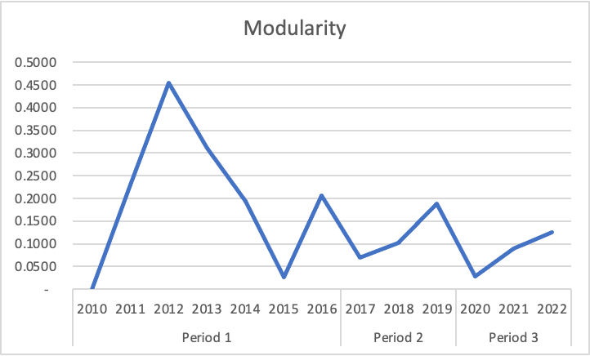 | 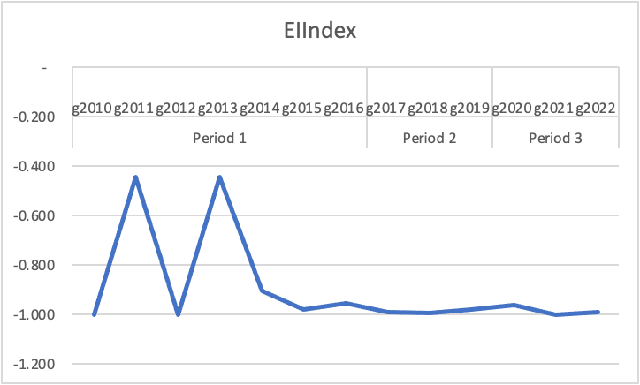
FIGURE 3. MODULARITY AND EI-INDEX OF THE DATASET BY YEAR AND PERIOD.

In this research, we have identified four mechanisms for building consensus on Twitter. First, supporters consistently disseminated messages that could be shared by most users on the platform, pointing not only to tangible benefits but also to beliefs about the continuous progress, nationalistic sense, and technological importance of CAREM-25. Second, the nuclear subsystem could promptly adjust policies based on feedback received during all phases of the project. Adjustments had a dual consequence of either excluding former opponents or causing them to switch their opinions. Third, supporters were effective in articulating joint defensive actions when needed. Fourth, to adapt to changes in context, supporters generated new frames even when they were in control of the subsystem, confirming Hajer’s expected behavior of dominant coalitions.
Despite initial opposition and challenges, the dynamics of the Argentinian nuclear subsystem confirm H3 under the assumption of a consensus-building process. The analysis of network metrics, specifically modularity and the EI-Index, provides quantitative support for the observed consensus-building process.

Beyond political ideology
Our last hypothesis assumes that ideology influences the support or rejection of certain ideas about nuclear power. The evolution of CAREM-25’s debate seems to challenge the importance of the ‘rift’ between sides in this issue. As mentioned, we found that several actors changed sides based on their attitude towards nuclear energy; many of these actors were also ideological opponents of Peronism, which in our sample was rated to the left of the ideological spectrum. This means that center and right-wing actors also varied their positions towards the project, suggesting that cross-cutting arguments can garner support regardless of actors’ political ideology.
Table 3 shows the frequencies of acceptance or rejection per concept according to ideological positions. The majoritarian acceptance of certain frames supports the idea of concepts being held by all actors regardless of their ideology. For most periods, ideas such as “technological leadership,” “support for the nuclear plan,” “efficient production of electricity,” “solution to environmental issues,” “contribute to development,” and “made in Argentina” were supported by actors of all ideological signs.
In contrast, some frames show variations among periods for different reasons. For example, for concepts such as “building the reactor” or “safety for humans,” we can verify that the center and right-wing actors changed their positions between periods 1 and 3. The repositioning of right-wing actors was likely dictated by learning or resigned acceptance of policies. These actors changed their minds and remained in their new position for a long period, even after losing the election in 2015.
Our results also detected an important change in how left-wing actors evaluate concepts such as "it generates employment," "it is at risk," and "CAREM progresses": In our study, their opinion changed diametrically between periods 1 and 2, but they revert to their original position in period 3. We interpreted these fluctuations, at least partially, as maneuvers to defend the policy they originally proposed. As part of this protective strategy, they confirmed their authorship and support; took advantage of the image of right-wing actors as enemies of the subsystem to cast doubt on their views, as well as those that backed them; and vehemently denounced the ups and downs of the project during the Macri administration, alleging that it was at risk. More importantly, these latter changes are registered in what we could label as secondary aspects of policy implementation that are not part of the ‘core’ beliefs of actors.
Changes in opinion could indicate that ideology was not a determinant of support for certain concepts and, consequently, we could dismiss the importance of the rift in the evolution of the project. To support this proposal, we conducted a Fisher’s Exact Test to understand to what extent, if any, ideology was related to the support or rejection of the top 29 concepts. The results are shown in bold in Table 3. Very few concepts present an association between ideology and acceptance or rejection of the concept in the periods studied, confirming our conclusion. Moreover, the few cases where the Fisher Test is significant showed strong variations between periods. These results suggest that although some frames were used opportunistically and temporarily by certain groups, in general, there was no relation between ideology and acceptance of the CAREM-25 as a nuclear project.

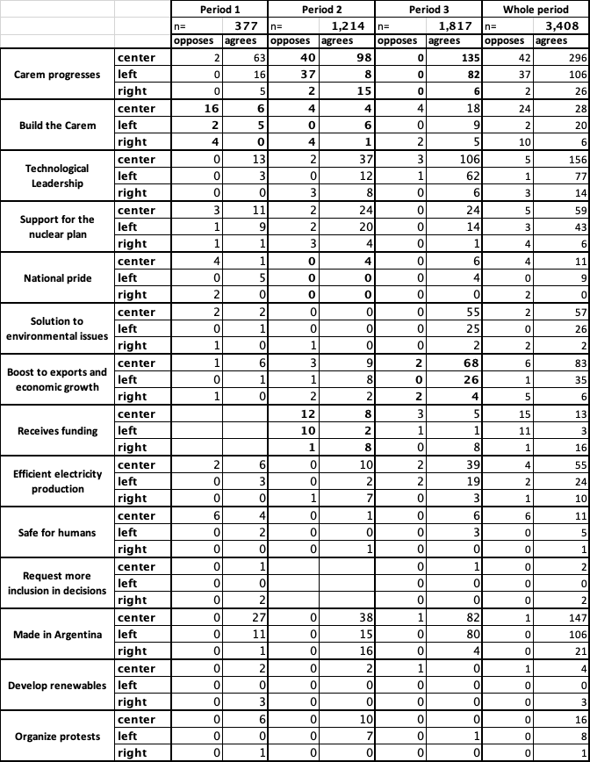 | 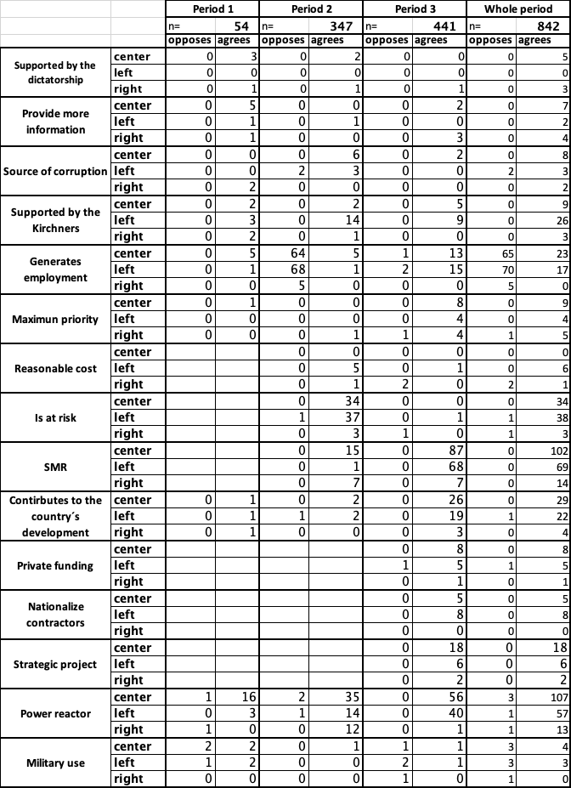
TABLE 3. FREQUENCIES OF SUPPORT/REJECTION OF CONCEPTS BY ACTORS’ POLITICAL IDEOLOGY (2010-2022).
Values highlighted in bold are statistically significant.

CONCLUSIONS
This study has found supporting evidence for several hypotheses in the context of the Twitter debate on the CAREM-25 project (2010-2022). First, we confirmed that stakeholders form coalitions either in favor or against nuclear projects in consonance with broader patterns verified globally. The examination of stakeholder alignment provides valuable insights into the composition and dynamics of these coalitions, which comprise numerous actors that had not been registered.
Second, our findings showcase the dynamic evolution of actors' narratives and strategies throughout the debate, underscoring the adaptability of stakeholders influenced by the context and evolving positions in the policy subsystem. This evidence aligns with the research of Patterson (2018) and Malacalza (2017), emphasizing the importance of considering the fluid nature of political discourse. But we also found evidence supporting ACF, which suggests that some values remain stable over time and unite actors around them.
Third, we revealed a tendency for consensus within the policy subsystem, even amidst external events. We found that actors can enter or leave the debate, or change their attitudes, because of adjustments in the policy or changes in the distribution of power. These changes dictated the permanency of the policy. This resilience in maintaining policy stability corresponds with the conceptualization of scholars like Sabatier & Jenkins-Smith (1988, 1994), and Rinscheid (2015).
Interestingly, our evidence does not confirm H4, challenging assumptions about a straightforward correlation between support or opposition and ideological positions. Exploring ideology within coalitions highlights the uniqueness of the Argentine case, the complexity of stakeholder interactions, and the limitations of ideological predictability in the context of emerging technologies.
Despite the valuable insights gained from our study, several limitations should be acknowledged. First, a considerable number of tweets issued by media organizations lacked proper source attribution, hindering the ability to directly link statements to specific actors or coalitions. This limitation might inadvertently overemphasize media actors at the expense of others who were the source of ideas. Second, the inherent complexity of tweets, which can include links, images, avatars, and special characters, posed a challenge. While efforts were made to analyze tweets directly on the platform during sample selection and to clean, the study did not follow links. Moreover, the Discourse Network Analysis (DNA) software used for coding relies solely on text, potentially overlooking additional contextual information embedded in multimedia components of tweets. Finally, we left the public out of our analysis. The reverberation of this debate in the unauthenticated portion of our sample is a pending task to understand its impact on Twitter as a whole. These limitations highlight the need for cautious interpretation and suggest avenues for future research to address these challenges.

REFERENCES
Barberá, P., Jost, J. T., Nagler, J., Tucker, J. A., & Bonneau, R. (2015). Tweeting From Left to Right: Is Online Political Communication More Than an Echo Chamber? Psychological Science, 26(10), 1531–1542. https://doi.org/10.1177/0956797615594620
Barceló, G. N. (2007). Nuclear energy in Argentina. Int. J. Nuclear Governance, Economy and Ecology, 1(4), 404–437.
Baumgartner, F. R., & Jones, B. D. (1991). Agenda Dynamics and Policy Subsystems. In Source: The Journal of Politics (Vol. 53, Issue 4). https://about.jstor.org/terms
Bellato, R. (2023, September 11). Elecciones 2023: la gravedad de frenar el proyecto Carem en un próximo gobierno. El Destape. Elecciones 2023: a gravedad de frenar el proyecto Carem en un próximo gobierno
Bossner, F., & Nagel, M. (2020). Discourse Networks and Dual Screening: Analyzing Roles, Content and Motivations in Political Twitter Conversations. Politics and Governance, 8(2), 311–325. https://doi.org/10.17645/pag.v8i2.2573
Brandes, U., & Wagner, D. (2004). Analysis and visualization of social networks. In Graph Drawing Software (pp. 321–340). Springer.
Bratt, D. (2012a). Canada, the provinces, and the global nuclear revival : advocacy coalitions in action. Montreal: McGill-Queen’s University Press.
Bratt, D. (2012b). Canada, the provinces, and the global nuclear revival : advocacy coalitions in action. In 2012.
Castro Madero, C., & Takacs, E. A. (1991). Política nuclear Argentina: ¿avance o retroceso? Instituto de Publicaciones Navales.
Cecchini Murúa, B. L. (2022). El uso de la “grieta” durante la pandemia por COVID-19. Un estudio sobre la polarización política en Twitter en materia de derechos humanos. Intersecciones En Comunicación, 1(16). https://doi.org/10.51385/ic.v1i16.136
Černý, O., & Ocelík, P. (2020). Incumbents’ Strategies in Media Coverage: A Case of the Czech Coal Policy. Politics and Governance, 8(2), 272–285. https://doi.org/10.17645/pag.v8i2.2610
Conover, M. D., Ratkiewicz, J., Francisco, M., Gonçalves, B., Flammini, A., & Menczer, F. (2011). Political Polarization on Twitter. www.aaai.org
De Dicco, R., Deluchi, F., & Ferrer, J. (2015). Argentina puesta a crítico. Resultados y desafíos del Plan Nuclear Argentino. Planeta.
Delmastro, D. F., Magan, H. B., Markiewicz, M., Lopasso, E., Diez, F., Giménez, M., Rauschert, A., Halpert, S., Chocrón, M., Dezzutti, J. C., Pirani, H., Balbi, C., Fittipaldi, A., Schlamp, M., Murmis, G. M., & Lis, H. (2011). CAREM project status. Science and Technology of Nuclear Installations, 2011. https://doi.org/10.1155/2011/140373
Dunn, C., & Wunnava, A. (2019). The Effect of the Fukushima Nuclear Disaster on The Evolution of the Global Energy Mix (127; M-RCBG Associate Working Paper Series). www.hks.harvard.edu/mrcbg
Fischer, F. (2005). Fischer, Frank. 2005. Reframing Public Policy: Discursive Politics and Deliberative Practices. Oxford University Press.
Fisher, D. R., Leifeld, P., & Iwaki, Y. (2013). Mapping the ideological networks of American climate politics. Climatic Change, 116(3–4), 523–545. https://doi.org/10.1007/s10584-012-0512-7
Fisher, D. R., Waggle, J., & Leifeld, P. (2013). Where Does Political Polarization Come From? Locating Polarization Within the U.S. Climate Change Debate. American Behavioral Scientist, 57(1), 70–92. https://doi.org/10.1177/0002764212463360
Gaggioli, N. N. (2003). La comunidad nuclear. Una mirada antropológica sobre el desarrollo nuclear argentino. Sociedad Argentina de Antropología.
Ghinoi, S., & Steiner, B. (2020). The political debate on climate change in Italy: A discourse network analysis. Politics and Governance, 8(2), 215–228. https://doi.org/10.17645/pag.v8i2.2577
Gil Gerbino, J. J. (2022). Breve historia del CAREM. https://aargentinapciencias.org/breve-historia-del-carem/
Girvan, M., & Newman, M. (2003). Mixing patterns and community structure in networks. In Statistical mechanics of complex networks (pp. 66–87).
Grenpeace. (2002). El informe de Greenpeace sobre INVAP.
Guo, Y., & Ren, T. (2017). When it is unfamiliar to me: Local acceptance of planned nuclear power plants in China in the post-fukushima era. Energy Policy, 100, 113–125. https://doi.org/10.1016/j.enpol.2016.10.002
Gupta, K., Ripberger, J., Fox, A., Jenkins-Smith, H., & Silva, C. (2021). Discourse Network Analysis of Nuclear Narratives. In Narratives and the Policy Process : Applications of the Narrative Policy Framework. Montana State University. https://doi.org/10.15788/NPF2
Gupta, K., Ripberger, J., & Wehde, W. (2018). Advocacy Group Messaging on Social Media: Using the Narrative Policy Framework to Study Twitter Messages about Nuclear Energy Policy in the United States. Policy Studies Journal, 46(1), 119–136. https://doi.org/10.1111/psj.12176
Hajer, M. A. (1993). Discourse Coalitions and the Institutionalization of Practice: The Case of Acid Rain in Britain. http://ebookcentral.proquest.com/lib/usask/detail.action?docID=178402.
Haunss, S., Hollway, J., Butts, C., Lomi, A., Snijders, T., & Stadtfeld, C. (2022). Multimodal mechanisms of political discourse dynamics and the case of Germany’s nuclear energy phase-out. Network Science, 1–19. https://doi.org/10.1017/nws.2022.31
Haunss, S., Kuhn, J., Padó, S., Blessing, A., Blokker, N., Dayanik, E., & Lapesa, G. (2020). Integrating Manual and Automatic Annotation for the Creation of Discourse Network Data Sets. Politics and Governance, 8(2), 326–339. https://doi.org/10.17645/pag.v8i2.2591
Hilton, S., Buckton, C. H., Henrichsen, T., Fergie, G., & Leifeld, P. (2020). Policy congruence and advocacy strategies in the discourse networks of minimum unit pricing for alcohol and the soft drinks industry levy. Addiction, 115(12), 2303–2314. https://doi.org/10.1111/add.15068
Ho, S., Leong, A., Looi, J., Chen, L., Pang, N., & Tandoc, E. (2019). Science Literacy or Value Predisposition? A Meta-Analysis of Factors Predicting Public Perceptions of Benefits, Risks, and Acceptance of Nuclear Energy. Environmental Communication, 13(4), 457–471. https://doi.org/10.1080/17524032.2017.1394891
Hurtado, D. (2014). El sueño de la Argentina atómica. Edhasa.
Hymans, J. E. (2014). Lessons from Latin America. In Routledge Handbook of Latin America in the World (pp. 362–375).
IAEA. (2022). Argentina. Country Nuclear Profile. https://www-pub.iaea.org/MTCD/Publications/PDF/cnpp2022/countryprofiles/Argentina/Argentina.htm
IEAE. (2023). Germany. https://cnpp.iaea.org/public/countries/DE/profile/preview
Ingersoll, D. T. (2016). A brief history of small nuclear power (1950–2000). In Small Modular Reactors (pp. 21–38). Elsevier. https://doi.org/10.1016/b978-0-08-100252-0.00002-1
Jenkins-Smith, H. C., & Sabatier, P. A. (1994). Evaluating the Advocacy Coalition Framework. Source: Journal of Public Policy, 14(2), 175–203. https://about.jstor.org/terms
Jewell, J. (2011). Ready for nuclear energy?: An assessment of capacities and motivations for launching new national nuclear power programs. Energy Policy, 39(3), 1041–1055. https://doi.org/10.1016/j.enpol.2010.10.041
Jin, Y., Schaub, S., Tosun, J., & Wesseler, J. (2022). Does China have a public debate on genetically modified organisms? A discourse network analysis of public debate on Weibo. Public Understanding of Science, 3(6), 732–750. https://doi.org/10.1177/09636625211070150
Kessler, G., & Vommaro, G. (2021). Polarización, consensos y política en la sociedad argentina reciente. Fundar.
Kingdon, J. W. (2003). Agendas, Alternatives and Public Policies (Second). Longman.
Kukkonen A, & Ylä-Anttila T. (2020). The Science–Policy Interface as a Discourse Network: Finland’s Climate Change Policy 2002–2015. Politics and Governance, 8(2), 200–214.
Leifeld, P. (2013). Reconceptualizing Major Policy Change in the Advocacy Coalition Framework: A Discourse Network Analysis of German Pension Politics. Policy Studies Journal, 41, 169–198.
Leifeld, P. (2014). Polarization of coalitions in an agent-based model of political discourse. In Leifeld Computational Social Networks (Vol. 1). http://www.computationalsocialnetworks.com/content/1/1/7
Leifeld, P. (2016a). Discourse Network Analysis: Policy Debates as Dynamic Networks. In J. N. Victor, A. H. Montgomery, & M. Lubell (Eds.), The Oxford Handbook of Political Networks. Oxford University Press. https://doi.org/10.1093/oxfordhb/9780190228217.013.25
Leifeld, P. (2016b). Policy Debates as Dynamic Networks German Pension Politics and Privatization Discourse. Campus.
Leifeld, P. (2020). Policy debates and discourse network analysis: A research agenda. Politics and Governance, 8(2), 180–183. https://doi.org/10.17645/pag.v8i2.3249
Leifeld, P., & Haunss, S. (2012). Political discourse networks and the conflict over software patents in Europe. European Journal of Political Research, 51(3), 382–409. https://doi.org/10.1111/j.1475-6765.2011.02003.x
Malacalza, B. H. (2017). A look inside an emerging nuclear supplier. Advocacy coalitions and change in Argentine foreign nuclear policy. Third World Quarterly, 38(10), 2295–2311. https://doi.org/10.1080/01436597.2017.1350100
Marcel, C., DelMastro, D., Schlamp, M., & Calzetta, O. (2017). CAREM-25: a safe innovative small nuclear power plant. Nuclear España, 1–5.
Minin, N. (2020). Post- Fukushima Discourse regarding Nuclear energy in the European Union and its Implications [Doctoral Dissertation]. Masaryk University.
Moltó, M. (2021). “La grieta” en el Congreso. Análisis exploratorio y propuesta metodológica para indagar sobre la polarización política en los debates legislativos en Argentina. Revista Enfoque, IXI(35), 65–89.
Nam, A., Weible, C. M., & Park, K. (2022). Polarization and frames of advocacy coalitions in South Korea’s nuclear energy policy. Review of Policy Research, 39(4), 387–410. https://doi.org/10.1111/ropr.12466
Neil, J., Schweickart, T., Zhang, T., Lukito, J., Kim, J. Y., Golan, G., & Kiousis, S. (2018). The Dash for Gas: Examining third-level agenda-building and fracking in the United Kingdom. Journalism Studies, 19(2), 182–208. https://doi.org/10.1080/1461670X.2016.1181528
Obradovich, G., Heredia, M., Moltó, M., Morresi, S., & Sosa, P. (2021). Los Inicios de la Polarización Política y Social en Argentina. Repensando el Conflicto Agrario de 2008. In POSTData (Vol. 26).
O’Connor, C., & Joffe, H. (2020). Intercoder Reliability in Qualitative Research: Debates and Practical Guidelines. International Journal of Qualitative Methods, 19. https://doi.org/10.1177/1609406919899220
Patterson, F. (2018). Las Coaliciones Promotoras y Los Contextos que Llevaron al Avance del Proyecto Atómico CAREM (Central Argentina de Elementos Modulares) en Argentina entre 1976 y 2015 [Master]. Georgetown University.
Piaz, A. (2015). Acciones de resistencia a la tecnología nuclear en la Argentina: mapeando el terreno. REDES, 21, 111–140.
Piaz, A. G. (2020). Riesgo, tecnología nuclear y resistencia en Formosa, Argentina: la controversia en torno al proyecto CAREM y la NPUO2. Revista Iberoamericana de Ciencia, Tecnología y Sociedad - CTS, 15(43), 109–136.
Rinscheid, A. (2015). Crisis, Policy Discourse, and Major Policy Change: Exploring the Role of Subsystem Polarization in Nuclear Energy Policymaking. European Policy Analysis, 1(2). https://doi.org/10.18278/epa.1.2.3
Rinscheid, A. (2020). Business Power in Noisy Politics: An Exploration Based on Discourse Network Analysis and Survey Data. Politics and Governance, 8(2), 286–297. https://doi.org/10.17645/pag.v8i2.2580
Rinscheid, A., Eberlein, B., Emmenegger, P., & Schneider, V. (2020). Why do junctures become critical? Political discourse, agency, and joint belief shifts in comparative perspective. Regulation and Governance, 14(4), 653–673. https://doi.org/10.1111/rego.12238
Sabatier, P. A. (1988). An Advocacy Coalition Framework of Policy Change and the Role of Policy-Oriented Learning Therein. Policy Sciences, 21, 129–168. https://www.jstor.org/stable/4532139
Schaub, S., & Metz, F. (2020). Comparing discourse and policy network approaches: Evidence from water policy on Micropollutants. Politics and Governance, 8(2), 184–199. https://doi.org/10.17645/pag.v8i2.2597
Schmid, N., Sewerin, S., & Schmidt, T. (2020). Explaining Advocacy Coalition Change with Policy Feedback. Policy Studies Journal, 48(4), 1109–1134. https://doi.org/10.1111/psj.12365
Schmidt, V. A. (2010). Taking ideas and discourse seriously: Explaining change through discursive institutionalism as the fourth ‘new institutionalism.’ European Political Science Review, 2(1), 1–25. https://doi.org/10.1017/S175577390999021X
Schuliaquer, I., & Vommaro, G. (2020). La polarización política, los medios y las redes. Coordenadas de una agenda en construcción. REVISTA SAAP, 14(2). https://doi.org/10.46468/rsaap.14.2.i
Shulman, S. (2011). DiscoverText: Software Training to Unlock the Power of Text. Proceedings of the 12th Annual International Digital Government Research Conference: Digital Government Innovation in Challenging Times, 373. https://doi.org/10.1145/2037556.2037632
Slovic, P. (1999). Trust, Emotion, Sex, Politics, and Science: Surveying the Risk-Assessment Battlefield. In Risk Analysis (Vol. 19, Issue 4). https://doi.org/https://doi.org/10.1023/A:1007041821623
Sovacool, B. K., & Ramana, M. V. (2015). Back to the Future: Small Modular Reactors, Nuclear Fantasies, and Symbolic Convergence. Science Technology and Human Values, 40(1), 96–125. https://doi.org/10.1177/0162243914542350
Steinfeld, N. (2016). The F-campaign: a discourse network analysis of party leaders’ campaign statements on Facebook. Israel Affairs, 22(3–4), 743–759. https://doi.org/10.1080/13537121.2016.1174385
Stirling, A., & Johnstone, P. (2018). A Global Picture of Industrial Interdependencies Between Civil and Military Nuclear Infrastructures. https://ssrn.com/abstract=3230021Electroniccopyavailableat:https://ssrn.com/abstract=3230021
Truelove, H. B., & Greenberg, M. (2013). Who has become more open to nuclear power because of climate change? Climatic Change, 116(2), 389–409. https://doi.org/10.1007/s10584-012-0497-2
Vaughan, M. (2020). Talking about tax: the discursive distance between 38 Degrees and GetUp. Journal of Information Technology and Politics, 17(2), 114–129. https://doi.org/10.1080/19331681.2019.1705220
Wallaschek, S., Kaushik, K., Verbalyte, M., Sojka, A., Sorci, G., Trenz, H. J., & Eigmüller, M. (2022). Same Same but Different? Gender Politics and (Trans‐)National Value Contestation in Europe on Twitter. Politics and Governance, 10(1), 146–160. https://doi.org/10.17645/pag.v10i1.4751
World Nuclear Association. (2021). Small nuclear power reactors. https://www.world-nuclear.org/information-library/nuclear-fuel-cycle/nuclear-power-reactors/small-nuclear-power-reactors.aspx
Xia, D., Li, Y., He, Y., Zhang, T., Wang, Y., & Gu, J. (2019). Exploring the role of cultural individualism and collectivism on public acceptance of nuclear energy. Energy Policy, 132, 208–215. https://doi.org/10.1016/j.enpol.2019.05.014

