# Case study

Moravian-Silesian Region

PETR MACH

ÚJV Řež, a. s.  
ENERGOPROJEKT PRAHA Division

Prague, Czech Republic

Email: Petr.Mach@ujv.cz

BŘETISLAV HORÁK

LUBOR ŽEŽULA  
ÚJV Řež, a. s.

ENERGOPROJEKT PRAHA Division

Prague, Czech Republic

**Abstract**

The paper presents general observations from the development of the technical-economic study of possibility to replace the existing heating plants and cogeneration power plants burning mostly hard coal exploited in local deep pit mines with a nuclear option located. The referred study was in initiated by the Energy Development Office set up under the Government of Moravian-Silesian Region [1].

The study specified nuclear option compiled from Nuclear Power Plants with Small Modular Reactors with capacity to reduce emissions from energy conversion sources in the Moravian-Silesian Region by approximately 80%.

The Small Modular Reactors were sited in compliance of nuclear safety rules for siting of Nuclear Power Plants, connected to the Local District Heating Systems and the electric grids and located with consideration of the planned development of residence centers and industry in the Moravian-Silesian Region.

The economic assessment was carried out using the calculation of discounted cash flow for a whole lifetime of the plants considered in the nuclear scenario. Uncertainties in the parameters used in the calculation were analyzed by sensitivity analysis to these parameters. **Performed calculations demonstrated that positive discounted cash flow results of nuclear option can be achieved** with investment costs that correspond to credible construction price assumptions and to the operation costs derived from the real operated nuclear power plants.

The observations presented in the paper are focused on technical-economic elements of the conceptual study of the wide deployment of Small Modular Reactors aimed at decarbonizing the centralized heating plants. The final part of the study contains a list of items that require solutions during the development of the study or need to be solved with the permitting authorities.

## INTRODUCTION

### Background

The National Power Policy approved in the Czech Republic accounts for nuclear energy as a source of about 1/3 of the national electricity consumption with a planned further increase of that share up to about 50%. The project to increase the capacity of the currently operated 6 nuclear units by another one with a size of around 1 GW is in the phase of evaluation. The State Nuclear Safety Authority (SUJB) and the Building Office already granted the decisions permitting siting of that nuclear unit.

Concurrently with the preparation of the mentioned unit prepared with an installed capacity of the order of 1 GW prefeasibility and feasibility studies on the implementation of Nuclear Power Plants (NPP) with Small Modular Reactors (SMR) were developed. The studies were sponsored by the Ministry of Industry and Trade that administrates national energy policy, the Czech principal power utility already operating above mentioned NPPs and the Energy Development Office of the Government of Moravian-Silesian Region (MoSR). The purpose of feasibility studies sponsored by the ministry and the power utility was to assess the possible benefit of NPP with SMR for the development of the electricity and heating industry in the Czech Republic while the administrative office of the Moravian-Silesian Region government was interested in sustaining of Local District Heating Systems (LDHS) operated in MoSR [1].

The study on the implementation of NPP with SMR was completed in the year 2020 when the default terms included the following factors:

* The ban on the use of coal for delivery of heat and electricity was scheduled for the horizon of the year 2030, alternatively 2035.
* The selling price and availability of natural gas in the Czech Republic made use of that fuel highly competitive.

The recent price increase and limits to availability of natural gas in the Czech further promote competitiveness of the nuclear scenario compared to the study's conclusions outlined later in this paper. Later in 2023, the study was updated and possibility of hydrogen production was assessed taking into consideration [The Czech Republic’s Hydrogen Strategy](https://www.mpo.cz/assets/cz/prumysl/strategicke-projekty/2021/9/Hydrogen-Strategy_CZ_2021-09-09.pdf) approved by the Czech government in 2021 [3].

*FIG. 1. Low-carbon hydrogen price development [3]*

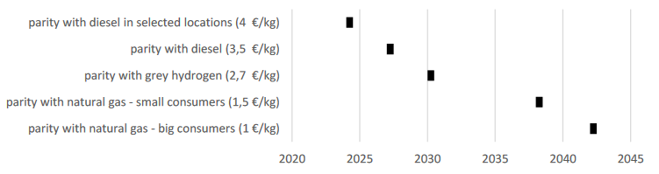

*Note to FIG 1: “**Hydrogen price parity with diesel in selected locations” means that hydrogen will only be used where it is produced, which will reduce the cost of transport and make it possible for price parity to be achieved earlier.*

Document “Czech SMR Roadmap" [4] proposes to take advantage of SMR power units to suitable replace of coal-fired units and large CHP plants with the aim of decarbonising them. In the context of high-performance large-scale nuclear or, conversely, climate-dependent renewables, SMRs are potentially the missing link between the two, capable of providing both stable power output and a degree of flexibility similar to today ‘s coal-fired sources. This implies a degree of decentralisation for SMRs on a local scale at the level of industry, cities and regions, e.g., for the heating sector in conjunction with district heating.

In the future, they can, together with renewables, form a „backbone of the European zero carbon energy system “. While requiring lower backups and reserves, compared to sources at the power level of 1 GWe and above.

For inclusion of the SMR technology in spatial development policies and plans of the Czech Republic it is a prerequisite introduction of the SMR technology into the following strategic documents: the State Energy Policy (SEP), the National Action Plan for the Development of Nuclear Energy in the Czech Republic (NAP NE) and the radioactive waste (RW) and spent nuclear fuel (SNF) management policy.

### Objective

The objective of the study is an evaluation of replacement of existing coal burning thermal plants and cogeneration plants used for district heating in MoSR, the Czech Republic with a nuclear scenario that consists of NPP with SMR. The evaluation of replacement included key aspects of siting of nuclear facility, safety of operation, technical feasibility to provide heat to district heating systems by power plants with SMR and assessment of the economic efficiency of construction and operation regarding related investments needed for implementation of the nuclear scenario.

## Prerequisites for the study elaboration

The text of a paper submitted to this conference must be original and must not have been published elsewhere previously. All papers will be scanned to ensure originality; if they are found to contain non-original text, only their abstract will be included in the proceedings.

If text or images included in the paper have been published elsewhere, the paper must be accompanied by evidence such as licences that permission has been given for the reuse. If no such evidence is supplied, only the abstract will be included in the proceedings. In addition, text must be properly cited and images properly acknowledged.

Papers will only be included in the proceedings if the IAEA Form B has been submitted prior to the conference. If the Form B is not received, only the abstract may be included in the proceedings, but this may also be omitted.

Assumptions for the development of the study and features of the nuclear option were as follows:

* Coal sources of heat and electricity are not restored after their end-of-life. A carbon-free technology for energy conversion and measures to save energy consumption are planned to substitute fossil fuel plants.
* Existing networks of LDHS (1,238.9 km) and household consumers are sustained in the evaluated period.
* The framework for substitution of fossil plants was heat amounting to 16,757 TJ/year in the year 2017 supplied to 15 municipalities in MoSR each with more than 10 thousand inhabitants, from that the coal sources supplied 15,347 TJ of heat.
* Power plants used in the nuclear option implement nuclear reactors of new generation with the risk of serious accidents reduced by several orders of magnitude and minimizing the radiation effect on the surroundings, which makes it possible to limit the emergency planning zone only to the nuclear facility itself.
* Secondary circuits of NPP with SMR are suitable for use in the cycle of combined production of heat and electricity. Combining heat and electricity generation promotes load follow function of electric energy supply and delivery of auxiliary services to the electric power grid.
* A commercially available SMR at the time of construction of the power plant was assumed at the time of the considered implementation, Unit electrical output of NPP with SMR was not exceeding 300 MWe. Other features of the SMR were considered following the specification of WENRA related to SMR.
* Maintaining electricity production with grid stability, increasing share of renewable and secondary sources (for example: waste incineration) and production in nuclear sources gradually replacing coal energy. The recommended variant of the nuclear scenario uses cogeneration of heat and electricity to increase the efficiency of energy conversion and offers support of ancillary services to the electric system operator needed to further increase electricity production in renewable energy sources that are dependent on meteorological conditions.
* Use of storage capabilities of heating systems was considered to improve the plant capacity for supply of the auxiliary services to the electric system operator. The recommended variant of the nuclear scenario includes the interconnections of existing LDHS, which increase their storage capabilities. Connections of a smaller LDHS to create a large LDHS also improve the economy of NPP with SMR.
* Using SMRs hydrogen production was proposed for storing surplus energy that cannot be used to the electricity network. Hydrogen production from surplus energy could be a suitable alternative for load following operation modes of SMRs. Electrolysers can change their output very dynamically. The produced hydrogen can be used for decarbonization of the heavy industry and ironworks deployed in the Moravian-Silesian Region.
* The Czech Republic’s Hydrogen Strategy is being developed in the context of the Hydrogen Strategy for a climate-neutral Europe, which reflects the European Green Deal objective of climate neutrality by 2050. The objective of the Strategy is thus to reduce greenhouse gas emissions in such a way that the economy shifts smoothly to low-carbon technologies [3].
* Combining intermittent renewable energy sources with nuclear power plants with a constant output and hydrogen production can create a very efficient and stable energy system.
* The Czech Republic wants to continue to use nuclear energy in the future, which creates a competitive advantage over countries without nuclear power.

## Sitting of plants with smr

The distinctive main industrial activities in MoSR were deep pit coal mining and steel production in the history. It caused that industrial and residential centres and also heat production and electricity generation plants are built near mines and steel works. Considered development of the Moravian-Silesian Region is the annual calculated consumption of heat supplied by the nuclear option 14,753 TJ/year.

The locations of existing electric power plants and fossil heating plants connected to LDHS were assessed as starting points. The used siting criteria were the same as determined by the requirements for the location of NPP with a unit output of the order 1 GW. Furthermore, the following criteria for sitting were used:

* Economy of scale – as mentioned previously proximity of municipalities with at least 10 thousand inhabitants was required.
* Improvement of the environmental impact of heat delivery - LDHS with heat supplied at least 50% from sources burning coal or burning secondary products of coal processing (coke oven, blast furnace gas) were considered for evaluation.
* Priority in the site use – the criterion considers the expected long-term use of the construction site for the location of the nuclear facility.

The criteria specified above were applied one by one. The first, the criteria for the siting of nuclear facilities were applied and then, in successive steps the criteria specific to the economy, ecology, and long-term priority in the use of the site. This resulted in narrowing down step by step the original group of 57 sites to 6 prequalified sites for which prefeasibility study analyses were completed. The level of details of a prefeasibility study was considered as an adequate basis for a continuation of business appraisal of the project provided by the potential entrepreneurs interested in SMR business.

Description of the topography of construction sites is beyond the scope of this information about analysis of SMR utilization.

## Selection of nuclear technologies for smr

The subject of the study was not an assessment of the suitability of specific types of SMR for heating plant use. However, the possible achievable advantages of some SMR groups had to be considered. Compared to other energy sources, SMR has possible comparative advantages, which can be divided into the following groups:

* Ecological advantage,
* High safety,
* Operational flexibility,
* Possibility of extending the fuel campaign
* Multipurpose use,
* Simplification of construction,
* Economic efficiency.

Further elaboration on those features depends on a specific project and it is beyond this information about the study. However, two issues are considered general for projects implementing SMR: the needed temperature of heat produced by the reactor system and the combined generation of electricity and heat.

The intended use of the plant largely determines the choice of reactor type. In case of justified need, it is also possible to use a source with superheating to achieve high-potential heat, e.g. the temperature reached in the source with a light water reactor can be increased to the required level by reheating using gas or hydrogen combustion or even heat recovered from electricity. Capacity of SMR reactor types design and their corresponding non-electric applications of is outlined in the IAEA report Advances in Small Modular Reactor Technology Developments [4] that was implemented in the referred study for MoSR [1].

Electricity in condensing power plants is obtained with an efficiency of 35-40% from the heat produced in the boiler (for NPP this efficiency is somewhat lower, usually 30-34%), a significant part of the heat with cooling of the condenser connected to the low-pressure end of the turbine. Low-potential heat the condenser is discharged into the environment (heat that is no longer economically usable without special infrastructure).

In the heating plants, there is a high use of heat with an efficiency of 80-90%, but without the production of electricity. Heat is therefore usually more expensive than from combined production.

In the case of combined production of electricity and heat, the share of waste heat is significantly smaller compared to a condensing power plant producing only electricity, which leads to a substantial increase in the degree of fuel energy utilization to the level of 80-90%. This value is practically comparable to the use of fuel in a heating plant, but with the advantage of electricity production and the income associated with it. Therefore, the price of heat is more favourable.

The combined production of electricity and heat (cogeneration) represents one of the important measures for increasing the efficiency of the thermodynamic cycle and for saving fuel. In combined production, part of the energy released in the fuel is used for electricity generation and part for other purposes (for the supply of heat for industry, heating, etc. from specially adapted extraction turbines).

## Replacement results

The nuclear scenario implemented in the time horizon around 2035 has capacity to replace existing sources with annual emissions of 5,380 t NOx, 5,289,000 t CO2, 4,600 t CO, 6,220 t SO2 and 440 t solid polluting substances, and creates the preconditions for a reliable annual supply 12,500 TJ of heat, including potential heat supply 2,900 TJ to the industry and 4,73 TWh electricity.

Calculated income from the operation of SMR consisted of the sale of heat, electricity, and ancillary services to the electric power grid operator.

The calculation model of Discounted Cash Flow for 30 years of power plant operation was used for determination of Net Present Value (NPV). The positive value of NPV was further verified by sensitivity analyses performed on key input parameters with an uncertainty of further development. The following figure is an example of sensitivity analyses on the influence of interest rate and capital cost.

For economic analyses, the following parameters were used, see Table 1:

TABLE 1. PARAMETER USED FOR ECONOMIC EVALUATION

|  |  |
| --- | --- |
| Parameter used for economic evaluation | Value |
| **Installed capacity** |  |
| Number of units | **6** |
| Installed electric power output MWe | 60 |
| Installed thermal power output MWt | 150 |
| **CAPEX – Price level of 2017** | 31 bn/CZK ~ 1.37 bn USD |
| Per unit | 228 mil USD |
| Per MWe | 3.8 mil USD |
| Operation period | 30y |
| **Financing** |  |
| Investor’s equity | 20% |
| Discount rate | 6% |
| Loan | 80% |
| Interest rate | 15y 6% |
| Grace period | Last unit in operation |
| Revenue from electricity and heat | Ratio 3:2 2017 prices + inflation |
| **OPEX** |  |
| Regular and major refurbishments | 2017 prices + inflation |
| Fuel | 2017 prices + inflation |
| Other operational cost | (HR, RW, SF storing, maintenance, …) |

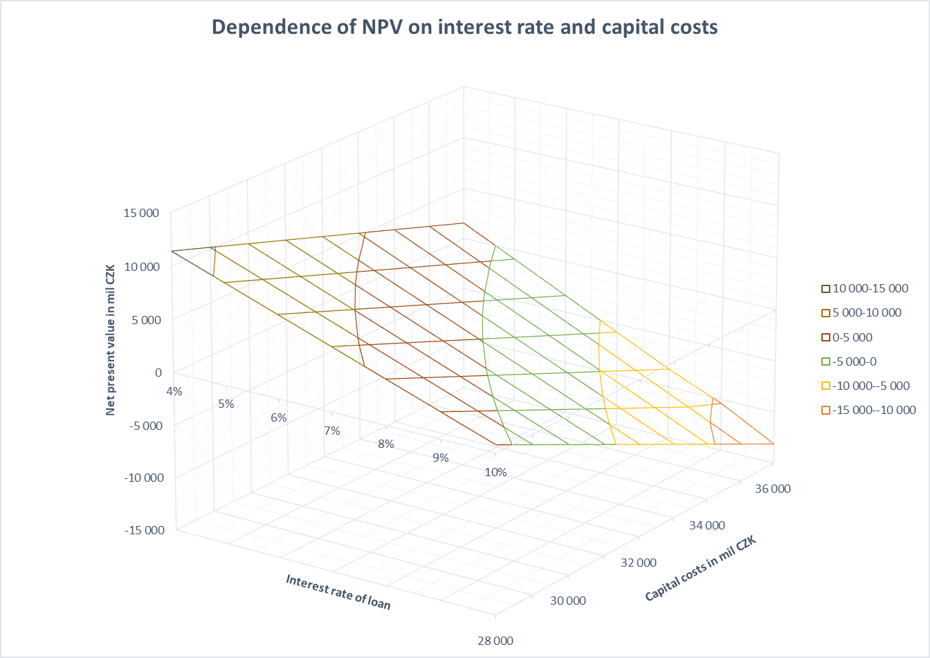

*FIG. 2. Dependence of NPV on interest rate capital costs*

From the results of economic analysis, it is obvious that the projects are highly sensitive to most of the key selected parameters. The economic calculation was based on the price levels of year 2019 and no benefit from exclusion of the power plant from carbon tax was considered.

The current global economic development potentially provides other positive factors that further improve economy results of the SMR projects. Below are examples of those factors:

* Extending of lifetime of the power plant beyond 60 years
* Consider benefit of no carbon tax imposed on SMR project
* Lower interest rate (e.g. in case of state support of the projects which is in place currently for another existing project)
* Higher electricity and heat prices (valid also for other energy options)

Extending the life of the power plant within the economic model significantly improves the economics of the project: NPV 6,46 bn CZK for 30 years → 18.08 bn CZK for 60 years life expectancy.

The Levelized Cost of Electricity (LCOE) was calculated check of possible the selling price of electricity generated by plants in nuclear option for 60 years life expectancy -1.620 CZK/MWh.

Similarly, the Levelized Cost of Heat (LCoH) for cogeneration sources (share of electricity generation costs 0,76) – 194 CZK/TJ.

## Specific topics to adress for smr deployment

This section presents specific topics to address for deployment of NPP with SMR at several sites (for instance for heat supply as necessary for national/regional use as centralized heating source or hydrogen production) to expedite their preparation, licensing and reduce the price of the plant construction and operation.

### Ownership concept

* In the case of using SMR to transition from existing local heating sources burning fossil fuels owned by different owners without licenses to operate nuclear energy facilities according to the nuclear law of the relevant state, it is necessary to choose one of the options to ownership of NPP with SMR or solicit some combination those extreme options:
  + - * All *NPPs* are owned by one company that purchases the necessary infrastructure from existing owners of fossil heat sources and becomes the operator of all NPP with SMR in the State or in the County.
      * Each owner of the current fossil plants separately applies for and obtain authorization to operate the owned nuclear facility from the National Nuclear Safety Authority.

### Sitting and design

* In some countries criteria for siting nuclear power plants do not consider inherited safety features specific for some NPP with SMR. Particularly:
  + - * Nuclear reactors of a new generation have extremely favorable safety characteristics, with a reduction in the probability of serious accidents by several orders of magnitude and with a minimization of the radiation effect on the surroundings, which makes it possible to limit the emergency planning zone only to the site of the nuclear facility itself.
      * Civil structure and safety important systems of some SMR are built with significantly higher resistance to impact of external events than NPP with 1 GW capacity.
* From that point of view, it should be considered shortened site review process for site with SMR only.
* The National Nuclear Safety Authority (further “Authority”) approval of SMR standard design documentation would expedite licensing of the plant with SMR at particular sites. The Authority activity during licensing process of particular NPP with SMR could be focused on site specification and evidence submitted by the applicant that site features comply with design bases of the SMR.
* Additional benefit of SMR design standardization is possibility to prepare concept of decommissioning as part of standard design and simplified preparation of technical documentation for decision of the Authority during licensing process.

### Operation (measures for operation cost reduction)

* From a technical point of view design of some SMR can enable operation without full time presence of licensed operation personal at the SMR site. In such cases the group of licensed operation personal could be licensed for operation of several units of technically same SMR and can serve them by means distant control.
* The design of NPP with SMR should assure security of nuclear facility and fissile material without permanent stay of armed security personal.
* Measures for pre-stocking with nuclear fuel (for several core refurbishment) would reduce fuel cost dependence on fluctuations of cost on market.
* Capacity for maintenance of NPP with SMR should be centralized with aim to minimize scope of maintenance and storage facilities at SMR site or exclude then completely.
* The inherited safety features specific for some NPP with SMR already mentioned with siting should be recognized by organization providing nuclear insurance and the price of insurance should reflect that.

## Summary

For the planned replacement of coal-fired heat sources with carbon-free sources in Moravian-Silesian County was developed nuclear option with SMR. Economic evaluation of that option gives the positive value of NPV that remained positive even with large changes in the input factors. The prices of electricity and heat are competitive with the current usual prices in the Czech Republic.

Specific issues that should be addressed in time when planning the use of SMR for supply heat are presented in Chapter 6 of this report.

References

1. [Dopadová studie odchodu od energetického spalování uhlí v Moravskoslezském kraji](https://www.msk.cz/assets/temata/chytry_region/dopadova-studie-odchod-od-energet--spalovani-uhli.pdf) (in Czech), November 2020
2. IAEA, Advances in Small Modular Reactor Technology Developments, Annex IV, 2020 Edition
3. [The Czech Republic’s Hydrogen Strategy](https://www.mpo.cz/assets/cz/prumysl/strategicke-projekty/2021/9/Hydrogen-Strategy_CZ_2021-09-09.pdf), July 2021
4. Czech SMR Roadmap Applicability and Contribution to Economy, MIT, 2023
5. The National Energy and Climate Plan of the Czech Republic, MoE/MIT, 2023