# Extended assessment of nuclear and alternative electricity generating technologies based on their impact ON national GDP (Cost-to-GDP concept)

S.V. ROZHENKO

JSC Kept

Moscow, Russian Federation

Email: srozhenko@kept.ru

V.A. KARLE

JSC Kept

Moscow, Russian Federation

**Abstract**

Small modular reactors (SMR) is a promising solution for low carbon generation technologies, which is potentially applicable for power systems at the initial stage of economic development and is in price competition with other solutions, especially with Variable Renewable Energy technologies (VRE). Therefore, there is a need for a simple metric that adequately considers both the benefits of SMR in terms of the energy performance of dispatchable generation and the macroeconomic impact on the local economic development. The Leveraged Cost of Electricity (LCOE) metric is often used to compare production costs for initial planning to rank options and advocate solutions. The use of this metric may be quite misleading as it does not tell us about the affordability and does not take into account the impact on the national GDP for a particular country. To account for this complexity, the paper introduces a new Cost-to-GDP extended cost assessment concept developed to estimate and compare production costs for various power sources by combining LCOE and econometric methods within one parameter – called RealLCOE. The concept helps adopt a more balanced approach towards nuclear and fossil technologies compared to renewables alternatives, which is especially important for the early stage energy planning in developing markets considering the SMR inclusion into the energy mix. The paper describes the methodology and demonstrates the principles of cost estimation using African indicators as an example.

## INTRODUCTION

Nuclear SMR is one of newest energy power technology solutions being closer to real life implementation. The SMR characteristics contribute to the application of this technology mostly under the following two types of market conditions:

* Type 1 “National nuclear programs”: SMR is included as an integral part of the national power system, also at the initial stages of the country’s electrification and extensive economic growth;
* Type 2 “Corporate nuclear programs”: SMR is used as part of the industrial energy complex most probably within distant and isolated territories.

The paper concentrates on consideration of the first type of the SMR application and analyzes advantages of SMR technologies that rank on a par with other technologies like RES providing a wide range of opportunities.

The first market type is perspective and has significant potential size (150-170 GW) [1], but this also means that the energy sector and the national economy have to grow at the same time. This is a challenge for energy decisions because in this case generation technologies must help get a multiplicator for the local economic development.

LCOE is the principal tool used for comparing the costs of different electricity generation technologies. It is a measure of the total cost and the energy/electricity generated by an asset over its lifetime. The calculation results in a single value that represents each technological option available at a particular location. The LCOE calculation formula involves taking the net present value of the total cost over the lifetime (by using a discount factor to arrive at the net present value of the cost) and dividing it by the net present value of the total power generation over the project lifetime.

The system of energy planning assumes an iterative approach for gradual selection of technological solutions. The first phase of energy planning includes scenario analysis of different technological solutions in accordance with the technology and sources affordability, market needs, objectives of socio-economic development, the structure of fuel and energy mixes, and other factors affecting the future energy system vision.

The review of various electrification plans prepared by international institutions and utilities over the recent years shows that in most cases the least cost energy approach is used as the main approach when developing energy plans. The target function of this approach is to minimize the cost of electricity generated over the planning horizon.

The Levelized Cost of Energy or Levelized Energy Cost (LCOE) metric is often used for initial planning and ranking of power generation options under the least cost generation planning approach [2-10]. According to LAZARD, IRENA and other organizations' LCOE studies, VRE (wind and solar) outperform widely fossils fuels and nuclear [11-13].

The analysis of the research publications statistics for the period from 2000 to 2024 on the subject of using LCOE parameters as a tool in cost generation planning shows that there are more than 10,000 papers. According to the ResearchGate materials, more than 85% of such papers are devoted to the application of the LCOE approach in renewables generation, which confirms the main focus of this tool.

Existing industry methodological approaches apply the LCOE parameter primarily in the format of, or in combination with, energy adjustments. These energy adjustments usually contain a cost (System LCOE) [14] or value (VaLCOE) [15] adjustment.

The use of these least cost metrics for choosing the preferred energy mix may be quite misleading, even putting aside the issue of comparing the cost of variable and dispatchable capacities. This approach does not tell us much about the real affordability of large electrification programs for a particular country as it is applied in isolation from macroeconomic planning which takes into account the total value for the economy that investments bring.

The paper proposes to consider the possibility of applying macroeconomic adjustments to the LCOE parameter. In this case, the cost adjustment will take into account the cost of generated electricity to national GDP, and the value adjustment will take into account the contribution to GDP (see Fig. 1 below). The paper is devoted to the description of the methodological approach to the cost adjustment based on the electricity cost to GDP and demonstration of the possibility of its application for nuclear and SMR generation types.

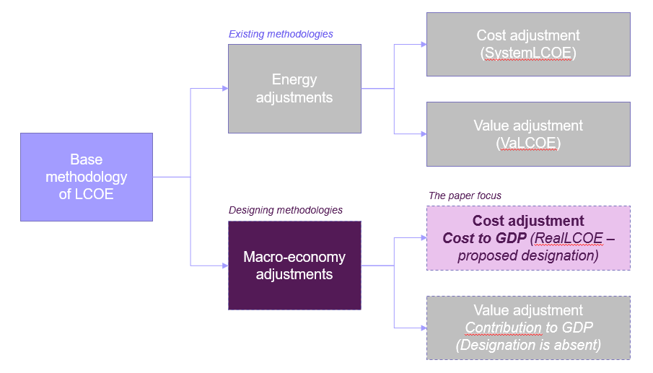

*FIG. 1. Existing and proposed LCOE-based approaches*

Considering macroeconomic factors, the cost of electricity generated can represent a very different value multiplier for the economy as well as the cost to GDP depending on the use of local labour, financial, energy, production resources [16], which finally is critical for understanding the affordability of an electrification program.

As the next step in the energy planning theory and as an extension to the classic least cost analysis, we suggest accounting for direct macroeconomic effects of deploying particular generation technologies on particular national markets.

The paper focuses on the development of a methodological basis for comprehensive assessment of the technology cost (Cost to GDP), and provides an indicative quantitative assessment of the specific ranges of technology costs according to the LCOE and Cost to GDP criteria to visualise the principles and approaches used. For the sake of simplicity, the quantitative indicators used in the paper are taken according to the African energy study [17] and are shown for illustrative purposes only. Detailed estimation of quantitative LCOE and RealLCOE parameters for specific countries, regions and technologies is the subject of further research.

## METHODOLOGICAL APpROACH

The paper proposes a new energy planning concept called Cost to GDP. The method determines the cost share of imports within LCOE comprising imported fuel, equipment and services, adversely impacting GDP – called ‘RealLCOE’ (see Fig. 2 below).

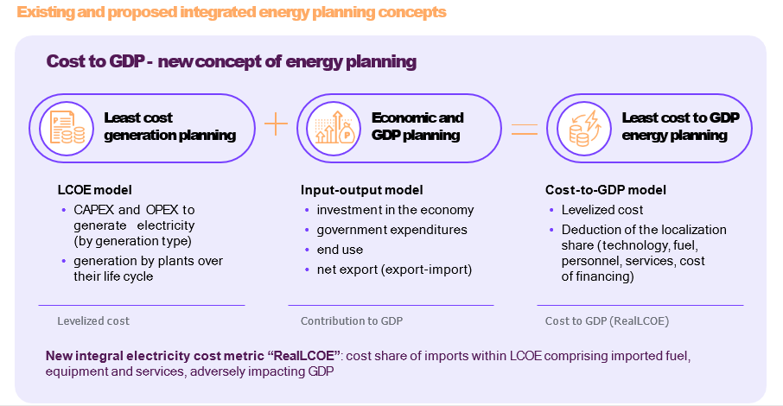

*FIG. 2. Existing and proposed integrated energy planning concepts*

The proposed RealLCOE estimation methodology is based on the traditional approach to calculating the LCOE parameter. The traditional LCOE calculation formula involves taking the net present value of the total cost over the lifetime (by using a discount factor to arrive at the net present value of the cost) and dividing it by the net present value of the total power generation over the project lifetime (1).

$LCOE=\frac{Net Present Value of Costs over Lifetime}{Net Present Value of Energy Produced over Lifetime}$ (1)

In order to estimate the cost component of the electricity cost for national GDP, the calculation of the RealLCOE value involves considering the following factors: the ratio of imports and the local share for each of the components of the Net Present Value of Costs over Lifetime, and also an assessment of the localization potential of the technology in the current market. An additional factor considered in estimating the value of RealLCOE under the proposed approach is the cost component of the cost of integrating generation facilities into the power system. The general formula for RealLCOE can be expressed in terms of LCOE and looks as follows (2).

$RealLCOE=LCOE-ValueComponent-LocalizationComponent-Integration$ (2)

As part of formula 2, the ‘ValueComponent’ reflects the share of the levelized costs incurred in the market and considering the use of fully local supply chains, local labor, financial and material resources, including local fuel. ‘LocalizationComponent’ reflects the share of levelized costs incurred within the market and considering the localization potential of supply chains, local labor, financial and material resources specific to the market and technology in the period under analysis. The ‘Integration’ parameter reflects the cost component of the cost of integrating generation facilities into the power system; for the purposes of the paper, the value of the ‘Integration’ parameter is assumed to be comparable to ½ RealLCOE for PV and wind power generation facilities.

The complete RealLCOE formula can be presented as follows (3).

$RealLCOE=LCOE·\left[1-((δ_{CAPEX}∙\left(L_{CAPEX}+{LZ}_{CAPEX}\right)+\left(δ_{OM}^{fix}+δ_{OM}^{var}\right)∙\left(L_{OM}+{LZ}_{OM}\right)+δ_{Fuel}∙\left(L_{Fuel}+{LZ}_{Fuel}\right)+δ_{Fin}∙\left(L_{Fin}+{LZ}_{Fin}\right))\right]-Integration$ (3)

δCAPEX, δOM, δFuel, δFin – the share of the levelized costs (Capex, fixed and variable part of O&M costs (separately), fuel costs, cost of financing) in the LCOE structure, expressed in relative terms;

LCAPEX, LOM, LFuel, LFin – the percentage of the localized share of costs (Capex, fixed and variable part of O&M costs (aggregated), fuel costs, cost of financing), accounted for as a part of LCOE;

LZCAPEX, LZOM, LZFuel, LZFin – the cost localization potential (Capex, fixed and variable part of O&M costs (aggregated), fuel costs, cost of financing), expressed in percentage points.

The share of levelized costs in the LCOE structure, expressed in relative terms, was calculated according to formula (4) (using the CAPEX component as an example).

$δ_{CAPEX}=\frac{\sum_{t=1}^{LifetimePeriod}{{Capex}_{t}∙{(1+r)}^{-t}}}{Net Present Value of Energy Produced over Lifetime}$ (4)

(1+r)-t – the real time discount rate corresponding to the cost of capital (cost of financing). For the purposes of the paper, the discount rate (r) is assumed at the level of 7%;

LifetimePeriod – is expected lifetimes for each technology across countries are as follows through;

t – the sequence number of the year within LifetimePeriod.

The RealLCOE approach makes it possible to choose the most affordable option to GDP by taking into account not only the absolute LCOE value, but rather the actual cost to GDP for a particular electricity generation technology in the analyzed market environment, which helps get the highest multiplicator for the local economic development.

Fig. 3 below illustrates how the change in optimization criteria from least cost to least cost to GDP impacts the merit order of preferred generation technologies for a range of exporting and importing countries taken as an example (to illustrate the absolute values of LCOE for exporting and importing countries are equated).

For example, in Germany the nominal costs for a new lignite power plant may be comparable to a CCGT - 98 USD/MWh vs. 115 USD/MWh, however in “real terms” coal generation is times cheaper compared to gas - 8 USD/MWh vs. 79 USD/MWh as coal uses almost exclusively local resources of fuel, technology, O&M and financing. Using the same logic, it may seem cheaper for Russia to buy a German gas turbine, but measured by the cost to GDP impact it is more efficient to build a new nuclear power plant based on the Russian design and components (nuclear LCOE is 101 USD/MWh and RealLCOE is 4 USD/MWh for the domestic market). China outperforms all other countries by localizing supply chains for renewables, so wind generation is very affordable in China even at high VRE integration costs (as high as additional 1.0-2.0 times VRE build costs) or a 50% curtailment.

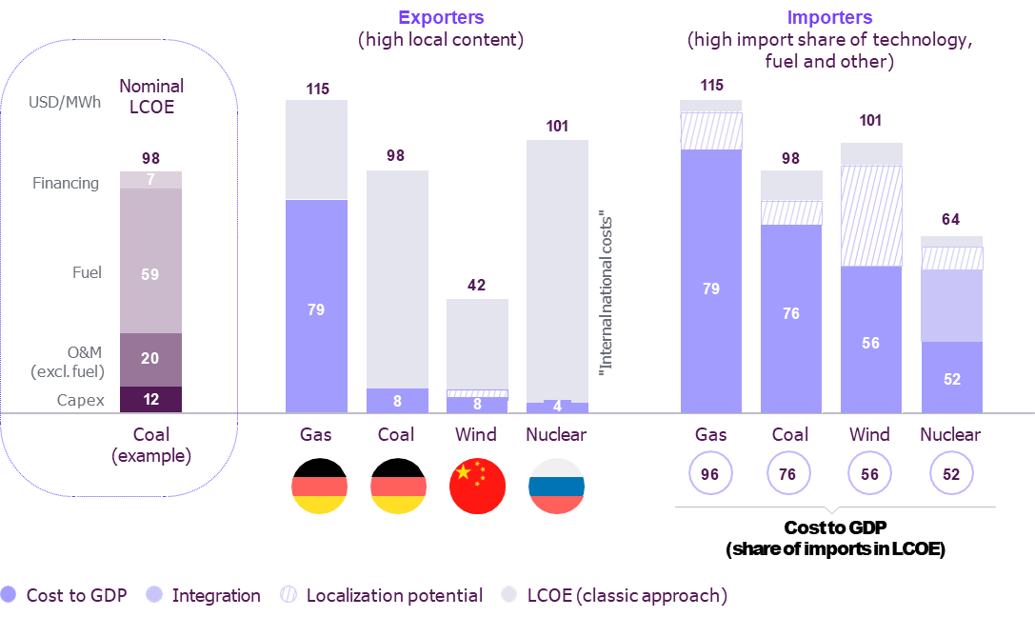

*FIG. 3. Cost of electricity based on LCOE and RealLCOE by type of economy*

## impact of supply chain localization on RealLCOE for various technologies

The paper estimates the impact of the supply chain localization on RealLCOE for various generating technologies. In order to demonstrate the proposed approach, a number of countries in the Southern and Eastern Africa region are analyzed and empirically determined the numerical value of the localization possibility by type of technology and by region is empirically determined. The localization possibility value is expressed in USD/MWh and determined by experts as the possibility of reducing the import component for each of the main cost elements forming LCOE (capital expenditures, operational expenditures (excl. fuel costs), fuel costs, cost of financing) with the help of existing or developing internal capabilities of the African regions under consideration (see Fig. 4 below).

The results of the analysis show that the greatest localization potential is usually formed for fossil generation – up to 90-93% in countries with a rich local resource base for coal and gas and 58-67% for nuclear generation, assuming development of the local construction industry, raw material supply and skilled workforce. Wind and solar have the lowest local content share of 27-46% due to a high share of the imported technology cost and a low share of local skilled labour in the operation phase.

The estimate of localization limits is essential for estimation of RealLCOE for a particular technology and region. The RealLCOE value may range from 7% to 84% of the nominal LCOE value, influenced by the share of costs for imported financial resources, raw and other materials, technologies, fuel and human resources.

Thus, technologies that have the most developed local supply chains (now and projected) of raw and other materials, equipment and components, design, construction and installation, commissioning services, as well as technologies that can be operated and serviced by qualified local personnel and there are specialized secondary and higher education programs and professional retraining programs in this region will have the lowest Cost to GDP value.

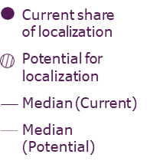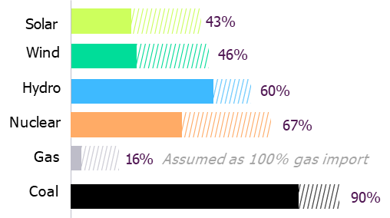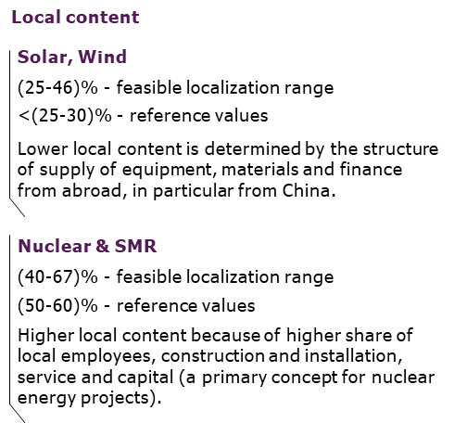

*FIG. 4. Current and future localization level by type of technology and region (example of South Africa)*

## relevance for nuclear aND SMR generation

In order to demonstrate the relevance of the proposed approach and to compare generating technologies using the cumulative effects on the national economy, the paper shows the results of the South Africa case. The calculation results for a wide range of power generation technologies can be seen below (Fig. 5).

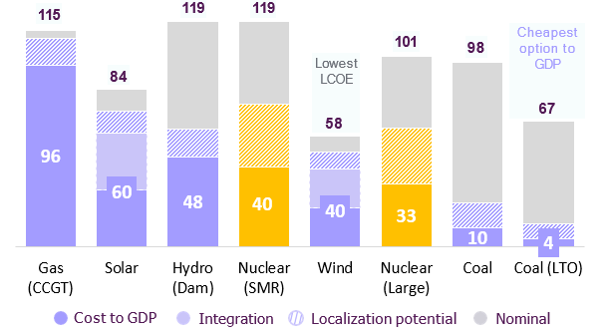

*FIG. 5. Merit order of power generation technologies by RealLCOE (example of South Africa), USD/MWh*

The values obtained from the calculations demonstrate that both LCOE and RealLCOE vary over a wide range of values. However, the variation between the minimum and maximum value for LCOE is 55 USD/MWh and for RealLCOE is 92 USD/MWh. A significant difference in the ratio of minimum and maximum values between the two indicators under consideration leads to the formation of different prioritization orders of technologies prioritization when ranking them in ascending or descending order. For example, the lowest LCOE value is obtained for wind generation, while the lowest RealLCOE value is obtained for coal generation (Coal LTO – coal power plants with a long-term operation period). Consequently, in the considered region the cheapest generation for the national GDP is new or modernized coal power plants.

It should be noted that for this region, large HPPs and SMRs are equal to or lower than WPPs in terms of the RealLCOE indicator. As the volume and cost of RES integration into the energy system grows, the cost to GDP of solar and wind generation increases, which leads to a decrease in the economic effect of their operation and, accordingly, an increase in the electricity cost to GDP. When ranked by RealLCOE, nuclear generation is competitively positioned in the medium or low value range, indicating a relatively low cost of electricity for South Africa's GDP - at the level of the locally-fueled coal-fired generation. The specifics of the SMR position in the merit order ranking (mostly applicable to developing countries) consist in a significantly lower value of RealLCOE relative to LCOE. The main reason for this is the lowest share of fixed costs and the potential effect of a projects pipeline on the same site.

## extended ASSESSMENT of THE COST-TO-GDP CONCEPT applicability for NUCLEAR AND ALTERNATIVE ELECTRICITY GENERATion technologies

The paper estimates the applicability of the Cost to GDP concept for comparison of different types of generation technologies. To assess the applicability of the proposed concept, the comparison was based on three main low-carbon technologies: solar, wind and nuclear SMR generation. In order to compare the effects, alternative calculations are based on three different approaches: classic LCOE, System LCOE and RealLCOE.

Before performing comparative calculations, the factors that are considered for the proposed approaches were systematized. The comparison in Table 1 shows that unlike the LCOE and System LCOE approaches, the proposed RealLCOE assessment methodology allows all three quantitative factors to be taken into account. These are the factors that affect the cost of electricity for the economy – technology expenditures, integration costs and the share of localization.

TABLE 1. FACTORS AFFECTING THE COST OF ELECTRICITY PRODUCTION CONSIDERED WITHIN THE ELECTRICITY GENERATION TECHNOLOGIES ASSESMENT

|  |  |  |  |
| --- | --- | --- | --- |
| Name of parameters | LCOE | System LCOE | RealLCOE  (Cost-to-GDP method) |
| Factor 1 (Technology expenditures) |  |  |  |
| Factor 2 (Integration costs) [1] |  |  |  |
| Factor 3 (Localization level and share of imports) |  |  |  |

Considering the data in Table 1, calculations were performed to compare the concepts for the assessment of the cost of electricity produced by low carbon technologies. The results of the comparative calculations are shown in Fig. 6.

Fig. 6 shows how factors are considered and the results of the calculations change when different approaches are applied. Using the classical LCOE method, the solar and wind technologies (with the values ​of LCOE 53 USD/MWh and 38 USD/MWh respectively) are significantly cheaper than the Nuclear SMR with the value of LCOE 119 USD/MWh. In this case, the wind technology looks like a cheaper technology than the solar and Nuclear SMR (their cost being more than two times higher).

The application of the SystemLCOE approach makes it possible to take into account the additional cost of integrating technologies into the power system. As the VRE generation penetration increases, generation costs grow [18]. Thus, according to the SystemLCOE indicator, the technology merit order does not change, but the difference becomes significantly smaller. SystemLCOE of the solar generation technology equals 106 USD/MWh and this is comparable to Nuclear SMR with the value of 119 USD/MWh.

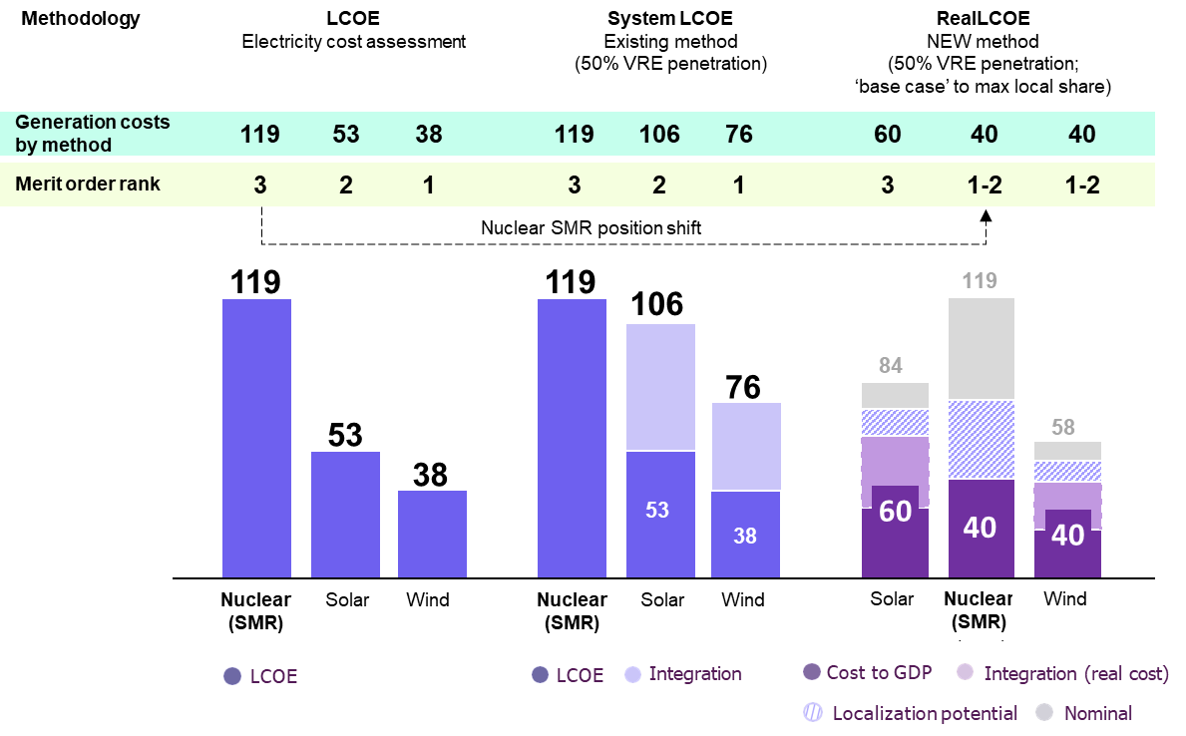

*FIG. 6. Merit order of different electricity sources by methodology, USD/MWh*

The assessment of the proposed RealLCOE approach considering a set of factors that take into account the technology expenditures, the cost of integration and the potential for localization of the technology at a specific location makes it possible to form another picture. In this case, the technology merit order is changing and solar generation becomes the most expensive technology – the RealLCOE value is 60 USD/MWh. At the same time, RealLCOE of the Nuclear SMR technology corresponds to wind generation and this is more than 30% lower than solar generation. Therefore, using the Cost-to-GDP approach, the ranking of technologies changes significantly, becoming more adequate to real conditions, and nuclear solutions can be objectively compared in terms of price, considering a complex of factors.

## PRACTICAL USE FOR EARLY-STAGE ENERGY AND ECONOMIC PLANNING

In practical terms, the proposed RealLCOE approach can be used for early-stage technical and economic planning for the purpose of comparing various power sources. Depending on the priorities of economic development and LCOE to RealLCOE ratio, different technologies may be favored. Fig. 7 illustrates a simplified distribution of technology applicability depending on the results of the indicators assessment.

* **“Simple-minded” cases** (quadrants 2 and 3): Quadrant 3 reflects the “safest” and favorable solutions in which the availability of technology can be effectively used for strategic economic development at lowest absolute costs and lowest costs to GDP. Using same logic at high nominal (LCOE) and real cost for the economy (quadrant 2), the technology is clearly not promising, because in conditions of impossibility of localization such a solution may lead to economic stagnation and strengthening of technological gap in countries with a low development base.
* **“Complex-minded” cases** (quadrants 1 and 4): At low nominal cost and high Cost-to-GDP (quadrant 4), the deployment of cheap and non-localized technology does not produce positive effects for the economy or they are minimal, which creates the risks of resource leakage and increasing import dependence. When LCOE is high but Cost-to-GDP is low (quadrant 1), there are opportunities for momentum of economic growth. In other words, the technology can be beneficial if there are no local resources constraints in the country, including human, engineering, fuel and other resources. In this option, the technology being evaluated is nominally expensive, but it can have a positive effect on the energy and economic growth.

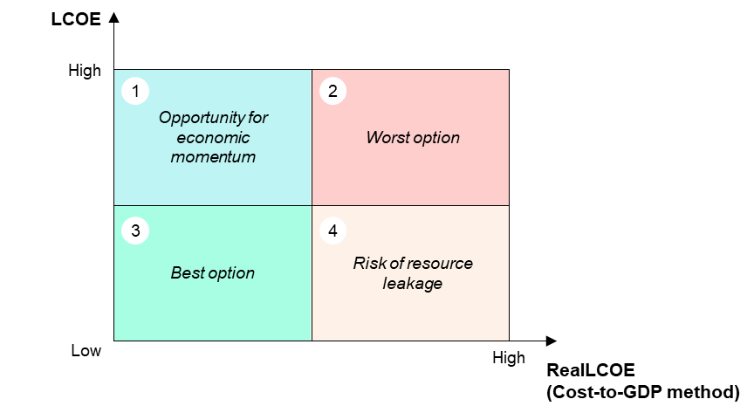

*FIG. 7. Classification of technology applicability options depending on the LCOE and RealLCOE estimates*

In conclusion, the proposed Cost to GDP methodology (with the RealLCOE assessment approach), which is described in the sections above, can be effectively used for preliminary comparative assessment of the cost-effectiveness of various low-carbon energy sources in relation to Nuclear SMR and other technologies. The complexity and the objectivity of the proposed approach makes it possible to use it when making strategic decisions on the future energy mix both in the framework of primary discussions and at the level of industry regulators.

References

1. Navigating the Future of Small Modular Reactors in Competitive Global Low-Carbon Energy Markets, NNWI, 2023.
2. Uganda Least Cost Electricity Expansion Plan 2020-2030, Electricity regulatory authority of Uganda, 2021.
3. Least Cost Energy Investment Study for Namibia to 2040, International Rivers, Earthlife Namibia, 2023.
4. Rwanda: Least Cost Power Development Plan 2023-2050 (2022-2040), Rwanda Energy Group, 2023.
5. Power Generation Master Plan in Burundi to 2030, AfDB for Ministry of Energy and Mines, 2020.
6. Tanzania Power System Master Plan to 2044, Ministry of energy of United Republic of Tanzania, 2020.
7. Integrated Master Plan Mozambique Power System Development to 2042, Japan International Cooperation Agency (JICA), 2018.
8. Clean Energy Transition in Tanzania, Multiconsult, 2022.
9. South Africa’s Just Energy Transition Investment Plan (JET IP) for the Initial Period 2023-2027, The Presidency of the Republic of South Africa, 2022.
10. Integrated Resource Plan for the Power Sector in Zambia, Zambia Ministry of Energy, 2023.
11. Lazard’s Levelized Cost of Energy Analysis — Version 15.0, Lazard, 2021.
12. Planning and Prospects for Renewable Power: Eastern and Southern Africa, IRENA, 2021.
13. Electricity Generation Costs 2020, Department for Business, Energy & Industrial Strategy of UK Government, 2020.
14. UECKERDT, F., HIRTH, L., LUDERER, G., EDENHOFER, O., System LCOE: What are the Costs of Variable Renewables, Potsdam-Institute for Climate Impact Research, Germany, 2013.
15. Projected Costs of Generating Electricity, IEA, NEA, 2020.
16. Measuring Employment Generated by the Nuclear Power Sector, NEA, 2018.
17. New Just: Paths to Affordable Energy Transition in Eastern and Southern Africa, Kept, 2024.
18. Full Cost of VRE Integration into the South UPS of the Russian Federation: Impact of Geospatial Optimization Factors, Kept, 2022.

1. **Integration costs assumptions for VRE**: (a) to estimate the integration costs for VRE (wind and solar) the SystemLCOE methodology is used as described in the study by Ueckerdt and Hirth [14]; (b) generally the integration costs differ significantly from power system to power system depending on VRE technology, climatic conditions, energy mix baseline, level of VRE penetration, electricity demand dynamic, geospatial distribution on VRE and other factors and tend to increase non-linearly upon increase of VRE penetration; (c) the quantitative estimates by Ueckerdt and Hirth [14] for Germany and Kept for Russia [18] shows that for high VRE penetration levels from 30% to 70% the SystemLCOE may reach x1.25-3.0 to LCOE. Moreover, SystemLCOE is higher for emerging markets: in power systems with low basis of energy consumption and high demand growth rate, the cost of integration increases significantly, as it includes the cost of building new generation required due to the low development base and lack of generating capacity; (d) in this paper, for simplicity reasons, an 1:1 ratio of generation cost to integration cost is used to visualize the concept. Detailed considerations for SystemLCOE are required to provide site specific estimates (outside of this work).