Italian Scenario: reintroduction of

new nuclear and benefits for the system

GIADA CAPRIOLI

Edison

Milan, Italy

Email: giada.caprioli@edison.it

VALERIA OLIVIERI

Edison

Milan, Italy

LORENZO MOTTURA

Edison

Milan, Italy

**Abstract**

Challenging European and Italian regulation aims at reaching carbon neutrality in Italy by 2050. A scenario totally fueled by renewable sources would be compliant with this target, with strong drawbacks from economical and system security point of views.

For this reason, through a proprietary model an optimized scenario has been drafted, starting from Italian PNIEC energy mix at 2030 [1]. Reintroducing nuclear technology, with the first plant in 2030-35 and one plant per year, at 2050 a pipeline of 15-20 plants would cover the 10% of production. At 2050, ~20% of programmable capacity (nuclear and decarbonized gas) will guarantee economic and adequacy sustainability of the system.

This optimized mix guarantees significant investment reduction (more than 400B€).

The introduction of new nuclear leads to positive impacts for the Italian system:

- Macroeconomic: 40+ B€ GDP increase, 36+ k AWU during construction and 3+ k AWU in operation

- Environmental: reduced LCA emissions, land occupancy and water need

- Strategic: revitalization of national industrial cluster, valorization of carbon neutral Made in Italy and boost of high-technology export in Europe (benefit enabled by the hybridization of electric and thermal applications)

## INTRODUCTION: LONG-TERM SCENARIOS

The evolution of Italian energy scenarios is influenced by a variety of economic, environmental and technological needs.

The European Union, and therefore Italy, is committed to an ambitious climate policy. The European decarbonization path aims at reducing emissions by at least 55% compared to 1990 levels and reaching carbon neutrality by 2050. The 2050 target became legally binding when the EU climate law was adopted by the European Parliament in 2021. At the Italian level, the PNIEC (Integrated National Energy and Climate Plan) sets targets for the 2030 emission trajectory in line with European objectives.

As for climate and environmental objectives, there are requirements for economic viability and for the security of supply in Italy, thus minimizing system costs and at the same time ensuring the safety and adequacy of the national electricity grid. While drafting the Italian scenario, the aim is therefore the definition of the energy mix that allows to achieve carbon neutrality by 2050, minimize the costs for the system and ensure the security of energy supply.

How to achieve this objective? The possible paths to reach Net Zero by 2050 are plenty, for the purposes of the study two main layouts have been compared: a scenario composed by 100% of renewable sources and an "optimized" scenario that includes the different technologies in a complementary mix in order to optimize the required investments at the Italian system level. Hereinafter, the two scenarios will be named Scenario 100% RES and optimized Scenario.

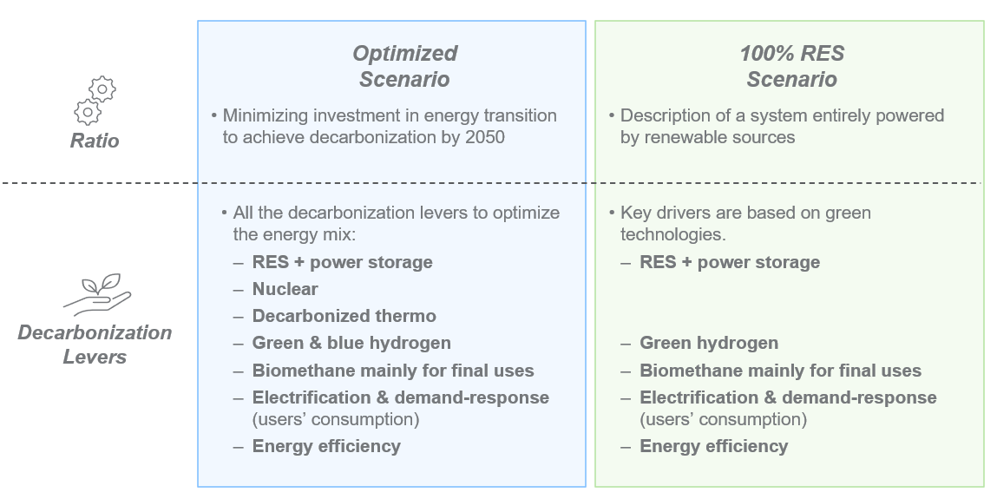The following figure represents the main levers considered to depict the evolution of the two scenarios, whose contribution and impact are better deepened throughout the document.

*FIG. 1. Description of the 2 scenarios: Optimized and 100% RES.*

Edison has simulated such scenarios through a proprietary model with some key features:

- Simulation of dispatching on hourly base

- Modelling of the European grid

- Simulation of the evolution of major commodities on the base of global balances

- Estimation of demand and technologies evolution.

In the simulation of the scenarios, the common starting point is 2030 which takes as reference the Italian situation described by the latest version of the PNIEC presented in June 2023 [1]. Starting from common 2030, the two scenarios are then developed following the aforementioned directives, of which results are shown at 2050.

To depict the evolution of the Italian energy mix, first the main assumptions are shown.

## italian demand evolution

The electricity demand is the same in both scenarios and shows to be growing along the time horizon. The volume of electricity required at Italian level increases of 60-70% in 2050 compared to 2022 (520 TWh at 2050 vs 318 TWh at 2022).

Growth is mainly driven by the electrification trend, which outlines a progressive switch of uses from gas commodity to electric commodity. This trend characterizes all major sectors, although the electrification of transport and the production of hydrogen are the two main drivers.

More specifically, the development of power demand is influenced by three distinct effects:

- Activity effect, which describes the Italian trends in terms of population growth/reduction, GDP, household composition, composition of productive activity by sector

- Electrification effect, gas to electric conversion phenomenon, technological evolution and replacement of gas-fired appliances with electric appliances (e.g. heat pump vs gas heating)

- Energy efficiency effect, linked to energy efficiency measures that allow a reduction in energy consumption.

While electrification leads to an increase in electricity demand, at the same time it causes a contraction in gas demand.

The overall evolution of gas demand, including both natural gas and green gas, leads to a reduction of ~50% at 2050 compared to 2022 (36 Bcm at 2050 vs 69 Bcm at 2022). Over the period analyzed, also the composition of gas portfolio evolves, shifting more and more in favor of green gases (hydrogen and biomethane) compared to natural gas, reaching a share of 60-70% in 2050.

## installed capacity

In parallel to the evolution of the illustrated demand, the two scenarios subtend a different evolution of the installed capacity of:

* Renewable sources (PV, onshore and offshore wind, hydroelectric, geothermal and biomass)
* Electric grid
* Power storage
* Gas and nuclear plants.

### Renewable sources

The development of renewable sources takes into account their peculiarities that characterize the operation and role within the electricity mix. These sources generate energy:

* in a non-programmable way, whereby it is necessary to associate power storage capacity able to provide time-shift services
* in an unbalanced way on the Italian area, production is concentrated in the south while ~2/3 of the electricity needs is in the north
* with a production profile concentrated at certain times of the day, with peaks in production not matching with the load demand and which therefore requires to oversize the capacity due to curtailment.

To manage these characteristics, and so to satisfy the energy demand, in the 100% RES scenario the installed capacity required is significantly greater than in the optimized scenario (+200 GW). This differential capacity of renewable sources allows to cover 100% of the demand, which drops to ~80% in the optimized scenario.

In both scenarios, PV is the technology with the greatest development potential, covering about 60-65% of the capacity. More than 60% of this capacity is developed through grid-scale installation, the remaining through energy communities (REC) and rooftop installations at end users.

### Electrical grid

The direct consequence of non-programmability and unbalanced production profile of renewable sources is the need for further development of the power grid. Terna will modernize the electricity grid to facilitate the energy flow from the highest generation regions (South) to the areas with the highest load (North).

The grid development of both scenarios originates from the Development Plan published by Terna in 2023 [2]. The main innovation introduced by the Development Plan is the Hypergrid network, which will take advantage of the technologies of energy transmission in direct current (HVDC, High Voltage Direct Current). This network will be set up in parallel with the numerous measures to develop the existing network.

The additional need to increase network capacity of the 100% RES scenario results in a delta, compared to the optimized scenario, of about 10 GW. This incremental delta is required to ensure the adequacy of the system.

### Power storage

In addition to the development of the grid, a large development of renewable sources requires a significant increase in power storage capacity that provides time-shift services in order to ensure the availability of electricity production at all times of the day.

The development of storage in Italy is promoted by the new regulation:

* During 2024 tenders for hydro-pumping and grid-scale batteries are planned (possible requirement 10 GW+ by 2030)
* DM FER X proposes to incentivize RES sources with a standardized profile that could be reached through the time-shift market.

Hydro-pumping will be developed to its maximum technical potential (15 GW), mainly in southern Italy from 2028, due to the long construction times and the legislation still in development. The batteries will be installed systematically in REC and will support the development of renewables. The energy-to-power ratio of batteries will also increase from 4 hours in 2030 to 6-8 hours in 2050.

The aggregation of small-scale generation and load, such as demand-response, UVAM and electric vehicles, will play an important role in ensuring load-shift services.

At last, the production of green hydrogen also acts as a storage source that allows the consumption of renewable energy at times of overgeneration and the release into the network at off-peak times.

### Thermo and nuclear plants

In the optimized scenario, thermoelectric plants play a fundamental role in the electrical mix, indeed, they allow to cover the demand peaks and meet the requirements of flexibility. Since in the 100% RES scenario the gas and nuclear generation is not present, these services will be fulfilled thanks to storage and mainly by grid-scale batteries.

Focusing on the optimized scenario, the installed capacity of thermoelectric plants is decreasing from the current 50 GW to ~26 GW in 2050. Despite the overall reduction, the remaining capacity continues to ensure the energy balance of the system and avoid blackouts. The thermal plants will face a decarbonization path from 2030, mainly driven by CO2 regulations and prices, and will achieve a complete decarbonization by 2050 mainly through:

* Use of biomethane for CHP by 2030, which will become the only fuel for CHP by 2040
* After 2030 the price of CO2 is going to enable CCS for the new CCGTs in the North, plants with more operation hours and closer to the CO2 storage hub in Ravenna
* Green hydrogen does not seem to be never the most competitive form of hydrogen, but at 2050 a part of imported hydrogen will be used for thermal plants in the south

As illustrated in the dedicated chapter, this scenario aims to reach a 10% nuclear production share at 2050. To achieve this goal, the scenario expects the first nuclear plant in operation by 2035 and, at a rate of ~1 installation per year, 15-20 new plants operatives by 2050.

## electric mix

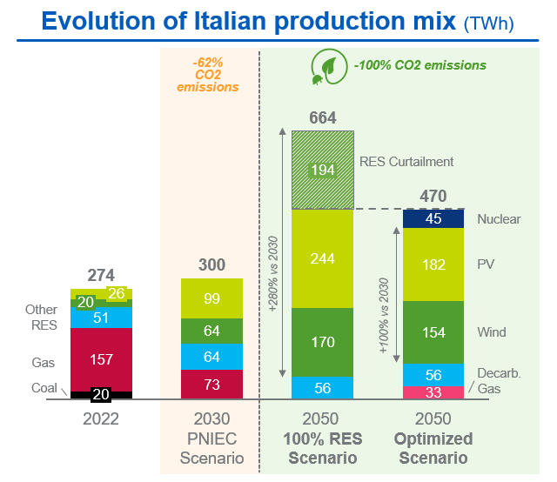The main assumptions introduced lead to the evolution of the electric mix shown below.

*FIG. 2. Evolution of Italian production mix (import excluded), TWh.*

The energy requirement in the optimized scenario is satisfied by a mix of: renewable technologies, which guarantee a decarbonized production but not programmable, and a fraction of programmable sources consisting of gas (decarbonized by technologies such as CCS or hydrogen) and nuclear.

The contribution from nuclear energy reaches 10% of the mix by 2050 thanks to a pipeline of 15/20 installed from 2030-35.

In the evolution of this scenario, gas is a vector that allows the energy transition until there is sufficient nuclear capacity for the system. Maintaining or increasing the rate of installation of nuclear plants, the total phase-out of the gas could be reached in less than 10 years (between 2055 and 2060).

The 100% RES scenario leads to the need of oversizing the electricity generation vs the demand, for the above characteristics, since about 30% of the production translates into curtailment.

Both the scenarios would enable Italy to reach the target of carbon neutrality by 2050, but with a significantly different impact for the system. The need to install considerable renewable capacity, electricity storage and network development determine significant investments for the country.

In the case of 100% RES, the lack of thermoelectric capacity leads to inefficiency in generation, which is manifested in several phenomena:

* In peak production hours, mainly in the middle of the day, the excess over demand becomes curtailment (~50% of the energy produced by wind and PV) and part is exported (~15% of the total production)
* Excess energy is partially absorbed by pumping and then sold during off-peak hours
* During non-peak hours the production gap is compensated by storage, both hydroelectric pumping and batteries

On the other hand, the presence of thermoelectric and nuclear plants allows the optimization of the mix and an efficient production-demand balance. In this case, indeed, there is a drastically lower curtailment, which occurs in limited periods and limited quantities. Even the contribution of flexibility systems is optimized, power storage can manage production variability in an optimal way.

## new nuclear in the italian scenario

The reintroduction of nuclear technology in Italy is enabled by the technological evolution of the field. The new nuclear technologies represent a technological discontinuity compared to the "conventional nuclear" currently in operation globally (generation 2 and 3). The reactors under discussion have small size (300-400 MWe), are modular and produced in series, with simplified design and passive safety.

The new nuclear technologies Italy is focusing on are Small Modular Reactors (SMR) and Advanced Modular Reactors (AMR). The two technologies are complementary both in possible uses, time availability and also in the management of nuclear waste. SMRs are the evolution of the latest generation of plants (gen 3+) and will be commercially available from 2030, while AMRs (gen 4) are expected after 2040 and will allow the recycling of part of nuclear waste and therefore a better use of natural resources of uranium. Compatible with their availability on the market, these technologies can gradually become part of the Italian energy mix to achieve the 2050 targets.

The complementarity between these technologies, in different aspects such as technological maturity and fuel cycle management, will lead to a technological relay that involves the introduction of SMR when available from 2030 and then the AMR from 2040. This relay will lead to synergies at the infrastructural level, ready for one technology and then available for the next, optimizing the process of construction and the associated costs.

## positive impacts for the italian system

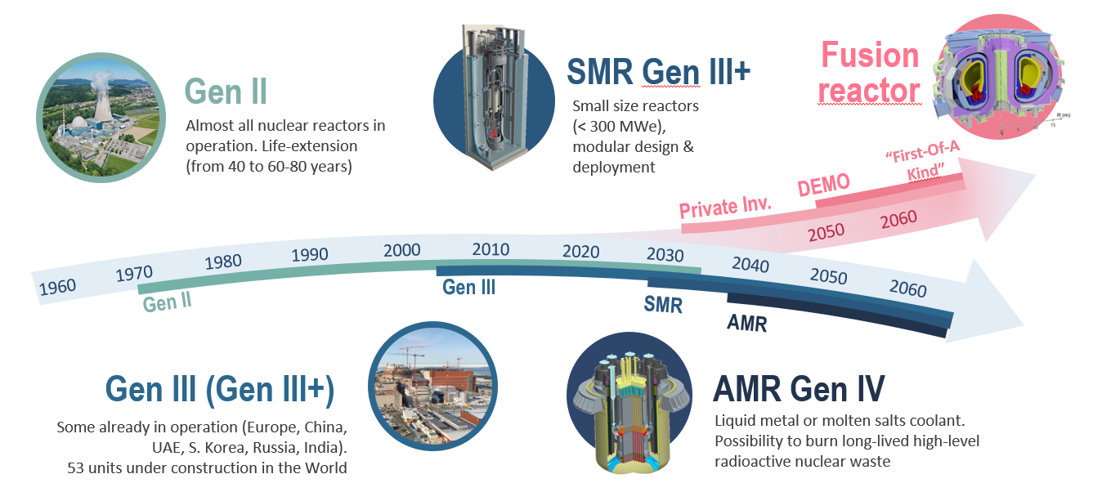

*FIG. 3. Availability of new nuclear technologies over the time horizon.*

In a conservative hypothesis of reaching a production share of ~10% from nuclear at 2050 and considering building the first SMR before 2035 and about one plant per year between 2035 and 2050, we would get a pipeline of 15-20 plants in operation by 2050.

The optimized scenario, maximizing the contribution of the different energy sources available, allows considerable investment savings needed at the country level. In the period until 2050, total net savings would exceed 400B€ (optimized scenario vs 100% RES scenario).

The estimation encompasses the investments’ differential between the two scenarios over the period up to 2050, including the main items described above:

* Development of nuclear and renewable capacity (solar and wind)
* Development of power storage sources (batteries and hydro-pumping)
* Development and strengthening of the national electricity grid

The new nuclear would lead to a positive impact on the Italian country system for several aspects.

At first glance the macroeconomic benefits. The total expenditure determined by the investments for the construction of the nuclear power plants in Italy in direct, indirect and induced way activates a large part of the supply chains composing the national economic context. The impact on GDP benefits both the sectors directly involved in the construction and design of the plants, but it is also extended to sectors not directly involved but part of the supply chains of the fields targeted by the expenditure, or sectors activated by the expenditure of the households in an induced way (manufacturing, transport, services, ...). Compared to a total expenditure of ca. 30 B€ in the period 2030-45, the added value increase would exceed 40 B€ and a positive impact on employment, with an increase of up to 40k units of equivalent work.

Another positive aspect would be the environmental benefits:

- Production with low pollutants emissions and extremely low carbon intensity over the entire life cycle, much less than renewable technologies such as PV and wind

- Water consumption is limited, no consistent water sources are needed near the site, ensuring also more flexibility in choosing the site

- Land consumption is limited, the area per unit of energy produced is significantly lower than other renewable technologies, helping to limit the pressure on ecosystems

- Possibility of reducing nuclear waste thanks to the complementarity of SMRs and AMRs that could lead to a closing fuel cycle (AMRs could use part of nuclear wastes produced y SMRs)

These technologies allow also to limit European dependence on foreign markets because the requirement of critical materials is lower, with the same energy produced, than other renewable technologies. The same is true for fuel, the supply of uranium can be guaranteed from diversified sources and not at geopolitical risk, such as Australia and Canada, which are among the main exporting countries.

Further benefit for the country system concerns the Italian industrial context. The modularity of SMRs and AMRs allows the production and assembly of components in factory, enabling the development of the Italian supply chain. At the same time, the production of electricity and heat through these technologies will allow the decarbonization of industries at a competitive cost, creating opportunities to adapt industrial processes and make the final made in Italy products carbon neutral with a greater push to export. One of the major benefits of these technologies are the different applications for industrial clients, both electrical and thermal consumptions could be decarbonized (directly or with hydrogen produced with high-temperature electrolyzers, using electricity and heat provided by SMRs-AMRs).

## CONCLUSIONS

In order to have the first SMR in operation by 2035 in Italy, and benefit all the themes mentioned above, it is necessary to implement, or finish to implement, the 19 infrastructures described by IAEA in the Milestones Approach [3] as soon as possible.

First of all, Italy needs to implement a regulatory framework and create a NEPIO (Nuclear Energy Program Implementing Organization) to assess the infrastructures for the restart of an Italian nuclear program. An Italian Safety Authority is required to guarantee the compliance of nuclear power to international safety standards. On the industrial side, it is fundamental to develop a medium-long term industrial plan focused on fostering Italian supply chain, including the definition of support mechanisms and of a plan of skills development. Another strategic infrastructure deals with financing and funding, requiring the development of adequate public support (i.e. state guarantees on loans and stable pricing mechanisms). Then, it is fundamental to set a plan for the management of radioactive waste (e.g. definition of the Italian repository) and a program to enhance public acceptance of new nuclear projects.

The renaissance of interest for new nuclear power in Italy has been shown by some recent events. Italy joined the European Industrial Alliance on SMRs, with high participation of Italian companies (second in number after French ones). Moreover, the Italian Ministry of the Environment and Energy Security launched its National Platform for Sustainable Nuclear Power to reintroduce nuclear energy into the electric mix and has included nuclear development scenarios in the National Energy and Climate Plan (NECP) delivered to the European Commission in July 2024 [4].

References

1. MINISTERO DELL’AMBIENTE E DELLA SICUREZZA ENERGETICA, Piano Nazionale Integrato per l’Energia e il Clima, June 2023
2. TERNA, 2023 Development Plan – Renewable Development and Connection Activities, March 2023
3. IAEA, Milestones in the Development of a National Infrastructure for Nuclear Power, July 2015
4. MINISTERO DELL’AMBIENTE E DELLA SICUREZZA ENERGETICA, Piano Nazionale Integrato per l’Energia e il Clima, June 2024