Towrds a sustainable future: SMR Smart net zero city

J.H. KANG
KHNP (Korea Hydro & Nuclear Power CO., LTD)
Yuseong-gu/Daejeon-si, Republic of Korea
Email: jinhuikang@khnp.co.kr

Y.H. JANG
KHNP (Korea Hydro & Nuclear Power CO., LTD)
Yuseong-gu/Daejeon-si, Republic of Korea
Email: khnpjang@khnp.co.kr

Abstract

As cities globally strive for sustainability, the concept of SMR Smart Net-zero City(SSNC) emerges as a pivotal solution. This paper explores the framework and strategies for establishing SSNC, focusing on leveraging Small Modular Reactor(SMR) as a foundational energy element. By integrating versatility of SMR with advanced technologies like IoT and AI, SSNC can achieve efficient energy management, demand response, and renewable energy integration. The paper discusses key components such as smart grids, energy storage systems, and intelligent energy management systems, emphasizing their role in optimizing energy consumption and reducing carbon emissions. Several virtual cities created based on actual energy production and consumption data simulate carbon reductions and energy costs to demonstrate the feasibility and benefits of SSNC implementation.

INTRODUCTION
The Nuclear Energy Agency(NEA) analysis found that, on average, the 90 pathways for the 1.5℃ scenario considered by the Intergovernmental Panel on Climate Change(IPCC) require nuclear energy to triple and to reach 1,160 gigawatts of electricity by 2050 as shown in figure 1. Reaching the target of 1,160 gigawatts of electrical capacity from nuclear energy would avoid 87 gigatonnes of cumulative emissions between 2020 and 2050, preserving 20% of the world’s carbon budget consistent with a 1.5℃ scenario. SMRs are leading a wave of near-term and medium-term nuclear innovation that has the potential to open up new opportunities, including power and non-power applications as part of nuclear hybrid energy systems. From this perspective, KHNP declared the SMR Smart Net-zero City(SSNC) which designs a feasible carbon-neutral city by combining SMRs and smart cities as a new business model. SMR is able to supply not only electricity but also process heat, it can be used simultaneously in various demand areas in the city such as industrial, residential, commercial areas and so on.

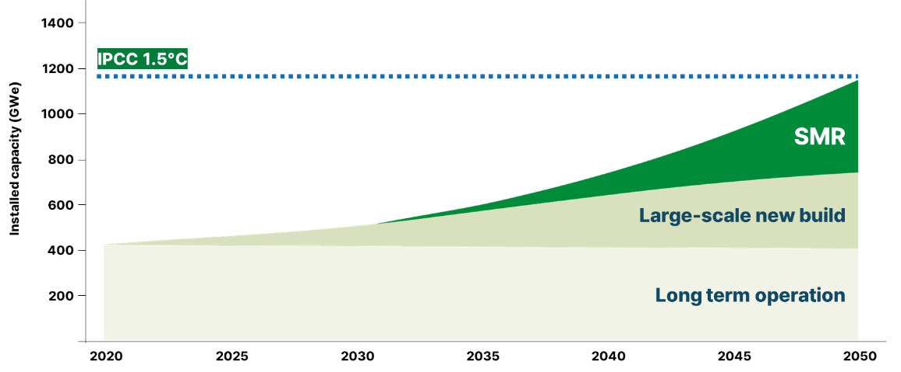
FIG. 1. Potential of nuclear contributions to net zero

Project Outline
The SSNC is a simulation that estimates energy demand by analysing various information such as population distribution, climate environment, geographical requirements, industrial ecosystem of a smart city and shows the optimal energy mix scenario based on the amount of renewable energy generation in the region. This means that based on the excellent elastic operation of SMR, it overcomes the intermittency of renewable energy and provides operation scenario that can safely and economically supply electric power and heat energy to the city. By installing SMR in a location adjacent to a smart city, it is possible to calculate the appropriate amount of electric power and heat energy supplied through combination with various sector couplings and estimate the amount of carbon reduction in the city. The SSNC platform is configured to process large amounts of time series data on urban energy supply and demand. In addition, it is a structure that provides simulation by visualizing real-time calculation results according to input conditions on a web dashboard and 3D engine program. Therefore, it is possible to freely change the composition of urban elements according to each stage of urban growth, and to monitor the optimal energy mix results, power generation costs, and annual carbon reduction information.

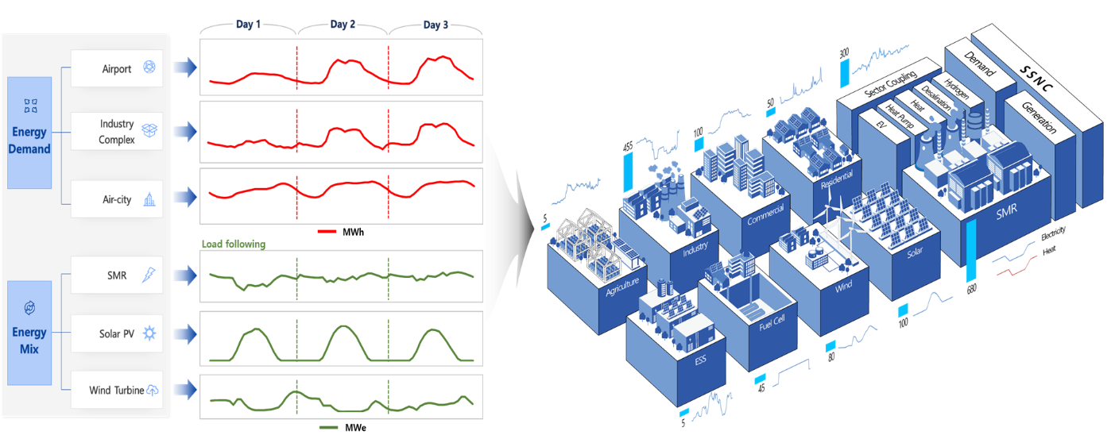
FIG. 2. Schematic diagram of SSNC

SMR-centered energy mix
Renewable energy has data patterns depending on the local environment and climate. Most countries set an appropriate rate of renewable energy for cities scheduled to be built in the future to respond to the climate crisis. In this respect, the SSNC overcomes the intermittency of renewable energy by utilizing the flexible operation of SMR and can respond customized to urban growth by increasing the number of reactors according to the city’s master plan. The most important process in building the SSNC model is the process of deriving the energy mix of SMR and renewable energy, which begins with the analysis of the city master plan. Based on the plan, demand information for electric power and heat energy is organized into a time series data set. In the case of energy supply, renewable energy generation and related policies are reflected based on geographic and climate information. Through the process, the city’s annual day and night energy patterns are secured to determine appropriate SMR facility capacity and operation ratio. In the case of solar power generation, the energy shortfall can be solved by load following of SMR because of weather deterioration or limited power production at night. On the other hand, it is possible to create added value by adjusting the process heat production rate and using it for hydrogen production or fresh water production if surplus power is generated. The SSNC platform sets weights for each energy demand element and configures it to enable simulation by adjusting the weights if user want to increase or decrease a specific demand.

SSNC Simulations
The SSNC simulations consist of SMR Energy Complex simulation which experiences the versatility of SMR, and SSNC simulation where SMR is introduced into smart cities to monitor urban energy flow. Each simulation can be operated through a web controller and the results according to the operation can be checked in the 3D engine model. The SSNC simulation were built based on the city master plan with various characteristics including island, inland, Southeast Asian and Middle Eastern cities. It expresses characteristic elements of different terrains, environments and provides energy mix scenarios accordingly.

SMR Energy Complex Simulation
The SMR Energy Complex simulation shows a multi-purpose utilization process for urban industries and regional heating, hydrogen production, freshwater production by adjusting electric power and heat production ratio for each SMR unit. A web controller manipulates the production ratio and the changed results appear in the 3D engine virtual model. The 3D engine consists of models representing SMR complex, electric power, hydrogen production and freshwater production facilities.

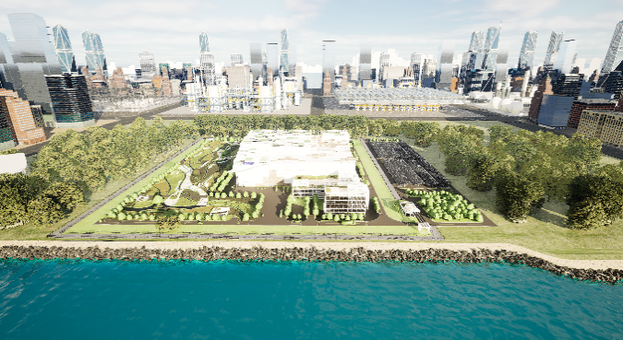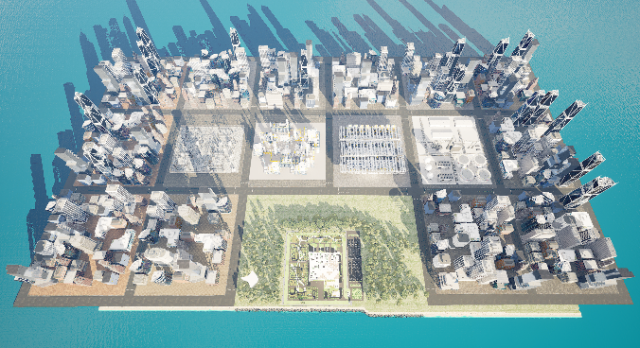
FIG. 3. 3D models of SMR Energy Complex

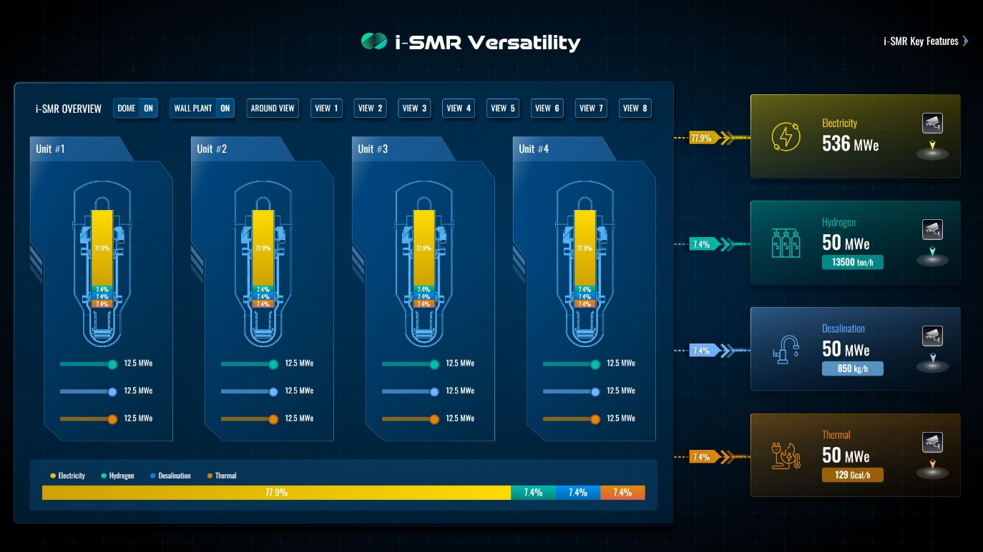
FIG. 4. Web controller of SMR Energy Complex

SSNC Simulation
The SSNC simulation shows how SMR combines with a smart city to supply energy with renewable energy, creates added value for the city and contributes to carbon reduction. It consists of a 3D virtual city engine configured according to various urban environmental requirements and a web dashboard that monitors the energy demand and supply of cities in real time. During the daytime, when the power generation of renewable energy is high, SMR automatically follows the load to produce less electricity or increase process heat production to use it for hydrogen or freshwater production. On the other hand, SMR supplies electric power stably by automatically increasing the amount of electricity generated at night when the amount of renewable energy generation decreases. The city 3D engine builds a city model according to each city’s climate environment and industrial ecosystem allowing detailed views of the energy demand and supply as well as carbon reduction for each element.

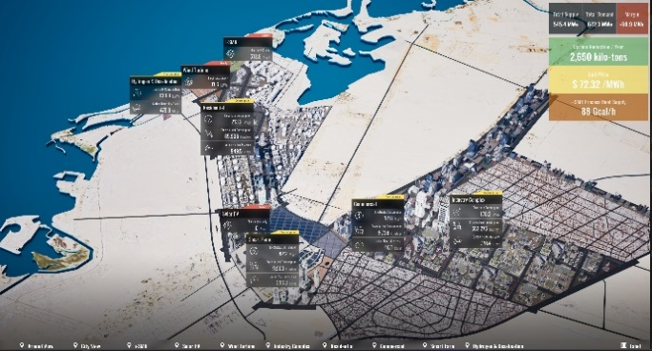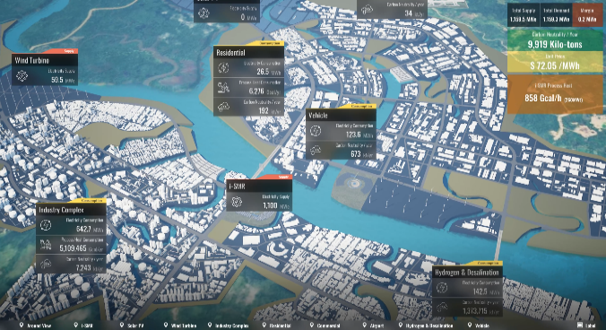
FIG. 5. 3D models of Middle East & Southeast Asia SSNC

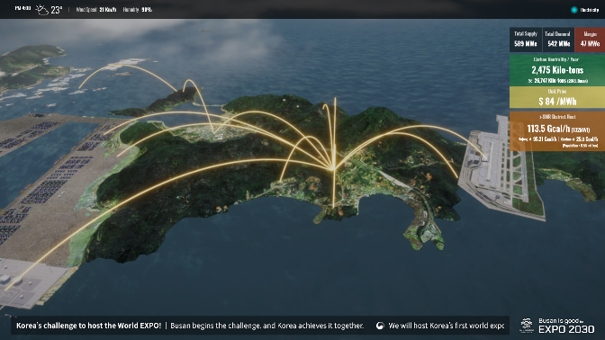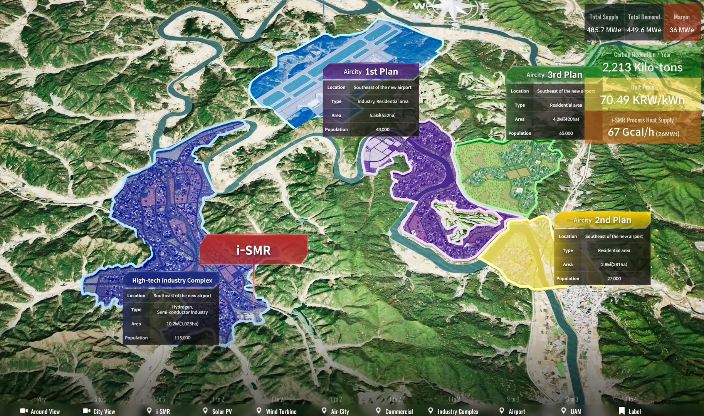
FIG. 6. 3D models of Island area & Inland area SSNC

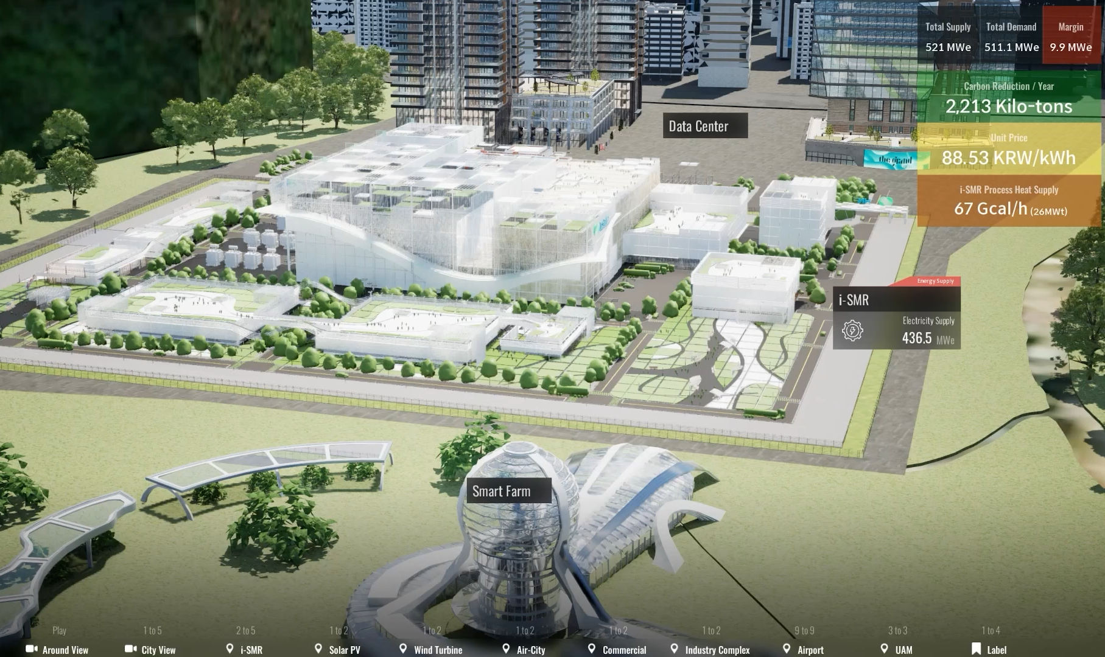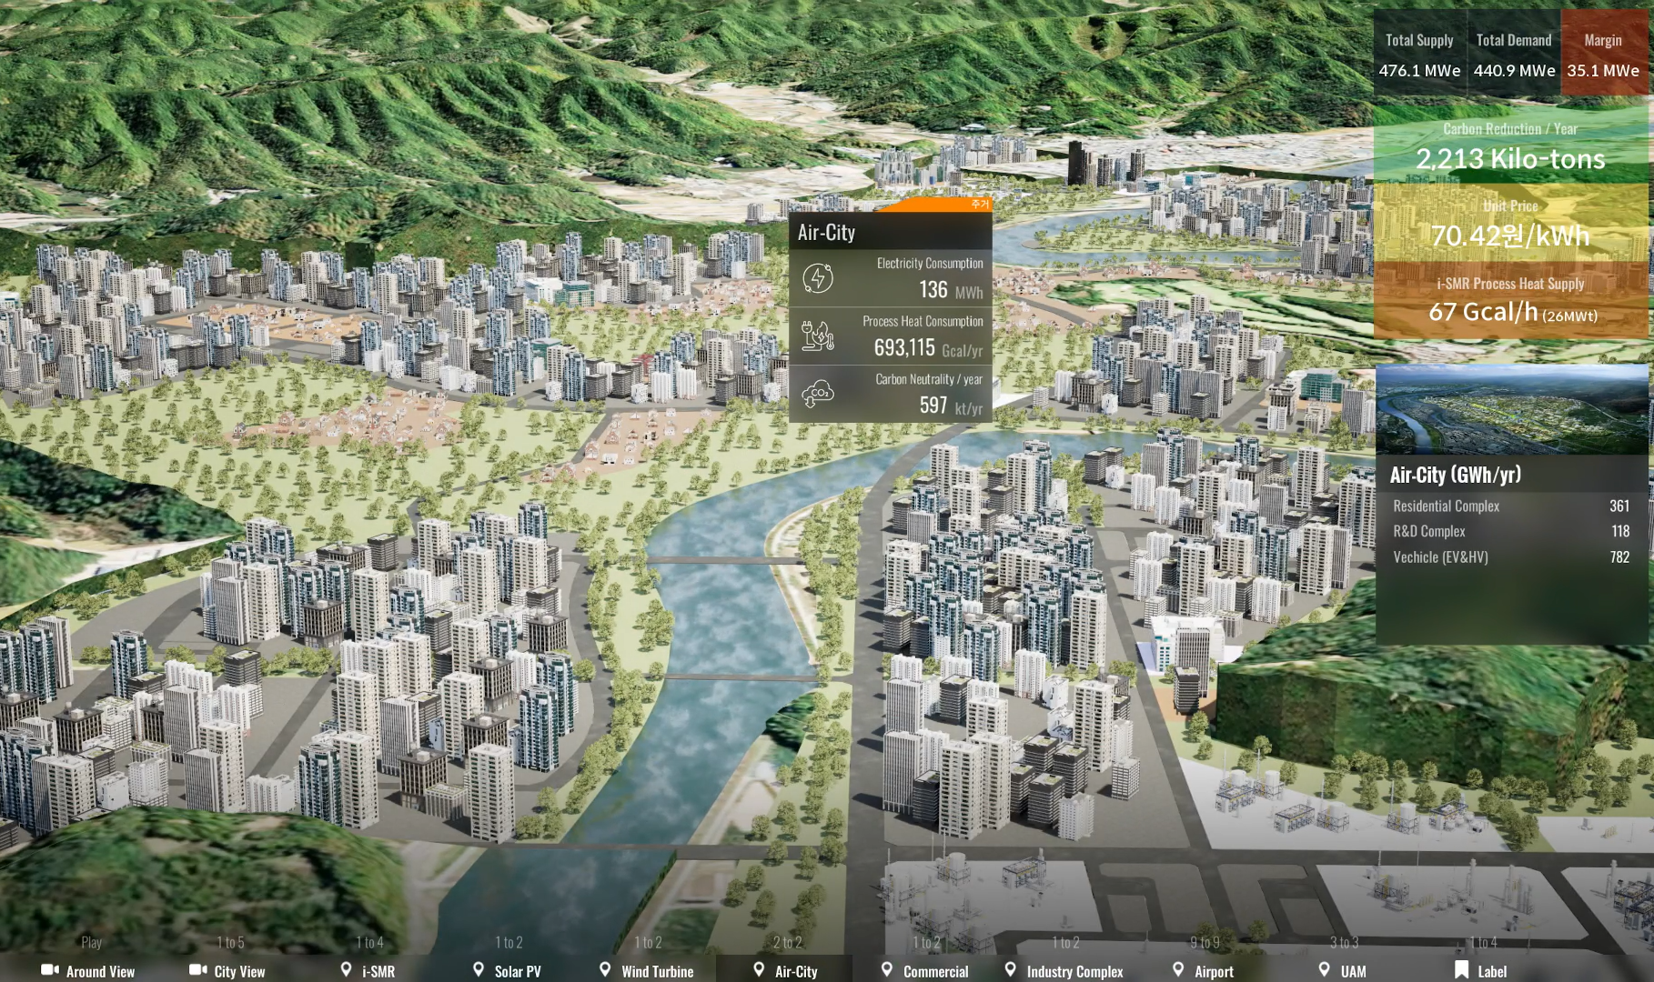
FIG. 7. 3D models of SMR complex & Air-city

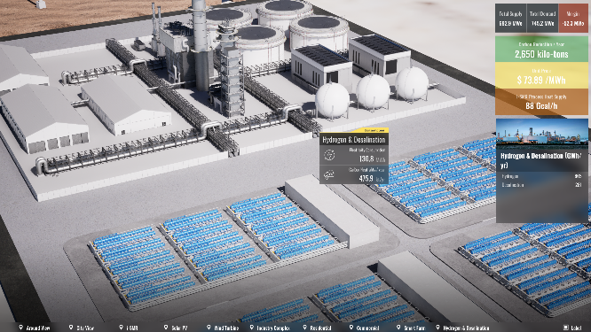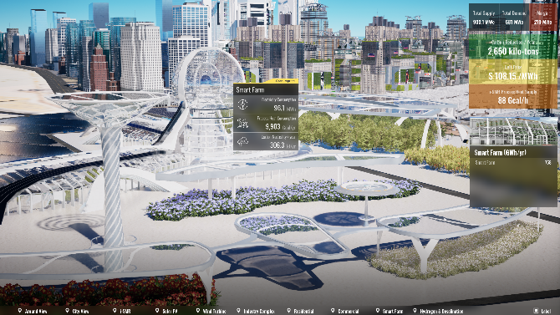
FIG. 8. 3D models of Hydrogen, Desalination facilities & Smart-farm

The web dashboard provides information on a stable supply process and power generation cost according to the energy demand including the population and area or the region. In addition, it is implemented to adjust the weight of each element that makes up the city showing the process of energy mix change as the user adjusts the ratio of desired elements. The unit price of power generation is calculated based on the levelized cost of energy that can be referenced for each region. By selecting the view point at the bottom of the web dashboard, it is possible to move the screen from the virtual city engine to the desired area.

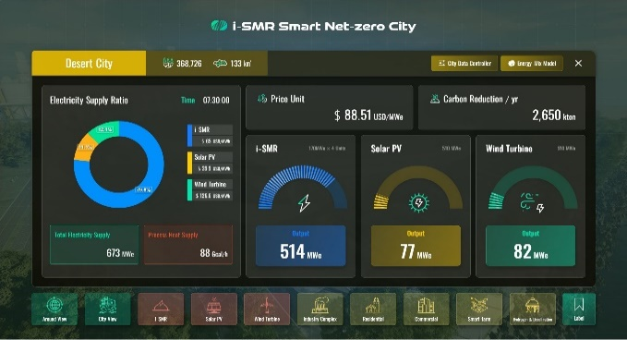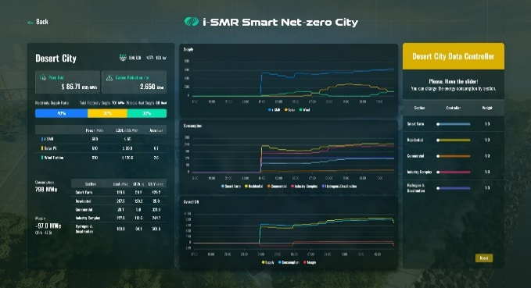
FIG. 9. Web controller of SSNC simulation

conclusions
The SSNC platform is a carbon-neutral energy source to respond to the global climate crisis and the optimal solution to the rapidly increasing energy demand of future smart cities such as the semiconductor industry and large data centers. In order for the SSNC platform to be used universally, it is important to reflect in detail the requirements of various countries and companies. To realize commercialization, expansion is required to a stage where energy policies and carbon tracks according to urban growth can be forecast on a 10year basis. In addition, detailed information such as construction cost, tax policy, plant operation period must be reflected simultaneously in order to produce meaningful results. It needs to be upgraded to a level that can be sued in various regions and environments through continuous research, and to improve it as a flexible platform that increases effectiveness by reflecting sustainable policies.
References
- Allen, M. R., et al., “IPCC special report on impacts of global warming of 1.5℃”, Intergovernmental Panel on Climate Change, 2021.
- OECD/NEA, “The NEA Small Modular Reactor Dashboard: Second Edition”, OECD/NEA, 2024
- OECD/NEA, “Meeting Climate Change Targets: The Role of Nuclear Energy”, OECD/NEA, 2022
- Soler, A., V., “The future of nuclear energy and small modular reactors”, Living with Climate Change, 465–512, Elsevier, 2024
- Microsoft “Accelerating a Carbon-Free Future – Microsoft policy brief on advanced nuclear and fusion energy” Microsoft, 2023
- Locatelli, G., Bingham, C., and Mancini, M., “Small modular reactors: A comprehensive overview of their economics and strategic aspects”, Progress in Nuclear Energy, 73, 75–85, 2014

