**INCORPORATING SMALL MODULAR REACTORS WITH SOLAR AND WIND FOR GHANA'S SUSTAINABLE ENERGY TRANSITION BEYOND CONVENTIONAL NUCLEAR POWER AMBITION POST-COP28**

M. A. Nyasapoh1,2*, S. Gyamfi1 S. K. Debrah2,3, H. A. Gabbar5, N. S. Agyemang Derkyi1, A. Buah-Kwofie2, J. Gbinu2, Felix Ohene-Fobih Ameyaw2

1 Department of Renewable Energy Engineering, School of Energy, University of Energy and Natural Resources (UENR) and Regional Center for Energy and Environmental Sustainability (RCEES), (UENR), P. O. Box 214. Sunyani, Ghana

2 Nuclear Power Institute, Ghana Atomic Energy Commission (GAEC), P. O. Box LG 80, Legon, Accra, Ghana

3 Department of Nuclear Engineering, School of Nuclear and Allied Sciences, University of Ghana – Legon, P. O. Box AE1. Accra, Ghana

4 Smart Energy Systems Lab (SESL), and Advanced Plasma Engineering Lab (APEL) Faculty of Energy Systems and Nuclear Science, and Faculty of Engineering and Applied Science Ontario Tech University, Canada

*Corresponding author email:* [*markamoah51@gmail.com*](mailto:markamoah51@gmail.com) */ mark.nyasapoh@gaec.gov.gh*

**Abstract**

**Purpose:** The paper explores integrating Small Modular Reactors (SMRs) with solar and wind energy as an alternative to conventional/traditional nuclear power plants/reactors for Ghana's sustainable energy transition post-COP28.

**Methods:** The study employed a quantitative analysis to evaluate the effects of combining SMRs with solar and wind energy in Ghana's energy landscape using HOMER and the IAEA MESSAGE tool.

**Findings:** The study found that CO2 emissions dropped by 67.97%, from 20,264.8 kilotons to 6,490.63 kilotons, by 2040. The hybridisation of SMRs and renewable energy proved economically viable, reducing energy costs to $0.1888 per kWh compared to Ghana's $0.20 per kWh. This approach also reduces greenhouse gas emissions, decreases reliance on fossil fuels, and enhances energy security and grid stability.

**Research Limitation/Implications:** This study concentrates on the technical planning and elements of combining solar and wind energy with SMRs in Ghana. Hence, emphasis on the need for additional research on public acceptance, regulatory frameworks, and socio-political factors that affect adoption.

**Practical Implication:** The study highlights the importance of investing in integrated energy infrastructure combining SMRs with renewables to accelerate Ghana's post-COP28 energy transition ambitions. This approach can enhance energy security, support sustainable development, and significantly reduce greenhouse gas emissions.

**Keywords:** sustainable energy development, electricity generation, energy transition, Ghana's energy landscape, renewable energy, nuclear energy

1. **INTRODUCTION**

In recent times, net zero energy scenarios have gain a more prominent attention serving as a guide to policymakers on possibilities, consequences, and difficulties associated with achieving the objectives of the Paris Agreement [1]. The Paris Agreement came into play to help guide and keep global warming well below 2ºC and pursuing efforts to keep it to 1.5ºC [2]. Thus, increased electrification with high fossil fuel dependency is a concern for decarbonisation which is accompanied by low-carbon technologies [3], [4], [5]. Reliable and sustainable energy sources are becoming more and more important in changing the global energy landscape [6], [7], [8] The demonstrated ability of nuclear energy to decarbonise the production of electricity is typically taken into account with low-carbon energy sources such as solar and wind in net zero energy scenarios as envisaged in the recent Conference of Parties (COP28) [9].

While conventional nuclear power is taken into consideration, a more adaptable and scalable solution is offered by integrating solar and wind energy with Small Modular Reactors (SMRs) [4]. Thus, SMRs offer a promising substitute for traditional nuclear power because of their enhanced safety features and modular design [10]. In addition, SMRs can be installed in remote locations and have a lower initial capital cost, which makes them a useful addition to developing countries' abundant solar and wind resources [11], [12]. Ghana’s energy sector is undergoing a significant transformation, with an emphasis on utilising sustainable energy sources to both meet rising demand and lessen environmental effect. In addition to diversifying the energy mix, the hybrid approach improves grid resilience and stability, which is vital for Ghana's sustainable energy transition [13].

Ghana's population is growing faster than ever, and its industrial sectors are becoming more and more ambitious, which is driving up energy demand [14]. Ghana, like many developing nations, must balance the need to counteract climate change with the nation's electricity consumption while also taking environmental concerns into account [15]. Before, during and after the COP28, Ghana and the rest of the world are becoming more and more aware of how vital it is to switch to greener, more sustainable energy sources. In order to satisfy Ghana's energy demands and fulfil its Nationally Determined Contributions (NDCs) and Sustainable Development Goals (SDGs) under the Paris Agreement, this transformation calls for creative solutions [15]. Ghana has made a historic commitment to integrate nuclear power alongside renewable energy sources in the framework for the country's energy transition (2022 to 2070) as sustainable energy alternatives [13]. The new investment plan to attain net zero emissions by 2060 further adhered to the energy transition framework for the country [16].

Planning for the inclusion of nuclear power in national energy programmes is becoming more and more crucial, especially for emerging nations like Ghana where the emphasis is on creative solutions [17], [18]. The integration of solar and wind power with Small Modular Reactors (SMRs) is becoming more and more popular. The several benefits of SMRs that include but are not limited to flexibility, scalability, and safety over conventional or traditional large-scale nuclear reactors makes SMRs a viable alternative for nations like Ghana looking to sustainable energy solutions. Thus, it is incumbent on Ghana to decrease the dependency on fossil fuels, increase energy security, and lessen greenhouse gas emissions through the integration of SMRs with wind and solar power.

Thus, this paper explores the possibility of combining SMRs with wind and solar energy as a backup plan for Ghana's sustainable energy transition upon the ambitions undertaken during the COP28. The study employed the International Atomic Energy Agency's (IAEA) MESSAGE tool and Hybrid Optimization Model for Electric Renewables (HOMER) software to access the inclusion of nuclear and renewable energy sources for sustainable development. Ghana has the potential to advance socio-economic development and environmental sustainability while attaining its energy goals by adopting the unique energy mix of the SMR’s and renewables, mainly solar and wind and straying from the typical nuclear power reactor aspiration, considering the time of manufacturing, size, and upfront capital cost.

**2. METHODOLOGY**

A quantitative analysis was carried out to evaluate the benefits and viability of integrating SMRs with solar and wind energy in Ghana. First, the IAEA MESSAGE tool made it easier to analyse long-term energy scenarios and their consequences for policy, while the HOMER software was used in the analysis to simulate the ideal blend of SMRs and renewable energy sources.

**2.1 Electricity Supply System Modelling using MESSAGE model**

The analytical tool used in this study, Model for Energy Supply System Alternatives and their General Environmental Impacts (MESSAGE), serves as the cornerstone for examining the long-term share of energy in Ghana's energy mix. The MESSAGE optimisation model with the an objective function under a set of defined constraints [47–49] has also been used in studies like [50–52] for Ghana. The main objective of the tool is to maximise the cost target function by employing conversion technologies based on linear programming and capable of utilising mixed-integer alternatives to balance the demand for final power use [48,51,53]. The electricity demand estimates utilised by Nyasapoh et al. [51-53] were incorporated into the analysis under a set of scenario assumptions. The energy options that Ghana's 2021 Energy Policy [14] and Energy Transition Framework [26] take into consideration to ensure a sustainable energy future for Ghana are compatible with the resources, fuels, and power plants.

The objective function used in the minimization process for the MESSAGE model is presented as Eqn. 1.

$Min \sum{Cost×\left(X_{i,j,t}+Y_{i.t}\right)}$ (1)

where;

$X_{i,j,t}$: is a fuel form *i* flow variable (input) in technology *j* at time step *t*.

$Y_{i.t}$: is a new technological installation *(j)* in time step *t.*

Eqn. 2 depicts the power demand-supply balance at the ideal level, when the supply must at least match the demand.

$\sum_{i=1}^{i=1}{ղi,Xi,t≥ Di,t}$ (2)

where;

*t* is the time step, *ϲ* represents the technology efficiency, *X* is the technology's production decision, *i* is the number of technologies, and n is the total number of technologies. *D* stands for the energy demand of *j*.

**2.2. Integrated System Configuration and Simulation using HOMER software**

The HOMER software was used to configure and analyse the simulation of an integrated nuclear energy system consisting primarily of SMRs and renewable energy sources, primarily solar and wind. The combined scoping report of Ghana's hypothetical coal-fired power station location by Shenzhen Energy & Volta River Authority (VRA) [27] was used for this study’s system setup and simulation. Because of the scoping report, the research site's special qualities make it appropriate for evaluating the economic feasibility of combining SMR with solar and wind energy sources, a process known as nuclear renewable hybrid energy systems (N-R HES). Thus, the location was chosen because of the least environmental impact and ramifications, according to the scoping assessment for the proposed coal power plant in 2015 [27].

***2.2.1 System Configuration and Simulation***

Hybrid Optimization of Multiple Energy Resources (HOMER) Pro software was used for system design, simulation, and analysis of economic parameters. Fig. 1 represents the components of the system design in the HOMER Pro software.

*FIG. 1. Off-grid stand-alone N-R HES.*

The lifeline and bulk commercial consumer tariffs were modelled at 0.05USD/kWh and 0.2 USD/kWh, respectively [28].

**4. FINDINGS AND DISCUSSIONS**

The finds and discussions of the study are presented under this section.

**4.1 MESSAGE Optimisation analysis**

The output of the optimization analysis using the IAEA MESSAGE model is presented below.

***4.1.1 The Reference Scenario***

The total installed electricity capacity to meet demand in Ghana increased significantly from 2,348.33 MW in 2020 to 5,137.28 MW by 2040, as illustrated in Fig. 2. This expansion was achieved through a corresponding rise in generation capacity, which grew from 2,197.5 MWyr in 2020 to 5,034.6 MWyr in 2040. The reference scenario excludes heavy fuel oil (HFO), biomass, and nuclear power, focusing instead on solar, wind, and hydro. Solar capacity saw a substantial increase from 22.0 MWyr in 2020 to 102.7 MWyr in 2040. Wind capacity remained stable at 128.9 MWyr from 2020 to 2034. Hydro power experienced a modest increase from 558.0 MWyr in 2020 to 613.7 MWyr in 2040. Gas generation, the predominant energy source, rose from 1,442.9 MWyr in 2020 to 1,834.6 MWyr in 2040. Notably, coal power, which started at 391.1 MWyr in 2025, surged to 2,480.8 MWyr by 2040, overtaking gas as the dominant source by 2037.

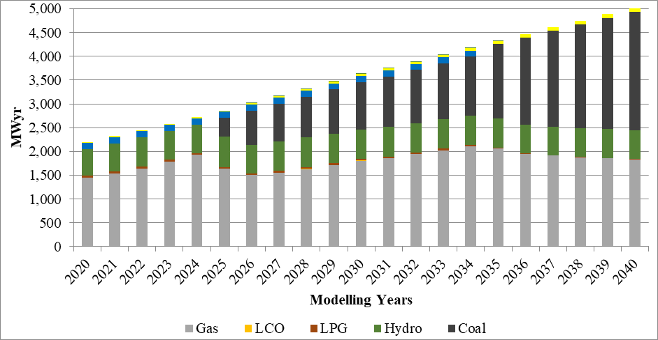

*FIG. 2. Reference scenario generation capacity*

The emphasis on renewables like hydro, solar, and wind, combined with the exclusion of nuclear power, highlights the need for a diversified energy generation mix. This approach aligns with Ghana's energy policies, including the "National Energy Policy" [14] and "Ghana's National Energy Transition Framework (2022–2070) [13]"

***4.1.2 An All-inclusive Technology Scenario***

In the all-inclusive technology scenario, total generation capacity expanded from 2,197.5 MWyr in 2020 to 5,034.6 MWyr in 2040, incorporating nuclear energy alongside other technologies. Nuclear power commenced in 2029 with 296.1 MWyr, rising to 1,782.9 MWyr by 2040, gradually displacing coal. The detailed generation capacity for this scenario is depicted in Fig. 3.

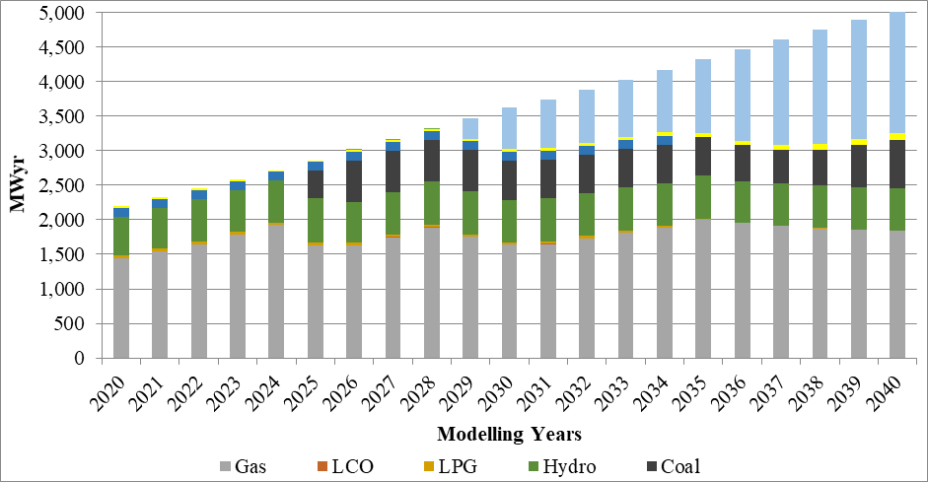

*FIG. 3. All-inclusive technology scenario*

***4.1.3 Carbon Dioxide Emissions of Scenarios***

The carbon dioxide (CO2) emissions of the two scenarios are depicted in Fig. 4. With the inclusion of nuclear power in the generation mix, CO2 emissions began to decrease from 2025, reducing from 9,489.1 kilotons to 8,554.72 kilotons in 2026. By the end of the study period in 2040, emissions were 20,264.8 kilotons for the reference scenario and 6,490.63 kilotons for the all-inclusive scenario. These findings align with previous studies for Ghana [23], [24] and further support the nation's energy policy ambitions to integrate nuclear energy, curtail emissions, and ensure a sustainable energy future [14], [26], [29].

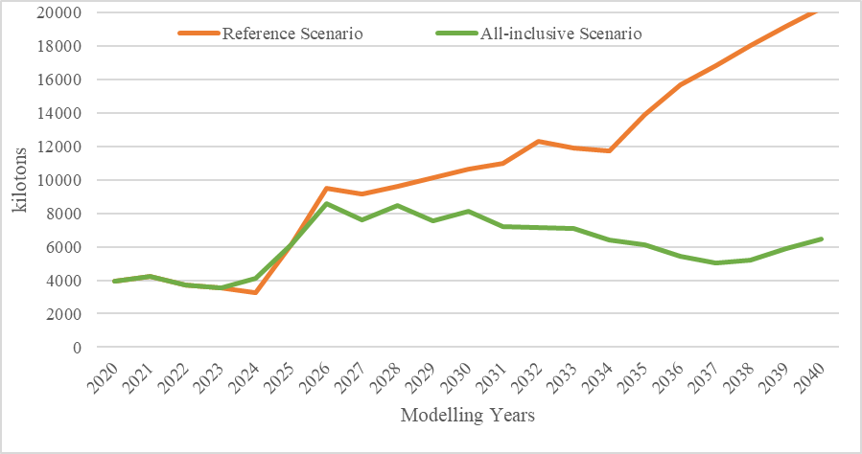

*FIG. 4. Carbon Dioxide (CO2) Emissions of Scenarios*

Thus, evaluating Ghana's integrated energy system, including SMRs, solar power, and wind power, has become increasingly significant.

**4.2 HOMER hybridization analysis**

The study by Nyasapoh et al. [29] concluded that a lifeline scenario does not offer a cost-effective energy source, whereas a hybrid energy system (HES) connected to the grid is optimal. The off-grid hybrid energy analysis is depicted in Fig. 5. For the off-grid N-R HES site analysed, the proposed system has a net present cost (NPC) of $2,392,143, incorporating 137 kW of PV and 129 kWh of battery capacity. The expected operating cost is $112,200.80 per year, compared to $128,162 per year for the current system. The payback period is 11.4 years with an internal rate of return (IRR) of 6.44%. The cost of energy (COE) for the project is $0.1888.

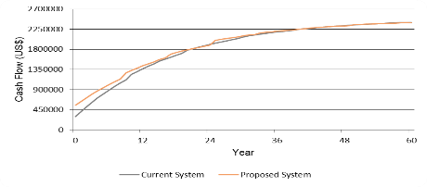

*FIG. 5. Cumulative cash flow over project life*

**8. RESEARCH LIMITATIONS AND FUTURE DIRECTIONS**

While this study offers insightful information about the proportional and economic integration or feasibility of SMRs with solar and wind energy in Ghana, there exist a number of limitations. Future studies should concentrate on technical, socio-political aspects, legal frameworks, and public acceptance in order to guarantee the effective implementation of integrated energy solutions.

**7. CONCLUSION**

In conclusion, Ghana's shift to a sustainable energy source has a lot of potential when Small Modular Reactors are combined with solar and wind energy. Ghana can meet its energy needs and help the global effort to address climate change by combining these technologies in concert. Therefore, governments and stakeholders need to give integrated clean energy infrastructure investments top priority if they want to expedite Ghana's energy transformation beyond COP28. The installation of SMRs alongside solar and wind energy sources should be given priority in this infrastructure. Ghana stands to gain a great deal from this, including increased economic growth, environmental sustainability, and energy security. However, a comprehensive strategy that takes into account socio-political, legal, and technical factors would be needed for its implementation.

**ACKNOLEDGEMENT**

This study, as part of student work was funded by the Regional Centre for Excellence in Energy and Environmental Sustainability of the University of Energy and Natural Resources, Sunyani-Ghana. The authors also appreciate the contribution of the International Atomic Energy Agency (IAEA) for funding capacity building through a Coordinated Research Project (CRP) (I32012).

**REFERENCES**

[1] M. Browning *et al.*, “Net-zero CO2 by 2050 scenarios for the United States in the Energy Modeling Forum 37 study,” *Energy Clim. Chang.*, vol. 4, p. 100104, Dec. 2023, doi: 10.1016/j.egycc.2023.100104.

[2] United Nations Climate Change, “The Paris Agreement,” UNFCCC Process-and-meetings. Accessed: Feb. 14, 2022. [Online]. Available: https://unfccc.int/process-and-meetings/the-paris-agreement/the-paris-agreement

[3] D. Icaza-Alvarez, F. Jurado, M. Tostado-Véliz, and P. Arevalo, “Decarbonization of the Galapagos Islands. Proposal to transform the energy system into 100% renewable by 2050,” *Renew. Energy*, vol. 189, pp. 199–220, Apr. 2022, doi: 10.1016/j.renene.2022.03.008.

[4] IAEA, “Nuclear–Renewable Hybrid Energy Systems,” 2023. [Online]. Available: https://www.iaea.org/publications/15098/nuclear-renewable-hybrid-energy-systems

[5] M. A. Nyasapoh, S. K. Debrah, N. E. L. Anku, and S. Yamoah, “Estimation of CO2 Emissions of Fossil-Fueled Power Plants in Ghana: Message Analytical Model,” *J. Energy*, vol. 2022, pp. 1–10, Apr. 2022, doi: 10.1155/2022/5312895.

[6] IRENA, “World Energy Transitions Outlook-2023.” 2023. [Online]. Available: https://www.irena.org/Publications/2023/Jun/World-Energy-Transitions-Outlook-2023

[7] E. N. Carpenter, “Chemistry of Sustainable Energy - 1st Edition.” Accessed: Jul. 18, 2023. [Online]. Available: https://www.routledge.com/Chemistry-of-Sustainable-Energy/Carpenter/p/book/9781466575325

[8] D. Ahuja and M. Tatsutani, “Sustainable energy for developing countries,” *SAPI EN. S. Surv. Perspect. Integr. Environ. Soc.*, no. 2.1, 2009.

[9] IAEA, “Nuclear Energy and Climate Change: Questions and answers on progress, challenges and opportunities,” 2023. Accessed: Dec. 12, 2023. [Online]. Available: https://www-pub.iaea.org/MTCD/publications/PDF/PAT-002_web.pdf

[10] US Department of Energy, “Benefits of Small Modular Reactors (SMRs).” Accessed: Jul. 23, 2024. [Online]. Available: https://www.energy.gov/ne/benefits-small-modular-reactors-smrs

[11] M. Bowen, E. Ochu, and J. Glynn, “The Uncertain Costs of New Nuclear Reactors,” *Columbia Univ. CGEP*, 2023.

[12] Z. Gilani, “Will Small Modular Reactors Surpass Regulatory and Supply Chain Hurdles to Fill the Need for Stable, Baseload Power?,” Cleantech Group. Accessed: Jul. 23, 2024. [Online]. Available: https://www.cleantech.com/will-small-modular-reactors-surpass-regulatory-and-supply-chain-hurdles-to-fill-the-need-for-stable-baseload-power/

[13] Ministry of Energy, “Ghana’s National Energy Transition Framework (2022-2070).” Accessed: May 17, 2023. [Online]. Available: https://www.energymin.gov.gh/search/node?keys=energy+transition

[14] Ministry of Energy, “National Energy Policy: Energy Sector, an Engine for Economic Growth and Sustainable Development,” 2021. [Online]. Available: https://energymin.gov.gh/sites/default/files/2023-09/2021 ENERGY POLICY.pdf

[15] MESTI, “Ghana: Updated Nationally Determined Contribution under Paris Agreement (2020-2030),” *Environ. Prot. Agency Minist. Environ. Sci. Technol. Innov.*, no. September, 2021, [Online]. Available: https://www4.unfccc.int/sites/ndcstaging/PublishedDocuments/Ghana First/Ghana%27s Updated Nationally Determined Contribution to the UNFCCC_2021.pdf

[16] MESTI, “Energy Transition and Investment Plan,” 2023. [Online]. Available: https://www.seforall.org/our-work/initiatives-projects/energy-transition-plans/ghana

[17] S. K. Debrah, M. A. Nyasapoh, F. Ameyaw, S. Yamoah, N. K. Allotey, and F. Agyeman, “Drivers for Nuclear Energy Inclusion in Ghana’s Energy Mix,” *J. Energy*, vol. 2020, pp. 1–12, Nov. 2020, doi: 10.1155/2020/8873058.

[18] IAEA & GNPPO, “MISSION REPORT ON THE PHASE 1 FOLLOW-UP INTEGRATED NUCLEAR INFRASTRUCTURE REVIEW (INIR) MISSION,” 2019. Accessed: Aug. 06, 2020. [Online]. Available: https://www.iaea.org/sites/default/files/documents/review-missions/inir-mission-to-ghana-january-2019.pdf

[19] International Atomic Energy Agency, “Modelling Nuclear Energy Systems with MESSAGE: A User’s Guide,” 2016. Accessed: Jul. 08, 2020. [Online]. Available: http://www.iaea.org/Publications/index.html

[20] S. Messner, “Endogenized technological learning in an energy systems model,” *J. Evol. Econ.*, vol. 7, no. 3, pp. 291–313, 1997.

[21] L. Schrattenholzer, “The energy supply model MESSAGE,” Laxenburg, Austria, 1981. [Online]. Available: http://pure.iiasa.ac.at/1542

[22] M. A. Nyasapoh, S. Gyamfi, S. K. Debrah, H. A. Gaber, and N. S. A. Derkyi, “Evaluating the Effectiveness of Clean Energy Technologies (Renewables and Nuclear) and External Support for Climate Change Mitigation in Ghana,” in *2023 IEEE 11th International Conference on Smart Energy Grid Engineering (SEGE)*, IEEE, 2023, pp. 167–171. doi: 10.1109/SEGE59172.2023.10274595.

[23] M. A. Nyasapoh, S. K. Debrah, and D. K. Twerefou, “Long-term electricity generation analysis and policy implications – the case of Ghana,” *Cogent Eng.*, vol. 10, no. 1, Dec. 2023, doi: 10.1080/23311916.2023.2209996.

[24] M. A. Nyasapoh and S. K. Debrah, “Nuclear Power Contribution Towards a Low-Carbon Electricity Generation for Ghana,” in *Climate Change and the Role of Nuclear Power. Proceedings of an International Conference. Supplementary Files*, 2020. [Online]. Available: https://inis.iaea.org/search/search.aspx?orig_q=RN:52004321

[25] M. A. Nyasapoh, “Modelling Energy Supply Options for Long-term Electricity Generation - A Case Study of Ghana Power System,” University of Ghana, 2018. [Online]. Available: http://ugspace.ug.edu.gh/bitstream/handle/123456789/34942/Modelling Energy Supply Options for Long-Term Electricity Generation - A Case Study of Ghana Power System.pdf?sequence=1&isAllowed=y

[26] Ministry of Energy Ghana, “National Energy Transition Framework Abridged Version.”

[27] Shenzhen Energy & VRA, “2x350 MW Supercritical Coal-Fired Power Plant. Environmental & Social Impact Assessment: Scoping Report,” 2015. Accessed: Aug. 06, 2020. [Online]. Available: https://www.vra.com/media/scoping_notices/2015/2x350MW Ghana Supercritical Coal Fired Power Plant - Scoping Report.pdf

[28] PURC, “Public Utilities Regulatory Commission (PURC) Publication Of Electricity Tariffs,” vol. 1997, no. December 2020, 2021, [Online]. Available: https://www.purc.com.gh/attachment/642643-20210225110236.pdf

[29] M. A. Nyasapoh, S. Gyamfi, S. K. Debrah, H. Gaber, and N. S. A. Derkyi, “Assessment of the Economic Viability of Nuclear-Renewable Hybrid Energy Systems: Case for Ghana,” in *2022 IEEE 10th International Conference on Smart Energy Grid Engineering (SEGE)*, IEEE, 2022, pp. 74–80. doi: 10.1109/SEGE55279.2022.9889765.