Comparative Assessment of Small Modular Reactors versus Large Nuclear Power Plants for Future Electricity Generation in Libya

Tariq Zakariya Malatim

Libyan Atomic Energy Establishment

Tripoli, Libya

Email: [Tariqmolatim@gmail.com](mailto:Tariqmolatim@gmail.com)

Mustafa Ali Ben Ghzail

Libyan Atomic Energy Establishment

Tripoli, Libya

Email: [mustafa002000@Yahoo.com](mailto:mustafa002000@Yahoo.com)

**Abstract**

Libya faces a critical electricity shortage due to high demand, aging infrastructure, and reliance on fossil fuels. The study investigates the potential of Small Modular Reactors (SMRs) and compare it with to large Nuclear Power Plants (NPPs) for future electricity generation. We compare three scenarios: a single large NPP with four VVER-1200 reactors situated in Sirt city -in the middle of the country-, a single NPP in Sirt equipped with multiple ACP100 SMRs, and multiple SMR-based NPPs distributed across Libya. SMRs offer advantages in construction time and modularity, potentially facilitating a phased approach to nuclear energy development in Libya. However, the economic and logistical complexities of deploying numerous SMRs currently outweigh the benefits for Libya's immediate needs. While SMRs hold promise in the long term, a large-scale NPP represents a more viable near-term solution. We recommend a VVER-1200-based NPP in Sirt as the first stage, followed by the potential for SMRs as Libya's capabilities expand. This approach balances immediate energy needs with long-term sustainability and flexibility.

## NTRODUCTION

The global energy demand is rising due to population growth and increasing technological reliance. However, Libya's energy consumption stands out for its exceptionally high growth rate, exceeding its population increase. Libyans consume electricity at a remarkably high rate – nearly equal to Italy, double Jordan, triple Egypt, and quadruple Algeria and Tunisia [1]. This trend is further evidenced by the significant rise in gasoline and diesel imports between 2012 and 2016 (2,540,213 tons to 3,542,803 tons for gasoline and 1,415,200 tons to 2,146,691 tons for diesel) [2]. Such a dramatic increase cannot be solely attributed to normal consumption patterns. This exceptional reliance on fossil fuels is further underscored by the fact that hydrocarbons constitute 100% of Libya's energy production [1]. This dependence on fossil fuels directly translates to rising Carbon dioxide (CO2) and greenhouse gas (GHG) emissions. The EDGAR report (2023) on global fossil fuel emissions confirms this trend, highlighting a continuous rise in Libya's CO2 emissions since 1970 [3]. Additionally, the Global Carbon Atlas identifies Libya as one of the countries with the fastest-growing CO2 emission rates where in (2022) Libya had a rank of 50 in the world by emissions and 63 of MTCO2 [4].

The situation is further complicated by Libya's damaged energy infrastructure, a consequence of the civil war that began in 2011. This damage has led to extended blackouts, particularly during the summer months. In 2018 and 2019, blackouts reached nearly 50%, causing widespread disruptions and threatening national stability [5]. Experts predicted a further decline in grid performance, potentially leading to a complete collapse by 2022. This pessimistic forecast included extensive blackouts in 2021 and a fragmented national grid by 2022-2023, with power generation localized to functional power stations [5]. Recognizing the critical situation, a coalition of organizations including USAID, UNEP, UNDP, World Bank, and UNSMIL joined forces in early 2020 to support the restoration and improvement of Libya's electricity grid. In collaboration with GECOL, this initiative resulted in the Libya Emergency Grid Stabilization Program, endorsed in February 2021. This program outlines nine key components aimed at stabilizing the grid, enhancing overall energy efficiency and reducing costs. Notably, component eight states that “a national sustainable energy strategy for 2035 should be established” while component nine states “renewable energy project should be developed” [5]. While experts favor solar energy as a more suitable solution for Libya. However, the reality is that no single source, including solar, can meet a nation's entire energy needs. Given the absence of significant wind and hydropower resources in Libya, nuclear energy remains a potential long-term option, where it is the only clean and mature energy source.

### Libya's Nuclear Program

Libya embarked on its nuclear program in the early 1970s. This initiative included the construction of the Tajura Nuclear Research Center (TNRC) in the early 1980s [6]. The TNRC that includes a 10-megawatt research reactor and aimed to cultivate a domestic nuclear workforce. To achieve this, Libya established in late 1970s the Nuclear Engineering Faculty at the University of Tripoli and offered scholarships for students to study in developed countries. Additionally, Libya pursued collaboration with the Soviet Union throughout the 1970s to build a nuclear power plant using the VVER-440 reactor design. The project progressed significantly, with even site surveys completed. Later, in 2006, Libya signed a cooperation agreement with France to construct a power plant utilizing EPR-1600 reactors [7]. Unfortunately, both projects ultimately stalled due to political circumstances. Despite the unfulfilled large-scale projects, Libya did achieve notable successes. The country cultivated a skilled workforce capable of operating the research reactor safely for extended periods. Additionally, a strong scientific foundation in the nuclear field was established. These accomplishments will undoubtedly facilitate the future adoption of a nuclear power plant in Libya. Currently, the Libyan Atomic Establishment oversees all nuclear activities within the nation.

### Electricity Situation in Libya

Libya's electricity sector is entirely state-owned, with the General Electricity Company of Libya (GECOL) overseeing generation, transmission, and distribution. Prior to the 2011 revolution, Libya boasted one of the highest electrification rates in Africa. However, the sector now faces significant challenges, including inadequate generation capacity, low tariffs, high commercial losses, and substantial subsidy burdens. These issues have resulted in poor quality of supply, frequent outages, and daily load-shedding due to power generation shortfalls. Recent years have also seen multiple instances of grid collapse. Between 2010 and 2015, while revenue collection decreased, electricity consumption rose from 32.5 TWh in 2010 to 40.3 TWh in 2015, making Libya's per capita consumption significantly higher than regional comparators [5]. In 2012, total electrical energy production was 33.980 GWh. By 2017, GECOL reported that the network's available capacity was 4,900 MW against a demand of 6,500 MW, with a deficit of 130 MW in the east and 1,470 MW in the west. GECOL projects that maximum load will increase to 14,834 MW by 2030 and 21,669 MW by 2050. In 2020, despite having an installed capacity of 10,236 MW, Libya only produced an average of 5,300 MW. This output drops further to 3,700 MW during the summer months, when peak demand, such as in August 2019, reached 7,639 MW—a supply-demand deficit of 52%. Although the UNEP and UNDP have collaborated on the Libyan energy sector support project (LESST) [5] since 2019, leading to some improvements in the grid, a comprehensive plan for alternative solutions is urgently needed. This is crucial to meet the growing electricity demand driven by population growth and the aging infrastructure of existing power plants. The lack of reliable electricity also severely impacts access to fresh water. Most of Libya's future freshwater needs will depend on desalination, which is both energy and capital intensive. Current desalination capacity and wastewater treatment have significantly eroded. Coastal aquifers are increasingly infiltrated by seawater due to overuse and rising sea levels, leaving the fossil aquifers of the Man Made River (MMR) as the primary freshwater source. Addressing these interconnected challenges is vital for Libya's sustainable development. Next figure shows a map of Libya’s electricity grid.

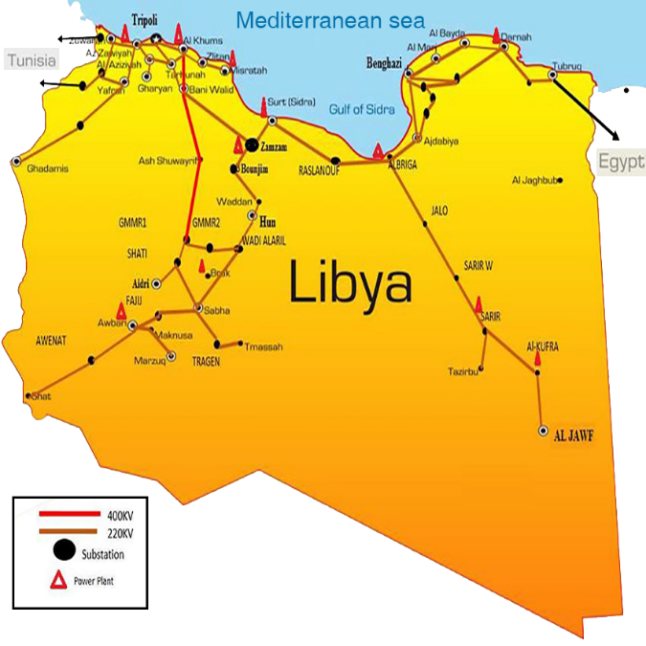

*FIG. 1. Map of Libya’s electricity grid 1*

### Libyan Population and Geography

Libya, located in North Africa, is characterized by its vast geographical expanse and relatively sparse population distribution. Covering approximately 1.76 million square kilometers, it is the fourth largest country in Africa. Despite its size, Libya's population is 6,958,666 people, with a significant concentration in the coastal regions, particularly around the capital city of Tripoli in the west and Benghazi in the east. These urban areas, benefiting from access to the Mediterranean Sea, are the most densely populated. In contrast, the interior regions, dominated by the Sahara Desert, are sparsely inhabited. The most stable areas in terms of natural crises tend to be the coastal cities, as they are less susceptible to the extreme desert conditions and occasional flooding that can affect the inland areas. Additionally, these coastal cities have better infrastructure and resources to manage and mitigate natural disasters, making them relatively more resilient. The next figure shows the population density in Libya 2023 [8]

*FIG. 2. Map of Libya’s population density.*

## REACTOR TECHNOLOGY SELECTION

The Libyan Atomic Energy Establishment (LAEE) has identified four potential large reactor types for consideration: AP1000, APR1400, EPR1600, and VVER-1200. While recently exploring Small Modular Reactors (SMRs) as an option, this study will focus on a single representative from each category.

### Large Reactor Selection

The VVER-1200 was selected among four reactors to be the proposed reactor for the NPP, which will include four units of this reactor. The choice of the VVER-1200 over other reactors was primarily geopolitical rather than technical, although it does possess advanced safety systems. The main reason for selecting the VVER-1200 is its higher likelihood of being adopted due to Russia's longstanding alliance with Libya. It is unlikely that Western companies would currently provide Libya with nuclear technologies. Libya has historical experience with Russia, as the only research reactor in the country was built by Russia, and a nuclear power plant (NPP) was planned for construction by Russia in the 1970s-1980s. Additionally, aside from the UAE, all other countries in the region with operational or under-construction nuclear reactors are using Russian technology, including Egypt, Turkey, Bangladesh, and Iran. This regional trend further supports the potential for the VVER-1200 to be favored over other reactors.

### SMRs Selection

The selection of Small Modular Reactors (SMRs) is more complex compared to large reactors, primarily because SMR technology is still under research and development, with only a few reactors currently under construction. Furthermore, the LAEE has not yet decided which reactors will be nominated. However, to narrow down the options, we considered various available SMR technologies, including Fast Breeder Reactors (FBR), Molten Salt Reactors (MSR), Supercritical Water Reactors (SCWR), High-Temperature Gas-Cooled Reactors (HTGR), Pressurized Water Reactors (PWR), and Boiling Water Reactors (BWR). Among these, the PWR was selected due to its well-understood physics and extensive operational experience in large reactors. As of 2020, 67% of reactors worldwide were of the PWR type [9]. This decision reduced the number of potential SMR candidates to those using PWR technology, including (CAREM, ACP100, CANDU SMR, CAP200, DHR400, HAPPY200, NHR200-II, TEPLATOR, NUWARD, IMR, i-SMR, SMART, RITM-200, RITM-200N, OPEN20, mPower, Westinghouse SMR, SMR-160, VOYGRT, Rolls-Royce SMR, STAR, and RUTA-70) [10]. Since only CAREM and ACP100 are currently under construction, these two reactors were considered. Ultimately, ACP100 was selected to be the reactor operating both single NPP and Multi NPP in the subsequent sections. ACP100 has the potential for export outside China, unlike CAREM, which was developed by Argentina. Additionally, China has established strong relationships with the African Union and possesses the economic capability to undertake such significant projects within a short timeframe.

## SCENARIOS

This study employs a hypothetical approach, assuming the establishment of a nuclear power plant (NPP) in Libya. The plant's capacity is based on the Libyan General Electricity Company's expectation of energy demand for 2050, which is projected to be 21,669 MW [11]. The percentage of nuclear energy in the national energy mix is assumed to be 22%.

* 1. **Scenario 1:** an NPP with large reactors located in Sirt, with four units of the VVER-1200. Each unit will produce 1,198 MWe, resulting in a total capacity of 4,792 MWe, which will be connected to the grid.
  2. **Scenario 2:** an NPP using SMR technology, with all reactors located in Sirt within one power plant. Given that the ACP100 has an electric power output of 125 MWe, 40 units of ACP100 will be required to supply 22% of the electricity to the grid.
  3. **Scenario 3:** Implement multiple SMR-based NPPs with 40 units of ACP100 reactors distributed throughout the country. The specific locations for these reactors will be identified in the next section.

## SITTING SELECTION

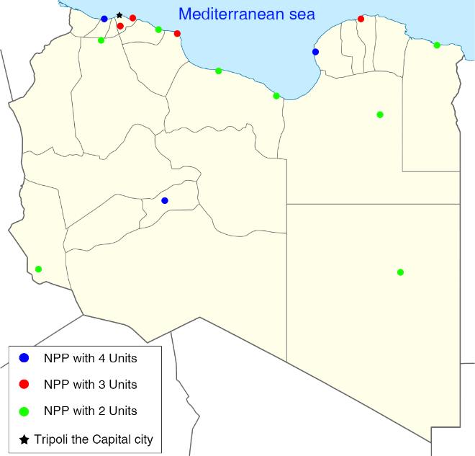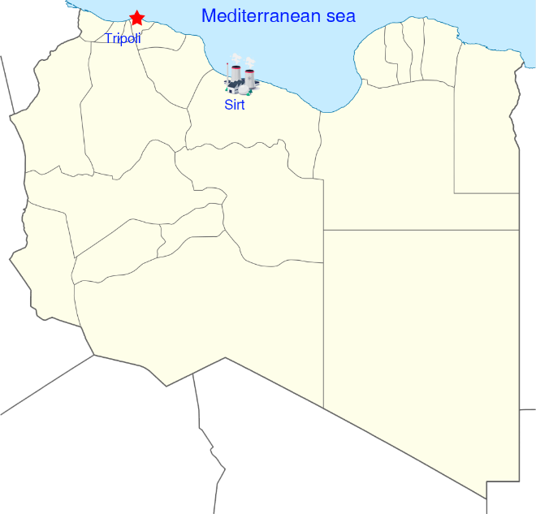 For the first and second scenarios, the study relies on research conducted in the 1980s in Libya, which identified a suitable location for the NPP site 107 km north of Sirt city, in the central northern part of Libya along the Mediterranean Sea. For the third scenario, Libya's geology and population distribution are critical factors. Therefore, the NPPs will be built near cities with high population densities. Although Libya generally has stable conditions, sites with potential natural disaster risks will be avoided. The following map shows the locations of each NPP. As most Libyan cities with high population densities are located along the Mediterranean Sea, the NPPs in these areas will use seawater for cooling. For southern cities, the Man-Made River (MMR) could be utilized as a cooling water source.

*FIG. 3. Sitting selection in the right the single NPP in Sirt while in the left Multi NPP with SMRs units.*

## RESULTS

### Cost

* + 1. *Capital costs*

The capital cost for building a unit ACP100 reactor is estimated to be around $1 billion, however, subsequent reactors can be cheaper due to shared infrastructure and economies of scale. For instance, each additional reactor might cost around $800 million. While 1 unit of VVER1200 is estimated to be around $6 billion to $7 billion [] in both cases the construction of the reactor, associated facilities, and the initial fuel load costs are included.

#### Regulatory and licensing costs

Typically add tens of millions to the overall cost due to the extensive safety and environmental reviews required.

#### Infrastructure and grid connection

Costs for site preparation, grid connection, and supporting infrastructure for ACP100 can range from $100 million to $300 million. While in case of VVER1200 it can range from $500 million to $1 billion depending on local conditions.

#### Transportation

SMRs like the ACP100 are designed to be modular and more compact than traditional reactors, with an estimated weight of around 400-500 tons per unit while VVER1200 are large reactors with significant weight and size, approximately 1,000-1,200 tons per unit. Weight and Size and distance are the most important factors, for distance the VVER1200 will shipped from Russia to Libya by sea by distance of 7000 Km while ACP100 units will be shipped from China to Libya by distance of 18000 KM, by calculate freight charges, insurance and permits and compliance the results for 4 units of VVER1200 will be $240.28 million to $721.2 million while $40.8 million to $123.6 million

.

Table 1 shows the cost of each units

|  |  |  |  |
| --- | --- | --- | --- |
| Parameter | Scenario 1  (4 Vver1200) | Scenario 2  (Single Npp 40 Acp100) | Scenario 3  (Multi Npp 40 Acp100) |
| Capital Costs | $27 billion | $32 billion | $40 billion |
| Infrastructure and Grid Connection | $1 billion | $500 million | $300 million |
| Transportation | $721.2 million | $123.6 million | $129.8 million |
| Total | $28.72 billion | $32.623 billion | $40.430 billion |

This calculation shows that ACP100 SMRs can be significantly cheaper per unit compared to large reactors like the VVER-1200. However, the total cost scales with the number of units, and the overall cost for a large number of ACP100 units can exceed that of fewer large reactors.

### Safety and Security Consideration

#### Security

Security is a crucial aspect of an NPP, requiring continuous training and financial support to ensure effective procedures. Having a single site within the country is preferable to multiple sites, as securing numerous locations across Libya’s vast area would be challenging and require substantial personnel and a large financial budget.

* + 1. *EPR Plan*

The Emergency Preparation and Response (EPR) plan for the first and second scenarios can be similar. However, for the third scenario, implementing a plan for multiple NPPs in different locations would be very challenging. As mentioned in the previous section.

#### Eliminate off-site emergency zones

The table below compares the elimination of off-site emergency zones for large reactors and SMRs.

Table 2 comparison between large and SMR in EOSEZ [12]

|  |  |  |
| --- | --- | --- |
|  | ACP100 | VVER1200 |
| Non-Residential Area (EAB) | 300 M | 500m |
| Planned Restricted Zone (LPZ) | 800 M | 5km |
| Emergency Plan Zone (EPZ)  Internal Zone | 400 M | 3—5 Km |
| Emergency Plan Zone (EPZ)  External Zone | 600 M | 7—10 Km |

Although SMRs have smaller emergency zones, this is not a disadvantage in this case since the NPP with large units will be built in an unpopulated area near Sirt city.

#### Waste Management

Although studies suggest that the nuclear waste produced by the ACP100 may be slightly more than that from the VVER1200, waste management remains the most difficult and dangerous part to handle. For a single site, a plan can be made to establish storage facilities beside the station. However, for multiple NPPs located far apart, this process becomes significantly more complex. Even if one site is chosen for storage of all NPPs waste, the transportation process itself would add to the complexity.

### Workforce

For the workface each unit is expected to require about 15-20 nuclear engineers. This number is achievable in Scenario 1, where the NPP with 4 units would need around 50 nuclear engineers. In Scenario 2, with 40 units of ACP100 SMRs (single NPP), the number increases to around 120 nuclear engineers. For Scenario 3, with 40 individual NPPs, each with one unit of ACP100 SMR, the number would increase further to around 200 nuclear engineers. While the number of engineers required for the first scenario can be achieved with national staff, it would be challenging for both the second and third scenarios, considering that some engineers will soon retire. Therefore, a capacity-building plan should be implemented parallel to the construction of the NPP to ensure the required number of qualified engineers is available.

* 1. **Time of Construction.**

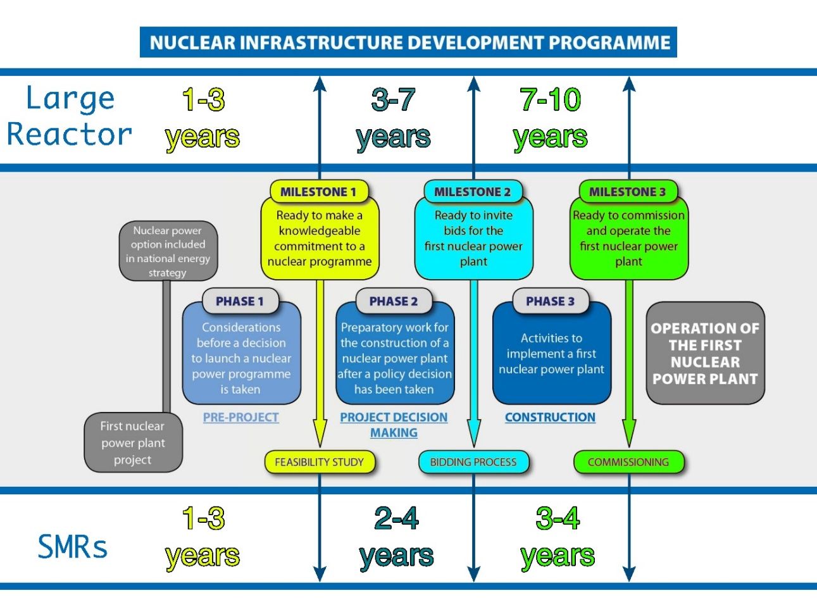The construction time for nuclear power plants (NPPs) can vary significantly due to numerous factors. This study considers both best-case and worst-case scenarios. The IAEA milestones can be time-consuming and require substantial effort to complete. The following figure illustrates the time needed for each unit for both large reactors and SMRs:

*FIG. 4 Milestones in the Development of a National Nuclear Infrastructure programme for Nuclear Power [13]*

Table 3 Comparison of Construction Time for Large Reactors and SMRs

|  |  |  |
| --- | --- | --- |
|  | Best Scenario | Worst Scenario |
| Large Reactor | 11 Years | 20 Years |
| SMR | 6 Years | 11 Years |

It can be concluded that the worst-case scenario for SMRs equates to the best-case scenario for large reactors. However, this comparison is based on a one-to-one unit basis. In our case, it is unlikely that 40 units of ACP100 would be built simultaneously, as this would require a substantial amount of personnel, materials, and equipment. Conversely, constructing four units of VVER-1200 simultaneously is more feasible.

1. **CONCLUSION**

While SMRs present a promising alternative to large NPPs due to their shorter construction times, lower initial costs, and modularity, the overall economic and logistical complexities associated with deploying multiple SMRs make large NPPs a more viable option for Libya's immediate nuclear energy needs. The VVER1200-based NPP scenario is economically more feasible, easier to manage in terms of workforce and infrastructure, and better suited to Libya's current nuclear capabilities and geopolitical context.

Given the urgent need to address Libya's electricity shortages and aging infrastructure, a phased approach could be considered. Initially, deploying a large NPP in Sirt could stabilize the grid, followed by a gradual introduction of SMRs as the workforce and infrastructure capabilities expand. This approach balances immediate energy needs with long-term sustainability and flexibility.

**REFERENCE**

1. PATHWAYS TOWARDS A STABLE AND RESILIENT LIBYA- Libya Joint Country Assessment 2018 UN
2. United Nations Strategic Framework for Libya 2019 – 2022
3. <https://edgar.jrc.ec.europa.eu/report_2023>
4. RESEARCHER, A., Organization, unpublished data.
5. United Nations Development Program & United Nations Environmental Program Libyan Electricity Sector Stabilisation and Transition Support (LESST) Final Narrative Report January 2021 – Dec 2022
6. Libya Nuclear Facilities (https://www.nti.org/analysis/articles/libya-nuclear-facilities/)
7. <https://www.world-nuclear-news.org/Articles/France-and-Libya-sign-for-nuclear-cooperation>
8. <http://www.geo-ref.net/ph/lby.htm>
9. IAEA Nuclear Power Reactors in the World REFERENCE DATA SERIES No. 2 2021 Edition
10. Advances in Small Modular Reactor Technology Developments A Supplement to: IAEA
11. Exploring Solar andWind Energy as a Power Generation Source for Solving the Electricity Crisis in Libya – 3 June 2020
12. Advanced SMR and Multipurpose Applications - Zeng Chang - Nuclear Power Institute of China -September 2023
13. Nuclear Infrastructure for SMRs- Interregional Training Course on Safety Of Small Modular Reactors (SMRS) - 30.10.2023