# Optimization of SMR cogeneration application

# in an urban environment

Endre Börcsök

HUN-REN EK-CER

Budapest, Hungary

endre.borcsok@ek.hun-ren.hu

Veronika Groma

HUN-REN EK-CER

Budapest, Hungary

Péter Füri

HUN-REN EK-CER

Budapest, Hungary

Lilla Barancsuk

HUN-REN EK-CER

Budapest, Hungary

**Abstract**

Primary goal of the paper to determine what expectations can be formulated for a newly installed SMR in terms of district heating supply and integrated electricity production in an urban environment. Alongside optimal sizing, the level of flexibility and cogeneration capability required for integration into the urban energy system was examined. When establishing the potential role, a fundamental question naturally arises regarding how competitive nuclear energy is compared to the most important alternatives currently used, such as waste, biomass, fossil fuel-based, or electrically powered heat pumps. In formulating optimal solutions, economic considerations were taken into account along with climate impact and environmental effects. Results of the paper was based on Budapest's building typology, district heating system, and a fine resolution dataset of its energy demand, implementing our optimization calculations as a type of fixed cost distribution problem. The results presented could provide guidance in designing cogeneration applications for SMRs..

## INTRODUCTION

In many countries around the world, ensuring a carbon-neutral energy source for the heat sector, especially residential heating, poses significant challenges. In previous studies, we have often dealt with the optimal design of primary energy sources related to the heating sector of large cities. In these projects, we could only consider the use of nuclear energy to a limited extent because the types of currently operating power plants are mostly not located in the immediate vicinity of large cities for safety and social reasons. As a result, integrating nuclear energy into the heating sector portfolio is possible through long pipelines. The construction costs of these pipelines and the market uncertainties associated with half a century of operation undermine these investments in most cases, removing the most important carbon-neutral alternative from the portfolio. These outlined difficulties increasingly shift the heating sector towards the use of electricity with the application of heat pumps. Heat pumps powered by the electrical grid offer many advantages, as they can also utilize traditional renewable energy sources; however, ensuring supply security in this case also requires additional investments. In such competitive environment, we are examining the new opportunities offered by SMRs (Small Modular Reactors) and the conditions which under they can be competitive in the current technical level. In the present work, the modeling is performed for the heat demand of three building typology groups in a city with a continental climate (Budapest, Hungary) where the heating season lasts 4-6 months.

## Methodology

Our primary goal in this study is to reduce the carbon intensity related to the heating and electricity sectors in urban environments. Obviously, our goal was to achieve this without compromising the environmental aspects of sustainability and the security of supply. Taking these aspects into account, our aim was to determine the role of nuclear energy, particularly SMR technology, in the energy supply. Calculations were performed for the individual and district heating of three building typology groups (family houses, apartment buildings, and industrial multi-story buildings) for heat supply. Since the heat sector is closely intertwined with electricity usage on the production side through cogeneration and on the consumption side through heat pumps, we had to consider the entire energy sector in our model. In our model, we used the energy demand and electricity generation profile for 28 days of the year 2019 based on ENTSO-E database.[1] These selected days covered four weeks of the year, one each from winter and summer, and two from the transitional periods. We considered the daily heat production profile to be homogeneous and only took seasonal differences into account. For electricity generation, we applied fixed daily profiles only for intermittent renewable energy sources, such as wind, solar, and hydro power. Other electricity generation alternatives were optimized to meet consumption. Calculations were solved as a distribution task. Storage capacities and the predefined performance gradients of power plants played an important role in harmonizing the production and consumption curves. The objective function of the optimization considered four criteria: fixed and variable costs, air pollution and climatic impacts. [2] The uniformed criteria values for the main electricity generation alternatives are presented in TABLE 1..

TABLE 1. UNIFORMED CRITERIA VALUES FOR AGGREGATED ALTERNATIVES

|  |  |  |  |  |  |  |  |
| --- | --- | --- | --- | --- | --- | --- | --- |
| Heat | | | | | | | |
|  | natural gas | brown coal | biomass | electric | heat pump | municipal waste | SMR |
| Fixed cost | 0.22 | 0.33 | 0.33 | 0.22 | 0.23 | 0.67 | 1.28 |
| Variable cost | 1.27 | 0.79 | 0.79 | 2.05 | 0.36 | 0.55 | 0.75 |
| Climate effect | 0.47 | 3.30 | 0.07 | 0.34 | 0.08 | 0.01 | 0.01 |
| Environmental impacts | 0.52 | 1.59 | 0.62 | 0.44 | 0.11 | 0.08 | 0.10 |
| Electricity | | | | | | | |
|  | natural gas | brown coal | biomass | nuclear | wind | solar | hydro |
| Fixed cost | 0.38 | 0.93 | 1.11 | 1.28 | 0.70 | 0.17 | 1.20 |
| Variable cost | 0.95 | 0.54 | 0.63 | 0.29 | 0.23 | 0.40 | 0.34 |
| Climate effect | 1.73 | 3.30 | 0.30 | 0.04 | 0.03 | 0.29 | 0.02 |
| Environmental impacts | 0.59 | 1.59 | 3.04 | 0.17 | 0.09 | 0.98 | 0.06 |

For economic considerations, we accounted for a 25% fuel savings due to the efficiency increase related to cogeneration. However, we tried to control the up and down regulation of power plants with additional costs. Since we separated fixed and variable costs in our work, our model belongs to a narrow group of distribution tasks, which we solved as a continuous relaxation of the transportation task with fixed costs. The study introduces $w\left(s\right)$ importance weights of criteria (*s*), the scores of alternatives according to criteria based on data from the literature, in case of installed capacities $CP\left(s;a\right)$, and for hourly electricity or heat generation $CE\left(s;a\right)$. The hourly electricity or heat generation $x\left(a;d\right)$ and the installed capacities $x_{p}\left(a;d\right)$ optimized as variables, whilst the objective function to be minimized is formalized as follows:

$$\sum_{s}{\sum_{a}{\sum_{d}{w\left(s\right)\left(CE\left(s;a\right)x\left(a;d\right)+CP\left(s;a\right)x_{p}\left(a;d\right)\right)=z\left(min\right).}}}$$

This linear programming optimization problem is a type of fixed cost distribution problem, with production constraints summarized by the equation:

$\sum_{a_{h}}{x\left(a;d\right)= dem(t;h) }$ $\sum_{a_{h}}{x\left(a;d\right)= dem(e;h) }$

where $a_{h}$ is the hourly value of the electricity or heat generation time series, while the parameter $dem(t;h)$ and $dem\left(e;h\right)$ are the hourly electricity and heat demand of the city. For the thermal power plants, two artificial variables were introduced to account for the hourly increase and decrease in production:

${x(a}_{th};d)+x(a_{uh};d)-x(a_{dh};d)=x(a_{t\left(h+1\right)};d$),

where production data of alternatives are $x(a_{th};d)$, for the hour *h* of each day *d*, the hourly increase in production $x(a_{uh};d)$, and the hourly decrease in production $x(a_{dh};d)$. Similarly, for energy storage, the recursive conditions were given by:

${x(a}_{qh};d)+x(a_{ih};d)-x(a_{oh};d)=x(a_{q\left(h+1\right)};d$) ,

where $x(a_{qh};d)$ is the stored energy value for the given hour, while the ${x(a}_{ih};d)$ and $x(a_{oh};d)$ values are the amounts of the charged and discharged energy. Constraints corresponding to the installed capacities and the potential constraint of the annual maxima of alternatives related to variable renewable energy sources were also applied:

$$x(a;d)≤δ_{sph}x_{p}\left(a;d\right)$$

where seasonal hourly profiles for the variable renewable energy sources ${0≤δ}_{sph}≤1$. Beyond economic considerations, the other aspects considered in the objective function also exhibit high uncertainty in evaluating energy alternatives. The wide evaluation intervals found in the literature shifted our model calculations towards robust optimization, which is facilitated by w(s) importance weights introduced in the objective function. This allowed us to perform global sensitivity analysis, based on which we attempted to formulate basic expectations related to SMR technology. We implemented robust optimization using Monte Carlo simulation on the evaluation intervals of the alternatives. It is important to note, however, that in our calculations, we did not use the current heating and electricity generation infrastructure, relying only on the existing distribution network. In light of this, our modeling results should primarily be viewed as potential development directions for the upcoming decades. The primary aim of this study is not to present our modeling results but to determine the conditions for the application of SMR reactors.

## Results

We aimed to model the heating and domestic hot water supply for a 4-hour period related to three building typology groups in an urban environment. A crucial part of the developed model was ensuring the hourly demand for electricity supply. Our previous calculations [3][4] supported the indispensable role of nuclear energy in the electricity and heat sector. The main question was under what conditions the SMR technology could play a role in either the heat or electricity sector. In our work, we allowed three SMR categories, each with an identical 200MW capacity. Besides the heat-generating unit installed for district heating and the reactor purely generating electricity, cogeneration usage also played a role. During robust optimization, we based our analysis on the data from large 2400MW power plants (Paks II.) for both the SMR and the electricity supply. Naturally, the initial data for SMR did not play a decisive role, as we varied them extremely (40%-160%) during the modeling. We summarize the results of the several hundred runs by presenting the extremes. The change in the criteria for robust optimization was uniformly applied to all alternatives. This allowed us to examine what scenarios emerge in the case of high carbon prices or increasing investment costs. Based on these, it can be observed that even with a 16% increase in investment costs, nuclear energy is still present in the electricity sector with a significant 1200MW installed capacity, although it decreases. (*Fig. 1*.)

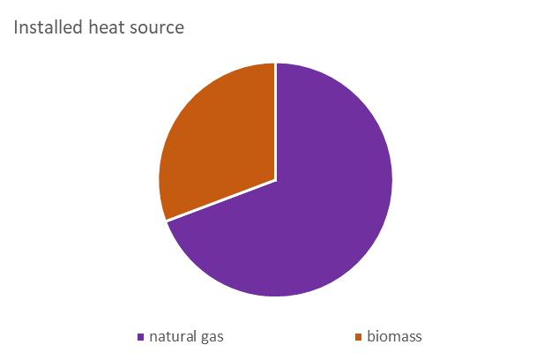 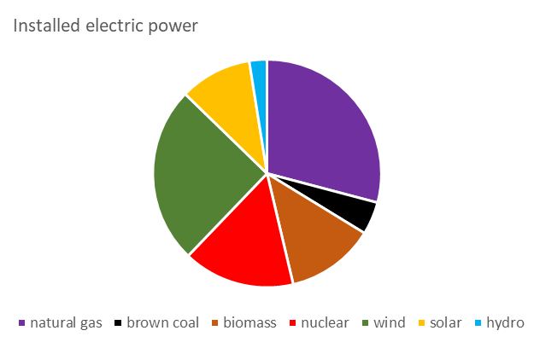

*FIG. 1. Installed heat and electric power in main city with increased in investment cost.*

Highlighting the environmental impacts, the inefficient biomass burning associated with family houses disappears from the energy mix, being replaced by large-scale district heating. In the case of electricity generation, nuclear energy takes over the role of brown coal and biomass. (*Fig. 2*.)

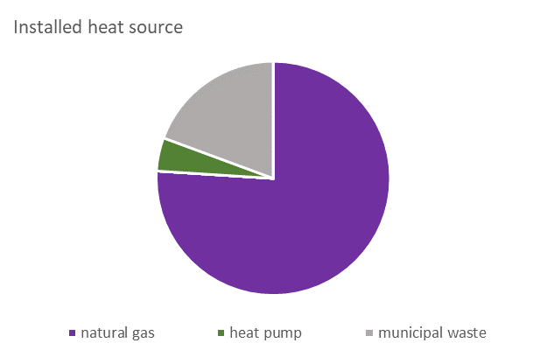 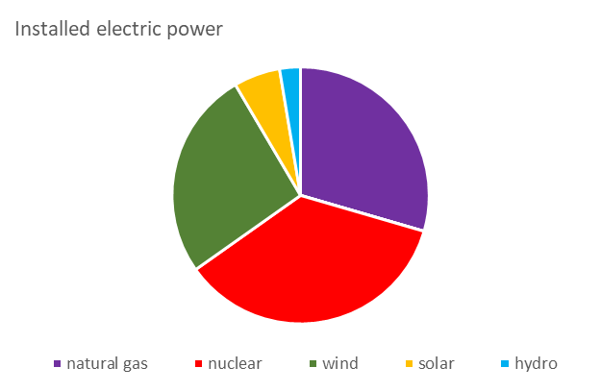

*FIG. 2. Installed heat and electric power in main city with highlighted environmental impact.*

In our model, nuclear energy could be used directly in the heat sector only through the application of SMR reactors. Naturally, the indirect utilization of nuclear energy via heat pumps had already been realized in previous scenarios; however, its direct implementation primarily depended on the investment cost. To introduce SMR reactors, it was necessary to significantly reduce the reactor's fixed cost by at least 48%. (*Fig. 3*.)

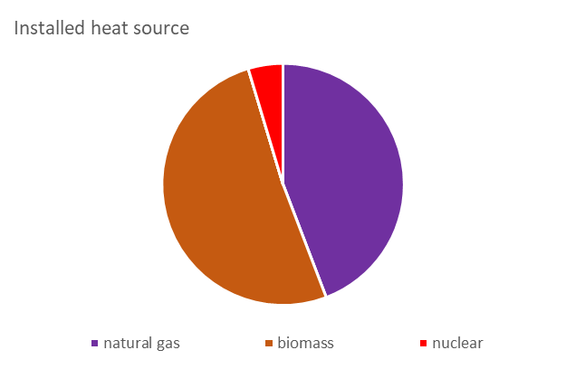 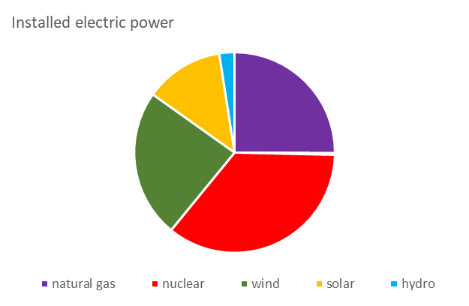

*FIG. 3. Installed heat and electric power in main city with reduced SMR investment cost.*

In the outlined scenario, SMR with cogeneration played a role in the energy mix, with a heat to electricity ratio considered at 65% to 20%. The heat provided by the reactor supplies domestic hot water and heating throughout the year, while other energy sources provide the seasonal balancing energy. Regarding the obtained results, it is important to highlight that large nuclear power plants were also included in our model, making them competitors to the SMR reactors. In reality, the prominent role of SMR reactors is evident where geographical or geopolitical conditions do not permit the operation of large power plants.

## Conclusion

Based on the results, it can be stated that nuclear energy is indispensable in carbon-neutral energy scenarios. According to our calculations, a 2000MW or larger nuclear power plant always formed the basis of the electricity sector. In the shadow of large power plants, SMR technology is only competitive with a significant reduction in capital costs. Since our model did not exclude the presence of large power plants, this study did not address scenarios where only SMR implementation is feasible.

Based on the results, it can be stated that nuclear energy is indispensable in carbon-neutral energy scenarios. According to our calculations, a 2000MW or larger nuclear power plant always formed the basis of the electricity sector. In the shadow of large power plants, SMR technology is only competitive with a significant reduction in capital costs. Since our model did not exclude the presence of large power plants, this study did not address scenarios where only SMR implementation is feasible.

References

1. ENTSO-E Transparency Platform. Available online: https://transparency.entsoe.eu.
2. Hartmann B., Börcsök E., Groma V., Osan J., Talamon A., Torok S., Alfoldy-Boruss M.: Multi-criteria revision of the Hungarian Renewable Energy Utilization Action Plan—Review of the aspect of economy. Renew. Sustain. Energy Rev. 2017, 80, 1187–1200..
3. Börcsök E., Gerse Á., Fülöp J.: Possibility of nuclear cogeneration development in the region of Paks. Acta Polytechnica Hungarica Vol. 15, No. 6, 2018.
4. Börcsök E., Gerse Á., Fülöp J.: Applying Multiobjective Optimization for the Heat Supply in the Residential Sector in Budapest, 12th IEEE International Symposium on Applied Computational Intelligence and Informatics, SACI 2018, Timisoara, Romania, pp. 213-217, 2018.