**Feasibility study of hybridization of small modular reactor with a solar power plant using molten-salt heat storage in Algerian south**

Dougdag M., Bourenane A.,Yahiaoui M.L., Mohammedi B., Mellel N., Attari K.,

Haddad M., Bouiouna M., Halla M., and Salhi M.

# Abstract

*In view of the growing of the future energy security challenges in the both national and international levels, it becomes necessary and urgent to set up a new and renewable energy policy in order to respond to the increasing demand for electric power. These quests involve exploring all available energy resources.*

*Nowadays, there is a growing worldwide interest in green energies, which provide decarbonised, climate-friendly electricity (without greenhouse effects or pollution). Coupling renewable energies with nuclear power can be a promising way of overcoming renewable energy deficiencies and reducing dependence on fossil energy.*

*In Algeria, a country with invaluable solar resources, interest in renewable energies is growing, to the point where ideas are beginning to emerge for coupling solar and nuclear power.*

*In order to explore such possibilities and respond to the concerns of the isolated regions of southern Algeria not connected to the national electricity networks. This paper presents the results obtained of the site selection study and the different configurations of hybridization of a very small modular reactor with a concentrated solar power plant (CSP), taking into account the economic, technological parameters and severe climatic conditions of the environment of these regions.*

*The main result of this study reveals that the configuration of Brayton cycle is the more adapted to the selected zone of Tamanghasset.*

**Keywords**: Hybridization, Thermal power plant, SMR, Physical modelling, LEU, Heat-pipe, CSP, TES.

# 1. Introduction

Today, green energies, which reduce dependence on fossil fuels and provide decarbonized, climate-friendly electricity (without greenhouse effects or pollution), present problems of intermittency; and to resolve them, several solutions are being considered, one of which has attracted particular interest is that which uses the principle of coupling renewable energies with traditional energies such as nuclear power.

The Nuclear-Renewable Hybrid Energy Systems N-R HES concept was first presented to an Electric Power Research Institute technical since 2016 [1]. Many research projects emerged after, claim the high benefits that can be brought from this association, particularly with the small modular reactorsSMRs [2,3 and 4].

In Algeria, with invaluable solar energy resources compared to other renewable energies such as wind and water power, growing interest in this type of energy has been observed in recent years, and the coupling of solar and nuclear power seems to be a promising way.

While nuclear energy can provide good responses, without carbon emissions, to solar deficiencies, like unavailability of sunniness and heat lost at night. Our aim is to explore and to enhance this promising method in order to demonstrate the validity of such approach. Unfortunately, this way faces to some challenges, among them the choice of the most favourable solar and nuclear technologies to realize this hybridization.

Regarding the nuclear energy options, our choices lead to the SMR liquid metal reactor technology. In fact, recent safety studies show that metal liquids used in nuclear technology present a high level of safety, since, on one hand, they have a very high ebullition temperature, and on the other side, they allow a better heat transfer. Besides, the use of water with high thermal performance needs high pressure [1]. While liquid metal can operate under atmospheric pressure, which reduced risks.

Among the benefits that can be obtained by our country through the use of solar coupling with nuclear power, there is a reduction in dependence on natural gas and therefore an increase in foreign currency inflows into the national economy.

The desalination of water by cogeneration energy, which is interesting too, knowing that the region of the Algerian desert contains a very important Albian aquifer supply of fresh water unfortunately, a little bit salty [6].

In this paper, the pre-conceptual design of the hybrid system and its modules will be presented; the focus will be attributed only to the thermal energy balance of different configurations of hybridization. These proposals are based on current used models, but adapted to the Algerian for south regions conditions, such as the offline electric network grid and the meteorological environment.

The obtained results are satisfying; they show that Brayton cycle is the most favourable for the selected region, giving high efficiency and useful energy, and the SMR reactor can take care easily of the sun’s intermittent deficiencies.

# 2. Site selection study

Selecting a site for implanting a hybrid solar thermal power plant with a small modular reactor (SMR) involves an analysis process based on a set of criteria including an environmental study, a power grid study and a study of climatic conditions.

## 2.1 Environmental study

This part of the study consists of identifying all conditions reigning in the selected zones and places in Algerian south, in order to identify the most appropriate region for implanting such small modular reactor hybridized with a solar power plant. Figure 1 shows that the region of Tamanghasset provided the highest daily sun in Algeria.

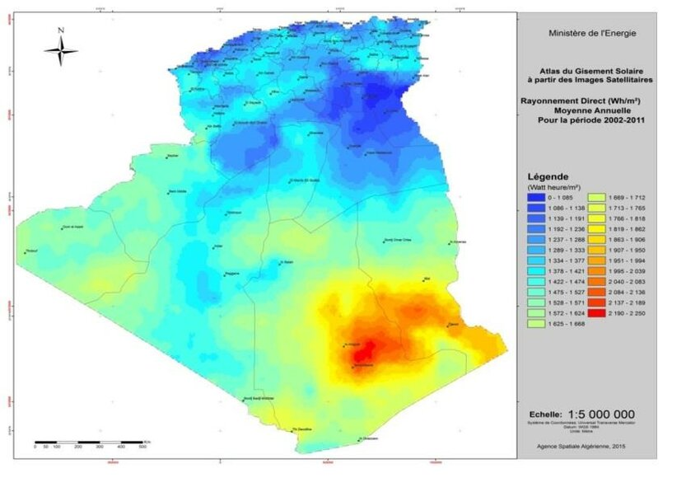

Figure1 Average daily sun of direct normal solar irradiation during the period 2001-2002 [7]

## 2.2 Eclectic network grid

The electric power choice should be accommodated to the conditions of the selected zone. Based on the data of electric network grids brought from the table given by a subsidiary company SPE of SONALGAZ [8], as illustrated in Figure 2, it appears that the produced power is about 3.5MW by unity. Another factor that can influence the choice is the great distance between villages, which are isolated from the local power grid and need electricity.

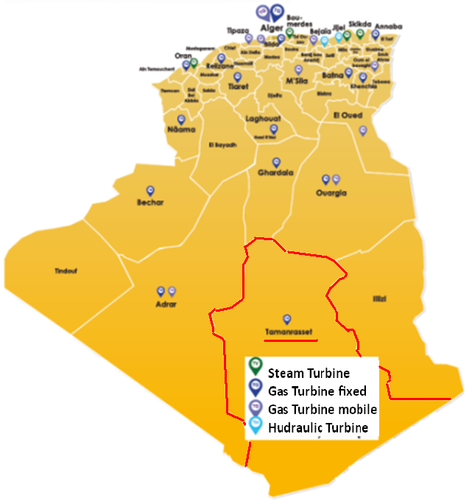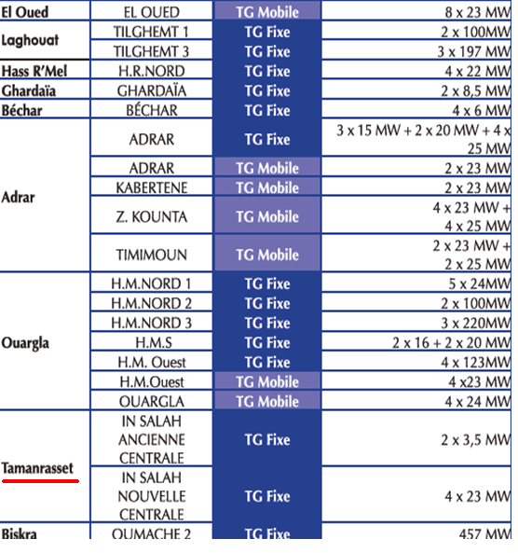

Figure 2 Distribution of electric power grid in the Algerian south town [8]

## 2.3 Climatic conditions

Tamanghasset region has climatic conditions characterized by the following metrological parameters illustrated in Figure 3 These data are collected along the year [9].

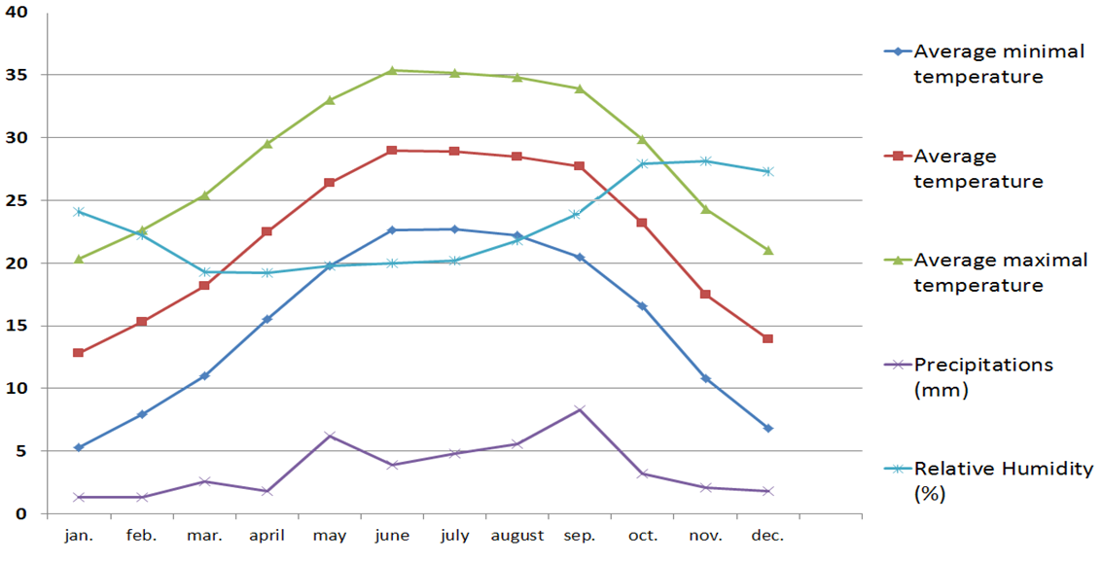

Figure3 Climatic data of the Tamanghasset region [9]

Figure 3 shows that in this city, the summer has a very warm climate, while the winter has a moderately warm climate, where the average temperature that can be taken is about 28°C.

# 3. Selection of SMR type and coupling configuration

The primary choice of the SMR type in this work is tributary directly to the availability of data and to the available conditions. The main selection criteria are as follows:

* Systems working in an isolated region with severe climatic conditions such as water deficiency,
* Electric network off grid,
* Weak power of 3.5 MWe (electric) or around 10 MWth (thermal).

The preliminary selection of the SMR according to the previous criteria, leads to a very small reactor vSMR. Therefore, our choice was towards MoveluX (Mobile-Very-small reactor for Local Utility in X-mark) using LEU fuel [10,11] illustrated by Figure 4. This vSMR enables us also to take maximal benefit from its specific technological aspects related particularly to the natural cooling system based on the passive safety of heat-pipe technology. In our opinion, this advantage is appropriate for the isolated zone like Tamanghasset region.

The MoveluX reactor produces a temperature of around 700°c, which is favourable for providing high temperatures, cogeneration and hydrogen production. This situation encourages using it as a super-heater.

The solar thermal power plant SPP choice leads to a concentrated solar plant CSP of the parabolic through collector PTC type, due to many factors, where the main key was their aptitude to be modular, as illustrated by Figure 5.

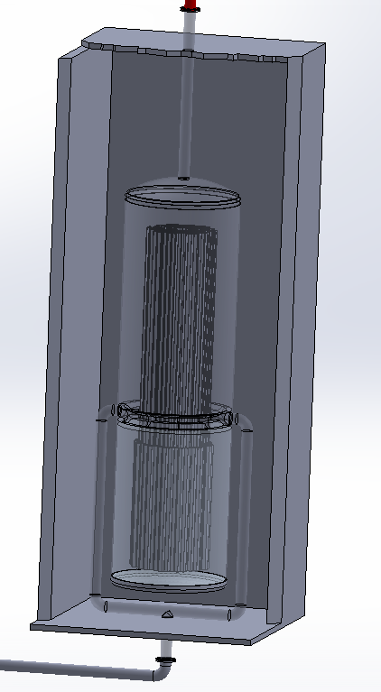 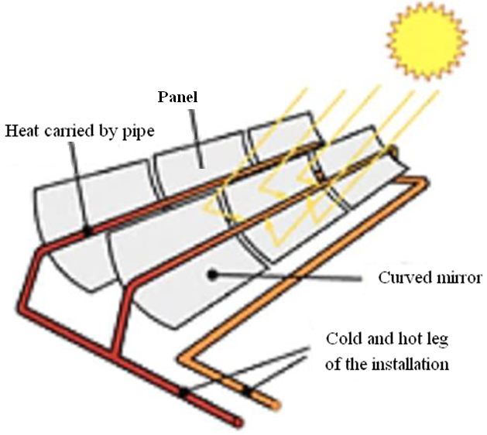

Figure 4 Conceptual design of MoveluX reactor Figure 5 Parabolic through collector

The maximum temperature produced by PTC, depending on the coolant, can reach 550°C, which is lower than that produced by SMR. This situation boosts the use of the SPP as a base heater.

The comparison of various storage systems give advantages to thermal energy storage TES; due to their lowest position in terms of capital energy cost vs. capital power cost [12].

The coolant material choice is a big challenge. Thanks to research in materials science that is being done on structural materials and functional materials. These materials can offer promising solutions to achieve accessible, renewable, and sustainable energy pathways for the future [13]. Among those functional materials are the coolants like liquid metals and molten salts that have good thermal and physical properties [5,14].

## 3.1 Hybridization choice

In our case, different configurations can be taken; however, each configuration can be based on one of the two thermodynamic cycles, Rankin cycle or Brayton cycle.

Figure 6 illustrates the main scheme, which can include different configurations. This proposal includes four loops, each providing 10 MWth, one loop for the PTC CSP using sodium as heat transfer fluid HTF, the steam-water or air-gas loop for power generation (electricity production), one loop for the PTC CSP using sodium as HTF. The MoveluX loop uses helium as refrigerant, and the cogeneration loop uses sodium as HTF.

To deal with irregularities in solar energy (such as sunset, sunrise, the winter season), several measures are planned. The first one is to operate the SMR at its nominal capacity (100%) and continually. The second parade is the regulation by the SMR contribution. The third parade is the arrangement of thermal storage tanks to be used as needed. The regulation is ensured by valves, flow dividers and mixers.

To deal with some risks like the freeze or the inlet temperature decrease of HTF, a heat exchanger is expected.

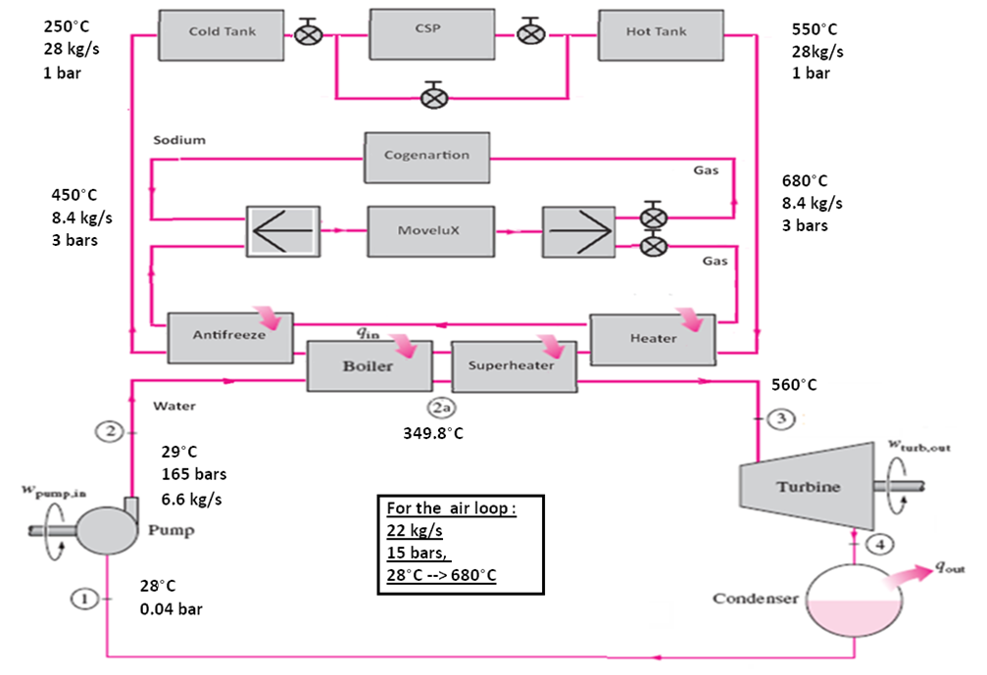

Figure 6 Proposed diagram principal for hybridization system

## 3.2 Adopted configuration

In fact, two configurations were adopted. The first one is based on the steam cycle or Rankin cycle with super-heater, which is based on the Hirn cycle [15,16,17] without exceeding threshold temperature due to technological constraints [18]; two variants are expected, with and without a second super-heater. The second configuration is based on the Brayton cycle; two variants are expected with and without PTC operating. This gives us four configurations.

## 3.3 Thermal balance models

This work focuses on the computation of energy balances based on data illustrated in Figure 6.

# 4. Results and discussions

In this study, the software ThermOptim version java 1.45[12] was used in order to resolve the thermal balance. An established homemade program called “Tharmal Analysis” was used also to compute the sun's direct sunniness, tank size, the CSP configuration and diverse design parameters.

The main results obtained include general parameters of the hybridization system and the hybrid configurations.

## 4.1 Conceptual design of hybridization feature

This proposed hybridization system was concretized in the form of a conceptual design including PTC, hot and cold tanks, heat exchangers and MoveluX reactor, as illustrated in Figure 7.

To reach the power of 10 Mwth for each system, the computation by “TermalAnalysis” program gives the following results: a tank of 10m high and diameter, a PTC installation of 228 assemblies of panels, each assembly is composed of seven (7) panels, as illustrated in Figure 7.

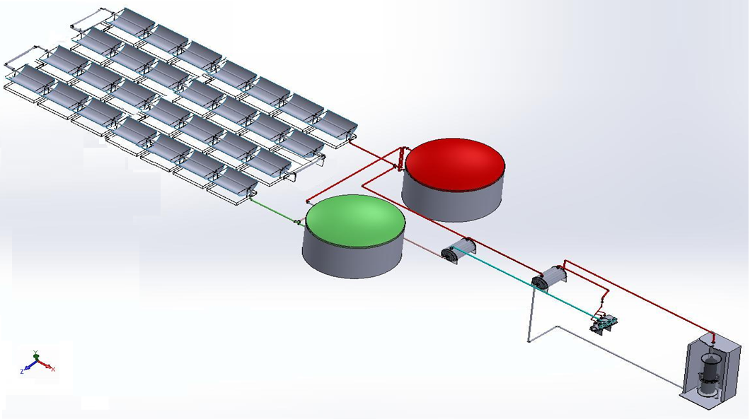

Figure 7 Conceptual design of a hybridization system

## 4.2 Rankin cycle with one super-heater

Based on Figure 6, the first configuration considers one super-heater and the SMR loop contribution is 15% for electricity and 85% for cogeneration. The main results are presented in the following figures.

Figure 8 shows the high temperature reached after the steam crosses the super-heater, allowing it to have a high efficiency close to the technological limits.

## 4.3 Rankin cycle with two super-heaters

The second configuration includes a second super-heater; the steam is heated directly by SMR loop at the first turbine exit. In this case, the SMR contribution is increased to 53% for electricity and 47% for cogeneration. However, some modifications were introduced to simplify this configuration. Results are presented respectively in Figure 8 and Figure 9.

Figure 9 shows that the contribution of the SMR must be significant to obtain a higher temperature.

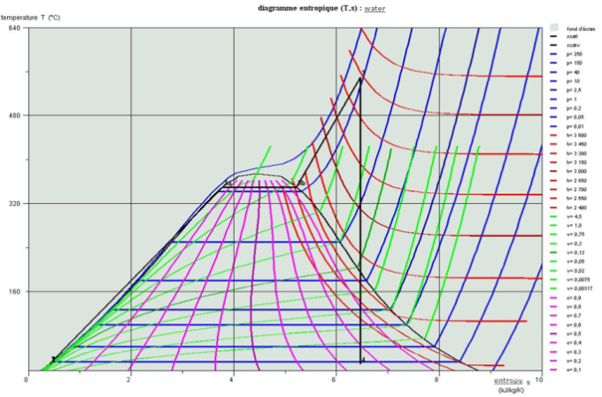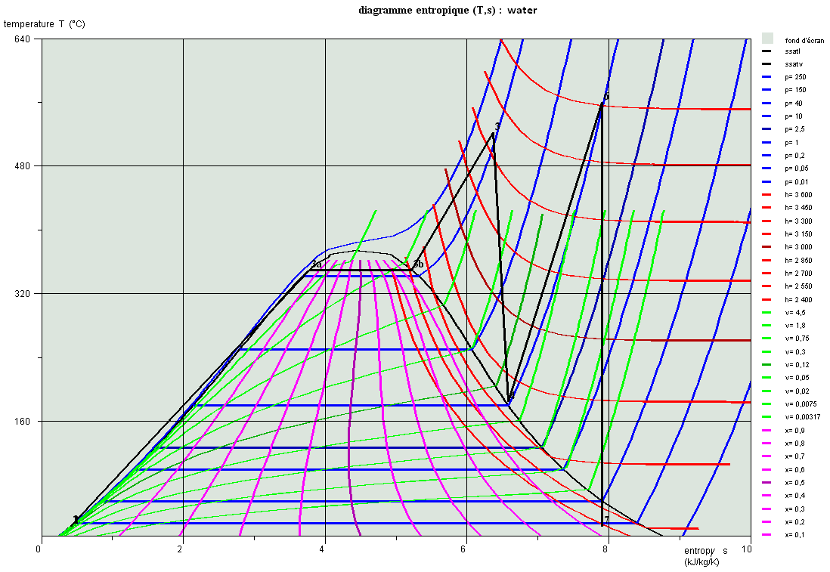

Figure 9. T-S diagram for Steam-water cycle

for (53/47%) contribution

Figure 8. T-S diagram for Steam-water cycle for (15/85%) contribution

## 4.4 Brayton cycle with 100% PTC contribution

For the Brayton cycle, the PTC is used at its nominal capacity (100%). The SMR contribution is about 53% for electricity and 47% for cogeneration. Results are presented in Figure10.

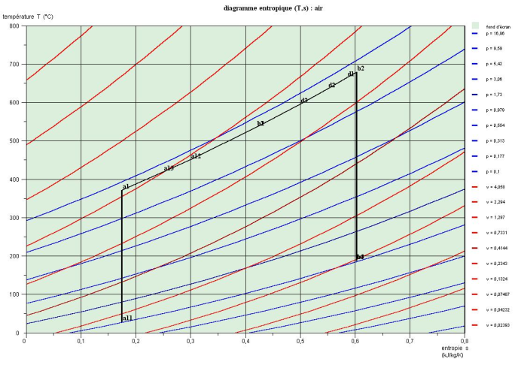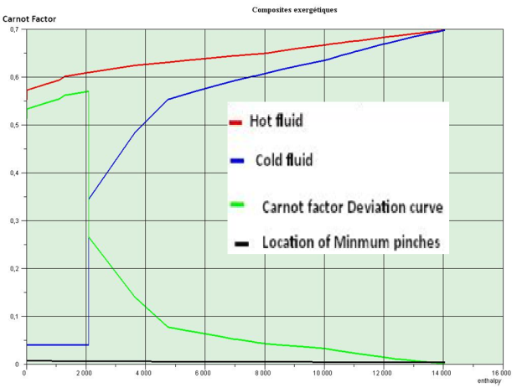

Figure 10.T-S diagram for air cycle results and Carnot factor for (53/47%) contribution

Figure 10 shows high performance of the configuration with the Brayton cycle compared to that of the Rankin cycle, this is due to the easiness it has to reach high temperatures; where the cold fluid temperature approaches closer to the hot fluid one at the end.

## 4.5 Brayton cycle with 0% PTC contribution

The second configuration of Brayton cycle consists of reducing the PTC contribution to zero. The SMR contribution is 78% for electricity and 22% for cogeneration. The results are presented in Figure11.

Figure 11 shows similar results to the previous Figure 10. However, it is observed that to maintain the same useful energy, the SMR contribution is increased.

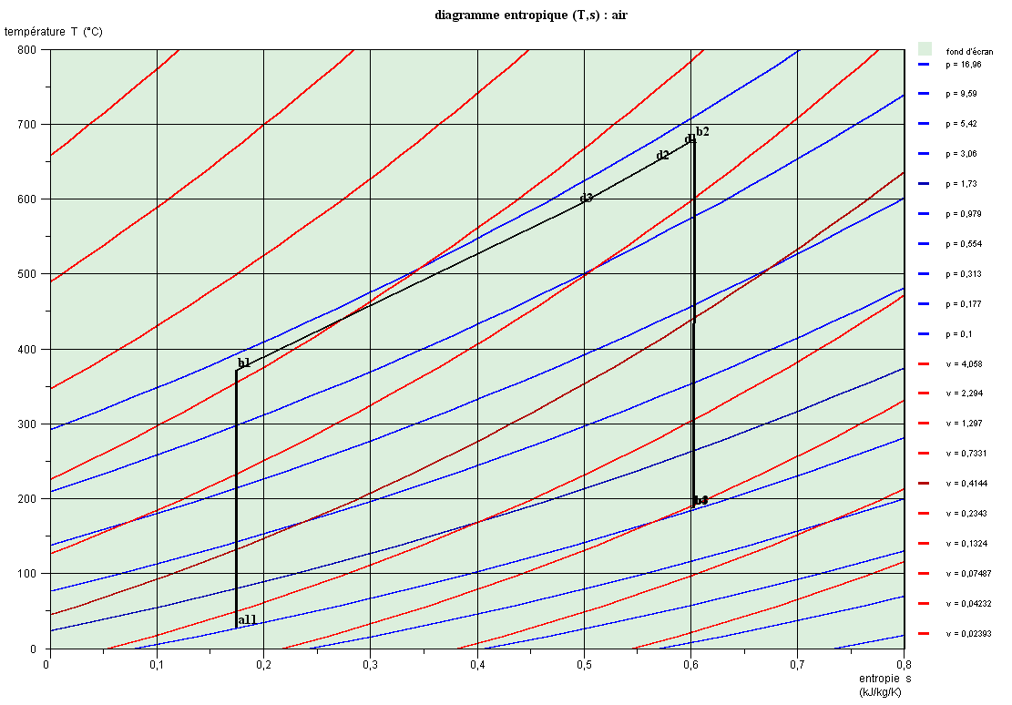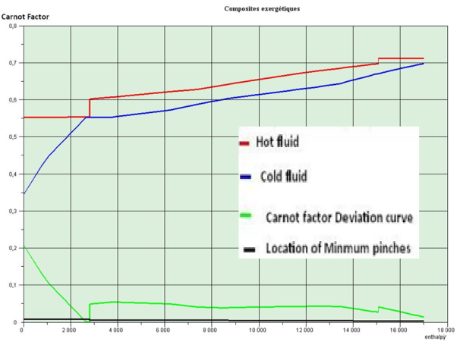

Figure 11.T-S diagram for air cycle results and Carnot factor for (78/22%) contribution

## 4.6 Summary results

The results illustrated in Table 1 show that, globally, the Brayton cycle outperforms the Rankin cycle in terms of power and efficiency. In our case, the SMR has the capacity to cover the sun intermittency, even the total lack of sun energy contribution, where it seems that the Rankin cycle struggles to cover the same performance. The reason for this poor performance can be explained by their weak efficiency. While the SMR contribution is higher, it is easier to Rankin cycle with two super-heaters to be equivalent to Brayton cycle but with lower efficiency. However, it is limited by a threshold temperature, where, it cannot exceed this level due to technological limits.

The results obtained for the Brayton cycle appear to be similar to those of Pan Wua [4] or others [17] for the supercritical carbon dioxide Brayton cycle [4], in terms of efficiency.

The SMR's contribution to cogeneration is low when its involvement to electricity production is high.

Table 1. Summary results

|  |  |  |  |  |  |  |
| --- | --- | --- | --- | --- | --- | --- |
| **Method** | **Power [kWatt]** | **Efficiency ThermOptm**  **[%]** | **Efficiency computed**  **[%]** | **PTC contribution**  **[%]** | **Cogeneration [kWatt]** | **Movelux contribution Electricity/Cogeneration**  **[%]** |
| Rankin full charge | 9692.68 | 44.72 | 44.45 | 100 | 8526.84 | 15/85 |
| Rankin full charge (two s.h.) | 11663.45 | 44.24 | 44.24 | 100 | 4683.756 | 53/47 |
| Brayton full charge | 11651.15 | 76.7 | 54.0 | 100 | 4580.9 | 52/48 |
| Brayton partial charge | 11651.15 | 76.6 | 51.6 | 0 | 2223.48 | 78/22 |

# 5. Conclusion

This study has been of great benefit to us. In fact, it introduces us to the field of hybridization, where a great deal of work has been done; however, the focus is done only on the energy balance for four configurations of solar-nuclear coupling.

In this paper, the most relevant simulation results reveal the important roles played by the SMR MoveluX, from one side as a super-heater that is a good tool of efficiency improvement and from the other side as a regulator that ensures power stability and can easily take care of the sun’s intermittent deficiencies.

Results also reveal the importance of the Brayton cycle as an effective means of useful energy production with high efficiency. Although the Rankin cycle could have matched the Brayton cycle, it presents some performance gaps.

However, given the conditions in the chosen area, which is Tamanghasset and suffers from a severe lack of water, the Rankin cycle does not appear to be a good choice. Other regions, such as El-Menia, a district located in the center of the Algerian desert, have important water sources, where the Rankin cycle can be implemented.

# Acknowledgements

We thank Medea University for providing ThermOptim software for use in this study.

# Reference

1. Richard Boardman and Shannon Bragg-Sitton. How Nuclear Hybrids Could Redefine the Industry’s Future. .https://powermag.com/ how-nuclear hybrids-could-redefine-the-industrys-future/. Power Magazin. USA. 2019
2. IAEA TECDOC SERIES, nuclear–renewable hybrid energy systems for decarbonized energy production and cogeneration, proceedings of a technical meeting held in VIENNA, 22–25 october 2018, international atomic energy agency,iaea-tecdoc-1885 ,Vienna, 2019
3. Q.T. Pham. N. Tauveron. N. Alpy. V. Vuillerme. Hybridization of a small modular reactor with a solar power plant using a supercritical carbon dioxide Brayton cycle. 3rd European Conference on supercritical CO2 (sCO2) Power systems. Paris. France. CEA. 19-20 September 2019
4. Pan Wua et al, A review of research and development of supercritical carbon dioxide Brayton cycle technology in nuclear engineering applications, https://doi.org/10.1016/j.nucengdes.2020.110767, Nuclear Engineering and Design 368 (2020) 110767,
5. MouradDougdag, Rafaël Fernandez and Damien Lamberts, Comparison between liquid coolants behaviours on thermal striping in new nuclear research reactor, International Conference on Research Reactors: Addressing Challenges and Opportunities to Ensure Effectiveness and Sustainability, 25-29 November 2019, at Buenos Aires, Argentina
6. Boudjenah S,,Dadamoussa B,,Hadj-Mahammed M,, Etude de la variation spatiale de la salinite des eaux exploitees dans la cuvette d’ouargla, 1er Séminaire International sur la Ressource en eau au sahara : Evaluation, Economie et Protection, le 19 et 20 janvier 2011(Ouargla-Algérie),
7. AbdelouadoudLoukriz, Contribution au Développement de Techniques de Recherche de la Topologie Optimale d’un Générateur Photovoltaïque, Thèse de Doctorat, Université Mohamed Khider Biskra, https://www,researchgate,net/publication/370342304, 2022
8. SPE, Société Algérienne de Production de l'électricité, Parc de production SPE en exploitation, www,spe,dz, 2018
9. Tamanghasset, https://fr,wikipedia,org/wiki/Wilaya_de_Tamanghasset, 2024
10. IAEA, Advances in Small Modular Reactor Technology Developments A Supplement to: IAEA Advanced Reactors Information System (ARIS), Septembers 2020
11. ARIS, Status Report-MoveluX (Toshiba Energy Systems & Solutions) Japan,
12. Jidai Wang, Kunpeng Lu, Lan Ma, Jihong Wang, Mark Dooner, Shihong Miao, Jian Li and Dan Wang, Overview of Compressed Air Energy Storage and Technology Development, Energies 2017, 10, 991; doi:10,3390/en10070991 www,mdpi,com/journal/energies, 13 July 2017
13. Dr, Colin Tong , Introduction to Materials for Advanced Energy Systems, Print ISBN: 978-3-319-98001-0, Electronic ISBN: 978-3-319-98002-7, https://link,springer,com/book/10,1007%2F978-3-319-98002-7, : Springer International Publishing
14. MouradDougdag, Rafaël Fernandez, Damien Lamberts, Risk assessment of thermal striping in MYRRHA research reactor, Nuclear Engineering and Design 319 (2017) 40–47, http://dx,doi,org/10,1016/j,nucengdes,2017,04,031, 0029-5493/ 2017 Elsevier
15. Renaud Gicquel, Guide d'usages pédagogiques des ressources du portail Thermoptim, Mines ParisTech, mai 2011, pp, 34, 381 and 41
16. Alain Dubarquet, Nouvelle méthode d’évaluation de cycle régénératifs, ScienceLib Edition Mersene, Volume 5, N° 131105, ISSN 2111-4706, publie 2013, Version 2015, pp, 11
17. Richard E. Sonntag, Claus Borgnakke and Gordon J. Van Wylen, Fundamentals of thermodynamics, sixth edition, ISBN 0-471-15232-3, printed in the USA, , (c) Joh, Wiley & Son, 2003
18. Ibrahim Dincer, Marc A, Rosen, Exergy (third edition), Chapter 12: Exergy analysis of steam power plants, Energy, ISBN 978-0-12-824372-5, Elsevier, 2021, pp, 325-354