# TECHNO-ECONOMIC ANALYSIS OF SMR DEPLOYMENT IN THE ESTONIAN POWER SYSTEM

|  |  |
| --- | --- |
| R.H. IVASK, A.H. TKACZYK  University of Tartu  Tartu, Estonia  Email: alan@ut.ee  Y. LI, M. TOT, H. PAILLERE  International Atomic Energy Agency Vienna, Austria |  |

**Abstract**

Energy production in Estonia has heavily relied on fossil fuels, namely 70% of electricity generation in 2019 was powered by oil shale. Estonia has committed to contribute to joint EU greenhouse gas reduction targets. The Estonian Ministry of Climate, to ensure preparedness and resilience to react to the impact of climate change, has set a target to reduce Estonian greenhouse gas emissions by 80% by 2050. Recognizing this, the Estonian government’s Nuclear Energy Working Group report published at the end of 2023 indicated that introduction of nuclear power into the Estonian energy system could significantly contribute to achieving climate neutrality goals. A suitable nuclear power option to consider could be a small modular reactor (SMR) with a capacity of 300-400 MW. To assess techno-economic aspects of the nuclear option, the IAEA’s energy system assessment tool MESSAGE was applied. A case study was developed to understand how an SMR would integrate into the Estonian energy system, including regional grid and market considerations. Existing and planned power generation technologies were analysed, including seasonal electricity and heat demand. Several scenarios were simulated for the period up to 2050. The paper summarizes the results and conclusions of this analysis.

## INTRODUCTION

Estonia, a small Baltic nation with a population of approximately 1.3 million, has a unique energy system. Estonia experiences cold winters, with an average temperature of -8 °C, and reasonably warm summers, with an average temperature of 20.9 °C [1]. The natural energy resources in Estonia include peat, wood and oil shale, the latter of which the country has historically relied on. In 2019, 70% of electricity generation was powered by oil shale, which is linked to the relatively high carbon intensity ranking of Estonia within European Union (EU) countries [2]. Estonia has been an EU member state since 2004 and therefore is subject to EU targets and common rules for the promotion of clean energy. In 2023, the EU set a mandatory target requiring each EU member state to achieve a renewable energy share of least 42.5% by 2030 [3].

### Energy demand in Estonia

The all-time highest peak electricity consumption for Estonia was 1599 MW on January 4, 2024. Before this, the highest peak electricity consumption was 1591 MW on February 18, 2021 [4]. According to the latest released draft of the National Energy and Climate Plan (NECP), Estonian electricity consumption is expected to double within the next 25 years. Table 1 shows the projection of annual Estonian electricity consumption according to the draft NECP.

TABLE 1. PROJECTION OF ANNUAL ELECTRICITY CONSUMPTION IN ESTONIA [5]

|  |  |  |  |  |  |  |
| --- | --- | --- | --- | --- | --- | --- |
| Year | 2022 | 2025 | 2030 | 2035 | 2040 | 2050 |
| Electricity consumption (TWh) | 8.5 | 9.2 | 9.9 | 11.3 | 13.0 | 16.0 |
| Peak load (GW) | 1.3 | 1.4 | 1.5 | 1.7 | 2.0 | 2.4 |

The annual output of heat is about 9 TWh, with 89% reaching consumers and 11% lost in the heating networks [6].

### Energy system of Estonia

Estonia has been reliant on domestically supplied oil shale, of which it possesses one of the largest reserves in the world. The country’s energy mix is shaped by its geography, economic policies, and commitments to environmental safekeeping and EU regulations. The current energy portfolio in Estonia consists of both traditional and renewable energy sources. The main components are as follows:

* Electricity production: In Estonia, electricity production sources are a mix of oil shale, biomass, peat and renewables such as solar power and wind. In 2022, the electricity generation mix in Estonia was 66.5% oil shale, 17.1% biomass and waste, 7.5% wind, 6.3% solar and 0.4% oil products. Net energy imports account for 7.1% of the total energy supply [7]. It is relevant to note external events such as the COVID-19 pandemic and the Ukraine conflict have recently affected the energy import supply.
* Oil shale: Oil shale has played a crucial role in Estonian electricity generation and oil production. While it is less expensive economically, it is a carbon-intensive source which generates significant greenhouse gas emissions.
* Renewable energy: In alignment with EU climate targets, Estonia has made advances in increasing the share of renewables in its energy mix. Estonia has maintained a steady development of renewable energy production by utilising wind farms, biomass plants, and solar power.
* Natural gas: A measurable share of Estonian energy production comes from natural gas plants. Historically, Estonia has imported natural gas primarily from Russia [8]. Recently, there has been an increased emphasis on reducing reliance on energy imports from Russia.
* As of 2023, the net installed capacity of the electricity system in Estonia was 2542 MW. Estonian installed electricity generation capacities as of 2023 are shown in Table 2.

TABLE 2. SOURCES OF ELECTRICITY GENERATION IN ESTONIA IN 2023 [5]

|  |  |  |  |  |  |  |  |  |  |
| --- | --- | --- | --- | --- | --- | --- | --- | --- | --- |
| Source of electricity generation | Onshore wind | Hydro | Solar | Oil shale | Waste | Natural gas | Biomass | Other | TOTAL |
| Capacity (MW) | 317 | 8 | 510 | 1330 | 17 | 188 | 152 | 20 | 2542 |

### Greenhouse gas emissions

Estonia’s electricity production has historically been dominated by oil shale. This consequently presents great challenges for EU initiatives regarding the reduction of greenhouse gas emissions. Despite this, annual greenhouse gas emissions of Estonia have been decreasing since 2018. Table 3 shows the total emission of greenhouse gases from heat and electricity production since Estonia became an EU member state in 2004.

The recent decline in total emission of greenhouse gases is due to a combination of developments in renewable power generation, stricter EU energy regulations and evolving public perception about climate change. In 2021, Estonian energy industries accounted for 6.99 Mt of CO2 equivalent greenhouse gas emissions, which represents a 68.4% reduction of these emissions since 1990.

TABLE 3. EMISSIONS OF GREENHOUSE GASES FROM ELECTRICITY AND HEAT PRODUCTION IN ESTONIA [9]

|  |  |  |  |  |  |
| --- | --- | --- | --- | --- | --- |
| Year | 2005 | 2010 | 2015 | 2020 | 2021 |
| Mt of CO2e | 12.61 | 15.01 | 11.84 | 5.75 | 6.99 |

### Potential for nuclear power in the Estonian energy system

The Estonian energy system is shifting toward renewable energy production. The country has set an ambitious goal to replace all electricity generation with renewables by 2030. An attractive environment for investors of green energy has been created, particularly as the cost of renewable technologies have decreased. It is projected that by 2030, an addition of 2000 MW of wind energy into Estonia’s energy system will be a substantial part of achieving policy goals set by the government. However, the “Final Report – Possibilities for the Implementation of Nuclear Energy in Estonia” [10] published in 2023 by the Estonian government’s Nuclear Energy Working Group suggests that “nuclear energy produces electricity at lower long-term costs compared to some renewable energy sources.” The introduction of nuclear energy in Estonia through Small Modular Reactors (SMRs) has been a relevant topic of discussion for the past five years.

Potential benefits of SMRs which have been highlighted include addressing the need for a clean baseload energy source and providing inertial capability for the system (i.e., solving a potential future issue with system stability). In the paper, one of the considerations is to have a dispatchable net installed capacity of 1000 MW. In the work, the inertial requirements of the system are not considered explicitly.

## KEY METHODOLOGIES

### MESSAGE modelling software

The future pathways for the Estonian energy system are analysed using MESSAGE (Model for Energy Supply Strategy Alternatives and their General Environmental Impact) [11]. The MESSAGE modelling software is an optimisation tool designed for medium to long-term energy system planning, climate policy analysis, and scenario development for national or global regions. It can model all types of thermal generation, renewable energy, storage, conversion, and transportation technologies, as well as carbon capture and storage.

MESSAGE employs a linear programming algorithm, where an objective function is minimised subject to constraints. The objective in this case is minimization of total discounted system cost of the Estonian energy system over the entire planning horizon. These costs include investments, operation and maintenance costs, fuel costs, externalities (e.g. as CO2 prices) and costs of energy imports from other markets.

### Modelled scenarios

Two alternative power supply scenarios were modelled. The Reference scenario assumes that investment decisions of all electricity production technologies are based on system cost considerations (grid investments and balancing costs are not included in this version of the model). All capacity build-out units are endogenous within the model. In this scenario, all electricity production technologies and import/export options were considered based on their technical and economic characteristics.

The Nuclear scenario focuses on the introduction of nuclear power into Estonia’s energy system. The goal is to analyse the cost of incorporating nuclear power and assess if the nuclear option would accelerate the phase-out of conventional oil shale, natural gas and peat-based electricity production. In this scenario, nuclear generation is deployed exogenously in 2035 and 2040 (i.e., two sequential SMR units of 300 MW each).

### Main assumptions

#### Demand

Both electricity and heating demands are included in the model. Table 1 shows the demand trajectories until 2050. Hourly electricity demands are retrieved from power statistics data of ENTSO-E [12], while hourly heat demand profiles are retrieved as synthetic data from Renewables Ninja [13]. The hourly demand profiles in each year are assumed to retain the same shape, scaled by total yearly demand. In addition, the reserve margin for modelled energy generation is set at 33% above peak load, to account for unexpected maintenance and forced outage rate. The capacity credit values for wind power plants were set to 0.05 for both onshore and offshore wind power plants.

#### Renewables potential

Renewables profiles were retrieved from Renewables Ninja [13]. From this data, the average yearly capacity factors for onshore wind, offshore wind, solar PV, and biomass were calculated.

TABLE 4. AVERAGE ANNUAL CAPACITY FACTOR AND RENEWABLES POTENTIAL IN ESTONIA

|  |  |  |  |  |
| --- | --- | --- | --- | --- |
|  | Solar PV | Onshore wind | Offshore wind | Biomass |
| Annual capacity factor | 0.126 | 0.48 | 0.504 | ≈0.85 |
| Additional capacity possible MW | 3000 | 7000 | 7000 | 600 |

#### CO2 prices

TABLE 5. PROJECTED TRAJECTORY FOR THE CARBON PRICE IN ESTONIA [14]

|  |  |  |  |  |  |  |  |
| --- | --- | --- | --- | --- | --- | --- | --- |
| Year | 2020 | 2025 | 2030 | 2035 | 2040 | 2045 | 2050 |
| Carbon price (EUR2020 / tCO2) | 24 | 90 | 100 | 120 | 250 | 360 | 410 |

The carbon prices come from European Commission’s projection for carbon price with an existing ETS (Emissions Trading Scheme) up to 2030. From 2030 onwards, the WAM (With Additional Measures) trajectory is used.

## ANALYSIS OF RESULTS

The analysis focuses on achieving internal energy policy goals and greenhouse gas emission reduction targets from power generation set by the European Commission. The main metrics analysed and compared were:

* Capacity and energy mix: Installed capacities and electricity generation/supply.
* CO2 emissions: The total emissions from power generation activities. (CO2 intensity of imported electricity is not considered)
* Total discounted power generation costs (i.e., the value of the objective function). This consists of investments, operational costs (fixed, variable and fuel costs), and CO2 costs. All costs are reported in 2020 euros (EUR).
* Total investment costs: Total capital expenditure for building new power plants and interconnectors, in 2020 EUR.
* Average generation cost: The average cost per unit of electricity generated, in 2020 EUR.

### Installed capacities and electricity generation by energy source in Estonia

The model results of annual installed capacities and electricity generation by energy source are analysed for both scenarios.

FIGURE 1. PROJECTED INSTALLED CAPACITIES BY ENERGY SOURCE IN ESTONIA FOR REFERENCE AND NUCLEAR SCENARIOS

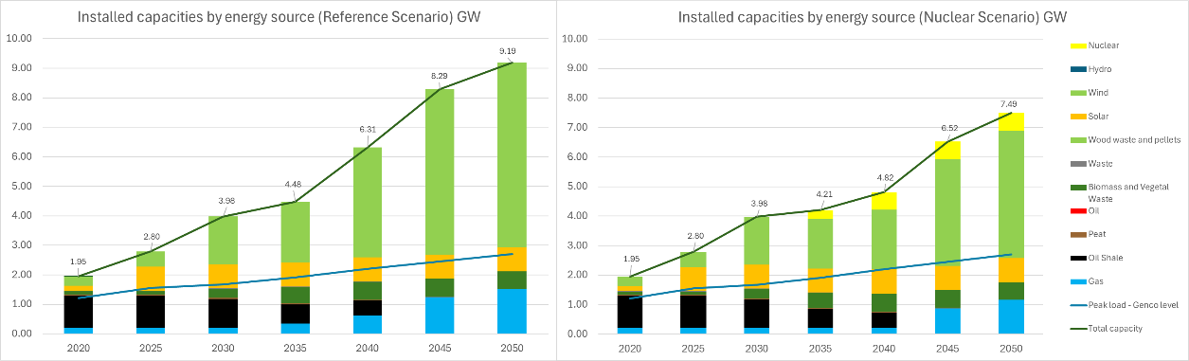

Figure 2 shows modelled electricity capacities in Estonia’s energy system by energy sources. In both scenarios, the capacity of wind power increases. Additional import capacity introduced from 2040 onwards accounts for the required dispatchable capacity, as peak load increases according to the increasing demand. Beyond the government targets of building 2000 MW of wind power, an additional 3936 MW and 1995 MW of wind capacity would be installed in the Reference and Nuclear scenarios, respectively. As existing oil shale units undergo decommissioning, natural gas units are constructed primarily to serve as the backup option for renewables in the system, to fulfil the minimum system reserve constraint. In the Nuclear scenario, the construction of SMRs delays the need to add these gas capacities, since nuclear power can provide firm generation and contribute to the system reserve. The biomass option is deployed in both scenarios up to the maximum assumed availability. In both scenarios, solar PV remains at capacity as of 2024 (812 MW), indicating that this option is less economically attractive compared to wind power. Incentives such as feed-in tariffs and subsidies are not included in the modelling of wind power and solar PV.

The total installed capacity at the end of the planning period in Nuclear scenario is lower compared to the reference scenario by 1697 MW, as nuclear units offer a higher capacity factor than wind power.

FIGURE 2. ELECTRICITY GENERATION BY ENERGY SOURCE IN ESTONIA FOR REFERENCE AND NUCLEAR SCENARIOS

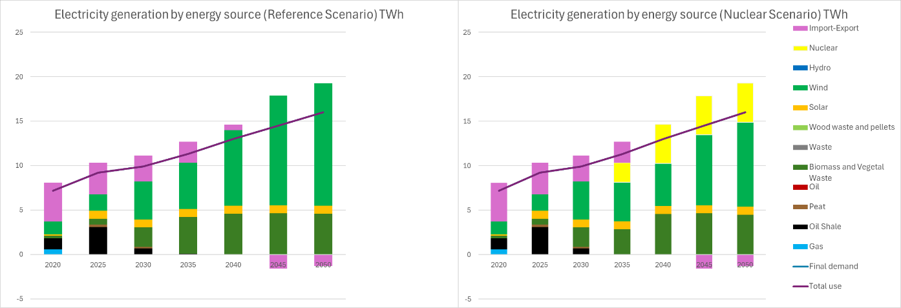

Figure 3 shows electricity generation in Estonia by energy source. Total electricity generation increases in accordance with the rising energy demand. Specifically, wind generation in both scenarios increases significantly: by 2050, wind generation in the Reference scenario reaches 13773 GWh, accounting for 71% of total generation, whereas in the Nuclear scenario, it reaches 9501 GWh, representing 49% of total generation. Relative to the Reference scenario, the Nuclear scenario has a lower share of wind production due to the introduction of SMR units from 2035 onwards. By 2035, nuclear power constitutes 23% of total electricity production in the Nuclear scenario. In both scenarios, total generation from gas is close to zero in 2050 despite the construction of gas capacities. This is because gas capacities are constructed for meeting reserve margin requirements. Gas plants only produce during periods of very high demand, since they are the last in the merit order due to higher Variable Operations and Maintenance (VOM) and fuel costs (EUR 0.17/kWh in 2050) compared to wind.

Despite the presence of oil shale capacity until 2044, electricity production from oil shale plants falls significantly from 2035 onwards. This is mainly due to the imposition of a CO2 price, which makes production from oil shale plants economically unviable.

In the base year, Estonia is a net importer of electricity, where 54% of its total use demand comes from neighboring countries. With the expansion of wind power and the export of surplus wind-generated electricity in both scenarios, Estonia is expected to become a net exporter of electricity around 2040 in both Reference and Nuclear scenarios. This shift occurs as the cost of wind-generated electricity in Estonia is lower than the assumed electricity prices in markets connected to Estonia. The prices of electricity of connected markets are exogenously defined in the model.

### Total discounted costs

The objective of the model is to minimise the overall system cost over the planning horizon (investment, fixed and variable costs, fuel costs, CO2 costs, import costs and export revenues). The resulting system achieves the lowest possible cost within a set of defined constraints. By building these SMRs, the overall system cost is marginally higher (by 2.7%) compared to the Reference scenario, where no nuclear plants are built endogenously. This difference is based on the system cost alone and does not consider expenses associated with grid investments or balancing, which could impact the currently observed differences. The economic results of the Nuclear scenario are highly dependent on the investment cost of SMR units. In this case, it was assumed that the investment cost for such units is 6000 EUR/kW.

TABLE 6. TOTAL SYSTEM COSTS OF MODELLED SCENARIOS

|  |  |  |  |
| --- | --- | --- | --- |
| Scenario | Total discounted cost (billion EUR) | Difference | |
| (billion EUR) | % |
| Reference | 15.0 | 0.4 | 2.7 |
| Nuclear | 15.4 |

### Average generation costs

FIGURE 6. AVERAGE GENERATION COST IN ESTONIA

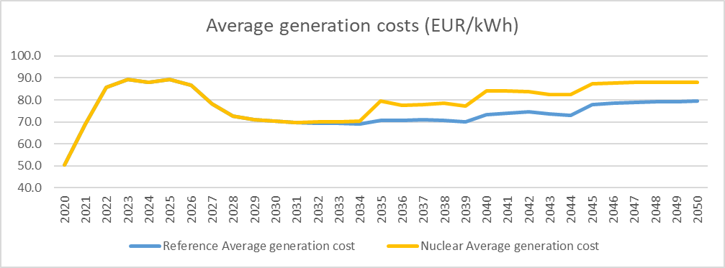

Average generation cost is the cost of generating one kWh of electricity from domestic power plants. It is calculated by aggregating all generation cost (annualised investment, Fixed Operation and Maintenance/FOM, VOM, fuel and CO2 costs) and dividing it by total generation for each year. This calculation excludes costs and benefits of import and export. The increase in the first few years corresponds to increasing CO2 prices (carbon taxes) set by the EU and high CO2 emissions. During the phase‑out period of oil shale, CO2 costs decrease to zero, which results in lower total electricity costs. From 2027 to 2035 average generation costs remain stable as demand is increasing and the trend of investments into wind power and biomass plants follows a similar pattern.

The average generation costs of the Nuclear and Reference scenarios diverge from 2035. The first SMR unit is deployed in 2035 in the Nuclear scenario, and this is reflected in high investment cost, which translates into higher average generation cost. The increase of average generation cost in the Reference scenario is smooth due to smaller capacity additions from wind and biomass projects. Without considering grid investment and balancing costs, the Nuclear scenario has a higher average generation cost (by 11% or 8.8 EUR/MWh) as compared to the Reference scenario in 2035. If grid investment and balancing costs were considered, this could impact the currently observed differences.

Part of the average generation cost increase from 2038 onwards in both scenarios is due to investment in gas units, which represent the main backup option replacing phased‑out oil shale plants.

### Limitations and externalities

It is important to note some limitations and externalities of the model. First, these findings are based on the construction and generation cost, and do not take into account costs associated with grid investments or balancing (e.g. re‑dispatching costs are not modelled or estimated). To provide a more accurate and comprehensive evaluation of the Reference vs. Nuclear scenarios, future work could account for the present status and future technical needs of the Estonian grid. More detailed accounting could influence the holistic costs for each scenario and possibly impact the differences observed in the present results.

Second, several factors such as energy security, system stability and reliability are not directly considered in this case study. These external, non-economic factors can be important as a country weighs future energy portfolio options. For example, the Nuclear scenario results in a lower total volume of electricity being imported, thus increasing the independence of the Estonian energy system. In choosing an energy trajectory for the country, national decision makers may consider the relative importance of both economic and non-economic factors.

## CONCLUSIONS

This paper presents a comparison of two possible trajectories of Estonia’s energy system: a Reference scenario and a Nuclear scenario. In both scenarios, CO2 emission reduction targets could be met with the phase‑out of oil shale and other intensive carbon sources, thus reducing carbon tax costs. Furthermore, in both cases, Estonia is expected to become a net energy exporter after the year 2040, by exporting surplus electricity generated by wind power.

Analysis indicates that compared to the Reference scenario, the deployment of two 300 MW SMR plants in Estonia’s future energy system is marginally more costly by 2.7% (total discounted costs). This difference is based on the generation cost and does not consider expenses associated with grid investments or balancing, which could impact the currently observed differences. To provide a more accurate and comprehensive evaluation of the Reference vs. Nuclear scenarios, future work could account for the present status and future technical needs of the Estonian grid.

Several factors such as energy security, system stability and reliability are not directly considered in the MESSAGE optimisation model. For example, the Nuclear scenario results in a lower total volume of electricity being imported, thus increasing the independence of the Estonian energy system. In choosing an energy trajectory for the country, national decisionmakers may consider the relative importance of both economic and non-economic factors.

References

1. STUDY IN ESTONIA, Nature and climate (2024), https://www.studyinestonia.ee/estonia/nature-and-climate
2. OECD, Regional Outlook 2021 - Country Notes Estonia (2024), https://www.oecd.org/regional/RO2021%20Estonia.pdf
3. EUROPEAN COMMISSION, Renewable Energy Targets (2024), https://energy.ec.europa.eu/topics/renewable-energy/renewable-energy-directive-targets-and-rules/renewable-energy-targets_en
4. ELERING, Electricity consumption and production (2024), <https://elering.ee/en/electricity-consumption-and-production>
5. ENTSO-E, Installed Capacity per Production Type 21.03.2024 (2024), https://transparency.entsoe.eu/generation/r2/installedGenerationCapacityAggregation/show
6. ESTONIA’S MINISTRY OF ECONOMIC AFFAIRS AND COMMUNICATIONS, Possibilities of Efficiency in Heating and Cooling in Estonia (2016), <https://energy.ec.europa.eu/system/files/2016-04/Art%252014%25281%2529%2520Estonia%2520EN_0.pdf>
7. INTERNATIONAL ENERGY AGENCY, Estonia (2024), <https://www.iea.org/countries/estonia/energy-mix>
8. LEPMETS, J., Country Report Estonia - Energy Without Russia (2023), <https://library.fes.de/pdf-files/bueros/budapest/20486.pdf>
9. EU COMMISSION, Energy datasheets: EU countries (2024), <https://energy.ec.europa.eu/document/download/6b6b548d-96f0-401b-84ed-0dc8f85a1110_en?filename=Energy%20statistical%20country%20datasheets%202024-04%20for%20web.xlsx>
10. MINISTRY OF CLIMATE OF ESTONIA, Tuumaenergia töörühma lõpparuanne (2023), <https://kliimaministeerium.ee/sites/default/files/documents/2023-12/Tuumaenergia%20t%C3%B6%C3%B6r%C3%BChma%20l%C3%B5pparuanne.pdf>
11. INTERNATIONAL ATOMIC ENERGY AGENCY, Energy modelling tools 05.09.2024 (2024), https://www.iaea.org/topics/energy-planning/energy-modelling-tools
12. ENTSO-E, Power Statistics (2023), <https://www.entsoe.eu/data/power-stats/>
13. RENEWABLES NINJA (2024), <https://www.renewables.ninja/>
14. EUROPEAN COMMISSION, Recommended parameters for reporting on GHG projections in 2023 (2022)