# HARNESSING THE POTENTIAL OF SMALL MODULAR

# REACTORS FOR CLIMATE CHANGE MITIGATION

# THROUGH ENERGY-MIX OPTIMIZATION

# AND HYDROGEN GENERATION

AHMED E. SALMAN

Operational Safety and Human Factors Department, Nuclear and radiological safety research center,

Egyptian Atomic Energy Authority, Cairo, Egypt

Email: [eng.ahmed8810@yahoo.com](mailto:eng.ahmed8810@yahoo.com); [ahmed.esalman@eaea.sci.eg](mailto:ahmed.esalman@eaea.sci.eg)

**Abstract**

Small modular reactors (SMRs) are gaining attention as potential contributors to climate change mitigation, particularly in hydrogen generation. SMRs are smaller and more flexible than traditional nuclear reactors, allowing for deployment in diverse locations and integration into existing energy infrastructure. They offer low-carbon electricity, reducing reliance on fossil fuels and supporting grid integration. This clean electricity can power electrolyzers for hydrogen production, aiding decarbonization in transportation, industry, and heating. The high-temperature gas-cooled SMRs also offer a reliable and continuous source of heat, which can be efficiently utilized for producing hydrogen using thermolysis through different processes. SMRs have inherent safety features, standardized manufacturing, and simplified construction, potentially reducing costs and timelines. They can provide continuous power with a smaller footprint, benefiting remote communities and industries. However, deploying SMRs for energy planning and hydrogen generation requires considerations such as regulatory frameworks, public acceptance, waste management, and non-proliferation. Economic viability and scalability must also be assessed compared to alternative low-carbon energy solutions. Careful consideration of various factors is necessary to ensure the safe and sustainable deployment of energy systems. In this work, the IAEA-MESSAGE code is used to model the energy-supply systems to determine the optimum energy-mix technology in addition to the hydrogen demand to meet future energy demands in the country.

## INTRODUCTION

The threat of climate change has become one of the defining challenges of our time, demanding urgent and comprehensive actions to reduce greenhouse gas emissions and transition to sustainable energy sources. Small modular reactors (SMRs) have emerged as a promising technology with the potential to contribute significantly to this global effort. Compared to traditional large-scale nuclear power plants, SMRs offer a range of advantages, including enhanced safety, modularity, and scalability, making them an attractive option for diverse energy applications [1-4].

This research work aims to explore the potential of SMRs in climate change mitigation through two key avenues: energy-mix optimization and hydrogen generation. Firstly, we investigate the role of SMRs in optimizing the energy mix, analyzing their ability to complement intermittent renewable energy sources and provide reliable base load power. By integrating SMRs into the energy landscape, we seek to identify strategies for reducing the overall carbon footprint and enhancing the resilience of energy systems. Secondly, the paper examines the potential of SMRs to enable large-scale hydrogen production, a critical component in decarbonizing hard-to-abate sectors such as transportation and heavy industry. The high-temperature heat generated by SMRs can be leveraged for efficient hydrogen generation through processes like thermochemical water splitting, offering a sustainable pathway for the hydrogen economy.

Through a comprehensive analysis of technical, economic, and environmental factors, this research aims to provide policymakers, energy planners, and industry stakeholders with valuable insights into the strategic deployment of SMRs as a climate change mitigation technology. By harnessing the unique advantages of SMRs, this study seeks to chart a course towards a more sustainable and resilient energy future, ultimately contributing to the global effort to combat the adverse impacts of climate change. The problem addressed is the need to assess the economic feasibility and benefits of transitioning to a decarbonized energy mix in Egypt. The energy sector in Egypt is a significant contributor to carbon emissions, and there is a growing global trend towards clean energy alternatives and reducing carbon emissions. However, there is a lack of comprehensive analysis and understanding of the economic implications of decarbonization efforts in Egypt. The objective is to explore the economic case for investing in decarbonizing Egypt's energy mix. The study quantifies costs and benefits of transitioning to cleaner energy sources, identifies the optimal energy mix configuration for decarbonization, and proposes using SMR for hydrogen production and water desalination. It guides policy decisions, provides a roadmap for clean energy infrastructure investment, and considers long-term implications on adaptation, mitigation strategies, sustainable development goals, affected economic sectors, diversification opportunities, job creation/losses, and necessary industry adjustments.

## THEORETICAL WORK

The proposed study consists of three key components: energy-mix optimization, carbon capture and storage (CCS) integration, and hydrogen generation from small modular reactors (SMRs).

### Energy-Mix Optimization

The first part of the study will focus on optimizing the energy mix to incorporate SMRs and evaluate their role in reducing the overall carbon footprint of the energy system. This will involve the development of a comprehensive energy system model that captures the techno-economic and environmental characteristics of various energy technologies, including renewable sources, conventional fossil fuels, and nuclear power.

Using advanced optimization techniques, such as multi-objective linear programming, the study will seek to determine the optimal energy mix that minimizes the system-wide levelized cost of energy (LCOE) and greenhouse gas emissions, while ensuring grid reliability and stability. Key factors to be considered in the optimization include:

* Capital and operating costs of different energy technologies
* Capacity factors and intermittency profiles of renewable energy sources
* Flexibility and dispatch ability of SMRs and other base load power plants
* Transmission and distribution infrastructure constraints
* Policy incentives and regulatory frameworks

The optimization model will be developed for specific case studies, taking into account regional variations in energy resources, market conditions, and policy environments. Sensitivity analysis will be conducted to assess the robustness of the optimal energy mix under different future scenarios, such as changes in fuel prices, technology costs, and carbon pricing policies.

### Carbon Capture and Storage Integration

The second component of the study will investigate the integration of carbon capture and storage (CCS) technology with SMRs to further enhance their climate change mitigation potential. The high-temperature heat output from SMRs can be leveraged to power energy-intensive CCS processes, such as amine-based CO2 capture and geological sequestration.

The study will evaluate the technical and economic feasibility of integrating CCS with SMRs, considering factors such as:

* Efficiency and energy penalties of the CCS system
* Capital and operating costs of the integrated SMR-CCS facility
* Transportation and storage infrastructure requirements for captured CO2
* Regulatory and policy frameworks supporting CCS deployment

### Hydrogen Generation from SMRs

The third component of the research will focus on the potential of SMRs to enable large-scale, sustainable hydrogen production. The high-temperature heat generated by SMRs can be used to drive efficient thermochemical water-splitting processes, such as the sulfur-iodine (SI) or copper-chlorine (Cu-Cl) cycles, for hydrogen generation.

The study will explore the technical and economic feasibility of integrating hydrogen production systems with SMRs, considering factors such as:

* Thermodynamic efficiency and hydrogen yield of the water-splitting processes
* Capital and operating costs of the hydrogen production facility
* Synergies between hydrogen production and SMR operation
* Potential markets and applications for the generated hydrogen

### Desalination for Hydrogen Production

In addition to the thermochemical water-splitting processes, the proposed study will also explore the integration of desalination technology with SMRs to provide a reliable and sustainable water source for the hydrogen production system.

* + 1. *Desalination of Seawater or Brackish Water*

Many regions with the potential for large-scale hydrogen production from SMRs are located in coastal or arid areas, where access to freshwater resources may be limited. To address this challenge, the research will investigate the feasibility of coupling desalination systems with the SMR-based hydrogen production facilities. The desalination process can leverage the high-temperature heat and/or electricity generated by the SMRs to power energy-efficient desalination technologies, such as multi-effect distillation (MED) or reverse osmosis (RO). This integrated approach can provide a reliable supply of clean water for the thermochemical water-splitting reactions, while also reducing the freshwater demand on local water resources. Key aspects to be addressed in this component of the study include:

* Evaluation of desalination technology options (MED, RO, etc.) and their integration with SMRs
* Optimization of the desalination system design and operating parameters to maximize energy efficiency and water output
* Assessment of the impact of desalination on the overall system performance, including hydrogen production yield and cost
* Analysis of the environmental benefits of using desalinated water instead of freshwater for hydrogen generation
  + 1. *Addressing Water Scarcity and Enhancing Sustainability*

By integrating desalination capabilities with the SMR-based hydrogen production system, the proposed study aims to address the challenge of water scarcity in regions with high potential for large-scale hydrogen generation. This approach can help to ensure a sustainable and reliable water supply, while also reducing the burden on local freshwater resources. Furthermore, the synergies between desalination, hydrogen production, and SMR operation can enhance the overall sustainability of the system. The waste heat from the SMR can be utilized for the desalination process, improving the energy efficiency and reducing the carbon footprint of both the hydrogen production and water purification components. Overall, the integration of desalination technology into the SMR-based hydrogen generation system represents a comprehensive solution for addressing the water-energy nexus and contributing to the development of a more sustainable hydrogen economy.

By addressing these key aspects, the proposed study aims to provide a comprehensive assessment of the role of SMRs in climate change mitigation, offering valuable insights for policymakers, energy planners, and industry stakeholders in their efforts to transition towards a sustainable energy future.

## METHODOLOGY AND ANALYSIS

### Proposed Energy-Mix Optimization Study

To explore, what are the consequences of decarbonization on the growth of the economy?, using Accounting Theory by applying Emission Reduction Accounting Approach; the International Atomic Energy Agency's Model for Energy Supply System Alternatives and their General Environmental Impacts (IAEA-MESSAGE) framework in the context of decarbonization efforts will be adopted [5, 6]. IAEA-MESSAGE is a widely recognized and comprehensive energy accounting system modeling tool, with decarbonization strategies to identify the optimal energy mix that minimizes carbon emissions. The analysis focuses on a specific case study, evaluating the energy mix optimization in the current case study. Various factors will be considered such as energy demand, resources availability, technological constraints, investment and operational costs, economic growth rate, employment rate and policy objectives. Data series from 2010 to 2022 will be extracted from published reports and databases, such as; World Bank, IRENA (International Renewable Energy Agency), NPPA (Nuclear Power Plants Authority) and CAPMAS (Central Agency for Public Mobilization and Statistics). Further, interviews with expert personals in energy sections will be conducted. The work outlines the key components and modeling techniques employed in IAEA-MESSAGE to simulate different energy pathways and assess their environmental impacts. The work discusses the input data requirements, scenario development, and parameterization process within the IAEA-MESSAGE framework. It presents the results of different scenarios, comparing the environmental and economic performance of various energy sources, including fossil fuels, renewable energy, nuclear power, and energy efficiency measures. Furthermore, Causal Loop System would be adopted to depict the highly affected sectors and the booming industries to addresses the challenges and opportunities associated with transitioning to a low-carbon energy system, considering the role of different energy sources in achieving decarbonization targets. The analysis also will highlight the importance of considering the interplay between energy-mix optimization, decarbonization, and other socio-economic factors to ensure a sustainable and resilient energy future. At the end, the proposed work will discuss the implications of the findings in terms of decarbonization efforts and policy-making. Fig. 1, presents the proposed study of the energy-mix optimization for the 2021-2060 period. As can be seen, the currently installed plants are presented in solid-line boxes and the new proposed plants are shown in center-lined boxes. Fig. 2 presents the proposed study of the system including energy-mix optimization, CCS, and hydrogen generation.

The first information introduced into MESSAGE is the time frame of the model. The first and last model years determine the study period (or planning horizon). The study period is divided into time steps. Table 1 summarizes the time frame input data to MESSAGE. The second type of information entered into MESSAGE defines the energy levels and the information at each level of the energy forms that is considered by the system which is illustrated in Fig. 1 and Fig. 2. The input data to the technology are illustrated in Table 2. The parameters identified for each technology are efficiency, capacity factor, retired time, investment cost, fixed cost and historical capacity of this technology.

TABLE 1. Input parameters of the general tab in MESSAGE

|  |  |
| --- | --- |
| Parameters | Input values |
| Base Year | 2021 |
| Modelling Period | 2021 to 2060 |
| Time Step | One year |
| Discount Rate Used | 8.75% |
| Resources Used | Gas, Coal, Nuclear and Solar |

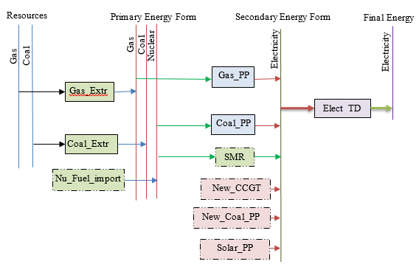

*FIG. 1. The proposed study for energy-mix optimization*

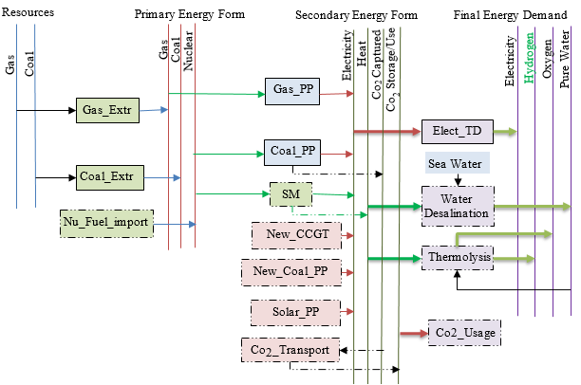

SMR

*FIG. 2. The proposed study for energy-mix optimization, carbon capture and storage, and hydrogen generation.*

TABLE 2. Input parameters of the technologies in MESSAGE [6-8]

|  |  |  |  |  |  |
| --- | --- | --- | --- | --- | --- |
| Technology | Efficiency, % | Operational time, % | Investment Cost (USD/kW) | Fixed Cost (US$/kW/yr) | Retired Time (Year) |
| Electricity distribution (Elect TD) | 95 | - | - | - | 50 |
| Gas power plant (Gas\_PP) | 38.5 | 75 | - | 33 | 30 |
| Coal power plant (Coal\_PP) | 31.6 | 75 | - | 55 | 30 |
| Advanced coal power plant (New\_Coal\_PP) | 46 | 75 | 2200 | 63 | 30 |
| Combined cycle gas turbine (New\_CCGT) | 56 | 75 | 800 | 28 | 30 |
| Solar power plant (Solar\_PP) | - | - | 2060 | 43 | 25 |
| Small modular reactor (SMR) | - | 91 | 4000 | 80 | 60 |

Table 3 represents the final energy (Demand) input values that is used in the proposed model.

TABLE 3. Final energy (Demand) input to MESSAGE.

|  |  |
| --- | --- |
| Year | Demand (Input)  [MWe] |
| 2021 | 555 |
| 2022 | 557 |
| 2025 | 568 |
| 2030 | 635 |
| 2035 | 684 |
| 2040 | 736 |
| 2045 | 793 |
| 2050 | 855 |

### Applying Different Scenarios

The importance of applying different scenarios in a MESSAGE model study can be highlighted in several ways:

* + - 1. Capturing Uncertainty and Exploring Alternative Futures:

1. Scenarios allow the exploration of different assumptions, policy choices, and external factors that can significantly impact the energy system.
2. By running the model under various scenarios, the study can capture a range of possible outcomes and identify the key drivers that influence the energy mix and emissions.
3. This helps in understanding the robustness of the energy system and its ability to adapt to different future conditions.
   * + 1. Informing Policy and Decision-Making:
4. The scenarios provide a platform to evaluate the effectiveness of different policy interventions, such as carbon pricing, renewable energy targets, or energy efficiency measures.
5. By comparing the outcomes of these scenarios, policymakers can assess the trade-offs, identify the most impactful levers, and make informed decisions for the energy system.
6. This information can guide the development of tailored policies and strategies to achieve desired energy and environmental goals.
   * + 1. Evaluating the Importance of Modeling Assumptions:
       2. The scenarios allow the study to isolate the impact of specific modeling assumptions, such as the inclusion of seasonal load profiles, on the energy system outcomes.
       3. By comparing the results of scenarios with and without the load region curves, the study can quantify the importance of accurately capturing the temporal variations in energy demand.
       4. This understanding can inform the level of detail and granularity required in the modeling approach to ensure reliable and actionable insights.
       5. Strengthening the Robustness of Energy System Planning:
7. Applying multiple scenarios in the MESSAGE model study can help identify the key vulnerabilities and sensitivities of the energy system.
8. This can inform the development of more resilient and adaptable energy strategies that can withstand a range of future conditions.
9. The scenario analysis can also highlight the potential risks and trade-offs associated with different energy system configurations, allowing for more informed decision-making.
   * + 1. Enhancing Stakeholder Engagement and Transparency:
10. The scenario-based approach in the MESSAGE model study can facilitate effective communication and engagement with various stakeholders, such as policymakers, industry, and the public.
11. By presenting the results of different scenarios, the study can demonstrate the implications of various policy choices and energy system pathways.
12. This transparency can build trust, foster collaboration, and enable more inclusive decision-making processes.

In the context of the Egypt energy system, the application of scenarios that account for seasonal load variations can provide valuable insights that might not be captured in a more simplistic, annual-based model. By explicitly modeling the temporal patterns of supply and demand, the MESSAGE model study can identify opportunities for improved system optimization, increased renewable energy integration, and more effective emissions reduction strategies.

### Load Regions and Load Curves

The IAEA MESSAGE model is a widely used energy system optimization model that can be used to analyze the long-term development of energy systems. The model allows for the representation of multiple regions, each with their own characteristics and constraints, as well as the use of load regions and load curves to capture the temporal variation in energy demand.

* + 1. *Load Regions:*
* Load regions are used to represent different geographical or administrative areas within the energy system.
* Each load region has its own set of demand profiles, supply options, and other characteristics.
* The load regions can be used to capture regional differences in energy demand, resource availability, and other factors that affect the energy system.
  + 1. *Load Curves:*
* Load curves are used to represent the temporal variation in energy demand within a load region.
* The load curves can be defined for different energy services (e.g., electricity, heating, transportation) and can have different shapes and characteristics depending on the energy service and the region.
* The load curves are used to determine the optimal mix of energy supply technologies and the required energy storage and flexibility options to meet the fluctuating energy demand.

In this study, load regions and load curves are applied in the proposed MESSAGE model:

1. Define the load regions and their characteristics in the model input data.
2. Specify the load curves for each energy service and load region, including the temporal resolution (e.g., hourly, daily, seasonal) and the demand profiles.
3. Ensure that the energy supply technologies and other model components are properly linked to the load regions and load curves.
   * 1. *Proposed Seasonal Study:*

In the IAEA MESSAGE model, the year is divided into 3 seasons, then three separate load curves for each energy service are defined within each load region. Here's an example of how you could set this up:

* Season 1 (Winter/Spring): January to April
* Season 2 (Summer): May to September
* Season 3 (Fall): October to December

In this step:

* The load region is "Egypt".
* The three seasons are: Winter/Spring (January to April), Summer (May to September), and Fall (October to December).
* Each energy service (Electricity, Heating, Cooling) has a separate load curve defined for each season in the Egypt load region.

The actual values for the load curves would need to be provided based on historical data, forecasts, or other sources of information about the energy demand patterns in Egypt for each of the three seasons (Table 4). To ensure that the load curve parameters and other model inputs are consistent and properly linked to the energy supply technologies and other components of the MESSAGE model.

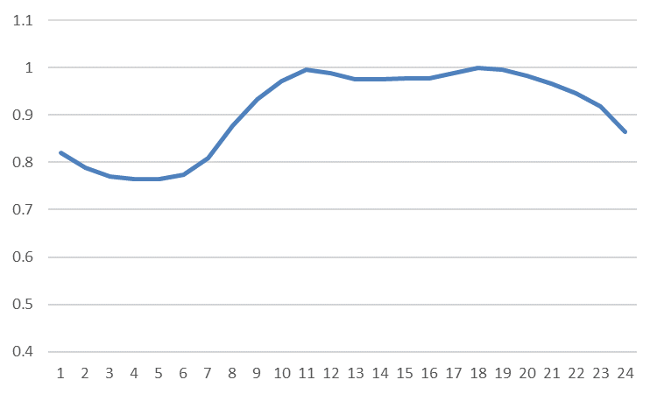

hr

*Fig. 1. The studied load curve*

TABLE 4. The proposed seasonal load region definition.

|  |  |  |  |  |
| --- | --- | --- | --- | --- |
|  | Length of the season | Day type | Duration | Time slices of the day type |
| Season 1 | January – April  (start 01.01.2021) | Any day | 6 hours | 0,250 |
| 4 hours | 0,167 |
| 9 hours | 0,375 |
| 5 hours | 0,208 |
| Season 2 | May – September  (start 01.05.2021) | Any day | 6 hours | 0,250 |
| 4 hours | 0,167 |
| 9 hours | 0,375 |
| 5 hours | 0,208 |
| Season 3 | October – December  (start 01.10.2021) | Any day | 6 hours | 0,208 |
| 4 hours | 0,250 |
| 9 hours | 0,333 |
| 5 hours | 0,209 |

### Hydrogen Generation using (Cu–Cl cycle)

### The copper-chlorine cycle (Cu-Cl cycle) is a four-step thermochemical cycle for hydrogen generation [9, 10]. The Cu-Cl cycle is a hybrid process that includes both thermochemical and electrolysis stages, as seen in Fig. 3. It requires a maximum temperature of around 530 degrees Celsius. The Cu-Cl cycle involves four chemical processes for water splitting, the net result of which is the breakdown of water into hydrogen and oxygen. Every other chemical is recycled. The Cu-Cl process, when combined with nuclear power plants or other heat sources like solar and industrial waste heat, has the potential to reach higher efficiency, reduced environmental impact, and lower hydrogen production costs than any other traditional technique. The Cu-Cl Thermochemical water splitting cycle has special working conditions that must be compatible with the studied system. Applying the thermodynamic analysis to compute the enthalpies of the reactions (7:10) using ($∆H_{f}^{°}=\sum{{∆H_{f_products}^{°}}_{}-\sum{{∆H_{f_reactants}^{°}}_{}}}$). Thermodynamic analysis of the reaction based on the equilibrium conversion and extent of reaction. Detailed thermodynamic modeling is studied to calculate the amount of heat needed to execute the chemical reactions which is 310.8 KJ/mol.

### C:\Users\T O P\AppData\Local\Microsoft\Windows\INetCache\Content.Word\Copper_-_Chlorine_Cycle.svg.png

*FIG. 3. Simplified diagram of the Copper–Chlorine cycle.*

## RESULTS

### Energy-mix optimization

The methodology employed in this study is based on two factors: the amount of energy required to meet the demand for electricity and the examination of the environmental impact. Improving the energy mix to satisfy future electricity demand falls under the first category and mitigates the climate change effect. The second kind is about lowering carbon emissions and the study's effect on the environment. The second study is to generate hydrogen using SMR.

Additionally, many scenarios were used to present the study including limitations in using CO2 taxes and on the SMR capacity. The basic idea behind using CO2 taxes to optimize an energy mix is to provide financial incentives for energy producers and consumers to shift towards lower-emission energy sources. By placing a tax on the carbon content of different fuels, it increases the relative cost of high-emission options like coal, and makes lower-emission alternatives like natural gas, nuclear, and renewables more economically viable.

Since the use used in this study is based on two dependencies of energy need from experience and environmental impact study, the results are classified into two categories. The first category is concerned with improving the electricity mix and future demand for electricity. The second type is related to environmental impact and reducing carbon emissions. The study is presented through different scenarios, shown in Fig.4 to Fig.10.

* + 1. *Scenario 1: Energy-mix and CO2 emissions with no CO2 tax, without load regions*

In this scenario, where the seasonal load region curves were not applied, the majority of the energy mix was from solar power, Fig.4.

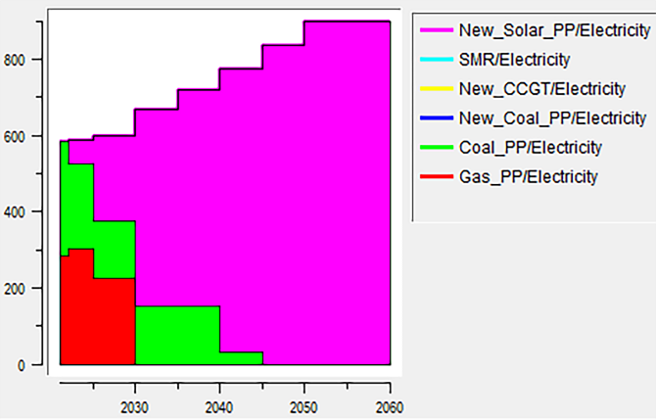

MWyr

Year

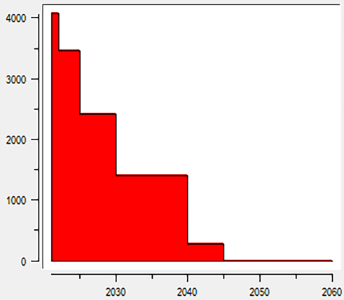

kton\_CO2

Year

*FIG. 4. The resulting energy-mix and Co2 emissions with no CO2 tax without load regions*

* + 1. *Scenario 2: Energy-mix and CO2 emissions with no CO2 tax, applying the load region curves*

In this scenario, where the seasonal load region curves were applied, the majority of the energy mix was from Combined Cycle Gas Turbine (CCGT) technology, Fig.5.

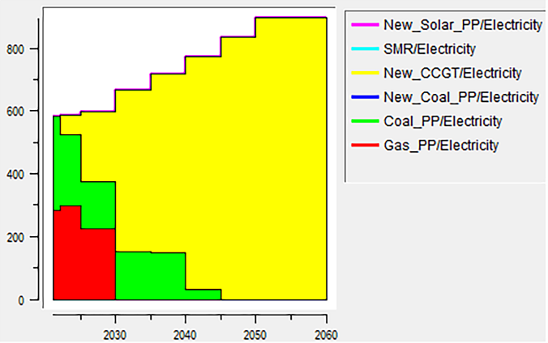

MWyr

Year

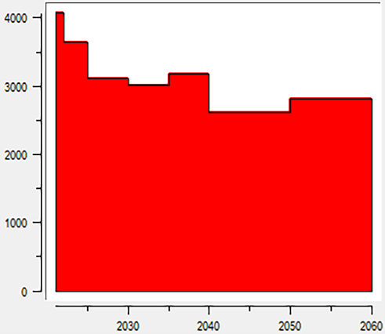

Kton\_CO2

Year

*FIG. 5. The resulting energy-mix and Co2 emissions with no CO2 tax with load regions*

The key difference between the two scenarios is the impact of considering the seasonal load variations on the optimal energy system configuration. When the seasonal load region curves were not applied (Scenario 1), the model likely found that the relatively lower cost and higher availability of solar resources made them the most attractive option for meeting the aggregated annual energy demand. The model would have optimized the system to prioritize solar power, as it did not have to account for the temporal mismatches between solar generation and the actual demand patterns. However, when the seasonal load region curves were applied (Scenario 2), the model had to take into account the temporal variations in energy demand. In this case, the model likely found that CCGT technology, with its ability to better match the fluctuating demand patterns, was a more optimal solution compared to relying solely on solar power. The inclusion of the load region curves allowed the model to better capture the real-world dynamics of energy supply and demand, leading to a different optimal energy mix that prioritized the flexibility and dispatchability of CCGT over the dominance of solar power observed in the first scenario. This highlights the importance of incorporating realistic seasonal demand patterns in energy system modeling, as it can significantly impact the optimal technology mix and the overall system performance.

* + 1. *Scenario 3: Applying a Constant CO2 Tax ($25/ton CO2)*

In Scenario 3, the introduction of a $25/ton CO2 tax leads to a significant transformation of the energy mix, with coal-fired power facing substantial limitations due to the increased operational costs, while natural gas-based Combined Cycle Gas Turbine (CCGT) technology maintains a prominent role, and renewable energy sources, such as solar, experience notable growth. This shift in the energy system, with the reduced reliance on high-emissions coal and the increased deployment of cleaner CCGT and still very little renewable energy, results in a significant overall reduction in the CO2 emissions from the energy system.

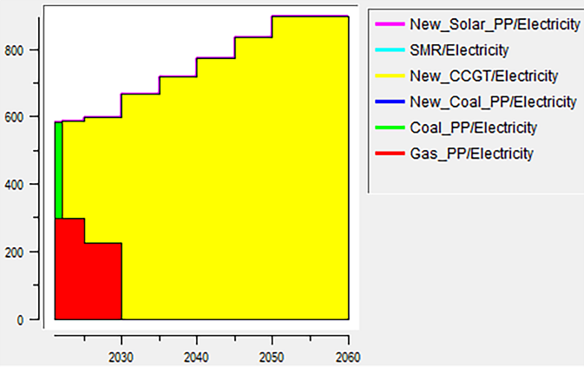

MWyr

Year

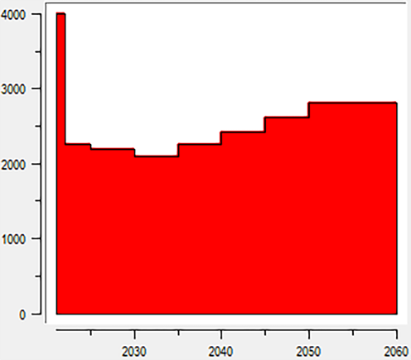

Kton\_CO2

Year

*FIG. 6. The resulting energy-mix and Co2 emissions after applying a fixed CO2 tax*

* + 1. *Scenario 4: Applying an increasing CO2 Tax*

In Scenario 4, a carbon tax price of $25 per ton of CO2 was added, with an annual increase of 20% gradually, combined with the introduction of Small Modular Reactors (SMRs) in 2035 and a reduced reliance on CCGT, leads to a transformative shift in the energy mix. The model simulates a steady decline in the use of carbon-intensive fossil fuels, such as coal and conventional natural gas, as they become increasingly uncompetitive. This is accompanied by a significant growth in clean energy sources, whose competitiveness improves with the rising CO2 tax. The introduction of SMRs in 2035 provides a new low-carbon technology option that gradually gains a larger share in the energy mix, complementing the expansion of renewable energy. The reduced reliance on CCGT, due to the high carbon tax payments, results in a highly decarbonized energy system by 2060, with a substantial reduction in overall CO2 emissions.

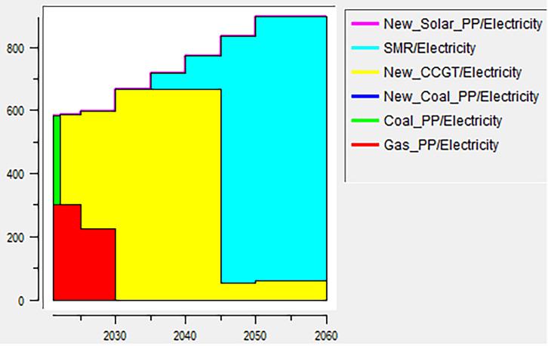

MWyr

Year

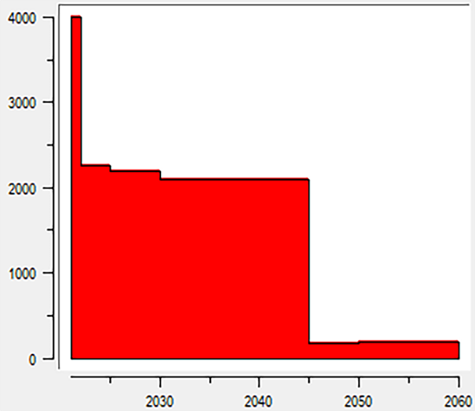

Year

Kton\_CO2

*FIG. 7. The resulting energy-mix and Co2 emissions after applying a high CO2 tax*

* + 1. *Scenario 5: Applying limits on CO2 emissions*

This scenario explores the impacts of introducing strict limits on the volume of CO2 emissions within the energy system. In this scenario, the model applies a hard cap on the total CO2 emissions, forcing the system to rapidly decarbonize in order to comply with the emission constraints. The results show a dramatic shift in the energy mix, with a rapid phase-out of carbon-intensive fossil fuels, such as coal and conventional natural gas. Clean energy sources, experience exponential growth, becoming the dominant contributors to the energy supply. Additionally, the deployment of Small Modular Reactors (SMRs) ramps up significantly, providing a low-carbon baseload power option to complement the variable renewable generation. The hard limit on CO2 emissions leads to a steep decline in overall emissions, with the energy system achieving deep decarbonization by 2060. This is in stark contrast to the more gradual emissions reduction trajectory observed in the previous scenarios. Table 5 presents the key values for the CO2 emissions (in kilotons) under Scenario 5. This scenario demonstrates the significant impacts that can be achieved through the implementation of strict CO2 emission limits, driving a rapid and comprehensive transition towards a low-carbon energy system.

TABLE 5. The proposed volume of CO2 emissions.

|  |  |  |  |  |  |  |  |  |  |
| --- | --- | --- | --- | --- | --- | --- | --- | --- | --- |
| Year | 2021 | 2022 | 2025 | 2030 | 2035 | 2040 | 2045 | 2050 | 2060 |
| Limitation [kton] | 4081.6 | 3989.4 | 3712.8 | 3251.8 | 2790.8 | 2329.8 | 1868.9 | 1407.9 | 1407.9 |

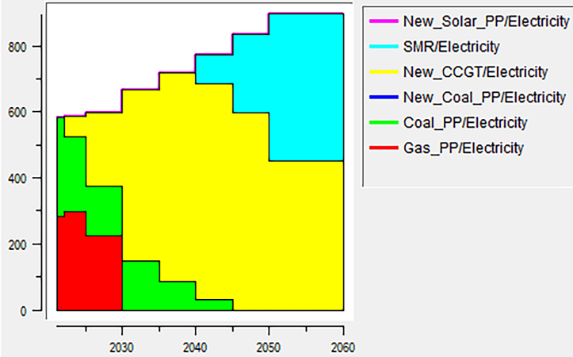

MWyr

Year

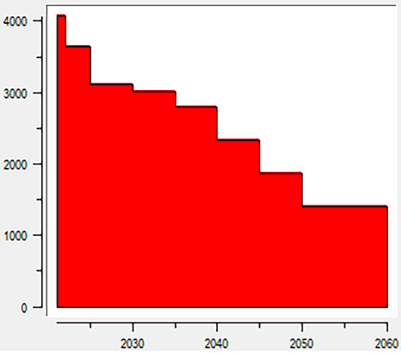

Year

Kton\_CO2

*FIG****. 8****. The resulting energy-mix and Co2 emissions after applying limits on CO2 emissions*

On the other hand, Fig.6 presents the resulted energy-mix with limits on CO2 emissions and Fig.7 presents the resulted energy-mix with limits on CO2 emissions and SMR capacity (300 MWe).

* + 1. *Scenario 6: Applying limits on CO2 emissions and SMR capacity (up to 300 MWe limit)*

Scenario 6 builds upon the previous Scenario 5, which introduced strict limits on the total volume of CO2 emissions. In this new scenario, the model not only applies the hard cap on emissions but also imposes a limit on the capacity of Small Modular Reactors (SMRs) to a maximum of 300 MWe. The results show that the combination of the CO2 emission constraints and the SMR capacity limit leads to a further transformation of the energy system. While clean energy sources still experience substantial growth, becoming the dominant contributors to the energy mix, the role of SMRs is somewhat constrained compared to the previous scenario. The limited SMR capacity means that the energy system must rely more heavily on other low-carbon technologies, such as utility-scale renewable energy projects and potentially advanced nuclear designs beyond the 300 MWe limit. This diversification of the technology portfolio helps ensure the energy system can still achieve the deep decarbonization required to comply with the strict CO2 emission limits. This scenario highlights the importance of considering multiple constraints and technology options to achieve a successful energy transition under strict emissions reduction targets.

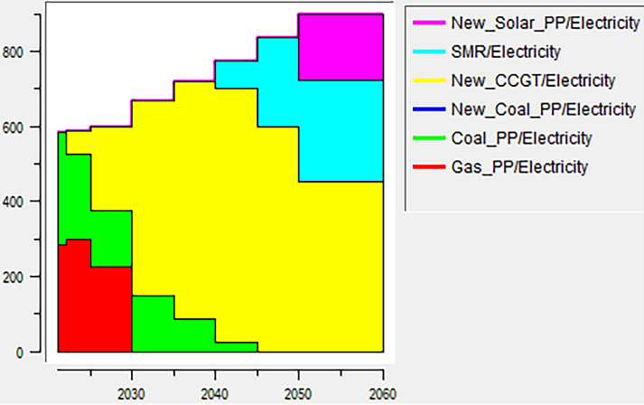

MWyr

Year

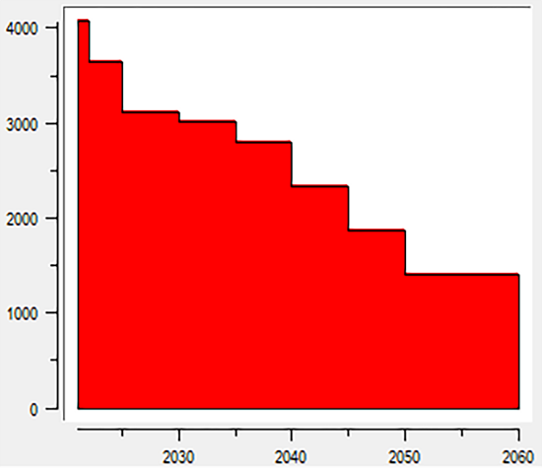

Year

Kton\_CO2

*FIG.* ***9****. The resulting energy-mix and Co2 emissions after applying limits on CO2 emissions and SMR capacity (up to 300 MWe)*

* + 1. *Scenario 7: Applying limits on CO2 emissions and fixed SMR capacity (300 MWe limit)*

Scenario 7 builds upon the previous Scenario 6, which introduced strict limits on the total volume of CO2 emissions and a capacity limit of 300 MWe for Small Modular Reactors (SMRs). In this new scenario, the model applies the same CO2 emission constraints and the fixed 300 MWe SMR capacity, with the additional assumption that the SMR technology is designed to be available and deployed starting from 2035 with a fixed power capacity. The results of this scenario show a more gradual transition towards a low-carbon energy system, compared to the previous scenarios with more flexible technology options. The delayed availability of SMRs until 2035 means that the energy system must rely more heavily on other decarbonization technologies, such as renewable energy solar source, in the earlier years to comply with the strict CO2 emission limits. However, once the SMR technology becomes available in 2035, it plays a significant role in the energy mix, complementing the continued growth of renewable energy. The combination of renewable energy and the fixed-capacity SMRs helps the system achieve the required deep decarbonization by 2060, despite the constraints on technology options. This scenario highlights the importance of considering the timing and availability of low-carbon technology options, such as SMRs, in the context of strict emissions reduction targets. The gradual transition observed in this scenario may be more realistic and achievable compared to the more rapid changes seen in the previous scenarios.

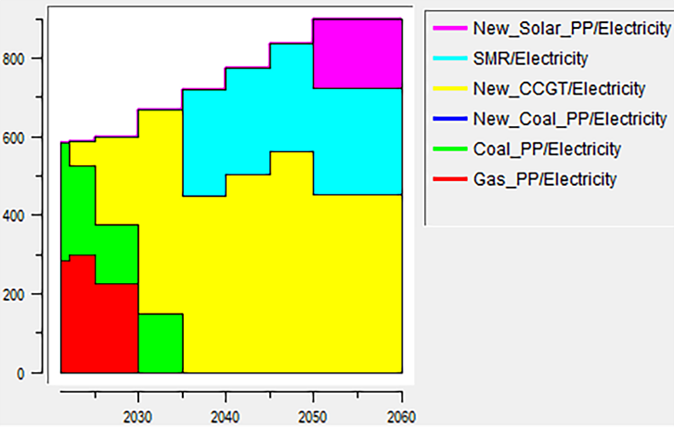

MWyr

Year

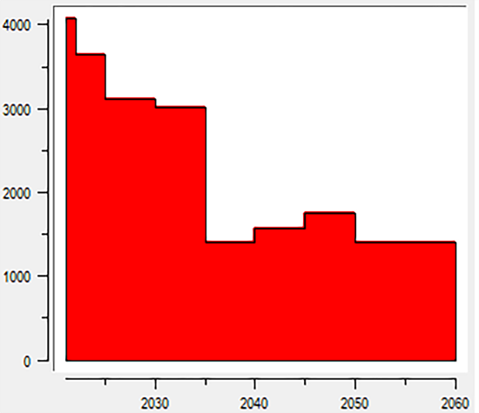

Year

Kton\_CO2

*FIG. 10. The resulting energy-mix Co2 emissions after applying limits on CO2 emissions and fixed SMR capacity (300 MWe)*

### Thermolysis Hydrogen Generation

In order to produce 1 kg of hydrogen, 500 moles of each reactant should be used; we need 200 kg of (cucl\_aq) and 9 kg of water. Other products of the cycle may be economically beneficial such as 8 kg of oxygen. To calculate the economic feasibility of hydrogen production via the nuclear industry precisely, we should take all products into consideration. In this study, 300 MWe from the high temperature SMR (approximately 803 MWth). The proposed system runs at a temperature of 500℃. The proposed system is studied to generate 14 tons of Hydrogen, and 112 tons of Oxygen. $7×{10}^{6}$ moles of each reactant should be used. In a weight study reactants of 126 tons of water and 2800 tons of ${cu-cl}_{aq}$ should be used as reactants. The net required energy to complete the reactions equals 310.8 kJ/mol which was calculated using a designed thermodynamic model. On the other hand, a typical seawater reverse osmosis plant can be used also, however it consumes 3:10 Kw.hr of electric energy to produce one cubic meter of fresh water.

## CONCLUSIONS

The study presents a compelling case for the integration of small modular reactors (SMRs) with thermochemical hydrogen production processes as a promising approach to address the critical challenges of future energy demand and climate change mitigation. The proposed SMR-based system, centered around the copper-chlorine (Cu-Cl) thermochemical cycle, demonstrates the potential to generate substantial quantities of clean hydrogen (14 tons per cycle) and valuable oxygen (112 tons per cycle) in a highly efficient manner. The research highlights the benefits of SMR technology, which can provide the necessary high-temperature thermal input (803 MW) to drive the energy-intensive Cu-Cl cycle, while also offering inherent advantages such as modularity, scalability, and improved safety features. The integration of a seawater reverse osmosis (SWRO) desalination plant further enhances the system's sustainability by optimizing the water usage and reducing the external electricity demands. Importantly, the study's scenario analysis, which incorporated the impact of CO2 taxes, revealed that such policy measures can serve as effective financial incentives to encourage a shift towards lower-emission energy sources. This aligns with the primary objective of the research, which was to improve the energy mix and mitigate the climate change effects associated with the growing electricity demand. By optimizing the energy mix and leveraging the carbon-free nature of nuclear power through SMRs, the proposed system has the potential to significantly reduce greenhouse gas emissions while meeting the future energy needs. Furthermore, the integration of large-scale hydrogen production capabilities expands the system's impact, as hydrogen can serve as a valuable energy carrier and fuel for transportation, industrial, and other applications. Overall, the comprehensive methodology, promising results, and the consideration of critical factors such as climate change mitigation and energy mix optimization demonstrate the compelling potential of SMR-based thermochemical hydrogen production systems as a holistic solution to the energy and environmental challenges of the future.

References

1. Iyer, Gokul, et al., Implications of small modular reactors for climate change mitigation. Energy Economics, 45 (2014): 144-154.
2. Lebrouhi, B. E., Schall, E., Lamrani, B., Chaibi, Y., & Kousksou, T., Energy transition in France. Sustainability, 14(10) (2022), 5818.
3. Dirk Schindler, Leon Sander, Christopher Jung., Importance of renewable resource variability for electricity mix transformation: A case study from Germany based on electricity market data. Journal of Cleaner Production, (2022) Volume 379, Part 1, ISSN 0959-6526,
4. Handayani, K., Anugrah, P., Goembira, F., Overland, I., Suryadi, B. and Swandaru, A., Moving beyond the NDCs: ASEAN pathways to a net-zero emissions power sector in 2050. Applied Energy, (2022) 311, p.118580.
5. Popov, Nikola, Igor Ilijovski, and Vladimir Popovski., Planning of Energy Demand and Supply in Macedonia Using the MAED and MESSAGE Model. (2015).
6. Rečka, L., Electricity system optimization: A case of the Czech electricity system–application of model MESSAGE. Proceedings of the 5th International Days of Statistics and Economics, (2011)
7. Energy Information Administration, U., Capital Cost and Performance Characteristic Estimates for Utility Scale Electric Power Generating Technologies. (2020)
8. Shen, W., Chen, X., Qiu, J., Hayward, J. A., Sayeef, S., Osman, P., & Dong, Z. Y. A comprehensive review of variable renewable energy levelized cost of electricity. Renewable and Sustainable Energy Reviews, (2020) 133, 110301
9. Litwin RZ, Pinkowski SM, inventors; Pratt, Whitney Rocketdyne Inc, assignee. Solar power for thermochemical production of hydrogen. United States patent US 7,726,127. (2010).
10. Rosen, M.A., Naterer, G.F., Sadhankar, R., Suppiah, S., "Nuclear-Based Hydrogen Production with a Thermochemical Copper-Chlorine Cycle and Supercritical Water Reactor", Canadian Hydrogen Association Workshop, Quebec, (2006) 19 – 20.