**EVALUATION OF POTENTIAL LOCATIONS FOR SITING SMALL MODULAR REACTORS IN IRAQ TO SUPPORT CLEAN ENERGY GOALS**

Muataz.D.Shnawa

Iraqi Atomic Energy Authority

Baghdad, Iraq

Email: motaz.1761981@gmail.com

Haidar M. Hadi

Iraqi Atomic Energy Authority

Baghdad, Iraq

Ali.m lami

Iraqi Atomic Energy Authority

Baghdad, Iraq

**Abstract**

This study provides an overview of the energy sector in Iraq and the activities of the Commission related to small modular reactors, as well as the study contains the feasibility of small modular reactors and an assessment of the site selection process for small modular reactors in Iraq to produce electrical energy to contribute to solving the problem of shortage of electrical energy in Iraq, where Iraq needs (35000) MW to meet the actual need for energy while the total production (24000) MW and Iraq seeks to diversify the sources of power generation and reduce the bill Fossil fuels and reducing greenhouse gas emissions resulting from power generation, where the need arose in remote areas for small power plants, where the study begins with the stages of selecting the preferred sites for the installation of small modular reactors, the stage of office studies, the collection of IAEA literature, the stage of preliminary reconnaissance visits, and the stage of investigation and final exploration, and work was done within the criteria for selecting the site of the station for the initial exploratory phase stipulated in the publications of the International Atomic Energy Agency and due to the acute shortage of electrical power in Villages and multiple districts in Iraq, so Iraq went to find solutions in the field of electric power production and water desalination using nuclear energy, and small modular reactors are among the proposed solutions, in addition to alternative energies wind and solar.Where work was done within the work methodology to choose sites for establishing a standard reactor station, which is based on scientific literature published in the field of earth sciences, water resources, environment, climate, satellite images, geological, topographical and hydrological maps, etc. and adopting projective standards according to the literature of the International Atomic Energy Agency.and working on advanced scientific programs such as (GIS). These programs were used to analyze satellite and digital images to choose the best sites. The first revealed multiple sites in different governorates of Iraq, including (7) sites in Babil Governorate. (5) sites in Diwaniyah Governorate, (3) sites in Muthanna Governorate, and (3) sites in Najaf Governorate, where a comparison was made between them in terms of describing their geographical locations and their distance from the center of the governorate, as well as the area available for each site, the type of available water source, and proximity to transmission lines. Energy and population density of the areas and their surroundings, as well as the topography of the nominated areas, and the best reality was in Babil Governorate.

1. INTRODUCTION

This study provides an overview of the energy sector in Iraq and the Authority’s activities related to small modular reactors. The study also contains the feasibility of small modular reactors and an evaluation of the site selection process for small modular reactors in Iraq to produce electrical energy to contribute to solving the problem of electrical energy shortage in Iraq, as Iraq needs (35) thousand megawatts to meet the actual need for energy, while the total production is (24) thousand megawatts. Iraq seeks to diversify the sources of energy generation, reduce the fossil fuel bill, and reduce greenhouse gas emissions resulting from power generation. The study begins with the stages of selecting preferred sites for installation Small standard reactors, the stage of office studies and collecting agency literature [1], the stage of initial reconnaissance visits, and the stage of investigation and final exploration. The work was done within the criteria for choosing the station’s location for the initial exploratory stage stipulated in the publications of the International Atomic Energy Agency, and given the presence of a severe shortage of electrical power in multiple villages and districts. In Iraq, therefore, Iraq turned to finding solutions in the field of electrical energy production, and small standard reactors are among the proposed solutions, in addition to alternative energies, wind and solar. The work was done within the work methodology to choose sites for constructing a standard reactor station, which is based on scientific literature published in the field of earth sciences, water resources, environment and climate [2], satellite images, geological, topographical and hydrological maps, etc. and adopting projective standards according to the literature of the International Atomic Energy Agency.and working on advanced scientific programs such as (GIS). These programs were used to analyze satellite and digital images to choose the best sites. The first revealed multiple sites in different governorates of Iraq, including (7) sites in Babil Governorate. (5) sites in Diwaniyah Governorate, (3) sites in Muthanna Governorate, and (3) sites in Najaf Governorate, where a comparison was made between them in terms of describing their geographical locations and their distance from the center of the governorate, as well as the area available for each site, the type of available water source, and proximity to transmission lines. Energy and population density of the areas and their surroundings, as well as the topography of the nominated areas, and the best locations were in Babil Governorate.

2. STAGES OF CHOOSING PREFERRD SITES FOR INSTALLING SMR REACTORS:

The stage of office studies and collecting the agency’s literature: in which all studies and literature related to the initial nomination mechanism for places that are believed to be good and suitable for the installation of small modular reactors (which fall within the first phase of work) are prepared. It ends with the nomination of potential sites for establishing the reactor (SMR), and also results in sites. It is rejected and excluded because it does not meet the requirements for constructing this type of reactor [1], [2], [3]

The stage of initial reconnaissance visits: This falls within the second stage of the work on selecting appropriate sites for constructing reactors (SMR), which results in selecting potential places for installing standard reactors and other rejected sites.

The final investigation and exploration phase: This falls within the second, final phase, which results in selecting preferred sites for installing small standard reactors and rejecting unsuitable sites [4], [5].

3. CRITERIA FOR SELECTING THE STATION SITE FOR THE INITIAL EXPLORATORY PHASE

3.1- The required area is (6 to 10) km2.

3.2- Close to water sources with a discharge of (2.5 to 3) m3/s and a distance of (0 to 10) km.

3.3- Areas that do not fall within the governorate’s future plans and projects.

3.4- Close to electricity transmission stations (substation) in agreement with representatives of the Ministry of Electricity.

3. 5- Roads and transportation, as it is necessary to stay away from the main land roads and railways by a distance of (1) km.

3.6- Population density, as you must stay away from high-density population centers at an appropriate distance, as follows:

-A distance of (15) km from communities of more than one hundred thousand people or more.

-A distance of (7) km from communities whose size ranges between (50,000-100,000) people.

-A distance of (2) km from communities whose size ranges between (5000-50000) people.

-A distance of (1) km from communities of less than (5000) people.

3.7- Airports, equipment stores, and camps. It is necessary to stay away from the locations of military and civilian airports, equipment stores, and fixed camps by a distance of no less than 10 km.

3.8- Archaeological sites, as archaeological sites and tourist areas must be avoided and kept away from them according to directives issued by the relevant authorities.

3.9- Energy and water transmission lines, as it is necessary to stay away from the paths of all high-voltage electrical power transmission lines, pipelines for transporting oil, gas, petroleum products, and water transport networks, and the distance should not be less than (1) km.

3.10- International borders, as you must stay away from international borders by a distance of no less than

(5) km.

4. WORKING METHODOLOGY FOR SELECTING SITES FOR CONSTRUCTING A STANDARD REACTOR STATION:

4.1- Relying on published scientific literature in the field of earth sciences, water resources, environment, climate, satellite images, geological, topographical and hydrological maps, etc.

4.2- Adopting the projective criteria in accordance with the literature of the International Atomic Energy Agency.

4.3- Advanced scientific programs such as GLOBLE GEOGRAPHICAL INFORMATION SYSTEM (GIS). These programs were used to analyze satellite and digital images to choose the best sites according to the approved parameters and their intersection with the province’s parameters and projects through direct meetings and discussions to achieve accuracy and speed of completion in nominating suitable sites for the first exploratory phase.

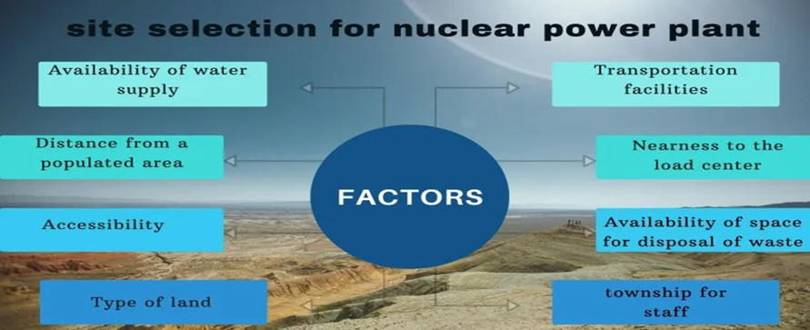

*Fig. (1): stages of best site selection.*

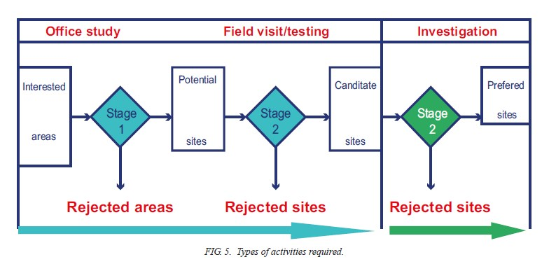

Nomination of primary sites

Holding a technical meeting with relevant governorate representatives

Nomination and selection of sites

Exclude areas

Nomination and selection others areas

Field visit to the nominated sites

Confirm sites nomination

Exclude

*Flowchart of the work methodology for selecting and nominating sites to establish the station*

5. Results and discussion:

Through analyzing satellite images, field visits, and determining the selected criteria to nominate suitable sites, the most important of these criteria is the presence of sufficient permanent water sources throughout the year. Therefore, several sites were nominated in Babylon Governorate, Diwaniyah, Muthanna, and Najaf.

A. Candidate sites in Babil Governorate

|  |
| --- |
| Site number area(km2) Region location |

1 10 Hilla Al-Kifl

2 20 Al-Hashimiya Al-Shumali

3 21 Al-Musayyib Al-Mashroh

4 9 Al-Hashimiya Al-Taliah

5 6 Al-Mahawil Al-Imam

6 11 Al-Musayyab Al-Mashrou

7 7 Mahawil Nile

*Table No. (1): Shows the nominated sites in Babil Governorate*

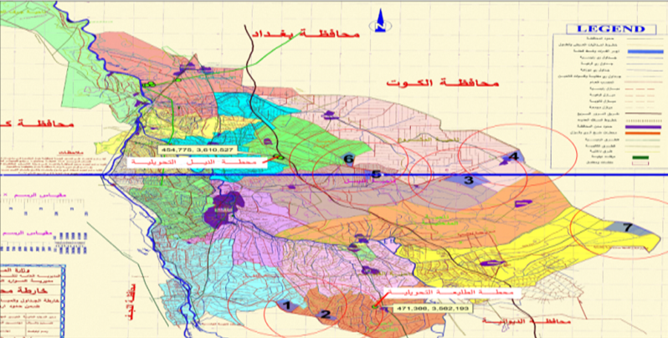

Description of the first site, its advantages and disadvantages (Al-Hilla Region, Al-Kifl District) The site is located within the Babil Governorate, Al-Mahawil Region, Al-Imam District. The water source is fresh surface water, a canal branching off from the Euphrates River, 40 km away from the Euphrates River. The area is characterized by a small population density and is close to transportation and electricity lines. Disadvantages: The location is 40 km away from the main river, the Euphrates. The recommendation is acceptable.

Description of the second site, its advantages and disadvantages (Al-Hashimiya Region, Al-Shumali District) The site is located within Babel Governorate, Al-Hashimiya Region, Al-Shumali District, and the area is characterized by a small population density and is close to transportation and electricity lines. Disadvantages of the location: There is no fresh water in the area. Recommendation is average.

Description of the third site, its advantages and disadvantages (Al-Musayyab Region, Al-Mashroh District) The site is located within the Babel Governorate, Al-Musayyib Region, AL-Mashroh District, and the area is characterized by a small population density and is close to transportation and electricity lines. Disadvantages of the location: There is no fresh water in the area. It is 12 kilometers away from the main estuary. The recommendation is rejected.

Description of the fourth site, its advantages and disadvantages (Al-Hashimiyeh Region, Al-Taliah District) the site is located within the Babil Governorate, Al-Hashimiyeh Region, Al-Taliah District. The water source is fresh surface water, a canal branching off from the Euphrates River. It is 18 km away from the Euphrates River. The area is characterized by a small population density and is close to transportation and electricity lines. recommendation Acceptable to average.

Description of the fifth site, its advantages and disadvantages (Al-Mahawil Region, Al-Imam District) The site is located within the Babil Governorate, Al-Mahawi Region, Al-Imam District. The water source is fresh surface water, a canal branching off from the Euphrates River, 40 km away from the Euphrates River. The area is characterized by a small population density and is close to transportation and electricity lines. Disadvantages: The location is 40 km away from the main river, the Euphrates. The recommendation is acceptable.

Description of the sixth site, its advantages and disadvantages (Al-Musayyab Region, Al-Mashrou’ District) The site is located within the Babil Governorate, Al-Musayyib Region, Al-Mashrou’ District. The area is characterized by a small population density and is close to transportation and electricity lines. Disadvantages of the site: There is no fresh water in the area, and it is 12 kilometers away from the public estuary. The recommendation is rejected.

Description of the seventh site, its advantages and disadvantages (Al-Mahawi Region l, Nile District) The site is located within Babil Governorate, Al-Mahawi Region, Nile District. The water source is fresh surface water, a canal that branches off from the Euphrates River for 50 km. The area is characterized by a small population density and is close to transportation and electricity lines. Disadvantages: Location is far from the main water source (Euphrates River). Recommendation: Acceptable.

B. Nominated sites in Diwaniyah Governorate

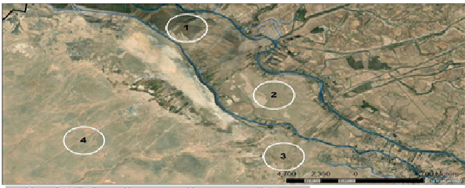

*Fig 2 Nomination Sites in AL-Dewanya Gov*

Candidate site number one (1), which is located in Al-Hamza Region, Al-Shinafiya district, which is characterized by the following: (80) km away from the center of Al-Diwaniyah. The area is sparsely populated agricultural area. There are scattered homes for farmers. The population density ranges between (15 to 20) people/ km2, the site is surrounded on both sides by the Euphrates River and the Qadisiyah River, the amount of water is available, easy access to site No. 1, an hour from the center, a temple and the areas near the site are not paved. The area is considered good in terms of the availability of sufficient space and ease of access to the site, and the Euphrates River is only 100 meters away. And the Al-Qadisiyah River as well. Electricity transmission lines are fairly close. The location is considered average to good.

Candidate site no. (2), which is located in Al-Hamza district, Al-Shinafiya region, which is characterized by the following it is 80 kilometers away from the center of Al-Diwaniyah. The area is sparsely populated agricultural areas. There are scattered homes for farmers. The population density ranges between (15 to 20) people/km2. It surrounds... The site is located on both sides: the Euphrates River and the Qadisiyah River. The amount of water is available. Easy access to site no. (2) is an hour away from the center. It is a temple and the areas near the site are not paved. The area is considered good in terms of the availability of sufficient space and ease of access to the site, and the Euphrates River is only (100) away. and the Qadisiyah River as well. Electricity transmission lines are fairly close. The location is considered average to good.

Candidate site no. (3), which is located in Al-Hamza region, Al-Shinafiya district, and is characterized by the following: (It is 80 km away from the city center of Al-Diwaniyah. The area is sparsely populated agricultural area. There are scattered homes for farmers. The population density ranges between 15 and 20 people/km2. It is located The location is on the Al-Qadisiyah River, the required amount of water is available, easy access to site No.3, an hour away from the center, a temple and the areas near the site are not paved. The area is considered good in terms of the availability of sufficient space and ease of access to the site, the Euphrates River is only (100) meters away, and the Al-Qadisiyah River as well. Electricity transmission lines are fairly close. The location is considered average to good.

Candidate site no. (4), which is located in Al-Hamza region, Al-Shinafiya district, and which is characterized by the following: (It is 85 kilometers away from the center of Al-Diwaniyah. The area is sparsely populated agricultural area. There are scattered homes for farmers. The population density ranges between 15 and 20 people/km2. The site is located within the Al-Shinafiya district towards the west. Water is available from the Al-Qadisiyah River, which is 8 km away from the site. easy access to site No.4, an hour and a half away from the center. It is a temple and the areas near the site are not paved. The area is considered good in terms of the availability of sufficient space and ease of access to the site. Electricity transmission lines are fairly close. The location is considered average to good.

C. AL-Samawa Governorate:

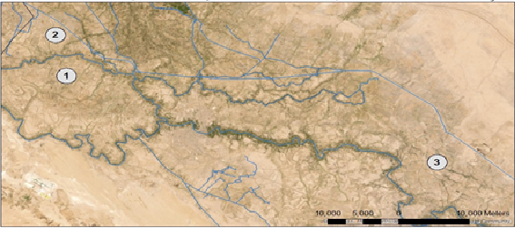

*Fig 2 Nomination Sites in AL-Samawa Governorate*

Candidate site no. (1), which is located in Al-Rumaith region a, Al-Hilal district, and which is characterized by the following it is 25 kilometers away from the center of Samawah, the area is sparsely populated agricultural area. There are scattered homes for farmers, the population density ranges between 20 to 25 people/km2, the site is located Within the Crescent and Glory area, water is available from the Euphrates River, which is 2 km away from the site. easy access to Site No.1, half an hour from the center. It is a temple and the areas near the site are not paved. The area is considered good in terms of the availability of sufficient space and ease of access to the site, transportation lines. Electricity is fairly close. The location is considered average to good.

Nominated site no. (2) With some representatives of the governorate, which is located in Al-Rumaitha region, Al-Hilal district, which is characterized by the following It is 25 kilometers away from the city center of Samawah. The area is sparsely populated agricultural area. There are scattered homes for farmers. The population density ranges between 20 to 25 people. / km2, the site is located within the Crescent and Glory district. Water is available from the Euphrates River, which is 2 km away from the site. Easy access to site No. 2 is half an hour away from the center. The road is paved and the areas near the site are not paved. The area is considered good in terms of the availability of sufficient space and ease of access. Access to the site (electricity transmission lines are fairly close) The location is considered average to good.

Candidate site no. (3), which is located in Al-Khader region, Al-Khader district, which is characterized by the following it is 40 km away from the center of Samawah. The area is sparsely populated agricultural area. There are scattered homes for farmers. The population density ranges between 20 to 25 people/km2. The site is located Within the Crescent and Glory area, water is available from the Euphrates River, which is 6 km away from the site. Easy access to Site No. 3, an hour from the center. There is a temple and the areas near the site are not paved. The area is considered good in terms of the availability of sufficient space and ease of access to the site. Electricity transmission lines are close by. Somewhat) The location is considered average to good.

D. Alnajaf Governorate

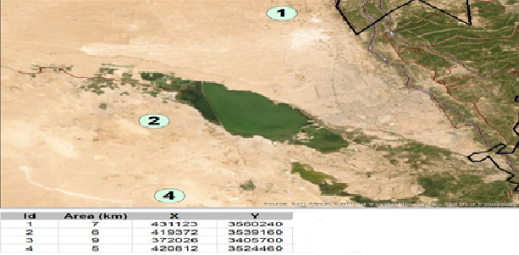

*Fig4 Nomination Sites in Alnajaf Governorate*

Candidate site no. (1), which is located in the Najaf region, Najaf district, north of Najaf, and which is characterized by the following it is 30 km away from the center of Najaf city. The area is sparsely populated agricultural area. There are scattered homes for farmers. The population density ranges between 20 to 25 people/km2. The site is located within the Najaf district. Water is available from the Euphrates River, which is 2 km away from the site, but in the governorate’s opinion, water should be provided from treated heavy water in the future. Easy access to Site No. 1 is an hour away from the center. It is a temple and the areas near the site are not paved. The area is considered good. In terms of the availability of sufficient space and ease of access to the site, the electricity transmission lines are fairly close. The site is considered acceptable. It is currently excluded due to its reliance on future projects.

Candidate site no. (2), which is located in the Najaf region, Najaf district, adjacent to the Najaf Sea, which is characterized by the following it is 40 kilometers away from the center of the city of Najaf. The area is sparsely populated agricultural area. There are scattered homes for farmers. The population density ranges between 20 to 25 people/km2. The site is located within the Najaf district. Salty water is available from the Najaf Sea, which is 4 km away from the site. Easy access to site No. 2 is an hour and a quarter away from the center. It is a temple and the areas near the site are not paved. The area is considered good in terms of the availability of sufficient space and ease of access to the site. Electricity transmission lines are fairly close. The site is considered acceptable, although reservations are currently made regarding it because we do not have information about the available quantities of water in the Najaf Sea throughout the year.

Candidate site no. (3), which is located in the Najaf region, Al-Shabaka district, which is characterized by the following it is 160 kilometers away from the center of the city of Najaf. The area is sparsely populated agricultural area. There are scattered homes for farmers. The population density ranges between 0 people/km2 except in the center of the district. The site is located within the network area. Groundwater is available in the area only. easy access to site no.3 It is 3 hours away from the center. It is a temple and the areas near the site are not paved. The area is considered good in terms of the availability of sufficient space and ease of access to the site. Electricity transmission lines are fairly close.) The site is considered acceptable, but it is currently reserved because we do not have information about the available quantities of groundwater and whether they are sufficient.

6. SUMMARY:

Through preliminary studies, setting criteria, and analyzing data, it becomes clear to us that the best sites are those in Diwaniyah Governorate, Al-Shinafiyah District, in terms of the availability of sufficient space, far from population centers, and its proximity to water sources and energy transmission lines. We recommend completing preliminary studies for the rest of the governorates and making a comparison between them to move to the studies stage. detailed information about choosing appropriate sites.

References

[1] INTERNATIONAL ATOMIC ENERGY AGENCY, Geotechnical Aspects of Site Evaluation and Foundations for Nuclear Power Plants, IAEA Safety Standards Series No. NS-G-3.6, IAEA, Vienna (2004).

[2] INTERNATIONAL ATOMIC ENERGY AGENCY, External Events Excluding Earthquakes in the Design of Nuclear Power Plants, IAEA Safety Standards Series No. NS-G-1.5, IAEA, Vienna (2003).

[3] INTERNATIONAL ATOMIC ENERGY AGENCY, Seismic Design and Qualification for Nuclear Power Plants, Safety Standards Series No. NS-G-1.6, IAEA, Vienna (2003).

[4] INTERNATIONAL ATOMIC ENERGY AGENCY, Site Evalution of Nuclear Facility, IAEA Safety Standards Series No. SSR-1, IAEA, Vienna (2019).