# Integration of Small Modular Reactors (SMRs) in Ghana's Energy Mix: A Pathway to Sustainable Development

J. GBINU

Ghana Atomic Energy Commission, Nuclear Power Institute1

Accra, Ghana2

Email: [joshua.gbinu@gaec.gov.gh](mailto:joshua.gbinu@gaec.gov.gh) / kjosh8676@gmail.com

F. Ameyaw PhD1,2, M. Nyasapoh1,2, B. Emi-Reynolds1,2, A. Buah-Kwofi PhD1,2, S. K. Debrah PhD1,2

**Abstract**

The addition of Small Modular Reactors (SMRs) into Ghana's electricity generation mix presents a promising pathway towards achieving sustainable development goals through the reduction of greenhouse gas emissions while solving the challenges of meeting energy demand. The paper explores the key considerations and strategies for establishing an enabling environment to facilitate the successful deployment of SMRs in Ghana. Energy planning plays a pivotal role in aligning SMR deployment with national energy demand and climate goals. Through comprehensive energy planning, Ghana can optimize the integration of SMRs alongside renewables, ensuring a balanced and resilient energy system. Furthermore, the development of robust nuclear infrastructure, including capacity building and stakeholder engagement, is essential to build public trust and support for SMR projects. Again, financing, and economic appraisals are critical aspects of SMR deployment, requiring innovative approaches to address investment challenges associated with SMR deployment. The paper investigates various financing structures, and conditions that will support SMR projects in Ghana. Additionally, Reactor Technology Assessment (RTA) was highlighted as a crucial component of SMR deployment, encompassing safety, reliability, and efficiency evaluations. This assessment informs decision-making processes and ensure the selection of suitable SMR technologies for Ghana's specific energy needs and infrastructure. International cooperation for harmonization and standardization was emphasized to leverage global expertise and best practices in SMR technology and regulatory frameworks. Collaboration amongst vendors, utilities, end-users, and other stakeholders is essential to navigate regulatory processes, streamline project implementation, and ensure the successful integration of SMRs into Ghana's energy mix. In conclusion, the paper advocates for a holistic approach to integrate SMRs into Ghana's energy mix, encompassing energy planning, nuclear infrastructure development, technology assessment, financing strategies, stakeholder engagement, and international cooperation. By addressing these critical issues, an enabling environment will be created for deployment of SMRs in Ghana to support sustainable development objectives.

## INTRODUCTION

The integration of Small Modular Reactors (SMRs) into national energy strategies presents an innovative pathway towards achieving sustainable development. Energy demand continue to rise globally, necessitating the exploration of diverse, reliable, and low-carbon energy sources. Ghana relies heavily on traditional energy sources such as hydropower and fossil fuels, which are susceptible to supply disruptions and contribute to environmental degradation through greenhouse gas emissions. However, these sources alone are unable to meet the country's burgeoning energy demands neither are they aligned with its commitments to mitigate climate change under international agreements such as the Paris Agreement. Ghana’s quest for energy security and sustainable economic growth, makes SMR a capable solution due to the scalability, cogeneration capability, lower upfront cost, and compatibility with existing grid infrastructure [1]. Moreover, the global push for reduced carbon emissions positions nuclear technology as a vital component in the transition towards cleaner energy production [2]. Ghana therefore seeks to diversify its energy portfolio to enhance this transition by opting for SMR technology.

Ghana’s ambition to exploit peaceful uses of nuclear technology began in 1960s which led to the formation of Ghana Nuclear Reactor Project which is now Ghana Atomic Energy Commission (GAEC). Since the inception of the project, the country faced series of political instability which brought the programme to hiatus. The country experienced major electrical power crisis in the mid 2000s resulting in the formation of a committee to study the feasibility of adopting nuclear power. This committee’s report shows the need to include nuclear power in its energy mix and its possibility to meet the vision of being the energy hub of West Africa and the industrialization agenda. The Ghana Nuclear Power Programme Implementation Organization (GNPPO) was established to coordinate the nuclear power development agenda based on the International Atomic Energy Agency’s (IAEA) phased approach for newcomer countries developing a nuclear power programme [3]. The Nuclear Power Institute (NPI) was established by GAEC to serve as the technical driving force for Ghana’s nuclear power programme development. The country successfully completed Phase 1 studies which led to an Integrated Nuclear Infrastructure Review (INIR) in 2017. This was followed by a subsequent follow-up INIR mission in 2019 to assess how the gaps identified during the earlier mission were addressed [4]. The INIR mission team’s evaluation stated based on the studies carried out by Ghana that the country is ready to make informed decision regarding its nuclear power programme. The Programme Comprehensive Report (PCR) was compiled and submitted to the president of Ghana through the cabinet for final decision making. In July 2022, the president officially announced the decision to include nuclear energy in Ghana’s energy mix [5]. Fig 1 below shows Ghana’s nuclear journey.

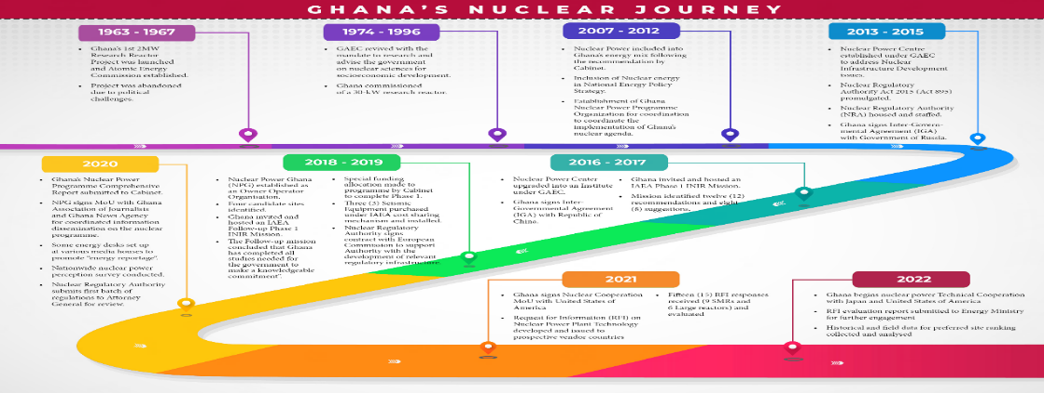

*FIG. 1. Progress of Ghana’s nuclear power programme [4]*

The Nuclear Regulatory Authority (NRA), the Nuclear Power Ghana (NPG) – Ghana’s Owner/Operator are already established as key organizations for a nuclear power programme development. NPI is currently being transitioned into local Technical and Scientific Support Organization (TSO) to support the nuclear programme. This shows Ghana’s eagerness to deploy its first nuclear power plant (NPP).

This paper aims to explore the key considerations and strategies for integrating SMRs into Ghana's energy mix, addressing challenges and opportunities associated with SMR deployment, and advocating for a holistic approach to sustainable development through nuclear energy. By contextualizing the significance of SMRs within Ghana's specific energy context, the paper seeks to provide valuable insights into the role of nuclear energy in advancing Ghana's sustainable development objectives.

## SMALL MODULAR REACTORs AND GHANA’S Electricity generation mix

The planning of energy in Ghana gives priority to streamline energy production with Sustainable Development Goals (SDGs) hence advocating social, economic, and environmental sustainability [6]. Ghana projects to universally access resilient, affordable, and emerging energy services while promoting renewable energy use, energy efficiency, and clean technologies. Sustainable energy planning comprises stakeholder engagement, adherence to policy and investing in clean energy technologies to foster growth, reduce poverty and reduce climate change [7].

The electrical energy generation sources of Ghana comprised mainly of thermal power plants and hydro-electric plants. The contribution of solar and other sources is very minimal. The country’s energy demand keeps increasing with the current generation sources unable to meet the demands of homes and industries hence electrical load shedding being experienced across the country. Fig 2 below represents the various electricity generation by sources in Ghana as at 2023. An investigation into the electrical energy demand for Ghana from 2021 – 2030 shows an increasing demand over the period [8]. This increase can be attributed to population growth, expansion of electricity to rural areas etc. Figure 3 below shows a graph of the electricity demand and projections. Despite the numerous thermal plants deployed in the country, it is still unable to meet the growing demands. The price volatility of the fuel and frequent disruptions in the gas supply to the thermal plant stations affects the capacity factor. The West African Gas Pipeline (WAGP) has proven to be an unreliable source of natural gas, as it has experienced frequent disruptions due to marine accidents and sabotage [9]. Currently, about 85% of Ghana’s hydro potential has been exhausted with the remaining just enough for mini dams which is not economical, considering the rapid rise in the country’s energy demand. The renewable energy being considered mainly solar energy is not resilient enough to meet the growing demand.

*FIG. 3. Ghana’s Electricity Demand from 2021 to 2030. [8]*

*FIG. 2. Share of Electricity supply by generation type in Ghana as of 2023 [10]*

The consideration of SMRs to be added to Ghana’s electricity generation mix is carefully associated with the country's burgeoning electricity demand. From figure 3 above, the electricity demand is projected to increase considerably due to rapid population growth, urbanization, and industrialization [10]. The scalability and flexibility of SMRs makes it unique to meet various demand conditions thereby delivering reliable electricity to support economic growth, infrastructure development, and social services. The quest to become an energy hub in West Africa and be highly industrialized to boost economic growth requires innovative solutions. SMRs offer a convincing addition to Ghana’s energy mix due to their several advantages. SMRs have load-follow capability which makes them to easily manoeuvre their power output depending on energy demand, enhancing grid stability [11]. The modular construction nature allows deployment in phases and scalability making them perfect for incremental capacity addition. Also, SMRs have cogeneration capabilities making them able to produce both electricity and heat for industrial processes or potable drinking water for Ghanaians. Their shorter construction duration quickens deployment and reduced upfront investment risks. SMRs also have higher capacity factor and availability, this ensures a reliable and consistent source of power which is needed for industrial activities and economic stability [12]. Including SMRs into Ghana’s energy mix will enhance energy security, support industrialization, and drive economic growth while maintaining environmental sustainability.

## financing and appraisals of smrs in ghana

Financing of nuclear power project requires cautious consideration of economic viability and investment opportunities. Several nuclear power projects delayed leading to cost escalation and financial stress for the company as well as the nation. This erodes public confidence in the ability to complete nuclear power projects on time and within budget. Notable among such projects are the Olkiluoto 3 EPR project in Finland being jointly constructed by Areva and Siemens. It was originally scheduled to be completed in 2009 with an initial cost estimate of around €3 billion, but it escalated to approximately €11 billion upon completion in 2022. Nevertheless, this is not a practice in the industry, major projects such as the Barakah Nuclear Power Plant in UAE which consist of four APR-1400 reactors were started and finished within schedule with Unit 1 in commercial operation by April 2021. The Qinshan Phase II in China, which comprises of two CNP-600 reactors was completed on schedule as well.

The primary factors contributing to the underperformance of megaprojects are their size, complexity, and uniqueness, both in physical and organizational terms. The custom nature inherent to megaprojects, often exposes them to multiple challenges, including frequent scope changes [13]. SMRs are therefore designed to eradicate the problems associated with mega nuclear projects.

The Government of Ghana considers financing model as a major factor in its nuclear power agenda. The Government is therefore exploring various financing models presented by technology holders to choose the most suitable for Ghana’s socio-economic development. Among the various models are Build-Own-Operate (BOO) as adopted by the Akkuyu Nuclear Plant in Turkey being constructed by Rosatom; Build-Own-Operate-Transfer (BOOT) which is similar to BOO but has a transfer of ownership clause after a period, example is the Turnkey Projects; Public-Private Partnerships (PPP) involves collaboration between government and private sector companies; Vendor financing and Government Financing and Ownership [14].

In the context of Ghana, the BOOT approach is recommended. This will significantly reduce the financial burden on the country’s economy and eradicate the challenge of accessing the substantial capital required for NPPs. It minimizes the country’s risk of cost overruns, construction delays, and early operational challenges. Since the technology holder is involved in the BOOT projects, valuable expertise and advanced technology will be in Ghana. This will facilitate the transfer of knowledge and skills to local workers and engineers, boosting the domestic capabilities in the nuclear industry and related sectors. The BOOT agreement will allow for the transfer of infrastructure developed for the SMR projects, including the power plant and ancillary facilities, to the Ghanaian government. This long-term asset can enhance the country’s infrastructure without the immediate heavy financial burden on the national budget. Construction and operation of SMRs will stimulate local economic development by creating jobs, boosting local businesses, and developing human capital through training and capacity-building programs associated with the project. Ghana will eventually have a long-term control over the critical energy infrastructure, contributing to sustainable national development and energy independence.

## ASSESSMENT OF SMR TECHNOLOGIES FOR DEPLOYMENT IN GHANA

As Ghana’s Nuclear Power Programme progresses into Phase II, there is a need to select suitable reactor technology to be deployed. The country therefore began assessment on the feasibility of deploying SMRs into the energy mix to meet its nuclear energy objectives.

* + 1. Assessment of Technologies

The main aim of the selection criteria is to carefully choose the SMR technologies for an in-depth analysis considering technical and other associated features. Several technologies were evaluated using the IAEA Technology Assessment tool to determine how well an SMR design satisfies the country’s needs and requirements [15]. Figure 3 below shows the steps involved in the reactor selection process.

The IAEA’s reactor technology assessment tool was employed in the assessment of SMR technologies for Ghana. The assessment tool consists of set of key elements as shown in figure 4 which is sub-divided into features and sub-features to be satisfied by a technology. The ranking of key elements and features/sub-features are based on the functions and objectives required for selecting the technology, and in which performance can be measured for evaluation of how well a technology meets the country’s fundamental needs and requirements. The features and sub-features were also scored on a five-point scale with one being lowest and 5 highest depending on how well the feature satisfies the country’s need. Final evaluation were then integrated and compared.

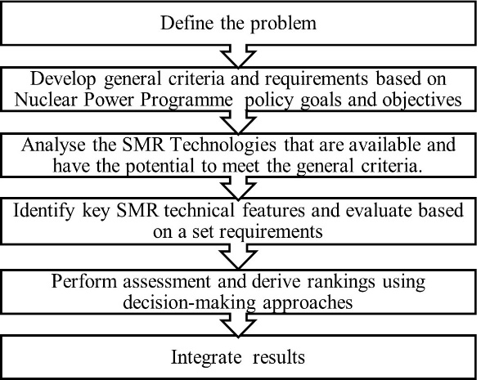 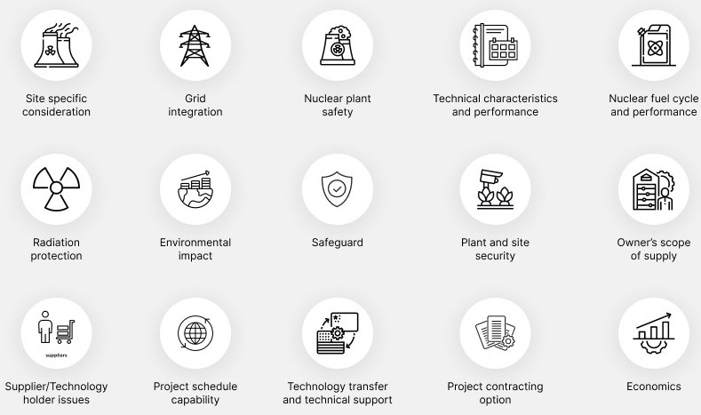

*FIG. 4. Key Elements used in Reactor Technology Assessment [17]*

*FIG. 3. Five steps of Reactor Technology Selection. [16]*

### Suitability of SMRs for Ghana

The assessment carried out shows the viability of deploying SMRs in Ghana. The suitability options considered include:

Investment capability: The smaller unit size and shorter construction time for SMRs makes it flexible for financing. A major hurdle for a country like Ghana is obtaining the necessary funds to finance a nuclear power project.

Plant unit size and grid matching: A small modular reactor will best match Ghana’s limited electric grid.

Improved Construction Schedule: The pre-fabrication and standardization of SMR components through factory construction reduces construction time and financing costs.

Remote location consideration: Industries in aluminium and oil productions such as VALCO and Tema Oil Refinery (TOR) which currently operates at reduced capacity due to inadequate electrical power, can be revitalised through SMR deployment.

Water desalination: An SMR plant will not only produce electricity but also supply steam for desalination which is worthwhile investment. This will limit the dependence on unsafe water from lakes and rivers which has resulted in drilling of more than 10,000 boreholes nationwide [17].

## INternational cooperation and harmonization

International cooperation and harmonization have been part of Ghana’s nuclear power development agenda since the 1960s. The collaboration covers many areas including technological development, training of human resource, development of regulatory frameworks and infrastructure enhancement.

* 1. Cooperation with the IAEA and Other International Partners

The cooperation between Ghana and the IAEA has been the bedrock of the country’s nuclear power development plan. The agency provides scientific support, human resource development, and guidance in compliance to internationally accepted nuclear safety principles and standards. The partnership aided Ghana to manoeuvre the difficulties of nuclear technology implementation and management [18]. Aside the IAEA, Ghana signed Memoranda of Understanding (MoUs) with China, Russia, South Korea, Japan and the USA.

* 1. Recent Development in International Cooperation

Ghana is determined to select the suitable technology holder to build its first NPP. The country therefore has engaged with advanced nuclear nations to make a knowledgeable decision by the end of 2024.

The most recent advancement took place in Accra in May, 2024. A memorandum of Understanding and contractual agreement with the United States for the provision of NuScale Exploration (E2) Center and related services at GAEC. The collaboration is part of the FIRST (Foundational Infrastructure for the Responsible Use of Small Modular Reactor Technology) programme which is geared towards developing Ghana’s capabilities in deploying SMRs [19].

Also, in April 2024, Nuclear Power Ghana Limited (Ghana’s Owner Operator of its first NPP) and China National Nuclear Corporation Overseas Limited signed a cooperation and framework agreement for constructing HPR1000 Technology Nuclear Power Project. This agreement was signed in Rotterdam, Netherlands, during the 26th World Energy Congress, also includes upgrading Ghana’s electrical grid infrastructure [20].

* 1. Human Resource Development and Grid Infrastructure

The development of a skilled workforce is very important to maintain Ghana’s nuclear power programme. Hence, young nuclear professionals are being educated in countries with advanced nuclear programmes such as China, USA, South Korea and Russia. The studies are modelled to give Ghanaian professionals with technical knowledge and practical skills necessary for operating and managing nuclear facilities [21]. Also, considerable efforts are being made to enhance Ghana’s electric grid to contain the integration of NPP.

* 1. Leveraging Global Expertise and Best Practices

Knowledge sharing is an important norm in the nuclear industry. Ghana is therefore leveraging on global capability and best practices for its nuclear agenda through capacity building in advanced nuclear countries.

* 1. Collaborating Among Stakeholders

Effective corporation among various stakeholders is vital for productive nuclear programme development. The cooperation involves a broad range of activities among which are vendor partnerships, technology transfer, regulatory processes, as well as public engagement.

* + 1. *Vendor Collaboration and Technology Transfer*

The Nuclear Power Institute (NPI) of GAEC plays a crucial role in facilitating collaboration with international vendors and technology holders. The cooperation involves detailed agreements that outline the terms of technology transfer, which make sure that Ghana will not only adopt the technology but also tailored it to its specific needs. For example, the MoU with the US FIRST programme highlights the focus on SMRs [19].

* + 1. *Regulatory Process and Project Implementation*

Ghana’s Nuclear Regulatory Authority (NRA) cooperates with advanced nuclear regulatory bodies in countries with developed nuclear programmes such as the US-NRC and the IAEA for guidance in development and implementation of regulatory structures [22]. The partnerships ensure that Ghana’s nuclear programme follow international safety and security criterions, hence promoting public trust and international confidence in Ghana’s nuclear agenda.

* + 1. *Public Engagement and Education*

The Nuclear Power Institute’s Stakeholder Centre plays a pivotal role in engaging and educating the public about Ghana’s nuclear power programme. Knowing the importance of public acceptance, the centre periodically carries out various informative and sensitization campaigns. These initiatives include media programme, exhibition and events, targeted outreach (Universities, Senior High Schools) etc.

## COnclusion

A study of Ghana’s energy system shows that, including SMRs into its energy generation mix is achievable. SMRs can complement current thermal plants, hydroelectric stations, and renewable energy sources due to their load-follow capability. They also match Ghana’s small electricity grid and provides a lower financial investment. Furthermore, SMRs have additional benefits such as cogeneration.

For these innovative technologies to be successfully implemented in Ghana, key factors need to be considered, among these are;

* Building capacity and Engaging Stakeholders: Gaining public trust in Ghana’s nuclear program is vital for its success. This comprises educating and engaging stakeholders at all levels to ensure widespread support and understanding of the nuclear energy benefits.
* Government Support: A conducive atmosphere need to be provided by government for SMR deployment. These includes provision oof security, giving tax incentives, and maintaining bipartisan political support for the project.
* Assessment of Reactor Technologies and Site Selection: Sites have been identified for the country’s nuclear power plant and reactor technology assessment is ongoing. Detail site and technology assessments need to be conducted as soon as possible to select the most suitable technology.
* Strategic International Partnership: Leveraging strategic cooperation with institutions and countries with developed nuclear power programmes such as USA, China, Russia and the IAEA is essential for Ghana’s nuclear energy ambition.
* Financial Strategies: Innovative financing model of Build-Own-Operate-Transfer (BOOT) should be considered to attract investment and reduce financial risks associated with SMR projects.

Including SMRs in Ghana’s energy mix is in line with Sustainable Development Goals (SDGs). SMRs gives reliable and low-carbon electricity, enhancing energy security and affordability that is Affordable and Clean Energy (SDG 7). It also brings industrial growth, technology innovation and vibrance to energy sector of Ghana which satisfies SDG 9 – Industry, Innovation and Infrastructure. Deployment of SMRs aligns with SDG 13 thus Climate Action by reducing dependence on fossil fuels and reducing greenhouse gas emissions. Finally, SDG 6 (Clean Water and Sanitation) can be met by desalination to provide clean water to Ghanaians which is exacerbated by illegal mining activities.

To conclude, a comprehensive methodology which comprise of thorough energy planning, robust nuclear infrastructure development, strategic technology assessment, innovative financing, active stakeholder involvement and strong international cooperation is crucial for the success of SMR deployment in Ghana. By addressing these critical aspects, a favorable environment can be created for SMR deployment and hence achieving sustainable and diversified energy future.

References

1. E. Shitsi, E. Ampomah-Amoako, S. K. Debrah, V. Y. Agbodemegbe, J. Gbadago, and F. Ameyaw, "The Role of Nuclear Energy in Ghana’s Electric Energy Mix," *International Journal of Energy and Power Engineering*, vol. 11, no. 3, pp. 68-76, May 2022. doi: 10.11648/j.ijepe.20221103.11
2. M. Usman and M. Radulescu, "Examining the role of nuclear and renewable energy in reducing carbon footprint: Does the role of technological innovation really create some difference?" *Science of The Total Environment*, vol. 841, 156662, Oct. 2022.
3. International Atomic Energy Agency (IAEA). Milestones in the Development of a National Infrastructure for Nuclear Power. IAEA 2020
4. Ghana Atomic Energy Commission (GAEC). "Ghana Completes Phase 1 Studies for Nuclear Power." GAEC, 2019.
5. Office of the President, Ghana. "Official Declaration of Nuclear Energy Inclusion in Ghana's Energy Mix." Office of the President, 2022.
6. United Nations. “Sustainable Development Goals.” United Nations, 2021
7. Ghana Energy Commission. “National Energy Policy: Policy Targets and Priorities.” Energy Commission, 2010
8. Sasu, D. D., 2022. Electrical energy demand in Ghana 2021- 2030. Energy & Environment. [Source: https://www.statista.com/statistics/1292126/electricitydemand-forecast-in-ghana/]
9. S. Adu-Gyamfi, K. Amakye-Boateng, E. Brenya, H. T. Yartey, A. Dramani, and V. N. Adoteye, "Nuclear Energy in Ghana? History, Science and Policy," Journal of Social and Development Sciences, vol. 8, no. 3, pp. 11-34, Sep. 2017.
10. Ghana Energy Commission. "Energy Sector Outlook for Ghana: 2019-2040." Energy Commission, 2023.
11. International Atomic Energy Agency (IAEA). "Small Modular Reactors: Key to Sustainable Energy Development." IAEA, 2020.
12. U.S. Department of Energy, Office of Nuclear Energy, "Benefits of Small Modular Reactors (SMRs)," [Online]. Available: https://www.energy.gov/ne/articles/benefits-small-modular-reactors-smrs. [Accessed: May 21, 2024].
13. F. Reilly, "Market framework for financing small nuclear," A report to Her Majesty’s Government by the Expert Finance Working Group on Small Nuclear Reactors, Expert Finance Working Group on Small Nuclear Reactors, 2019.
14. J. Haverkamp, "Financing Models for Nuclear Power Plants," Nuclear Monitor, World Nuclear Industry Status Report 2017, no. 85, Sept. 20, 2017. [Online]. Available: <https://wiseinternational.org/sites/default/files/NM851-final.pdf>
15. M. Z. Zolkaffly, and K. Han, Reactor technology assessment and selection utilizing systems engineering approach, 2014
16. S. P. Schultz, IAEA Technical Meeting on Technology Assessment for New Nuclear Power Programmes, Vienna –Austria, 1-3sept 2015.
17. International Atomic Energy Agency, Nuclear Reactor Technology Assessment for near term deployment, IAEA Nuclear Energy Series No. No. NP-T-1.10, IAEA, Vienna (2013)
18. Harvey, F., & Vidal, J. Global climate change treaty in sight after Durban breakthrough, The Guardian (2011).
19. IAEA, "Ghana and the IAEA Collaborate on Nuclear Power Development," [Online]. Available: https://www.iaea.org/newscenter/news/ghana-and-the-iaea-collaborate-on-nuclear-power-development
20. US Department of Energy, "USA and Ghana Sign Agreement for NuScale Exploration Center," [Online]. Available: https://www.energy.gov/articles/usa-and-ghana-sign-agreement-nuscale-exploration-center
21. World Energy Congress, "Ghana and China Sign Nuclear Power Project Agreement," [Online]. Available: https://www.worldenergycongress.org/news/ghana-and-china-sign-nuclear-power-project-agreement
22. IAEA, "Training Programs for Young Nuclear Professionals in Ghana," [Online]. Available: https://www.iaea.org/newscenter/news/training-programs-for-young-nuclear-professionals-in-ghana
23. US NRC, "Collaborative Efforts Between the US NRC and Ghana's NRA," [Online]. Available: https://www.nrc.gov/international/ghana-collaborative-efforts.html