**Assessing the Role of Small Modular**

**Reactors (SMRs) in Achieving Sustainable**

**Industrial Growth in Africa: Opportunities,**

**Challenges and Policy Implications**

A. S. Aliyu

Centre for Renewable Energy and

Sustainability Transitions (CREST)

Kano State, Nigeria.

[asaliyu.crest@buk.edu.ng](mailto:asaliyu.crest@buk.edu.ng)

U. F. Ahmad

Centre for Renewable Energy and

Sustainability Transitions (CREST)

Kano State, Nigeria

**Abstracts**

With an approximate population of 1.5 billion, Africa's need for sustainable industrial growth must be taken seriously. There is a critical need for clean and reliable energy to facilitate and sustain this growth. Africa's energy situation, characterized by insufficient energy and its detrimental effects on the environment, demands urgent attention. This work will highlight how Small Modular Reactors (SMRs) can be utilized to provide the necessary energy for Africa's factories and industries. SMRs are small, safe nuclear reactors that can generate substantial energy with minimal pollution. The opportunities presented by SMRs, such as lower initial capital costs, sitting Flexibility, and wider range of applications will also be investigated. Furthermore, the necessary measures to implement SMRs in Africa, including the establishment of regulations and waste management strategies, will be underscored. By considering the deployment of SMRs in Africa, efforts can be made to ensure that the region's industrial landscape continues to grow in a sustainable and environmentally friendly manner.

**1.0 Introduction**

Africa is the fastest-urbanizing place in the world, with more than 500 million people likely to move from the countryside to the cities between now and 2040 [5]. Expanding hubs for industries, factories, and businesses in smaller cities could alleviate the pressure on larger cities across the continent. Despite a GDP of over 2.7 trillion USD, the continent still suffers from inadequate electricity to cater to the anticipated industrial growth. There is a pressing need for clean and reliable energy to sustain this advancement.

Small Modular Reactors (SMRs) could play a key role in addressing this need. Known for their compact size and enhanced safety and security features, SMRs could potentially address Africa's energy deficit and foster sustainable industrial development while mitigating environmental concerns [6]. This paper aims to point out the opportunities, challenges, and policy implications associated with the deployment of SMRs in Africa's industrial landscape

**1.1 Energy situation in Africa**

Access to energy remains a major developmental challenge for the African continent [4].. While energy continues to be at the heart of many pressing issues and opportunities, including industrial growth, recent estimates suggest that about 600 million people or more lack access to electricity in Africa [8]. Africa's industrial advancement is hindered by energy shortages. Moreover, reliance on fossil fuels contributes to environmental degradation and undermines efforts toward sustainability.

Certain African countries have already expressed interest in pursuing large-scale nuclear projects. Currently, only South Africa has an operating nuclear power reactor, while Egypt has an ongoing construction project. Several other countries like Ghana, Nigeria, Kenya, Morocco and Tanzania are at various stages of embarking on their nuclear journey[7]. However, Africa’s current grid limitations pose a significant hurdle in deploying large nuclear reactors (LNRs), and SMRs could serve as a substitute solution until these grid issues are addressed [1].

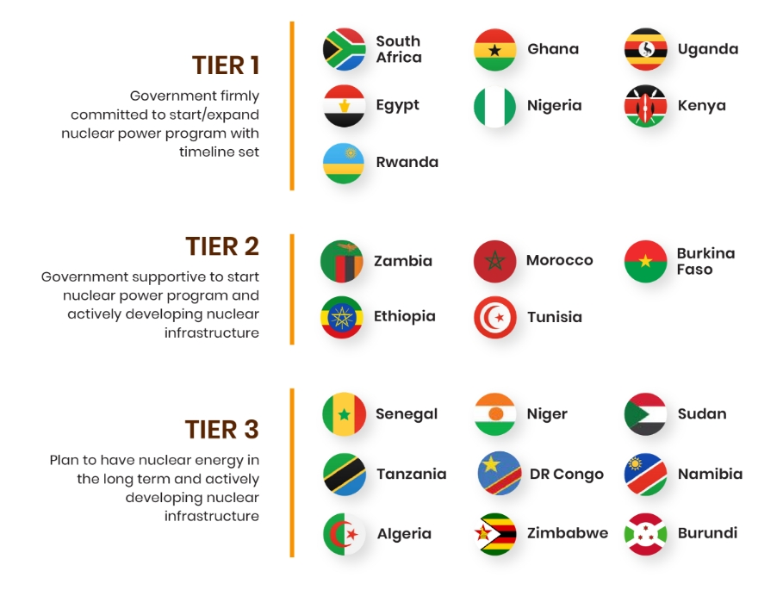

Embarking Countries in Africa

Source: Nuclear Business Platform (NBP)

1.2 Overview of Small Modular Reactors

SMRs represent a paradigm shift in nuclear energy technology, offering scalable and versatile solutions for power generation. By harnessing nuclear fission, SMRs can generate substantial energy output while minimizing greenhouse gas emissions and environmental footprint. Unlike Large nuclear reactors (LNRs), Small modular reactors (SMRs) are defined by the International Atomic Energy Agency (IAEA) as reactors that can produce a maximum of 300 MW of electricity [9]. Lately, Small modular reactors (SMRs) have attracted global attention due to their modular design, scalability, small footprint, increased safety, security features, and cost advantages compared to LNRs [2].

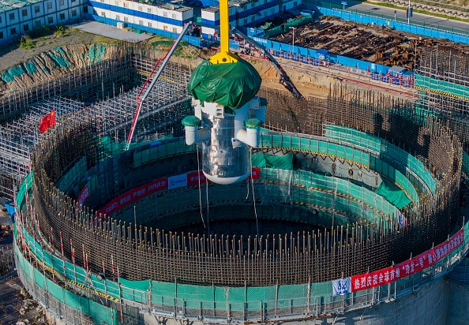

World's First Commercial Small Nuclear Reactor

Source: gettyimages

3.0 Opportunities Associated with SMR Deployment

There are numerous opportunities associated with SMR deployment that African countries can leverage to fast-track industrial growth in the region. These opportunities include:

3.1 Lower Initial Capital Investment

Small Modular Reactors (SMRs) offer a significant reduction in initial capital investment compared to traditional large nuclear reactors. This is due to their nature of m**o**dular construction, smaller size and Scalability. This feature makes them more accessible to a wider range of investors, including smaller utility companies and, thereby facilitating broader deployment and reducing the financial risk associated with LNRs.

**3.2 Siting Flexibility**

SMRs offer enhanced sitting flexibility, enabling deployment in locations unsuitable for LNRs. Due to their smaller footprint, SMRs can be deployed in remote or off grid areas, providing a reliable power source where LNRs or other larger energy infrastructure cannot be installed[7]. This flexibility allows SMRs to serve a wider range of communities and industries, providing localized energy solutions. Moreover, the ability to place SMRs closer to end-users can reduce transmission losses and enhance grid stability.

**3.3 Enhanced Safety, Security, and Nonproliferation**

One of the major challenges of deploying LNRs in developing countries is the question of **S**afety, Security, and Nonproliferation. SMRs incorporate advanced safety and security features designed to minimize risks with their passive and inherent safety systems. Some of these SMRs are designed to use fuel that is less suitable for weaponization, some others are designed to operate on a closed fuel cycle, reducing the need for fuel enrichment and reprocessing.

**3.4 Wide Range of Users and Applications**

The versatility of SMRs makes them suitable for a broad spectrum of applications and users. It could be used for Electricity Generation, Industrial Heat, District Heating, powering mining sites and other suitable proposes. The ability to serve multiple applications enhances their economic viability and attractiveness to various sectors [7].

**3.5 Increasing Interest in SMRs**

The growing global interest and investment in SMRs present another opportunity that African countries should consider. This increasing interest in SMRs is driven by several factors, including climate goals, energy security, and economic development. Various countries are investing in SMR development and creating regulatory frameworks to facilitate their deployment. This trend is also reflected in the formation of international partnerships and collaborations aimed at advancing SMR technology and sharing best practices. The heightened focus on SMRs is likely to drive innovation, reduce costs, and accelerate the commercialization of these reactors.

**4.0 Challenges and Concerns**

Challenges and valid concerns about the deployment of SMRs are inevitable, especially since they are new technologies. Some of these challenges or concerns include:

### 4.1 Financing Nuclear Energy

### Securing financing for SMRs is challenging due to the high initial costs and the long-term nature of the investment. Investors are often wary of the financial risks, which include regulatory uncertainties, potential construction delays, and market competition from other energy sources. Developing a viable financial model that attracts investment necessitates demonstrating cost competitiveness, reliable return on investment, and the ability to scale production and deployment. Public-private partnerships and innovative financing mechanisms, such as green bonds or government-backed loans, can play a critical role in addressing these challenges.

### 4.3 Technological Expertise

### SMRs require advanced technological expertise distinct from that used LNRs. Most African newcomer countries are in the early phases of training experts on LNR technologies in areas such as reactor design and construction techniques, operations and maintenance (O&M), safety and security. With the introduction of the SMR option, it will be necessary to allocate some of these efforts towards developing expertise in SMR design and O&M as well. Developing expertise for both LNRs and SMRs demands significant investment in research and development, specialized training programs for engineers and technicians, and collaboration between academia, industry, and government.

### 4.3 Waste Management

Like all nuclear Reactors, waste management in the context of SMRs primarily refers to the management of radioactive waste produced during the operation and decommissioning of these nuclear reactors. Although SMRs produce less waste than LNRs, the challenges of storage, transportation, and disposal remain a critical issue. Effective waste management solutions need to ensure safety over long periods and comply with stringent regulatory requirements. This involves not only technological solutions, such as advanced containment and recycling methods, but also gaining regulatory approval and public trust. Developing long-term storage facilities and secure disposal sites is crucial for addressing this challenge.

4.4 Public Perception and Acceptance

The perception of the populace regarding Small Modular Reactors (SMRs) and their acceptance largely depend on public perception of general nuclear energy projects. Although the perception of many African countries public on nuclear power project is encouraging, more efforts need to be invested towards fostering a better understanding of SMRs and promoting their acceptance among the African communities. Fact-based information about nuclear energy through outreach programs, social media engagements and other available channels should be communicated to the public to educate them on the benefits of nuclear energy

### 4.5 Invest in First-of-a-Kind Technology

Investing in first-of-a-kind (FOAK) SMR projects entails significant risks due to the novelty and unproven nature of the technology. These projects often face unforeseen technical and financial challenges, leading to cost overruns and possible delays. However, successful FOAK projects can demonstrate the viability and benefits of SMRs, paving the way for broader adoption. Attracting investment for these initial projects requires mitigating risks through public-private partnerships, government incentives, and demonstrating strong potential for long-term returns.

### 5.0 Policy Implications

The deployment of SMRs in Africa involves significant policy considerations. Existing and evolving nuclear regulations on the continent are primarily centered on LNRs, necessitating the development of new regulatory frameworks that accommodate the unique characteristics of SMRs. This includes safety standards, emergency preparedness, and security measures. This process can be time-consuming and costly, with regulatory uncertainty posing a significant barrier to development and deployment.

Efforts to streamline licensing processes, harmonize international standards, and establish clear and consistent guidelines are essential to mitigate these challenges. Policymakers should also consider incentives for innovation, such as subsidies or tax credits, to encourage investment in SMR technology deployment. Advisedly, organizations like the International Atomic Energy Agency (IAEA) and the African Commission on Nuclear Energy (AFCONE) should facilitate regional cooperation for the development and adoption of SMR policy documents.

**6.0 Conclusion**

The deployment of Small Modular Reactors (SMRs) in African countries would significantly enhance electricity generation options and strengthen energy security for sustainable industrial growth. SMRs present a particularly attractive option for African nations with limited budgets, allowing them to start with small generating capacities and expand as their industrial development progresses, with minimal investment in electrical grids and less environmental concern.

The inherent features of SMRs, including site flexibility, a wide range of applications, enhanced safety, security, and nonproliferation, make them especially suitable for the African context. Despite increasing interest across the continent, many countries still need to improve their infrastructure and develop standardized regulations and policies to support SMR deployment. The potential benefits of SMRs make them a compelling option for Africa's sustainable energy and industrial future.

REFERENCES

1. African Commission on Nuclear Energy (AFCONE), 2023. Africa’s Energy Future: Exploring Small Modular Reactors (SMRs). [Africa’s Energy Future: Exploring Small Modular Reactors (SMRs) - AFCONE](https://www.afcone.org/africas-energy-future-exploring-small-modular-reactors-smrs/)
2. Ghimire, L., and Waller, E. (September 15, 2023). "Small Modular Reactors: Opportunities and Challenges as Emerging Nuclear Technologies for Power Production." ASME J of Nuclear Rad Sci. October 2023; 9(4): 044501. <https://doi.org/10.1115/1.4062644>.
3. International Atomic Energy Agency (IAEA), 2023. What are Small Modular Reactors (SMRs)? <https://www.iaea.org/newscenter/news/what-are-small-modular-reactors-smrs>
4. Manfred H., Lucia S. and Simone T., 2017. Energy in Africa Challenges and Opportunities. <https://doi.org/10.1007/978-3-319-92219-5>
5. McKinsey Global Institute (MGI), 2023. Reimagining Economic Growth in Africa: Turning Diversity into opportunity. https://www.mckinsey.com/mgi/our-research/reimagining-economic-growth-in-africa-turning-diversity-into-opportunity.
6. Nuclear Energy Agency - organisation for Economic Co-operation and Development (OECD-NEA), 2021. Small Modular Reactors: Challenges and Opportunities <http://oecd-nea.org/upload/docs/application/pdf/2021-03/7560_smr_report.pdf>
7. Nuclear Business Platform (NBP), 2024. [Nuclear Business Platform (nuclearbusiness-platform.com)](https://www.nuclearbusiness-platform.com/)
8. Ronald Djeunankan, Sosson Tadadjeu, Brice Kamguia, Linking energy poverty and industrialization: Empirical evidence from African countries, Energy,Volume 292,2024, <https://doi.org/10.1016/j.energy.2024.130374>.
9. Salah Ud-Din Khan and Rawaiz Khan, 2023. Techno-economic assessment of a very small modular reactor (vSMR): A case study for the LINE city in Saudi Arabia, *Nuclear Engineering and Technology,* Volume 55, Issue 4, <https://doi.org/10.1016/j.net.2022.12.015>