From Vision to Reality: Building Capacity and Bridging Gaps in SMR Technology Adoption

M. OZERINA

International Atomic Energy Agency

Vienna, Austria

Email: milanaozerina24@gmail.com

**Abstract**

The paper explores the transformative journey of Small Modular Reactors (SMRs) from conceptualization to practical implementation. It delves into the various aspects of SMR deployment, emphasizing the critical need for capacity building and collaboration to bridge existing gaps across multiple infrastructure issues specified in the IAEA publication NG-G-3.1 (Rev. 2) Milestones in the Development of a National Infrastructure for Nuclear Power.

In the pursuit of sustainable and scalable nuclear energy solutions, nations are increasingly turning to SMRs. However, this transition involves overcoming several challenges, ranging from regulatory hurdles and technical complexities to developing human resources capable of managing SMR technology. The abstract examines strategies to turn the vision of SMR integration into a tangible reality.

The discussion revolves around the collaborative efforts required for successful SMR deployment, emphasizing the importance of bilateral and multilateral engagements. Regulatory frameworks play a pivotal role, and the paper explores how nations can cooperate to facilitate SMR reviews and deployment. It also sheds light on the significance of technical cooperation in ensuring the seamless integration of SMRs into diverse national infrastructures.

Furthermore, the paper highlights the crucial role of public engagement and stakeholder engagement in the developmental phase of SMRs. Effective communication and collaboration with diverse stakeholders are essential for building public trust and support, ultimately contributing to the success of SMR projects.

In summary, the paper comprehensively explores strategies, collaborations, and initiatives required to build capacity and bridge gaps in the adoption of SMR technology on a global scale.

## INTRODUCTION

According to the International Atomic Energy Agency (IAEA), there are 83 SMR projects at different stages of development in various countries [1]. In fact, there are currently more than 90 SMR designs worldwide. Most of them relate to Generation IV nuclear energy systems with alternative coolants (liquid metal, gas, or molten salt) that have improved technical characteristics in terms of their efficiency, ensuring nuclear and nuclear physical safety, applying IAEA safeguards, and reducing the negative impact on the environment.

SMRs represent a significant innovation in the nuclear energy sector, offering potential solutions to many of the challenges faced by traditional large-scale nuclear reactors. These advanced reactors are designed to be compact, scalable, and more adaptable to diverse energy needs, making them an attractive option for countries seeking to enhance their energy security while addressing climate change. The deployment of SMRs can support the transition to a low-carbon economy by providing a stable and reliable source of clean energy, complementing intermittent renewable sources like wind and solar.

However, transitioning from the conceptual and developmental stages to widespread adoption of SMR technology involves overcoming substantial hurdles. Building capacity involves not only the technical development and regulatory approval of these reactors but also ensuring that there is a skilled workforce capable of operating and maintaining these advanced systems. Furthermore, there are significant gaps to bridge in terms of public acceptance, financial investment, and the establishment of robust supply chains.

The paper investigates the multidimensional strategy needed to go from vision to reality for SMR technology. By focusing on the status of SMR development, key challenges and opportunities are revealed within this concept.

## CHALLENGES AND SOLUTIONS IN SMR DEPLOYMENT

### Constructive features of SMRs

Light-water SMRs have the lowest technological risks associated with their deployment, as they are largely similar to the large light-water reactors (LWRs) in operation today and the reactors used in naval installations. LWRs primarily use fuel enriched to less than 5% in U-235, with fuel reload intervals not exceeding six years, and the regulatory barriers for constructing such reactors are effectively the lowest among all types of SMRs.

Fast neutron SMRs have a higher technological deployment risk because, unlike small LWRs that rely on extensive experience with large LWRs, the experience with fast sodium reactors, although present, is not as extensive. Fast reactors do not have a moderator and are cooled either by liquid metal (sodium, lead, or a lead-bismuth alloy) or gas. These reactors operate at high temperatures, ensuring high thermodynamic efficiency. However, it is important to note the significant limitations of metallic coolants: sodium easily ignites and reacts vigorously with water, while lead or lead-bismuth alloys do not react with water but are more corrosive to structural materials.

In gas-cooled fast reactors, helium is planned to be used as a coolant. This gas is non-explosive and non-corrosive, which is advantageous from a nuclear safety perspective. The designed reactors feature an annular core surrounded by an advanced reflector material and a steel vessel. The use of high-temperature composite cladding based on silicon carbide ensures structural integrity in case of an accident. Additionally, the reactor can be cooled for an extended period by a reactor vessel cooling system based on natural circulation. Engineering safety features (reactivity control system, emergency protection system, technical cooling system, reactor vessel cooling system, and containment) are implemented to mitigate the consequences of anticipated accidents. It is expected that gas-cooled reactors will use High-Assay Low-Enriched Uranium (HALEU) fuel.

Today, the development of modern high-temperature gas-cooled reactors (HTGRs) is actively underway. These reactors can achieve helium outlet temperatures ranging from 700 to 950°C and, ultimately, up to 1000°C. Their application is possible either with a gas turbine or an additional steam turbine. HTGRs can potentially use either mixed uranium-plutonium fuel or fuel based on U-233 and thorium. HTGRs have inherently safe properties due to the negative temperature coefficient of reactivity (the fission reaction slows down as temperature increases) and passive residual heat removal. An additional advantage of HTGRs is that they do not require containment structures, are small enough to enable factory fabrication, and are typically installed below ground level.

Molten salt reactors use molten fluoride salts as both fuel and coolant at low pressure. Lithium-beryllium fluoride and lithium fluoride remain liquid up to 1400°C at relatively low pressure, which contrasts with the parameters of pressurized water reactors operating at about 315°C and 160 atm. Other features of the molten salt reactor fuel cycle include the absence of minor actinides in high-level waste; high coolant temperatures, ensuring high thermal efficiency; deep fuel burnup and, consequently, low fuel consumption; safety ensured by passive cooling for any reactor installation size.

The diverse range of SMR technologies presents unique advantages and challenges. Together, these technologies represent a significant stride towards realizing the potential of SMRs, each contributing to the overarching goal of a safer, more efficient, and sustainable nuclear future.

### Technological readiness of SMRs

LWRs are currently the most technologically mature among SMRs. The primary challenges remaining for LWR SMRs are related to manufacturing and supply chain logistics, as well as the scaling down of infrastructure to accommodate smaller units.

Meanwhile, HALEU fuel is a critical component for many advanced SMR designs. HALEU, enriched to between 5% and 20% U-235, offers several advantages, including improved reactor performance and longer fuel cycles. However, the current supply chain for HALEU is limited, posing a significant challenge for SMR deployment. This limitation stems from the scarcity of enrichment facilities capable of producing HALEU, coupled with regulatory and logistical hurdles associated with handling and transporting higher enrichment fuels. Given the global interest in SMRs, international collaboration can help address HALEU supply issues. Collaborative efforts can include shared research, development of enrichment facilities, and standardized safety and handling procedures.

Moreover, the regulatory framework for SMRs must evolve to accommodate their unique features and operational characteristics. Traditional nuclear reactor regulations may not be entirely applicable to SMRs, necessitating tailored regulatory approaches. Hence, regulatory bodies need to establish streamlined and flexible licensing processes for SMRs. This includes developing guidelines that are specifically tailored to the modular nature and enhanced safety features of SMRs, potentially reducing the time and cost associated with licensing. International harmonization of regulatory standards can facilitate the deployment of SMRs. In this context, the IAEA Nuclear Harmonisation and Standardization Initiative could be very helpful. Harmonisation of regulations between countries can simplify and reduce cost entry to multiple markets for manufacturers, while safeguarding safety features.

Effective stakeholder engagement is crucial for the successful deployment of SMRs. Engaging with local communities, governments, industry partners, and the public helps build trust and support for SMR projects. This is discussed in greater detail in Section 4 of the paper.

## CAPACITY BUILDING AND INTERNATIONAL COLLABORATION

### Role of the Milestones Approach

The IAEA recently revised the publication NG-G-3.1 (Rev. 2), titled "Milestones in the Development of a National Infrastructure for Nuclear Power (currently available in the preprint version), which serves as a critical guideline for countries aiming to embark on or expand their nuclear power programmes, including the deployment of SMRs [2]. This publication contains an annex on the infrastructure considerations for SMRs.

This document outlines a structured approach to building the necessary infrastructure, addressing various stages from initial decision-making to operation and regulation. It provides a comprehensive framework that highlights essential elements such as legal and regulatory frameworks, safety standards, human resource development, and stakeholder involvement.

It also emphasizes a phased approach, known as a Milestones Approach, ensuring that each developmental milestone is met with adequate preparedness and capacity. This step-by-step methodology allows nations to undertake a systematic approach to overcoming infrastructure challenges, mitigating risks and creating the basis for the successful deployment of SMRs. By doing so, countries are able to better develop their national plans in parallel with best practices on an international level, securing a more efficient and coordinated route for SMR deployment.

### Importance of International Collaboration and Knowledge Exchange

Bilateral and multilateral engagements are crucial for the successful deployment of SMRs, as they facilitate the knowledge exchange, sharing of resources and best practices among nations. These collaborations help bridge gaps in expertise and infrastructure development, providing a platform for countries to learn from each other's experiences and challenges.

Such engagements can lead to tailored support and the direct transfer of technology and expertise. For example, a country with advanced nuclear capabilities can mentor a newcomer nation, offering technical assistance, regulatory guidance, and training programs. These partnerships enable a smoother and more confident transition into the nuclear energy landscape. Multilateral engagements with international organizations enable a much wider dissemination of information and the application of collective problem-solving. Frameworks such as the IAEA’s (INIR) missions and activities of the NEA Working Groups also offer venues for these types of discussions on common challenges, innovative practices, and internationally consistent approaches to regulation. These platforms also facilitate global collaboration, allowing each participating country to take advantage of mutual knowledge and experience.

In November 2023, at the European Nuclear Energy Forum (ENEF) in Bratislava, an important milestone for the future of nuclear energy in Europe was announced: the creation of the European Industrial Alliance on SMRs. This alliance aims to promote and accelerate the development and deployment of SMRs across Europe, targeting their operationalization in the early 2030s. The ENEF, which serves as a key platform for dialogue among stakeholders in the nuclear sector, underscored the strategic importance of SMRs in achieving Europe’s energy transition goals, enhancing energy security, and meeting climate targets.

The European Industrial Alliance on SMRs will bring together a wide array of stakeholders, including national governments, nuclear industry leaders, research institutions, and regulatory bodies. By fostering collaboration across these diverse entities, the alliance aims to harmonize efforts, streamline regulatory processes, and stimulate innovation in SMR technologies [3]. In addition to the announcement, a dedicated event has been organized on March 22, 2024, in Brussels as an integral part of the Nuclear Energy Summit. This event aimed at sharing information about the envisaged alliance-building process thereby communicating its key goals and expected actions. Keynote speakers included representatives from the European Commission, national energy ministries, industry experts, and international nuclear organizations.

The establishment of the European Industrial Alliance on SMRs represents a significant step forward in the European commitment to leveraging advanced nuclear technologies to achieve energy sustainability and security. The Brussels event marked the beginning of concerted efforts to turn the vision of widespread SMR deployment into a tangible reality, setting the stage for collaborative projects and initiatives that will drive the nuclear sector’s evolution over the coming decade.

Romania is planning to take a lead role in this process, reflecting its commitment to advancing nuclear energy as part of its national energy strategy. Romania’s involvement highlights the strategic importance of SMRs in achieving Europe’s energy transition goals, enhancing energy security, and meeting climate targets. The alliance will focus on addressing common challenges, such as regulatory harmonization, supply chain development, and financing mechanisms, to facilitate the widespread adoption of SMRs across the continent.

In terms of alliances there is another interesting trend in creation of informal alliances, such as Anglo-Saxon alliance, for example. It includes the USA, the UK, and Canada, and in some cases (based on concluded agreements), Japan can also be considered part of this alliance. In 2017, the British company URENCO signed a memorandum of understanding with the Canadian company Bruce Power L.P. to accelerate the process of developing, licensing, and constructing UBattery reactors in Canada. In November 2018, the American company NuScale announced the signing of a memorandum of understanding with Bruce Power L.P. to introduce its modular nuclear technology to the Canadian market. Additionally, Canada, the USA, and the UK are jointly working on the development of the STARCORE SMR.

### Countries’ cases

Usually, it is governments who initiate nuclear power program development, overseeing the complex process of infrastructure planning and implementation. In most instances, private companies in the nuclear sector are startups focused on developing new reactor technologies. However, Estonia presents a unique case where a private company has taken the lead. It is a unique and illustrative case study in the deployment of SMRs. This highlights a broader movement where private sector innovation propels critical advancements in nuclear energy infrastructure, much like how startups revolutionized software development.

In October 2023, Estonia hosted the first IAEA INIR mission with a focus on SMRs. This mission is notable as the IAEA is working closely with Fermi Energia, a private company, marking a unique case of public-private partnership in the nuclear sector [4].

Fermi Energia is at the forefront of Estonia’s efforts to introduce SMRs, and its collaboration with the IAEA represents a significant step forward in the country's nuclear energy program. The INIR mission evaluated Estonia’s readiness to embark on an SMR project, examining all 19 infrastructure issues.

In June 2024, the Estonian Parliament voted for the continuation of the nuclear programme. Estonia’s proactive approach, leveraging both public and private sector expertise, underscores the potential for innovative partnerships in advancing SMR technology. The outcome of Estonia’s case could provide valuable insights and lessons for other countries considering SMR adoption.

Another example in rapid developments is African region. The figure 1 illustrates the number and geographical distribution of INIR missions conducted by the IAEA from 2009 to 2024. INIR missions assess the development of nuclear infrastructure in various countries, providing a comprehensive evaluation and offering recommendations to enhance the national frameworks necessary for the successful deployment of nuclear power programs. As of 2024, there have been 37 INIR missions globally, with 11 of these missions taking place in Africa. This significant involvement in the African region underscores the continent's commitment to advancing nuclear capabilities to achieve enhanced energy security, economic growth, and technological innovation. The figure visually emphasizes the increasing interest and proactive measures taken by African nations in embracing nuclear technology as part of their energy strategies.

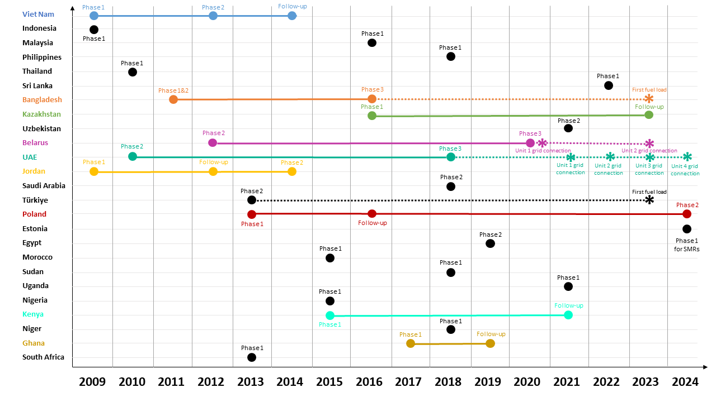

Figure 1. INIR missions conducted by the IAEA from 2009 to 2024

Moreover, Sub Sahara Region is well represented at the annual IAEA’s Technical Meeting on Topical Issues in the Development of Nuclear Power Infrastructure, as seen at Figure 2. This participation highlights the growing interest and commitment of African countries in advancing their nuclear power infrastructure. It reflects a proactive approach to engaging with global nuclear experts, sharing experiences, and gaining insights into best practices and emerging technologies. This engagement is crucial for building robust frameworks and ensuring sustainable development of nuclear power in the region, contributing to its energy security and development goals.

Figure 2. Representation of Sub Sahara Region at the IAEA Technical Meetings on Topical Issues in the Development of Nuclear Power Infrastructure from 2014 to 2024

It is also worth mentioning that over the years, there has been an “exponential” increase in references to SMR technology in presentations at the IAEA’s Technical Meeting on Topical Issues in the Development of Nuclear Power Infrastructure, see Figure 3. The growing number of references reflects the rising interest and recognition of SMRs as a viable and innovative solution for future energy needs. SMRs are increasingly viewed as a transformative advancement in the nuclear energy sector due to their enhanced safety features, scalability, and adaptability to diverse energy demands. The trend illustrated in the Figure 3 underscores the potential impact SMRs are expected to have on the future of global nuclear power infrastructure, signaling a shift towards embracing smaller, more flexible nuclear reactor designs to complement existing and future energy systems​.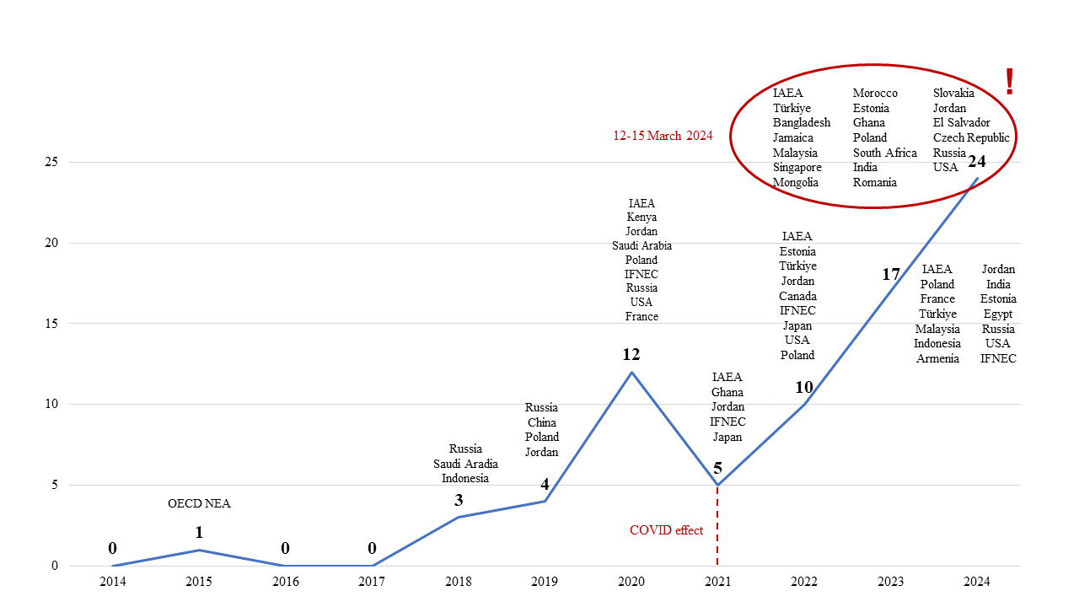

Figure 3. References to SMRs in presentations at the Technical Meetings on the Topical Issues in the Development of Nuclear Infrastructure

## public acceptance and stakeholder engagement

Despite efforts to enhance public engagement, a significant level of scepticism and opposition to nuclear energy remains around the world. Overcoming public distrust and addressing safety concerns will be a major challenge in the deployment of new technologies like SMRs. Past nuclear accidents, such as Chernobyl and Fukushima, have left enduring negative perceptions that could impede public acceptance of SMRs. Even with SMRs promising enhanced safety features, gaining public trust is essential for their development and deployment.

To effectively engage the public, transparent communication is paramount. This involves providing clear, accurate, and accessible information about SMR technology, including its benefits and safety measures. Various platforms, such as websites, social media, public forums, and informational brochures, can be used to disseminate this information. Additionally, openly addressing common concerns about nuclear safety, waste management, and environmental impact is crucial. Presenting evidence-based responses and sharing success stories from other regions or countries where SMRs have been successfully deployed can help build confidence and support.

Engaging the media is equally important. Regularly updating the media on project developments, safety measures, and milestones achieved ensures that information is presented in a way that is understandable and newsworthy. Collaborating with respected figures in science, technology, and environmental advocacy to help communicate the benefits and safety of SMRs to a broader audience can also be beneficial.

Moreover, in many countries, especially in the Global South, it is important to explain that the deployment of SMRs can lead to significant local benefits. Improved economic conditions, the creation of new jobs, and increased access to education for children are some of the potential positive impacts. By highlighting these socioeconomic benefits, SMR projects can gain greater acceptance and support from communities that stand to benefit directly from their implementation.

Engaging stakeholders early and continuously throughout the project can help identify potential issues, develop mutually acceptable solutions, and build a broad base of support for SMR projects.

## CONCLUSION

In conclusion, the SMR journey from vision to reality is marked by both big potential and substantial challenges. SMRs represent a transformative advancement in the nuclear energy sector, promising enhanced safety, efficiency, and adaptability to diverse energy needs. These advanced technologies are supposed to play a crucial role in the global transition to a low-carbon economy by providing a reliable and clean energy source that can complement intermittent renewables.

However, achieving widespread adoption of SMR technology necessitates a concerted effort to overcome various hurdles. Technical challenges, regulatory frameworks, and supply chain logistics must be meticulously addressed to ensure the smooth deployment and operation of these reactors. The need for a skilled workforce and robust infrastructure further underscores the importance of capacity building. Moreover, the limited supply of HALEU fuel remains a critical issue that requires international collaboration and innovative solutions.

Public acceptance is another significant barrier that must be surmounted. The gap in public awareness highlights the necessity for targeted education and outreach efforts to inform the public about the benefits and safety features of SMR technology. Transparent communication and engagement with stakeholders, including local communities and media, are essential to build trust and support for SMR projects.

International collaboration and knowledge exchange are pivotal in accelerating the development and deployment of SMRs. International and interregional initiatives exemplify how global cooperation can harmonize efforts, streamline regulatory processes, and stimulate innovation. Collaborative endeavors not only facilitate the sharing of best practices and resources but also ensure that countries, regardless of their nuclear capabilities, can contribute to and benefit from the advancements in SMR technology.

Ultimately, the successful integration of SMRs into the global energy landscape hinges on a multifaceted strategy that encompasses technical innovation, regulatory adaptation, capacity building, and public engagement. By addressing these critical areas, stakeholders can unlock the full potential of SMRs, paving the way for a sustainable and secure energy future. Through continued effort and collaboration, the vision of widespread SMR adoption can indeed become a reality, offering a resilient and environmentally responsible energy solution for generations to come.

References

1. International Atomic Energy Agency, Advances in Small Modular Reactor Technology Developments, A Supplement to: IAEA Advanced Reactors Information System (ARIS), 2022 Edition
2. International Atomic Energy Agency, Milestones in the Development of a National Infrastructure for Nuclear Power, IAEA Nuclear Energy Series No. NG-G-3.1 (Rev. 2), preprint
3. European Commission, Internal Market, Industry, Entrepreneurship and SMEs, European Industrial Alliance on SMRs, Available: <https://single-market-economy.ec.europa.eu/industry/strategy/industrial-alliances/european-industrial-alliance-small-modular-reactors_en#:~:text=European%20Industrial%20Alliance%20on%20SMRs,-Page%20contents&text=The%20European%20Industrial%20Alliance%20on,Europe%20by%20the%20early%202030s>.
4. International Atomic Energy Agency, IAEA Reviews Estonia’s Nuclear Power Infrastructure Development, 30 October 2023, Available: https://www.iaea.org/newscenter/pressreleases/iaea-reviews-estonias-nuclear-power-infrastructure-development