# ANALYSIS OF THE STABILITY OF A SMR WITH

# LYAPUNOV METHODS

Javier RIVEROLA

ENUSA Industrias Avanzadas S.A.

Madrid, Spain

Email: jrg@enusa.es

**Abstract**

Light water SMRs cooled by natural circulation have intrinsic safety features that make them particularly interesting. The stability of these reactors, in which coupled neutronic, thermal and hydraulic phenomena coexist, has been satisfactorily studied for certain designs with different methods under normal and accidental conditions or after a scram.

The paper addresses the study of stability from an alternative point of view. Starting from the simplified differential equations of the dynamics of a reactor with the peculiarities of a light water SMR reactor cooled by natural circulation, the characteristics that determine the evolution of the system over time are studied, and the Lyapunov methods for local and global stability are applied. The NUSCALE design reactor, with data obtained or estimated from public information, is taken as a reference, but the methods are universally applicable to other SMR of the same type. As a result, local asymptotic stability has been verified by studying the responses to a step of reactivity and also verifying that the eigenvalues of the equivalent reduced dynamic system are all real-negative. The global stability has also been tested by finding a valid Lyapunov function that involves the different state variables. Finally, it has been shown that the trajectories of the power and reactivity deviations in the phase plane converge towards the equilibrium state as a stable node. The study does not replace other existing works, but rather reinforces and aligns with its conclusions.

## INTRODUCTION

Small modular reactors (SMR) have emerged in the nuclear sector as an interesting alternative to the large Generation II and III reactors in operation or under construction. Depending on the scenario considered, SMR present very attractive characteristics such as high capacity factor, scalability, speed of construction, and contribution to decarbonization. Their small size and robust design against accidents make them much more acceptable than their older and bigger cousins. They are based on solutions tested for decades and incorporate fuel similar to that supplied for PWR and BWR plants, with enrichment <5% w/o and typically exhibit power of 300 MWt or less. Some designs have vessels that integrate the main RCS components such as the core, control rods, steam generator, and even the pressurizer. With natural or forced circulation, they have redundant alternative heat sinks. Designed with a fail-safe philosophy, they do not require human intervention or electrical supply to maintain the refrigeration in normal or accidental operation, since they obey phenomena such as natural circulation and gravity. The NUSCALE, SMR-160, CAREM-25 and BWRX-300 designs, among others, fall into this category.

In these reactors, power variations induce variations in temperature and density of the moderator, which affects the buoyancy, and with it, the natural circulation flow. This direct action can coexist with a neutron feedback mechanism due to density variations with different time scales. The dynamic stability of this type of reactor together with other types of stability (Ledinegg, boiling,...) has already been studied with advanced models, proving stability provided that there is no core exit boiling. In fact, the NUSCALE design has already been evaluated and certified by the USNRC [1].

In the paper we approach to the general problem of stability of light water SMRs operating in natural circulation from an alternative point of view. We return to the fundamentals and rely on methods that are understandable with simple equations, and apply the Lyapunov methods, which are generally valid for the study of the stability of dynamic systems. The NUSCALE design reactor is taken as a reference, with data obtained or estimated from information available in the literature, but the methods are universally applicable to other light water and natural circulation SMRs.

## Neutronic and ThermAL-hidraulic Equations

### Reactor Point Kinetics

To represent the reactor power response to a reactivity input, the one-speed non-linear point kinetics model and six delayed neutron groups is considered [2]. These equations are accurate enough if there are no strong absorbers and variations of reactivity are not large.

|  |  |  |
| --- | --- | --- |
|  | $$\frac{dP}{dt}=\frac{ρ-β}{Λ}P+\sum_{1}^{6}{λ_{i}C_{i}}$$ | (1) |

|  |  |  |
| --- | --- | --- |
|  |  | (2) |

with reactivity feedbacks for the fuel and moderator:

|  |  |  |
| --- | --- | --- |
|  | $$ρ=ρ_{ext}+α_{f}\left(T_{f}-T_{f0}\right)+α_{w}\left(T_{w}-T_{w0}\right)$$ |  |

where *P*, is the reactor power, *ρ* is the total reactivity, *ρext* is the externally added reactivity, *β* is the delayed neutron fraction, *Λ* is the neutron generation time, *λ* is the decay constant of precursors, *C* is the precursors concentration, *αf* is the fuel reactivity coefficient due to Doppler effect, *αw* is the moderator (water) reactivity coefficient , *Tf*is the fuel temperature, and *Tw* is the moderator (water) temperature.

### Fuel, cladding, and coolant heat balance

The following lines show the simplified transient state heat balance equations for fuel, cladding, and moderator.

|  |  |  |
| --- | --- | --- |
|  | $$\frac{dT_{f}}{dt}=\left[P-{UA}_{f}\left(T_{f}-T_{c}\right)\right]/\left(m_{f}{cp}_{f}\right)$$ | (3) |

where UAf is the heat transfer from fuel to cladding, and mf and cpf are the fuel mass and specific heat.

The heat transfer from the cladding to the coolant is by natural convection with approximated dependence of one third of the temperature difference as follows:

|  |  |  |
| --- | --- | --- |
|  | $$Q_{cw}={UA}_{c}\left(T_{c}-T_{w}\right)=μ{\left(T_{c}-T_{w}\right)}^{0.33}\left(T_{c}-T_{w}\right)$$ |  |

Thus, for the cladding and the coolant, we have the following expressions:

|  |  |  |
| --- | --- | --- |
|  | $$\frac{dT_{c}}{dt}=\left[{UA}_{f}\left(T_{f}-T_{c}\right)-μ{\left(T_{c}-T_{w}\right)}^{1.33}\right]/\left(m_{c}{cp}_{c}\right)$$ | (4) |

|  |  |  |
| --- | --- | --- |
|  |  | (5) |
|  |  |  |

where *Qcw* is the heat transferred from cladding to coolant, *UAc* is the heat transfer coefficient from cladding to coolant, *Tc* is the cladding temperature, *μ* is the coefficient for non-linear heat transfer to coolant, *mc* and *cpc* are the mass and specific heat of cladding, *mw* and *cpw* are the water mass and specific heat, and *Ww* is the coolant mass flow rate.

In a reactor cooled by natural circulation, an equilibrium is established between pressure drop due to buoyancy and pressure due to friction, resulting in the flow rate being proportional to the cubic root of the power or heat transmitted. Actually, these pressure drops are out of phase so the momentum balance equation becomes as shown by [3]:

|  |  |  |
| --- | --- | --- |
|  | $$I\frac{dW_{w}}{dt}=\frac{gLβ_{v}{ρ_{w}Q}_{cw}}{{cp}_{w }W_{w}(t-τ)}-ξW_{w}^{2}$$ | (6) |

With a good fit $\frac{gLβ_{v}ρQ}{{cp}_{w}^{}W_{0}^{2}I}=\frac{ξW_{0}}{I}=a = 0.5 \sec^{-1}$, so eq(6) can be restated in a convenient manner as:

|  |  |  |
| --- | --- | --- |
|  | $$\frac{dW_{w}}{dt}=0.5\frac{W_{w0}^{2}}{W_{w}(t-τ)}-0.5\frac{W_{w}^{2}}{W_{w0}}$$ | (7) |

where τ is the characteristic water loop delay.

## Time domain respOnse of ODE11

Equations (1), (2), (3), (5), and (7), constitute a set of eleven ordinary differential equations (ODE11), that can be solved with a PYTHON script for any desired external input of reactivity. To have a first examination of the system stability, it is very useful to simulate the response to an arbitrary step of external reactivity. States A and B (see Table 1) are considered as envelopes of a wide range of NUSCALE operating states, with values estimated from published information. Hot full Power response obtained is shown in Fig. 1 and 2, where a bounded response is obtained with minor decaying oscillation and tending asymptotically to an equilibrium, denoting a marked stable behavior. Hot Zero Power responses are not shown since they are not different to any typical HZP step responses.

TABLE 1. bounding states DATA

|  |  |  |
| --- | --- | --- |
| Parameter | State A | State B |
| Power, % of 200 MWt | HZP, assumed 1% | HFP, 100% |
| Pressure, MPa | 13.8 | 13.8 |
| Exposure | Beginning of cycle | End of cycle |
| Mean neutron lifetime, s | 1e-4 | 1e-4 |
| Beta | 0.0065 | 0.0065 |
| Lambda, 1/s | 0.0767 | 0.0767 |
| αf, pcm/ºC | -3.3 | -3.3 |
| αw, pcm/ºC | -15 to +5 | 0 to -60 |
| Flow rate, kg/s | 143.9 | 667 |
| Average water temperature, ºC | Assumed 266 – 293 | 293 |
| mf, mc, mw and other properties | Estimated | Estimated |
| Tf0, Tc0, Tw0, ºC | Consistent with power and exposure | Consistent with power and exposure |

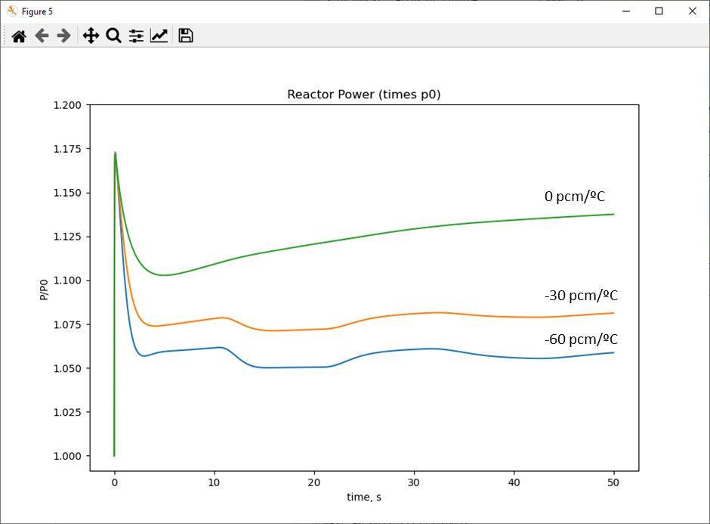

*FIG. 1. Response of ODE11 to an external reactivity step of 0.15 times beta at HFP for different αw*

*FIG. 2. Response of ODE11 to reactivity impulse of 0.60 times beta at HFP*

## METHODS OF LYAPUNOV

### First Method of Lyapunov or “Indirect Method” – Local Stability

According to the first method of Lyapunov, if all eigenvalues of the Jacobian of a non-linear system *f(x)* evaluated at *xeq* are real-negative, then the system is *locally* asymptotically stable, and the solution will converge to a finite value for time large enough. If any eigenvalue is Real-positive, the system is unstable. The same conclusion can be obtained from mathematics theory realizing that the solutions of a linear ODE system can be expressed as a linear combination of eigenvectors multiplied by exponentials with eigenvalues as time constants.

### Second Method of Lyapunov or “Direct Method” – Regional Stability

In order to study the stability beyond the immediate neighbourhood of the equilibrium point, the eigenvalues method described above is not valid. Instead, the Lyapunov second theorem (known as the “direct method”), which is based in a generalization of the concept of energy in theoretical mechanics, is utilized: Stability of a system *f(x)* is reached if the total energy continually decreases over time and the energy is never restored.

Lyapunov´s achievement was that stability in a region can be proven without requiring knowledge of the true physical energy, providing an analogue *V* function can be found to satisfy some special conditions:

* *V(x) = 0* at *xe*, and *V(x) > 0* except at *xe*
* *dV(x)/dt = grad V⋅ f(x)* *≤ 0* except at *xe*

There are several methods for finding Lyapunov functions, none of them is universally applicable, so frequently one has so go through a trial and error process.

## LOCAL STABILTY ANALYSIS

### Simplifications to the model, ODE5

To obtain the Jacobian, it is convenient to reduce the system from ODE11 to ODE5 by taking some simplifications, which are described below:

* One group of delayed neutron precursors. It is a very frequent simplification in reactor stability studies that preserves the qualitative behavior of the power in a transient.
* Instantaneous cladding response. Cladding has a small thermal inertia compared to the fuel and moderator, making it possible to eliminate differential equation Eq(4).
* Linear heat transfer to the coolant.

The equivalent system ODE5 is constituted by equations (1), (2) reduced to a group of delayed neutrons, (3), (5) considering linear heat transfer to coolant, and (7). Fig. 3 shows that the simplified ODE5 model evolves in a similar way to the ODE11 model and preserves the oscillations caused by the mismatch between buoyancy and friction that we pay attention to.

*FIG. 3. Performance of simplified ODE5 (red) compared to ODE11 (blue).*

### Jacobian and eigenvalues

The Jacobian matrix of ODE5 with respect to state variables *[p, c, Tf, Tw, Ww],* is given next:

|  |  |  |
| --- | --- | --- |
|  | $$J=\left[\frac{∂f_{i}}{∂x_{j}}\right]=\left[\begin{matrix}-\frac{β}{Λ} & λ & \frac{α_{f} P_{0}}{Λ} & \frac{α_{w} P_{0}}{Λ} & \frac{αw P0}{Λ} \\ \frac{β}{Λ} & -λ & 0 & 0 & 0 \\ \frac{1}{{cp}_{f} m_{f}} & 0 & -\frac{{UA}_{f}}{{cp}_{f} m_{f}} & \frac{{UA}_{f}}{{cp}_{f} m_{f}} & 0 \\ 0 & 0 & \frac{{UA}_{f}}{{cp}_{w} m_{w}} & -\frac{2{cp}_{w}W_{w0}+{UA}_{f}}{{cp}_{w} m_{w}} & \frac{P_{0}}{m_{w}{cp}_{w}W_{w0}} \\ 0 & 0 & 0 & 0 & -3a\end{matrix}\right]$$ | (8) |

Table 2 shows the eigenvalues of the Jacobian matrix for the envelope states. In all four cases, all eigenvalues present negative real part. Therefore, according to the first Lyapunov method, the system is asymptotically stable in the vicinity of the equilibrium point, which is consistent with the behavior observed in Section 3.

TABLE 2. EIGENVALUES FOR BOUNDING STATES

|  |  |
| --- | --- |
| **HFP** | **HZP (~ 1%)** |
| *αw = 0 pcm/ºC*  (-64.7724+0j)  (-0.9909+0.9351j)  (-0.9909-0.9351j)  **(-0.0634+0j)**  (-1.5+0j) | *αw = +5 pcm/ºC*  -65.0734  -1.0743  **-0.00012**  -0.1521  -1.5 |
| *αw = -60 pcm/ºC*  -64.7550  **-0.0422**  -0.5492  -1.4711  -1.5 | *αw = -15 pcm/ºC*  -65.0735  -1.0677  **-0.0031**  -0.1557  -1.5 |

## GLOBAL stabili ty ANALYSIS

### Additional simplifications, ODE2

To apply the second method we further scale down the equations to just the two known as prompt-jump approximation and Newton law of cooling.

|  |  |  |
| --- | --- | --- |
|  | $$\frac{dP}{dt}=-\left(ρλ+\frac{dρ}{dt}\right)P/\left(β-ρ\right)$$ | (9) |

|  |  |  |
| --- | --- | --- |
|  |  | (10) |

|  |  |  |
| --- | --- | --- |
|  |  | (11) |

This ODE2 model seems rather simplistic but is still suitable for studying system stability if we are interested only in qualitative behavior. In the case at hand, in order to reduce the ODE5 system to an ODE2 with only two state variables (*P* and *Tf*), we have seen that the cladding and coolant time constants are very small compared to that of the fuel, and it is reasonable to simplify to that both respond immediately to fuel temperature variations with negligible inertia. In addition, the previous section has shown the low sensitivity of the flow rate to power variations, so the approximate validity of an ODE2 system can be accepted.

### Application of the Second Method

For this simple ODE2 system, several Lyapunov V functions have been reported in the literature that meet the conditions indicated in point 4.2. For the paper, the function reported in [4] has been taken, which is shown in the following expression:

|  |  |  |
| --- | --- | --- |
|  | $$V=P-P_{0} ln\left(\frac{P}{P_{0}}\right)+{λ m}_{f}{cp}_{f}δT_{f}-\frac{λβ}{α}m_{f}{cp}_{f} ln\left(1+\frac{α}{β}δT_{f}\right)$$ | (12) |

Regional stability is guaranteed if *UA/ mf cpf*< 4λ, which is the case. Fig. 3 shows the positive definite form of the Lyapunov function for our reduced ODE2 system, particularized to the BOC-HFP state, for a region of interest in which the asymptotic stability is global. The trajectories in the temperature and power phase plane are also shown, where the deviations in these parameters converge asymptotically to the full power equilibrium point, and therefore it is a stable node.

*Fig. 4. Representation of Lyapunov V potential function and Phase-plane trajectories at the equilibrium point at BOC-HFP*

## Conclusions

A system of differential equations representative of a light water SMR cooled by natural circulation has been presented. For this system, step and impulse reactivity inputs have been simulated for different envelope states, and the reactor response has been obtained in terms of power, nuclear exposure, and reactivity feedbacks, resulting in stable and limited responses. The natural circulation loop sometimes causes oscillations that are small and highly damped. Furthermore, Lyapunov stability theorems have been applied to simplified versions of the system of equations, studying the Jacobian eigenvalues of the system and also presenting a Lyapunov function for the main state variables, concluding in local and regional asymptotic stability, which is the object of the study.

Although the study is novel in its approach, the result is consistent with the findings of previous studies on the NUSCALE reactor. This reactor has been taken as a reference or case study, but the methods are applicable to other reactors of this type.

Given the simplified nature of the study, and the approximate nature of the data used, the validity of this result is limited only to the conclusion about system stability in a limited range of operation, and no other conclusions can be drawn nor detailed behavior predicted against to external actions and disturbances.

## Acknowledgements

We would like to sincerely thank ENUSA for their valuable support in the completion of this work.

## References

1. STANDARD DESIGN APPROVAL FOR THE NUSCALE POWER PLANT BASED ON THE NUSCALE STANDARD PLANT DESIGN CERTIFICATION, ML20247J564, United States Nuclear Regulatory Commission, (2020).
2. DUDERSTADT, J., HAMILTON, L., Nuclear Reactor Analysis, John Wiley and Sons, Inc., New York (1976).
3. FARAWILA Y. M., TODD D., ADES M., “Analytical Stability analogue for a single-phase Natural Circulation Loop”, NURETH-16, Chicago, IL, August 30-September 4 (2015)
4. HETRICK D. L., Dynamics of Nuclear Reactors, The University of Chicago Press, Chicago and London (1971)