Development of nuclear infrastructure

based on different contracting models

and risks assessment

Y. Chernyakhovskaya

Rusatom Service JSC, Hungarian branch

Paks, Hungary

Email: YVaChernyakhovskaya@rusatomservice.ru

Y. Cherevko

Rusatom Service JSC

Moscow, Russian Federation

**Abstract**

The scope of activities and responsibilities division for nuclear infrastructure development between a recipient and a vendor countries is impacted by a chosen deployment model of a SMR project, which is reflected in the set of the contractual arrangements between the project parties. The range of common approaches in an embarking country encompasses a turn-key and a concession (build–own–operate). It is possible to determine the optimal legal construction for appropriate risks management based on parties’ risk profile and ability to manage their risk. An insufficient nuclear infrastructure is a trigger for SMR budget overruns, schedule slippage, as well as licensing and safety challenges. The determination of relevant obligations division in the project is possible based on the results of the (pre-) feasibility study and nuclear infrastructure assessment. To optimize nuclear infrastructure for SMR projects in embarking countries, one of the backbone measures for nuclear infrastructure development is assistance from the vendor state from the beginning, including a bilateral nuclear infrastructure plan with fixed commitments of parties and cooperation between regulatory bodies on regulatory framework and safety assessment (pre-licensing).

## NUCLEAR INFRASTRUCTURE AND GLOBAL NUCLEAR SAFETY REGIME

The implementation of the nuclear project takes place within the framework of global cooperation in the field of nuclear safety. Nonetheless the undisputable benefits nuclear energy brings it also bears potential transboundary risks, first and foremost from nuclear and radiation safety and national economy perspective.

Nuclear infrastructure lies at the heart of the global nuclear safety regime [1], therefore making a decision on nuclear project demands justified analysis of nuclear infrastructure requirements that rise before the country making such a decision. A risk-oriented approach should be applied towards the potential influence of the nuclear technology customer’s expectations and nuclear safety requirements on the project feasibility while bearing primary safety significance in mind. Nuclear power plants are designed with inherent safety characteristics. However, it is the national responsibility of the country deciding to pursue nuclear energy path to develop the required nuclear infrastructure which would support the nuclear project safe and efficient implementation. Among other issues, it encompasses development of an independent regulatory body, legal and regulatory framework, competent operator, safety culture, quality assurance tools and nuclear security and safeguards infrastructure. Partially, formulation and division of those responsibilities is established in the set of contracting arrangements between the nuclear project parties based on the preferred contracting model.

Nuclear infrastructure and milestone approach concept was formed by the IAEA in 2007 [2]. Since then, when making a decision and developing a nuclear project, countries evaluate the current stratus of nuclear infrastructure and develop it throughout the entire time of the nuclear project implementation and operation. The development of nuclear infrastructure is a continuous process of analysis and improvement. Nuclear infrastructure is an inherent framework for a nuclear facility project which contributes to achieving the highest level of safety (jointly with the nuclear technology itself).

After making a decision whether or not to introduce nuclear power, in order to reach the second milestone of a nuclear infrastructure development for a nuclear facility contracting and construction, a technology recipient country needs to create a set of safety requirements for the project, licensing process of the planned activities. It should be taken into account, that development of a national position at the first stages, the detailed elaboration of the roadmap[1] on the nuclear infrastructure enhancement, development of a national nuclear fuel cycle strategy, HRD and regulatory strategy would influence the schedule of the project implementation and the further requirements elaboration (as a requirements management system and configuration management system of a nuclear facility project management).

## RISKS - ORIENTED APPROACH IN NUCLEAR INFRASTRUCTURE DEVELOPMENT

Many of the factors that will either facilitate or obstruct the deployment of nuclear power relate to infrastructure — regional, national and international [3]. In the absence of nuclear infrastructure development, starting from the early stage of a nuclear facility project, risks arise in terms of delays in its implementation, in the timing of obtaining licences and permits, additional costs and etc. Lack of nuclear infrastructure assessment leads to the risk of compromising the safety, project cost increase, reduced return on investment, and an increase in the project implementation period (a vicious cycle of mega-projects synergetic domino effect).

Regulatory framework development and requirements establishment is one the most significate issues influencing the nuclear project contracting cost and schedule (see Fig. 1). When NPP/SMR negotiations start a reference plant is usually an initial stage for discussion of customer’s expectations and functional demands. Usually it is the very early stage of negotiation which brings the highest portion of recipient country regulatory requirements which drives NPP/SMR design change and adaptation to the local conditions (first of all climate, seismic, legal and regulatory framework). Although the customer’s requirements are not large at numbers they may change a reference plant configuration rather dramatically. According to cost estimate classification system of Association of Advancement of Cost Engineering, expected accuracy range for the initial project negotiation stage is extremely broad (so there is no opportunity to assess NPP/SMR cost correctly). Gradually, when the customer’s requirements are implemented in the NPP/SMR configuration, especially after inclusion the particular industrial partners in the future cooperation model, the expected accuracy of the NPP/SMR cost assessment may achieve an affordable level. Nuclear infrastructure and regulatory framework immaturity drives uncertainties in the NPP/SMR project implementation and sustainability.

At the same time, ten years of lessons learned in IAEA Integrated Nuclear Infrastructure Review (INIR) mission has shown that a lot of countries struggle with establishing a competent, effectively independent nuclear regulatory body and developing the regulatory framework [4].

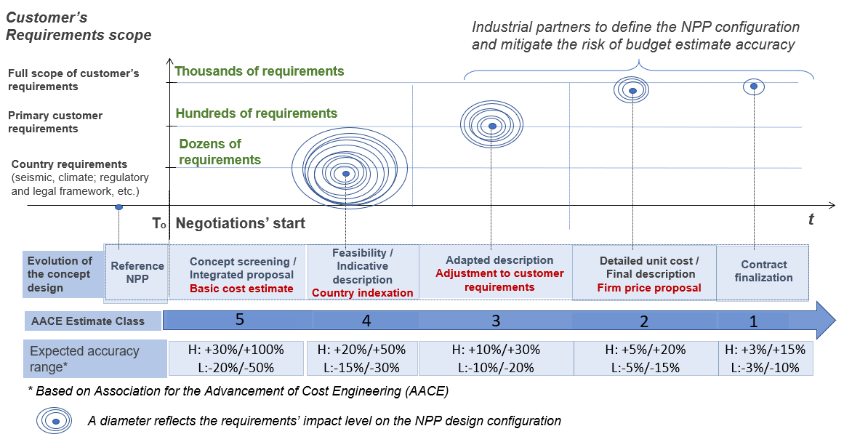

*FIG. 1. Step-by-step impact of Customer’s requirements on NPP design configuration, deviations from the reference plant, NPP/SMR project budget and accuracy of its assessment.*

The following main issues can be identified within the national nuclear infrastructure framework affecting safety, schedule and cost of the implementation of the nuclear project:

1. absence of a full-fledged national regulatory framework, the requirements of which are harmonized with the safety requirements of the IAEA with a detailed procedure or guidance on the explanation of regulations, guidelines and standards for licensing nuclear energy use. In the most cases the Intergovernmental Agreements (IGA) between the countries on cooperation in nuclear energy and a nuclear facility construction contains provisions on the application of national standards and regulatory requirements of the host party in the framework of licensing and implementation of the project, which is not established at the time of contracting for a new-comers’ case;
2. lack of financing for the activities on nuclear infrastructure development, specifically for the regulatory framework and human resources development;
3. no nuclear infrastructure roadmap available with defined responsibilities of national authorities on nuclear infrastructure development.

Nuclear infrastructure assessment at early stages of NPP/SMR project planning is a prerequisite for risks assessment and mitigation. First of all, it would provide the country with a certainty on the steps to be taken to fill in the gaps in the infrastructural environment or to bring the existing tools into line with the new goals of a new project, to plan and ensure availability of the necessary financing. Secondly, gradual development of a nuclear infrastructure based on the initial assessment would ensure timely establishment of effective and sufficient national legal and regulatory framework with requirements corresponding to the design features of the preferable nuclear facility and nuclear facility risks. Finally, it would assist in contract documents formation with inclusion of responsibilities on nuclear infrastructure development and establishment of the regulatory framework applied to the project.

* 1. **Bilateral cooperation mode**

Based on NPP project parties’ risk profile and ability to manage their risk it is possible to determine the optimal set of contract documents and their content for appropriate risks management. According to the principle of “communicating vessels”[2], risks and means of managing them can be reflected both in a single fundamental agreement on a NPP project or in a package of contract documents rigidly interconnected among each other according to the principle of hierarchy. In the most spread second case, the higher-level agreements (first of all, IGA) define the key conditions and parameters of the NPP project, which are subject to detail in the “lower-level” agreements at the level of organizations, and which could be supplemented by bilateral nuclear infrastructure development plan, as well as by national policy and regulatory framework of the country where the project is being implemented (see Fig. 2). Elaborated hierarchy (“a pyramid”) of cooperation legal documents (memoranda, agreements, contacts, etc.) interrelated in a manner of interconnected vessels is a pivotal tool for risk management and responsibilities division enabling finance raising to a new NPP/SMR project.

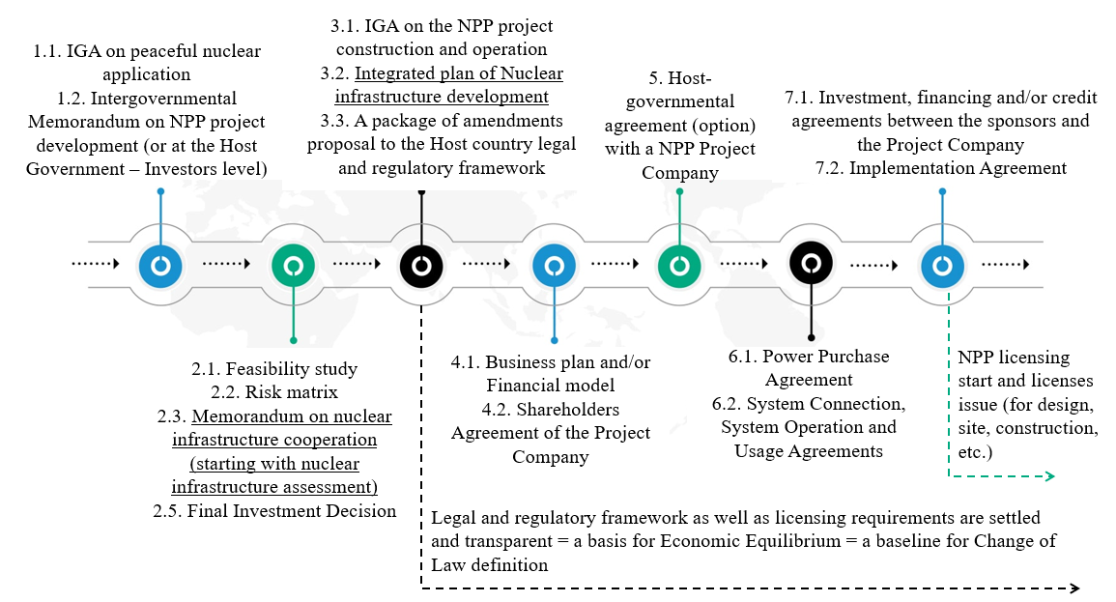

*FIG. 2. Possible evolution of the legal structure of the NPP/SMR project (EPC/BOO options) with specialized provisions for nuclear infrastructure development (decomposition of essential conditions and parameters of a NPP/SMR project, taking into account the gap analysis of nuclear infrastructure).*

- *At the first stage* of cooperation (FIG. 2) it is advisable to fix the obligations of the parties in a Memorandum on the Implementation of the NPP project on the following decision making process and implementation of the NPP project.

- *At the second stage* three reports (feasibility study, risk matrix and nuclear infrastructure gap analysis plan) should be taken into account when making a Final Investment Decision, as well as form the foundation of documents being developed and subject to agreement during negotiations with partners *at the third stage* (IGA) and a package of amendments proposal to the Host country legal and regulatory framework.

- *At the third stage* it is important to fix the regulatory and licensing basis for obtaining the necessary licenses and permits for the NPP project.

- *At the fourth stage* the Private party is to justify the target level of the electricity tariff of the NPP project, taking into account the capital and financing expenses, according to the legislation of the Host country (for handling spent nuclear fuel and radioactive waste, emergency planning and response measures and other necessary funds). Such justification can be carried out by presenting a Business plan and/or a Financial model of the project.

- *At the fifth stage* the parties could arrange the signing of the HGA with the Project Company. However, this stage may be skipped, and the HGA provisions may be included in other contract;

- *At the sixth stage* the parties need to sign a package of contract documents between the Project Company and authorized organizations of the Host country.

- *At the seventh stage* the parties can proceed to signing Financial and/or Credit Agreements as well as a NPP licensing.

Presented step-by-step approach contributes to diligent preparation of a NPP/SMR project with a coherent nuclear infrastructure development. At the highest level documents parties could fix an obligation of the recipient state to implement the plan of the nuclear infrastructure assessment and development, fix the regulatory and licensing basis for obtaining the necessary licenses and permits for the NPP/SMR project (or agree on the other forms of safety assessment) with the vital facilitation on behalf of the NPP exporting state.

The assistance in regulatory framework development is conducted though the separate agreement between the regulatory bodies of the recipient and exporting states (preferably at the 1st or 2nd cooperation stages according to FIG 2). For instance, to ensure multifaceted approach in regulatory framework development, the regulatory bodies cooperation should include:

* transfer of regulatory safety documentation (norms and rules) for its adoption before SMR commissioning, which will facilitate the licensing process and is in line with the recommendations of the IAEA's international nuclear safety group [5];
* regulatory body personnel training, including training in relation to the regulatory safety documentation transferred;
* pre-licensing joint review of the preliminary safety analysis report (PSAR) with relevant consideration of the reference plant PSAR;
* participation of host state’s regulator in inspections as observer to the SMR reference facility in vendor’s country together with the vendor country’s regulator. The inspections check-lists could also be shortened to make inspections more adaptable to different cases but in line with safety principles.

In general, IGAs or other forms of agreements may act as a mechanism for reducing the timeframe for the implementation of a NPP project with a fixed and clear allocation of responsibilities between the host country and the technology vendor country.

The bilateral nuclear infrastructure development plan could be also used when developing the integrated working plan with the IAEA after the Integrated Nuclear Infrastructure Review (INIR) mission, so that all the project parties could ensure that the activities planned are backed with the necessary assistance as from the vendor as from the IAEA.

* 1. **Multilateral cooperation mode**

Another example of the high level agreements with plans on nuclear infrastructure could be regional cooperation plans. For instance, in 2023 the Economic Counsel of the Commonwealth of Independent States (CIS) approved the programme of national nuclear infrastructures development and the plan of the programme implementation. Rusatom Service JSC, organisation of Rosatom State Corporation, has been appointed by the Economic Counsel as the organisation to assist CIS member states in the programme of national nuclear infrastructures development implementation based on the annual plans developed and agreed by the CIS Member States and the CIS Commission on nuclear energy use for peaceful purposes. This mechanism provides with the possibility to request the necessary assistance on nuclear infrastructure development at the regional level and share the experience and lessons learned. Under umbrella of Economic Counsel of the CIS a Nuclear Regulatory Bodies Forum also functions as a cooperation platform.

In the “lower-level” agreements at the level of organizations the parties could stipulate the rest of obligations of the parties with regards to the nuclear infrastructure development, including documentation development, at the level of the operating organisation.

## Impact of a NPP/SMR Project Deployment model on nuclear infrastructure

The scope of activities and issues to consider during nuclear infrastructure development would significantly rely on the chosen deployment model of a NPP/SMR project which is reflected in the set of the contractual arrangements between the project parties. The two most common approaches in an embarking country are turn-key (hereinafter referred to as EPC-contract) and build–own–operate (hereinafter referred to as BOO-project).

In the EPC model, a contractor takes overall responsibility for completing all parts and all phases of the project design and construction and the receiving party is responsible for NPP/SMR operation and decommissioning. Concerning nuclear infrastructure, while applying EPC model national authorities of the host state are responsible for the establishment of the nuclear infrastructure in full scope. This incorporates the national commitment to the programme, including stakeholder involvement, establishment of the legal and regulatory frameworks and development of the necessary policies and strategies for safety, security, safeguards, emergency preparedness and response, spent fuel, nuclear waste management, and decommissioning programme [6]. Still, the vendor state could share its expertise and thus provide substantial support to the recipient state in the field of nuclear infrastructure enhancement which can speed up the SMR project substantially in the field of all infrastructural issues.

In the BOO structure, a private or non-private entity (the developer, SPV) is granted the right by the government to develop, finance, build, own, operate and maintain a nuclear facility for a specified period, during which the entity owns the project, retains the revenue, bears the associated risk [7]. Moreover, the host state receives the key value from the project electricity. The host state typically offers a power purchase agreement (hereinafter referred to as PPA) for a certain period to give visibility on the return on investment to the project developer [8]. BOO-model assumes the division of responsibilities between the project parties in nuclear infrastructure development with greater scope to be provided through support of the technology vendor and its national regulatory authorities.

The described BOO model (Maximum outsourcing scenario) has a potential to simplify the procedures of nuclear infrastructure development in the host state, also from the point of view of licensing, ensuring non-proliferation regime and so on.

It is especially beneficial for floating nuclear power plants (FNPP) projects implementation. Maximum outsourcing scenario in relation to FNPP creates the opportunity for the vendor state to use its experience in operation of nuclear power plants and to extrapolate it to the host state. The latter one receives a reliable and stable (concerning the price of MW) source of energy in remote locations swiftly. Issues of safety are ensured by an experienced operator. At the same time the host state saves the opportunity to control the operation and partially holds responsibility for it.

It contributes to minimizing the scope of responsibilities of the host state in nuclear infrastructure development ensuring high level of nuclear safety at the same time. Within the host state would remain the following responsibilities in nuclear infrastructure development:

* regulatory framework establishment and ensuring regulatory control by national independent regulatory authorities in the field of nuclear energy and in the field of maritime safety over activities related to compliance with nuclear and maritime safety requirements by national organizations involved in the Project implementation on the territory of the country of FNPP location;
* enhancement and maintenance of national emergency preparedness and response system, development and maintenance of Environmental Radiation Monitoring System;
* establishing a system for informing the public about the safe use of nuclear energy and maintaining it at the required level;
* ensuring compliance with international binding instruments in the field of physical protection of nuclear materials and nuclear facilities;
* ensuring accounting and control system at the national level;
* the necessary port infrastructure development to ensure radiation safety and radiation control4
* grid system development, electricity tariff setting and a guarantee to purchase 100% of produced electricity of a FNPP.

The division of the responsibilities could be stated in the agreements between the project parties and bilateral nuclear infrastructure development plans.

## Ways to accelerate the development of nuclear infrastructure BASED ON NPP/SMR projects CONTRACTING MODELS

To accelerate the development of nuclear infrastructure for international NPP/SMR projects in embarking countries based on different contracting models (BOO / EPC), the backbone measures for nuclear infrastructure development could be:

1. a national strategy adoption and implementation for nuclear infrastructure development (integrated national nuclear infrastructure development plan coordinated with IAEA and supported by the vendor’s state resources) based on the national nuclear infrastructure assessment (including gap analysis and development of nuclear infrastructure roadmap);
2. breakdown of nuclear infrastructure development activities in a synchronized set of bilateral agreements between the customer and SMR vendor with fixed commitments of parties, between regulatory authorities;
3. use of bilateral nuclear infrastructure development plan while developing the integrated working plan with the IAEA after the INIR mission;
4. high level of assistance from the vendor state in nuclear infrastructure development, including cooperation in the regulatory framework development and safety assessment. One could consider to include a vendor/technical consultant expert team in NEPIO for joint development of documents, assistance in nuclear infrastructure assessment and comprehensive report development. Decision-making is always left to the partner country. This would ensure expertise transfer in parallel with NEPIO personnel development through learning-by-doing and coaching.

Well planned and transparent roadmap for nuclear infrastructure development contributes to safety and commercial feasibility of the NPP/SMR projects thus enhancing competitiveness of the nuclear power as an electricity generation source. Only competitive NPP/SMR projects can facilitate achievement of sustainable development goals.

References

1. IAEA, INSAG, Strengthening the Global Nuclear Safety Regime, ISAG-21, a report by the International Nuclear Safety Group, Vienna (2006)
2. IAEA, Milestones in the Development of a National Infrastructure for Nuclear Power, IAEA Nuclear Energy Series No. NG-G-3.1 (Rev. 1), Vienna (2015)
3. IAEA, INPRO Methodology for Sustainability Assessment of Nuclear Energy Systems: Infrastructure, INPRO manual, No. NG-T-3.12, Vienna (2014)
4. IAEA, Integrated Nuclear Infrastructure Review (INIR): Ten Years of Lessons Learned, IAEA-TECDOC-1947, Vienna (2021)
5. IAEA, INSAG, Licensing the First Nuclear Power Plant, INSAG-26, a report by the International Nuclear Safety Group, Vienna (2012)
6. IAEA, Initiating Nuclear Power Programmes: Responsibilities and capabilities of Owners and Operators, IAEA Nuclear Energy Series No. NG-T-3.1 (Rev. 1), Vienna (2020)
7. IAEA, Alternative Contracting and Ownership Approaches for New Nuclear Power Plants, IAEA-TECDOC-1750, Vienna (2014), p. 53. “AKKUYU NPP project based on the BOO approach: Turkey”, A.S. Dedusenko, T.V. Ivanov, U.V. Chernyakhovskaya, O. Ulasevich
8. IAEA, Management of Nuclear Power Plant Projects, IAEA Nuclear Energy Series No. NG-T-1.6, Vienna (2020)

1. The roadmap is a top-level plan for the development of the NI issues in support of a nuclear project implementation, which specifies the priority NI development activities to be performed by the host country organizations/institutions, their deadlines and key stakeholders involved in the implementation of the activities.
2. Communicating vessels’ principle means that all project’s risks scope is split between the project’s participants and allocated accordingly in the responsibilities division matrix of the project’s contractual arrangement.