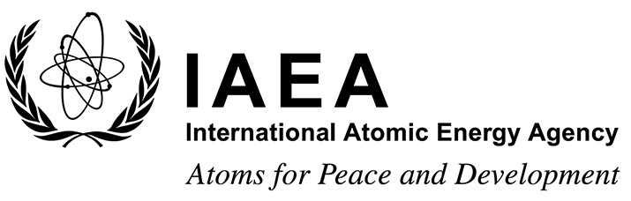 |  |  | Form A  EVT2205764
Participation Form
Workshop on Artificial Intelligence for Accelerating Fusion and Plasma Science
IAEA Headquarters, Vienna, Austria
28 November – 1 December 2023
To be completed by the participant and sent to the competent national authority (e.g. Ministry of Foreign Affairs, Permanent Mission to the IAEA, or National Atomic Energy Authority) of his/her country for subsequent transmission to the International Atomic Energy Agency (IAEA) either by email to: Official.Mail@iaea.org or by fax to: +43 1 26007 (no hard copies needed). Please also send a copy by email to the Scientific Secretary M.Barbarino@iaea.org and to the Administrative Secretary I.Andrejic-Dukic@iaea.org.
Participants who are members of an invited organization can submit this form to their organization for subsequent transmission to the IAEA.
Deadline for receipt by IAEA through official channels: 30 June 2023
Family name(s): (same as in passport) |  | First name(s): (same as in passport) |  | Mr/Ms
Institution:

Full address:

Tel. (Fax):

Email:
Nationality: | Representing following Member State/non-Member State/entity or invited organization:
If/as applicable:
Do you intend to submit a paper? Yes No
Would you prefer to present your paper as a poster? Yes No
Title:

Participants are hereby informed that the personal data they submit will be processed in line with the Agency’s Personal Data and Privacy Policy and is collected solely for the purpose(s) of reviewing and assessing the application and to complete logistical arrangements where required. The IAEA may also use the contact details of Applicants to inform them of the IAEA’s scientific and technical publications, or the latest employment opportunities and current open vacancies at the IAEA. These secondary purposes are consistent with the IAEA’s mandate.

