This is the title of my isotope hydrology SYNOPSES submitted to the 2023 IAEA Isotope Hydrology SYMPOSIUM
A. SMITH,
Isotope Hydrology Laboratory, Address and Street, Vienna, Austria
E-mail address: myemail@domain.com.

K. D. SAMUEL, B. JONES
Isotope Hydrology Institute, Address and Street, Vienna, Austria.
Abstract: Extended synopses covering various areas of isotope hydrology and related disciplines are welcome, and may be requested for an oral or poster presentation, and in a specific session. Where the number of oral requests exceeds slots available, the IAEA reserves the right to assign papers to an appropriate poster session. A Book of Synopses of accepted contributions will be made available online about one week before the opening of the Symposium.
1. INTRODUCTION
The first step in submission requires creation of a user account on the INDICO conference system, using the 'Login' tab in the top right corner of the page. If you are already a registered INDICO user, please log into the system.
2. METHODS
Here is an example of my water sample collection in Figure 1:
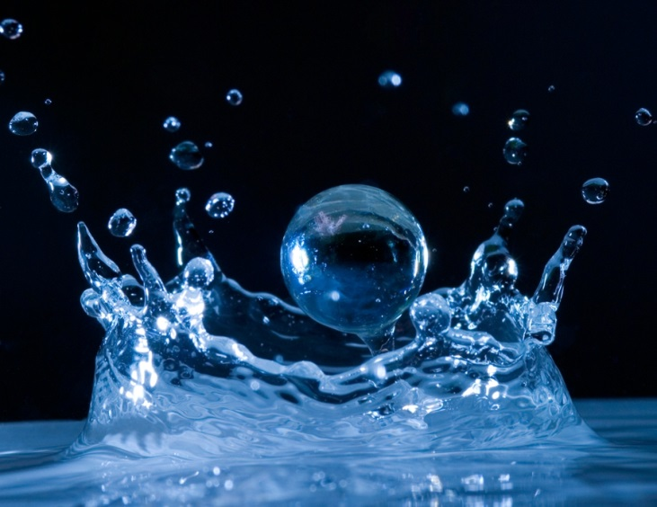
Figure 1. Water sample collection.
3. RESULTS
The first step in submission requires creation of a user account on the INDICO conference system, using the 'Login' tab in the top right corner of the page. If you are already a registered INDICO user, please log into the system. My data are tabulated in in Table 1 as shown below:
Table 1. My ground water isotope results.
δ¹⁸O | δ²H | ³H (TU) | ¹⁴C (pmC)
-23.5 | -220.1 | <0.1 | 54.3±1.0
-16.3 | -153.2 | 0.9±0.2 | 25.3±0.9

The first step in submission requires creation of a user account on the INDICO conference system, using the 'Login' tab in the top right corner of the page. If you are already a registered INDICO user, please log into the system. My data are tabulated in in Table 1 as shown below.
4. CONCLUSIONS
All of the citations in my abstract [1] must follow the IAEA citation style as shown below.
The maximum length of this synopsis is 2 pages [2-10]. Minimum length is 300 words.

REFERENCES
[1] STEPHENSON, R., Introduction to Nuclear Engineering, 2nd edn, McGraw-Hill, New York
(1958) 491 pp.
[2] GEYH, M.A., Messungen der Tritium-Konzentration in Salzlaugen, Kali Steinsalz 5 (1969)
208.
[3] INTERNATIONAL COMMISSION ON RADIOLOGICAL PROTECTION, Evaluation of
Radiation Doses to Body Tissues from Internal Contamination due to Occupational Exposure,
Publication 10, Pergamon Press, Oxford and New York (1968).
[4] GUTHRIE, F.E., PERRY, J.J. (Eds), Introduction to Environmental Toxicology, Blackwell,
Oxford (1980).
[5] HOWLAND, G.P., HART, R.W., “Radiation biology of cultured plant cells”, Applied and
Fundamental Aspects of Plant Cell, Tissue, and Organ Culture, 2nd edn (REINERT, J.,
BAJAJ, Y.R.S., Eds), Springer-Verlag, Berlin (in press).
[6] BURKE, S.D., HOWELL, J.P., “Impact of prolonged wet storage of DOE reactor irradiated
nuclear materials at the Savannah River Site”, Proc. Topical Mtg on DOE Spent Nuclear Fuel
— Challenges and Initiatives, Salt Lake City, 1994, USDOE, Washington, DC (1994) 118–124.
[7] COCHRANE, M.P., DUFFS, C.M., Endosperm cell number in barley, Nature 289 (1981) 399.
[8] BLOUNT, E.I., Symmetry properties of triplet superconductors, Phys. Rev., B: Condens. Matter 32 (1985) 2935.
[9] TEPPER, L., Suboptimal control study of a nuclear power plant, IEEE Trans. Nucl. Sci. NS-22 (1975) 812.
[10] PEACOCK, K.L., Design of discrete bandpass filters for petroleum exploration, Oil Gas J. 83
42 (1985) 121.

