- Background and Goal of the present work
A radioactive source that is no longer in use or not intended to be used, for the practice for which an authorization has been granted, is termed as disused(1). Improperly controlled and stored DSRS has caused many accidents around the world(2-5). To avoid harmful effects coming from DSRS, the Cameroon centralized storage facility for the safe management of DSRS have been developed in order to reduce the radiological risks to the workers, the general public and the environment. The National Radiation Protection Agency (NRPA) which is the regulatory body in Cameroon manages this facility.
Due to the fact that, the IAEA does not encouraged storage of DSRS at third party facility, licensees have been requested to take safety measures for their transfer to the centralized storage facility in order to be conditioned and safely stored.
The objective of the work was to handle the radiation sources in suitable and adequate workplaces. This paper describes radiation protection measures taken during operations.

- Materials and Method

The conditioning operation required working areas with adequate ventilation system. The working areas were covered with plastic sheets to limit probable contamination during operations. The radiation level of areas was checked by using a tele-survey meter and the contamination level was measured by using a contamination monitor. A HEPA ventilation system have been installed in the conditioning area to protect personnel and the environment from airborne contaminants.

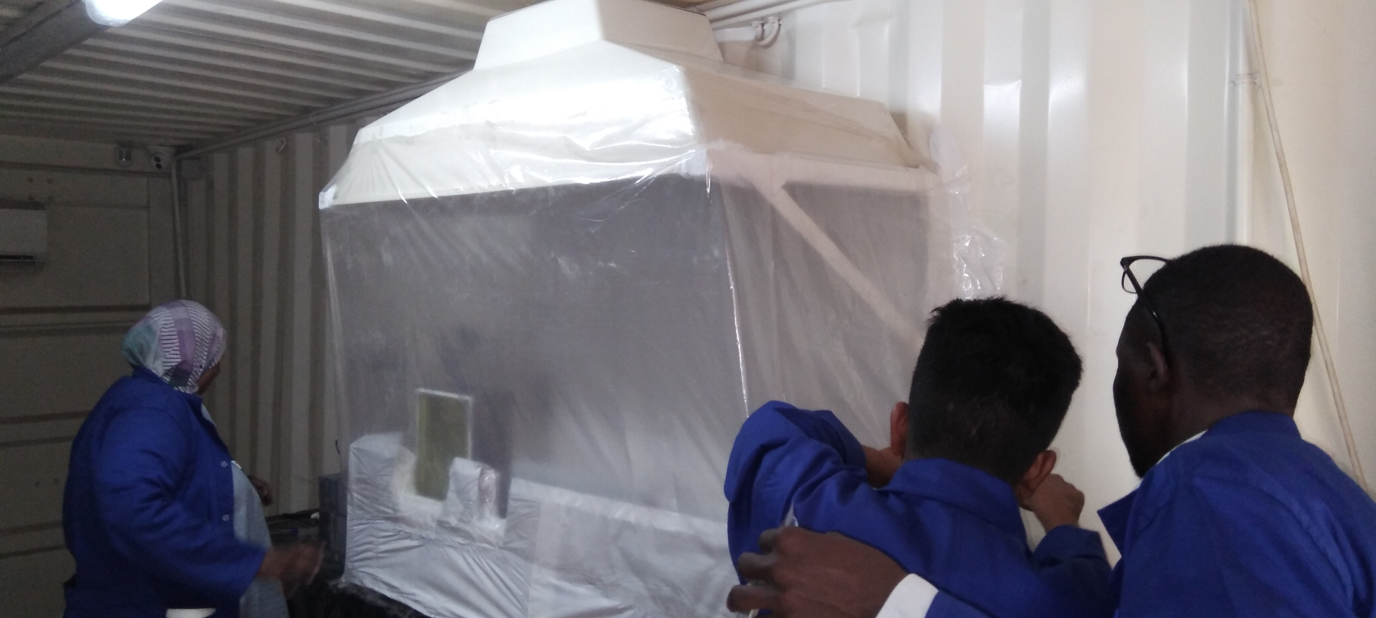
Figure1: Conditioning area with the HEPA ventilation system
Responsibilities have been assigned in order to guarantee safety measures and radiological protection of involved persons and environment. Peoples involved in the operation were radiation workers and wore an individual dosimeter, overalls and overshoes.

Two stainless steel capsules were prepared for DSRS recovered from devices (one for the gamma emitting sources (SSC-01) and
one for neutron sources (SSC-02)).

Identical DSRS have been confined in the same capsule and then their characteristics have been recorded.
Stainless steel capsules containing gamma and neutron sources have been stored inside lead containers and then in pre-cemented 200 L drum (SSC-01) and 120 L drum with paraffin (SSC-02) respectively.
After dismantling of devices, source lengths and diameters have been measured in order to know the individual volume of each DSRS. This information was helpful to estimate the number of DSRS to be introduced in a given capsule.

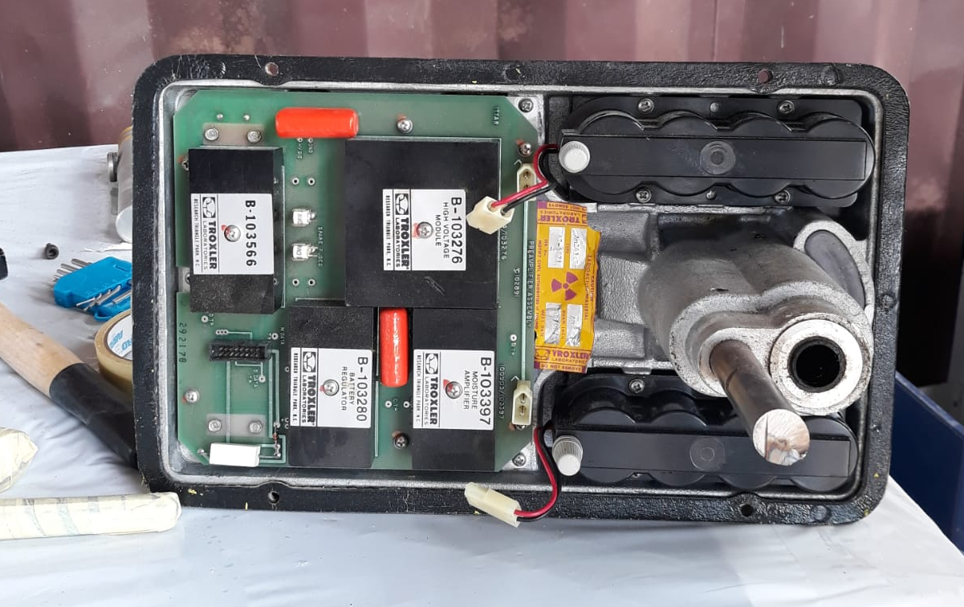 | 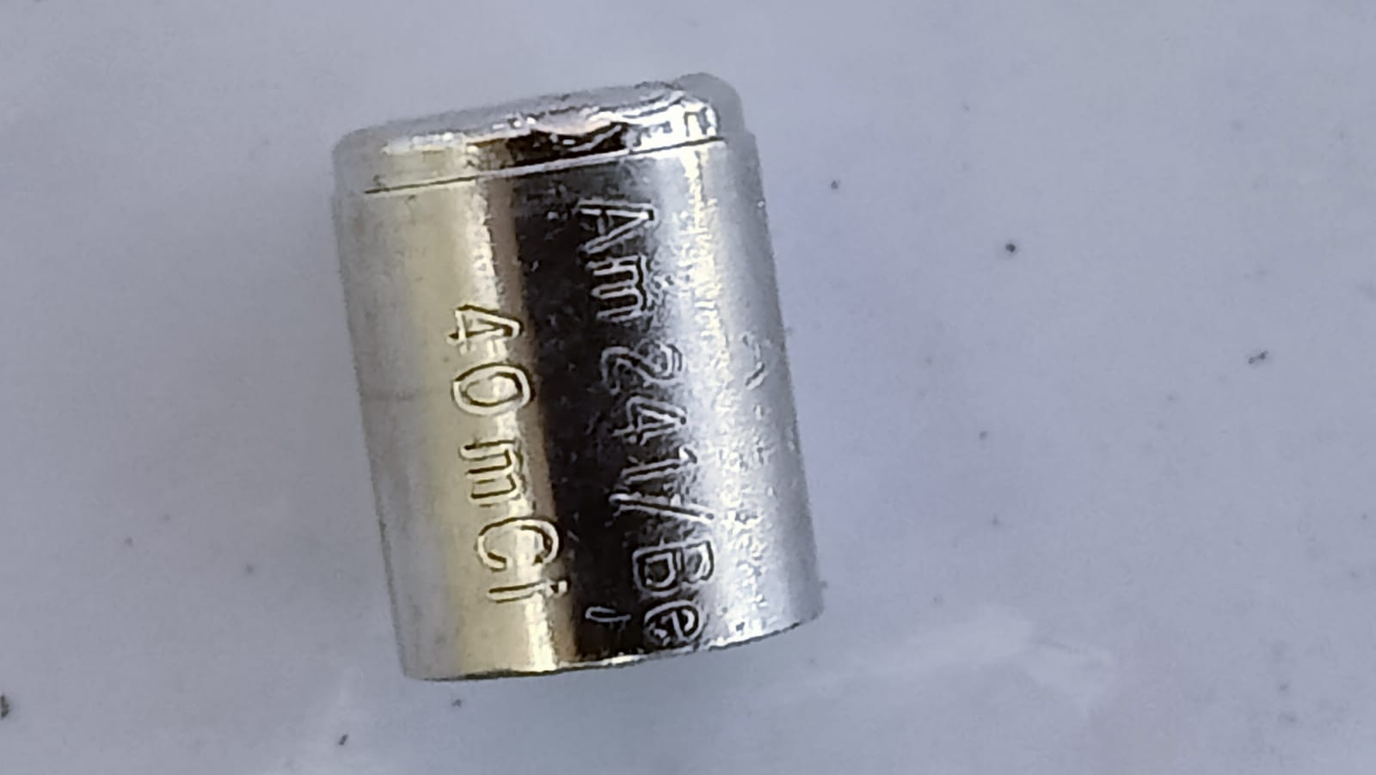 | 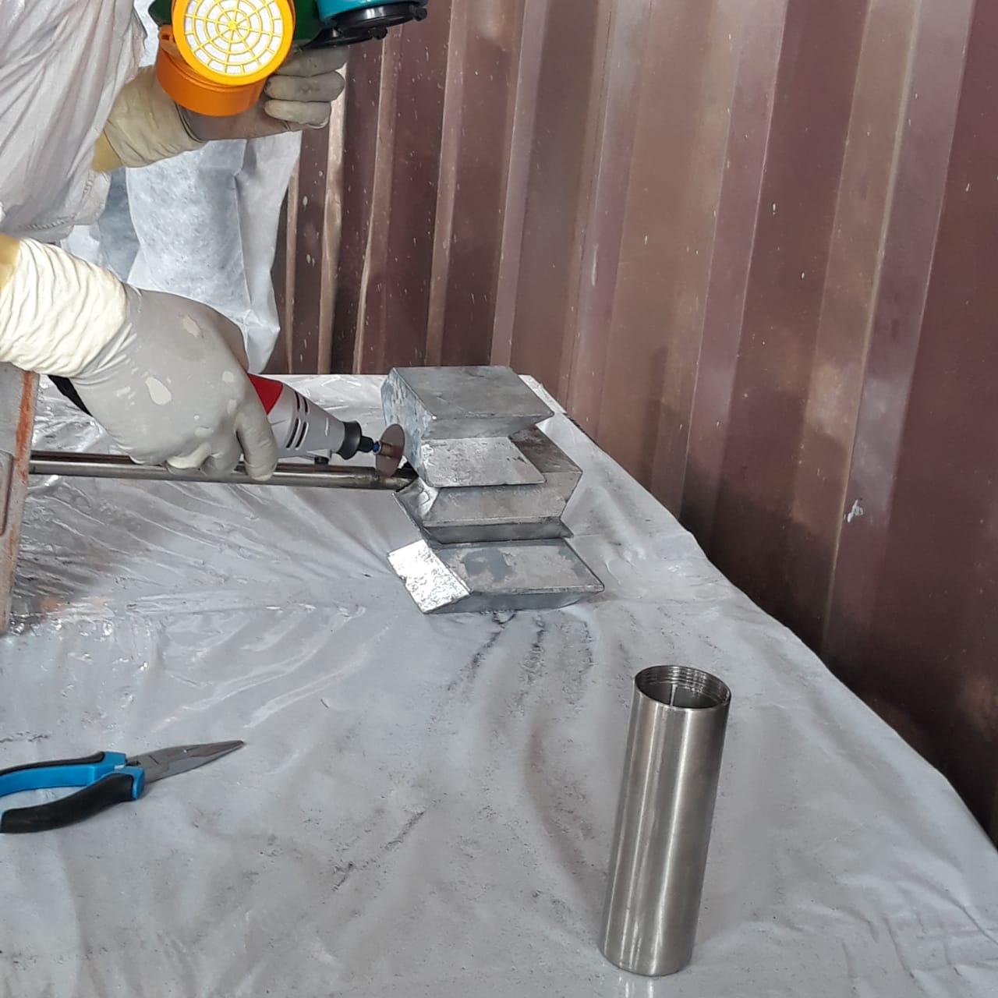 | 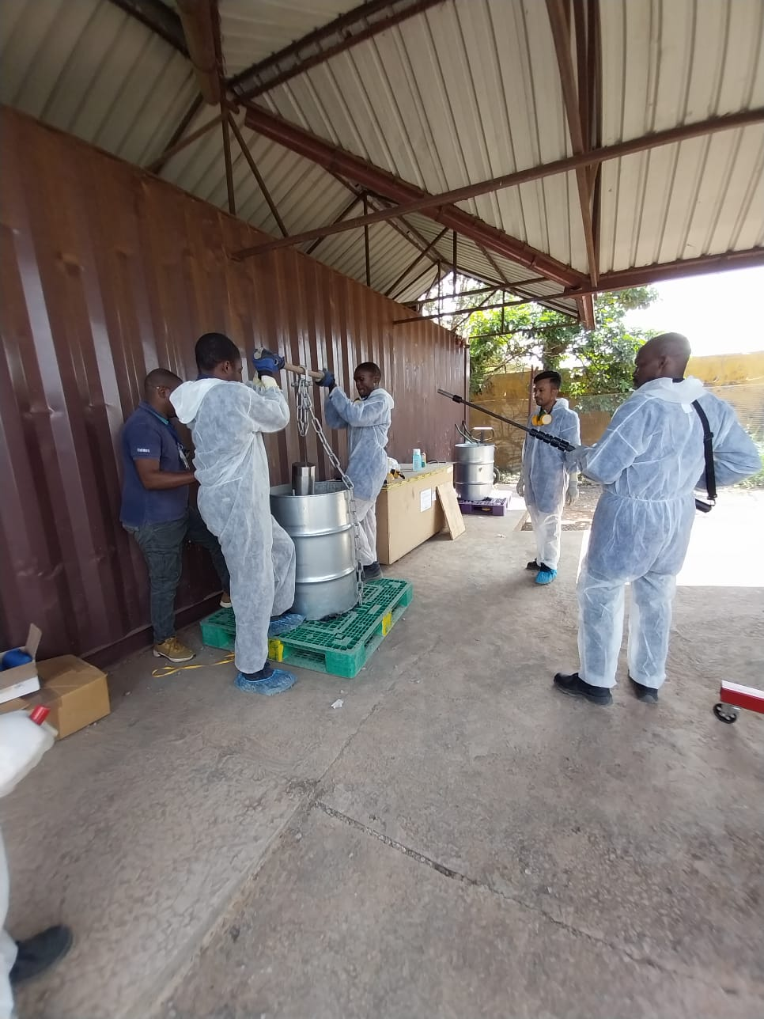
Figure 2 (1)Troxler device disassembled to recover DSRS | Figure 2 (2) DSRS recovered from Troxler device | Figure 2 (3) Empty SSC to be contained DSRS | Figure 2 (4) Introduction of the shielding containing SSC with DSRS to the Pre-cemented 200 L drum

- Results and discussion

A total of 20 gamma emitting sources and 8 neutron sources were conditioned in 2 capsules and stored in 2 drums.
Dose rates have been measured at the contact and at 1meter from the capsules. In addition, dose rates have also been recorded when capsules have been introduced in the drums. Measurements of dose rates have been performed in order to control the radiological exposition of workers.
Radioactive contamination has been monitored before, during and at the end of the operation. The measured data were approximately equal to the Background. According to the measurements, radioactive contamination was not detected.
Doses of involved persons measured during the dismantling process and the conditioning operation have been reported.
The highest individual dose equivalent measured was 0.130 mSv. Radiation doses received by the other persons were lower or equal to 0.050 mSv.

- Conclusions and Acknowledgements
Conditioning operation in Cameroon have been conducted under the supervision of experts from the IAEA. Dose rate measurements and contamination monitoring implemented during the work have revealed that, operations were conducted following the IAEA safety standards.
The authors thank the IAEA for their support during this work.
- References
- INTERNATIONAL ATOMIC ENERGY AGENCY, IAEA Nuclear Safety and Security Glossary: Terminology Used in Nuclear Safety, Nuclear Security, Radiation Protection and Emergency Preparedness and Response, 2022 Interim Edition, IAEA, Vienna (2022).
- FRIEDRICH V., GERA F. Safe Management of Disused Radioactive Sources: Lowering the Risk. IAEA Bulletin, 42/3 (2000).
- INTERNATIONAL ATOMIC ENERGY AGENCY, Safety of Radioactive Waste Management, Technical Session 6. Proceedings of an International Conference, Cordoba, Spain (2000).
- INTERNATIONAL ATOMIC ENERGY AGENCY, Management for prevention of accidents from disused sealed radioactive sources. IAEA TECDOC 1205 (2001).
- INTERNATIONAL ATOMIC ENERGY AGENCY, Nature and Magnitude of the Problem of Spent Radiation Sources. IAEA-TECDOC 620, IAEA, Vienna (1991).

