# Commitment to Long-Term Stewardship: An Overview of Safe and Sustainable Management and Reuse of Legacy Sites

B. SOKOLOVICH

U.S. Department of Energy Office of Legacy Management

Westminster, Colorado, USA

Email: [bud.sokolovich@lm.doe.gov](mailto:bud.sokolovich@lm.doe.gov)

T. TAYLOR

U.S. Department of Energy Office of Legacy Management

Washington, D.C., USA

Email: [tania.taylor@hq.doe.gov](mailto:tania.taylor@hq.doe.gov)

**Abstract**

The operations of the U.S. Department of Energy Office of Legacy Management are far reaching. Its charge is to protect human health and the environment at 101 sites in 30 states and territories, from Puerto Rico in the Caribbean Sea to Amchitka Island, Alaska, in the Bering Sea. It is the caretaker or steward of the legacy sites that played a critical role in the United States of America’s nuclear history. As such, its commitment to long-term stewardship is at the center of everything it does, beginning the moment it takes over a site and continuing throughout long-term legacy management efforts. The paper reviews the long‑term stewardship undertaken by the Office of Legacy Management in recent years. It describes the necessary components of an effective program, such as the protection of human health and the environment, beneficial reuse, monitoring of remedial activities, stakeholder engagement, and international collaboration. Additionally, the paper explores engagements with local communities, state and local governments, and tribal nations across numerous mediums to educate and inform the public of ongoing stewardship activities. The paper will emphasize the importance of and commitment required for long-term stewardship.

## INTRODUCTION

The Office of Legacy Management’s (LM’s) mission is to fulfil the U.S. Department of Energy’s (DOE’s) postclosure responsibilities and ensure the future protection of human health and the environment. LM accomplishes this mission with many long-term stewardship functions including: (1) protection of human health and the environment and (2) long-term stewardship of DOE assets at postclosure sites.

Stewardship is defined by Merriam-Webster as “the conducting, supervising, or managing of something, especially the careful and responsible management of something entrusted to one’s care.” We are all stewards of our country, land, and resources; our family’s well-being; and our children’s future. We have an important job, a moral obligation, to safeguard our country and protect human health and the environment. This work is the core mission of LM.

LM’s real estate portfolio of 101 sites will expand to include an additional 17 sites because of site transitions across the DOE complex in the coming years, and it will have a total of 29 new sites in its portfolio by September 2030. LM manages its mission at these sites to be sustainable and resilient in the face of change and to support communities that were affected by DOE’s historic activities. Whether the change in site conditions is associated with extreme weather events, changing communities, or changing regulatory standards and emerging contaminants, LM develops and implements unique solutions and options to accommodate these communities.

## STEWARDSHIP AND DISPOSITION OF FEDERAL PROPERTY

The commitment to stewardship is fundamental to everything LM does, beginning the moment it receives a legacy site and continuing throughout long-term management efforts. Stewardship is demonstrated through the protection of human health and the environment.

LM is responsible for maintaining the continuity of stewardship while a legacy site transitions from cleanup to long-term care. In most cases, environmental remedies performed by DOE are conservative in nature and include multiple layers of protection. DOE has spent a considerable amount of effort, time, and money to perform cleanup and establish long-term sustainable remedies that protect human health and the environment. LM protects those investments through active maintenance and surveillance, record-keeping, inspections, groundwater monitoring, ongoing pump and treat activities, cap repair, and many other activities. LM continues to evaluate how potential environmental changes may impact its approach to monitoring, inspection, and maintenance at the sites. There are many aspects involved in the long-term surveillance and maintenance (LTS&M) of remediated sites.

LM prioritizes placing DOE legacy sites and property in circumstances that allow for the most beneficial use, consistent with its mission, which is to revitalize 100% of available DOE-owned sites and implement multifaceted reuse at as many sites as is feasible. Where possible, LM makes lands and facilities available for governmental agencies and for public and private use, consistent with the tenets of sustainability and good land management practices.

LM’s preferred option is to transfer property to another party who will facilitate its best use, which reduces LM’s overall land inventory and minimizes LTS&M costs. However, many LM sites may not be suitable for transfer because of the nature of the contaminants and restrictions on land use imposed by regulations or statutes. In the case of these sites, LM evaluates other types of reuse opportunities that might enhance the site’s value and performance, consistent with its LTS&M Plan, including encouraging collaboration between the public and private sectors to provide reuse for properties that would otherwise sit unused.

Federally owned properties have environmental liability provisions required under federal laws and regulations that impose additional restrictions associated with their transfer and acquisition.[1] Under these statutes and regulations, the federal government is ultimately responsible for the contaminants or contamination (or both) resulting from historic activities. Not all LM sites are suitable for beneficial reuse at the time of closure, but as communities change and technologies advance, new options may become available that can protect human health and the environment while providing beneficial reuse.

The Mound, Ohio, Site (and its land transfer to the Mound Development Corporation) is an example in which early collaboration and planning with regulatory agencies and stakeholders led to agreement among all parties on the future uses of a site (Fig. 1). The Mound site in Miamisburg, Ohio, operated from 1948 to 2003 as part of the U.S. Atomic Energy Commission (AEC) and later DOE. It was built to continue Dayton, Ohio, Manhattan Project work on polonium-beryllium initiators used in early atomic weapons. The site later expanded into an integrated research, development, and production facility supporting weapons, energy, and space missions.

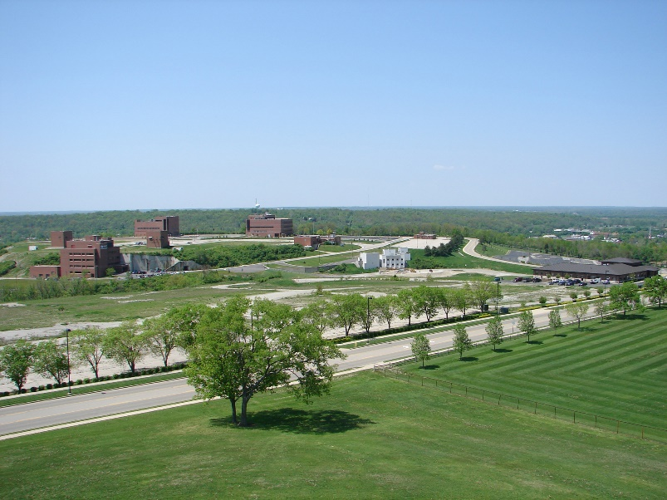

*FIG. 1. Mound site.*

The challenges LM has experienced in transferring real property assets out of its portfolio are similar to those associated with other environmentally impaired property with respect to balancing reuse with institutional controls unique to its program. LM’s ability to achieve reuse goals is dependent on the level of cleanup (industrial, commercial, residential, or recreational), the number and types of residual hazards (disposal cells, contaminated groundwater, etc.), and the schedules of the organizations performing the remediation. LM is responsible for sites remediated by various parties, including the DOE Office of Environmental Management, the U.S. Army Corps of Engineers (USACE), and private uranium mill tailings licensees. Remedy decisions, remediation delays, and changes in site transition schedules impact LM’s ability to achieve its stated goals and objectives.

## Some other challenges associated with transfer include:

* Changing communities and stakeholders;
* Infrastructure (aging or inadequate);
* Zoning considerations, neighbourhood concerns, and the local economy.

## Some of these challenges are further complicated by the uniqueness of LM’s program. LM must be creative and innovative in its strategies to resolve these issues against the backdrop of the various regulatory authorities and responsibilities.

## LIABILITY CONSIDERATIONS

The real estate and regulatory terms, conditions, and documentation developed for the long-term stewardship of these properties, including considerations regarding changes in land use, law, or postclosure activities, must work together to effectively protect human health and the environment. For example, inconsistencies between and among these types of documents may lead to disputes or future lawsuits.

Another issue to consider is how to make legal documents that remain intact for many years, especially when the parties to these agreements could change. The risk associated with including new parties, whether they are people, government entities, or third-party buyers, is that the original agreements may not have been provided to new owners and that the original agreements may not address subsequent ownership or changes in land use. For example, 100 years from today, someone could sell a property formerly managed by LM and fail to disclose that there are certain limitations in place on what the buyer can do with the property, and the buyer may want to build new houses on the land. This could mean that a renegotiation of the original agreement would become necessary over time and with changes in circumstances. The conclusion is that it is important to make sure that the parties understand the underlying liabilities associated with such changes and how they will affect other parties. No one wants to take on additional liability under these circumstances, which could include renegotiation of regulatory documents.

Changes in regulators, laws, and regulations affecting a site carry the risk of potential changes in remedy and postclosure requirements. Regulatory agreements may be modified, and these changes may shift or add liabilities, including additional costs and changes to land development transactions well after the initial transaction has closed. For example, contamination present at a site that may not be a concern today may become a concern in the future. This change will then need to be addressed by additional steps and potential remedial actions associated with the new contaminant. This may affect not only postclosure obligations but also future development schedules and plans. Changes due to transfer of property interests by and among buyers, sellers, leaseholders, and other types of real property stakeholders may also affect land use and the implementation of institutional controls and other protective measures.

Additionally, changes in regulatory or real estate documents may impact the financial security of a transaction. While the U.S. government is a self-insured entity, third parties, including individuals, corporate entities, states, and municipalities, may be covered by commercially available products, such as bonds or insurance policies. These products are based on the documents provided when the insurance policy was initially written. If regulatory agreements change or real property interests are transferred, the risk profile may change, which may affect coverage under those policies. This could leave a landholder with no coverage in certain circumstances.

In light of such liabilities for long-term stewardship of sites and properties, particular consideration should be given to certain provisions in contracts that address modification, the replacement of one party with another, or property transfer (whether those provisions are provided for under laws and regulations or whether they are contractual). A proposed process for review and assessment contemplated at the time of the original deal could provide a predictable and efficient way to cut down on the time and costs necessary to address these issues.

## SUSTAINABILITY AND RESILIENCE FOR REUSE OF LM SITES

Beneficial reuse of former DOE sites supports resiliency and sustainability by reevaluating risk to benefit the community at large and facilitate the management of LM’s long-term liabilities. LM implements DOE’s integrated land-use planning processes, considering environmental, economic, ecological, social, and cultural factors affecting each site or parcel of land. LM supports seven categories of reuse: disposal, energy-related, conservation, commercial/industrial, community (Fig. 2), agriculture, and cultural resources.

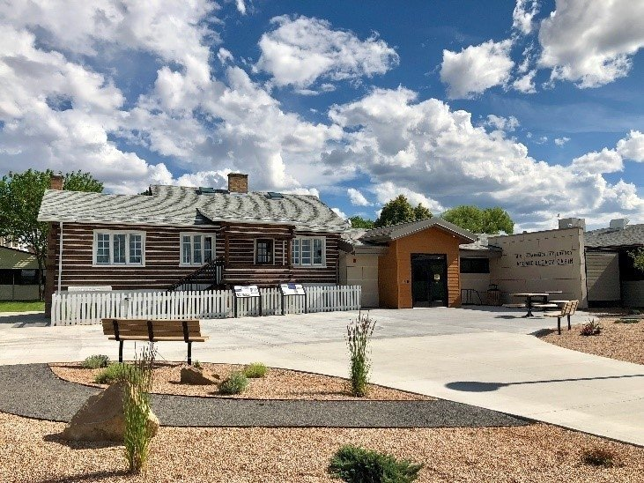

*FIG. 2. Atomic Legacy Cabin in Grand Junction, Colorado.*

Because many sites in LM’s portfolio have LTS&M activities spanning hundreds of years, the challenge LM faces is that long-term stewardship and management is not a static objective but a condition that must be maintained throughout the lifespan of the remedy. The LM portfolio has several sites with remedies that have been in place for decades. Whether a remedy is sustainable and resilient not only impacts the planning, sustaining, and managing of these assets, but also factors into the changing environments, whether those changes are related to remedy or regulatory standards, land use, or climate. LM develops and integrates these concepts into the review and management of its sites.

LM utilizes expertise, such as its Applied Studies and Technology program, to recognize, understand, and implement sustainable and resilient management practices throughout the organization and its sites. LM has been collaborating with Lawrence Berkeley National Laboratory to perform a comprehensive analysis of the impacts of climate change on the remedies at LM sites, which supports LM’s overall strategy for sustainability.

While most discussion about resiliency has been focused on climate change, LM is also assessing resiliency and sustainability for all aspects of its program. As noted above, disruptions and changes to LTS&M can also stem from regulatory, environmental, community, workforce, or economic changes that affect the future management of these lands.

The following are some examples of stewardship across LM’s portfolio:

* 1. **New Brunswick, New Jersey, Site**

From 1948 to 1977, AEC, the U.S. Energy Research and Development Administration, and DOE operated the New Brunswick Laboratory as a general radiological chemistry and assay facility. Contaminated soil from the Middlesex Municipal Landfill was used to backfill an abandoned railroad spur in 1960. Remediation of the site under the Formerly Utilized Sites Remedial Action Program began in the late 1970s. This entailed removing buildings and infrastructure in several phases between 1978 and 1983. The contaminated backfill in the railroad spur was remediated in 1996.

DOE completed remediation of the New Brunswick site before 1997. However, when the New Jersey Department of Environmental Protection (NJDEP) reviewed final site conditions, it determined that arsenic in one sample of the soil used to backfill the former railroad spur exceeded the State of New Jersey standard of 20 milligrams per kilogram. The state required that DOE prevent disturbance of the area through the implementation of a deed notice in accordance with state regulations.

DOE and NJDEP agreed that a deed notice would allow for declaration that no further remedial action at the site was needed. The deed identified the affected area, presented concentrations of hazardous materials, designated the clean soil backfill used to restore the excavation to grade as an engineered control, and restricted excavation in the identified arsenic-contaminated soil areas.

All future owners of the site are bound to the excavation restrictions in the deed. Property owners are required to inspect the site and submit a remedial action protection certification to NJDEP every 2 years. LM is responsible for managing site records and responding to stakeholder inquiries.

* 1. **L-Bar, New Mexico, Disposal Site**

LM is implementing many measures and solutions to climate-related risks due to the consequences of climate hazards at some of its sites. As shown in Fig. 3, at the L-Bar site in New Mexico, LM installed rock erosion barriers to secure the disposal site and the previously completed remedy.

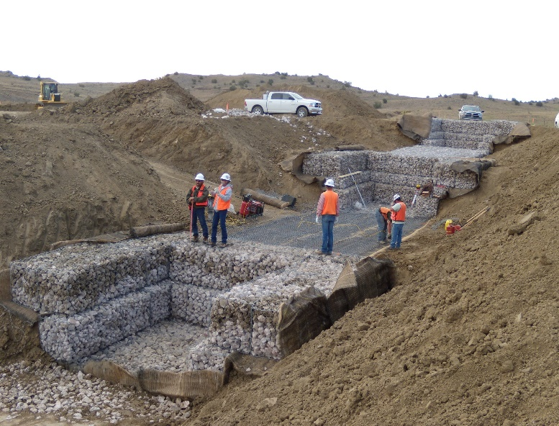

*FIG. 3.* *Installation of rock erosion barriers at the L-Bar site.*

LM manages the disposal site according to a Long-Term Surveillance Plan to ensure that the disposal cell systems continue to prevent the release of contaminants to the environment. It conducts annual inspections of the site to evaluate the condition of surface features, perform site maintenance as necessary, and monitor groundwater to ensure the continued integrity of the disposal cell. This ensures that the contaminated groundwater does not migrate offsite and prevents residual contamination.

Due to a series of rainfall events, LM identified concerns with its erosion control structures, disposal cell, and roads. Many other sites, especially in the southwestern climate region, have experienced or anticipate similar problems. LM is conducting aerial surveys over time at sites to provide a method of analyzing and understanding the rates of erosion progression, sedimentation volumes, and changes in topography.

Many remote LM sites use System Operation and Analysis at Remote Sites (SOARS) telemetry equipment. A variety of environmental parameters can be measured with SOARS dataloggers and sensors, including groundwater elevation, flow rates, groundwater quality (conductivity, pH, etc.), meteorological parameters (precipitation, air temperature, etc.), and electrical power consumption from buildings. SOARS can provide real‑time data after extreme hazard events, which inform the site management team of problems. LM continues to upgrade or expand existing LM SOARS systems to monitor site-specific data and the effects of climate change.

LM continually evaluates potential avenues for integration of these concepts into its planning and development as site remedies age and sites are impacted by various sources. LM will also look to other federal landowners for best practices and programs that may support LM sites. This evaluation will be conducted, along with monitoring for further potential impacts of climate change, during annual site inspections and event-specific changes. The implementation of proposed solutions may be incorporated into the life-cycle baselines and 75-year liability estimates for LM sites. However, LM is cognizant of implementation challenges that may arise due to appropriation and funding shortfalls in future fiscal years.

* 1. **Education and outreach programs on the Navajo Nation**

LM provides long-term stewardship for four former mill sites on Navajo Nation land: the Shiprock, New  Mexico, Disposal Site; the Tuba City, Arizona, Disposal Site; the Mexican Hat, Utah, Disposal Site; and the Monument Valley, Arizona, Processing Site. The Tuba City site is also in the vicinity of Hopi tribal lands. LM additionally has Uranium Mill Tailings Radiation Control Act sites that are in the vicinity of Window Rock, Arizona, including the Bluewater, New Mexico, Disposal Site and the L-Bar site.

In 2007, Congress issued a directive for five federal agencies and various Navajo tribal agencies to create a Five-Year Plan to address uranium contamination within the Navajo Nation. The federal agencies involved in this effort are DOE, the U.S. Environmental Protection Agency, the U.S. Nuclear Regulatory Commission, the U.S. Department of Health and Human Services, and the U.S. Department of the Interior. The tribal entities include the Navajo Nation Office of the President and Vice President, the Navajo Abandoned Mine Lands/Uranium Mill Tailings Remedial Action Department, the Navajo Nation Department of Health, the Navajo Nation Environmental Protection Agency, and the Navajo Nation Department of Justice. As part of the collaboration, DOE works closely with the Hopi tribe as well. The Navajo Nation Community Outreach Network Office in Window Rock, Arizona, is tasked with coordinating and supporting the multiagency effort through community outreach, joint agency and tribal planning, and information sharing.

The Community Outreach Network Office in Window Rock, Arizona, was established in 2016 to advance the Five-Year Plan outreach objectives through the Community Outreach Network. The Community Outreach Network Office serves as a centralized resource of information for the public about uranium issues and as a space for partnering agencies. Science, technology, engineering, and mathematics (STEM) outreach, including middle school, high school, and higher-education events, helps meet the LM-1 group’s mandate to increase such outreach to encourage future generations of scientists and engineers. It reaches thousands of ninth through twelfth grade science students during STEM events on the Navajo Nation each year (Fig. 4). Last year, there were fifteen different tribal and federal agencies and programs that took part in the events to educate Navajo Nation science students, using hands-on activities that promote STEM learning. The events are organized by the Navajo Abandoned Mine Lands/Uranium Mill Tailings Remedial Action Department and the Navajo Transitional Energy Company.

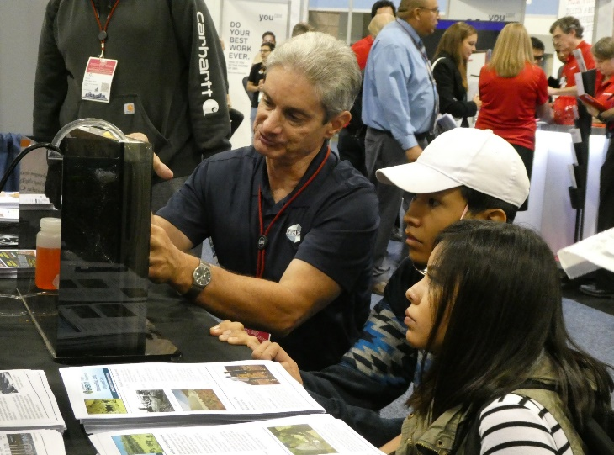

*FIG. 4. Illustrating three-dimensional modelling at a Navajo Nation STEM event.*

Students also receive information related to disposal sites near their communities. For instance, students at a Shiprock High School STEM event were given an overview of the Shiprock site’s disposal cell, which encapsulates low-level radioactive material generated from uranium milling operations between 1954 and 1968. When operating, the mill used leaching processes to separate uranium from crushed ore. The “tailings” left behind are the radioactive material that was placed in the disposal cell. Students also learned about an evaporation pond and the activities to clean contaminated groundwater using extraction wells.

* 1. **Collaborating internationally**

LM collaborates with international organizations, such as the International Atomic Energy Agency (IAEA). Like IAEA, LM understands that stakeholders today expect timely access to information delivered in a user-friendly fashion.

Following this idea, decades of nuclear research supported by DOE and its predecessor agencies were made searchable on the internet, as part of a collaborative effort between DOE and IAEA. The project gave researchers, academics, and the public access to vast volumes of valuable nuclear-related research.

Fig. 5 shows the collaboration in 2015 when LM sponsored a tour of the disposal cell at the Durango, Colorado, Disposal Site. The disposal cell was built by DOE to contain 2.5 million cubic yards of radioactive tailings and buildings from the days of uranium processing at a mill in the town.

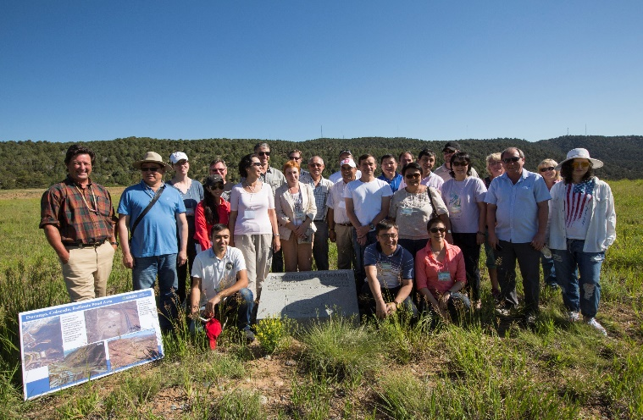

*FIG. 5. IAEA tour of the disposal cell at the Durango site.*

International collaborations are important because they strengthen self-awareness, science and technology and, in the case of learning organizations, education. They allow participants the benefit of coming to the table to articulate their competencies and telling others what they excel at and what they can improve. They also allow participants to collaborate with others who might do what they do but on a larger scale. Everyone can learn from those collaborations.

Also, this is a time in which forming those collaborations is more necessary than ever, and thankfully, advances in technology and travel have made this simpler than it was in the past. The rate of internationalization is increasing, with unhindered communication channels and more affordable travel. It is evident that industry, academia, and governments across the world are already seeking to make the most of these possibilities by forming global partnerships and fostering relationships with one another.

## Conclusion

LM is committed to long-term stewardship and the protection of public health and the environment from hazards associated with the cleanup of legacy sites that played a critical role in America’s nuclear history. These sites may have residual contamination or require ongoing waste management responsibilities that must be fulfilled for as long as necessary or until there are no requirements for further response actions. LM will be at these sites for as long as it takes. There is a moral obligation to manage that environmental legacy, to honor the obligations of the past, and to make steady and sustained progress on the cleanup in a safe, efficient, and cost-effective manner.

As with the Fernald Preserve, Ohio, Site (Fig. 6), LM honors the rich history of these sites and celebrates the work done to restore their environmental health without erasing their past. The goal is to return the land as a living tribute to all that occurred there. That is a legacy of which LM can be proud.

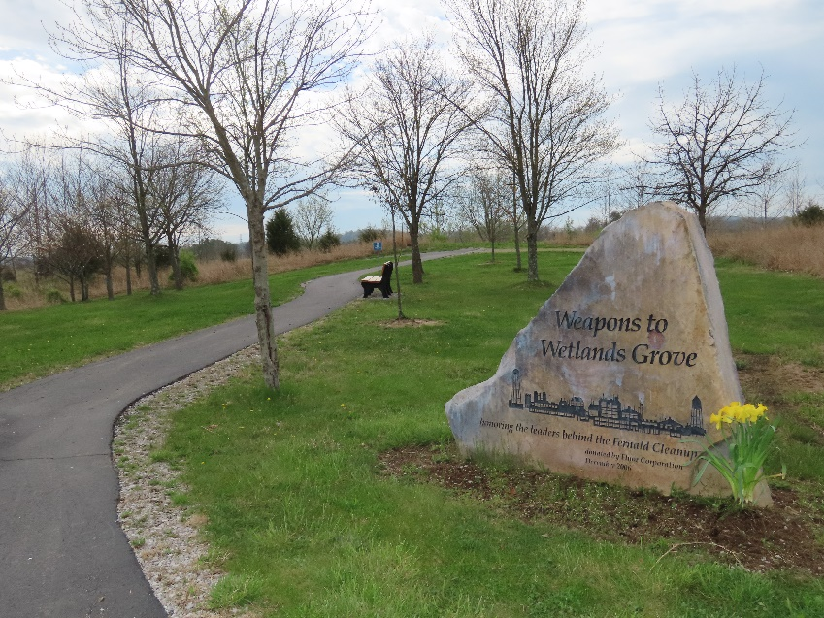

*FIG. 6. Fernald Preserve.*

## **BIBLIOGRAPHY**

INTERNATIONAL ATOMIC ENERGY AGENCY, DOE, IAEA Collaborate to Put Decades of Nuclear Research Online (2009), <https://www.iaea.org/newscenter/pressreleases/doe-iaea-collaborate-put-decades-nuclear-research-online>.

LOFHOLM, N., Grand Junction was Home to a Top-Secret Manhattan Project Uranium Mill During WWII, Colorado Public Radio (2018), <https://www.cpr.org/news/story/grand-junction-was-home-to-a-top-secret-manhattan-project-uranium-mill-during-wwii>.

U.S. DEPARTMENT OF ENERGY

2020–2025 Strategic Plan, DOE/LM-1488, Office of Legacy Management (2020), <https://www.energy.gov/lm/articles/2020-2025-strategic-plan>.

Grand Junction, Colorado, Site, <https://www.energy.gov/lm/grand-junction-colorado-site>.

L-Bar, New Mexico, Disposal Site, <https://www.energy.gov/lm/l-bar-new-mexico-disposal-site>.

Navajo and Hopi Students Learn About Uranium Legacy Sites (2019), <https://www.energy.gov/lm/articles/navajo-and-hopi-students-learn-about-uranium-legacy-sites>.

Talking STEM with the Navajo Nation: STEM-sation Day (2018),

<https://www.energy.gov/articles/talking-stem-navajo-nation-stem-sation-day>.

U.S. Department of Energy Grand Junction Office Listed on National Register of Historic Places (2016), <https://www.energy.gov/lm/articles/us-department-energy-grand-junction-office-listed-national-register-historic-places>.

U.S. ENVIRONMENTAL PROTECTION AGENCY

Navajo Nation: Cleaning Up Abandoned Uranium Mines (2023), <https://www.epa.gov/navajo-nation-uranium-cleanup/federal-plans-related-documents>.

1. For example, see Section 120 of the Comprehensive Environmental Response, Compensation, and Liability Act (CERCLA) (Title 42 *United States Code* Section 9620 [42 USC 9620]). Also, under the Uranium Mill Tailings Radiation Control Act (UMTRCA), see 42 USC 7914 and Appendix A of Title 10 *Code of Federal Regulations* Section 40. The regulatory authority associated with LM sites crosses several laws, regulations, authorities, and programs. These currently include CERCLA and the Resource Conservation and Recovery Act; UMTRCA Title I; UMTRCA Title II; the Nuclear Waste Policy Act; state Ground Water Quality Standards; the Formerly Utilized Sites Remedial Action Program; the DOE Decontamination and Decommissioning program; the Nevada Offsites; Manhattan Engineer District/U.S. Atomic Energy Commission legacy sites; and Plowshare/Vela Uniform Program sites.