Commitment to Long-Term Stewardship: An Overview of Safe and Sustainable Management and Reuse of Legacy Sites

Bud Sokolovich, Tania Smith Taylor, MEng, MBA[1]; Carmelo Melendez, PE, PMP, EngD[2]; and Jay Glascock, PMP, MEng[3], U.S. Department of Energy, Office of Legacy Management (LM)

**The Dept of Energy, Office of Legacy Management**

The operations of the Department of Energy, Office of Legacy Management, are trans-hemispheric. The Office of Legacy Management is charged to protect human health and the environment at 102 sites in over 30 states and territories, from Puerto Rico in the Caribbean Sea to Amchitka Island, Alaska, in the Bering Sea. The Office is the caretaker or steward of the legacy sites that played a critical role in America’s nuclear history. As such, its commitment to sustainable long-term stewardship is at the core of everything it does, beginning the moment the Office takes over a legacy site and continuing throughout long-term management efforts. This discussion reviews the long-term stewardship undertaken by the Office of Legacy Management in recent years. It describes the necessary components of an effective program, including the protection of human health and the environment, beneficial reuse, record keeping, monitoring remedial activities, stakeholder engagement, and international collaboration. The topic explores engagements with local communities, state and local governments, and tribal nations across numerous mediums to educate and inform the public of ongoing stewardship activities. Finally, the discussion includes current efforts to assess risks associated with climate change and to incorporate measures to increase climate resiliency of legacy sites. It is hoped that this discussion will convey the importance and commitment required of long-term stewardship.

**Safely and Sustainably Managing Legacy Sites Over Generations**

Established in 2003, the Office of Legacy Management continually evaluates how potential environmental changes may impact the approach to monitoring, inspection, and maintenance at the sites. Its scope has grown from 30 in 2003 to 102 sites today, and the number will continue to increase to 125 by 2030. The organization comprises approximately 80 federal employees and 500 contractor partners including geologists, hydrologists, engineers, physical scientists, and other professionals to ensure long-term environmental protection. It includes actuaries, financial managers, and procurement specialists to provide for retired contractor pension payments and post-retirement benefits. Certified realty officers and property specialists manage federal property and information technology specialists and records professionals to capture, safeguard, and share information. Historians and public participation specialists help facilitate engagements with stakeholders and governments. Finally, there are human resource and administrative staff to support personnel and workflow needs.

The Office operates using five key components or goals. The Office protects human health and the environment; makes legacy and environmental clean-up records accessible to the public and future generations; funds pensions and post-retirement benefits for over 10,000 former contractor workers and their spouses; manages land and facilitates beneficial reuse of closed sites; and ensures meaningful involvement by all stakeholders, especially tribal and local community members in all long-term stewardship activities.

In keeping with the theme of this year’s 5th International Mining Symposium, “Re-thinking Mining Remediation, Innovative Approaches Towards Sustainability”, it is important to review how the Office of Legacy Management shapes the future of legacy sites through its commitment to safe and sustainable long-term stewardship. This presentation will discuss how all these activities work together to accomplish successful long-term stewardship of legacy sites, that engages communities and promotes safe and sustainable reuse where feasible.

*Right: Children catch and tag butterflies at the Weldon Spring site.*

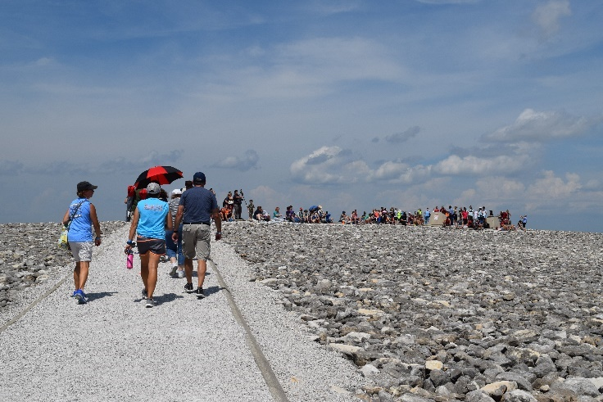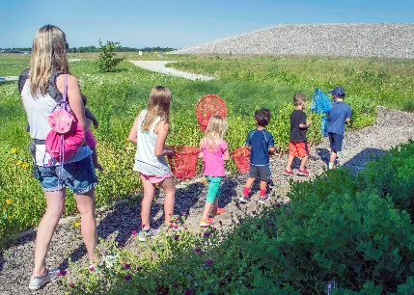

*Above: Weldon Spring Uranium Feed Materials Plant, circa 1957.*

*Right: Visitors walk to the top of the Weldon Spring disposal cell during a solar eclipse event.*

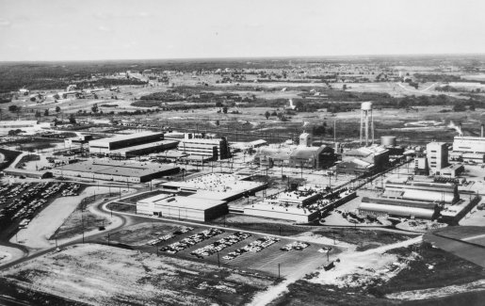

# 

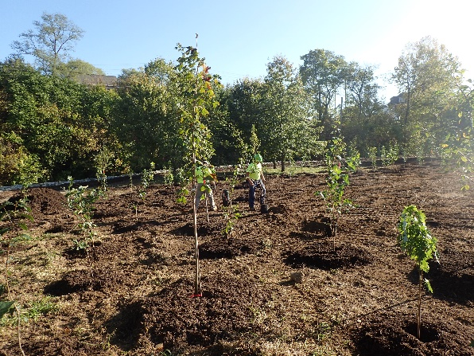

*Left: LM plants several hundred trees to reduce soil erosion at the Canonsburg site.*

# References

Canonsburg, Pennsylvania, Site. https://www.energy.gov/lm/canonsburg-pennsylvania-disposal-site

Grand Junction was Home to a Top-Secret Manhattan Project Uranium Mill During WWII, October 5, 2018. <https://www.cpr.org/news/story/grand-junction-was-home-to-a-top-secret-manhattan-project-uranium-mill-during-wwii>

Strategic Plan, 2020-2025, Department of Energy, Office of Legacy Management, January 2020. https://www.energy.gov/lm/articles/2020-2025-strategic-plan

Weldon Spring, Missouri, Site. https://www.energy.gov/lm/weldon-spring-site-missouri

1. Director, Technical Programs, Forrestal Office, Washington DC, Office of Legacy Management
2. Director, Office of Legacy Management, Department of Energy, Forrestal Office, Washington DC
3. Director, Site Operations, Westminster Center, Office of Legacy Management