# Effort on volume reduction and Recycling of Removed Soil and waste Arising from Off-site Decontamination Activities in Japan

MORI Yoshitomo, Ph.D.

Ministry of the Environment, Japan

Tokyo, Japan

Email: [yoshitomo_mori@env.go.jp](mailto:yoshitomo_mori@env.go.jp)

**Abstract**

Since shortly after the accident of the Fukushima Daiichi Nuclear Power Station (FDNPS) in 2011, the Japanese national government (mainly the Ministry of the Environment, Japan (MOEJ)) has made continuous effort on off-site decontamination projects. The full-scale decontamination activities and the large-scale transportation activities of the resulting waste and soil to the Interim Storage Facility (ISF) have been completed by March 2022, except for the Restricted Areas. As a result of the activities, a large amount of volume of removed soil and waste have been generated, and more than 13 million m3 of removed soil and waste have been transported into the ISF. The stored soil and waste are supposed to be transported from the ISF for final disposal outside Fukushima Prefecture, to be completed by March 2045. Taking account of difficulty to find out the place to accommodate all the stored soil for its final disposal, as well as the distribution of radioactivity concentration of the removed soil, the MOEJ has promoted recycling of removed soil to reduce the volume of the soil for final disposal in the future. The MOEJ has implemented a couple of demonstration projects using removed soil to ensure its safety from technological point of view, and also has implemented policies to earn trust and build understanding of the public. In the paper, progress made and issues to be addressed toward the future are presented, including the new framework between the IAEA and the MOEJ.

## Background

Five months after the accident of the FDNPS, the Act on Special Measures concerning the Handling of Environment Pollution by Radioactive Materials [1] was promulgated in August, 2011 and fully taken into effect in January, 2012.

Based on this Act, off-site decontamination activities had been implemented in the wide range of eastern Japan, in the Special Decontamination Areas (SDA) and the Intensive Contamination Survey Areas (ICSA), where the national government (mainly the MOEJ has been responsible for its implementation) and local municipalities with support of the national government, have worked as main practitioners of the activities, respectively (Fig. 1). The full-scale off-site decontamination activities in both areas were completed by March 2018, other than the Restricted Areas (RA)[1], where the air dose rate is relatively higher than the surrounding areas, and partially evacuation orders have not been lifted to this date (Fig. 1).

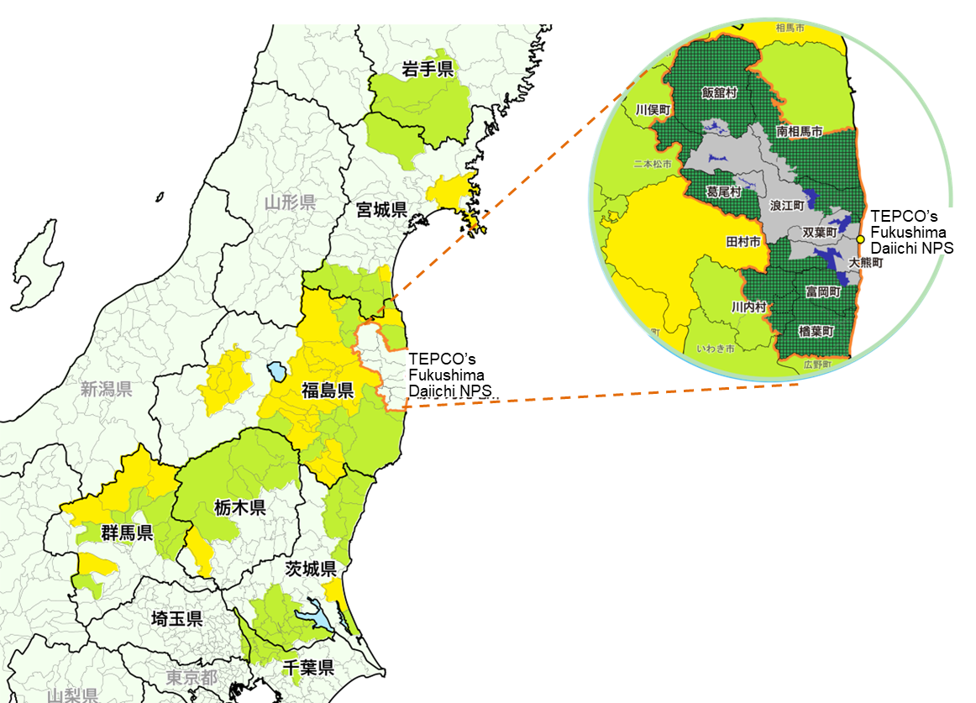

*FIG. 1. Categories and progress in decontamination areas and remaining evacuation areas.*

Municipalities designated as Intensive Contamination Survey Area

Municipalities where designation of Special Decontamination Area or Intensive Contamination Survey Area was lifted

Special Decontamination Area where full-scale decontamination was completed

The Specified Reconstruction and Revitalization Base Areas

Special Decontamination Area

Restricted Area

## Interim storage of removed soil and waste in fukushima prefecture

The off-site decontamination activities have been implemented both in and outside Fukushima Prefecture, but most of the removed soil and waste have been generated within Fukushima Prefecture, where the FDNPS is located, due to the different circumstance between 2 areas, including radiation level and consequent decontamination methods. Necessity of construction of the facility to accommodate the soil and waste in a concentrative manner, arising from the off-site decontamination activities, had been recognized since shortly after the start of the activities, and as a result of close and repetitive coordination between the national government, local governments and other relevant stakeholders, transportation of removed soil and waste into the ISF began in March 2015. The ISF is a group of a variety of facilities with dimension of around 16 km2, straddling both Okuma Town and Futaba Town (Fig. 2), which also home to the FDNPS. Difficult decision of the local authorities and people in the 2 towns to accept the ISF is here to be noted.

After the start of transportation projects, the amount of removed soil and waste to be transported into the ISF had skyrocketed in line with progress of the off-site decontamination activities, and it hit its peak in FY2019 and FY2020: around 4 million m3 of removed soil and waste was transported in each year to the ISF. By the end of FY2021, almost all of the removed soil and waste, other than those generated in the RA, was transported into the ISF.

The soil and waste transported into the ISF have been treated in the Soil Separation Facilities to remove large debris and contained combustible waste, followed by further transportation into the Soil Storage Facilities to temporarily and safely store the treated soil. The amount of soil and waste, which has been already transported into the ISF reached more than 13.5 million m3 as of end of July 2023 [2], and what needs to be underlined is that, it is stipulated in the Japanese law, that the removed soil and waste, which are currently stored in the ISF after the treatment, are supposed to be disposed of outside Fukushima Prefecture, within 30 ダイアグラム
years after the start of interim storage in the ISF (i.e. by March 2045).

*FIG. 2. The Interim Storage Facility.*

## promotion of volume reduction and recycling of removed soil and waste

The national government, however, regards it as very difficult to find a place outside Fukushima Prefecture, which could accommodate all the removed soil and waste which are currently stored in the ISF. And as a result of component analyses, it has become apparent, that around 75% of the removed soil has radioactivity concentration of 8,000 Bq/kg or less, the criterion which the MOEJ regards as possible, for the removed soil to be recycled under proper management of public authorities.

Taking account of the above-mentioned situation, the national government has promoted the volume reduction and recycling policy to reduce volume of soil and waste to be disposed of in the future. The Strategy for Volume Reduction and Recycling of Removed Soil from Interim Storage (the Strategy)- formulated in 2016 and revised in 2019 – is the one of the major documents to represent policy from mid-term and long-term perspectives, regarding steps for the volume reduction and recycling of the removed soil and waste, for the final disposal project to be completed by March 2045 [3]. The followings are summary of key policies relevant to the paper, both from technical and social point of view, represented in the Strategy.

### Technical point of view

In line with the Strategy, development of basic technologies for volume reduction and recycling of removed soil and waste is supposed to be completed by the end of FY2024 (March 2025). The technologies to be developed will include classification, chemical treatment and heat treatment of removed soil, as well as cleaning treatment and heat treatment of ash, generated through volume reduction processes.

In addition to the development of basic technologies, the MOEJ has concurrently implemented a couple of demonstration projects for the recycling of removed soil, to accumulate knowledge and first-hand experience with regard to the recycling of removed soil, that could also contribute to the building understanding and earning trust of the public in a step-by-step manner.

The demonstration project in Nagadoro District, Iitate Village, Fukushima Prefecture, is one of the representative demonstration projects, where the removed soil is used as basis of agricultural land, and rice is cultivated on the covered soil, above of the basis (Fig. 3).

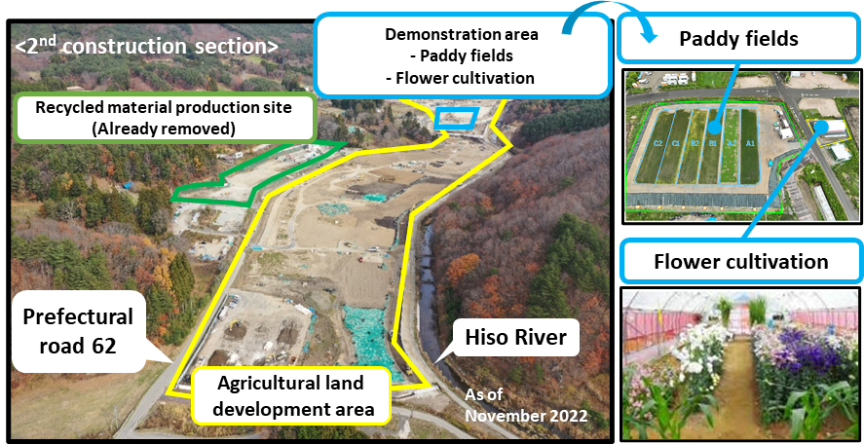After the completion of the demonstration projects, the MOEJ plans to proceed to full-scale application of recycling of removed soil, by securing actual construction sites which will accommodate the removed soil as recycle material, on the premise of the safety of the public and workers on and around the sites.

*FIG. 3. Demonstration project site in Nagadoro District, Iitate Village, Fukushima Prefecture.*

### Social point of view

To realize the final disposal of the removed soil and waste outside Fukushima Prefecture within 30 years after the start of interim storage in the ISF, nationwide public understanding for policy on recycling and final disposal of the removed soil and waste is important. Therefore, the MOEJ has made continuous efforts to disseminate information about necessity and specific demonstration projects for volume reduction and recycling, toward the final disposal in the future, with close cooperation with relevant organizations, including national and local authorities, as well as academic societies.

The specific examples for the measures taken are listed as follows:

* A number of nationwide dialogue forums with people;
* Site visits by people to the demonstration project site (e.g. the ISF, the Nagadoro project site);
* Lectures for university and high school students;
* Internet surveys to know current situation for public understanding for the policies;
* Installation of potted plants using removed soil in relevant Japanese ministries and agencies.

## Cooperation with international society

These projects which have been implemented so far have no precedents in the human history and they need to be shared with international society, as a common asset to provide experience and lessons learned to the present and future generations.

Since shortly after the accident of the FDNPS, the MOEJ has established bilateral meetings with countries with considerable experience for response and remediation to address environmental contamination caused by released radioactive materials, and the MOEJ also has had a number of opportunities to disseminate its experience to the international society and exchange views with international organizations: presentations in international conferences, receiving international missions of the IAEA, holding Experts Meetings with the IAEA and selected experts all over the world.

For example, the MOEJ had 4 Experts Meetings with the IAEA from 2016 to 2017, in order to discuss the situation of off-site decontamination activities in the areas affected by the accident, and also in order for assistance and advice to be provided to the MOEJ for its future works. The consolidated report to integrate achievements made through the Experts Meetings was published in March 2023 and available in the IAEA website [4].

Concurrently, in response to progress made for the off-site remediation projects mentioned above, including completion of full-scale off-site decontamination activities other than the RA, the MOEJ has faced new challenges like volume reduction and recycling of removed soil and waste. After close interaction with the IAEA, a new framework to discuss this issue has been established and the 1st Experts Meeting was held in 8 - 12 May, 2023 in Japan, and the 2nd Experts Meeting is to be held in a hybrid style: face-to-face in Vienna and online as well, in 23 -27 October, 2023. Another Experts Meeting is scheduled in early 2024, and final report is supposed to be published by the IAEA after the last 3rd meeting.

References

1. E-GOV Japanese Law Database, The Act on Special Measures concerning the Handling of Environment Pollution by Radioactive Materials (2011) (in Japanese)

https://elaws.e-gov.go.jp/document?lawid=423AC1000000110

1. Ministry of the Environment, Japan, Information Site of the Interim Storage Facility (2023) (in Japanese)

http://josen.env.go.jp/chukanchozou/transportation/

1. Ministry of the Environment, Japan, The Strategy for Volume Reduction and Recycling of Removed Soil from Interim Storage -Review toward achievement of strategy goal- (2019) (in Japanese)

http://josen.env.go.jp/chukanchozou/facility/effort/investigative_commission/pdf/investigative_commission_review_1903.pdf?1904

1. International Atomic Energy Agency, Ten Years of Remediation Efforts in Japan (2023)

https://www.iaea.org/publications/15193/ten-years-of-remediation-efforts-in-japan

1. The Restricted Areas were once named the ‘Difficult-to-Return Zones’ but their official name is currently defined as the ‘Restricted Areas’.