International Conference on the Safety of Radioactive Waste Management, Decommissioning, Environmental Protection and Remediation:

Ensuring Safety and Enabling Sustainability

6 - 10 November 2023

Vienna, Austria

Ref: CN-318/ EVT2102343
BIOGRAPHICAL SUMMARY FOR SPEAKERS
Please ensure to include in a separate file of your photo saved in a JPEG format with a resolution of 200 x 200 pixels. Send the photo together with the following form to ICWEDR2023@iaea.org
NAME: | Adriaan Hengeveld
SESSION # | 5
PAPER/ POSTER TITLE: | Bulk radioactive residuals from cyclotron decommissioning in the Netherlands
AFFILIATION/COMPANY: | Dutch Institute for Public Health and the Environment (RIVM)
SHORT BACKGROUND FOR INTRODUCTION (3-4 LINES): | I am a physicist with an interest in nuclear technology and applications. I have worked in research in an academic hospital and in my nation’s Institute for public health and the environment.

Release of Electronic (MS PowerPoint) Presentation or Poster

I agree that my oral presentation or poster to be presented at Safety of Radioactive Waste Management, Decommissioning, Environmental Protection and Remediation: Ensuring Safety and Enabling Sustainability which will be held in Vienna, Austria from 6 to 10 November 2023, may be made available on the IAEA conference app and/or website as a PDF or MP4 Video.
YES | NO  Signature: 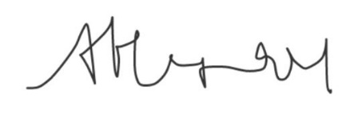

Please complete and return this form as Word document by email to: ICWEDR2023@iaea.org

